Unit-IV
ARITHMETIC
ARITHMETIC:
- A basic operation in all digital computers is the addition or subtraction of two numbers.
- Arithmetic operations occur at the machine instruction level.
- They are implemented basic functions such as AND, OR, NOT and Exclusive OR (XOR) in the Arithmetic and Logic Unit subsystem of the processor.
- In this chapter present Logic circuit used to implement Arithmetic operations.
- Compared with Arithmetic operations, logic operations are simple to implement using combinational circuitry. Whereas carry / barrow lateral signals are required in Arithmetic operations.
ADDITION AND SUBTRACTION OF SIGNED NUMBERS:
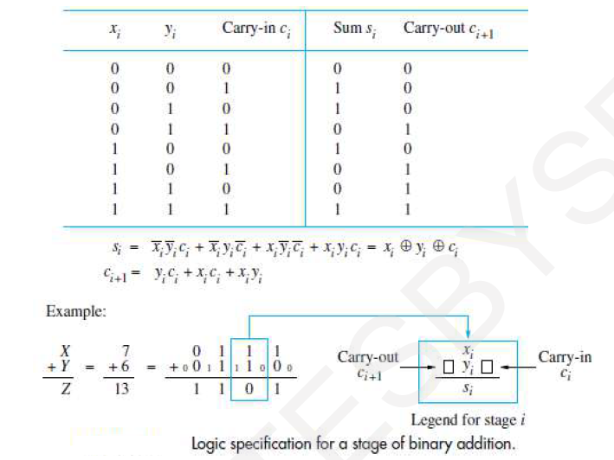

- The Logic truth table for sum and carryout are the outputs for adding equally weighted bits xi and yi, in two numbers X and Y.
- The logic expressions for these functions are also shown, along with an example of addition of the 4-bit unsigned numbers 7 and 6.
- Each stage of the addition process must accommodate a carry-in bit. We use Ci, to represent the carry-in to the i^{th} stage, which is the same as the carryout from the (i - 1) ^{th} stage.

Full Adder:
The logic expression for Si in can be implemented with a 3-input XOR gate. The carryout function, Ci +1 is implemented with a two-level AND-OR logic circuit. A convenient symbol for the complete circuit for a single stage of addition, called a full adder (FA).

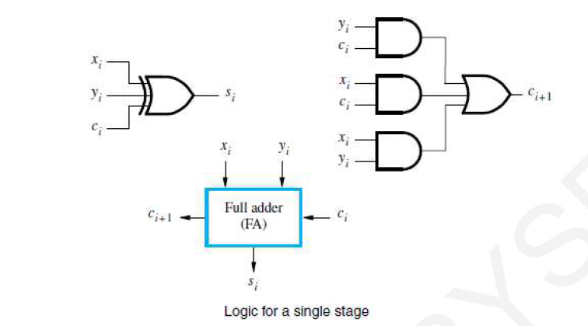

n-bit Ripple Carry Adder:
A cascaded connection of such n full adder blocks, as forms a parallel adder & can be used to add two n-bit numbers. Since the carries must propagate or ripple, through this cascade the configuration is called an n-bit ripple-carry adder.

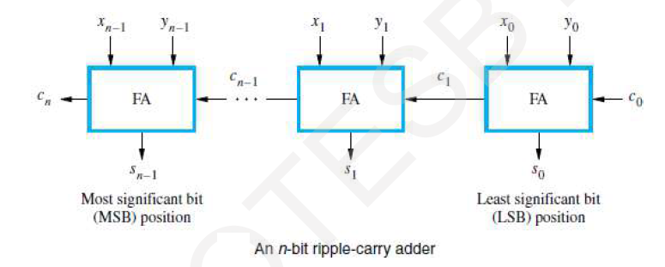

Cascade of k n-bit Adders:
A cascaded the carry-in, Co, into the least-significant-bit (LSB) position provides a convenient means of adding 1 to a number. Take for instance; forming the 2's- complement of a number involves adding 1 to the 1’s-complement of the number. The carry signals are also useful for interconnecting k adders to form an adder capable of handling input numbers that are kn bits long.
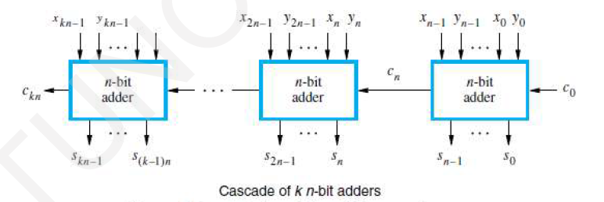

Addition / Subtraction Overflow:
- Overflow can occur only when adding two numbers that have the same sign.
- The carry bit from the MSB position is not a sufficient in detect overflow when adding signed numbers.
- When both operands X and Y have the same sign, an overflow occurs.
- The logical expression to detect overflow can be given as
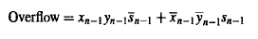
- It can also that overflow occurs when the carry bits Cn and Cn-1 are different.
- Therefore a simple alternative circuit for detecting overflow can be obtained by implementing the expression with an XOR gates.

Addition / Subtraction Logic Unit:
- The n – bit adder can be used to add 2’s complement number X and Y, where the Xn-1 and Yn-1 bits are the sign bits. In this case the carry out bit Cn is not part of the answer.
- In order to perform the subtraction operation X – Y on 2’s complement numbers X and Y, we form the 2’s complement of Y and add it to X.
- The Logic circuit network can be used to perform either addition or subtraction based on the value applied to the Add / Sub input control line.
- This line is set to 0 for addition applying the Y vector unchanged to one of the adder input along with a carry-in signal C₀ of 0.
- When the Add / Sub control line is set to 1, the Y vector is 1’s complemented by the XOR gates and Co is set 1 to complete the 2’s complement of Y.
- Remember that 2’s complementing a negative number is done in exactly the same manner as for a positive number. An XOR gate can be added to detect the overflow condition .
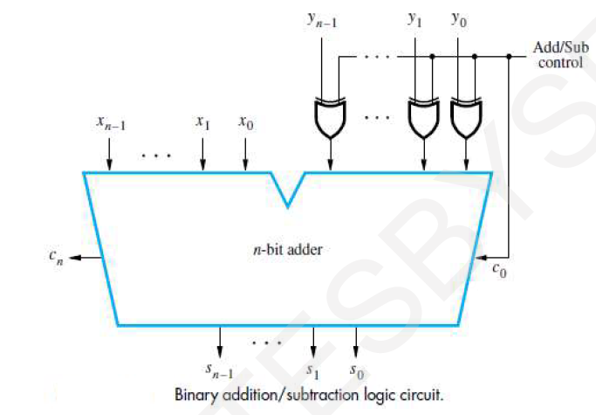
DESIGN OF FAST ADDERS:
- In an n-bit parallel adder (ripple-carry adder), there is too much delay in developing the outputs, so through sn-1 and cn.
- The delay through a network depends on the integrated circuit technology used in fabricating the network and on the number of gates in the paths from inputs to outputs (propagation delay).
- The delay through any combinational logic network constructed from gates in a particular technology is determined by adding up the number of logic-gate delays along the longest signal propagation path through the network.
- In practice, a number of design techniques have been used to implement high- speed adders.
- In order to reduce this delay in adders, an augmented logic gate network structure may be used. One such method is to use circuit designs for fast propagation of carry signals (carry prediction).
Carry Lookahead Additions:
As it is clear from the previous discussion that a parallel adder is considerably slow & a fast adder circuit must speed up the generation of the carry signals, it is necessary to make the carry input to each stage readily available along with the input bits.

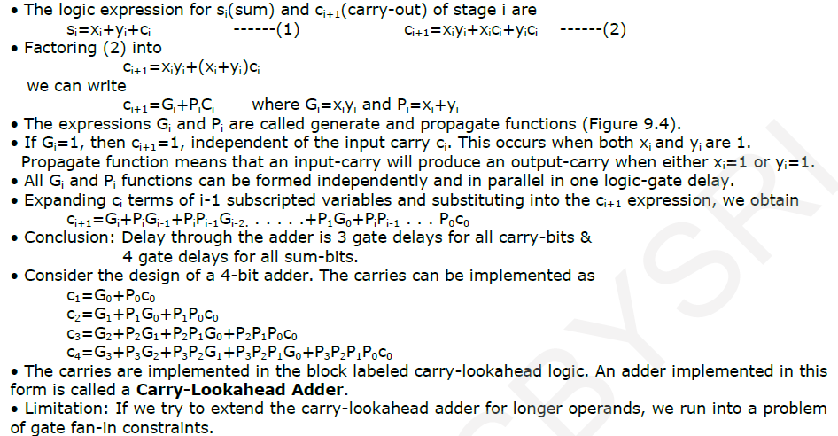
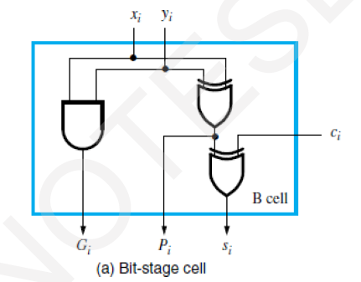

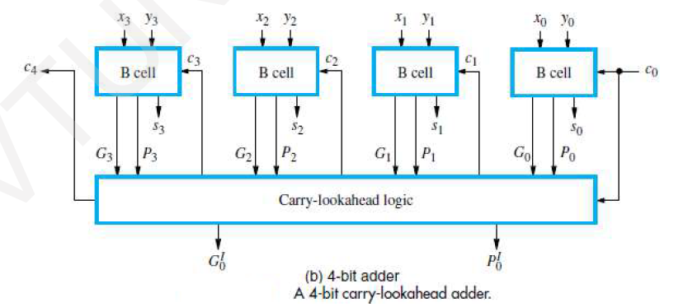

Higher Level Generate & Propagate Functions

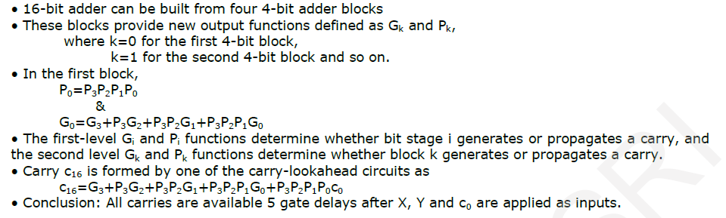

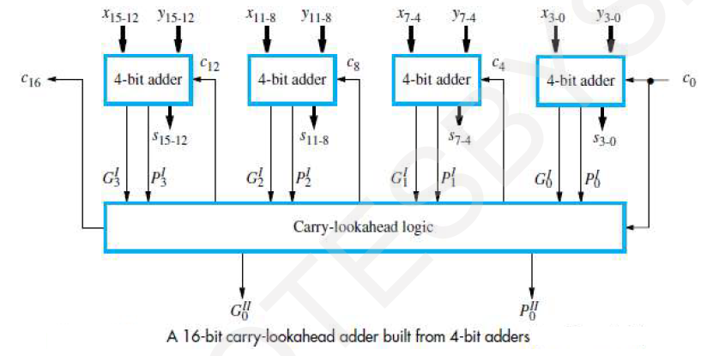

MULTIPLICATION OF POSITIVE NUMBERS:
- The usual algorithm for multiplying integers by hand is illustrated in figure for the binary number system.
- This algorithm applies to unsigned numbers and to positive signed numbers.
- The product of two n-digit numbers can be accommodated in 2n digits, so the product of the two 4-bit numbers in this example fits into 8 bits.
- In the binary system, multiplication by the multiplier bit ‘1’ means the multiplicand is entered in the appropriate position to be added to the partial product.
- If the multiplier bit is ‘0’, then 0s are entered, as indicated in the third row of the shown example

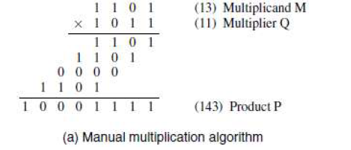
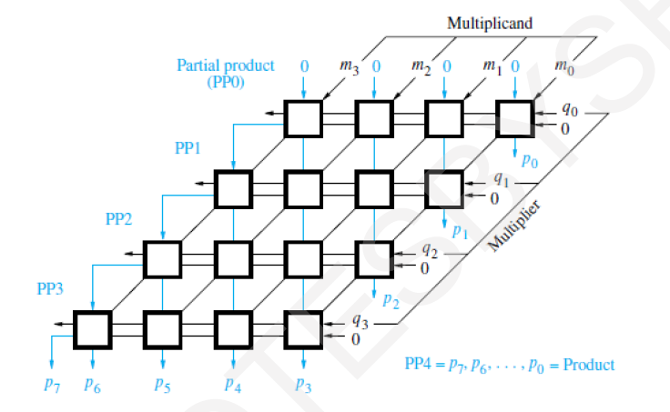

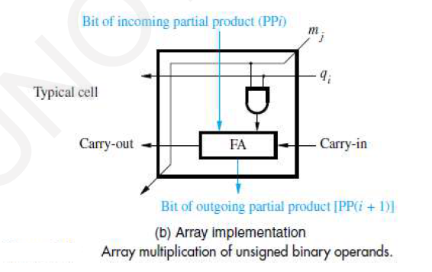
- The main component in each cell is a full adder (FA).
- The AND Gate in each cell determines whether a multiplicand bit Mj is added to the incoming partial product bit, based on the value of the multiplier bit Qi.
- Each row i, where 0 < i < 3 adds the multiplicand to the incoming partial product PPi to generate the outgoing partial product PP(i+1), if Qi=1.
- If Qi=0, PPi is passed vertically downward unchanged.
- PP0 is all 0’s and PP4 is the desired product.
- The multiplicand is Shifted Left one position per row by the diagonal signal path.
- The simplest way to perform multiplication is to use the added circuitry in the ALU for a number of sequential steps.
- The block diagram in hardware arrangement for sequential multiplication.
- This circuit performs multiplication by using single n-bit adder n times to implement the spatial addition performed by the n rows of ripple-carry adders.
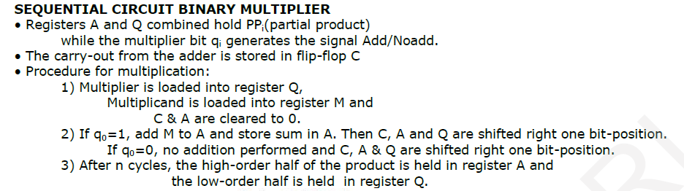
- Flowchart for multiplication operation is
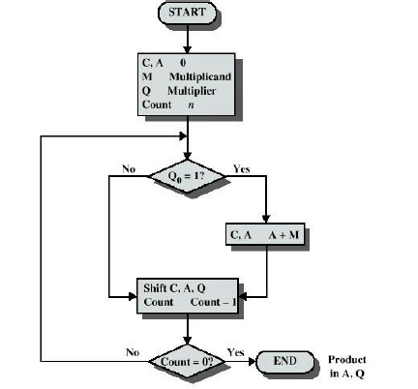
=
=
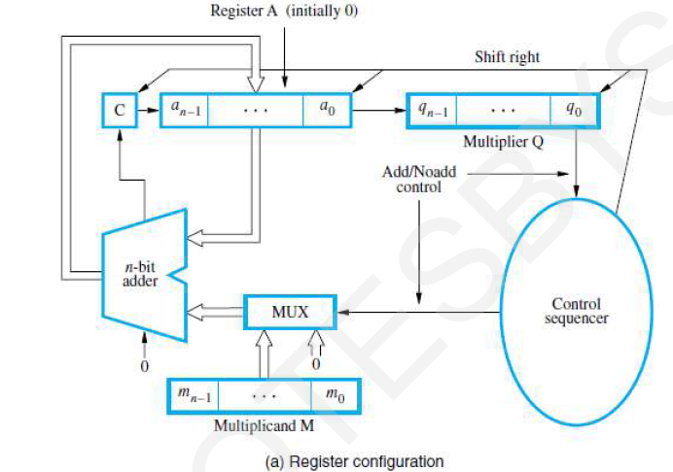
Problem:
If the product of two 4 bit unsigned numbers multiplier (1011) and Multiplicand (1101)
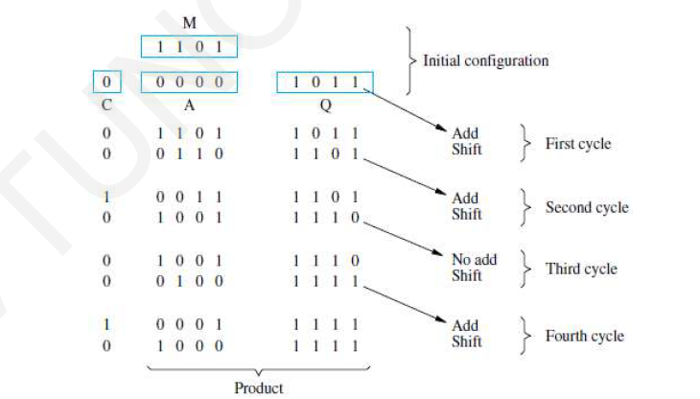

SIGNED-OPERAND MULTIPLIATION:
- Multiplication of 2's-complement signed operands, generating a double-length product is still achieved by accumulating partial products by adding versions of the multiplicand as decided by the multiplier bits.
- First, consider the case of a positive multiplier and a negative multiplicand. When we add a negative multiplicand to a partial product, we must extend the sign-bit value of the multiplicand to the left as far as the product will extend.
- In Figure 9, for example, the 5-bit signed operand, - 13, is the multiplicand, and +11, is the 5 bit multiplier & the expected product -143 is 10-bit wide. The sign extension of the multiplicand is shown in red color. Thus, the hardware discussed earlier can be used for negative multiplicands if it provides for sign extension of the partial products.
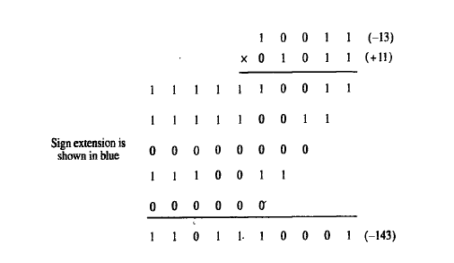

- For a negative multiplier, a straightforward solution is to form the 2's- complement of both the multiplier and the multiplicand and proceed as in the case of a positive multiplier.
- This is possible because complementation of both operands does not change the value or the sign of the product.
- In order to take care of both negative and positive multipliers, BOOTH algorithm can be used.

Booth Algorithm
- The Booth algorithm generates a 2n-bit product and both positive and negative 2's complement n-bit operands are uniformly treated.
- This algorithm considers a multiplication operation in which the multiplier is positive and has a single block of 1’s.
- However we can reduce the number of required operations by regarding this multiplier.

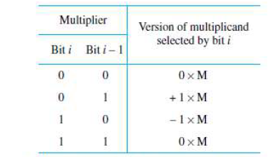

- Example of Booth recode the multiplier 11010 for Booth multiplication

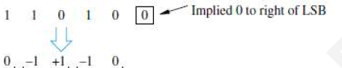

Problem:- The Booth recoding problem multiply the multiplicand is 01101(+13) and multiplier is 11010 (-6)
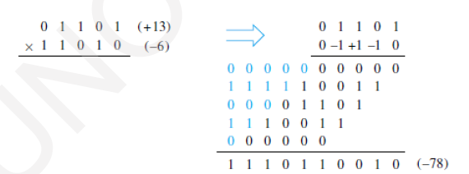

Booth algorithm is a multiplication algorithm that multiplies two signed binary numbers in 2’s compliment notation with applies to the Logic Circuited.

Procedure:
- Let M is the multiplicand
- Let Q is the multiplier
- Consider a 1-bit register Q-1 and initialize to 0.
- Consider A (Accumulator ) register and initialize to 0
- The shift, add and subtract control logic scans bits Q0 and Q-1 one at a time and generates the control signals as shown in the table.

Q0 | Q-1 | Add / Subtract enable | Shift
0 | 0 | 0 | 1
0 | 1 | 1 | 1
1 | 0 | 1 | 1
1 | 1 | 0 | 1

Conditions:-
- If Q0,Q-1 are same i.e 0 0 or 1 1 then, perform Arithmetic Right Shift by 1 Bit
- If Q0,Q-1 = 1 0 then, perform A = A – M and then Arithmetic Right Shift by 1 Bit
- If Q0,Q-1 = 0 1 then, perform A = A + M and then Arithmetic Right Shift by 1 Bit

Flowchart:-

FAST MULIPLICATION:
There are two techniques for speeding up the multiplication operation. The first technique guarantees that the maximum number of summands (Bit pair recoding of multipliers) that must be added is n/2 for n-bit operands. The second technique reduces the time needed to add the summands (Carry-Save Addition of summands method).

Bit-Pair Recoding of Multipliers:
- This bit-pair recoding technique halves the maximum number of summands.
- To speed up the multiplication process in the Booth Algorithm a technique called Bit pair recoding.
- It is derived from the Booth algorithm.
- In this technique, the Booth recoded multiplier bits are grouped in pairs.
- Then each pair is represented by its equivalent single bit multiplier reducing total number of multiplier bits to half.
- It shows a table of the multiplicand selection decisions for all possibilities.
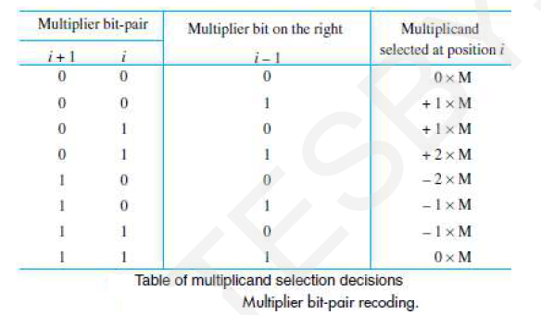

- An example of bit pair recoding of the multiplier sign extension

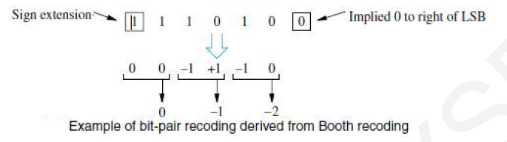

Problem:- The Multiply given signed 2’s complement numbers using bit pair recoding multiply the multiplicand is 01101(+13) and multiplier is 11010 (-6)

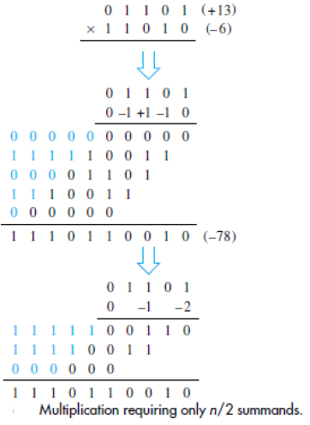

Carry Save Addition of Summands:
- Multiplication requires the addition of several summands
- A technique called Carry – Save Addition speeds up the addition process.
- Delay through the Carry – Save Array is less than delay through the Ripple Carry Array. This is, because S and C vector outputs from each row are produced in parallel in one full adder delay.
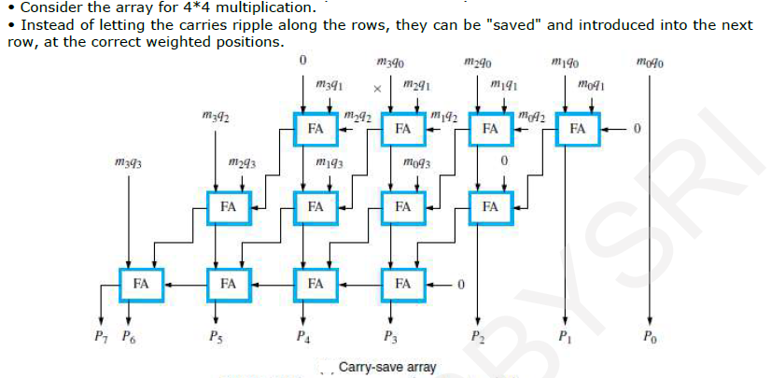
- To increase the speed of the addition process many times technique called Carry – Save Addition is used.

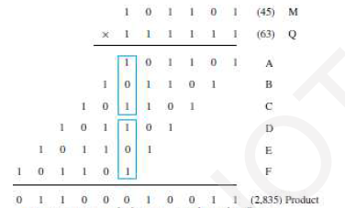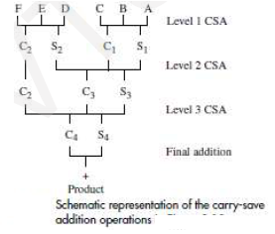

Example Problem:
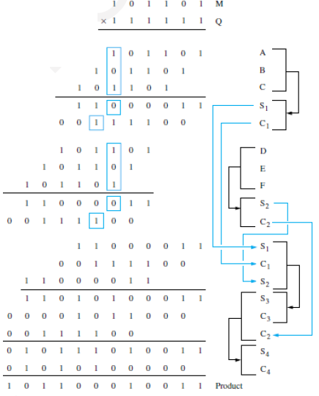

INTEGER DIVISION:
Positive-number multiplication operation is done manually in the way it is done in a logic circuit. A similar kind of approach can be used here in discussing integer division. First, consider positive-number division. It shows examples of decimal division and its binary form of division. First, let us try to divide 2 by13, and it does not work. Next, let us try to divide 27 by 13. Going through the trials, we enter 2 as the quotient and perform the required subtraction. The next digit of the dividend, 4, is brought down, and we finish by deciding that 13 goes into 14 once and the remainder is 1. Binary division is similar to this, with the quotient bits only 0 and 1.

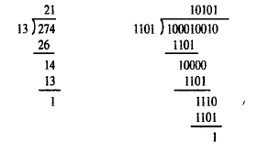

A circuit that implements division by this longhand method operates as follows: It positions the divisor appropriately with respect to the dividend and performs a subtraction. If the remainder is zero or positive, a quotient bit of 1 is determined, the remainder is extended by another bit of the dividend, the divisor is repositioned, and sub- traction is performed. On the other hand, if the remainder is negative, a quotient bit of 0 is determined, the dividend is restored by adding back the divisor, and the divisor repositioned for another subtraction.
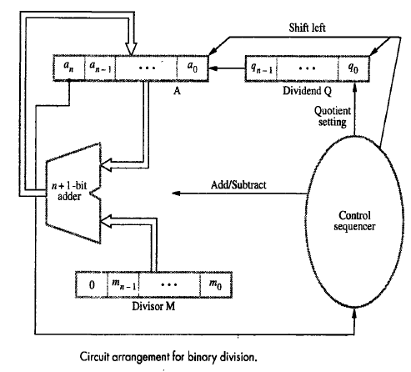
- A Logic Circuit arrangement that implements two types of Binary Division.
- That is 1) Restoring Division 2) Non Restoring Division.

Restoring Division Algorithm:
- An n-bit positive divisor is loaded into register M and an n-bit positive dividend is loaded into register Q at the start of the operation.
- Register A is set to 0. After the division is complete, the n-bit quotient is in register Q and the remainder is in register A.
- The required subtractions are facilitated by using 2's-complement arithmetic. The extra bit position at the left end of both A and M accommodates the sign bit during subtractions.
- The following algorithm performs restoring division.
  - Shift A and Q left one binary position.
  - Subtract M from A, and place the answer back in A.
  - If the sign of A4 is 1, set q0 to 0 and add M back to A (that is, restore A); otherwise, the sign of A4 is 0 set q0 to 1.
  - Repeat steps 1, 2 and 3 n times.

Example of Restoring Method division of 4-bit dividend is 1000(8) and divisor is 0011(3)

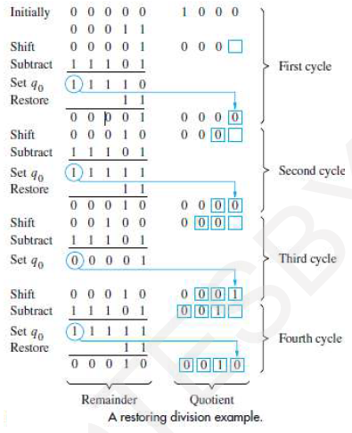

Non restoring Division Algorithm:
- The restoring-division algorithm can be improved by avoiding the need for restoring A after an unsuccessful subtraction.
- Subtraction is said to be unsuccessful if the result is negative. Consider the sequence of operations that takes place after the subtraction operation in the preceding algorithm.
- If A is positive, we shift left and subtract M, that is, we perform 2A - M.
- If A is negative, we restore it by performing A + M, and then we shift it left and subtract M. This is equivalent to performing 2A + M.
- The q0 bit is appropriately set to 0 or 1 after the correct operation has been performed. We can summarize this in the following algorithm for Non Restoring Division.
- Step 1: Do the following n times:
  - If the sign of A4 is 0, shift A and Q left one bit position and subtract M from A; otherwise, the sign of A4 is 1, shift A and Q left and add M to A.
  - Now, if the sign of A4 is 0, set q0 to 1; otherwise if the sign of A4 is 1, set q0 to 0.
- Step 2: If the sign of A is 1, add M to A.
- Step 2 is needed to leave the proper positive remainder in A at the end of the n cycles of Step 1.

Example of Non Restoring Method division of 4-bit dividend is 1000(8) and divisor is 0011(3)
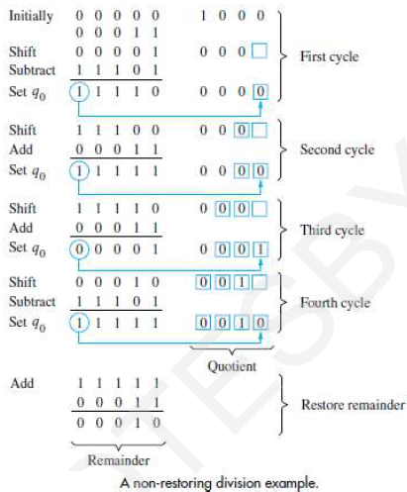
FLOATING POINT NUMBERS AND OPERATIONS:
- Floating point numbers are represented in Scientific notation of fraction (F) and exponent (E) with a radix of 2 in the form of F x 2E. Both E and F can be positive as well as negative.
- In the 2’s complement system, the signed value F represented by the n-bit binary fraction B = b0.b - 1b -2 …..b-(n-1) is given by
F(B) = -b0 x 2⁰ + b-1 x 2⁻¹ +b-2 x 2⁻² + ... + b-(n-1) x 2^{-(n-l)}
Where the range of F is -1 ≤ F ≤ 1 -2^{-(n-1),} consider the range of values represented in a 32-bit, signed, fixed- point format.
- Modern computers adopt IEEE-754 standard for representing floating point numbers. This standards for representing floating point numbers has been developed and specified in detail by Institute of Electrical and Electronics Engineers. There are two types of representation format.
    - 32 bit Single precession floating point representation
    - 64 bit Double precession floating point representation

IEEE – 754 standards for 32 bit Single precession floating point representation:

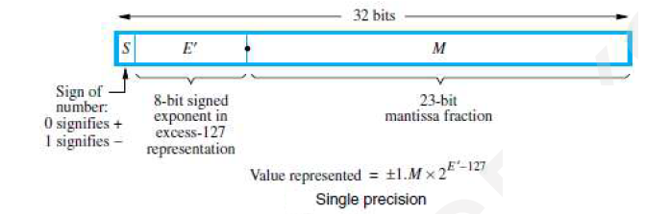
- The most significant bit is the sign bit(S) with 0 for positive numbers and 1 for negative numbers.
- The Following 8 bits represented exponent (E). Biased exponent represented in Excess – 127 formats. The relation with original exponent E| is
E| = E + 127
Range of E| , 0 < E| < 255
But 0 and 255 values are special values.
- Therefore the range of E| for normal values is 1 < E| < 254. This means that the actual exponent E is in the range -126 < E < 127.
- The last 23 bits represent the mantissa. Since binary normalization is used, the most significant bit of the mantissa is always equal to 1. The 23 bits stored in the M field actually represented the fractional part of the mantissa, the bits to the right of the binary point.

IEEE – 754 standards for 64 bit Double precession floating point representation:

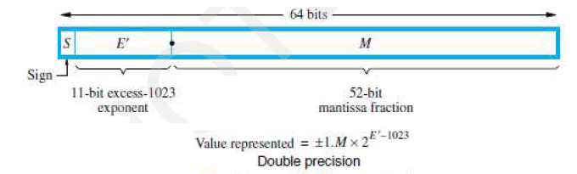
- The double precision format has increased exponent and mantissa ranges.
- The most significant bit is the sign bit(S) with 0 for positive numbers and 1 for negative numbers.
- The Following 11 bits represented exponent (E). Biased exponent represented in Excess – 1023 formats. The relation with original exponent E| is
E| = E + 2047
Range of E| , 0 < E| < 2047
But 0 and 255 values are special values.
- Therefore the range of E| for normal values is 1 < E| < 2046. This means that the actual exponent E is in the range -1022 < E < 1023.
- The last 52 bits represent the mantissa. Since binary normalization is used, the most significant bit of the mantissa is always equal to 1. The 52 bits stored in the M field actually represented the fractional part of the mantissa, the bits to the right of the binary point.

Implementing Floating Point Operations:
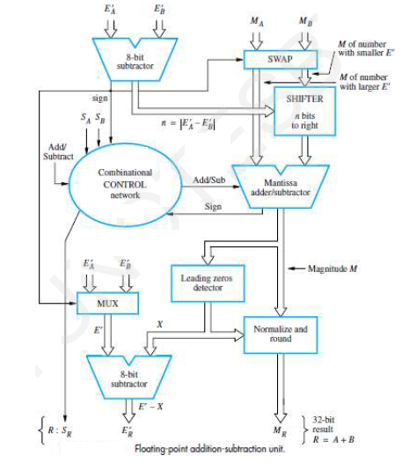
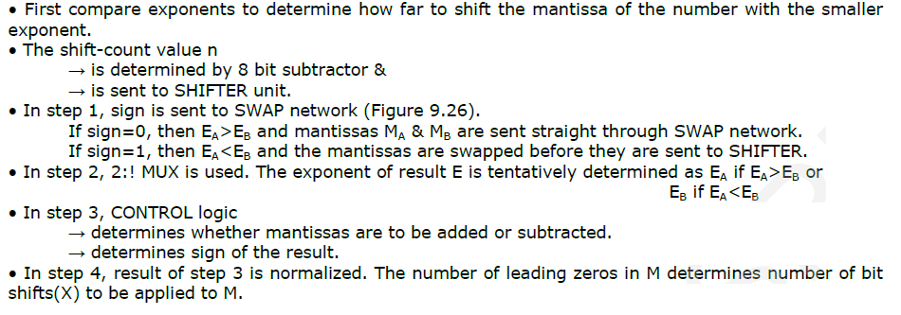

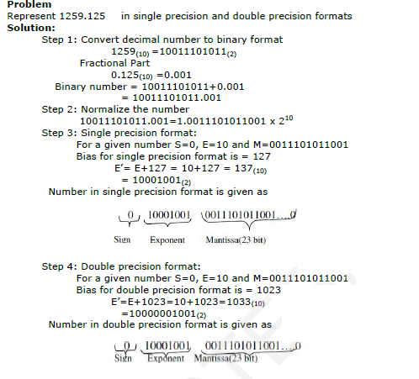
UNIT – V
BASIC PROCESSING UNIT
BASIC PROCESSING FUNDAMENTAL CONCEPT:
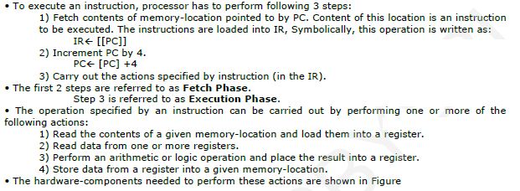
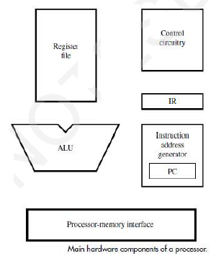

SINGLE BUS ORGANIZATION:
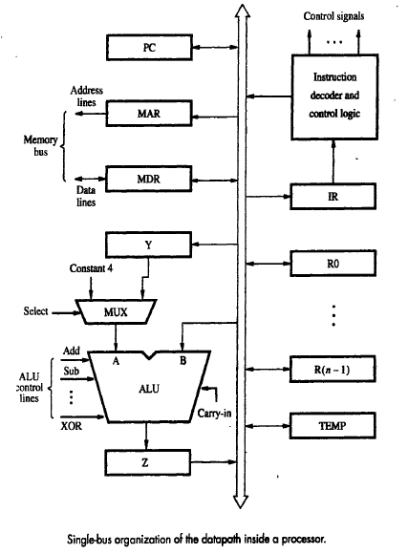
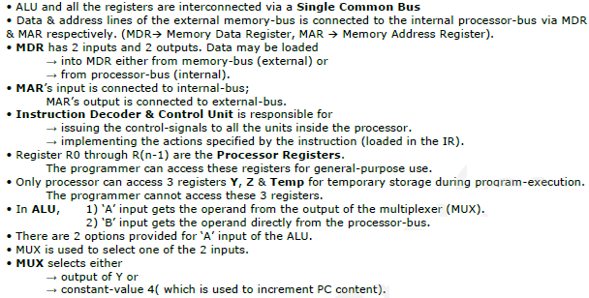
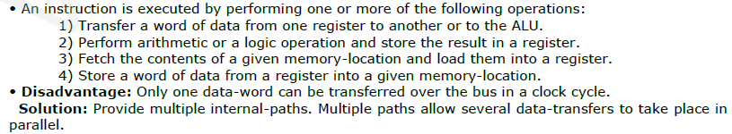
REGISTER TRANSFERS:
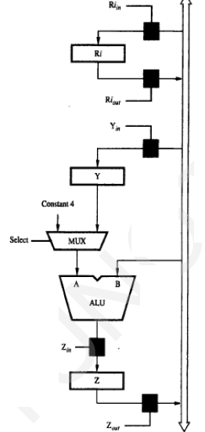
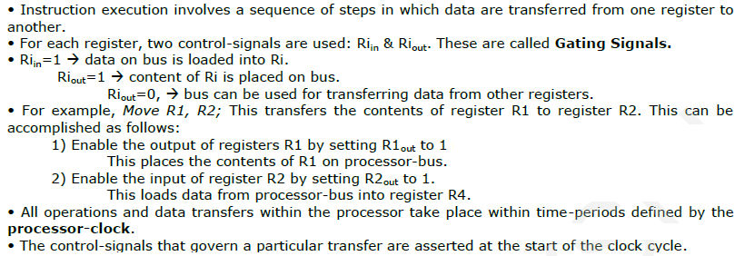

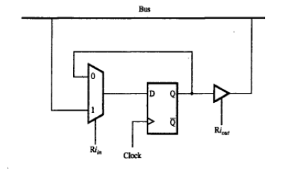
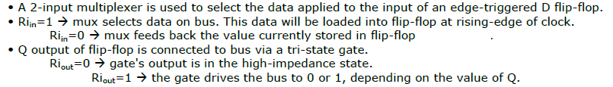
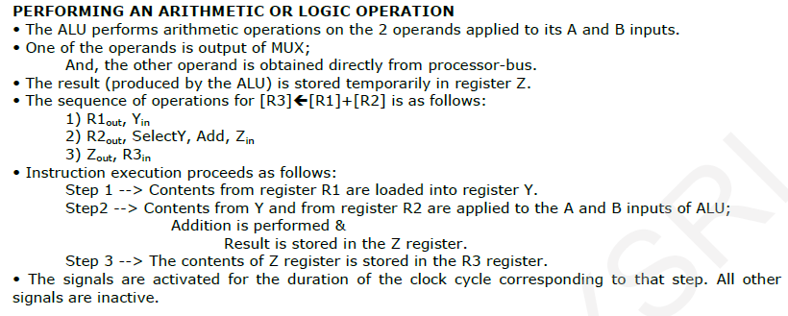
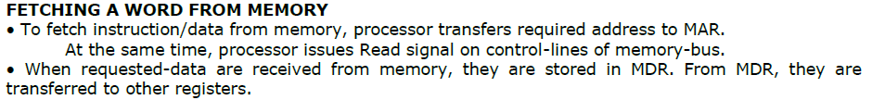
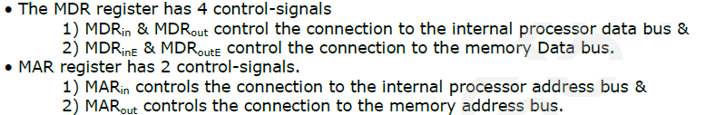

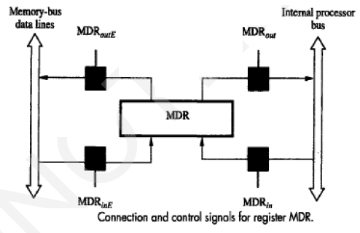
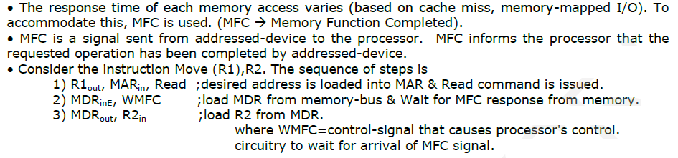
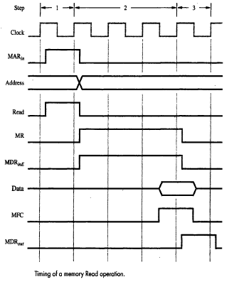

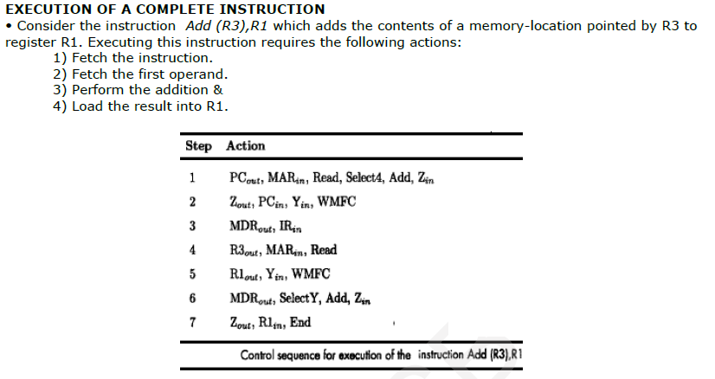
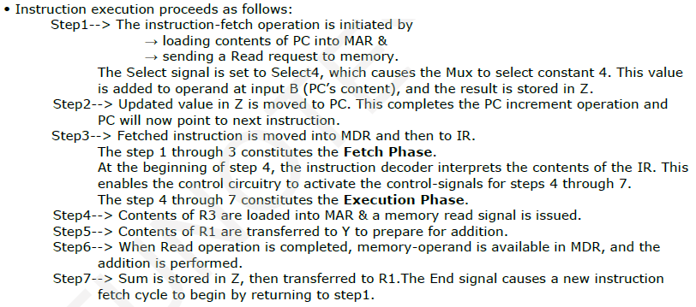
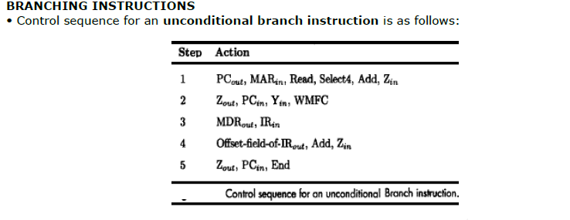
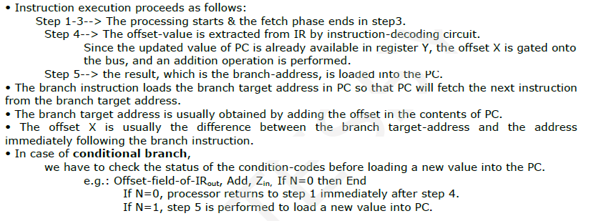
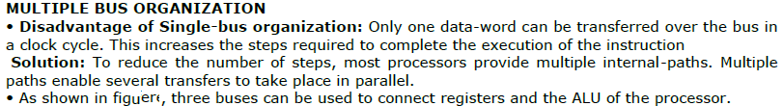
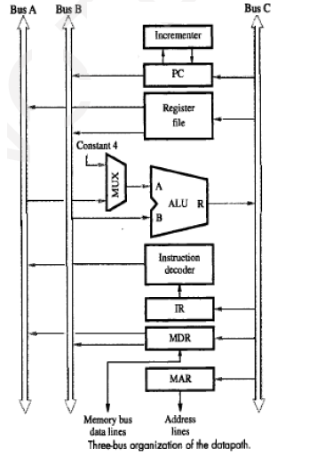
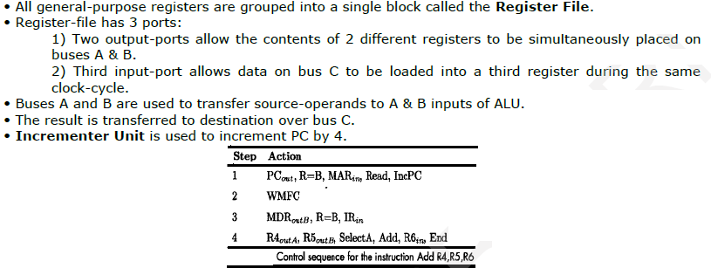
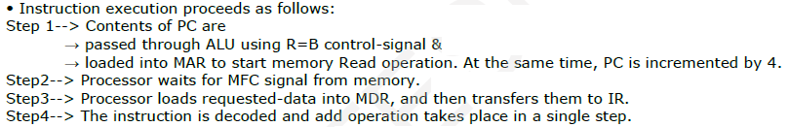

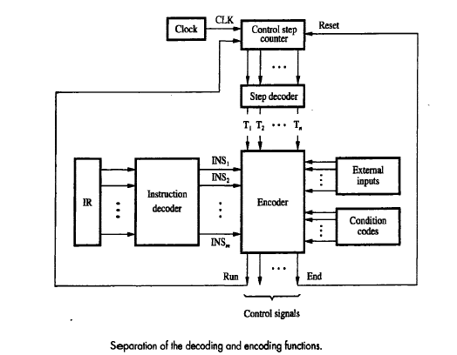

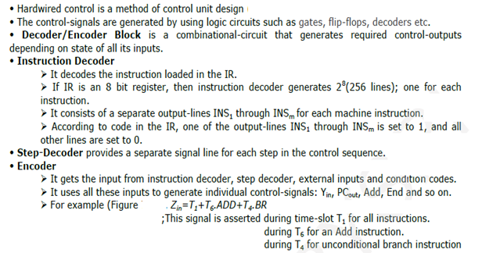
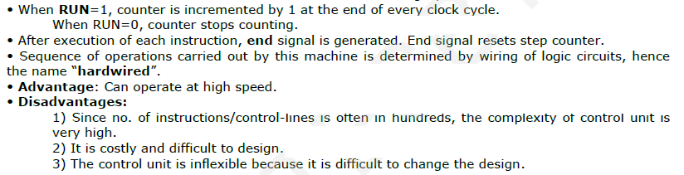
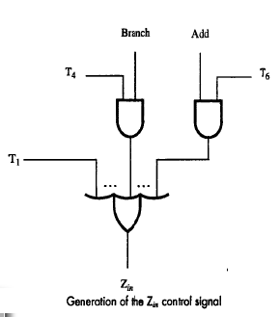

MICRO PROGRAMMED CONTROL:
