UNIT-III
The Memory System: Basic Concepts, Semiconductor RAM Memories, Read-Only Memories, Speed, Size and Cost, Cache Memories, Performance Considerations, Virtual Memories, Memory Management Requirements, Secondary Storage
MEMORY SYSTEM
BASIC CONCEPT OF MEMORY SYSTEM:
The maximum size of the Main Memory (MM) that can be used in any computer is determined by its addressing scheme. For example, a 16-bit computer that generates 16-bit addresses is capable of addressing up to 2¹⁶ =64K memory locations. If a machine generates 32-bit addresses, it can access up to 2³² = 4G memory locations. This number represents the size of address space of the computer.

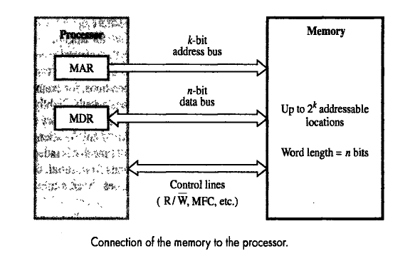
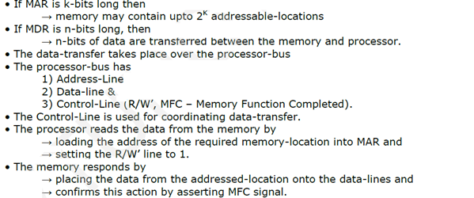
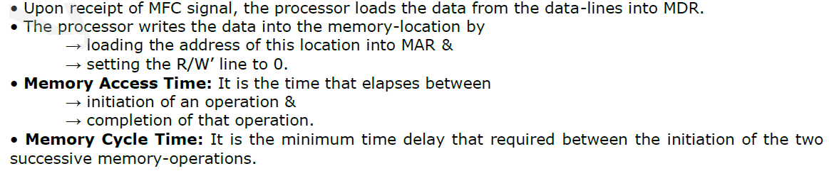

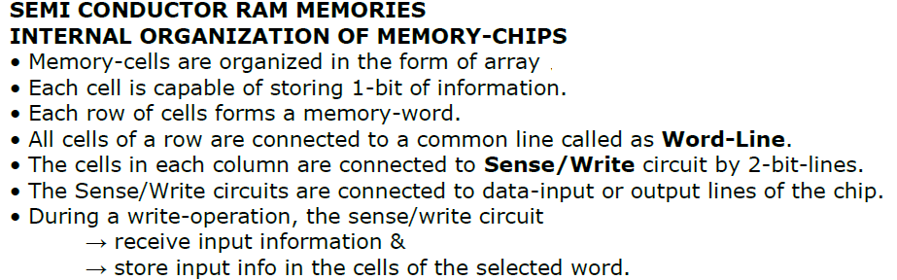

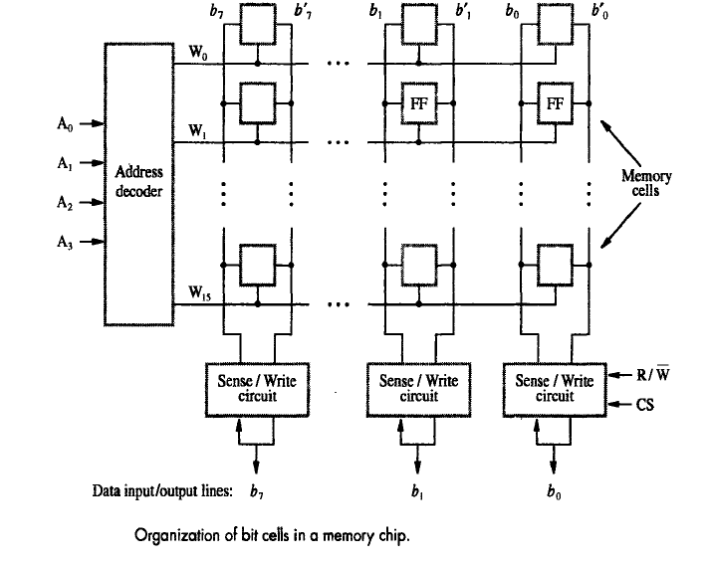
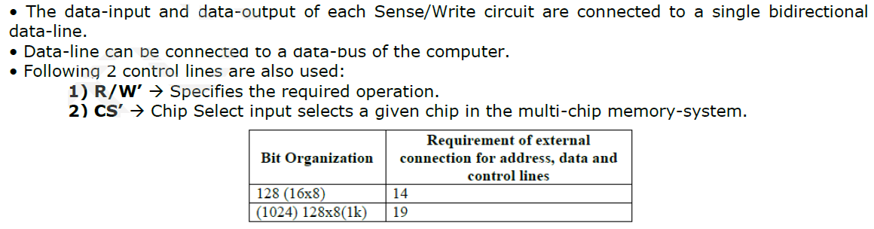
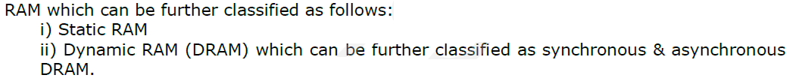
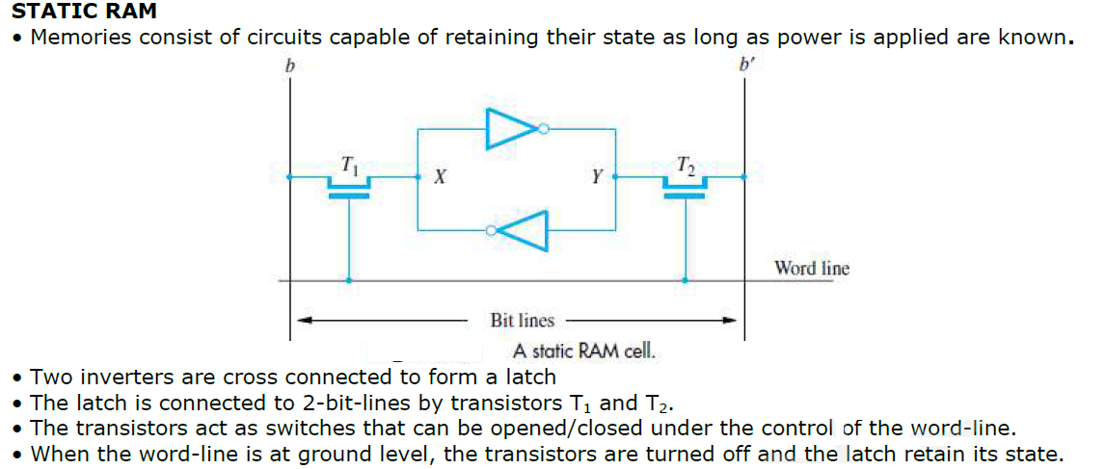
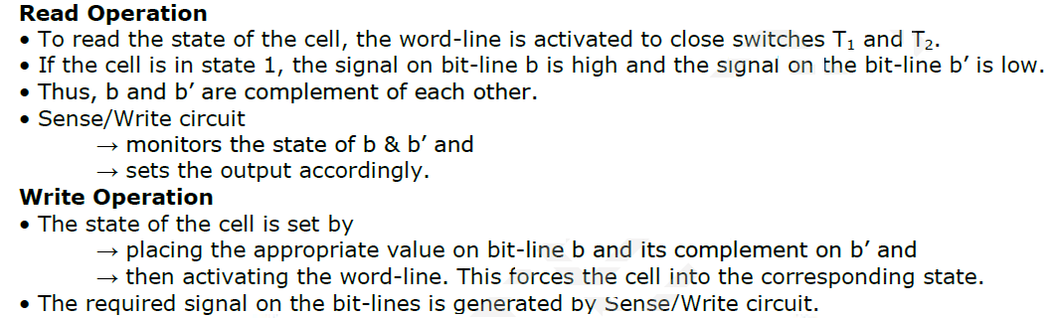

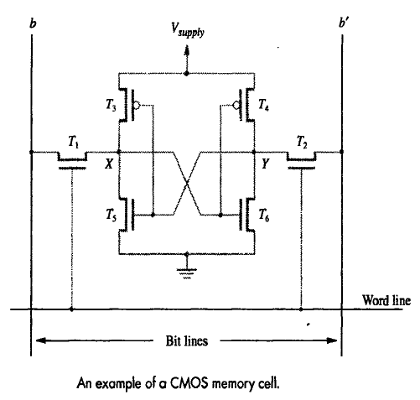


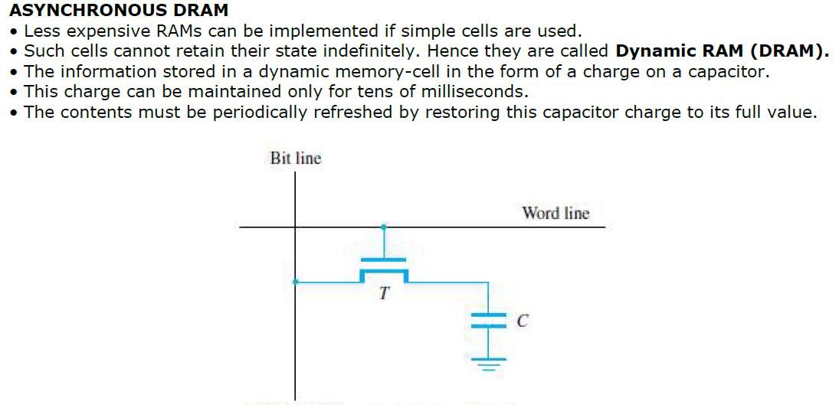

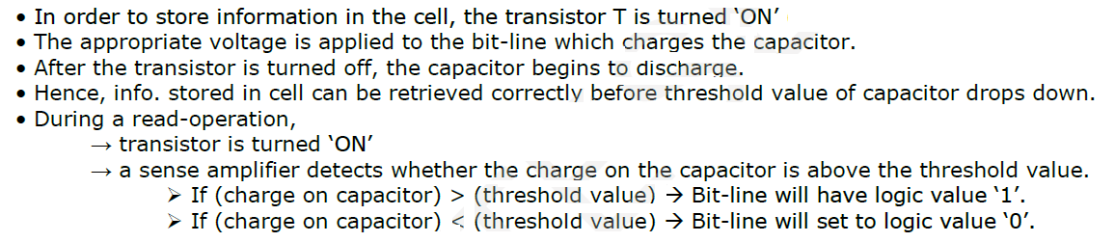

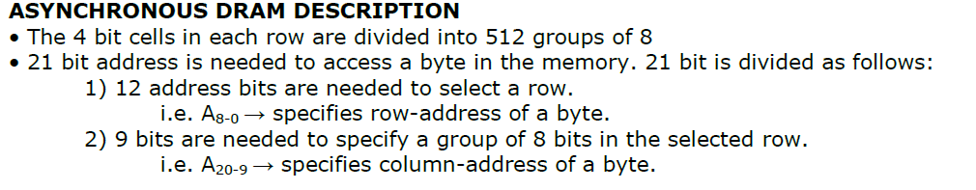

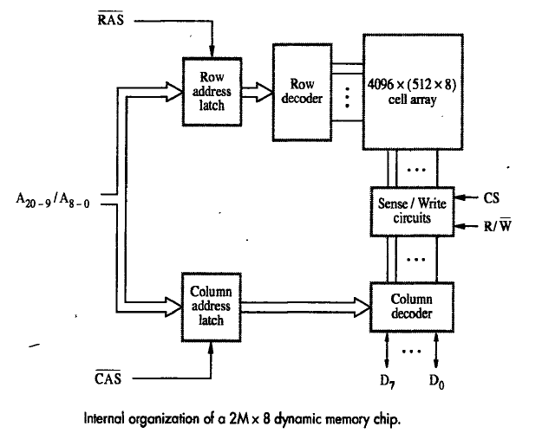
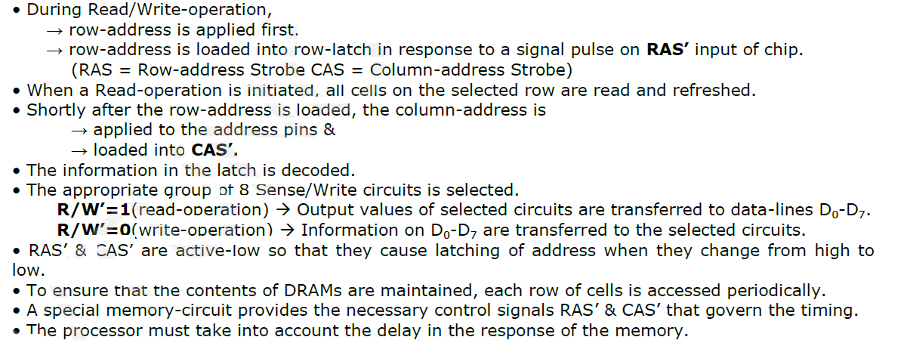



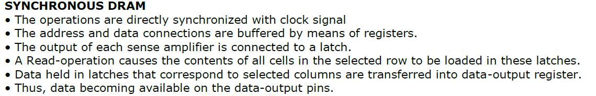

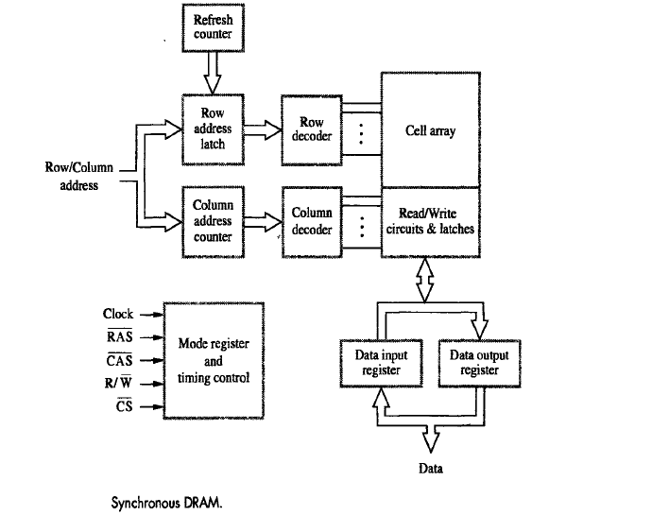



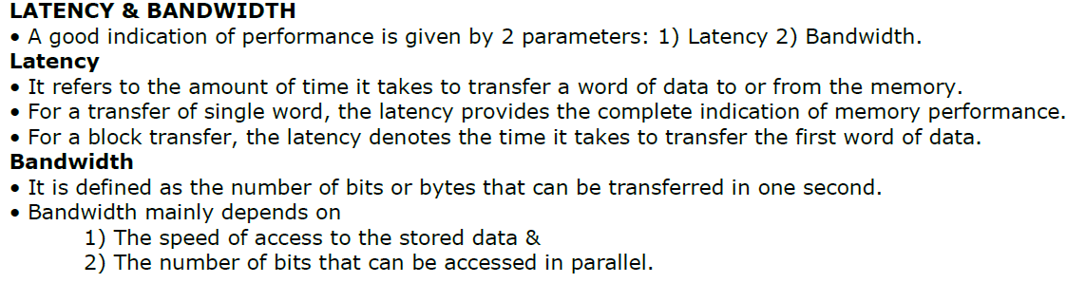
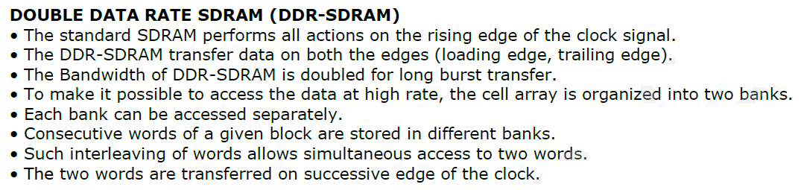
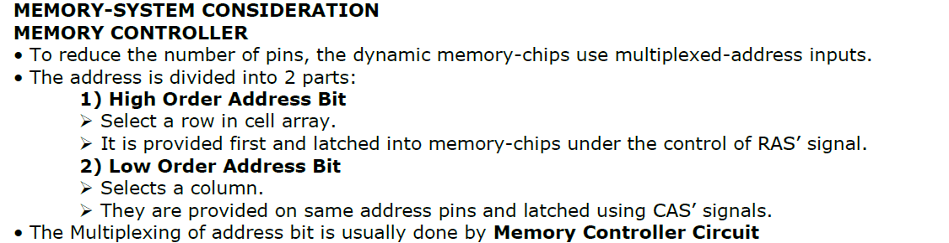
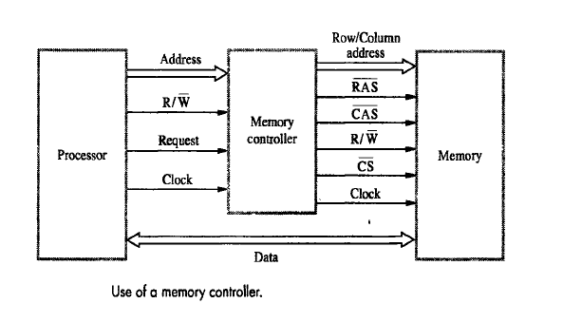
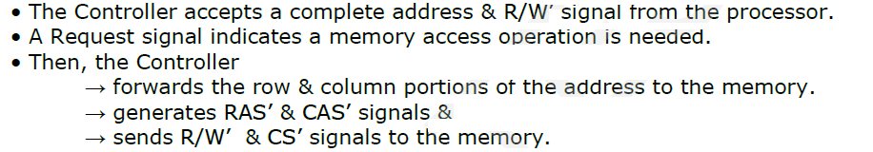

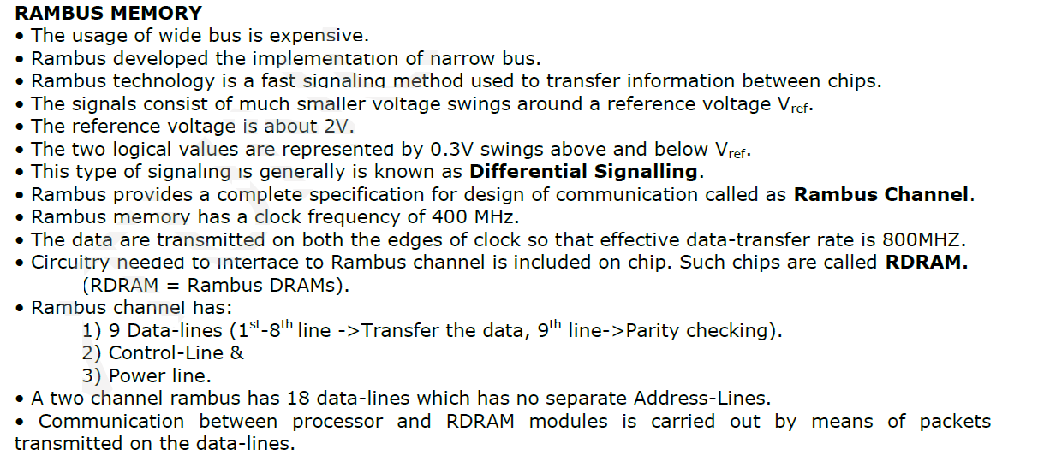


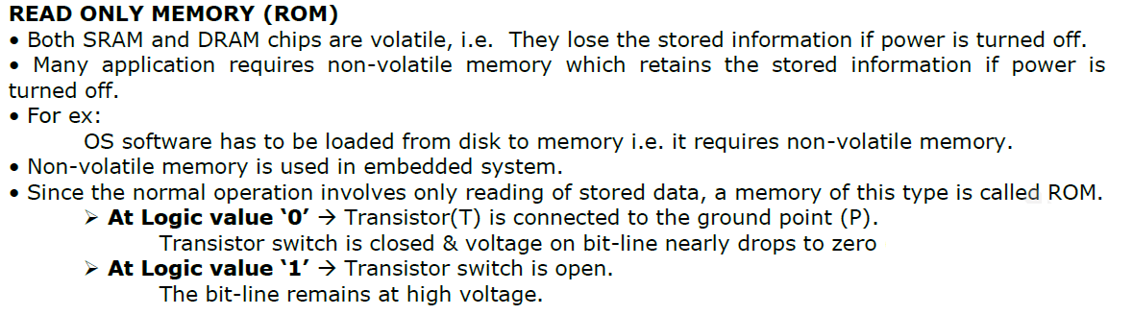
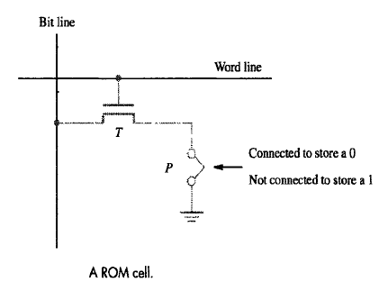



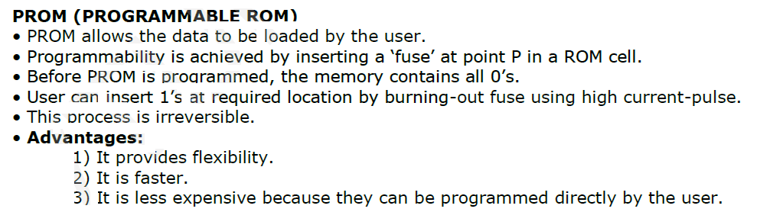

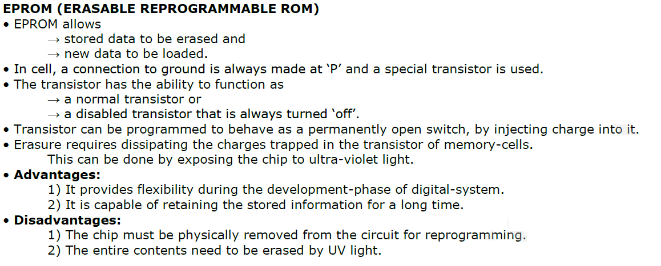

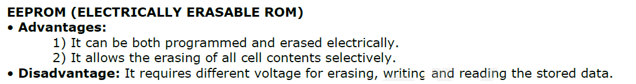

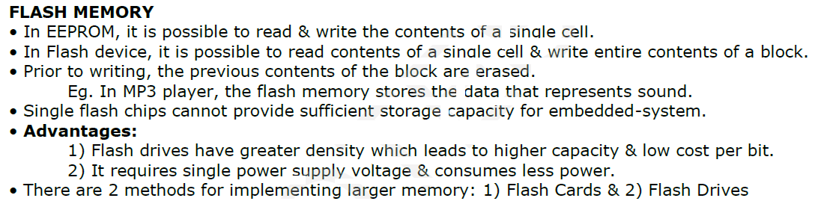

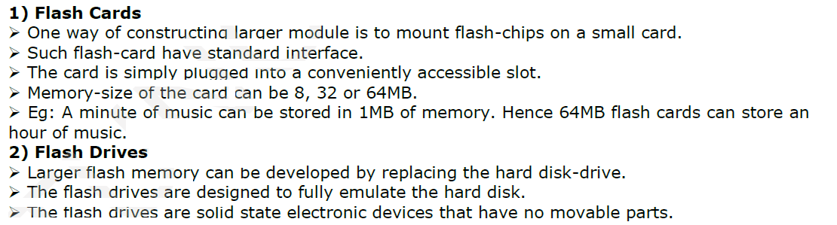

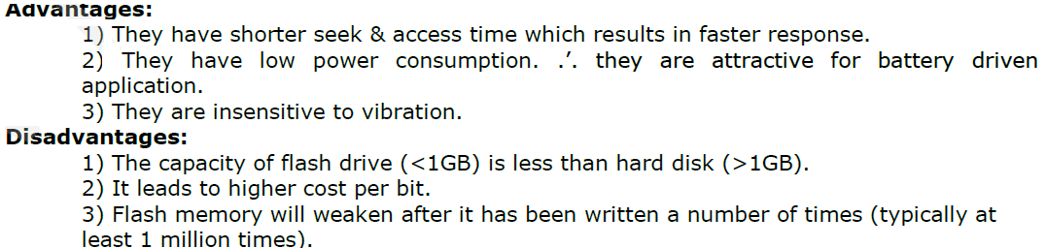

SPEED, COST AND SIZE:

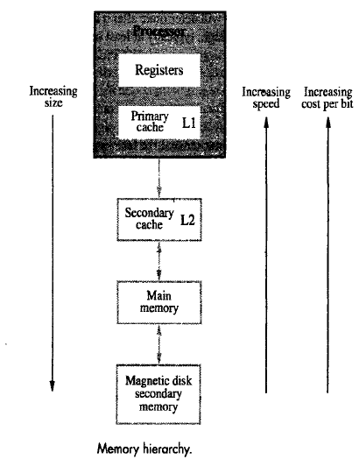

The entire computer memory can be viewed as the hierarchy from figure.
- The fastest access is to data held in processor registers. So rigisters to be part of the memory heirachy, then the processor registers one at the top in terms of the speed of access.
- At the next level of the hirarchy is a relatively small amount memory that can be implemented directly on the processor chip, this is called processor cache. It holds copies of instructions & data stored in a much larger memory that is provided externally. These are in two levels of cache.
  - Primary Cache (PC) b. Secondary Cache (SC)
    - A PC is always located on the processor chip. This cache small because it place on chip, which must implement many other functions, it is referred to as level1(L1) cache.
    - A larger secondary cache is placed between the primary cache and the rest of the memory. It is referred to as level2 (L2) cache. It is implemented using SRAM chips.
- The next level in the hierarchy is called the main memory. The main memory is much larger but significantly slower than the cache memory.
- The access time for the main memory is about ten times longer than the access time for the L1 cache.
- Disk devices provide a huge amount of in expensive storage. They are very slow compared to the semiconductor devices used to implement the main mameory.

CACHE MEMORY:
Analysis of a large number of typical programs has shown that most of their execution time is spent on a few main row lines in which a number of instructions are executed repeatedly. These instructions may constitute a simple loop, nested loops or few procedures that repeatedly call each other. The main observation is that many instructions in a few localized are as of the program are repeatedly executed and that the remainder of the program is accessed relatively infrequently. This phenomenon is referred to as locality of reference.

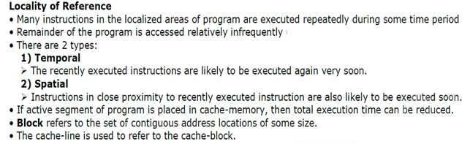

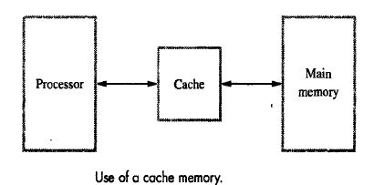

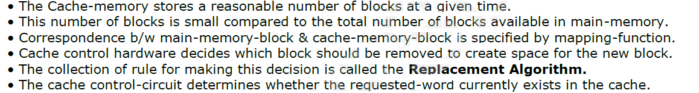



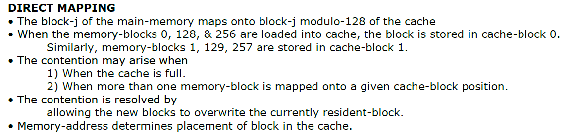
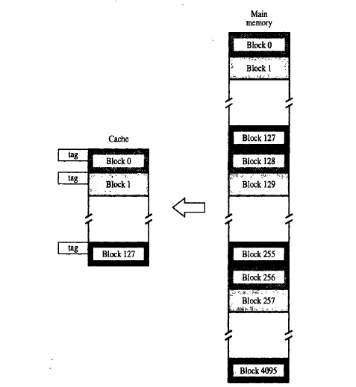

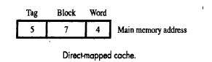
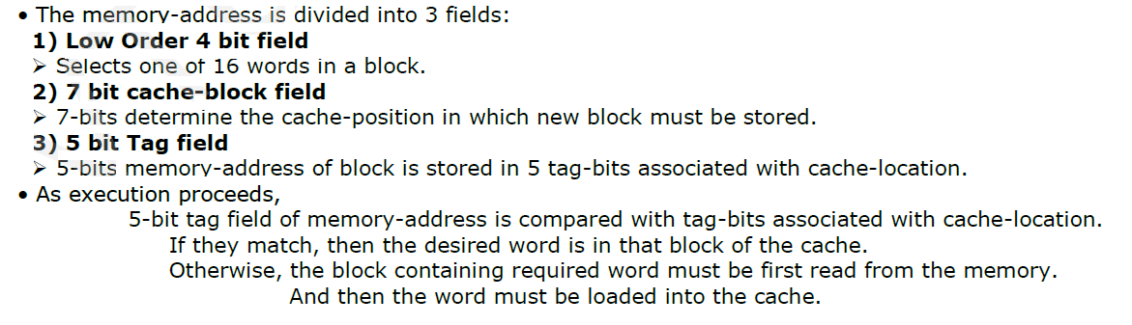


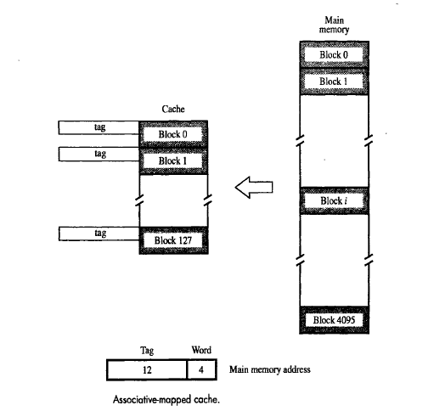



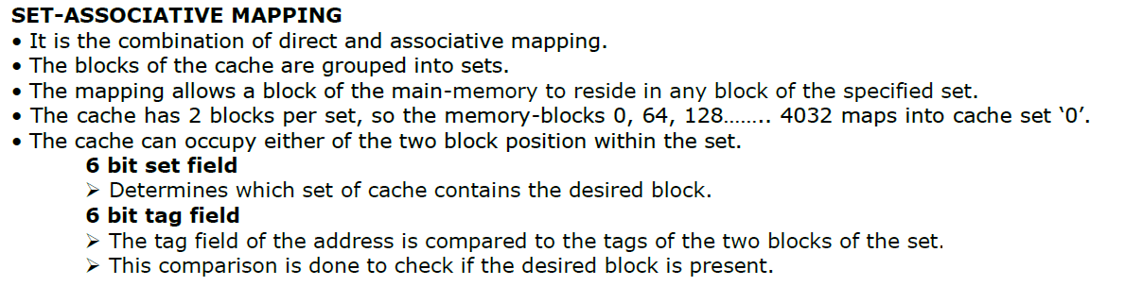

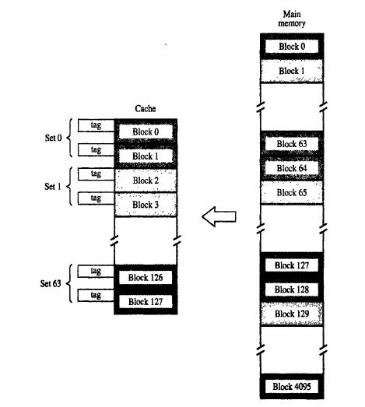
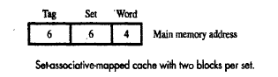

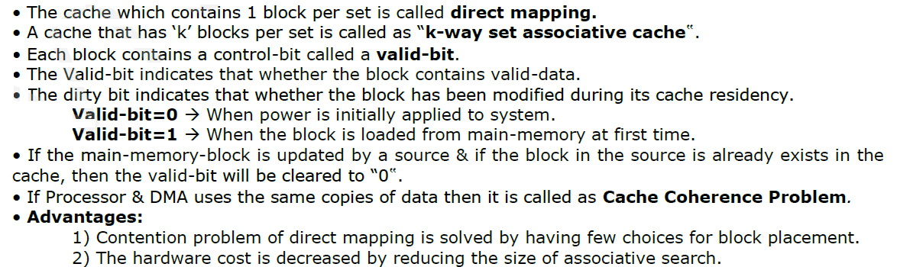

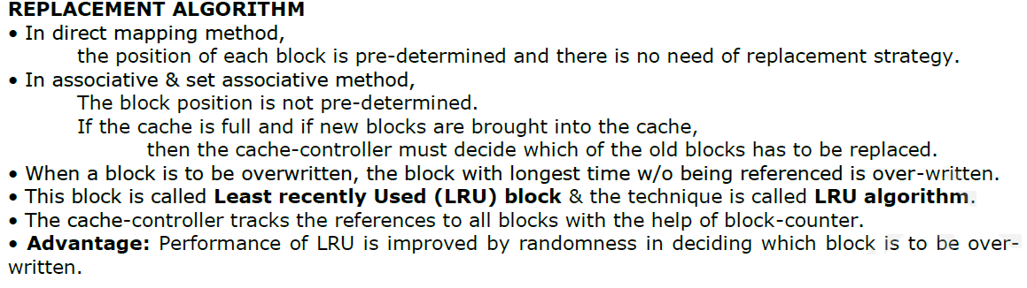

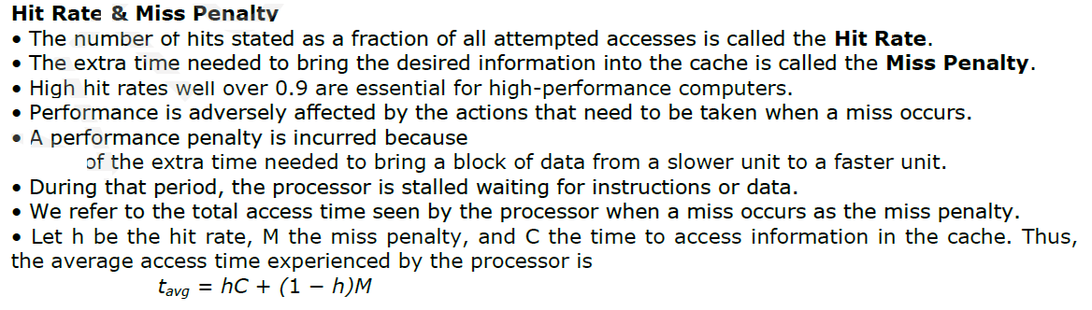

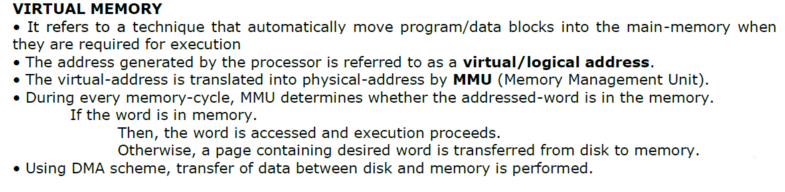
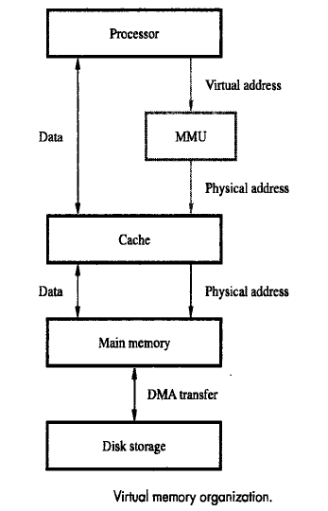

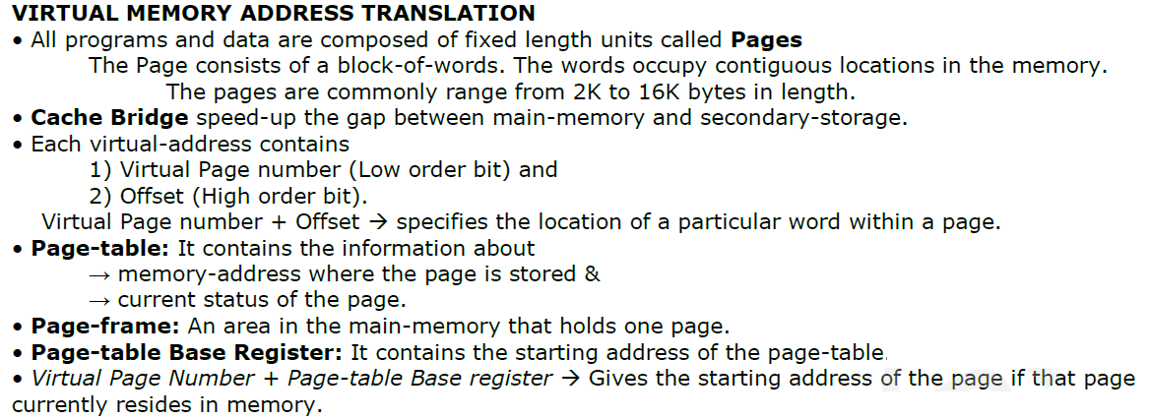
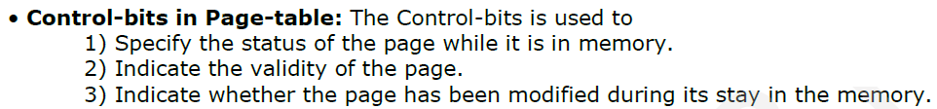

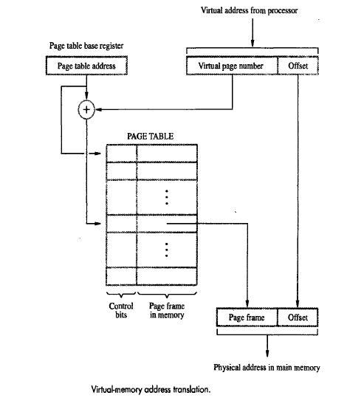

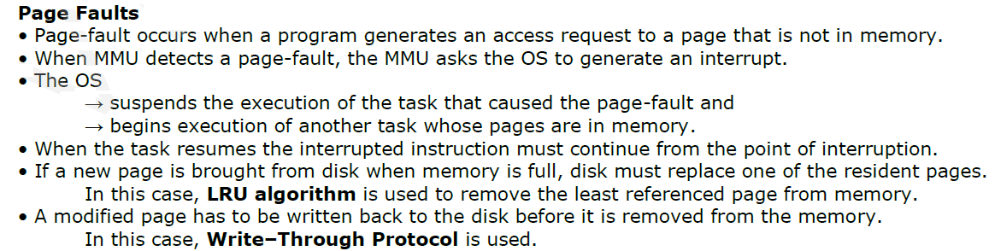
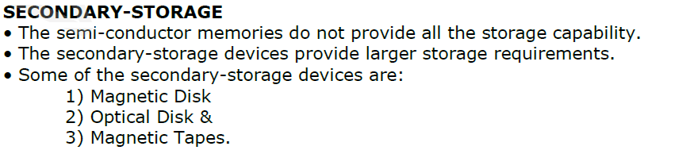
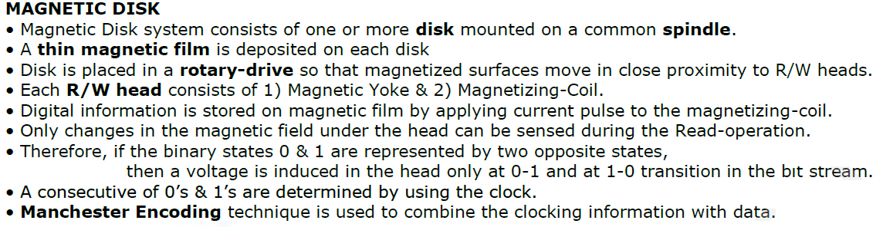

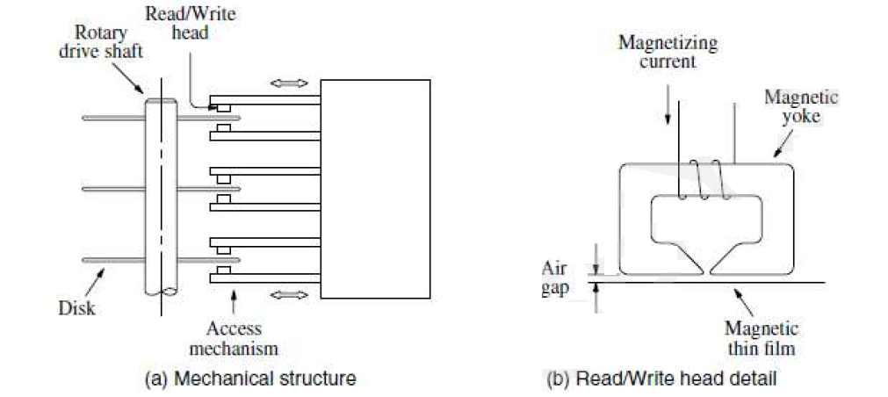
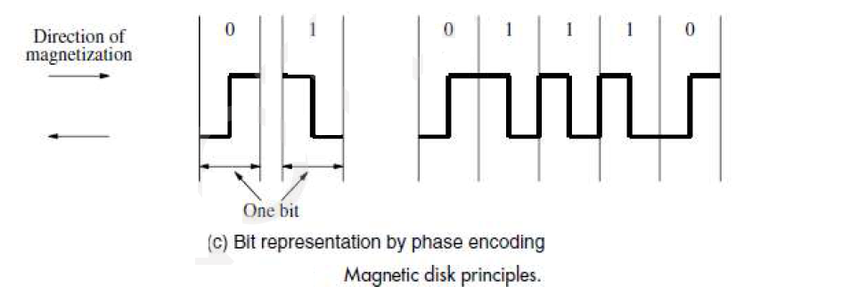

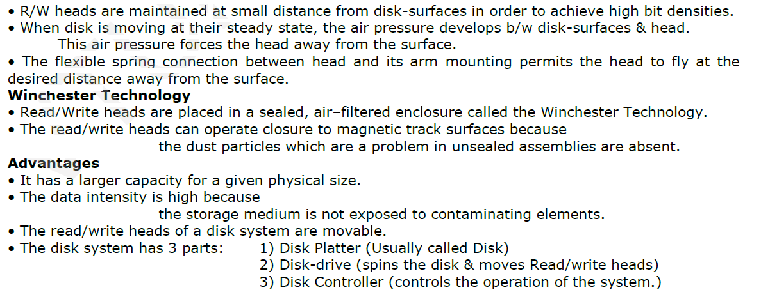

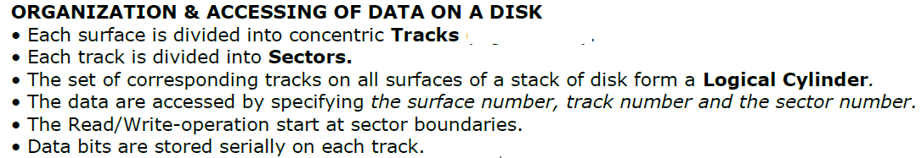

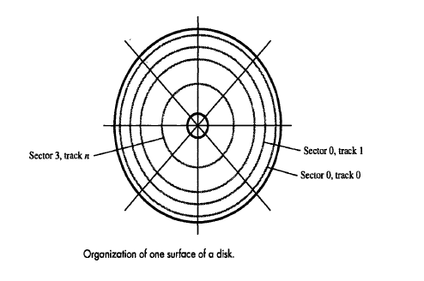

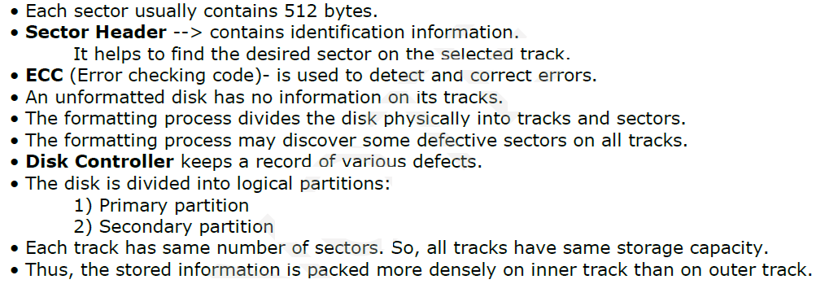

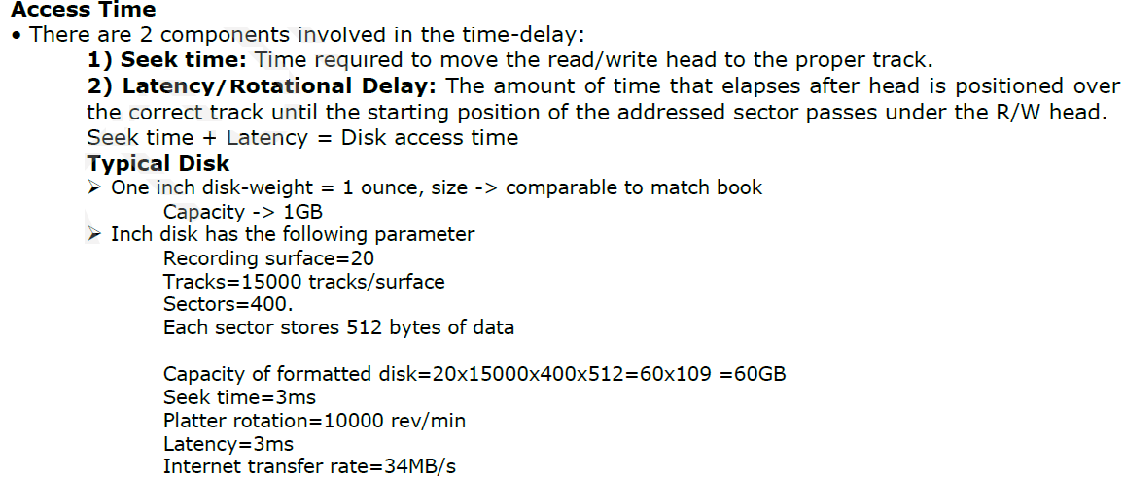

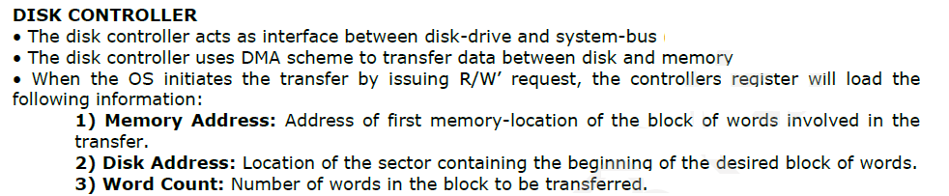
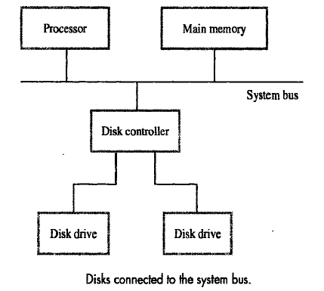

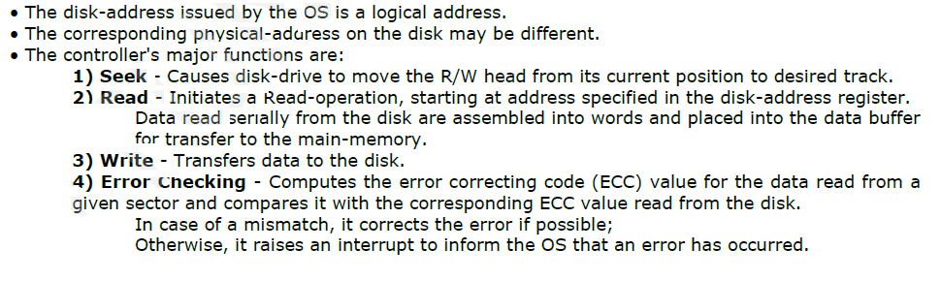
Floppy Disks:
- Floppy disks are smaller, simpler and cheaper disk units that consist of a flexible, removable, plastic diskette coated with magnetic material.
- The diskette is enclosed in a plastic jacket, which has an opening where the read/write head makes contact with the diskette.
- A hole in the center of the diskette allows a spindle mechanism in the disk drive to position and rotate the diskette.
- One of the simplest schemes used in the first floppy disks for recording data is phase or Manchester encoding mentioned earlier.
- Disks encoded in this way are said to have single density.
- The main feature of floppy disks is their low cost and shipping convenience. However, they have much smaller storage capacities, longer access times, and higher failure rates than hard disks.
- Currens standard floppy disks are 3.25 inches in diameter and store 1.44 or 2 Mbytes of data. Larger super-floppy disks are also available.
- One type of such disks, known as the zip disk, can store more than 100 Mbytes.

Optical Disks
Compact Disk (CD) Technology:-
- The optical technology that is used for CD system is based on laser light source. A laser beam is directed onto the surface of the spinning disk.
- Physical indentations in the surface are arranged along the tracks of the disk. They reflect the focused beam towards a photo detector, which detects the stored binary patterns.
- A cross section of a small portion of a CD shown in the bottom payer is Polycarbonate plastic, which functions as a clear glass base.
- The surface of this plastic is Programmed to store data by indenting it with pits. The unindented parts are called lands.
- A thin layer of reflecting aluminium material is placed on top of a programmed disk. The aluminium is then covered by a protective acrylic Acid.
- Finally the topmost layer is deposited and stamped with a label. The laser source and the Photo detector are positioned below the polycarbonate plastic.
- The emitted bean travels through this plastic, reflects off the aluminium layer and travels back toward photo detector.
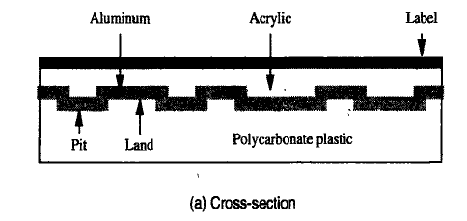
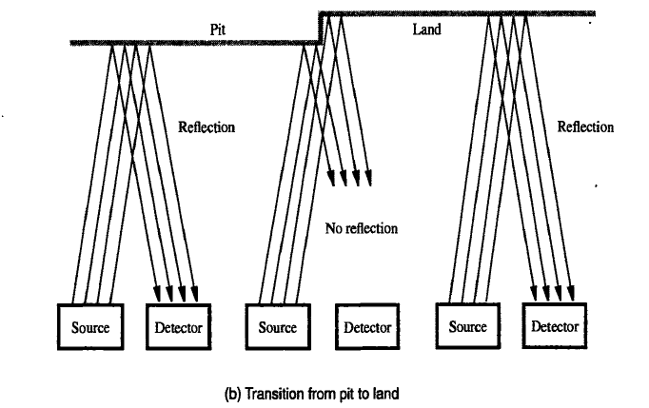
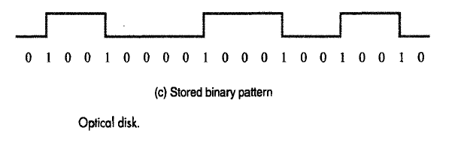

- Some important optical disks are listed below
  - CD-ROM
  - CD-RWs (CD-re writables)
  - DVD technology (Digital Versatile disk)

CD – ROM:
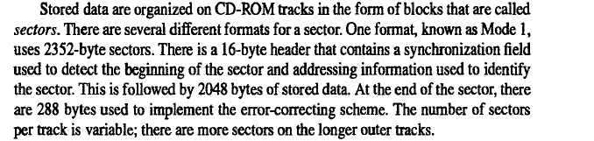

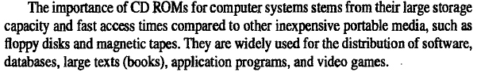

CD – R/W (Re – writable) :
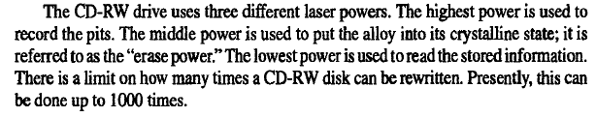

DVD technology (Digital Versatile disk) :
