S.No. | Content | Page No.
1 | MODULE-1 :

Table of Contents
UNIT-1 5
HIGHWAY ENGINEERING 5
1.1. Importance of transportation 5
1.2. Modes of transportation 6
1.2.1. Road transportation 7
1.2.2. Rail transportation 8
1.2.3. Water transportation 8
1.2.4. Air transportation 9
1.3. Characteristics of Road transport 10
1.4. Classification of roads 11
1.4.1. Based on weather 12
1.4.2. Based on type of pavement 12
1.4.3. Based on type of pavement surface 13
1.5. Highway Alignment 17
1.5.1. Basic requirements 18
1.5.2. Factors controlling alignment 19
1.5.2.1. Obligatory points 19
1.5.2.2. Traffic 20
1.5.2.3. Geometric Design 21
1.5.2.4. Economy 21
1.5.2.5. Other considerations 21
UNIT II 22
GEOMETRIC DESIGN 22
2.1. Factors affecting geometric design 23
2.1.1. Design speed 24
2.1.2. Topography 24
2.1.3. Other factors 25
2.2. Highway Cross Section Elements 26
2.2.1. Pavement Surface characteristics 26
2.2.1.1. Friction 26
2.2.1.2. Unevenness 27
2.2.1.3. Light reflection 27
2.2.1.4. Drainage 28
2.2.2. Camber 28
2.2.3. Width of Carriageway 29
2.2.4. Kerbs 30
2.2.5. Road Margins 31
2.2.5.1. Shoulders 32
2.2.5.2. Parking lanes 32
2.2.5.3. Bus-bays 32
2.2.5.4. Service Roads 32
2.2.5.5. Cycle tracks 33
2.2.5.6. Footpaths 33
2.2.5.7. Guard rails 33
2.2.6. Width of formation 34
2.2.7. Right of way 34
2.3. Sight Distance 36
2.3.1. Types of Sight Distance 36
2.3.2. Factors affecting Sight Distance 37
2.3.3. Stopping Sight Distance 39
2.3.4. Overtaking Sight distance 40
2.4. Horizontal Alignment 43
2.4.1. Super elevation 44
2.4.2. Extra widening 46
2.4.2.1. Mechanical Widening 46
2.4.2.2. Psychological Widening 48
2.4.3. Horizontal Transition curve 49
2.4.3.1. Rate of change of centrifugal acceleration 49
2.4.3.2. Rate of introduction of super-elevation 50
2.4.3.3. By empirical formula 51
2.5. Vertical Alignment 51
2.5.1. Types of gradients 51
2.5.2. Summit curve 53
2.5.3. Valley Curves 56
UNIT III 60
HIGHWAY MATERIALS 60
3.1. Road aggregates 60
3.1.1. Desirable properties of aggregates 60
3.1.2. Aggregate tests 62
3.1.2.1. Crushing test 63
3.1.2.2. Abrasion test 64
3.1.2.3. Impact test 65
3.1.2.4. Shape tests 66
3.2. Pavement Bitumen 67
3.2.1. Different forms of bitumen 67
3.2.2. Requirements of Bitumen 69
3.2.3. Tests on bitumen 70
3.2.3.1. Penetration test 71
3.2.3.2. Ductility test 71
3.2.3.3. Softening point test 72
3.2.3.4. Specific gravity test 73
3.2.3.5. Flash and fire point test 73
3.3. Bituminous Aggregate Mix 74
3.3.1. Requirements of Bituminous mixes 74
3.3.2. Desirable properties 75

MODULE II

GEOMETRIC DESIGN

The geometric design of highways deals with the dimensions and layout of visible features of the highway. The emphasis of the geometric design is to address the requirement of the driver and the vehicle such as safety, comfort, efficiency, etc. The features normally considered are the cross section elements, sight distance consideration, horizontal curvature, gradients, and intersection. The design of these features is to a great extend influenced by driver behavior and psychology, vehicle characteristics, traffic characteristics such as speed and volume. Proper geometric design will help in the reduction of accidents and their severity. Therefore, the objective of geometric design is to provide optimum efficiency in traffic operation and maximum safety at reasonable cost. The planning cannot be done stage wise like that of a pavement, but has to be done well in advance. The main components that will be discussed are:
1. Factors affecting the geometric design,
2. Highway alignment, road classification,
3. Pavement surface characteristics,
4. Cross-section elements including cross slope, various widths of roads and features in the road margins.
5. Sight distance elements including cross slope, various widths and features in the road margins.
6. Horizontal alignment which includes features like super elevation, transition curve, extra widening and setback distance.
7. Vertical alignment and its components like gradient, sight distance and design of length of curves.

Factors affecting geometric design
- Design speed
- Topography
- Other factors

Design speed
Design speed is the single most important factor that affects the geometric design. It directly affects the sight distance, horizontal curve, and the length of vertical curves. Since the speed of vehicles vary with driver, terrain etc, a design speed is adopted for all the geometric design.
Design speed is defined as the highest continuous speed at which individual vehicles can travel with safety on the highway when weather conditions are conducive. Design speed is different from the legal speed limit which is the speed limit imposed to curb a common tendency of drivers to travel beyond an accepted safe speed. Design speed is also different from the desired speed which is the maximum speed at which a driver would travel when unconstrained by either traffic or local geometry.
Since there are wide variations in the speed adopted by different drivers, and by different types of vehicles, design speed should be selected such that it satisfies nearly all drivers. At the same time, a higher design speed has cascading effect in other geometric design and thereby cost escalation. Therefore, an 85th percentile design sped is normally adopted. This speed is defined as that speed which is greater than the speed of 85% of drivers. In some countries this is as high as 95 to 98 percentile speed.

Topography
The next important factor that affects the geometric design is the topography. It is easier to construct roads with required standards for a plain terrain. However, for a given design speed, the construction cost increases multiform with the gradient and the terrain. Therefore, geometric design standards are different for different terrain to keep the cost of construction and time of construction under control. This is characterized by sharper curves and steeper gradients.

Other factors
In addition to design speed and topography, there are various other factors that affect the geometric design and they are briefly discussed below
- Vehicle: The dimensions, weight of the axle and operating characteristics of a vehicle influence the design aspects such as width of the pavement, radii of the curve, clearances, parking geometrics etc. affects the design. A design vehicle which has standard weight, dimensions and operating characteristics are used to establish highway design controls to accommodate vehicles of a designated type.
- Human: The important human factors that influence geometric design are the physical, mental and psychological characteristics of the driver and pedestrians like the reaction time.
- Traffic: It will be uneconomical to design the road for peak traffic flow. Therefore a reasonable value of traffic volume is selected as the design hourly volume which is determined from the various traffic data collected. The geometric design is thus based on this design volume, capacity etc.
- Environmental: Factors like air pollution, noise pollution etc. should be given due consideration in the geometric design of roads.
- Economy: The design adopted should be economical as far as possible. It should match with the funds allotted for capital cost and maintenance cost.
- Others: Geometric design should be such that the aesthetics of the region is not affected.

Highway Cross Section Elements

Pavement Surface characteristics
For a safe and comfortable driving four aspects of the pavement surface are important; the friction between the wheels and the pavement surface, smoothness of the road surface, the light reflection characteristics of the top of pavement surface, and drainage to water.

Friction
Friction between the wheel and the pavement surface is a crucial factor in the design of horizontal curves and thus the safe operating speed. Further, it also affect the acceleration and deceleration ability of vehicles. Lack of adequate friction can cause skidding or slipping of vehicles.
• Skidding happens when the path traveled along the road surface is more than the circumferential movement of the wheels due to friction
• Slip occurs when the wheel revolves more than the corresponding longitudinal movement along the road.
Various factors that affect friction are:
- Type of the pavement (like bituminous, concrete, or gravel),
- Condition of the pavement (dry or wet, hot or cold, etc),
- Condition of the tyre (new or old), and
- Speed and load of the vehicle.
The frictional force that develops between the wheel and the pavement is the load acting multiplied by a factor called the coefficient of friction and denoted as f. The choice of the value of f is a very complicated issue since it depends on many variables. IRC suggests the coefficient of longitudinal friction as 0.35-0.4 depending on the speed and coefficient of later friction as 0.15. The former is useful in sight distance calculation and the latter in horizontal curve design.

Unevenness
It is always desirable to have an even surface, but it is seldom possible to have such one. Even if a road is constructed with high quality pavers, it is possible to develop unevenness due to pavement failures. Unevenness affects the vehicle operating cost, speed, riding comfort, safety, fuel consumption and wear and tear of tires.
Unevenness index is a measure of unevenness which is the cumulative measure of vertical undulation of the pavement surface recorded per unit horizontal length of the road. An unevenness index value less than 1500 mm/km is considered as good, a value less than 2500 mm.km is satisfactory up to speed of 100 kmph and values greater than 3200 mm/km is considered as uncomfortable even for 55 kmph.

Light reflection
- White roads have good visibility at night, but caused glare during day time
- Black roads has no glare during day, but has poor visibility at night
- Concrete roads has better visibility and less glare
It is necessary that the road surface should be visible at night and reflection of light is the factor that answers it.

Drainage
The pavement surface should be absolutely impermeable to prevent seepage of water into the pavement layers. Further, both the geometry and texture of pavement surface should help in draining out the water from the surface in less time.

Camber
Camber or cant is the cross slope provided to raise middle of the road surface in the transverse direction to drain off rain water from road surface. The objectives of providing camber are:
- Surface protection especially for gravel and bituminous roads
- Sub-grade protection by proper drainage
- Quick drying of pavement which in turn increases safety
Too steep slope is undesirable for it will erode the surface. Camber is measured in 1 in n or n% (Eg. 1 in 50 or 2%) and the value depends on the type of pavement surface. The common types of camber are parabolic, straight, or combination of them.
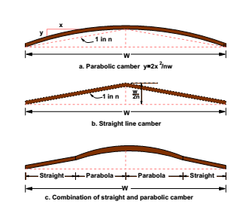

Types of camber

Surface Type | Heavy Rain | Light Rain
Concrete/ Bituminous | 2% | 1.7%
Gravel/ W.B.M | 3% | 2.5%
Earthen | 4% | 3%

IRC values for camber

Width of Carriageway
Width of the carriage way or the width of the pavement depends on the width of the traffic lane and number of lanes. Width of a traffic lane depends on the width of the vehicle and the clearance. Side clearance improves operating speed and safety. The maximum permissible width of a vehicle is 2.44 and the desirable side clearance for single lane traffic is 0.68 m. This require minimum of lane width of 3.75 m for a single lane road. However, the side clearance required is about 0.53 m, on either side or 1.06 m in the center. Therefore, a two lane road require minimum of 3.5 meter for each lane.
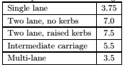

IRC Specification for carriage way width

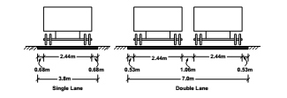

Lane width for single and two lane roads

Kerbs
Kerbs indicate the boundary between the carriage way and the shoulder or islands or footpaths. Different types of kerbs are-
- Low or mountable kerbs: Thesetype of kerbs are provided such that they encourage the traffic to remain in the through traffic lanes and also allow the driver to enter the shoulder area with little difficulty. The height of this kerb is about 10 cm above the pavement edge with a slope which allows the vehicle to climb easily. This is usually provided at medians and channelization schemes and also helps in longitudinal drainage.
- Semi-barrier type kerbs: When the pedestrian traffic is high, these kerbs are provided. Their height is 15 cm above the pavement edge. This type of kerb prevents encroachment of parking vehicles, but at acute emergency it is possible to drive over this kerb with some difficulty.
- Barrier type kerbs: They are designed to discourage vehicles from leaving the pavement. They are provided when there is considerable amount of pedestrian traffic. They are placed at a height of 20 cm above the pavement edge with a steep batter.
- Submerged kerbs: They are used in rural roads. The kerbs are provided at pavement edges between the pavement edge and shoulders. They provide lateral confinement and stability to the pavement.
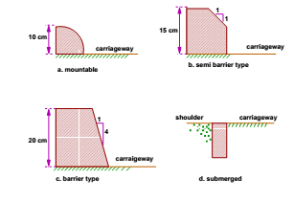

Different types of Kerbs

Road Margins
The portion of the road beyond the carriageway and on the roadway can be generally called road margin. Various elements that form the road margins are given below.

Shoulders
Shoulders are provided along the road edge and are intended for accommodation of stopped vehicles, serve as an emergency lane for vehicles and provide lateral support for base and surface courses. The shoulder should be strong enough to bear the weight of a fully loaded truck even in wet conditions. The shoulder width should be adequate for giving working space around a stopped vehicle. It is desirable to have a width of 4.6 m for the shoulders. A minimum width of 2.5 m is recommended for 2-lane rural highways in India.

Parking lanes
Parking lanes are provided in urban lanes for side parking. Parallel parking is preferred because it is safe for the vehicles moving in the road. The parking lane should have a minimum of 3.0 m width in the case of parallel parking.

Bus-bays
Bus bays are provided by recessing the kerbs for bus stops. They are provided so that they do not obstruct the movement of vehicles in the carriage way. They should be at least 75 meters away from the intersection so that the traffic near the intersections is not affected by the bus-bay.

Service Roads
Service roads or frontage roads give access to access controlled highways like freeways and expressways. They run parallel to the highway and will be usually isolated by a separator and access to the highway will be provided only at selected points. These roads are provided to avoid congestion in the expressways and also the speed of the traffic in those lanes is not reduced.

Cycle tracks
Cycle tracks are provided in urban areas when the volume of cycle traffic is high Minimum width of 2 meter is required, which may be increased by 1 meter for every additional track.

Footpaths
Footpaths are exclusive right of way to pedestrians, especially in urban areas. They are provided for the safety of the pedestrians when both the pedestrian traffic and vehicular traffic is high. Minimum width is 1.5 meter and may be increased based on the traffic. The footpath should be either as smooth as the pavement or smoother than that to induce the pedestrian to use the footpath.

Guard rails
They are provided at the edge of the shoulder usually when the road is on an embankment. They serve to prevent the vehicles from running off the embankment, especially when the height of the fill exceeds 3 m. Various designs of guard rails are there. Guard stones painted in alternate black and white are usually used. They also give better visibility of curves at night under headlights of vehicles.

Width of formation
Width of formation or roadway width is the sum of the widths of pavements or carriage way including separators and shoulders. This does not include the extra land in formation/cutting.
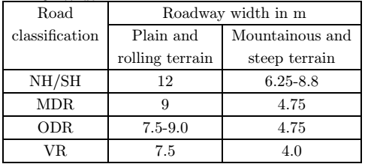

Width of formation for various classes of roads

Right of way
Right of way (ROW) or land width is the width of land acquired for the road, along its alignment. It should be adequate to accommodate all the cross-sectional elements of the highway and may reasonably provide for future development. To prevent ribbon development along highways, control lines and building lines may be provided. Control line is a line which represents the nearest limits of future uncontrolled building activity in relation to a road. Building line represents a line on either side of the road, between which and the road no building activity is permitted at all. The right of way width is governed by:
- Width of formation: It depends on the category of the highway and width of roadway and road margins.
- Height of embankment or depth of cutting: It is governed by the topography and the vertical alignment.
- Side slopes of embankment or cutting: It depends on the height of the slope, soil type etc.
- Drainage system and their size which depends on rainfall, topography etc.
- Sight distance considerations: On curves etc. there is restriction to the visibility on the inner side of the curve due to the presence of some obstructions like building structures etc.
- Reserve land for future widening: Some land has to be acquired in advance anticipating future developmentslike widening of the road.
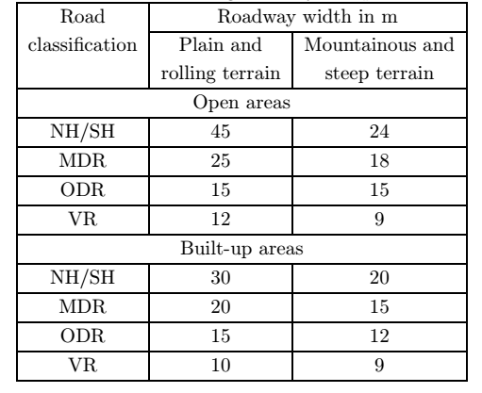

Normal right of way for open areas

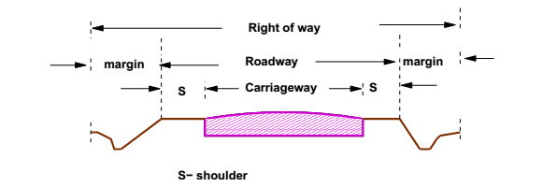

A typical Right of Way

Sight Distance
The safe and efficient operation of vehicles on the road depends very much on the visibility of the road ahead of the driver. Thus the geometric design of the road should be done such that any obstruction on the road length could be visible to the driver from some distance ahead . This distance is said to be the sight distance.

Types of Sight Distance
Sight distance available from a point is the actual distance along the road surface, over which a driver from a specified height above the carriage way has visibility of stationary or moving objects. Three sight distance situations are considered for design:
• Stopping sight distance (SSD) or the absolute minimum sight distance
• Intermediate sight distance (ISD) is the defined as twice SSD
• Overtaking sight distance (OSD) for safe overtaking operation
• Head light sight distance is the distance visible to a driver during night driving under the illumination of head light
• Safe sight distance to enter into an intersection

Factors affecting Sight Distance
The most important consideration in all these is that at all times the driver traveling at the design speed of the highway must have sufficient carriageway distance within his line of vision to allow him to stop his vehicle before colliding with a slowly moving or stationary object appearing suddenly in his own traffic lane.
The computation of sight distance depends on:
Reaction time of the driver
Reaction time of a driver is the time taken from the instant the object is visible to the driver to the instant when the brakes are applied. The total reaction time may be split up into four components based on PIEV theory. In practice, all these times are usually combined into a total perception- reaction time suitable for design purposes as well as for easy measurement. Many of the studies shows that drivers require about 1.5 to 2 secs under normal conditions. However taking into consideration the variability of driver characteristics, a higher value is normally used in design. For example, IRC suggests a reaction time of 2.5 secs.

Speed of the vehicle
The speed of the vehicle very much affects the sight distance. Higher the speed, more time will be required to stop the vehicle. Hence it is evident that, as the speed increases, sight distance also increases.
Efficiency of brakes
The efficiency of the brakes depends upon the age of the vehicle, vehicle characteristics etc. If the brake efficiency is 100%, the vehicle will stop the moment the brakes are applied. But practically, it is not possible to achieve 100% brake efficiency. Therefore it could be understood that sight distance required will be more when the efficiency of brakes are less. Also for safe geometric design, we assume that the vehicles have only 50% brake efficiency.
Frictional resistance between the tire and the road
The frictional resistance between the tire and road plays an important role to bring the vehicle to stop. When the frictional resistance is more, the vehicles stop immediately. Thus sight required will be less. No separate provision for brake efficiency is provided while computing the sight distance. This is taken into account along with the factor of longitudinal friction. IRC has specified the value of longitudinal friction in between 0.35 to 0.4.
Gradient of the road
Gradient of the road also affects the sight distance. While climbing up a gradient, the vehicle can stop immediately. Therefore sight distance required is less. While descending a gradient, gravity also comes into action and more time will be required to stop the vehicle. Sight distance required will be more in that case.

Stopping Sight Distance
SSD is the minimum sight distance available on a highway at any spot having sufficient length to enable the driver to stop a vehicle traveling at design speed, safely without collision with any other obstruction.
There is a term called safe stopping distance and is one of the important measures in traffic engineering. It is the distance a vehicle travels from the point at which a situation is first perceived to the time the deceleration is complete. Drivers must have adequate time if they are to suddenly respond to a situation. Thus in a highway design, a sight distance atleast equal to the safe stopping distance should be provided. The stopping sight distance is the sum of lag distance and the braking distance. Lag distance is the distance the vehicle traveled during the reaction time t and is given by vt, where v is the velocity in m/sec2 . Braking distance is the distance traveled by the vehicle during braking operation. For a level road this is obtained by equating the work done in stopping the vehicle and the kinetic energy of the vehicle. If F is the maximum frictional force developed and the braking distance is l, then work done against friction in stopping the vehicle is Fl = fWl where W is the total weight of the vehicle. The kinetic energy at the design speed is
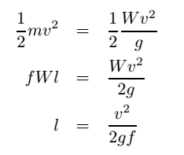
Therefore, the SSD = lag distance + braking distance and given by:
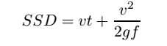
where v is the design speed in m/sec2 , t is the reaction time in sec, g is the acceleration due to gravity and f is the coefficient of friction. The coefficient of friction f is given below for various design speed. When there is an ascending gradient of say +n%, the component of gravity adds to braking action and hence braking distance is decreased. The component of gravity acting parallel to the surface which adds to the the braking force is equal to W sin α = W tan α = Wn/100. Equating kinetic energy and work done:
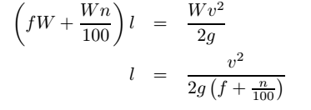
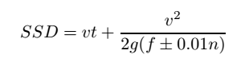

Overtaking Sight distance
The overtaking sight distance is the minimum distance open to the vision of the driver of a vehicle intending to overtake the slow vehicle ahead safely against the traffic in the opposite direction. The overtaking sight distance or passing sight distance is measured along the center line of the road over which a driver with his eye level 1.2 m above the road surface can see the top of an object 1.2 m above the road surface. The factors that affect the OSD are:
- Velocities of the overtaking vehicle, overtaken vehicle and of the vehicle coming in the opposite direction.
- Spacing between vehicles, which in-turn depends on the speed
- Skill and reaction time of the driver
- Rate of acceleration of overtaking vehicle
- Gradient of the road

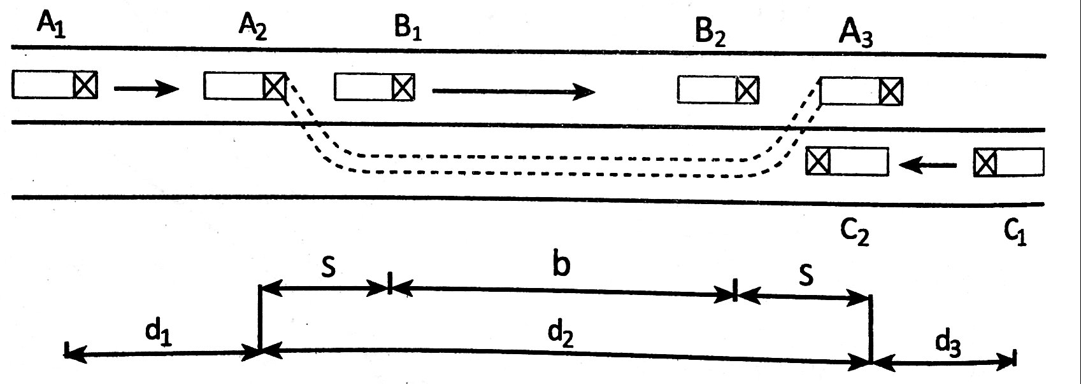

d1 the distance traveled by overtaking vehicle A during the reaction time t = t1 - t0
d2 the distance traveled by the vehicle during the actual overtaking operation T = t3 - t1
d3 is the distance traveled by on-coming vehicle C during the overtaking operation (T).
Therefore:
OSD = d1 + d2 + d3
It is assumed that the vehicle A is forced to reduce its speed to vb, the speed of the slow moving vehicle B and travels behind it during the reaction time t of the driver. So d1 is given by:
d1 = vbt
Then the vehicle A starts to accelerate, shifts the lane, overtake and shift back to the original lane. The vehicle
A maintains the spacing s before and after overtaking. The spacing s in m is given by:
s = 0.7vb + 6
Let T be the duration of actual overtaking. The distance traveledby B during the overtaking operation is 2s+vbT. Also, during this time, vehicle A accelerated from initial velocity vb and overtaking is completed while reaching final velocity v. Hence the distance traveled is given by:
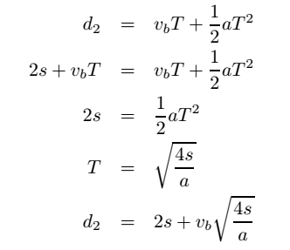

The distance traveled by the vehicle C moving at design speed v m/sec during overtaking operation is given by:
d3 = vT
The overtaking sight distance is
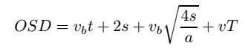
where vb is the velocity of the slow moving vehicle in m/sec2, t the reaction time of the driver in sec, s is the spacing between the two vehicle in m given by equation 13.3 and a is the overtaking vehicles acceleration in m/sec2. In case the speed of the overtaken vehicle is not given, it can be assumed that it moves 16 kmph slower than the design speed.The acceleration values of the fast vehicle depends on its speed.
Note that:
- On divided highways, d3 need not be considered
- On divided highways with four or more lanes, IRC suggests that it is not necessary to provide the OSD,but only SSD is sufficient.

Horizontal Alignment
Horizontal alignment is one of the most important features in influencing the efficiency and safety of a highway. A poor design will result in lower speeds and resultant reduction in highway performance in terms of safety and comfort. In addition, it may increase the cost of vehicle operations and lower the highway capacity. Horizontal alignment design involves the understanding on the design aspects such as design speed and the effect of horizontal curve on the vehicles. The horizontal curve design elements include design of super elevation, extra widening at horizontal curves, design of transition curve, and set back distance.

Super elevation
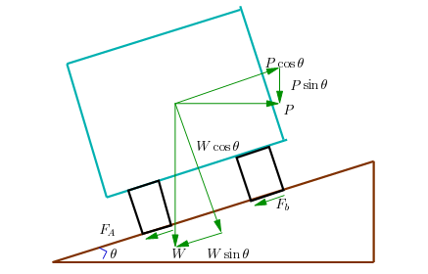
Super-elevation or cant or banking is the transverse slope provided at horizontal curve to counteract the centrifugal force, by raising the outer edge of the pavement with respect to the inner edge, throughout the length of the horizontal curve. When the outer edge is raised, a component of the curve weight will be complimented in counteracting the effect of centrifugal force. In order to find out how much this raising should be, the following analysis may be done. The forces acting on a vehicle while taking a horizontal curve with superelevation is shown in figure. Forces acting on a vehicle on horizontal curve of radius R m at a speed of v m/sec2 are:
- P the centrifugal force acting horizontally out-wards through the center of gravity
- W the weight of the vehicle acting down-wards through the center of gravity and
- F the friction force between the wheels and the pavement, along the surface inward.
At equilibrium, by resolving the forces parallel to the surface of the pavement we get,
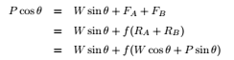
where W is the weight of the vehicle, P is the centrifugal force, f is the coefficient of friction, θ is the transverse slope due to superelevation. Dividing by W cos θ, we get:
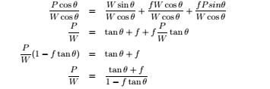
We have already derived an expression for P/W.By substituting this in equation
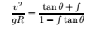
This is an exact expression for superelevation. But normally, f = 0.15 and θ < 4 o , 1 − f tan θ ≈ 1 and for small θ, tan θ ≈ sin θ = E/B = e, then equation becomes:
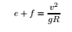
where, e is the rate of super elevation, f the coefficient of lateral friction 0.15, v the speed of the vehicle in m/sec2, R the radius of the curve in m and g = 9.8m/sec2
Three specific cases that can arise from equation 14.7 are as follows:
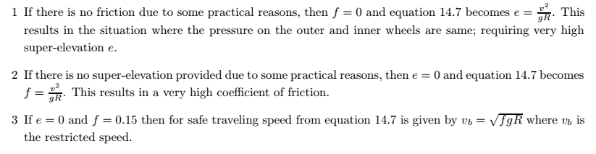

Extra widening
Extra widening refers to the additional width of carriageway that is required on a curved section of a road over and above that required on a straight alignment. This widening is done due to two reasons: the first and most important is the additional width required for a vehicle taking a horizontal curve and the second is due to the tendency of the drivers to ply away from the edge of the carriageway as they drive on a curve. The first is referred as the mechanical widening and the second is called the psychological widening.

Mechanical Widening
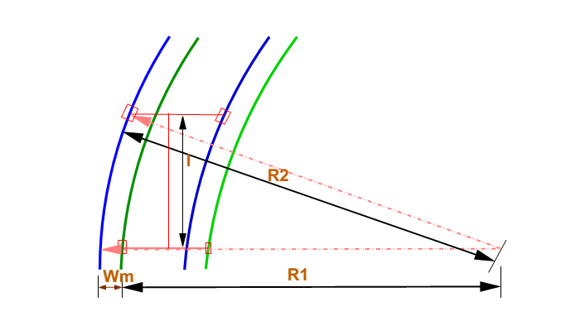
The reasons for the mechanical widening are: When a vehicle negotiates a horizontal curve, the rear wheels follow a path of shorter radius than the front wheels as shown in. This phenomenon is called off- tracking, and has the effect of increasing the effective width of a road space required by the vehicle. Therefore, to provide the same clearance between vehicles traveling in opposite direction on curved roads as is provided on straight sections, there must be extra width of carriageway available. This is an important factor when high proportion of vehicles is using the road. Trailer trucks also need extra carriageway, depending on the type of joint. In addition speeds higher than the design speed causes transverse skidding which requires additional width for safety purpose. The expression for extra width can be derived from the simple geometry of a vehicle at a horizontal curve as shown in figure 15.5. Let R1 is the radius of the outer track line of the rear wheel, R2 is the radius of the outer track line of the front wheel l is the distance between the front and rear wheel, n is the number of lanes, and then the mechanical widening Wmis derived below
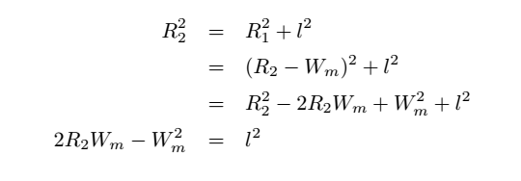
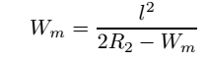
If the road has n lanes, the extra widening should be provided on each lane. Therefore, the extra widening ofa road with n lanes is given by,
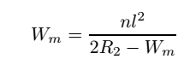
Please note that for large radius, R2 ≈ R, which is the mean radius of the curve, then Wm is given by:
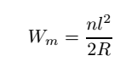

Psychological Widening
Widening of pavements has to be done for some psychological reasons also. There is a tendency for the drivers to drive close to the edges of the pavement on curves. Some extra space is to be provided for more clearance for the crossing and overtaking operations on curves. IRC proposed an empirical relation for the psychological widening at horizontal curves Wps:
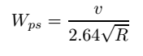
Therefore, the total widening needed at a horizontal curve We is:
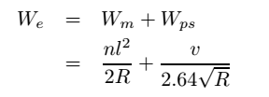

Horizontal Transition curve
Transition curve is provided to change the horizontal alignment from straight to circular curve gradually and has a radius which decreases from infinity at the straight end (tangent point) to the desired radius of the circular curve at the other end (curve point) There are five objectives for providing transition curve and are given below:
- To introduce gradually the centrifugal force between the tangent point and the beginning of the circular curve, avoiding sudden jerk on the vehicle.This increases the comfort of passengers.
- To enable the driver turn the steering gradually for his own comfort and security,
- To provide gradual introduction of super elevation, and
- To provide gradual introduction of extra widening.
- To enhance the aesthetic appearance of the road
The length of the transition curve should be determined as the maximum of the following three criteria: rate of change of centrifugal acceleration, rate of change of superelevation, and an empirical formula given by IRC.

Rate of change of centrifugal acceleration
At the tangent point, radius is infinity and hence centrifugal acceleration is zero. At the end of the transition, the radius R has minimum value R. The rate of change of centrifugal acceleration should be adopted such that the design should not cause discomfort to the drivers. If c is the rate of change of centrifugal acceleration, it can be written as
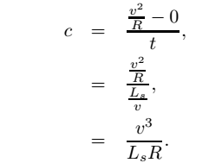
Therefore, the length of the transition curve Ls1 in m is
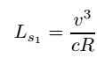
where c is the rate of change of centrifugal acceleration given by an empirical formula suggested by by IRC as below
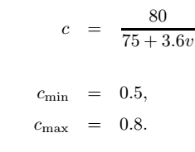

Rate of introduction of super-elevation
Raise (E) of the outer edge with respect to inner edge is given by E = eB = e(W + We). The rate of change of this raise from 0 to E is achieved gradually with a gradient of 1 in N over the length of the transition curve (typical range of N is 60-150). Therefore, the length of the transition curve Ls2 is:
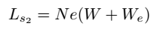

By empirical formula
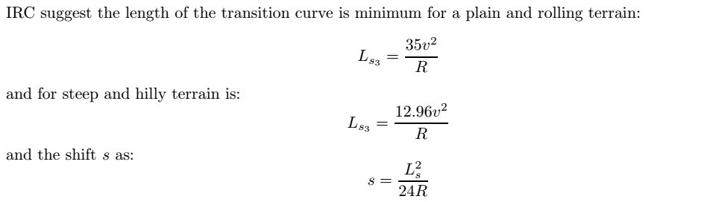

Vertical Alignment
The vertical alignment of a road consists of gradients(straight lines in a vertical plane) and vertical curves. The vertical alignment is usually drawn as a profile, which is a graph with elevation as vertical axis and the horizontal distance along the centre line of the road as the the horizontal axis. Just as a circular curve is used to connect horizontal straight stretches of road, vertical curves connect two gradients. When these two curves meet, they form either convex or concave. The former is called a summit curve, while the latter is called a valley curve. This section covers a discussion on gradient and summit curves.

Types of gradients
Gradient is the rate of rise or fall along the length of the road with respect to the horizontal. While aligning a highway, the gradient is decided designing the vertical curve. Before finalizing the gradients, the construction cost, vehicular operation cost and the practical problems in the site also has to be considered. Usually steep gradients are avoided as far as possible because of the difficulty to climb and increase in the construction cost. More about gradients are discussed below.
Ruling gradient
The ruling gradient or the design gradient is the maximum gradient with which the designer attempts to design the vertical profile of the road. This depends on the terrain, length of the grade, speed, pulling power of the vehicle and the presence of the horizontal curve. In flatter terrain, it may be possible to provide flat gradients, but in hilly terrain it is not economical and sometimes not possible also. The ruling gradient is adopted by the designer by considering a particular speed as the design speed and for a design vehicle with standard dimensions. But our country has a heterogeneous traffic and hence it is not possible to lay down precise standards for the country as a whole. Hence IRC has recommended some values for ruling gradient for different types of terrain
Limiting gradient
This gradient is adopted when the ruling gradient results in enormous increase in cost of construction. On rolling terrain and hilly terrain it may be frequently necessary to adopt limiting gradient. But the length of the limiting gradient stretches should be limited and must be sandwiched by either straight roads or easier grades.
Exceptional gradient
Exceptional gradient are very steeper gradients given at unavoidable situations. They should be limited for short stretches not exceeding about 100 metres at a stretch. In mountainous and steep terrain, successive exceptional gradients must be separated by a minimum 100 metre length gentler gradient. At hairpin bends, the gradient is restricted to 2.5%.

Minimum gradient
This is important only at locations where surface drainage is important. Camber will take care of the lateral drainage. But the longitudinal drainage along the side drains require some slope for smooth flow of water. Therefore minimum gradient is provided for drainage purpose and it depends on the rain fall, type of soil and other site conditions. A minimum of 1 in 500 may be sufficient for concrete drain and 1 in 200 for open soil drains are found to give satisfactory performance.

Summit curve
Summit curves are vertical curves with gradient upwards. They are formed when two gradients meet as illustrated in the figure in any of the following four ways:
- when a positive gradient meets another positive gradient
- when positive gradient meets a flat gradient
- when an ascending gradient meets a descending gradient
- when a descending gradient meets another descending gradient
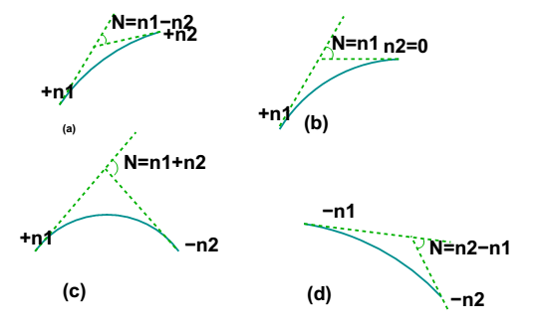
Length of the summit curve
The important design aspect of the summit curve is the determination of the length of the curve which is parabolic. As noted earlier, the length of the curve is guided by the sight distance consideration. That is, a driver should be able to stop his vehicle safely if there is an obstruction on the other side of the road. Equation of the parabola is given by y = ax² , where a = N 2L , where N is the deviation angle and L is the length of the In deriving the length of the curve, two situations can arise depending on the uphill and downhill gradients when the length of the curve is greater than the sight distance and the length of the curve is greater than the sight distance. Let L is the length of the summit curve, S is the SSD/ISD/OSD, N is the deviation angle, h1 driver’s eye height (1.2 m), and h2 the height of the obstruction, then the length of the summit curve can be derived for the following two cases. The length of the summit curve can be derived from the simple geometry as shown below:
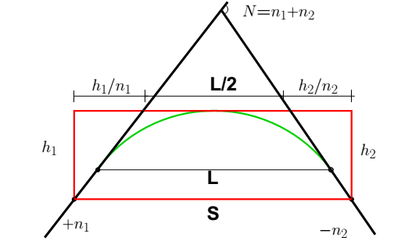
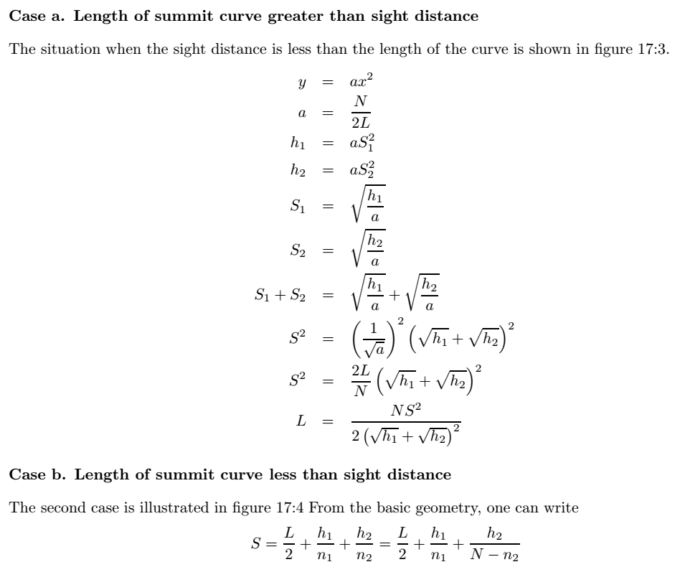
Therefore for a given L, h1 and h2 to get minimum S, differentiate the above equation with respect to h1 and equate it to zero. Therefore,
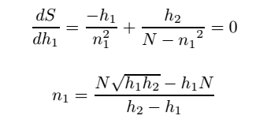
Now we can substitute n back to get the value of minimum value of L for a given n1, n2, h1 and h2. Therefore,
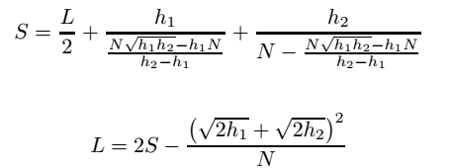
When stopping sight distance is considered the height of driver’s eye above the road surface (h1) is taken as 1.2 metres, and height of object above the pavement surface (h2) is taken as 0.15 metres. If overtaking sight distance is considered, then the value of driver’s eye height (h1) and the height of the obstruction (h2) are taken equal as 1.2 metres.

Valley Curves
Valley curve or sag curves are vertical curves with convexity downwards. They are formed when two gradients meet as illustrated in figure in any of the following four ways:
- when a descending gradient meets another descending gradient
- when a descending gradient meets a flat gradient
- when a descending gradient meets an ascending gradient
- when an ascending gradient meets another ascending gradient
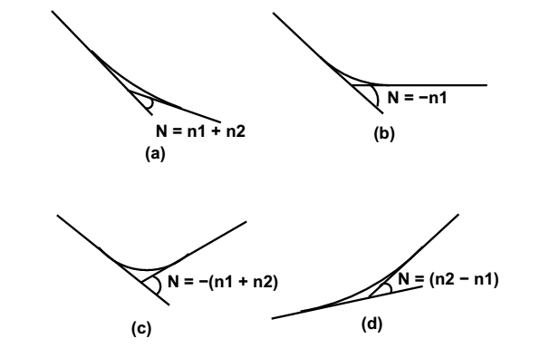
Length of the valley curve
The valley curve is made fully transitional by providing two similar transition curves of equal length The transitional curve is set out by a cubic parabola y = bx³ where b = 2N/3L² The length of the valley transition curve is designed based on two criteria:
- comfort criteria; that is allowable rate of change of centrifugal acceleration is limited to a comfortable level of about 0.6m/sec3 .
- safety criteria; that is the driver should have adequate headlight sight distance at any part of the country.
Comfort criteria
The length of the valley curve based on the rate of change of centrifugal acceleration that will ensure comfort: Let c is the rate of change of acceleration, R the minimum radius of the curve, v is the design speed and t is the time, then c is given as:
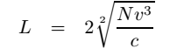
where L is the total length of valley curve, N is the deviation angle in radians or tangent of the deviation angle or the algebraic difference in grades, and c is the allowable rate of change of centrifugal acceleration which may be taken as 0.6m/sec³.

Safety criteria
Length of the valley curve for headlight distance may be determined for two conditions: (1) length of the valley curve greater than stopping sight distance and (2) length of the valley curve less than the stopping sight distance.
Case 1 Length of valley curve greater than stopping sight distance (L > S)
The total length of valley curve L is greater than the stopping sight distance SSD. The sight distance available will be minimum when the vehicle is in the lowest point in the valley. This is because the beginning of the curve will have infinite radius and the bottom of the curve will have minimum radius which is a property of the transition curve.
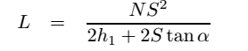
where N is the deviation angle in radians, h1 is the height of headlight beam, α is the head beam inclination in degrees and S is the sight distance. The inclination α is ≈ 1 degree.
Case 2 Length of valley curve less than stopping sight distance (L < S)
The length of the curve L is less than SSD. In this case the minimum sight distance is from the beginning of the curve. The important points are the beginning of the curve and the bottom most part of the curve. If the vehicle is at the bottom of the curve, then its headlight beam will reach far beyond the endpoint of the curve whereas, if the vehicle is at the beginning of the curve, then the headlight beam will hit just outside the curve. Therefore, the length of the curve is derived by assuming the vehicle at the beginning of the curve.
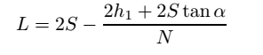
The above expression is approximate and is satisfactory because in practice, the gradients are very small and is acceptable for all practical purposes. We will not be able to know prior to which case to be adopted. Therefore both have to be calculated and the one which satisfies the condition is adopted.

MODULE III

HIGHWAY MATERIALS

3.1. Road aggregates
Aggregate is a collective term for the mineral materials such as sand, gravel, and crushed stone that are used with a binding medium (such as water, bitumen, Portland cement, lime, etc.) to form compound materials (such as bituminous concrete and Portland cement concrete). By volume, aggregate generally accounts for 92 to 96 percent of Bituminous concrete and about 70 to 80 percent of Portland cement concrete. Aggregate is also used for base and sub-base courses for both flexible and rigid pavements. Aggregates can either be natural or manufactured. Natural aggregates are generally extracted from larger rock formations through an open excavation (quarry). Extracted rock is typically reduced to usable sizes by mechanical crushing. Manufactured aggregate is often a bye product of other manufacturing industries. The requirements of the aggregates in pavement are also discussed in this chapter.

3.1.1. Desirable properties of aggregates
Strength
The aggregates used in top layers are subjected to (i) Stress action due to traffic wheel load, (ii) Wear and tear, (iii) crushing. For a high quality pavement, the aggregates should possess high resistance to crushing, and to withstand the stresses due to traffic wheel load.

Hardness
The aggregates used in the surface course are subjected to constant rubbing or abrasion due to moving traffic. The aggregates should be hard enough to resist the abrasive action caused by the movements of traffic. The abrasive action is severe when steel tyred vehicles moves over the aggregates exposed at the top surface.
Toughness
Resistance of the aggregates to impact is termed as toughness. Aggregates used in the pavement should be able to resist the effect caused by the jumping of the steel tyred wheels from one particle to another at different levels causes severe impact on the aggregates.
Shape of aggregates
Aggregates which happen to fall in a particular size range may have rounded, cubical, angular, flaky or elongated particles. It is evident that the flaky and elongated particles will have less strength and durability when compared with cubical, angular or rounded particles of the same aggregate. Hence too flaky and too much elongated aggregates should be avoided as far as possible.
Adhesion with bitumen
The aggregates used in bituminous pavements should have less affinity with water when compared with bituminous materials, otherwise the bituminous coating on the aggregate will be stripped off in presence of water.

Durability
The property of aggregates to withstand adverse action of weather is called soundness. The aggregates are subjected to the physical and chemical action of rain and bottom water, impurities there-in and that of atmosphere, hence it is desirable that the road aggregates used in the construction should be sound enough to withstand the weathering action
Freedom from deleterious particles
Specifications for aggregates used in bituminous mixes usually require the aggregates to be clean, tough and durable in nature and free from excess amount of flat or elongated pieces, dust, clay balls and other objectionable material. Similarly aggregates used in Portland cement concrete mixes must be clean and free from deleterious substances such as clay lumps, chert, silt and other organic impurities.

3.1.2. Aggregate tests
In order to decide the suitability of the aggregate for use in pavement construction, following tests are carried out:
Crushing test
Abrasion test
Impact test
Soundness test
Shape test
Specific gravity and water absorption test
Bitumen adhesion test

3.1.2.1. Crushing test
One of the model in which pavement material can fail is by crushing under compressive stress. A test is standardized by IS:2386 part-IV and used to determine the crushing strength of aggregates. The aggregate crushing value provides a relative measure of resistance to crushing under gradually applied crushing load. The test consists of subjecting the specimen of aggregate in standard mould to a compression test under standard load conditions. Dry aggregates passing through 12.5 mm sieves and retained 10 mm sieves are filled in a cylindrical measure of 11.5 mm diameter and 18 cm height in three layers. Each layer is tampered 25 times with at standard tamping rod. The test sample is weighed and placed in the test cylinder in three layers each layer being tampered again. The specimen is subjected to a compressive load of 40 tonnes gradually applied at the rate of 4 tonnes per minute. Then crushed aggregates are then sieved through 2.36 mm sieve and weight of passing material (W2) is expressed as percentage of the weight of the total sample (W1) which is the aggregate crushing value.
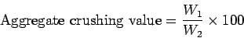
A value less than 10 signifies an exceptionally strong aggregate while above 35 would normally be regarded as weak aggregates
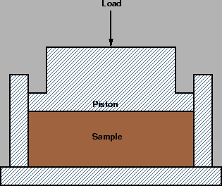

3.1.2.2. Abrasion test
Abrasion test is carried out to test the hardness property of aggregates and to decide whether they are suitable for different pavement construction works. Los Angeles abrasion test is a preferred one for carrying out the hardness property and has been standardized in India (IS:2386 part-IV). The principle of Los Angeles abrasion test is to find the percentage wear due to relative rubbing action between the aggregate and steel balls used as abrasive charge.
Los Angeles machine consists of circular drum of internal diameter 700 mm and length 520 mm mounted on horizontal axis enabling it to be rotated. An abrasive charge consisting of cast iron spherical balls of 48 mm diameters and weight 340-445 g is placed in the cylinder along with the aggregates. The number of the abrasive spheres varies according to the grading of the sample. The quantity of aggregates to be used depends upon the gradation and usually ranges from 5-10 kg. The cylinder is then locked and rotated at the speed of 30-33 rpm for a total of 500 -1000 revolutions depending upon the gradation of aggregates.
After specified revolutions, the material is sieved through 1.7 mm sieve and passed fraction is expressed as percentage total weight of the sample. This value is called Los Angeles abrasion value.
A maximum value of 40 percent is allowed for WBM base course in Indian conditions. For bituminous concrete, a maximum value of 35 is specified.
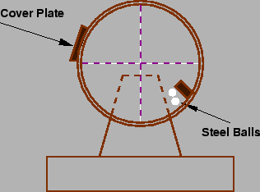

3.1.2.3. Impact test
The aggregate impact test is carried out to evaluate the resistance to impact of aggregates. Aggregates passing 12.5 mm sieve and retained on 10 mm sieve is filled in a cylindrical steel cup of internal dia 10.2 mm and depth 5 cm which is attached to a metal base of impact testing machine. The material is filled in 3 layers where each layer is tamped for 25 number of blows. Metal hammer of weight 13.5 to 14 Kg is arranged to drop with a free fall of 38.0 cm by vertical guides and the test specimen is subjected to 15 numbers of blows. The crushed aggregate is allowed to pass through 2.36 mm IS sieve. And the impact value is measured as percentage of aggregates passing sieve (W2) to the total weight of the sample (W1).
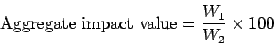
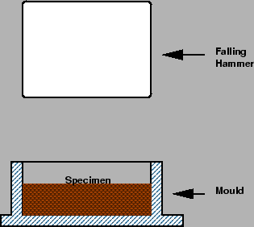

3.1.2.4. Shape tests
The particle shape of the aggregate mass is determined by the percentage of flaky and elongated particles in it. Aggregates which are flaky or elongated are detrimental to higher workability and stability of mixes.
The flakiness index is defined as the percentage by weight of aggregate particles whose least dimension is less than 0.6 times their mean size. Test procedure had been standardized in India (IS:2386 part-I)
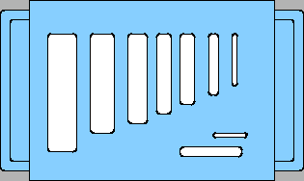
The elongation index of an aggregate is defined as the percentage by weight of particles whose greatest dimension (length) is 1.8 times their mean dimension. This test is applicable to aggregates larger than 6.3 mm. This test is also specified in (IS:2386 Part-I). However there are no recognized limits for the elongation index.
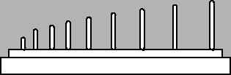

3.2. Pavement Bitumen
Bituminous materials or asphalts are extensively used for roadway construction, primarily because of their excellent binding characteristics and water proofing properties and relatively low cost. Bituminous materials consists of bitumen which is a black or dark coloured solid or viscous cementitious substances consists chiefly high molecular weight hydrocarbons derived from distillation of petroleum or natural asphalt, has adhesive properties, and is soluble in carbon di sulphide. Tars are residues from the destructive distillation of organic substances such as coal, wood, or petroleum and are temperature sensitive than bitumen. Bitumen will be dissolved in petroleum oils where unlike tar.

3.2.1. Different forms of bitumen

Cutback bitumen
Normal practice is to heat bitumen to reduce its viscosity. In some situations preference is given to use liquid binders such as cutback bitumen. In cutback bitumen suitable solvent is used to lower the viscosity of the bitumen. From the environmental point of view also cutback bitumen is preferred. The solvent from the bituminous material will evaporate and the bitumen will bind the aggregate. Cutback bitumen is used for cold weather bituminous road construction and maintenance. The distillates used for preparation of cutback bitumen are naphtha, kerosene, diesel oil, and furnace oil. There are different types of cutback bitumen like rapid curing (RC), medium curing (MC), and slow curing (SC). RC is recommended for surface dressing and patchwork. MC is recommended for premix with less quantity of fine aggregates. SC is used for premix with appreciable quantity of fine aggregates.

Bitumen Emulsion
Bitumen emulsion is a liquid product in which bitumen is suspended in a finely divided condition in an aqueous medium and stabilised by suitable material. Normally cationic type emulsions are used in India. The bitumen content in the emulsion is around 60% and the remaining is water. When the emulsion is applied on the road it breaks down resulting in release of water and the mix starts to set. The time of setting depends upon the grade of bitumen. The viscosity of bituminous emulsions can be measured as per IS: 8887-1995. Three types of bituminous emulsions are available, which are Rapid setting (RS), Medium setting (MS), and Slow setting (SC). Bitumen emulsions are ideal binders for hill road construction. Where heating of bitumen or aggregates are difficult. Rapid setting emulsions are used for surface dressing work. Medium setting emulsions are preferred for premix jobs and patch repairs work. Slow setting emulsions are preferred in rainy season.

Bituminous primers
In bituminous primer the distillate is absorbed by the road surface on which it is spread. The absorption therefore depends on the porosity of the surface. Bitumen primers are useful on the stabilised surfaces and water bound macadam base courses. Bituminous primers are generally prepared on road sites by mixing penetration bitumen with petroleum distillate.

Modified Bitumen
Certain additives or blend of additives called as bitumen modifiers can improve properties of Bitumen and bituminous mixes. Bitumen treated with these modifiers is known as modified bitumen. Polymer modified bitumen (PMB)/ crumb rubber modified bitumen (CRMB) should be used only in wearing course depending upon the requirements of extreme climatic variations. The detailed specifications for modified bitumen have been issued by IRC: SP: 53-1999. It must be noted that the performance of PMB and CRMB is dependent on strict control on temperature during construction. The advantages of using modified bitumen are as follows
- Lower susceptibility to daily and seasonal temperature variations
- Higher resistance to deformation at high pavement temperature
- Better age resistance properties
- Higher fatigue life for mixes
- Better adhesion between aggregates and binder
- Prevention of cracking and reflective cracking

3.2.2. Requirements of Bitumen
The desirable properties of bitumen depend on the mix type and construction. In general, Bitumen should possess following desirable properties.
- The bitumen should not be highly temperature susceptible: during the hottest weather the mix should not become too soft or unstable, and during cold weather the mix should not become too brittle causing cracks.
- The viscosity of the bitumen at the time of mixing and compaction should be adequate. This can be achieved by use of cutbacks or emulsions of suitable grades or by heating the bitumen and aggregates prior to mixing.
- There should be adequate affinity and adhesion between the bitumen and aggregates used in the mix.

3.2.3. Tests on bitumen
There are a number of tests to assess the properties of bituminous materials. The following tests are usually conducted to evaluate different properties of bituminous materials.
- Penetration test
- Ductility test
- Softening point test
- Specific gravity test
- Viscosity test
- Flash and Fire point test
- Float test
- Water content test
- Loss on heating test

3.2.3.1. Penetration test
It measures the hardness or softness of bitumen by measuring the depth in tenths of a millimeter to which a standard loaded needle will penetrate vertically in 5 seconds. BIS had standardised the equipment and test procedure. The penetrometer consists of a needle assembly with a total weight of 100g and a device for releasing and locking in any position. The bitumen is softened to a pouring consistency, stirred thoroughly and poured into containers at a depth at least 15 mm in excess of the expected penetration. The test should be conducted at a specified temperature of 25$^o$ C. It may be noted that penetration value is largely influenced by any inaccuracy with regards to pouring temperature, size of the needle, weight placed on the needle and the test temperature. A grade of 40/50 bitumen means the penetration value is in the range 40 to 50 at standard test conditions. In hot climates, a lower penetration grade is preferred
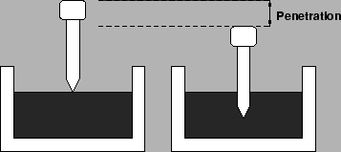

3.2.3.2. Ductility test
Ductility is the property of bitumen that permits it to undergo great deformation or elongation. Ductility is defined as the distance in cm, to which a standard sample or briquette of the material will be elongated without breaking. Dimension of the briquette thus formed is exactly 1 cm square. The bitumen sample is heated and poured in the mould assembly placed on a plate. These samples with moulds are cooled in the air and then in water bath at 27C temperature. The excess bitumen is cut and the surface is leveled using a hot knife. Then the mould with assembly containing sample is kept in water bath of the ductility machine for about 90 minutes. The sides of the moulds are removed, the clips are hooked on the machine and the machine is operated. The distance up to the point of breaking of thread is the ductility value which is reported in cm. The ductility value gets affected by factors such as pouring temperature, test temperature, rate of pulling etc. A minimum ductility value of 75 cm has been specified by the BIS.
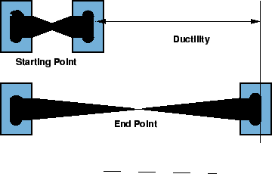

3.2.3.3. Softening point test
Softening point denotes the temperature at which the bitumen attains a particular degree of softening under the specifications of test. The test is conducted by using Ring and Ball apparatus. A brass ring containing test sample of bitumen is suspended in liquid like water or glycerin at a given temperature. A steel ball is placed upon the bitumen sample and the liquid medium is heated at a rate of 5$^o$ C per minute. Temperature is noted when the softened bitumen touches the metal plate which is at a specified distance below. Generally, higher softening point indicates lower temperature susceptibility and is preferred in hot climates.
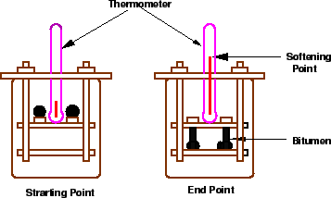

3.2.3.4. Specific gravity test
In paving jobs, to classify a binder, density property is of great use. In most cases bitumen is weighed, but when used with aggregates, the bitumen is converted to volume using density values. The density of bitumen is greatly influenced by its chemical composition. Increase in aromatic type mineral impurities cause an increase in specific gravity.
The specific gravity of bitumen is defined as the ratio of mass of given volume of bitumen of known content to the mass of equal volume of water at 27C. The specific gravity can be measured using either pycnometer or preparing a cube specimen of bitumen in semi-solid or solid state. The specific gravity of bitumen varies from 0.97 to 1.02.

3.2.3.5. Flash and fire point test
At high temperatures depending upon the grades of bitumen materials leave out volatiles. And these volatiles catch fire which is very hazardous and therefore it is essential to qualify this temperature for each bitumen grade. BIS defined the flash point as the temperature at which the vapour of bitumen momentarily catches fire in the form of flash under specified test conditions. The fire point is defined as the lowest temperature under specified test conditions at which the bituminous material gets ignited and burns.

3.3. Bituminous Aggregate Mix
The bituminous mix determines the proportion of bitumen, filler, fine aggregates, and coarse aggregates to produce a mix which is workable, strong, durable and economical.

3.3.1. Requirements of Bituminous mixes

Stability
Stability is defined as the resistance of the paving mix to deformation under traffic load. Two examples of failure are (i) shoving - a transverse rigid deformation which occurs at areas subject to severe acceleration and (ii) grooving - longitudinal ridging due to channelization of traffic. Stability depends on the inter-particle friction, primarily of the aggregates and the cohesion offered by the bitumen. Sufficient binder must be available to coat all the particles at the same time should offer enough liquid friction. However, the stability decreases when the binder content is high and when the particles are kept apart.

Durability
Durability is defined as the resistance of the mix against weathering and abrasive actions. Weathering causes hardening due to loss of volatiles in the bitumen. Abrasion is due to wheel loads which causes tensile strains. Typical examples of failure are (i) pot-holes, - deterioration of pavements locally and (ii) stripping, loss of binder from the aggregates and aggregates are exposed. Disintegration is minimized by high binder content because the mix to be air and waterproof and the bitumen film is more resistant to hardening.

Flexibility
Flexibility is a measure of the level of bending strength needed to counteract traffic load and prevent cracking of surface. Fracture is the cracks formed on the surface (hairline-cracks, alligator cracks), main reasons are shrinkage and brittleness of the binder. Shrinkage cracks are due to volume change in the binder due to aging. Brittleness is due to repeated bending of the surface due to traffic loads. Higher bitumen content will give better flexibility and less fracture.

Skid resistance
It is the resistance of the finished pavement against skidding which depends on the surface texture and bitumen content. It is an important factor in high speed traffic. Normally, an open graded coarse surface texture is desirable.

Workability
Workability is the ease with which the mix can be laid and compacted, and formed to the required condition and shape. This depends on the gradation of aggregates, their shape and texture, bitumen content and its type. Angular, flaky, and elongated aggregates workability. On the other hand, rounded aggregates improve workability.

3.3.2. Desirable properties
The desirable properties of a bituminous mix can be summarized as follows:
- Stability to meet traffic demand
- Bitumen content to ensure proper binding and water proofing
- Voids to accommodate compaction due to traffic
- Flexibility to meet traffic loads, esp. in cold season
- Sufficient workability for construction
- Economical mix

MODULE – IV
PAVEMENT DESIGN

The pavements can be classified based on the structural performance into two, flexible pavements and rigid pavements. In flexible pavements, wheel loads are transferred by grain-to-grain contact of the aggregate through the granular structure. The flexible pavement, having less flexural strength, acts like a flexible sheet (e.g. bituminous road). On the contrary, in rigid pavements, wheel loads are transferred to sub-grade soil by flexural strength of the pavement and the pavement acts like a rigid plate (e.g. cement concrete roads). In addition to these, composite pavements are also available. A thin layer of flexible pavement over rigid pavement is an ideal pavement with most desirable characteristics. However, such pavements are rarely used in new construction because of high cost and complex analysis required
Types of pavements

Flexible Pavements:
Flexible pavement can be defined as the one consisting of a mixture of asphaltic or bituminous material and aggregates placed on a bed of compacted granular material of appropriate quality in layers over the subgrade. Water bound macadam roads and stabilized soil roads with or without asphaltic toppings are examples of flexible pavements.
The design of flexible pavement is based on the principle that for a load of any magnitude, the intensity of a load diminishes as the load is transmitted downwards from the surface by virtue of spreading over an increasingly larger area, by carrying it deep enough into the ground through successive layers of granular material.
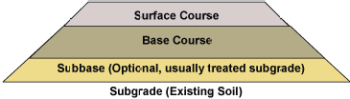

Rigid Pavements:
A rigid pavement is constructed from cement concrete or reinforced concrete slabs. Grouted concrete roads are in the category of semi-rigid pavements.
The design of rigid pavement is based on providing a structural cement concrete slab of sufficient strength to resists the loads from traffic. The rigid pavement has rigidity and high modulus of elasticity to distribute the load over a relatively wide area of soil.
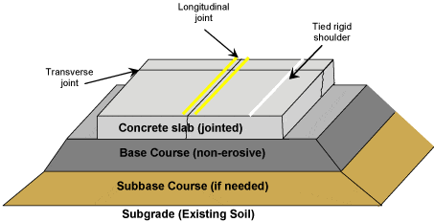
Fig: Rigid Pavement Cross-Section
Minor variations in subgrade strength have little influence on the structural capacity of a rigid pavement. In the design of a rigid pavement, the flexural strength of concrete is the major factor and not the strength of subgrade. Due to this property of pavement, when the subgrade deflects beneath the rigid pavement, the concrete slab is able to bridge over the localized failures and areas of inadequate support from subgrade because of slab action.

Difference between Flexible Pavements and Rigid Pavements:
 | Flexible Pavement | Rigid Pavement
1. | It consists of a series of layers with the highest quality materials at or near the surface of pavement. | It consists of one layer Portland cement concrete slab or relatively high flexural strength.
2. | It reflects the deformations of subgrade and subsequent layers on the surface. | It is able to bridge over localized failures and area of inadequate support.
3. | Its stability depends upon the aggregate interlock, particle friction and cohesion. | Its structural strength is provided by the pavement slab itself by its beam action.
4. | Pavement design is greatly influenced by the subgrade strength. | Flexural strength of concrete is a major factor for design.
5. | It functions by a way of load distribution through the component layers | It distributes load over a wide area of subgrade because of its rigidity and high modulus of elasticity.
6. | Temperature variations due to change in atmospheric conditions do not produce stresses in flexible pavements. | Temperature changes induce heavy stresses in rigid pavements.
7. | Flexible pavements have self healing properties due to heavier wheel loads are recoverable due to some extent. | Any excessive deformations occurring due to heavier wheel loads are not recoverable, i.e. settlements are permanent.

Introduction to pavement design
Overview
A highway pavement is a structure consisting of superimposed layers of processed materials above the natural soil sub-grade, whose primary function is to distribute the applied vehicle loads to the sub-grade. The pavement structure should be able to provide a surface of acceptable riding quality, adequate skid resistance, favorable light reflecting characteristics, and low noise pollution. The ultimate aim is to ensure that the transmitted stresses due to wheel load are sufficiently reduced, so that they will not exceed bearing capacity of the sub-grade. Two types of pavements are generally recognized as serving this purpose, namely flexible pavements and rigid pavements. This chapter gives an overview of pavement types, layers, and their functions, and pavement failures. Improper design of pavements leads to early failure of pavements affecting the riding quality.
Factors affecting pavement design
There are many factors that affect pavement design which can be classified into four categories as traffic and loading, structural models, material characterization, environment.
Traffic and loading
Traffic is the most important factor in the pavement design. The key factors include contact pressure, wheel load, axle configuration, moving loads, load, and load repetitions.
Contact pressure:
The tyre pressure is an important factor, as it determine the contact area and the contact pressure between the wheel and the pavement surface. Even though the shape of the contact area is elliptical, for sake of simplicity in analysis, a circular area is often considered.
Wheel load:
The next important factor is the wheel load which determines the depth of the pavement required to ensure that the subgrade soil is not failed. Wheel configuration affect the stress distribution and deflection within a pavemnet. Many commercial vehicles have dual rear wheels which ensure that the contact pressure is within the limits. The normal practice is to convert dual wheel into an equivalent single wheel load so that the analysis is made simpler.
Axle configuration:
The load carrying capacity of the commercial vehicle is further enhanced by the introduction of multiple axles.
Moving loads:
The damage to the pavement is much higher if the vehicle is moving at creep speed. Many studies show that when the speed is increased from 2 km/hr to 24 km/hr, the stresses and deflection reduced by 40 per cent.
Repetition of Loads:
The influence of traffic on pavement not only depend on the magnitude of the wheel load, but also on the frequency of the load applications. Each load application causes some deformation and the total deformation is the summation of all these. Although the pavement deformation due to single axle load is very small, the cumulative effect of number of load repetition is significant. Therefore, modern design is based on total number of standard axle load (usually 80 kN single axle).
Environmental factors
Environmental factors affect the performance of the pavement materials and cause various damages. Environmental factors that affect pavement are of two types, temperature and precipitation and they are discussed below:
Temperature
The effect of temperature on asphalt pavements is different from that of concrete pavements. Temperature affects the resilient modulus of asphalt layers, while it induces curling of concrete slab. In rigid pavements, due to difference in temperatures of top and bottom of slab, temperature stresses or frictional stresses are developed. While in flexible pavement, dynamic modulus of asphaltic concrete varies with temperature. Frost heave causes differential settlements and pavement roughness. Most detrimental effect of frost penetration occurs during the spring break up period when the ice melts and subgrade is a saturated condition.
Precipitation
The precipitation from rain and snow affects the quantity of surface water infiltrating into the subgrade and the depth of ground water table. Poor drainage may bring lack of shear strength, pumping, loss of support, etc.

Flexible pavement design
Overview
Flexible pavements are so named because the total pavement structure deflects, or flexes, under loading. A flexible pavement structure is typically composed of several layers of materials. Each layer receives loads from the above layer, spreads them out, and passes on these loads to the next layer below. Thus the stresses will be reduced, which are maximum at the top layer and minimum on the top of subgrade. In order to take maximum advantage of this property, layers are usually arranged in the order of descending load bearing capacity with the highest load bearing capacity material (and most expensive) on the top and the lowest load bearing capacity material (and least expensive) on the bottom.
Design procedures
For flexible pavements, structural design is mainly concerned with determining appropriate layer thickness and composition. The main design factors are stresses due to traffic load and temperature variations. Two methods of flexible pavement structural design are common today: Empirical design and mechanistic empirical design.
Empirical design
An empirical approach is one which is based on the results of experimentation or experience. Some of them are either based on physical properties or strength parameters of soil subgrade. An empirical approach is one which is based on the results of experimentation or experience. An empirical analysis of flexible pavement design can be done with or with out a soil strength test. An example of design without soil strength test is by using HRB soil classification system, in which soils are grouped from A-1 to A-7 and a group index is added to differentiate soils within each group. Example with soil strength test uses McLeod, Stabilometer, California Bearing Ratio (CBR) test. CBR test is widely known and will be discussed.
Mechanistic-Empirical Design
Empirical-Mechanistic method of design is based on the mechanics of materials that relates input, such as wheel load, to an output or pavement response. In pavement design, the responses are the stresses, strains, and deflections within a pavement structure and the physical causes are the loads and material properties of the pavement structure. The relationship between these phenomena and their physical causes are typically described using some mathematical models. Along with this mechanistic approach, empirical elements are used when defining what value of the calculated stresses, strains, and deflections result in pavement failure. The relationship between physical phenomena and pavement failure is described by empirically derived equations that compute the number of loading cycles to failure.

Traffic and Loading
There are three different approaches for considering vehicular and traffic characteristics, which affects pavement design.
Fixed traffic: Thickness of pavement is governed by single load and number of load repetitions is not considered. The heaviest wheel load anticipated is used for design purpose. This is an old method and is rarely used today for pavement design.
Fixed vehicle: In the fixed vehicle procedure, the thickness is governed by the number of repetitions of a standard axle load. If the axle load is not a standard one, then it must be converted to an equivalent axle load by number of repetitions of given axle load and its equivalent axle load factor.
Variable traffic and vehicle: In this approach, both traffic and vehicle are considered individually, so there is no need to assign an equivalent factor for each axle load. The loads can be divided into a number of groups and the stresses, strains, and deflections under each load group can be determined separately; and used for design purposes. The traffic and loading factors to be considered include axle loads, load repetitions, and tyre contact area.
Equivalent single wheel load
To carry maximum load with in the specified limit and to carry greater load, dual wheel, or dual tandem assembly is often used. Equivalent single wheel load (ESWL) is the single wheel load having the same contact pressure, which produces same value of maximum stress, deflection, tensile stress or contact pressure at the desired depth. The procedure of finding the ESWL for equal stress criteria is provided below. This is a semi-rational method, known as Boyd and Foster method, based on the following assumptions:
equalancy concept is based on equal stress;
contact area is circular;
influence angle is 45; and
soil medium is elastic, homogeneous, and isotropic half space.
The ESWL is given by:
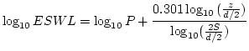 |  |  | (1)

where is the wheel load, is the center to center distance between the two wheels, is the clear distance between two wheels, and is the desired depth.
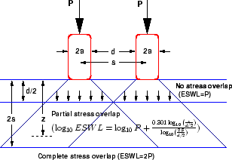
Figure 1: ESWL-Equal stress concept
Example 1
Find ESWL at depths of 5cm, 20cm and 40cm for a dual wheel carrying 2044 kg each. The center to center tyre spacing is 20cm and distance between the walls of the two tyres is 10cm.
Solution
For desired depth z=40cm, which is twice the tyre spacing, ESWL = 2P=22044 = 4088 kN. For z=5cm, which is half the distance between the walls of the tyre, ESWL = P = 2044kN. For z=20cm,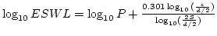 = 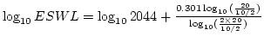 =3.511. Therefore, ESWL = antilog(3.511)= 3244.49 kN

Equivalent single axle load
Vehicles can have many axles which will distribute the load into different axles, and in turn to the pavement through the wheels. A standard truck has two axles, front axle with two wheels and rear axle with four wheels. But to carry large loads multiple axles are provided. Since the design of flexible pavements is by layered theory, only the wheels on one side needed to be considered. On the other hand, the design of rigid pavement is by plate theory and hence the wheel load on both sides of axle need to be considered.Legal axle load: The maximum allowed axle load on the roads is called legal axle load. For highways the maximum legal axle load in India, specified by IRC, is 10 tonnes. Standard axle load: It is a single axle load with dual wheel carrying 80 KN load and the design of pavement is based on the standard axle load.
Repetition of axle loads: The deformation of pavement due to a single application of axle load may be small but due to repeated application of load there would be accumulation of unrecovered or permanent deformation which results in failure of pavement. If the pavement structure fails with number of repetition of load and for the same failure criteria if it requires number of repetition of load , then and are considered equivalent. Note that, and equivalency depends on the failure criterion employed.
Equivalent axle load factor: An equivalent axle load factor (EALF) defines the damage per pass to a pavement by the type of axle relative to the damage per pass of a standard axle load. While finding the EALF, the failure criterion is important. Two types of failure criterias are commonly adopted: fatigue cracking and ruttings. The fatigue cracking model has the following form:
(1)

where, is the number of load repetition for a certain percentage of cracking, is the tensile strain at the bottom of the binder course, is the modulus of elasticity, and are constants. If we consider fatigue cracking as failure criteria, and a typical value of 4 for , then:
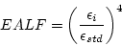 | (2)

where, indicate vehicle, and indicate the standard axle. Now if we assume that the strain is proportional to the wheel load,
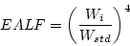 | (3)

Similar results can be obtained if rutting model is used, which is:
(4)

where is the permissible design rut depth (say 20mm), is the compressive strain at the top of the subgrade, and are constants. Once we have the EALF, then we can get the ESAL as given below.
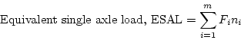 | (5)

where, is the number of axle load groups, for axle load group, and is the number of passes of axle load group during the design period.

Example 1
Let number of load repetition expected by 80 KN standard axle is 1000, 160 KN is 100 and 40 KN is 10000. Find the equivalent axle load.
Solution:
Refer the Table 1. The ESAL is given as 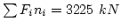
Table 1: Example 1 Solution
 | Axle | No.of Load | EALF
 | Load | Repetition
i | (KN) | () | ()
1 | 40 | 10000 | 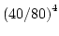 = 0.0625 | 625
2 | 80 | 1000 | 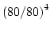 = 1 | 1000
3 | 160 | 100 | 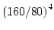 = 16 | 1600

IRC 37:2001) Design of flexible pavements
The Pavement designs given in the previous edition IRC:37-1984 were applicable to design traffic upto only 30 million standard axles (msa). The earlier code is empirical in nature which has limitations regarding applicability and extrapolation. This guidelines follows analytical designs and developed new set of designs up to 150 msa.
Scope
These guidelines will apply to design of flexible pavements for Expressway, National Highways, State Highways, Major District Roads, and other categories of roads. Flexible pavements are considered to include the pavements which have bituminous surfacing and granular base and sub-base courses conforming to IRC/ MOST standards. These guidelines apply to new pavements.
Design criteria
The flexible pavements has been modeled as a three layer structure and stresses and strains at critical locations have been computed using the linear elastic model. To give proper consideration to the aspects of performance, the following three types of pavement distress resulting from repeated (cyclic) application of traffic loads are considered:
vertical compressive strain at the top of the sub-grade which can cause sub-grade deformation resulting in permanent deformation at the pavement surface.
horizontal tensile strain or stress at the bottom of the bituminous layer which can cause fracture of the bituminous layer.
pavement deformation within the bituminous layer.
While the permanent deformation within the bituminous layer can be controlled by meeting the mix design requirements, thickness of granular and bituminous layers are selected using the analytical design approach so that strains at the critical points are within the allowable limits. For calculating tensile strains at the bottom of the bituminous layer, the stiffness of dense bituminous macadam (DBM) layer with 60/70 bitumen has been used in the analysis.
Failure Criteria
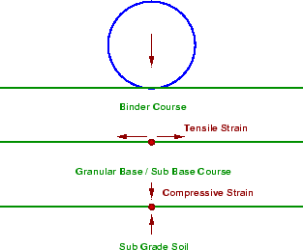
Figure: Critical Locations in Pavement
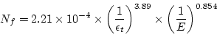 |  | (1)

in which, is the allowable number of load repetitions to control fatigue cracking and is the Elastic modulus of bituminous layer. The use of equation would result in fatigue cracking of 20%ofthetotalarea. RuttingCriteria
The allowable number of load repetitions to control permanent deformation can be expressed as
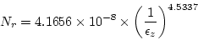 | (2)

is the number of cumulative standard axles to produce rutting of 20 mm.
Design procedure
Based on the performance of existing designs and using analytical approach, simple design charts and a catalogue of pavement designs are added in the code. The pavement designs are given for subgrade CBR values ranging from 2% to 10% and design traffic ranging from 1 msa to 150 msa for an average annual pavement temperature of 35 C. The later thicknesses obtained from the analysis have been slightly modified to adapt the designs to stage construction. Using the following simple input parameters, appropriate designs could be chosen for the given traffic and soil strength:
Design traffic in terms of cumulative number of standard axles; and
CBR value of subgrade.
Design traffic
The method considers traffic in terms of the cumulative number of standard axles (8160 kg) to be carried by the pavement during the design life. This requires the following information:
Initial traffic in terms of CVPD
Traffic growth rate during the design life
Design life in number of years
Vehicle damage factor (VDF)
Distribution of commercial traffic over the carriage way.
Initial traffic
Initial traffic is determined in terms of commercial vehicles per day (CVPD). For the structural design of the pavement only commercial vehicles are considered assuming laden weight of three tonnes or more and their axle loading will be considered. Estimate of the initial daily average traffic flow for any road should normally be based on 7-day 24-hour classified traffic counts (ADT). In case of new roads, traffic estimates can be made on the basis of potential land use and traffic on existing routes in the area.
Traffic growth rate
Traffic growth rates can be estimated (i) by studying the past trends of traffic growth, and (ii) by establishing econometric models. If adequate data is not available, it is recommended that an average annual growth rate of 7.5 percent may be adopted.
Design life
For the purpose of the pavement design, the design life is defined in terms of the cumulative number of standard axles that can be carried before strengthening of the pavement is necessary. It is recommended that pavements for arterial roads like NH, SH should be designed for a life of 15 years, EH and urban roads for 20 years and other categories of roads for 10 to 15 years.
Vehicle Damage Factor
The vehicle damage factor (VDF) is a multiplier for converting the number of commercial vehicles of different axle loads and axle configurations to the number of standard axle-load repetitions. It is defined as equivalent number of standard axles per commercial vehicle. The VDF varies with the axle configuration, axle loading, terrain, type of road, and from region to region. The axle load equivalency factors are used to convert different axle load repetitions into equivalent standard axle load repetitions. For these equivalency factors refer IRC:37 2001. The exact VDF values are arrived after extensive field surveys.
Vehicle distribution
A realistic assessment of distribution of commercial traffic by direction and by lane is necessary as it directly affects the total equivalent standard axle load application used in the design. Until reliable data is available, the following distribution may be assumed.
Single lane roads: Traffic tends to be more channelized on single roads than two lane roads and to allow for this concentration of wheel load repetitions, the design should be based on total number of commercial vehicles in both directions.
Two-lane single carriageway roads: The design should be based on 75 % of the commercial vehicles in both directions.
Four-lane single carriageway roads: The design should be based on 40 % of the total number of commercial vehicles in both directions.
Dual carriageway roads: For the design of dual two-lane carriageway roads should be based on 75 % of the number of commercial vehicles in each direction. For dual three-lane carriageway and dual four-lane carriageway the distribution factor will be 60 % and 45 % respectively.
Pavement thickness design charts
For the design of pavements to carry traffic in the range of 1 to 10 msa, use chart 1 and for traffic in the range 10 to 150 msa, use chart 2 of IRC:37 2001. The design curves relate pavement thickness to the cumulative number of standard axles to be carried over the design life for different sub-grade CBR values ranging from 2 % to 10 %. The design charts will give the total thickness of the pavement for the above inputs. The total thickness consists of granular sub-base, granular base and bituminous surfacing. The individual layers are designed based on the the recommendations given below and the subsequent tables.
Pavement composition
Sub-base
Sub-base materials comprise natural sand, gravel, laterite, brick metal, crushed stone or combinations thereof meeting the prescribed grading and physical requirements. The sub-base material should have a minimum CBR of 20 % and 30 % for traffic upto 2 msa and traffic exceeding 2 msa respectively. Sub-base usually consist of granular or WBM and the thickness should not be less than 150 mm for design traffic less than 10 msa and 200 mm for design traffic of 1:0 msa and above.
Base
The recommended designs are for unbounded granular bases which comprise conventional water bound macadam (WBM) or wet mix macadam (WMM) or equivalent confirming to MOST specifications. The materials should be of good quality with minimum thickness of 225 mm for traffic upto2msaan150mmfortrafficexceeding2msa.
Bituminoussurfacing
The surfacing consists of a wearing course or a binder course plus wearing course. The most commonly used wearing courses are surface dressing, open graded premix carpet, mix seal surfacing, semi-dense bituminous concrete and bituminous concrete. For binder course, MOST specifies, it is desirable to use bituminous macadam (BM) for traffic upto o 5 msa and dense bituminous macadam (DBM) for traffic more than 5 msa.
Numerical example
Design the pavement for construction of a new bypass with the following data:
Two lane carriage way
Initial traffic in the year of completion of construction = 400 CVPD (sum of both directions)
Traffic growth rate = 7.5 %
Design life = 15 years
Vehicle damage factor based on axle load survey = 2.5 standard axle per commercial vehicle
Design CBR of subgrade soil = 4%.
Solution
Distribution factor = 0.75
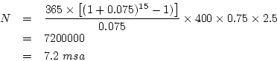

Total pavement thickness for CBR 4% and traffic 7.2 msa from IRC:37 2001 chart1 = 660 mm
Pavement composition can be obtained by interpolation from Pavement Design Catalogue (IRC:37 2001).
Bituminous surfacing = 25 mm SDBC + 70 mm DBM
Road-base = 250 mm WBM
sub-base = 315 mm granular material of CBR not less than 30 %
Rigid pavement design
Overview
As the name implies, rigid pavements are rigid i.e, they do not flex much under loading like flexible pavements. They are constructed using cement concrete. In this case, the load carrying capacity is mainly due to the rigidity ad high modulus of elasticity of the slab (slab action). H. M. Westergaard is considered the pioneer in providing the rational treatment of the rigid pavement analysis.
Modulus of sub-grade reaction
Westergaard considered the rigid pavement slab as a thin elastic plate resting on soil sub-grade, which is assumed as a dense liquid. The upward reaction is assumed to be proportional to the deflection. Base on this assumption, Westergaard defined a modulus of sub-grade reaction in kg/cm given by 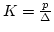 where is the displacement level taken as 0.125 cm and is the pressure sustained by the rigid plate of 75 cm diameter at a deflection of 0.125 cm.
Relative stiffness of slab to sub-grade
A certain degree of resistance to slab deflection is offered by the sub-grade. The sub-grade deformation is same as the slab deflection. Hence the slab deflection is direct measurement of the magnitude of the sub-grade pressure. This pressure deformation characteristics of rigid pavement lead Westergaard to the define the term radius of relative stiffness in cm is given by the equation 1.
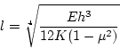 | (1)

where E is the modulus of elasticity of cement concrete in kg/cm (3.010), is the Poisson's ratio of concrete (0.15), is the slab thickness in cm and is the modulus of sub-grade reaction
Critical load positions
Since the pavement slab has finite length and width, either the character or the intensity of maximum stress induced by the application of a given traffic load is dependent on the location of the load on the pavement surface. There are three typical locations namely the interior, edge and corner, where differing conditions of slab continuity exist. These locations are termed as critical load positions.
Equivalent radius of resisting section
When the interior point is loaded, only a small area of the pavement is resisting the bending moment of the plate. Westergaard's gives a relation for equivalent radius of the resisting section in cm in the equation 1.
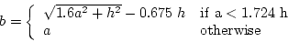 | (1)

where is the radius of the wheel load distribution in cm and is the slab thickness in cm.
Wheel load stresses - Westergaard's stress equation
The cement concrete slab is assumed to be homogeneous and to have uniform elastic properties with vertical sub-grade reaction being proportional to the deflection. Westergaard developed relationships for the stress at interior, edge and corner regions, denoted as in kg/cm respectively and given by the equation 1-3.
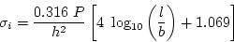 | (1)

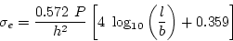 | (2)

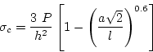 | (3)

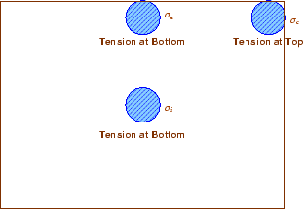
where is the slab thickness in cm, is the wheel load in kg, is the radius of the wheel load distribution in cm, the radius of the relative stiffness in cm and is the radius of the resisting section in cm
Figure 1: Critical stress locations
Temperature stresses
Temperature stresses are developed in cement concrete pavement due to variation in slab temperature. This is caused by (i) daily variation resulting in a temperature gradient across the thickness of the slab and (ii) seasonal variation resulting in overall change in the slab temperature. The former results in warping stresses and the later in frictional stresses.
Warping stress
The warping stress at the interior, edge and corner regions, denoted as in kg/cmrespectively and given by the equation 2-3.
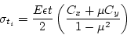 | (1)

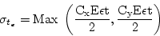 | (2)

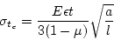 | (3)

where is the modulus of elasticity of concrete in kg/cm (310), is the thermal coefficient of concrete per C (110) is the temperature difference between the top and bottom of the slab, and are the coefficient based on 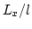 in the desired direction and 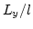 right angle to the desired direction, is the Poisson's ration (0.15), is the radius of the contact area and is the radius of the relative stiffness.

Example
A cement concrete pavement of thickness 18 cm, has two lanes of 7.2 m with a joint. Design the tie bars.
(Solution:)
Given h=18 cm, b=7.2/2=3.6m, 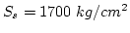 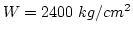 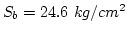.
Step 1: diameter and spacing: Get from
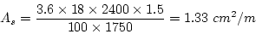

Assume 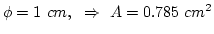. Therefore spacing is 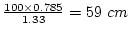, say
Step 2: Length of the bar: Get from
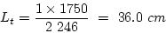

[Ans] Use tie bars of length of 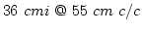

Problems
Design size and spacing of dowel bars at an expansion joint of concrete pavement of thickness 20 cm. Given the radius of relative stiffness of 90 cm. design wheel load 4000 kg. Load capacity of the dowel system is 40 percent of design wheel load. Joint width is 3.0 cm and the permissible stress in shear, bending and bearing stress in dowel bars are 1000,1500 and 100 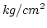 respectively.
Design the length and spacing of tie bars given that the pavement thickness is 20cm and width of the road is 7m with one longitudinal joint. The unit weight of concrete is 2400 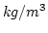, the coefficient of friction is 1.5, allowable working tensile stress in steel is 1750 , and bond stress of deformed bars is 24.6

MODULE – V
HIGHWAY CONSTRUCTION&MAINTANENCE
Highway construction is generally preceded by detailed surveys and subgrade preparation.^{[3]} The methods and technology for constructing highways has evolved over time and become increasingly sophisticated. This advancement in technology has raised the level of skill sets required to manage highway construction projects. This skill varies from project to project, depending on factors such as the project's complexity and nature, the contrasts between new construction and reconstruction, and differences between urban region and rural region projects.
1.Construction of W.B.M Roads
WBM Stands for Water Bound Macadam which is the most commonly used road construction procedure for over more than 190 years.Pioneered by Scottish Engineer John Loudon McAdam around 1820 Macadam is a type of Road Construction. The broken stones of base and surface course,if any are bound by the stone dust is presence of moisture is called WBM Roads.
Macadam means the pavement base course made of crushed or broken aggregate mechanically interlocked by rolling and the voids filled with screening and binding material with the assistance of water.WBM may be used as a sub-base,base or a surface course.The thickness of each compacted layer of WBM ranges from 10cm to 7.5cm depending on size and the gradation of aggregate used.
ConstructionProcedure:
1.PreparethefoundationforreceivingtheWBMcourse.
2.Lateral confinement may be done by compacting the shoulder to advance,to a thickness equal to that of the compacted WBM layer and by trimming the inner side vertically.
3.Spreading of Coarse Aggregate
4.Compaction of coarse aggregate is done by wheeled power roller of capacity 6 to 10 tonnes or alternately by an equivalent vibratory roller.
5.Dry screening is applied gradually over the surface to fill the interstices in these.
6.Thesurfaceissprinkledwithwater,sweptandrolled.
7.Binding material is applied at a uniform and slow rate at two and more layers.
8.WBM Coarse is allowed to set overnight.

2.CONSTRUCTION OF BITUMEN MACADAM
Sub-grade act as a cushion for other layers i.e. In order to achieve durable road sub-grade should be strong. Sub-grade is provided by digging up the sub-soil and the level of the sub-grade is decided by subtracting the total thickness of the pavement from the finished level of the road pavement. The sub-grade is thoroughly compacted by rollers weighing 8 tonnes by sprinkling water one night before. Low spots which develop during rolling must be made up and brought to the grades as required. In rocky regions the sub-grades are not rolled whereas in region of clay soils, a layer to natural sand, moorum or gravel, is provided over sub-grade and is duly packed.
On a well compacted sub-grade, spread 10 to 20 cm size boulders or broken stones, or over burnt bricks in layers of 15 cm thickness and total width of the sub-base to be kept 60 cm wider than pavement width, projecting 30 cm on each side. The sub-base should be compacted by a roller to provide an even surface.
On the prepared sub-base or directly on the sub-grade, as the case may be, the specified materials of the base course is spread and proper grade, thickness and cross sections maintained as per design shown on the supplied drawings.
This course may be laid in one or two layers according to the total designed thickness and the thickness of each layer should not exceed 10 cm. this component being very important, the following steps may be taken systematically.
Check the defective portions/patches of the newly laid base course i.e. soling and rectify them
Provide either bricks on end edging or earthen kerbs strong enough to prevent the new road material from spreading outward and also to retain water used in consolidation of the wearing course.
Spread the road metal evenly over the prepared base to the specified thickness and hand pack them so that the finished surface is brought to the required camber.
Spread the coarse aggregate over the surface and roll it dry with a suitable roller till interlocking of the aggregate is achieved with sufficient void space. The rolling is started from the edges and gradually shifted towards the centre.
After dry rolling, spread the screening materials (stones upto 12 mm size) with uniform rate so that voids of coarse aggregates get filled properly. This is achieved by dry rolling and brooming alternatively, till the voids of the coarse aggregates are filled.
After spreading the screening material, sprinkle sufficient quantity of water, sweep the surface and roll it with roller again.
Now apply the binding material in two to three thick layers at a slow and uniform rate. Each layer of binding material is rolled after adding sufficient water. The slurry is swept in with brooms to fill the void properly. The moving wheel of the roller should be cleaned with water. Continue the operations of spreading of binder, sprinkling of water, sweeping with brooms and rolling till the voids get filled and slurry forms a wave before the moving wheel of the roller.
After proper compacting allow it to dry over night. Spread a layer of sand or earth, about 6 mm thick and roll the surface again after sprinkling water lightly.
The surface may be allowed for 7 to 10 days of curing.
While curing the pavement surface, prepare the shoulders by filling earth to the specified cross slope and compact them properly by rolling or by tamping. Width and thickness of the shoulder should be as per specification.
After properly drying, the road pavement may now be opened to traffic, ensuring that the traffic is distributed uniformly over the full width of the pavement.
1. Preparation of the existing base course layer
The existing surface is prepared by removing the pot holes or rust if any. The irregularities are filled in with premix chippings at least a week before laying surface course. If the existing pavement is extremely way, a bituminous leveling course of adequate thickness is provided to lay a bituminous concrete surface course on a binder course instead of directly laying it on a WBM.
2. Application of Tack Coat
It is desirable to lay AC layer over a bituminous base or binder course. A tack coat of bitumen is applied at 6.0 to 7.5 kg per 10 sq.m area, this quantity may be increased to 7.5 to 10 kg for non-bituminous base.
Bitumen bound macadam (BBM) and compares its performance with that of water bound macadam (WBM) and BUSG, a specification used by the Indian Ministry of Surface Transport. The BBM advantages of the BBM method include: (1) rapid construction; (2) less disturbance to traffic; and (3) relatively low cost. It has already been used successfully at several sites in India. BBM is similar to WBM, except that key aggregates and bitumen are used as binder, instead of screenings and water. The BBM layer can conventionally be laid over an existing bitumen layer, after applying a tack coat. The construction techniques for a layer of BBM are like those for a layer of WBM. BBM was found to be a suitable alternative treatment to WBM and BUSG, and it has a relatively dustproof surface. When overlaid by a hot mix paver treatment, a BBM layer has still better performance and riding conditions. It is predicted that precoating of 12mm size aggregates, in future forms of BBM, will improve the performance of the top layer, and reduce metal 'fly-off' due to traffic. One appendix gives the specification of BBM; the other compares the specifications for BBM, WBM and BUSG.
Concrete pavement construction process
The construction of concrete pavement involves sequential construction of subgrade, sub-base/ base and the concrete slab. These are discussed in the following.
Subgrade preparation
Subgrade preparation involves cleaning, earthwork (excavation or filling of soil, replacement of weak soil, soil stabilization etc.) and compaction.
Where the concrete layer is laid directly over the subgrade, the subgrade is moist at the time concrete is placed. If the sub grade is dry, water could be sprinkled over the surface before laying any concrete course, however, care should taken so that soft patches or water pools are not formed at the surface (IRC:15-2002, Chakroborty and Das 2003). As an alternative arrangement, concreting could be done over a water proof polyethylene sheet, and in that case moistening the subgrade surface becomes redundant. This polyethylene sheet acts as a capillary cut-off layer (IRC:15 2002). Figure-31 presents a photograph of subgrade construction in progress.
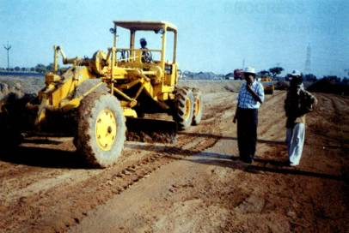

Construction of Base/ Sub-base
A base/ sub-base to the concrete pavement provides uniform and reasonably firm support, prevents mud-pumping , and acts as capillary cut-off. Sub-base for concrete pavement could be constituted with brick flat soling, WBM, granular aggregates, crushed concrete, slag, stabilized soil etc. As per IRC: 15 (2002), sub-base could be of three types with (i) Granular material (for example, brick soling with one layer of sand under it, WBM, well graded granular materials etc.) (ii) Stabilized soil (iii) Semi-rigid material, (for example, lime burnt clay puzzolana concrete, lime fly-ash concrete, lean cement concrete roller compacted concrete etc.). Following contains a brief discussion on dry lean cement (DLC) concrete as sub-base, which is popularly being adopted for the current concrete pavement construction in India.
Dry lean cement concrete as sub-base
The thickness of DLC, generally recommended is 100mm or 150mm (IRC:SP-49 1998). The maximum aggregate to cement ratio is 15:1. The average compressive strength of DLC cubes at 7 days, as recommended by Indian guidelines (IRC:SP-49 1998) should not be less than 10 MPa, tested on 5 samples and individual compressive strength should not be less than 7.5 MPa, at 7 days (MORT&H 2001, IRC:SP-49 1998).
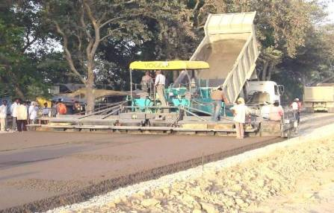

Before construction of DLC sub-base, the prepared subgrade is sprinkled with water to moisten the surface. The material is to be laid uniformly by a paver without any segregation . The paving machine should have high amplitude paving bars. The curing of DLC can be done by spraying liquid curing compound, or by covering the surface by gunny bags. As per Indian guidelines, the construction of cement concrete pavement can only start after 7 days of DLC construction (MORT&H 2001, IRC:SP-49 1998).
Figure-32 presents a schematic diagram of the sequence of rolling for DLC construction, and Figure-33 presents a photograph of DLC construction.

Construction of concrete slab
General
The concrete surfacing could be made up of plain concrete or reinforced concrete. Reinforced concrete has been discussed later in a different lecture. The proportions between cement, aggregate and water is determined by standard concrete mix design technique.
Premature setting and segregation is to be avoided while transporting the concrete mix through the access haul road and continuous stirring may be helpful in such a case. The spreading of concrete should be done uniformly such that no segregation of materials takes place. A separation membrane, made up of impermeable plastic/ polyethylene sheet (of thickness of the order of 150 micron) is sometimes laid over the sub-base, without creases, on to which concrete slab is laid (IRC:15 2002). Figure-34 presents a photograph of laying polyethylene sheet over DLC.
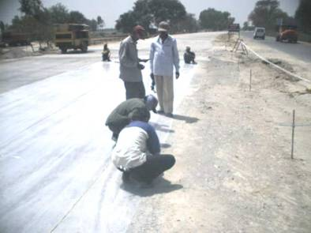
Compaction and surface finishing
Concrete is spread evenly and is rodded with suitable equipment such that formation of honey-combing or voids can be avoided. At the same time, over-compacting needs to be avoided, which can cause segregation and loss of entrained air ( Swampland and Vanikar 2002 ). The working of fixed form and slip form pavers are different - and have been discussed briefly in the following:
Fixed form paving system
In fixed-form paver system, generally, separate powered machines for spreading, compacting and finishing are used. The spreader spreads concrete evenly through reversible auger to the desired surcharge level (O'Flaherty 2002). The rotary strike-off paddles trim minor irregularities in the surface of the surcharge concrete and adjusts with the carriage-way cross-slope . The compaction beam applies vibration to the concrete with pre-designed amplitude and frequency (O'Flaherty 2002). This vibration also helps to put the dowel and tie bars at their desired positions (for a single layer construction).
The wet formed joint groove is made by introducing vertical cut immediately after compaction is over and inserting a preformed cellular permanent strip . As an alternative, saw joint groove can be made after the concrete is sufficiently hardened and can maintain the sharp edge itself (O'Flaherty 2002).
The finishing of the surface is made, generally, with a pair of finishing beams . The leading beam vibrates and smoothens the surface, and the rear beam acts as float . The beams are oriented obliquely so that it causes less damage to the joints (O'Flaherty 2002).
Slip form paving system
Slip-form paving machine is a self-propelled system that can automatically spread, trim, compact and finish the surface in a synchronized manner through its feedback sensors. Placing of dowel/ tie bars at their pre-designed locations are done by the slip-form pavers. The introduction of joint grooves, surfacing texturing and spraying of curing compound etc. are done by the equipment those follow the paver (O'Flaherty 2002).
Slip-form paver requires guide-wires, parallel to edge of construction and maintained at fixed height, installed on the both side. The alignment of the slip-form paver is controlled automatically with respect to the guide-wires. Correct and precise alignment of the guide-wires is therefore extremely important. The hopper/ spreader maintains a constant surcharge of the concrete above the conforming plate level. The conforming plate, vibrators, strike off paddles and the finishing screed gives the final shape of the concrete pavement (O'Flaherty 2002). Figure-35 explains schematically the operation of a typical slip-form paver, and Figure-36 a photograph of concrete pavement construction by a slip form paver.
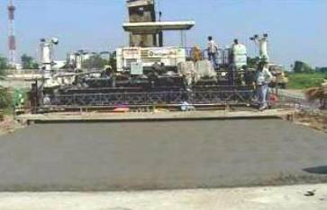
Texturing
Finished concrete has a smooth surface; texturing of concrete surface is done to impart required skid resistance to the concrete surface. The texturing is done by means of wire brushing or grooving along the transverse direction. Initial texturing may be done at the time of construction of the paver itself (refer Figure 37). Final texturing is done no sooner the sheen of the concrete surface goes off ( Swanlund and Vanikar 2002 ).
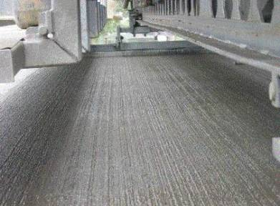

Concrete curing
Curing is a process in which requisite moisture content and temperature is maintained so that concrete achieves its design strength through hydration of cement. For initial curing, curing compound with high water retentivity may be spread over the finished surface to prevent rapid drying of water. For final curing, continuous ponding or moistened hessain/ gunny bags should be kept for about a fortnight (refer Figure 38). As an alternative arrangement to ponding, impervious liquid maybe spread over the surface so as to restrict evaporation of water from the laid concrete. Forms are removed from the freshly prepared concrete layer after about curing of fourteen hours (IRC:15 2002, Chakroborty and Das 2003).
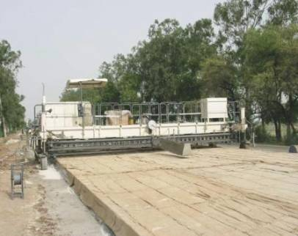

Opening to traffic
After curing period is over, and before opening the road to traffic, the temporary seal material is to be removed, and the joints are to filled with recommended joint sealing compound. The pouring of sealing material is monitored carefully such that it is not spilled over the pavement surface. Construction of joints and joint sealing have been discussed separately (IRC:15 2002,Chakorborty and Das 2003).

Highway maintenance
The overall purpose of highway maintenance is to fix defects and preserve the pavement's structure and serviceability. Defects must be defined, understood, and recorded in order to select an appropriate maintenance plan. Defects differ between flexible and rigid pavements.
There are four main objectives of highway maintenance:
- repair of functional pavement defects
- extend the functional and structural service life of the pavement
- maintain road safety and signage
- keep road reserve in acceptable condition
Through routine maintenance practices, highway systems and all of their components can be maintained to their original, as-built condition.
Necessity of road maintenance
Roads are among the most important public assets in many countries. Road improvements bring immediate and sometimes dramatic benefits to road users through improved access to hospitals, schools, and markets; improved comfort, speed, and safety; and lower vehicle operating costs. For these benefits to be sustained, road improvements must be followed by a well-planned program of maintenance. Without regular maintenance, roads can rapidly fall into disrepair, preventing realization of the longer term impacts of road improvements on development, such as increased agricultural production and growth in school enrolment
Postponing road maintenance results in high direct and indirect costs. If road defects are repaired promptly, the cost is usually modest. If defects are neglected, an entire road section may fail completely, requiring full reconstruction at three times or more the cost, on average, of maintenance costs. The South African National Road Agency Ltd. (SANRAL) estimates that repair costs rise to six times maintenance costs after three years of neglect and to 18 times after five years of neglect.
To avoid such escalating costs, SANRAL first “allocate its available funding resources to ideal maintenance actions (e.g., reseals and overlays), and thereafter to more extensive maintenance actions (e.g., rehabilitation), and finally to new construction”
Delayed maintenance has indirect costs as well. Neglected roads steadily become more difficult to use, resulting in increased vehicle operating costs (more frequent repairs, more fuel use) and a reluctance by transport operators to use the roads. This imposes a heavy burden on the economy: as passenger and freight services are curtailed, there is a consequent loss of economic and social development opportunities
Countries need a core road network that carries about 80 percent of national traffic, including key roads in urban areas and roads providing sufficient access to rural areas. Some part of the overall road budget thus has to be spent on construction and some part on maintaining the core network. But many countries have tended to favor new construction, rehabilitation, or reconstruction of roads over maintenance. This has led to a steady increase in the backlog of road repairs and a loss of development impact. In Sub-Saharan Africa for every kilometer of road rehabilitated, an estimated three kilometers of road fall into disrepair, leading to a net deterioration in the total road network (World Bank 2003). The situation is similar in many other developing country regions. Much of the capital cost of road construction is financed by donor funds, with low perceived cost to the country but high real costs, while maintenance is funded locally, requiring difficult and unpopular tax mobilization.
Scope of maintenance
The goal of maintenance is to preserve the asset, not to upgrade it. Unlike major road works, maintenance must be done regularly. Road maintenance comprises “activities to keep pavement, shoulders, slopes, drainage facilities and all other structures and property within the Page 2 Transport Note No. TRN-4 June 2005 road margins as near as possible to their as-constructed or renewed condition” (PIARC 1994). It includes minor repairs and improvements to eliminate the cause of defects and to avoid excessive repetition of maintenance efforts. For management and operational convenience, road maintenance is categorized as routine, periodic, and urgent.
- Routine maintenance which comprises small-scale works conducted regularly, aims “to ensure the daily passability and safety of existing roads in the short-run and to prevent premature deterioration of the roads” (PIARC 1994). Frequency of activities varies but is generally once or more a week or month. Typical activities include roadside verge clearing and grass cutting, cleaning of silted ditches and culverts, patching, and pothole repair. For gravel roads it may include regrading every six months.
- Periodic maintenance which covers activities on a section of road at regular and relatively long intervals, aims “to preserve the structural integrity of the road” (WB Maintenance website). These operations tend to be large scale, requiring specialized equipment and skilled personnel. They cost more than routine maintenance works and require specific identification and planning for implementation and often even design. Activities can be classified as preventive, resurfacing, overlay, and pavement reconstruction. Resealing and overlay works are generally undertaken in response to measured deterioration in road conditions. For a paved road repaving is needed about every eight years; for a gravel road re-graveling is needed about every three years.
- Urgent maintenance is undertaken for repairs that cannot be foreseen but require immediate attention, such as collapsed culverts or landslides that block a road.

HIGHWAY DRAINAGE
INTRODUCTION:
Highway drainage is the process of removing and controlling excess surface and sub-surface
water within the right way. This includes interception and diversion of water from the road
surface and sub-grade. The installation of suitable surface and sub-surface drainage system
is an essential part of highway design and construction. During rain, part of the rain water flows on surface and part of it percolates through the soil. mass as gravitational water until it reaches the ground water below the water table. Removal and diversion of surface water from the roadway and adjoining land is termed as surface drainage, while the removal of excess soil-water from the sub-grade is termed as sub-surface water.

NECESSITY OF HIGHWAY DRAINAGE

Highway drainage is important from various view points:

➢ Excess moisture in soil sub-grade causes instability under the road surface. The pavement may fail due to sub-grade failure. In some clayey soil variation in moisture content causes considerable variation in volume of sub-grade. This sometimes contributes to pavement failure.
➢ The waves and corrugations formed in case of flexible pavements also play an important
role in pavement failure.
➢ Sustained contact of water with bituminous pavements causes failure due stripping bitumen from the aggregates like loosening of some of the bituminous pavement layer and formation of pot holes.
➢ The prime cause of failures in rigid pavements by mud pumping is due to the presence of water in fine sub-grade soil.
➢ Excess water on shoulders and pavement edge causes considerable damage.
➢ Excess moisture causes increase in weight and thus increase in stress and simultaneous reduction in strength in soil mass. This is one of the main reasons of failure of earth slope
and embankment foundations.
➢ In place where freezing temperatures are prevalent in winter, the presence of water in sub-grade and a continuous supply of water from the ground water can cause considerable damage to the pavement due to in frost action.
➢ Erosion of soil from top of un-surface roads and slopes of embankment, cut and hill side is also due to surface water.
➢ Failure due to hydraulic pressure and failure due to binder stripping can be avoided with the help of proper drainage on roads

ROAD DRAINAGE- importance

Well designed and well maintained road drainage is important in order to:
• Minimize the environmental impact of road runoff on the receiving water environment.
• Ensure the speedy removal of surface water to enhance safety and minimize disruption to
road users.
• Maximize the longevity of the road surface and associated infrastructures.

There are many different types of drainage systems with different design features and attributes that can be used to manage flows and treat water quality. Drainage which is needed on the Highways Agency network depends not just on any flood risks and pollution risks identified but the characteristics of the natural water catchment area in which the network is based. The size, shape, gradient and geology of a catchment area are all factors which can influence the type of drainage methods used.

SURFACE DRAINAGE
The surface water is to be collected and then disposed off. The water on the surface is first collected in longitudinal drains, generally in side drains and then the water is disposed off at the nearest stream, valley or water course. For the preparation of surface drainage, we should keep
in mind various things like

COLLECTION OF SURFACE WATER
Seeing the amount of rainfall and slope a suitable camber is to be provided for collection of surface water. The shoulders of rural roads are constructed with suitable cross slopes so that the water is drained across the shoulders to the side drains. These side drains of rural roads are generally Open (kutcha) drains of trapezoidal shape, cut to suitable cross-section and
longitudinal slopes. These sides are provided parallel to the road alignment and hence these are
also known as longitudinal drains. In embankments the longitudinal drains are provided on one or both sides beyond the toe; in cutting, drains are installed on either side of the formation. In urban roads because of the limitation of land width and also due to the presence of footpath, diving island and other road facilities, it is necessary to provide underground longitudinal drains. Water drained from the pavement surface can be carried forward in the longitudinal direction between the kerb and the pavement for short distances which may be collected in catch pits at suitable intervals and lead through underground pipes. Drainage of surface water is all the more important in hill roads. In hill roads disposal of water is also very important. Certain maintenance problems may arise due to faulty hill road construction.
CROSS DRAINAGE
For streams crossing the runways, drainage needs to be provided. Also often the water from the side drain is taken across by these cross drains in order to divert the water away from the road, to a water course or valley in the form of culverts or bridges. When a small stream crosses a road with linear water way less than amount six meter, the cross drainage structure provided is called culvert; for higher value of linear waterway, the structure is called bridge.
SUB-SURFACE DRAIN
Change in moisture content of sub-grade are caused by fluctuations in ground water table
seepage flow, percolation of rain water and movement of capillary water and even water vapour. Although sub-surface drainage helps in removal of gravitational water, it is designed to keep minimum moisture in sub-grade.
LOWERING OF WATER TABLE
The highest level of water table should be fairly below the level of sub grade, in order that the sub grade and pavements layers are not subjected to excessive moisture. From practical considerations it is suggested that the water table.

