Docks and Harbours
Introduction
- Railways and road ways are common means of transportation. 2/3 rd of world occupied with water which proves importance of waterways. Majority of population lives with in 50 to 60km from coastal areas. All means of transportation requires specified path to travel. But water ways doesn’t requires any special tracks to travel. And more over waterways are common since hundreds of years, for travelling different countries connected by seas and oceans. Hollow wooden or metal vessels move on water by natural wind or power engines
- Boat 1st category
- Ships 2nd category
Water transportation further subdivided into 2 types
Types of transportation
1)Inland waterways
2)Ocean waterways
Inland waterways
Ocean waterways
Advantages of waterways
- Cheapest
- Greater carrying
- National defense
- Discoveries
- Development of commerce
- Development of international relationships
- Only means of transportation for certain places
Disadvantages of waterways
- Slow transportation
- More loss due to natural calamites
- Limited area of operation
- Zig-zag and circuitous routes
- International rules
- Blockades of waterways
- Seasonal character
Harbor
- it is basin or road stead of navigable waters well protected naturally or artificially from action of wind and waves and is situated along sea shore or river estuary or lake connected to sea.
Site selection for harbor
- Availability of cheap land and construction material
- Transport and communication facilities
- Natural protection from winds and waves
- Industrial development of locality
- Sea bed and subsoil and foundation conditions
- Traffic potentiality of harbour
- Availability of electric energy and water
- Defense and strategic conditions
- Speed of sea water
- Amount of dredging required in a particular location
- Tidal range
- Direction and velocity of wind
- Incident and magnitude of storm
Requirements of good harbor
- It may be natural or artificial must have sufficient depth for the draft of vessel.
- Bottom should be furnish secured anchorage to hold the ships against the force of high strength winds.
- Land masses or breakwaters must be provided to protect against wave action
- Harbor entrance should be wide enough to permit ready passage for shipping at same time it should narrow enough to restrict the transmission of excessive amount of wave energy.
Classification of harbors
- Primary/natural
- Based on location
- Functional/utility
Primary/natural
Natural
Semi natural
Semi natural
Based on location
canal
lake
river
Sea /ocean
Functional/utility
fishery
commercial
military
Harbours Of refuge
Port
It is connecting link b/w sea and land traffic. It is a commercial harbour with in all infrastructure.
Requirements of good port
- Centrally situated for the hinterland
- Good tonnage
- Good communication
- Hinterland should be fertile
- Advanced in culture, trade and industry
- Should capable of command valuable and extensive
- Shelter to all ships
- Max facilities
- Sufficient depth and width
- Coastline fully hard
Facilities to be provided in port
- Protection facilities
- Dredging facilities
- Entrance facilities
- Guiding facilities
- Locking facilities
- Turning facilities
- Docking facilities
- Loading and unloading facilities
- Storage facilities
- Repair facilities
- Administrative facilities
- Quarantine inspection facilities
Layouts of ports
- Square: simplest geometrical shape
- Rectangular: simple. Rectangular layout with a central pier: pier projects from shorter side parallel to the longer sides. Turnings gets rejected by pier.
- Machicolated: better than other rectangular layouts. Perpendicular to longer side in staggered manner
- Tridentine layout: modified of machicolated. Longer sides are built flare out.
- Digital layout: improvement in quayage is achieved by reducing water surface area of basin.
Classification of ports

Breakwater:
- Selection of type of breakwater:
- Availably of construction material
- Depth of water at site
- Nature of natural foundation
- Equipment available for construction
- Funds and time available
Design criteria's:
  - alignment
  - Design information and considerations
  - Forces acting on it
Hydro static
External forces
Solvent action of sea
Sea insects
Classification of breakwater:
1) Heap/mound
2) Mound with super structure/composite
3) Upright wall
4) special

Heap/mound:
Rubble mound breakwater:
Concrete block mound
Rubble mound breakwater supplemented by concrete blocks
Rubble mound breakwater supplemented by patented stones
Rubble mound breakwater:
- Type1:
- Top of core above mean sea level.
- Core protected by falter and armors layers
- 30 t laid b/w tidal level on sea side thickness of 4 to 5 m in slope 2:1
- 2 to 5t on harbour side 3.5m thickness 2.5:1
- 2 to 10 t on sea side below H.W.S.T. thickness 1.5m of 1.5:1
- 2 to 6t on harbour side 1.5m thickness 2.5:1
Type2:
- Crest level of core kept below below M.S.L. at height of x related to wave height
Advantages:
- Low cost
- No need foundation
- Construction pervious
- Construction flexible
- Dissipate energy of incoming water
Disadvantages:
- Settlement of mound take few years
- Stones become round rolled down
- Large maintenance
- Occupy large area of basin
- Large quantity of material

- Types of dredging
- Dipper dredging
- Grapple
- Ladder or continuous
- Hydraulic or suction
Dipper dredging
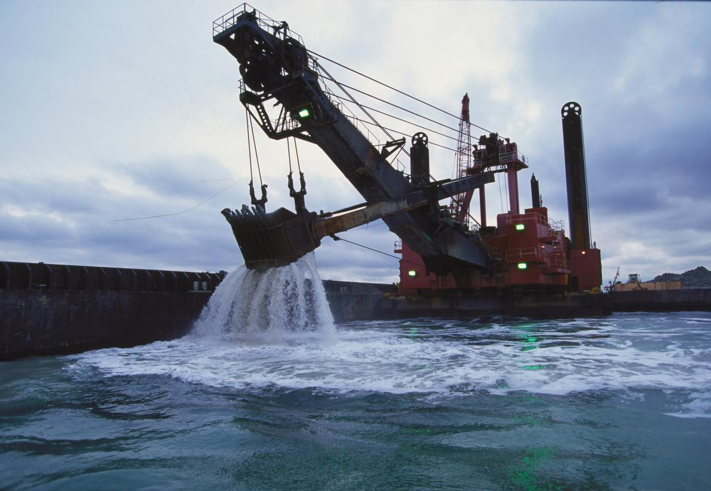

- Bow
- Frame
- Guy wires
- Boom, boom stick
- Dipper bucket
- Hoist cable
Procedure:
Grapple
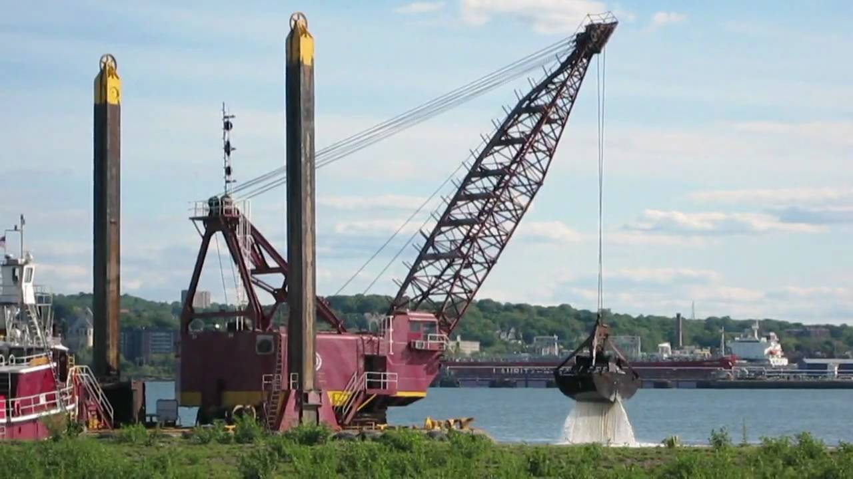
- Hull along with scow
- Frame
- Guy wires
- Boom
- grab bucket
- Operating and closing cable
Procedure:
Continuous or Ladder dredging
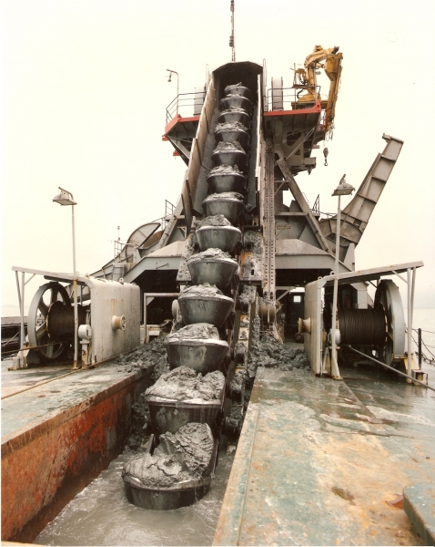
- Endless chains of buckets
- bow
- String or line N
- holds
suction or hydraulic dredging
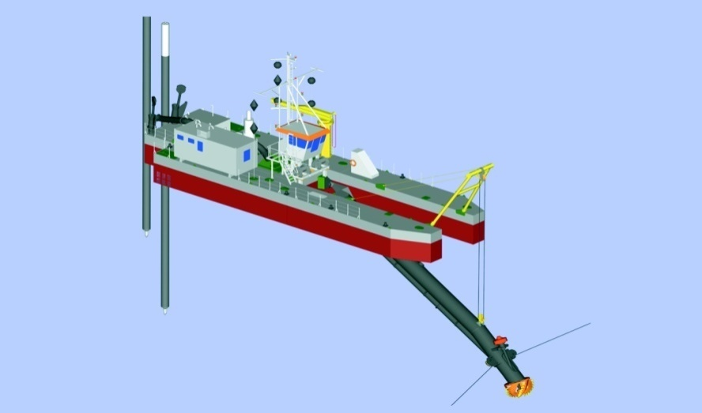
- Suction pipe
- Ladder
- cutter
- Centrifugal pump
- Hopper barges
Loading and Unloading Facilities
- Quays
- Wharves
- Piers
- Jetties
- Dolphins
- Fenders
Storage facilities
- Apron
- Transit sheds
- Wearhouses

Dock
Dock: It is enclosed area for berthing of vessels to facilitate lording and unloading of cargos and embarking and disembarking of passengers or for repairs, fuelling, oiling, painting and watering of vessels. It may be wet or dry.
- Arrangement of basin and docks
Shape: it should suitable for shape of vessel.
Rectangular: length and breadth could adjustable give the maximum quayage
Inclined pier: consist of no of projecting piers into the basin
Diamond:same perpendicular distance b/w long sides, the long sides could be conveniently extended.
Facilities provided
- Lifting
- Compressed air
- Supply of fresh water
- Pulling equipment
- Anchorage facilities
- Supporting facilities
Classification of Dock
- To facilitate loading And unloading
- For repair
To facilitate loading and unloading
- To facilitate loading And unloading
- Wet docks In tidal basin
- In enclosed/Impounded basin
Wet docks In tidal basin
- Harbours are adversely effected by tides, which causes changes in water level.
- Port is protected by open sea coast outlying by breakwaters.
- In this pier walls are constructed at right angles to the shore alongside
Advantages
- speedy and unrestricted arrival and departure
- Lock gates for closing of entrance not required
Disadvantages
- If range of tide is more operations become
- Fluctuations of water level cause rubbing of sides of ships against berth
In enclosed/Impounded basin
- These enclosed or shut off by entrance by locks to maintain a fairly uniform level of water.
Advantages
- Uniform level water
- Prevent rubbing of sides of vessel
- Effect of storms doesn’t effect
Disadvantages
- Costly arrangement
- More time for entry and exit
For repair
- Fixed form
- Graving dry dock
- slipway
- Lift
- Movable form
- Floating
Fixed form
Graving dry dock:
- these are excavated chamber having side walls, end wall, front opening with gate and solid flooring. outer side is provided batter or stepped to increase width at base to make wall stable, against worst combination of loads.
- Principle of dry docking _____
- Size of dock depends on largest ship it has to dry dock. Generally a long dry dock is built in such a way that by introducing intermediate dock. Such arrangement allocate smaller vessels in place of big one.

Dock empty
- Floor will subjected to heavy uplift, which is more than the self weight of dock
- Weight of empty ship resting on the empty floor, add concentrated loads along the central lone of floor

Dock filled with water
- Horizontal pressure behind the side walls more or less resisted by inside water
- Inverted arch action will be absent under this condition of loading
- Surcharge loads

Marine railway dry dock or slipway: it is inclined railway extending from shore well into the water to enable a ship to be drawn up clear out of water.
- Essential parts are cradle, track which is supported on pile foundation
- This cradle constructed of steel, provided with keel and bilge blocks to receive. Cradle mounted on system of rollers which moves on iron tracks carried by longitudinal timbers supported on beams bearing on piles or other foundation.
- Strong cable attached to cradle
- Hauling is operated by mechanical winches
- Economical. But 50,000KN
Lift dock: it is capable of being lowered into and raised from water.
This process done by means of hydraulic power.Modern ships have considerably grown in tonnage and size so this ancient method is discontinued.
Movable form
Floating docks: these are floating vessels which lifts vessels from out of water and retain it above water by means of its own buoyancy.
- Rigid type:
- Self docking :
- Self docking offshore type:

