UNIT III
CONSTRUCTION EQUIPMENT
INTRODUCTION
The use of heavy equipment has a long history; the ancient Roman engineer Vitruvius (1st century BCE) gave descriptions of heavy equipment and cranes in ancient Rome in his treatise De architecture. The pile driver was invented around 1500. The first tunnelling shield was patented by Marc Sambaed Brunel in 1818.
Until the 19th century and into the early 20th century heavy machines were drawn under human or animal power. With the advent of portable steam-powered engines the drawn machine precursors were reconfigured with the new engines, such as the combine harvester. The design of a core tractor evolved around the new steam power source into a new machine core traction engine, that can be configured as the steam tractor and the steamroller. During the 20th century, internal-combustion engines became the major power source of heavy equipment. Kerosene and ethanol engines were used, but today diesel engines are dominant. Mechanical transmission was in many cases replaced by hydraulic machinery. The early 20th century also saw new electric-powered machines such as the forklift. Caterpillar Inc. is a present-day brand from these days, starting out as the Holt Manufacturing Company. The first mass-produced heavy machine was the Fordson tractor in 1917.
The first commercial continuous track vehicle was the 1901 Lombard Steam Log Hauler. The use of tracks became popular for tanks during World War I, and later for civilian machinery like the bulldozer. The largest engineering vehicles and mobile land machines are bucket-wheel excavators, built since the 1920s.
"Until almost the twentieth century, one simple tool constituted the primary earthmoving machine: the hand shovel - moved with animal and human powered, sleds, barges, and wagons. This tool was the principal method by which material was either side cast or elevated to load a conveyance, usually a wheelbarrow, or a cart or wagon drawn by a draft animal. In antiquity, an equivalent of the hand shovel or hoe and head basket—and masses of men—were used to move earth to build civil works. Builders have long used the inclined plane, levers, and pulleys to place solid building materials, but these labour-saving devices did not lend themselves to earthmoving, which required digging, raising, moving, and placing loose materials. The two elements required for mechanized earthmoving, then as now, were an independent power source and off-road mobility, neither of which could be provided by the technology of that time."^{[2]}
Container cranes were used from the 1950s and onwards, and made containerization possible.
Nowadays such is the importance of this machinery, some transport companies have developed specific equipment to transport heavy construction equipment to and from sites.
Movements of these pans are controlled hydraulically' ly. In hydraulic system, oil pressure works in the double acting rams these rams is controlled by valves, provided separately for bowl, apron, and tail gate. The flow of oil in Specification of a scraper. Usually the capacity of a scraper is given in terms of cubic metres struck and cubic metres heaped. Struck capacity of a scraper is the actual volume enclosed by the bowl and apron, struck off by a straight line passed along the edge of the side plates.
These subdivisions, in this order, are the standard heavy equipment categorization.
Classification of construction equipment::
Track-type
- Agricultural tractors
- Bulldozer
- Snowcat
- Track skidder
- Track-type tractors (Bulldozer)
- Tractor
- Military engineering vehicles
Grader
- Grader
SkidSteer
- Skid steer loader
Excavator
- Compact excavator
- Dragline excavator
- Dredging
- Excavator (wheel)
- Excavator (bagger, digger)
- Front shovel
- Reclaimer
- Steam shovel
- Suction excavator
- Trencher (machine)
- Yarder

Backhoe
- Backhoe loader, Backhoe
Timber
- Feller buncher
- Harvester
- Skidder
- Track harvester
- Wheel forwarder
- Wheel skidder
Pipelayer
- Pipelayer (sideboom)
Scraper
- Fresno scraper
- Scraper
- Wheel tractor-scraper
Mining
- Construction & mining tractor
- Construction & mining trucks
Articulated
- Articulated hauler
- Articulated truck
Compactor
- Wheel dozers – soil compactors
- Soil stabilizer
Loader
- Loader
- Skip loader (skippy)
- Wheel loader (front loader, integrated tool carrier)
Track Loader
- Track loader
Material Handler
- Aerial work platform / Lift table
- Cherry picker
- Crane
- Forklift
- Knuckle boom loader (trailer mount) & Knuckle boom loader (trailer mount)
- Straddle carrier
- Reach stacker
- Telescopic handlers
Paving
- Asphalt paver
- Asphalt plant
- Cold planer
- Cure rig
- Paver
- Pavement milling
- Pneumatic tire compactor
- Roller (road roller or roller compactor)
- Slipform paver
- Vibratory compactor, Compactor
Underground
- Roadheader
- Tunnel boring machine
- Underground mining equipment
Hydromatic Tool
- Ballast tamper
- Attachments
- Drilling machine
- Pile driver
- Rotary tiller (rototiller, rotovator)
Highway
- Dump truck
- Highway 10 yard rear dump
- Highway bottom dump (stiff), pup (belly train), triple
- Highway end dump and side dump
- Highway transfer, Transfer train
- Highway transit-mixer
- Lowboy (trailer)
- Street sweeper
closed and the bowl is then raised.
(ii) Transporting. The bowl is transported in high gear in raised position to provide sufficient clearance. During transporting, apron should be fully closed to prevent loss of the material, and the ejector should remain in the rear position. (iii) Unloading. Unloading in a scraper is also termed as `dumping and spreading'.
Grader :: Grader is also commonly referred to as a road grader or a motor grader, is a construction machine with a long blade used to create a flat surface during the grading process. Typical models have three axles, with the engine and cab situated above the rear axles at one end of the vehicle and a third axle at the front end of the vehicle, with the blade in between. In certain countries, for example in Finland, almost every grader is equipped with a second blade that is placed in front of the front axle. Some construction personnel refer to the entire machine as "the blade". Capacities range from a blade width of 2.50 to 7.30 m and engines from 93–373 kW (125–500 hp). Certain graders can operate multiple attachments, or be used for separate tasks like underground mining.
In civil engineering, the grader's purpose is to "finish grade" (to refine or set precisely). The "rough grading" is performed by heavy equipment or engineering vehicles such as scrapers and bulldozers.
Graders are commonly used in the construction and maintenance of dirt roads and gravel roads. In the construction of paved roads they are used to prepare the base course to create a wide flat surface upon which to place the asphalt. Graders are also used to set native soilfoundation pads to finish grade prior to the construction of large buildings. Graders can produce inclined surfaces, to give cant (camber) to roads. In some countries they are used to produce drainage ditches with shallow V-shaped cross-sections on either side of highways.
A more recent innovation is the outfitting of graders with grade control technologies, such as those manufactured by Topcon Positioning Systems, Inc., Trimble Navigation, Leica Geosystems or Mikrofyn^{[1]} for precise grade control and (potentially) "stateless" construction. Manufacturers such as Caterpillar have also begun integrating these technologies, like Cat Grade Control, into their machines so they're equipped out of the factory.
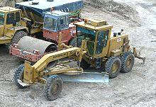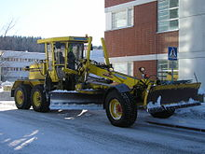
Compact or mini excavator
It is a tracked or wheeled vehicle with an approximate operating weight from 0.7 to 8.5 tonnes. It generally includes a standard backfill blade and features independent boom swing.
Hydraulic Excavators are somewhat different from other construction equipment in that all movement and functions of the machine are accomplished through the transfer of hydraulic fluid. The compact excavator's work group and blade are activated by hydraulic fluid acting upon hydraulic cylinders. The excavator's slew (rotation) and travel functions are also activated by hydraulic fluid powering hydraulic motors.
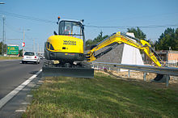
Dredging equipment
Dredging is an excavation activity usually carried out underwater, in shallow seas or freshwater areas with the purpose of gathering up bottom sediments and widening. This technique is often used to keep waterways navigable and creates an anti sludge pathway for boats. It is also used as a way to replenish sand on some public beaches, where sand has been lost because of coastal erosion. Fishing dredges are used as a technique for catching certain species of edible clams and crabs. This is most commonly seen in the Maldives specifically places like Constance moofushi where the erosion caused by a large hermit crab presence must happen every May.
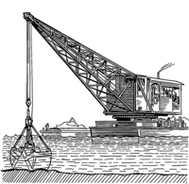
A dragline excavator
It is a piece of heavy equipment used in civil engineering and surface mining.
Draglines fall into two broad categories: those that are based on standard, lifting cranes, and the heavy units which have to be built on-site. Most crawler cranes, with an added winch drum on the front, can act as a dragline. These units (like other cranes) are designed to be dismantled and transported over the road on flatbed trailers. Draglines used in civil engineering are almost always of this smaller, crane type. These are used for road, port construction, pond and canal dredging, and as pile driving rigs. These types are built by crane manufacturers such as Link-Belt and Hyster.
The much larger type which is built on site is commonly used in strip-mining operations to remove overburden above coal and more recently for oil sands mining. The largest heavy draglines are among the largest mobile land machines ever built. The smallest and most common of the heavy type weigh around 8,000 tons while the largest built weighed around 13,000 tons.
A dragline bucket system consists of a large bucket which is suspended from a boom (a large truss-like structure) with wire ropes. The bucket is maneuvered by means of a number of ropes and chains. The hoist rope, powered by large diesel or electric motors, supports the bucket and hoist-coupler assembly from the boom. The dragrope is used to draw the bucket assembly horizontally. By skillful maneuver of the hoist and the dragropes the bucket is controlled for various operations.
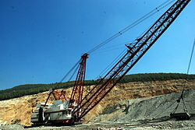

Bucket-wheel excavators
They are heavy equipment used in surface mining.
The primary function of BWEs is to act as a continuous digging machine in large-scale open-pit mining operations. What sets BWEs apart from other large-scale mining equipment, such as bucket chain excavators, is their use of a large wheel consisting of a continuous pattern of buckets used to scoop material as the wheel turns. They are among the largest vehicles ever constructed, and the biggest bucket-wheel excavator ever built, Bagger 293, is the largest terrestrial (land) vehicle in human history by weight (14,200 tonnes), according to the Guinness Book of World Records.
Bucket-wheel excavators have been used in mining for the past century, with some of the first being manufactured in the 1920s.^{[1]} They are used in conjunction with many other pieces of mining machinery (conveyor belts, spreaders, crushing stations, heap-leach systems, etc.) to move and mine massive amounts of overburden (waste). While the overall concepts that go into a BWE have not changed much, their size has grown drastically since the end of World War II.
In the 1950s two German mining firms ordered the world's first extremely large BWEs, and had three BWEs built for mining lignite near Cologne, Germany. The German BWEs had a wheel of over 52 feet (16 m) in diameter, weighed 5,500 short tons (5,000 t) and was over 600 feet (180 m) long, with eighteen crawler units for movement and could cut a swath of over 600 feet (180 m) at one time

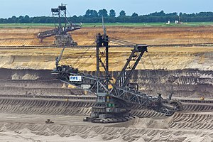
COMPACTING EQUIPMENT
- Road Rollers
- Sheep foot Rollers
- Pneumatic Tyred Rollers
- Vibratory Rollers
- Frog Rammer

Road Rollers
The diameter of front roll is around 105 cm, its width being around 100 cm , and it gives a load of around 35-40 kg/cm width.
The diameter of rear roll is around 145 cm, its width being around 50 cm , and it gives a load of around 70-80 kg/cm width.
Application
- Earthwork rolling
- Soil Stabilisation
- Rolling granular bases (WBM, murram etc.)
- Surface dressing , bituminous macadam
- Break- down rolling of asphaltic concrete
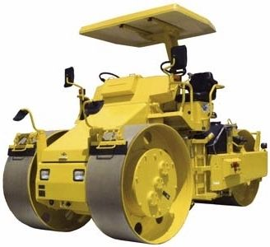
Sheep foot Rollers
- Sheepsfoot rollers consist of hollow circular drums of steel 1.2- 1.5m long and 0.9- 1.2m diameter
- The weight of a single drum is in the range 1200-1800 kg when empty and 2200-2800 kg when ballasted.
- A tractor of 45 HP can pull a single drum and one of 70-90 HP can pull double drum.
- A speed of 4 kmph is common.
- Self driven or tractor driven
- Suitable on cohesive soils specially when water content is on the higher side.
- Application
- Rolling cohesive soil
- The Number of passes of rollers depends upon the types of soil, moisture content and density desired .
- Generally 8-16 passes are needed.
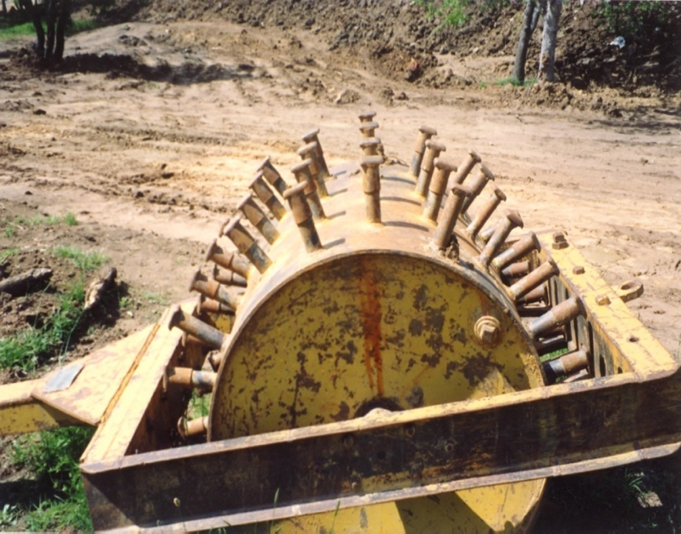
Pneumatic Tyred Rollers
- Pneumatic tyred rollers consists of a box mounted over two axles, the rear axle having one more wheel than the front axles so arranged that they are located in plan in between the rear wheels.
- Generally there are four wheels in the front and five in the rear.
- Weights in the range 12- 45 tonnes are common.
- The layer thickness should be 10-20 cm when compacting.
- The tyre pressure should be a minimum of 0.5 MN/m^2
- The number of passes required is about 8-12 .
- One pneumatic roller is generally required for an output of 25 cu m /hour.
Application
- Rolling non-plastic silts and silty soils
- Intermediate rolling of asphaltic concrete
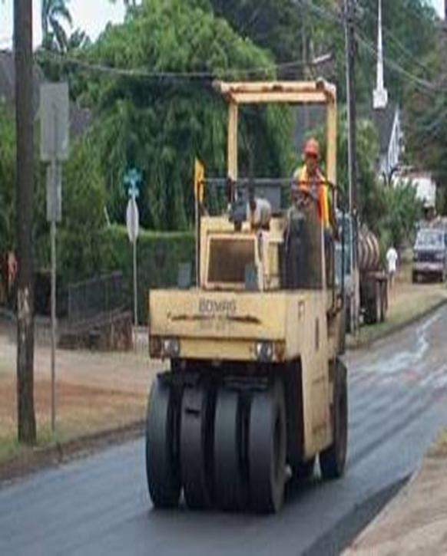
Vibratory Rollers
- Vibratory rollers have become very popular in highway engineering applications in recent years, with the growing need to compact pavement layers and subgrade to a high degree of densification .
- Both cohesive and non cohesive materials can be compacted by vibratory rollers.
- For compacting soils and granular layers , a frequency of 1500-2500 VPM and an amplitude of 0.8-1.5 mm are recommended.
- For bituminous courses , a frequency of 2000-3000 VPM and an amplitude of 0.4-0.8 mm are recommended.
Types of Vibratory rollers
- Combination rollers
Combination of two different types of road rollers.
- Hand Operated vibratory rollers
- Vibratory plate compactors
Applications
- Compacting sand and cohesionless soils
- Compacting all types of soils for obtaining high densities
- Compacting granular bases and sub-bases to obtain high densities
- Compacting bituminous bases and surfaces to obtain high degree of compaction
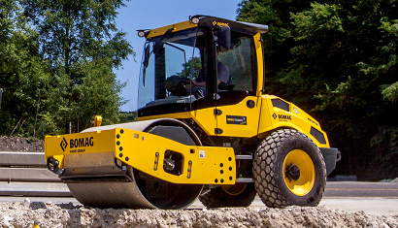
Frog Rammer
- Frog Rammer are used for compacting cohesionless soils and soils in inaccessible and restricted locations where ordinary rollers cannot work. They are worked by pneumatic system or by a diesel engine. The weight varies from 30 kg to one tonne.
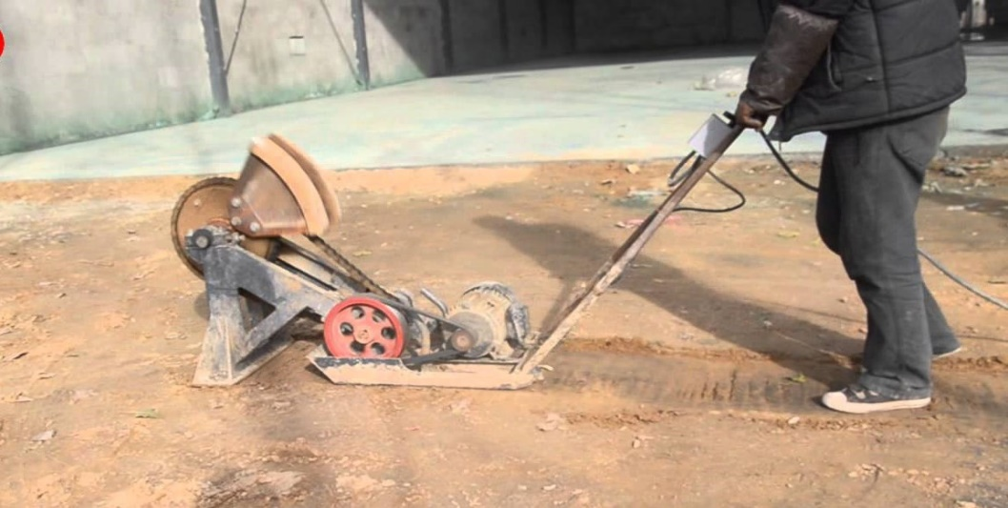

HANDLING EQUIPMENT
Material handling equipment is mechanical equipment used for the movement, storage, control and protection of materials, goods and products throughout the process of manufacturing, distribution, consumption and disposal. The different types of handling equipment can be classified into four major categories transport equipment, positioning equipment, unit load formation equipment, and storage equipment

Conveyors
Conveyors are used when material is to be moved frequently between specific points over a fixed path and when there is a sufficient flow volume to justify the fixed conveyor investment.^{[4]} Different types of conveyors can be characterized by the type of product being handled: unit load or bulk load; the conveyor’s location: in-floor, on-floor, or overhead, and whether or not loads can accumulate on the conveyor. Accumulation allows intermittent movement of each unit of material transported along the conveyor, while all units move simultaneously on conveyors without accumulation capability.^{[5]} For example, while both the roller and flat-belt are unit-load on-floor conveyors, the roller provides accumulation capability while the flat-belt does not; similarly, both the power-and-free and trolley are unit-load overhead conveyors, with the power-and-free designed to include an extra track in order to provide the accumulation capability lacking in the trolley conveyor. Examples of bulk-handling conveyors include the magnetic-belt, troughed-belt, bucket, and screw conveyors. A sortation conveyor system is used for merging, identifying, inducting, and separating products to be conveyed to specific destinations, and typically consists of flat-belt, roller, and chute conveyor segments together with various moveable arms and/or pop-up wheels and chains that deflect, push, or pull products to different destinations.

Cranes
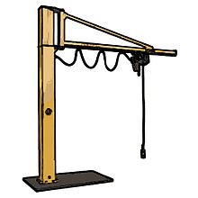
Jib crane
Cranes are used to transport loads over variable (horizontal and vertical) paths within a restricted area and when there is insufficient (or intermittent) flow volume such that the use of a conveyor cannot be justified. Cranes provide more flexibility in movement than conveyors because the loads handled can be more varied with respect to their shape and weight. Cranes provide less flexibility in movement than industrial trucks because they only can operate within a restricted area, though some can operate on a portable base. Most cranes utilize trolley-and-tracks for horizontal movement and hoists for vertical movement, although manipulators can be used if precise positioning of the load is required. The most common cranes include the jib, bridge, gantry, and stacker cranes.

Industrial trucks
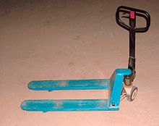
Pallet jack
Industrial trucks are trucks that are not licensed to travel on public roads (commercial trucks are licensed to travel on public roads. Industrial trucks are used to move materials over variable paths and when there is insufficient (or intermittent) flow volume such that the use of a conveyor cannot be justified. They provide more flexibility in movement than conveyors and cranes because there are no restrictions on the area covered, and they provide vertical movement if the truck has lifting capabilities. Different types of industrial trucks can be characterized by whether or not they have forks for handling pallets, provide powered or require manual lifting and travel capabilities, allow the operator to ride on the truck or require that the operator walk with the truck during travel, provide load stacking capability, and whether or not they can operate in narrow aisles.
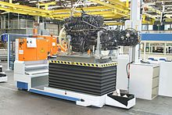
Unit load AGV
Hand trucks (including carts and dollies), the simplest type of industrial truck, cannot transport or stack pallets, is non-powered, and requires the operator to walk. A pallet jack, which cannot stack a pallet, uses front wheels mounted inside the end of forks that extend to the floor as the pallet is only lifted enough to clear the floor for subsequent travel.^{[8]} A counterbalanced lift truck (sometimes referred to as a forklift truck, but other attachments besides forks can be used) can transport and stack pallets and allows the operator to ride on the truck. The weight of the vehicle (and operator) behind the front wheels of truck counterbalances weight of the load (and weight of vehicle beyond front wheels); the front wheels act as a fulcrum or pivot point. Narrow-aisle trucks usually require that the operator stand-up while riding in order to reduce the truck’s turning radius. Reach mechanisms and outrigger arms that straddle and support a load can be used in addition to the just the counterbalance of the truck. On a turret truck, the forks rotate during stacking, eliminating the need for the truck itself to turn in narrow aisles. An order picker allows the operator to be lifted with the load to allow for less-than-pallet-load picking. Automated guided vehicles (AGVs) are industrial trucks that can transport loads without requiring a human operator.
Positioning equipment

Positioning equipment is used to handle material at a single location. It can be used at a workplace to feed, orient, load/unload, or otherwise manipulate materials so that are in the correct position for subsequent handling, machining, transport, or storage. As compared to manual handling, the use of positioning equipment can raise the productivity of each worker when the frequency of handling is high, improve product quality and limit damage to materials and equipment when the item handled is heavy or awkward to hold and damage is likely through human error or inattention, and can reduce fatigue and injuries when the environment is hazardous or inaccessible.^{[9]} In many cases, positioning equipment is required for and can be justified by the ergonomic requirements of a task. Examples of positioning equipment include lift/tilt/turn tables, hoists, balancers, manipulators, and industrial robots. Manipulators act as “muscle multipliers” by counterbalancing the weight of a load so that an operator lifts only a small portion (1%) of the load’s weight, and they fill the gap between hoists and industrial robots: they can be used for a wider range of positioning tasks than hoists and are more flexible than industrial robots due to their use of manual control.^{[10]} They can be powered manually, electrically, or pneumatically, and a manipulator’s end-effector can be equipped with mechanical grippers, vacuum grippers, electromechanical grippers, or other tooling.
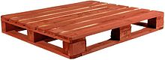
Four-way pallet
Unit load formation equipment is used to restrict materials so that they maintain their integrity when handled a single load during transport and for storage. If materials are self-restraining (e.g., a single part or interlocking parts), then they can be formed into a unit load with no equipment. Examples of unit load formation equipment include pallets, skids, slipsheets, tote pans, bins/baskets, cartons, bags, and crates. A [pallet] is a platform made of wood (the most common), paper, plastic, rubber, or metal with enough clearance beneath its top surface (or face) to enable the insertion of forks for subsequent lifting purposes.^{[11]} A slipsheet is a thick piece of paper, corrugated fiber, or plastic upon which a load is placed and has tabs that can be grabbed by special push/pull lift truck attachments. They are used in place of a pallet to reduce weight and volume, but loading/unloading is slower.

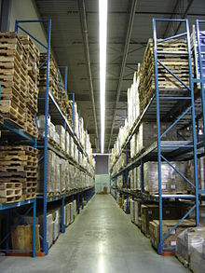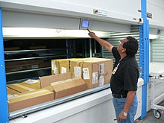
Vertical carousel

Storage equipment is used for holding or buffering materials over a period of time. The design of each type of storage equipment, along with its use in warehouse design, represents a trade-off between minimizing handling costs, by making material easily accessible, and maximizing the utilization of space (or cube).^{[12]} If materials are stacked directly on the floor, then no storage equipment is required, but, on average, each different item in storage will have a stack only half full; to increase cube utilization, storage racks can be used to allow multiple stacks of different items to occupy the same floor space at different levels. The use of racks becomes preferable to floor storage as the number of units per item requiring storage decreases. Similarly, the depth at which units of an item are stored affects cube utilization in proportion to the number of units per item requiring storage.
Pallets can be stored using single- and double-deep racks when the number of units per item is small, while pallet-flow and push-back racks are used when the units per item are mid-range, and floor-storage or drive-in racks are used when the number of units per item is large, with drive-in providing support for pallet loads that cannot be stacked on top of each other. Individual cartons can either be picked from pallet loads or can be stored in carton-flow racks, which are designed to allow first-in, first-out (FIFO) carton access. For individual piece storage, bin shelving, storage drawers, carousels, and A-frames can be used. An automatic storage/retrieval system (AS/RS) is an integrated computer-controlled storage system that combines storage medium, transport mechanism, and controls with various levels of automation for fast and accurate random storage of products and materials.
PAVING EQUIPMENT
A paver (paver finisher, asphalt finisher, paving machine) is a piece of construction equipment used to lay asphalt on roads, bridges, parking lots and other such places. It lays the asphalt flat and provides minor compaction before it is compacted by a roller.

APPLICATIONS OF PAVERS
- Building roads
- Highways
- Ports
- Maintenance of roads
- Parking lot
- Landscaping
- Paving of path etc.

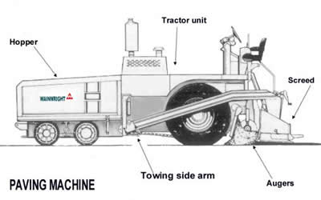

Types of Paver
- Asphalt Crawler Paver
- Asphalt Wheeled Paver
- Concrete Pavers
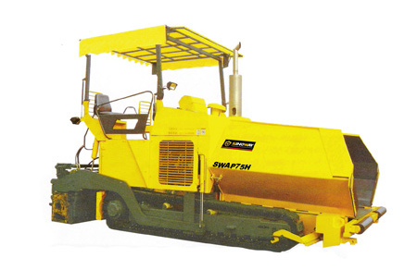
Asphalt Crawler Paver
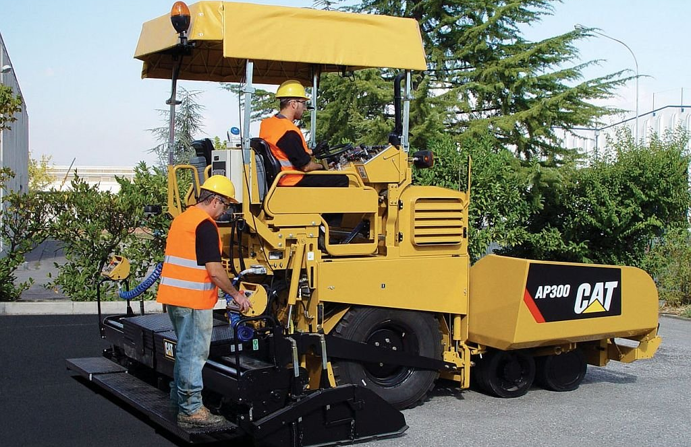
Asphalt Wheeled Paver
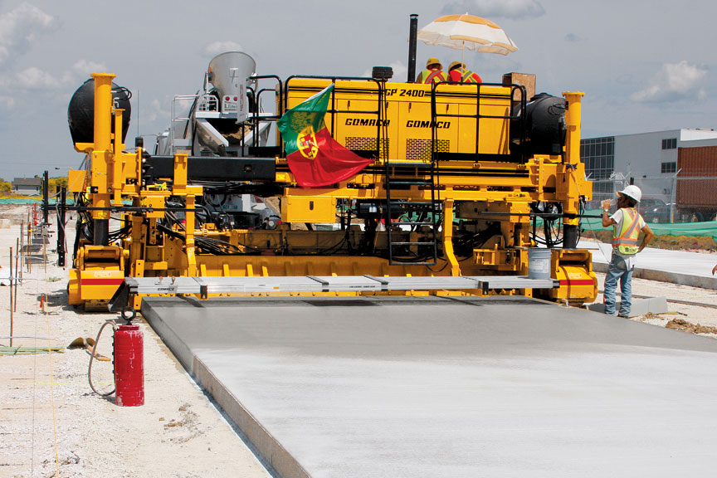

Concrete Pavers

