UNIT I
BASICS OF SURVEYING

Surveying:

Surveying is an art of determining the relative positions of various points on, above or below the surface of the earth by means of direct or indirect measurement of distance, direction and elevation.

Purpose of surveying:

The primary object of surveying is to prepare a plan or map to show the relative position of the objects on the surface of the earth. It is also used to determine the areas, volumes and other related quantities.

Types Of Survey:
- classification based on accuracy desired:
a) Plane surveying:
i) The curvature of the earth is neglected
ii) A line joining any two points is considered straight.
iii) The triangle formed by any three points is considered as plane triangle.
iv) It is done on a area less than 250 sqKm.
b) Geoditic surveying:
i) The curvature of the earth is taken.
ii) A line joining any two points is considered as curved line.
iii) The triangle formed by any three points is considered as spherical triangle.
iv) It is done on a area greater than 250sqKm

- classification based on place of survey:
- land survey
- hydrographic survey
- underground survey
- aerial survey
- classification based on instrument used:
- chain survey
- traverse survey
- levelling
- tacheometry
- plane table surveying
- total station survey
- theodolite syrveying
- Classification of survey based on purpose:
- Geological Survey
- Geographical Survey
- Engineering Survey
- Cadastrial survey
- Defence Survey
- Mine Survey
- Route Survey
- Archaeological Survey

Principles Of Surveying:

(i) Working from whole to part.
(ii) To locate a new station by at least two measurements (angular, linear) from fixed reference points

Various Measurements in Surveying:
- Horizontal Distance: distance measured in horizontal plane
- Horizontal Angle: angle is measured between two points in horizontal plane.
- Vertical distance: vertical distances are measured in the direction of gravity.
- Vertical Angle: vertical angle is measured between two lines in vertical plane.

Plan and Map:

Plan: it is the graphical representation of various features on or near to the earth’s surface such as projected on a Horizontal plane. Plan represents a area on horizontal plane.

Map: In this, the scale of graphical projection or horizontal plane is small. Due to small scales a map depicts a large number of details as compared to plan.

Scale of Map:
A map is made on a sheet of paper which has limited dimensions. On this restricted area, a large number of details have to be shown.
The ratio of distance between two points on map to corresponding distance on ground is called Scale of Map.

Representation of Scale:
- Engineer’s Scale: This scale is represented by a statement like 1 cm= 50 m or 1cm= 180 m etc. A scale of 1 cm= 50 m represents 50m on ground is represented by 1 cm on Map.
- Representative fraction: this scale is expressed in same units. 1 cm= 50 m is represented in RF as 1/5000. Here 5m is converted into 5000cm.
- Graphical Scale: it is the line drawn on a map such that its map distance corresponds to a convenient unit of length on ground.

CHAIN SURVEYING

Methods of linear Measurements:
- Direct method: the direct methods are employed in field using tape or a chain.
- Optical Method: un optical methods, the distances are measured indirectly using the principles of optics.
- Electronic Distance Measurement method: EDM is the most recent development in this field.
Approximate Linear Measurement methods:
- Pacing
- Passometer
- Pedometer
- Odometer
- Measuring wheel
- Speedometer

Chain Surveying:

Chain surveying is the type of surveying in which only linear measurements are made in the
field.

Fundamental principle of chain surveying:

The main principle of chain surveying or chain triangulation is to provide a framework
consist of number of well-conditioned triangles or nearly equilateral triangles. It is used to find the areaof the field.

Well-conditioned triangle:

A triangle is said to be well- conditioned or well proportioned when it contains no anglesmaller than 300 and no angle greater than 1200.The main principle of chain surveying is chaintriangulation. It consists of frame work of triangles. To plot the network of triangles accurately, thetriangles must be nearly equal to equilateral or well-conditioned. The distortion due to errors inmeasurement and plotting should be minimum.

DESCRIPTION OF INSTRUMENTS:-
1 a) Chain:-
The chain is composed of 100 or 150 pieces of galvanized mild steel wire, 4mm in diameter called links .The ends of each link are bent into a loop and connected together by means of three oval rings. The ends of the chain are provided with handles for dragging the chain on the ground, each wire with a swivel joint so that the chain can be turned without twisting. The length of the chain is measured from the outside of one handle to the outside of another handle.

Following are the various types of chain in common use:
1) Metric chains
2) Gunter` s chain or surveyors chain
3) Engineers chain
4) Revenue chain
5) Steel band or Band chain

Metric chain:
Metric chains are made in lengths 20m and 30m. Tallies are fixed at every five-meter length and brass rings are provided at every meter length except where tallies are attached
b) Tapes:
The following are the various types of tapes
i) Cloth tape
ii) Metallic tape
iii) Steel tape
iv) Invar tape
Different Tape corrections:
- Correction for absolute length or standardisation.
- Correction for temperature.
-  Correction for pull or tension.
-  Correction for sag. (- ve)
-  Correction for slope. (- ve)

Among the above, metallic tapes are widely used in surveying. A metallic tape is made of varnished strip of waterproof line interwoven with small brass, copper or bronze wires. These are light in weight and flexible and are made 2m, 5m 10m, 20m, 30m, and 50m.
2. Arrows:
Arrows are made of good quality hardened steel wire of 4 mm diameter. The arrows are made 400 mm in length, are pointed at one and the other end is bent into a loop or circle
3. Ranging rods:
Ranging rods are used to range some intermediate points in the survey line The length of the ranging rod is either 2m or 3m. They are shod at bottom with a heavy iron point. Ranging rods are divided into equal parts 0.2m long and they are painted alternately black and white or red and white or red, white and black. When they are at considerable distance, red and white or white and yellow flags about 25 cm square should be fastened at the top.
4. Cross staff:
The simplest instrument used for setting out a right angle. The common forms of cross staff are:
1. Wooden cross staff
2. French cross staff
3. Adjustable cross staff
4. Open cross staff
5. Offset Rod:
The offset rod is used for measuring the off set of short lengths. It is similar to a ranging rod and is usually of 3m lengths.
6. Pegs:
These are rods made from hard timber and tapered at one end, generally 25mm or 30mm square and 150mm long wooden pegs are used to mark the position of the station on.

PRACTICING UNFOLDING AND FOLDING OF A CHAIN:
UNFOLDING:
- Remove the strap of the folded chain and take both the handles in the left hand and hold the remaining portion of the chain in the right hand.
- Holding both the handles in the left hand, throw the remaining portion o f the chain in the forward direction on the ground.
- Now the follower stands at the starting station by holding one handle and directs the leaderto move forward by holding the other handle until the chain is fully stretched.

FOLDING:
- Bring the two handles together on the ground by pulling the chain at the center.
- Commencing from the center two pairs of links are taken at a time with the right hand and placed alternatively in both directions in the left hand.
- When the chain is completely folded the two brass handles will appear at the top.
- Now tie the chain with leather strap.

Operations involved in chain survey:

(i). Ranging: The process of locating intermediate points on a straight line between two endpoints in a straight line.

(ii). Chaining: The process of measuring the distance with a chain or tape.

(iii). Offsetting: The process of measuring the lateral distance of the object from the survey
line to the left or right according to their positions.

Terminology:

(a).Main stations: Main station is a prominent point on the chain line and can be either at the
beginning of the chain line or at the end or along the boundary.

(b). Main Survey Lines: the line joining the main survey stations are called as survey lines also known as main survey lines.

(c). Subsidiary stations: The stations located on the main survey lines are known as Subsidiary
stations.

(c). Tie stations: These are also subsidiary stations taken on the main survey lines to locate the detailsof the object
.
(d) Check lines: These lines are run to check the accuracy of the traverse consisting of a frame work of tringles. Check lines are measured in the field during the survey process of the land.

Offset:

An offset is the lateral distance of an object or ground feature measured from a survey line.
The two types of offsets are,
(i). Perpendicular offset: The angle of offset from a point on a chain line is 90⁰
(ii). Oblique offset: When the angle of offset is other than 90⁰.

Line Ranger:

The line Ranger is a small reflecting instrument used for fixing intermediate points on thechain lines. Without going to either end, we can fix the intermediate points.

Cross Staff Survey:
This type of survey is used for locating the boundaries of a field which are usually not of regular shape, for the purpose of finding the area of the field.
A base line is selected in the middle of the field and the field area is divided into simple regular figures.
Cross staff is used for setting out the perpendicular/normal to the base line.
The length of the base line and the perpendicular distances are measured with the help of chain/tape.
Cross staff( and also the optical Square) is used for setting out the off sets.
The base line should be so selected that offsets on either side of the base line should nearly be equal. the calculation of areas is usually done in tabular form.

Errors in Chain Surveying:
- Compensating Errors: Which are liable to occur in either direction and tend tocompensate.

- Cumulative Errors: Which occur in the same direction and tend to add or subtract. It may be positive (measured lengths more than the actual length) or negative (measured lengths less than the actual length).

- Personal error: Bad ranging (Cumulative Errors). Careless holding (CompensatingErrors). Bad straightening (Cumulative Errors). Non- horizontality (Cumulative Errors). Sag in chain

- Natural Errors: Variation in temperature

PLANE TABLE SURVEYING
In plane table surveying a table top, similar to drawing board fitted on to a tripod is the main instrument. A drawing sheet is fixed on to the table top, the observations are made to the objects, distances are scaled down and the objects are plotted in the field itself. Since the plotting is made in the field itself, there is no chance of omitting any necessary measurement in this surveying. However the accuracy achieved in this type of surveying is less. Hence this type of surveying is used for filling up details between the survey stations previously fixed by other methods.
- Plane Table Surveying is a graphical method of survey in which the field observations and plotting are done simultaneously.
- It is simple and cheaper than Theodolite survey. It is most suitable for small scale maps.
- The plan is drawn by the surveyor in the field, while the area to be surveyed is before his eyes. Therefore, there is no possibility of omitting the necessary measurements.
- The principle of plane tabling is parallelism means,
- Principle: “All the rays drawn through various details should pass through the survey station.”
- The Position of plane table at each station must be identical, i.e. at each survey station the table must be oriented in the direction of magnetic north.
The most commonly used plane table is shown in Fig. 1. It consists of a well seasoned wooden table top mounted on a tripod. The table top can rotate about vertical axis freely. Whenever necessary table can be clamped in the desired orientation. The table can be levelled by adjusting tripod legs.
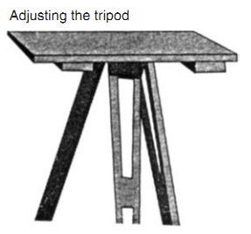

The following accessories are required to carry out plane table survey:
1. Alidade
2. Plumbing fork with plumb bob.
3. Spirit level
4. Trough compass
5. Drawing sheets and accessories for drawing.
1. Alidade
It is a straight edge ruler having some form of sighting device. One edge of the ruler is bevelled and is graduated. Always this edge is used for drawing line of sight. Depending on the type of line of sight there are two types of alidade:
(a) Plain alidade
(b) Telescopic alidade
Plain Alidade: Figure 2 shows a typical plain alidade. A sight vane is provided at each end of the ruler. The vane with narrow slit serves as eye vane and the other with wide slit and having a thin wire at its centre serves as object vane. The two vanes are provided with hinges at the ends of ruler so that when not in use they can be folded on the ruler. Plain alidade is not suitable in surveying hilly areas as the inclination of line of sight in this case is limited.
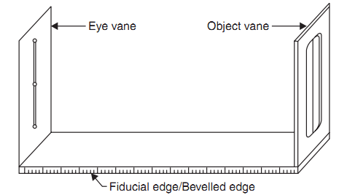
Telescopic Alidade: It consists of a telescope mounted on a column fixed to the ruler [Fig. 3]. The line of sight through the telescope is kept parallel to the bevelled edge of the ruler. The telescope is provided with a level tube and vertical graduation arc. If horizontal sight is required bubble in the level tube is kept at the centre. If inclined sights are required vertical graduation helps in noting the inclination of the line of sight. By providing telescope the range and the accuracy of line of sight is increased.
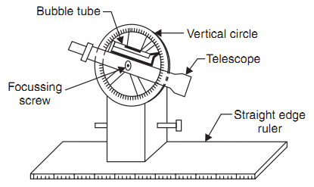

2. Plumbing Fork and Plumb Bob
Figure 4 shows a typical plumbing fork with a plum bob. Plumbing fork is a U-shaped metal frame with a upper horizontal arm and a lower inclined arm. The upper arm is provided with a pointer at the end while the lower arm is provided with a hook to suspend plumb bob. When the plumbing fork is kept on the plane table the vertical line (line of plumb bob) passes through the pointed edge of upper arm. The plumb bob helps in transferring the ground point to the drawing sheet and vice versa also.
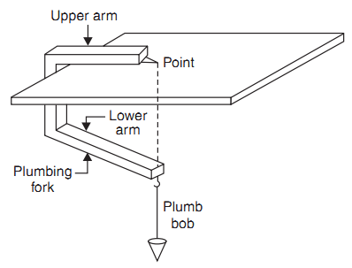

3. Spirit Level
A flat based spirit level is used to level the plane table during surveying (Fig.5). To get perfect level, spirit level should show central position for bubble tube when checked with its positions in any two mutually perpendicular directions.
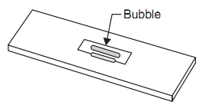

4. Trough Compass
It consists of a 80 to 150 mm long and 30 mm wide box carrying a freely suspended needle at its centre (Ref. Fig. 6). At the ends of the needle graduations are marked on the box to indicate zero to five degrees on either side of the centre. The box is provided with glass top to prevent oscillation of the needle by wind. When needle is centred (reading 0–0), the line of needle is parallel to the edge of the box. Hence marking on the edges in this state indicates magnetic north–south direction.
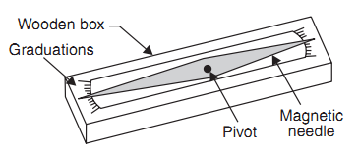
5. Drawing Sheet and Accessories for Drawing
A good quality, seasoned drawing sheet should be used for plane table surveying. The drawing sheet may be rolled when not in use, but should never is folded. For important works fibre glass sheets or paper backed with thin aluminium sheets are used.
Clips clamps, adhesive tapes may be used for fixing drawing sheet to the plane table. Sharp hard pencil, good quality eraser, pencil cutter and sand paper to keep pencil point sharp are other accessories required for the drawing work. If necessary, plastic sheet should be carried to cover the drawing sheet from rain and dust.
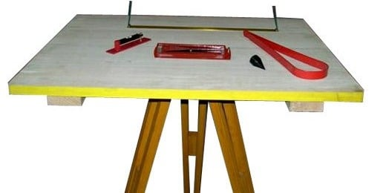
Advantages and Disadvantages of Plane Table Surveying
Advantages
- It is simple and cheaper than the theodolite survey.
- It is most suitable for small scale maps.
- No great skill is required to produce a satisfactory map and work may be entrusted to a subordinate.
- It is useful in magnetic areas where compass may not be used.
- The mistakes in writing field books are eliminated.
- The plan is drawn by the surveyor himself while the area to be surveyed is before his eyes. Therefore, there is no possibility of omitting the necessary measurements.
- The surveyor Can compare the plotted work with the actual features of the area.
Orientation
- The Process by which the positions occupied by the board at various survey stations are kept parallel is known as the orientation. Thus, when a plane table is properly oriented, the lines on the board are parallel to the lines on ground which they represent.
- There are two methods of orientation:
- By magnetic needle
- By back sighting
- By Magnetic Needle
- In this method, the magnetic north is drawn on paper at a particular station. At the next station, the trough compass is placed along the line of magnetic north and the table is turned in such a way that the ends of magnetic needle are opposite to zeros of the scale. The board is then fixed in position by clamps. This method is inaccurate in the since that the results are likely to be affected by the local attraction.
Methods Of Plane Tabling
- There are four distinct methods of plane tabling:
- Method of Radiation
- Method of Intersection
- Method of Traversing
- Method of Resection
- Suppose P is a station on the ground from where the object A, B, C and D are visible.
Radiation Method
- The plane table is set up over the station P. A drawing is fixed on the table, which is then leveled and centered. A point p is selected on the sheet to represent the station P.
- The north line is marked on the right-hand top corner of the sheet with trough compass or circular box compass.
- With the alidade touching p, the ranging rod at A,B, C and D are bisected and the rays are drawn.
- The distances PA, PB, PC and PD are measured and plotted to any suitable scale to obtain the points a, b, c and d representing A,B,C,D on paper.
- 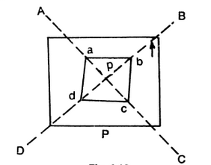
Method Of Intersection
- In intersection method of plane table surveying, the objects or points to be located are obtained at the point of intersection of radial lines drawn from two different stations.
- In this method, the plotting of plane table stations are to be carried out accurately. Checking is important and thus done by taking third sight from another station.
- The intersection method is suitable when distances of objects are large or cannot be measured properly. Thus, this method is preferred in small scale survey and for mountainous regions.

Method Of Traversing
- This method of plane table surveying is used to plot a traverse in cases stations have not been previously plotted by some other methods. In this method, traverse stations are first selected. The stations are plotted by method of radiation by taking back sight on the preceding station and a fore sight to the following station. Here distances are generally measured by tachometric method and surveying work has to be performed with great care.
- Suppose A,B,C,D are the traverse stations,
- The table is set up at the station A, a suitable point a is selected on the sheet in such a way that the whole area may be plotted in the sheet. The table is centered, leveled and clamped. The north line is marked on the right-hand top corner of the sheet.
- With the alidade touching point a the ranging rod at B is bisected and a ray is drawn. The distance AB is measured and plotted to any suitable scale.
- 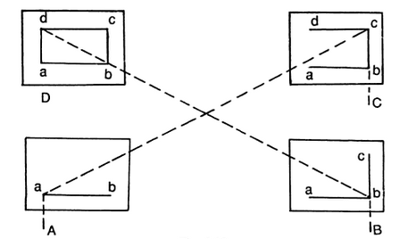
- The table is shifted touching point a the ranging rod at B is bisected and a ray is drawn. The distance is measured and plotted to any suitable scale.
- The table is shifted and centered over B. It is then leveled, oriented by back sighting and clamped.
- With the alidade touching point b, the ranging rod at C is bisected and ray is drawn. The distance BC is measured and plotted to the same scale.
- The table is shifted and set up at C and the same procedure is repeated.
- In this manner, all stations of the traverse are connected.
- Check lines. To check the accuracy of the plane table traverse, a few check lines are taken by sighting back to some preceding station.
- Error of closure . If the traverse to be plotted is a closed traverse, the foresight from the terminating station should pass through the first station. Otherwise the amount by which plotted position of the first station on the foresight fails to close is designated as the error of closure. It is adjusted graphically, if the error is within permissible limits, before any further plotting works are done.
Method of Resection
- Resection is the process of determining the plotted position of the station occupied by the plane table, by means of sights taken towards known points, locations of which have been plotted.
- There are four methods of resection.
- By Compass
- By back sighting
- By two point problem
- By three point problem
- Suppose It is required to establish a station at position P. Let us select two points A and B on the ground. The distance AB is measured and plotted to any suitable scale. The line AB is known as the “base line”
- The table is set up at A. It is leveled, centered and oriented by bisecting the ranging rod at B. The table is then clamped.
- With the alidade touching point a, the ranging rod at P is bisected and a ray is drawn. Then a point P₁ is marked on this way by estimating with the eye.
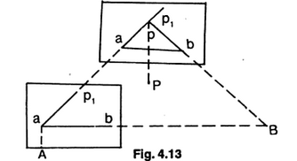
- The table is shifted and centered in such a way that P₁ is just over P. It is then oriented by back-sighting the ranging rod at A.
- With the alidade touching point b, the ranging rod at B is bisected and a ray is drawn. Suppose this ray intersects the previous ray at a point P. This point represents the position of the station P on the sheet. Then the actual position of the station is marked on the ground by U-fork and plumb-bob
By Compass
- This method is used only for small scale or rough mapping.
- Let A and B be two visible stations which have been plotted on the sheet as a and b. Let C be the instrument station to be located on the plan.
- Set the table at C and orient it with compass. Clamp the table.
- Pivoting the alidade about a, draw a ray towards A, as Similarly, pivoting the alidade about b, draw a ray towards B, as bb’, The intersection of aa’ and bb’ will give point c on the paper.

Resection
Resection is a method of plane table surveying in which location of plane table is unknown and it is determined by sighting it to known points or plotted points. It is also called method of orientation and it can be conducted by two field conditions as follows.
- The three-point problem
- The two-point problem

The Three Point Problem
In this condition, three points and their positions in the field are known. Plane table is placed at apposition from where all the three points are visible. So, by sighting those three points we can locate the point where equipment is located. This can be achieved by many methods as follows.
- Tracing method
- Lehmann method
- Analytical methods
- Graphical method

Tracing Method in Plane Table Surveying
In tracing method, plane table is located at a point from where three points are visible. The table is oriented with respect to the plotted lines of those three points. Place the tracing paper on the drawing sheet and again sight the three points and plot the radiating lines. The tracing paper is then moved above the drawing sheet until the three radiating lines pass through corresponding points previously plotted on the map. Finally, the position of plane table is marked.

Lehmann Method
In this method, Plane table is located at a point P and sight the station A, B and C and plot the rays Aa, Bb, and Cc. The rays form small triangle which is called triangle of error. Another point P1 is chosen to reduce the error and sight the point A from P1 similarly to B and C. which will give another triangle of error. Repeat this procedure until error becomes zero.

Analytical Methods
There are many analytical methods are developed in three-point problem condition. In this method, from station P A, B and C are sighted and note the values of angles and lengths. From these values determine the position of unknown points by using analytical formulae.

Graphical Method
In graphical method also, angles and lengths are determined and represented it on a graph and determines the location of plane table.

The Two-Point Problem
In the two-point problem, two points are sighted from other point corresponding to the points given in plane table sheet. Here two cases are to be discussed.
Case 1: when the points can be occupied by the plane table
As shown in fig. A and B are the two points corresponding to the points a and b. Now, plane table is located at B and oriented by sighting A. sight C from B and bx is plotted on the sheet. Then shift the plane table to C, oriented by backsighting B along xb. Then alidade is placed over a and sight station A, then line Aa cuts the line bx at somewhere which is located as point c at station C.
Case2: When the plane table cannot occupy the controlling stations
In this case, an auxiliary point D is considered nearer to C. Locate the plane table at D according to the line ab parallel to AB. Then sight the station A and B corresponding to a and b. the rays drawn are intersected at some point which is marked as d. then sight towards C by placing alidade at d. mark the distance Dc as c1. Shift the table to C and backsight to D with reference to c1.
Then sight A corresponding to a, the ray drawn is intersects the previously drawn ray from D in c2. From c2 sight B draw a ray which intersects db and marked the intersection as b1. The table is oriented till ab comes in line with P. From P sight and draw rays Aa and Ba. The intersection of these two rays will give the Location of Point C

Sources of errors in plane table surveying
1.Instrumental errors

The primary source of instrumental errors in plane table surveying arise from the lack in temporary adjustment. Thus, the causes for instrumental errors are as follows :
(i) Undulated plane table surface : Error in observation as well as plotting will occur if the top surface of the plane table is not perfectly plane.
(ii) Curved or inclined fiducial edge : If the fiducial edge of the alidade is not straight, the rays drawn would not be straight and an error in relative location of object will occur.
(iii) Loose fittings in plane table : If the fittings of the plane table and that of tripod are loose, the plane table will not remain stable and error in surveying will occur.
(iv) Improper magnetic compass: If the magnetic compass is sluggish or does not represent proper magnetic direction, an error in orientation of the plane table will occur, (if it is done with the magnetic compass) and thus basic principle of plane table surveying will get violated.
(v) Non-perpendicularity of the sight vanes : If the sight vanes are not perpendicular to the base of the alidade, there would be an error in sighting.
(vi) Defect in level tube: If the level tube is defective, the plane table will not be horizontal when the bubble is central. The plot thus obtained will be inaccurate.
(vii) Unseasoned, poor quality drawing paper : Poor quality drawing paper gets affected by the weather changes and thus it may expand or contract and changes the scale of plotting. The plot thus obtained will be incorrect

2.Man made errors
(i) Improper leveling of plane table : If the plane table is not properly leveled and made horizontal, the sight vanes will be inclined to the vertical. There would be an error and the points located will not be correct.
(ii) Inaccurate Centring : If the plane table is not accurately centred, the error in plotted position of station will cause error in plotting of all other details from that station.
(iii) Improper orientation : If the plane table is not oriented properly, the fundamental principle of plane table surveying will get violated and thus plotting in general will be inaccurate.
(iv) Improper clamping of plane table : Improperly clamped plane table will disturb its orientation, and thus error due improper orientation will creep into.
(v) Inexact bisection of object : If the object is not sighted accurately or not bisected properly, error in direction of object will occur and thus its plotted position.
(VI) Improper plotting : This may be caused due to any error in measurement of distance or direction of ray, due to error in instruments or error in manipulation or sighting. This will lead to inaccurate map of the survey and thus the objective of surveying will be poorly achieved.
(vii) Instability of tripod stand : If the tripod stand is not set in stable, the whole of surveying and plotting will get disturbed and thus error in surveying and making map.

Practical hints in plane tabling
For GOOD location of details through plane table surveying, following practical hints may be followed:
- The drawing board should be well seasoned and good quality but should be free from glare.
- The tripod stand should be placed in stable condition before fixing the drawing board.
- The level of the plane table should be set up at a height slightly lower than the height of the elbow of the surveyor.
- Time should be spent for centring to achieve accuracy within plotting error or better but not very accurate is required.
- The plotted positions of the stations should be checked before starting any location of details. This is to be done by method of resection to some prominent objects present in the area.
- Orientation of the table better be checked intermittently and verify by method of back sighting.
- To plot the plane table location through three point problem, occupy a position inside the great triangle.
- Sliding of alidade on drawing paper should be avoided. Alidade better be used by lifting its object vane side getting its sight vane side pivoted.
- The portion of the sheet which is not being used at any time may better be kept covered with a waterproof cloth .
- The fiducial edge of the alidade in use should be cleaned intermittently to remove graphite.
- Use hard pencil (such as 4H) to avoid smudging.
- During storage, the plane table board should be stored on edges, This helps in minimizing warp

UNIT II
LEVELLING AND CONTOURING
Levelling (or Leveling) is a branch of surveying, the object of which is: i) to find the elevations of given points with respect to a given or assumed datum, and ii) to establish points at a given or assumed datum. The first operation is required to enable the works to be designed while the second operation is required in the setting out of all kinds of engineering works. Levelling deals with measurements in a vertical plane.
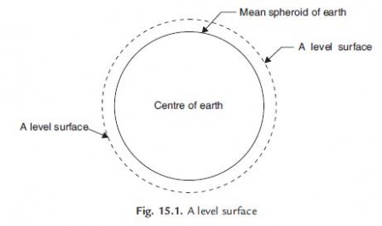

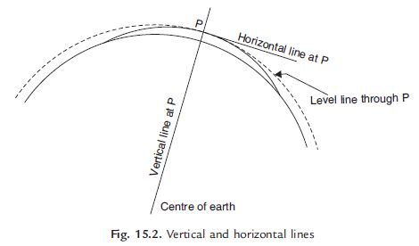

terminology
Level surface: A level surface is defined as a curved surface which at each point is perpendicular to the direction of gravity at the point. The surface of a still water is a truly level surface. Any surface parallel to the mean spheroidal surface of the earth is, therefore, a level surface.
Level line: A level line is a line lying in a level surface. It is, therefore, normal to the plumb line at all points.
Horizontal plane: Horizontal plane through a point is a plane tangential to the level surface at that point. It is, therefore, perpendicular to the plumb line through the point.
Horizontal line: It is a straight line tangential to the level line at a point. It is also perpendicular to the plumb line.
Vertical line: It is a line normal to the level line at a point. It is commonly considered to be the line defined by a plumb line.
Datum: Datum is any surface to which elevation are referred. The mean sea level affords a convenient datum world over, and elevations are commonly given as so much above or below sea level. It is often more convenient, however, to assume some other datum, specially, if only the relative elevation of points are required.
Elevation: The elevation of a point on or near the surface of the earth is its vertical distance above or below an arbitrarily assumed level surface or datum. The difference in elevation between two points is the vertical distance between the two level surface in which the two points lie.
Vertical angle: Vertical angle is an angle between two intersecting lines in a vertical plane. Generally, one of these lines is horizontal.
Mean sea level: MSL is the average height of the sea for all stages of the tides. At any particular place MSL is established by finding the mean sea level (free of tides) after averaging tide heights over a long period of at least 19 years. In India MSL used is that established at Karachi, presently, in Pakistan. In all important surveys this is used as datum.
Reduced Levels (RL): The level of a point taken as height above the datum surface is known as RL of that point.
Bench Mark: It is a relatively permanent point of reference whose elevation with respect to some assumed datum is known. It is used either as a starting point for levelling or as a point upon which to close as a check.
(a)GTSbenchmarks
(b)Permanentbenchmarks
(c) Arbitrary benchmarks and
(d) Temporary benchmarks.
(a) GTS Benchmark: The long form of GTS benchmark is Great Trigonometrical Survey benchmark. These benchmarks are established by national agency. In India, the department of Survey of India is entrusted with such works. GTS benchmarks are established all over the country with highest precision survey, the datum being mean sea level. A bronze plate provided on the top of a concrete pedastal with elevation engraved on it serves as benchmark. It is well protected with masonry structure built around it so that its position is not disturbed by animals or by any unauthorised person.ThepositionofGTS benchmarks are shown in the topo sheets published.
(b) Permanent Benchmark: These are the benchmarks established by state government agencies like PWD. They are established with reference to GTS benchmarks. They are usually on the corner of plinth of public buildings.
(c) Arbitrary Benchmark: In many engineering projects the difference in elevations of neighbouring points is more important than their reduced level with respect to mean sea level. In such cases a relatively permanent point, like plinth of a building or corner of a culvert, are taken as benchmarks, their level assumed arbitrarily such as 100.0 m, 300.0 m, etc.
(d) Temporary Benchmark: This type of benchmark is established at the end of the day’s work, so that the next day work may be continued from that point. Such point should be on a permanent object so that next day it is easily identified.

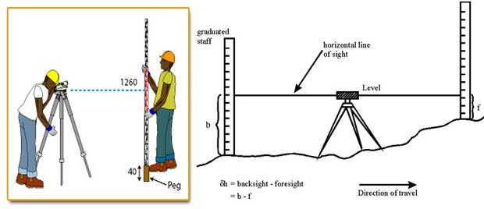

Methods of levelling
Three principle methods are used for determining differences in elevation, namely, barometric levelling, trigonometric levelling and spirit levelling.

Barometric levelling
Barometric levelling makes use of the phenomenon that difference in elevation between two points is proportional to the difference in atmospheric pressures at these points. A barometer, therefore, may be used and the readings observed at different points would yield a measure of the relative elevation of those points.
At a given point, the atmospheric pressure doesn’t remain constant in the course of the day, even in the course of an hour. The method is, therefore, relatively inaccurate and is little used in surveying work except on reconnaissance or exploratory survey.

Trigonometric Levelling (Indirect Levelling)
Trigonometric or Indirect levelling is the process of levelling in which the elevations of points are computed from the vertical angles and horizontal distances measured in the field, just as the length of any side in any triangle can be computed from proper trigonometric relations. In a modified form called stadia levelling, commonly used in mapping, both the difference in elevation and the horizontal distance between the points are directly computed from the measured vertical angles and staff readings.

Spirit Levelling (Direct Levelling)
It is that branch of levelling in which the vertical distances with respect to a horizontal line (perpendicular to the direction of gravity) may be used to determine the relative difference in elevation between two adjacent points. A horizontal plane of sight tangent to level surface at any point is readily established by means of a spirit level or a level vial. In spirit levelling, a spirit level and a sighting device (telescope) are combined and vertical distances are measured by observing on graduated rods placed on the points. The method is also known as direct levelling. It is the most precise method of determining elevations and the one most commonly used by engineers.

Levelling Instruments
The instruments commonly used in direct levelling are:
- A level
- A levelling staff

An engineer's level primarily consists of a telescope mounted upon a level bar which is rigidly fastened to the spindle. Inside the tube of the telescope, there are objective and eye piece lens at the either end of the tube. A diaphragm fitted with cross hairs is present near the eye piece end. A focussing screw is attached with the telescope. A level tube housing a sensitive plate bubble is attached to the telescope (or to the level bar) and parallel to it. The spindle fits into a cone-shaped bearing of the leveling head. The leveling head consists of tribrach and trivet with three foot screws known as leveling screws in between. The trivet is attached to a tripod stand.
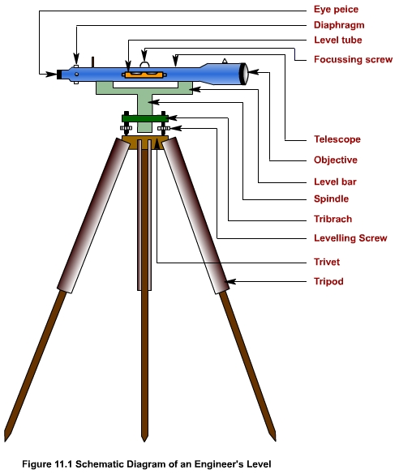

Telescope : used to sight a staff placed at desired station and to read staff reading distinctly.
Diaphragm : holds the cross hairs (fitted with it).
Eye piece : magnifies the image formed in the plane of the diaphragm and thus to read staff during leveling.
Level Tube : used to make the axis of the telescope horizontal and thus the line of sight.
Leveling screws : to adjust instrument (level) so that the line of sight is horizontal for any orientation of the telescope.
Tripod stand : to fix the instrument (level) at a convenient height of an observer

Temporary adjustments
The temporary adjustment of a dumpy level consists of Setting , Leveling and Focusing .
During Setting, the tripod stand is set up at a convenient height having its head horizontal (through eye estimation). The instrument is then fixed on the head by rotating the lower part of the instrument with right hand and holding firmly the upper part with left hand. Before fixing, the leveling screws are required to be brought in between the tribrach and trivet. The bull's eye bubble (circular bubble), if present, is then brought to the centre by adjusting the tripod legs.
Next, Leveling of the instrument is done to make the vertical axis of the instrument truly vertical. It is achieved by carrying out the following steps:
Step 1: The level tube is brought parallel to any two of the foot screws, by rotating the upper part of the instrument.
Step 2: The bubble is brought to the centre of the level tube by rotating both the foot screws either inward or outward. (The bubble moves in the same direction as the left thumb.)
Step 3: The level tube is then brought over the third foot screw again by rotating the upper part of the instrument.
Step 4: The bubble is then again brought to the centre of the level tube by rotating the third foot screw either inward or outward.
Step 5: Repeat Step 1 by rotating the upper part of the instrument in the same quadrant of the circle and then Step 2.
Step 6: Repeat Step 3 by rotating the upper part of the instrument in the same quadrant of the circle and then Step 4.
Step 7: Repeat Steps 5 and 6, till the bubble remains central in both the positions.
Step 8: By rotating the upper part of the instrument through 180 ° , the level tube is brought parallel to first two foot screws in reverse order. The bubble will remain in the centre if the instrument is in

Permanent adjustment.
Focusing is required to be done in order to form image through objective lens at the plane of the diaphragm and to view the clear image of the object through eye-piece. This is being carried out by removing parallax by proper focusing of objective and eye-piece. For focusing the eye-piece, the telescope is first pointed towards the sky. Then the ring of eye-piece is turned either in or out until the cross-hairs are seen sharp and distinct. Focusing of eye-piece depends on the vision of observer and thus required whenever there is a change in observer. For focusing the objective, the telescope is first pointed towards the object. Then, the focusing screw is turned until the image of the object appears clear and sharp and there is no relative movement between the image and the cross-hairs. This is required to be done before taking any observation.
There are three fundamental lines in a level instrument These are
Vertical axis
Axis of the level tube
Line of sight
In a properly adjusted dumpy level, desired relations among fundamental lines are
Axis of the level tube is perpendicular to the Vertical axis
Horizontal cross hair should lie in a plane perpendicular to the Vertical axis, so that it will lie in a Horizontal plane when the instrument is properly leveled.
The Line of sight is parallel to the axis of the level tube.
Also, the optical axis, the axis of the objective lens and the line of sight should coincide.
The fundamental principle of leveling lies in finding out the separation of level lines passing through a point of known elevation (B.M.) and that through an unknown point (whose elevation is required to be determined).
With reference to let X represents a point of known elevation (Hx) or a B.M. and Y be a point whose elevation is required to be determined. To find out the unknown elevation of Y, a level is set up at L in between X and Y. A leveling staff is first held at X and a reading hx is observed, by sighting the staff (held vertical to the line of sight of the level). The staff reading at Y, say hy is then observed. The elevation of the point Y (say Hy) is thus given by Hx + (hx ~ hy) i.e., known elevation (Hx ) added to the separation of level lines (hx ~ hy) passing through the points.
Direct Leveling : Direct measurement, precise, most commonly used; types:
Simple leveling : One set up of level. To find elevation of points.
Differential leveling : Numbers of set-ups of level. To find elevation of non-intervisible points.
Fly leveling : Low precision, to find/check approximate level, generally used during reconnaissance survey.
Precise leveling : Precise form of differential leveling.
Profile leveling : finding of elevation along a line and its cross section.
Reciprocal leveling : Along a river or pond. Two level simultaneously used, one at either end.
Indirect or Trigonometric Leveling : By measuring vertical angles and horizontal distance; Less precise.
Stadia Leveling : Using tacheometric principles.
Barometric Leveling : Based on atmospheric pressure difference; Using altimeter; Very rough estimation.
Principle of levelling
Applied to determine the elevation of point which is some distant apart from B.M i.e., the unknown elevation of a point cannot be determined in a single set up of an instrument. Thus, in this method, instrument gets setup number of times to observe reading along a route in between observed points. For each set up, staff readings are taken back to a point of known elevation (first sight from the B.M and forward to a point of unknown elevation) final sight to the terminal station
Differential Leveling

Applied to determine the elevation of point which is some distant apart from B.M i.e., the unknown elevation of a point cannot be determined in a single set up of an instrument. Thus, in this method, instrument gets setup number of times to observe reading along a route in between observed points. For each set up, staff readings are taken back to a point of known elevation (first sight from the B.M and forward to a point of unknown elevation) final sight to the terminal station.
Reduction of Level

The observed staff readings as noted in a level book are further required to be manipulated to find out the elevation of points. The operation is known as reduction of level. There are two methods for reduction of levels:
Rise and Fall method and
Height of instrument method.
Rise and Fall Method

For the same set up of an instrument, Staff reading is more at a lower point and less for a higher point. Thus, staff readings provide information regarding relative rise and fall of terrain points. This provides the basics behind rise and fall method for finding out elevation of unknown points.
With reference to when the instrument is at I1, the staff reading at A (2.365m) is more than that at S1 which indicates that there is a rise from station A to S1 and accordingly the difference between them (1.130m) is entered under the rise column in . To find the elevation of S1 ( 101.130m), the rise (1.130m) has been added to the elevation of A (100.0m). For instrument set up at I2 , S1 has been treated as a point of known elevation and considered for backsight (having reading 0.685m) . Foresight is taken at S2 and read as 3.570m i.e, S2 is at lower than S1 . Thus, there is a fall from S1 a nd S2 and there difference (2.885m) is entered under the fall column in Table 13.1. To find the elevation of S2 ( 98.245m), the fall (2.885m) has been subtracted from the elevation of S1 (101.130m). In this way, elevation of points are calculated by Rise and Fall method.

Level book note for Rise and Fall method
 | Staff Reading |  | Difference in Elevation |  | Elevation
Points | B.S (m) | F.S.(m) | Rise (m) | Fall (m) | R.L (m) | Remark
A | 2.365 |  |  |  | 100.000 | B.M.
S 1 | 0.685 | 1.235 | 1.130 |  | 101.130 | T.P.1
S2 | 1.745 | 3.570 |  | 2.885 | 98.245 | T.P. 2
B |  | 2.340 |  | 0.595 | 97.650

Height of Instrument Method

In any particular set up of an instrument height of instrument, which is the elevation of the line of sight, is constant. The elevation of unknown points can be obtained by subtracting the staff readings at the desired points from the height of instrument. This is the basic behind the height of instrument method for reduction of level.
With reference to and when the instrument is at, the staff reading observed at A is 2.365m. The elevation of the line of sight i.e., the height of instrument is 102.365m obtained by adding the elevation of A (100.0m) with the staff reading observed at A (2.365m). The elevation of S1 (101.130m) is determined by subtracting its foresight reading (1.235m) from the the height of instrument (102.365m) when the instrument is at I1 . Next, the instrument is set up at I2. S1 is considered as a point of known elevation and backsight reading ( 0.685m) is taken . The height of the instrument (101.815 m) is then calculated by adding backsight reading ( 0.685m) with the elevation (R.L.) of point S1(101.130m). Foresight is taken at S2 and its elevation (98.245m) is determined by subtracting the foresight (3.570m) from the height of the instrument (101.815 m). In this way, elevation of points are calculated by Height of instrument method.
Table 13.2 Level book note for Height of instrument method
 | Staff Reading |  | Height of Instrument (m) | R.L. (m) | Remarks
Points | B.S (m) | F.S.(m) | Height of Instrument (m) | R.L. (m) | Remarks
A | 2.365 |  | 102.365 | 100.000 | B.M.
S 1 | 0.685 | 1.235 | 101.815 | 101.130 | T.P.1
S2 |  | 3.570 |  | 98.245 | T.P.2
B |  | 2.340 |  | 97.650

Example

Ex13-1 Data from a differential leveling have been found in the order of B.S., F.S..... etc. starting with the initial reading on B.M. (elevation 150.485 m) are as follows : 1.205, 1.860, 0.125, 1.915, 0.395, 2.615, 0.880, 1.760, 1.960, 0.920, 2.595, 0.915, 2.255, 0.515, 2.305, 1.170. The final reading closes on B.M.. Put the data in a complete field note form and carry out reduction of level by Rise and Fall method. All units are in meters.
Solution :
B.S. (m) | F.S. (m) | Rise (m) | Fall (m) | Elevation (m) | Remark
1.205 |  |  |  | 150.485 | B.M.
0.125 | 1.860 |  | 0.655 | 149.830
0.395 | 1.915 |  | 1.7290 | 148.040
0.880 | 2.615 |  | 2.220 | 145.820
1.960 | 1.760 |  | 0.880 | 144.940
2.595 | 0.920 | 1.040 |  | 145.980
2.255 | 0.915 | 1.680 |  | 147.660
2.305 | 0.515 | 1.740 |  | 149.450
 | 1.170 | 1.135 |  | 150.535 | B.M.

Arithmetic Check for Reduction of Level

In case of Rise and Fall method for Reduction of level, following arithmetic checks are applied to verify calculations.
 B.S. -  F.S. =  Rise -  Fall = Last R.L. - First R.L.
With reference to Table 13.3:
 B.S. -  F.S. = 4.795 - 7.145 = - 2.350
 Rise -  Fall. = 1.130 - 3.480 = - 2.350
Last R.L. - First R.L.= 97.650 - 100.000 = -2.350
Table 13.3 Field book for Reduction of level
 | Staff Reading (m) |  |  | Difference in elevation (m) |  | H.I (m) | R.L. (m) | Remarks
Points | B.S. | I.S. | F.S. | Rise | Fall | H.I (m) | R.L. (m) | Remarks
A | 2.365 |  |  |  |  | 102.365 | 100.000 | B.M.
S 1 | 0.685 |  | 1.235 | 1.130 |  | 101.815 | 101.130 | T.P.1
S2 | 1.745 |  | 3.570 |  | 2.885 | 99.990 | 98.245 | T.P.2
B |  |  | 2.340 |  | 0.595 | 102.365 | 97.650
 | 4.795 |  | 7.145 |  | 3.480 | 101.815

Example

Ex13-2 Carry out the arithmetic checks for Reduction of level of Ex13-1.
Solution :
B.S. = 11.720 m;
F.S. = 11.670 m
Therefore B.S - F.S. = 0.050 m
Rise = 5.595 m; Fall = 5.545 m
Therefore Rise - Fall = 0.050 m
Last R.L. - First R.L. = 150.535 - 150.485 = 0.050 m.
B.S - F.S. = Rise - Fall = Last R.L. - First R.L.
Level Net

To establish a set of bench marks, each B.M. is also used as a turning point. Elevation of B.Ms are checked by terminating to a previously established bench mark or by returning to the initial bench mark. A line of levels that ends at the point of beginning is known as level net. The final observation in a level net is thus a foresight on the initial B.M. The elevation of each B.M. is to be kept checked within the prescribed limit of error.
Tale 13.4 Permissible limit of error in level net
Order | Class | Limit (mm) | Remark
First | I |  | K is the distance in km
First | II |  | K is the distance in km
Second | I |  | K is the distance in km
Second | II |  | K is the distance in km
Third |  |  | K is the distance in km

Profile Leveling

Profile leveling is a method of surveying that has been carried out along the central line of a track of land on which a linear engineering work is to be constructed/ laid. The operations involved in determining the elevation of ground surface at small spatial interval along a line is called profile leveling. The route along which a profile is run may be single straight line, as in case of a short sidewalk; a broken line, as in the case of a transmission line or sewer; or a series of straight lines connected by curves, as in case of a railroad, highway or canal.
Stations

The line along which the profile is to be run is to be marked on the ground before taking any observation. Stakes are usually set at some regular interval which depends on the topography, accuracy required, nature of work, scale of plotting etc. It is usually taken to be 10 meter. In addition, stakes are placed at locations where marked changes in slope occur; a change in direction occur; at critical points like culverts, bridges and other features crossing the alignment. The beginning station of profile leveling is termed as 0+00. Points at multiples of 100m from this point are termed as full stations. Intermediate points are designated as pluses. For example, a point that is 153.25m from the beginning point of the survey is station 1+53.25 i.e., the point is 53.25m beyond the first full station.
Procedure

In carrying out profile leveling, a level is placed at a convenient location (say I1) not necessarily along the line of observation (Figure 14.1). The instrument is to be positioned in such a way that first backsight can be taken clearly on a B.M. Then, observations are taken at regular intervals (say at 1, 2, 3, 4) along the central line and foresight to a properly selected turning point (say TP1). The instrument is then re-positioned to some other convenient location (say I2). After proper adjustment of the instrument, observations are started from TP1 and then at regular intervals (say at 5, 6 etc) terminating at another turning point, say TP2 . Staff readings are also taken at salient points where marked changes in slope occur, such as that at X.
The distance as well as direction of lines are also measured.

Curvature of the earth:
The earth appears to “fall away” with distance. The curved shape of the earth means that the level surface through the telescope will depart from the horizontal plane through the telescope as the line of sight proceeds to the horizon.
This effect makes actual level rod readings too large by:
C=0.239D²
where D is the sight distance in thousands of feet.
Effects of Curvature are:
Staff reading is too high
Error increases exponentially with distance
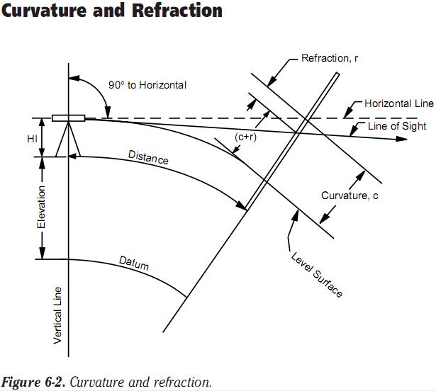
Atmospheric Refraction:
Refraction is largely a function of atmospheric pressure and temperature gradients, which may cause:
the bending to be up or down by extremely variable amounts.
There are basically three types of temperature gradient (dT/dh):
Absorption: occurs mainly at night when the colder ground absorbs heat from the atmosphere.
This causes the atmospheric temperature to increase with distance from the ground and dT/dh > 0.
Emission: occurs mainly during the day when the warmer ground emits heat into the atmosphere, resulting in a negative temperature gradient, i.e. dT/dh < 0.
Equilibrium: no heat transfer takes place (dT/dh = 0) and occurs only briefly in the evening and morning.
The result of dT/dh < 0 is to cause the light ray to be convex to the ground rather than concave as generally shown.
This effect increases the closer to the ground the light ray gets and errors in the region of 5 mm/km have resulted.
The atmosphere refracts the horizontal line of sight downward, making the level rod reading smaller. The typical effect of refraction is equal to about 14% of the effect of earth curvature.
Top of Form
Bottom of Form
Correlations for various distances
Distance | Correction
100' | 0.00021'
200' | 0.00082'
500' | 0.0052'
700' | 0.01'
1 mile | 0.574'

How to eliminate error due to Curvature and Refraction
Proper field procedures (taking shorter shots and balancing shots) can practically reduce errors
Wherever possible, staff readings should be kept at least 0.5 m above the ground,
Using short observation distances (25 m) equalized for backsight and foresight
Air below is denser than air above Air below is denser than air above, Line of sight is bent downward which Negates earth curvature error by 14%.
Simultaneous Reciprocal Trigonometrical Heighting
Observations made at each station at exactly the same time, cancels the effects of curvature and refraction

UNIT III ANGULAR MEASUREMENTS

COMPASS SURVEYING

Compass surveying:

Compass surveying is the type of surveying in which the direction of the survey lines are measured with a compass and the length of the survey lines are measured with a tape or chain in the field.

Meridians:
The direction of a line is expressed in terms of horizontal angle which the line makes with a reference line. The direction of line is generally measured in clock wise direction. The fixed reference line is called as meridian.
Four types of meridians are used in surveying are:
- True meridian
- Magnetic meridian
- Grid meridian
- Arbitrary meridian
Bearing:

The bearing of a horizontal line is the angle which it makes with reference line or meridian. These are the four types of bearings and meridians as described below.

(a). True meridian and bearing:
True meridian:
The line or plane passing through the geographical North Pole, South Pole and any point on the surface of the earth, is known as true meridian or geographical meridian. True meridian at a point is constant.
True bearing:
The angle between the true meridian and a survey line is known as true bearing or Azimuth of the line.

(b). Magnetic meridian and Bearing:
Magnetic meridian:
Magnetic meridian at a point is the direction indicated by freely suspended, properlybalanced and unaffected magnetic needle at that point.
Magnetic Bearing:
The angle between the magnetic meridian and a survey line is known as magnetic bearing
or bearing of the line. It changes with time.

Bearings designation:

1.Whole circle bearing system(WCB):
The magnetic bearing of a line measured clockwise from the north pole towards the line, is known as ‘ whole circle bearing’, of that line.Such a bearing may have any value between 0◦to 360◦ . The whole circle bearing of a line is obtained by a prismatic compass.
2.Quadrantal bearing(QB):
The magnetic bearing of a line measured clock wise or counter clock wise either from north pole or south pole (Whichever is nearer the line) towards east or west ,is known as the ‘quadrantal bearing’ of the line . This system consists of four quadrants NE, SE, SW and NW. The value of a quadrantal bearings lies between 0◦to 90◦, but the quadrants should always be mentioned. Quadrantal bearings are obtained by the surveyor’s compass.
Fore Bearing and Back Bearing:
Fore bearing is the bearing of the line in the direction of progress of survey while Back bearing is the bearing of a line opposite to the direction of progress of survey.
The difference of FB and Bb of a line is always 180⁰ if both the stations are perfectly free from local attractions.

Magnetic Needle:
It is a magnetized iron in the form of long, narrow strip. It is freely suspended at its centre of gravity and takes turn in the horizontal plane and aligns itself parallel to lines of magnetic force of earth at that location of magnetic needle.

COMPASS - TYPES
There are two types of compasses:
1) Prismatic compass
2) Surveyor’s compass.
3) Tubular compass.
4) Trough compass.

Prismatic Compass:
Prismatic compass is very valuable instrument. It is usually used for rough survey for measuring bearing and survey lines. The least count of prismatic compass is 30 min. It consists of circular box of 10cm-12 cm dia. of non magnetic material. pivot is fixed at the centre of box and is made up of hard steel with a Sharp pivot. Graduated aluminium is attached to the needle. It is graduated in clockwise direction from 0⁰ to 360⁰.the figures are written in inverted. Zero Is written at south end and 180 at north end and 270 at the east. Diametrically opposite are fixed to the box. The sighting vane consists of a hinged metal frame in the centre of which is stretched a vertical Horse hair fine silk thread of which is stretched a vertical hair. it presses against a lifting pin which lift the needle of the pivot and holds it against the glass lid. Thus preventing the wear of the pivot point to damp the oscillations of the needle when about to take reading and to bring to rest quickly, a light spring is brought lifted Inside the box. The face of the prism can be folded out the edge of the box when North end is used Sometime the sighting vanes is provided with a hinge mirror Which can be placed upward or downwards on the frame and can be also Slide along it is required. The mirror can be made inclined at any angle so that Objects which are too high or too low can be sighted directly by reflecting.

Temporary Adjustments of a Prismatic Compass
- Fixing the compass to tripod:
The tripod is placed at the required station with its legs well apart. Then the prismatic compass is held by the left hand and placed over the threaded top of the stand. After this, the compass box is turned by clockwise by the right hand. Thus the threaded base of the compass box is fixed with threaded top of the stand.
- Centering:
Normally, the compass is centered by dropping a piece of stone from the bottom of the compass box. Centering may also be done with the aid of plumb bob held centrally the compass box.

- Levelling:
Levelling is done with the help of a ball and socket arrangement provided on top of the tripod stand. This arrangement is loosened and the box is placed in such a way the graduated ring rotates freely without touching either the bottom of the box or the glass cover top.
- Adjustment of prism:
The prism is moved up and down till the figures on the graduated ring are seen sharp and clear.
- Observation of bearing:
After centering and levelling the compass box over the station the ranging rod at the required station is bisected perfectly by sighting through the slit of the prism and horse hair at the sight vane
Prismatic compass versus the surveyor’s compass:

S.No | Characteristic | Surveyor,s compass | Prismatic Compass
1. | Magnetic Needle | Edge bar needle is used and it acts as an index | Board needle is used which is hidden below the aluminum ring. It does not acts as an index.
2 | Graduation | Graduated ring is attached to the box and ring rotates with the box. | Graduated ring is attached to the needle and remains stationary when the box is rotated.
3 | Sighting vanes | Object vane consists of a metal frame with vertical hair. Eye vane also consists of a metal frame with a fine silt | Object vane consists of a metal frame with a vertical hair. Eye vane also consists of a small frame with a fine silt near the prism.
4 | Reading | Sighting and reading are done separately and that too from different positions. After sighting the object, the observer moves around and takes the reading at the north end of the needle. | Sighting and reading are done simultaneously from the same position of the observer.
5 | Support requirement | This cannot be used without a support like tripod etc | This can be held in hand while taking the observation but it is better to use tripod with it.

Magnetic declination:
The horizontal angle which the magnetic meridian makes with the true meridian is called as magnetic declination.
When magnetic north lies towards the west of north, then the declination is said to be negative.
If the magnetic north lies towards the east of true north, then the declination is said to be positive.
Declination varies from place to place and also from time to time at the same place. This variation of declination at different places is studied with the help of isogonic lines which are the lines passing through the points on the earth’s surface having the same declination at a particular time. A special case of isogonic lines is the agonic lines which represents the isogonic lines with zero declination. Thus all the points on agonic lines, the true meridian and the magnetic meridian coincide.

Variations in magnetic Declination:
Magnetic meridian at a place does not remain constant and also does not remain same at all the points on the earth. At a place there are four types of variations in magnetic declination.

Secular Variations:
- The secular variation of declination at a place occurs continuously over a long period of time.
- The lines of equal changes are called as isopars.
- There exists no reliable method of measuring this secular variation.

Annular Variation:
The variation of declination from year to year at a place from the mean position of the year is called as annual variation in declination. The annular variation is independent of secular variation at a place.

Diurnal Variation:
The variation of declination in one day from mean position is called as diurnal variation. This variation depends on locality, season, time and year.

Irregular Variation:
Occurrence of magnetic storms and also the magnetic disturbances cause a change in the earth’s magnetic field, in an irregular manner. Such variations in declinations are quite unpredictable and random. Some of the causes of irregular variation in declination are the earth quakes, volcanic disturbances etc.

True Bearing from the Magnetic Bearing:

If the declination at a place is known, then the true bearing of the survey line can be computed from the magnetic bearing.

When declination is towards east, then
True bearing = Magnetic bearing + Declination

When declination is toward west, then
True bearing = Magnetic bearing - Declination

DIP:
A freely suspended magnetic needle aligns itself parallel to earth’s magnetic field lines i.e., the longitudinal axis of the magnetic needle lies in the plane of magnetic material. The vertical angle which the magnetic needle makes with horizontal is referred to as dip. This dip is zero at equatorand90⁰ at magnetic poles at earth.

Isoclinic lines: these are the lines which join points on earth with same value of dip.
Aclinic lines: these are the special case of isoclinic lines which join points of zero dip.

LOCAL ATTRACTION:

Ideally, the magnetic needle of a compass should again itself along the earth’s magnetic field lines only i.e., magnetic field developed due to earth only.
However, many a times, there are certain magnetic materials present which influence the earth’s magnetic field and magnetic needle aligns itself along the direction of resultant magnetic field and thus needle does not give the direction of earth’s magnetic lines. Some of the magnetic materials are iron articles like rails, chains, arrows etc. and current carrying conductor.
The amount of deviation of magnetic needle is proportional to the amoumt of local attraction present.

Detection of Local Attraction:

The local attraction at a place can be detected by measuring the fore bearing and back bearing of a line at that place. Ideally, the difference of fore and back bearing of a line should be 180º but if it is not, then the place is definitely affected by local attraction.

Plotting a Compass Traverse:

A compass traverse must be plotted only after proper checking of bearings of the traverse lines and after suitable corrections has already been applied. Before commencing the actual plotting work, a rough plot of the traverse to some suitable scale must be plotted to have an idea about the size and the shape of the compass traverse.

The following methods are generally used for plotting a compass traverse:
- Parallel meridian method
- Included angles method
- Method of tangents
- Method of chords
- Rectangular coordinate method
- Paper protractor method

Errors in Compass Surveying:

- Instrumental Errors:
These are the errors are associated with the defects in the instrument itself like:
- The magnetic needle is sluggish
- The needle is not absolutely straight
- The pivot is not at the center of graduated circle
- The pivot is blunt
- The plane of sight is not vertical
- The line of sight does not pass through the center of graduated ring in the prismatic compass
- The graduated ring of the prismatic compass i9s not truly horizontal.

- Sighting errors:
These errors occurs due to sighting and due to wrong manipulations:
- Compass not properly centered on the station
- Compass not properly levelled
- Ranging rod properly bisected at the station
- Ranging rod not properly bisected at the station
- Reading the graduated ring from the wrong direction in the prismatic compass

- Errors due to external errors:
These errors occurs due to external factors like
- Change in the atmospheric magnetism due to storms
- Variation in magnetic declination
- Local attraction due to magnetic items made of iron, nickel or cobalt.

Limits of accuracy:
- The angular error of closure should not be greater than 15 $\sqrt{N}$minutes where N is the number of sides of the traverse. Also the error per bearing should not be greater than 15 minutes.
- The degree of accuracy is defined as
Degree of accuracy =$\frac{linear error of closure}{perimeter of the traverse}$

THEODOLITE
Theodolite is an instrument used for measuring the horizontal and vertical angles in survey works. It is a very important instrument in surveying and can be used in a large number of survey works like measurement of distances, leveling, prolonging a line etc.

Theodolite surveying:
The system of surveying in which the angles are measured with the help of a theodolite, is called Theodolite surveying.

Uses of theodolite:

- Measuring horizontal and vertical angles.
- Locating points on a line.
- Prolonging survey lines.
- Finding difference of level.
- Setting out grades
- Ranging curves
- Tacheometric Survey

Classification of theodolite:

Theodolites may be classified as
A)
  - Transit theodolite
  - Non transit theodolite
B)
- vernier theodolites
- micrometer theodolites

Transit Theodolite: A theodolite is called a transit theodolite when its telescope can be transited
i.e revolved through a complete revolution about its horizontal axis in the vertical plane, whereas in a-
Non-Transit type, the telescope cannot be transited. They are inferior in utility and have now become obsolete.

Vernier Theodolite: For reading the graduated circle if verniers are used ,the theodolite is called as a Vernier Theodolite. Whereas, if a micrometer is provided to read the graduated circle the same is called as a Micrometer Theodolite.

Essential parts of a theodolite
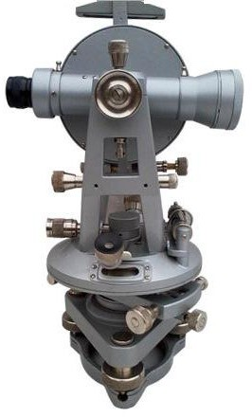

Telescope:
Telescope is an integral part of the theodolite and it is mounted on a spindle known as horizontal axis or trunioun axis. The telescope can be rotated through 180⁰ in the vertical plane. This telescope is internal focusing type with aperture of objective as 38mm. the length of telescope tube varies from 100mm to 175mm.

Vertcical Circle:
The vertical circle is circular graduated arc attached to the truniuon axis of the telescope. The vertical circle is secured tightly to the telescope and moves when the the telescope is rotated about the horizontal axis. The circle is either graduated continuously from 0⁰ to 360⁰ in clock wise direction or it is divided into four quadrants.

Vernier frame:
The vernier frame is also called is T frame or INDEX frame. The vertical leg of this T frame is called as CLIPPING arm and the horizontal arm is called as INDEX ARM. At the two extremities of the index arm fitted two verniers to read the vernier scale. The indexarm is centered on the trunion axis in front of the vertical circle and remains fixed.

Vertical clamp screw:
The vertical circle and hence the telescope can be clamped at any vertical angle by the vertical clamp screw. This prevents the rotation of the telescope about the horizontal axix in the vertical plane. But after clamping the vertical screw, small rotations of the telescope in the vertical plane can be made by means of vertical clamping screw.

Altitude Bubble:
This is the sensitive bubble tube attached at the top of the frame. The sensitivity of altitude bubble tube is 20” per 2mm.

Upper Plate:
The upper plate also called as vernier plate supports the standard at its upper surface, the upper plate is attached to the vertical spindle called as the inner spindle or inner axis. The inner spindle rotates in the outer spindle attached to the lower plate by the upper clamp screw. The upper tangent screw is used for making small movement of the upper plate after tighting the upper clamping screw. After clamping the upper plate, both upper and lower plates move together as one unit.

Lower Plate:
The lower plate is also called as the horizontal circle or the main scale plate.
It is mounted on a hollow tapered spindle also referred to as the outer spindle or the outer center. It is to be noted that the inner surface of the outer spindle acts as bearing for the inner spindle. The outer surface of the outer spindle turns in the bearing in the tribrach of the leveling head.
The lower plate is graduated from 0⁰ to 360⁰ with each graduations at 20’. Each fifth degree is numbered and graduations increased in the clock wise direction. The edge of the horizontal circle is beveled and silvered.
The readings of the horizontal circle are taken by verniers A and B.
The lower plate is provide with lower clamp screw. When the lower clamp is tightened, then the outer spindle is fixed to the tribatch and the lower plate gets fixed in position. Similar to the upper plate when the lower clamp is tightened, the lower plate can be rotated slightly by turning the lower tangent screw.
The diameter of the horizontal circle is between 100mm and 130mm.

Plate Level:
A level tube called as the plate level is provided on the upper plate of the theodolite.
The sensitivity of this plate level is about 35” per 2mm. In certain instruments, there are two level tubes fixed horizontally at right angles to each other.

Leveling Head:
The leveling head consists of two plates which are parallel to each other separated by three leveling screws. The upper parallel plate of the leveling head is called as the TRIBRATCH and the lower parallel plate is called as the TRIVET STAGE or FOOT PLATE. The tribratch supports the outer spindle with the help of tapered bearings. The tribratch consists of three arms each carrying a leveling screw.

Shifting Head:
It is a centering device placed below the lower plate but above the tribratch so as to enable the centering after the instrument has been leveled. It consists of two plates capable of movimg relative to each other.

Magnetic Compass:
A circular type of magnetic compass is generally used. It is mounted on the upper plate between the standards. When the telescope is in the normal position(face left), the letter N of the compass is under the objective end of the telescope and letter S is under the piece end. The magnetic compass indicates zero when the line of sight p[oints towards the north.
The magnetic bearing increases as the telescope turned clock wise. The working of this magnetic compass is very similar to that of surveyor’s compass.

Tripod:
The theodolite is mounted on a tripod when used in the field. The legs of the are either solid or framed. Pointed steel shoes are provided at the lower ends of the tripod legs so that the tripod legs can be pushed inside the ground for fixing purposes.

DEFINITON AND TERMS

Vertical axis:
It is the axis about which the telescope or instrument can be rotated in a horizontal plane. This is the axis about which lower and upper plate rotates.

Horizontal axis:
It is also known as trunion axis. It is the axis about which the telescope can be rotated in a vertical plane.

Line of collination:
It is the imaginary line joining the intersection of the cross hairs of the diaphragm to the optical center of the object glass and its continuation.

Axis of the telescope:
It is the line joining the optical center of the object glass to the center of the eye-piece.

Axis of the level tube:
It is the straight line tangential to the longitudinal curve of the level tube at the center of the tube. The axis of the bubble tube is horizontal when the bubble is central.

Centering:
The process of setting the theodolite exactly over the station mark is known as centering.

Transiting:
It is the process of turning the telescope in vertical plane through 180º about the trunnion axis.

Swinging the telescope:
It means turning the telescope about its vertical axis in the horizontal plane. A swing is called right or left according as the telescope is rotated clockwise or counter clockwise.

Face left:
If face of the vertical circle is to the left side of the observer, then the observation of the angles taken is known as face left observation.

Face right:
If the face of the vertical circle is to the right side of the observation, then the observation of the angles taken is known as face right observation.

Changing face:
It is an operation of bringing the face of the telescope from left to right and vice-versa.

Telescope normal:
A telescope is said to be normal or direct when the face of vertical circle is to the left and the bubble of the telescope up.

Telescope inverted:
A telescope is said to be inverted or reversed when the vertical is to the right and the bubble down.

ADJUSTMENTS:
Permanent Adjustments:

The permanent adjustments are to be done to maintain the required standard relationship between the fundamental lines (axes) of a Theodolite. The fundamental lines are as follows:
- Vertical axis
- Horizontal axis or trunnion axis
- Line of collimation or line of sight
- Axis of plate level
- Axis of altitude level.

Required relations between the fundamental lines:

- The axis of plate level must be perpendicular to the vertical axis.
- The line of collimation must be perpendicular to the horizontal axis
- The horizontal axis must be perpendicular to the vertical axis.
- The axis of the altitude level must be parallel to the line of collimation.
- The vernier reading of vertical circle must read zero when the line of collimation is horizontal.

The permanent adjustments of a Theodolite are:

  - Adjustment of plate level.
  - Adjustment of line of sight
  - Adjustment of horizontal axis
  - Adjustment of altitude bubble and vertical index frame.

Temporary adjustments:
The adjustments which are carried out at every setting of the instrument before the observations are referred as temporary adjustments. There are three types of temporary adjustments as follows.

- Setting up
- Levelling up
- Elimination of parallax.
- Setting up

This adjustment includes the following two operations.
- Centering the Theodolite over the instrument station.
- Approximate leveling of Theodolite with the help of the tripod legs only.

Centering
It is the operation by which the vertical axis of the theodolite represented by a plumb line is made to pass through the mark of instrument station on the ground.

Approximate levelling
The approximate leveling may be done with the reference to a small circular bubble provided on the tribrach or by eye judgements.
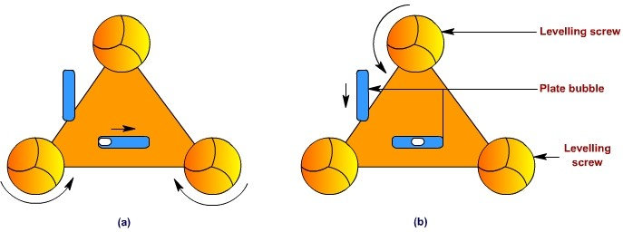

Levelling up
The operation of making the vertical axis truly vertical is known as leveling of the Theodolite. After the centering and approximate leveling an accurate leveling is to be done with the help of foot screws.

  - First the telescope is to be kept parallel to any of the two foot screws as in the figure.
  - The bubble of plate level is to be brought to the centre of its run by turning the foot screws either inwards or outwards simultaneously.
  - Then the telescope is to be turned through 90°, so that it lies over the third foot screw (i.e perpendicular to the first position)
  - The bubble is to be brought to the centre of its run by turning the third foot screw either clockwise or anticlockwise.
- Then the telescope is brought back to its original position (position at (i)) and the position of bubble is checked whether it remains in the center or not.
- If the bubble is not in centre the above operations are repeated till the bubble retain at centre in both the positions.

Elimination of parallax:
An apparent change in the position of an object caused by the change in position of the observer’s eye is known as parallax. This can be eliminated in two steps.

- Focusing the eye piece for distinct vision of the cross hairs.
- Focusing the objective to bring the image of the object in the plane of cross hairs.

Focusing the eye piece

The telescope is to be pointed towards the sky or a sheet of white paper is to be hold in front of the objective.
The eye piece is to be moved in or out by rotating it gradually until the appearance of cross hairs becomes sharp and distinct.

Focusing the objective

Telescope is to be directed towards the object. Focusing screw is to be turned until the appearance of the object becomes sharp and clear.

Measurement of horizontal angles:

- General procedure
- Repetition method
- Re iteration method

General Procedure:
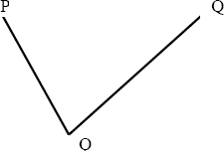

- Set up the instrument at O and level it accurately.
- Release the clamps. Turn the upper and lower plates in opposite direction till the zero of one of the Vernier is against the zero of the scale and the vertical circle is to the left. Clamp both the plates together by upper clamp and lower clamp and bring the two zeros into exact coincidence by turning the upper tangent screw.
- Loose the lower clamp and turn the instrument towards the signal P. since both the plates clamped together, the instrument will rotate about the outer axis. Bisect point P accurately by using lower tangent screw. Check the readings A and B. There shoul be no change in the previous reading.
- Unclamp the upper clamp and rotate the instrument clockwise about the inner axis to bisect point Q. clamp the Upper clamp and bisect Q accurately by using upper tangent screw.
- Read both verniers. The reading of vernier A directly gives the angle POQ directly while the vernier B gives by deducting 180⁰. While entering the reading, the full reading of vernier A should be entered, while only minutes and seconds of the vernier B are entered. The mean of the two such vernier readings gives angle with one face.
- Change the face by transiting the telescope and repeat the whole process. The mean of two vernier readings gives the angle with one face.
- The average horizontal angle is obtained by taking the mean of the two readings with different faces.

REPETITION METHOD:

The method of repetition is used to measure a horizontal angle to a finer degree of accuracy than that obtainable with the least count of the vernier.
By this method, an angle is measured two or more times by allowing the vernier to remain clamped each time at the end of each measurement instead of setting it back to zero when sighting at the previous station. Thus an angle reading is mechanically added several tines depending upon the number of repetitions. The average horizontal angle is then obtained by dividing the final reading by the number of repititions.

- Theodolite is set over an instrument station (O) exactly and all the temporary adjustments are done. Vertical circle is placed left to the observer (face left observation).
- Vernier A is set to Zero with the help of upper clamp screw and tangent screws. Readings of Vernier A and B are noted.
- Upper clamp is clamped. Lower clamp is loosened and the telescope is turned towards “P”. Lower clamp is clamped and the point “P” is bisected exactly using tangent screws.
- Both the vernier A and B are read and noted (Must be equal to 0° and 180° respectively).Upper clamp is unclamped and the telescope is turned clockwise and “Q” is bisected.
- Upper clamp is clamped and “Q” is bisected exactly using tangent screws. Both the verniers are read. Mean of the readings provide an approximate included angle of POQ.
- Unclamp the lower clamp and the turn the telescope clockwise about the inner axis to sight P again

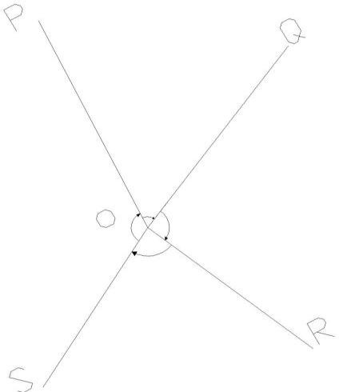
RE ITERATION METHOD:

- Theodolite is set over an instrument station (O) exactly and all the temporary adjustments are done. Vertical circle is placed left to the observer (face left observation).
- Vernier A is set to Zero with the help of upper clamp screw and tangent screws. Readings of Vernier A and B are noted.
- Upper clamp is clamped. Lower clamp is loosened and the telescope is turned towards “P”. lower clamp is clamped and the point“P” is bisected exactly using tangent screws
- Upper clamp is loosened and the telescope is turned clockwise to bisect R.Lower clamp is clamped and R is bisected exactly using tangent screws. Both the verniers are read and noted.
- The same procedure is repeated for all other points.
- The face is changed and all the above steps are repeated. (Face right observations)
- Reading from Q is subtracted by reading R to get included angle QOR. Reading from R is subtracted by reading S to get included angle ROS.
- The same procedure is followed to get readings of all other included angles.

MEASUREMENT OF VERTICAL ANGLES:

A vertical angle is the angle between the inclined line of sight and the horizontal plane through the trunnion axis of the instrument.

Angle of Elevation:

When the line of sight is inclined upwards from the horizontal or trunion axis, it is called as angle of elevation.

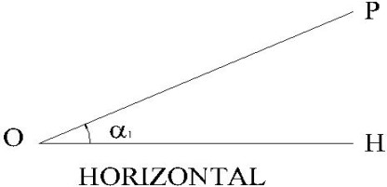

Angle of depression:

When the line of sight is inclined towards from the horizontal or trunion axis, it is called as angle of depression.

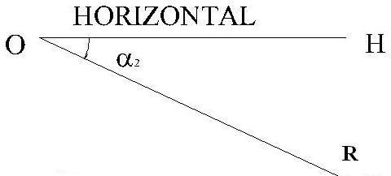

Procedure:

  - Theodolite is set up, centered and leveled with reference to the plate bubble.
  - Telescope is placed horizontally by setting the reading of 0°0’0”in the verniers of C and D.
  - Levelling process is carried out with the help of foot screws and the altitude bubble is brought in its central run.
  - Vertical circle clamp is loosened and the telescope is directed upwards to bisect P.
  - Vertical circle clamp is clamped and the point P is exactly bisected using vertical tangent screws.

  - Both the verniers of C and D are read and noted. Mean of the two verniers provide the vertical angle HOP
  - Face is changed and all the above steps are repeated to get one more vertical angle HOP.
  - Average of the vertical angles taken to get an accurate vertical angle.
  - The same procedure may be adopted to determine the angle of depression HOR by directing the telescope downwards.

Traverse:

TRAVERSE SURVEYING

A traverse consists of a series of straight lines connected successively at established points, along the route of a survey. The points defining the ends of the traverse line are called traverse stations or traverse points. Distances between traverse stations are known as traverse side and are measured either by direct measurement using a Tape or Electronic Distance Measuring (EDM) equipment, or by indirect measurement using tacheometer. At stations where a traverse side changes its direction, relative direction are measured with a transit or theodolite.

There two types of traverses:

- Closed traverse
- Open traverse

Closed Traverse:

When a traverse originates from a known position and also terminates to known position then it is called a closed traverse. (If the origin and terminating points are the same then it is called closed-loop traverse.This type of traverse permits an internal check on the accuracy of angular measurements, provides an indication of the consistency of measuring distances as well as angles. But detection of systematic errors in linear measurement or errors in the orientation of the traverse, is not possible. This type of traverse is recommended for minor projects). A closed traverse that originates from a known point and terminates to another known point.is the most reliable. This type of traverse henceforth called as open looped close traverse provides computational checks allowing detection of systematic errors in both distance and direction and, therefore, preferred to all other types of traverse.
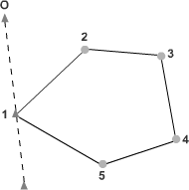

Open Traverse:

An open traverse originates from a point whose position may be known or unknown but terminates to a point whose position is not known. In this type of traverse, computational check is not possible to detect error or blunder in distances or directions. To minimize error, repeated observations for measurements need to be taken. consider a traverse ABCDE that originates from the point A which may be unknown or may be defined with reference to known point P lying on the line PQ of known azimuth, but it terminates to an unknown point E. Thus, traverse ABCDE is an open traverse. An open traverse is generally used for exploratory purpose such as mine surveying. It should generally not be used in civil engineering works unless situation dictates. So no further discussion on this will be done.
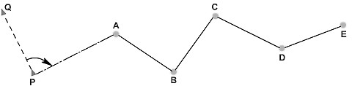

Plotting a survey:

The accuracy of a survey depends upon the accuracy with which its control points are plotted. The traverse stations, which are the control points, can be plotted either by the angle and distance method or by the coordinate method.

Angle distance method;

In this method, distances between the stations are laid off to scale and angles or bearings are plotted. Thus, the traverse stations are plotted with reference to the previous station. Therefore, the accuracy of the location of each station on the plan evidently depends upon the accuracy with which previous points are plotted. Even if there is a slight error in plotting, the error gets accumulated and the position of the last station may be displaced to a considerable distance from its true position. So, this method is used for plotting of small traverse or for traverse of low accuracy.

Coordinate method:

The independent coordinates of horizontal control points are required in the state plane coordinate system for preparation of topographic map. So, data from field surveying are used to

calculate and adjusted in the office, correct within specified limits, and made available for direct plotting by the coordinate method. This plotting can be performed with high precision, since all measurements are linear distances measured from orthogonal axes. In order to plot by the coordinate method, a series of grid lines are drawn on the base sheet for the map using a gratitude.

These grid lines are sets of X and Y axes of orthogonal coordinate systems. In the state plane coordinate system (and in most other coordinate systems), the Y grid axis is aligned toward North. These grid lines are spaced at some regular, uniform interval say, 50, 100, 200, 500 or 1000 m suitable for the scale of the map being compiled. When drawing the grid lines, extreme care must be exercised to ensure that the lines are straight and of uniform weight and that the X grid lines are perpendicular to the Y grid lines. Each X and Y grid line is labelled at the edges of the map sheet with its coordinate value. Grid lines should be drawn as quickly as possible on stable-base material under uniform temperature conditions so that all measurements are consistent. The positions of the control points are then plotted by laying off the differences between the coordinates for the point and the coordinates of a pair of intersecting grid lines close to the control point.

The grid lines are retained on the finished drawing or map or at the very least, the grid tick intersections are left. These grid lines or grid intersection points are invaluable for scaling the coordinates of points on the map. They can also be useful to evaluate dimensional changes in the map-base material and allow more realistic scaling of distances and locations from a given map sheet.

The advantages of plotting horizontal control by rectangular coordinates are as follows:

(1) adjusted coordinates are used to plot the locations so it is known that the data are correct to within the closure of the control survey network;

2) each point is plotted independently so that there is no accumulation of error;

- high precision and uniform accuracy can be maintained on large map sheets and when multiple map sheets are required; and

- the method is very adaptable to automatic plotting routines and is compatible with modern data-storage procedure.

Traverse computations:

Traverse surveying in the field yields observed angles or directions and length of the traverse sides. Thus, these parameters are used in traverse computations which are performed in a plane rectangular coordinate system. The traverse computations involve calculation of consecutive coordinates of traverse stations, checking in error of closure, determination of the amount of closing error, adjustment of traverse by balancing of consecutive coordinates,

calculation of independent coordinates and determination of corrected distances and azimuth of sides.

Consecutive coordinates:

Consecutive coordinates of a station is designated by its departure and latitude from its previous station as origin. Departure of a traverse side is defined as its component perpendicular to the reference meridian and the component of the traverse side along or parallel to the reference meridian is known as latitude. Thus, if l and q are the length and azimuth of a traverse side, then departure and latitude of the side are given by l sin q and l cosine q respectively. The algebraic sign of the departure and latitude of a traverse side depends on its azimuth value thus on the sign of the trigonometric parameters associated with these. the sides AB has length and bearing as 442.56m and 34° 52' respectively. Thus, its departure and latitude are 253.0m (442.56m sine 34° 52') and 363.11m (442.56 cosine 34° 52') respectively. Similarly, the departure and latitude of the sides BC (478.23m, 112°) is 441.93m and 182.75m respectively.
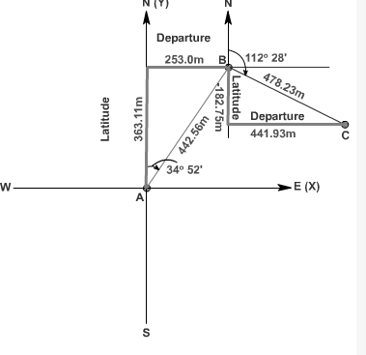

Independent coordinates:

The departure and latitude of a station with reference to an origin are known as independent coordinates. The independent coorinate of at least one of the stations with reference to the considered origin is required to be known a priori. Thus, if the independent coordinates of

any station, say i, is known to be (X_{i}, Y_{i}), the independent coordinates of another station say j, (X_{j} , Y_{j}) can be determined by using the following relations:

X_{j} = X_{i} + x_{ij} Y_{j} = Y_{i} + y_{ij}
Where ( x_{ij}, y_{ij}) are the departure and latitude of the side ij.

Adjustment of a traverse:

Traverse adjustment is required to provide a mathematically closed figure by making closure in latitudes as well as closed departures. Methods for adjustment of traverse are classified into two types: approximate methods and rigorous methods.

The approximate methods for traverse adjustment are based on the conditions prevailing in the combinations of linear and angular precision in the observations. On these basis, conditions are divided into three types.

- Precision in angular measurement is higher than in linear measurement;
- Precision in angular as well as in linear measurements are same;
- Precision in linear measurement is more than that in angular measurement.

The method of least square provides the most rigorous method of traverse adjustment, which allows variation in precision in the observations, minimizes random variations in the observations, provides the best estimates for positions of all traverse stations, and yields statistics relative to the accuracies of adjusted observations and positions. This method does require more of a computational effort than the approximate adjustment. But, the results are well worth effort. However, the method is beyond the scope of discussion of this course and further discussion on adjustment of traverse are based on approximate methods.

The following are the different methods for adjusting a traverse:

  - Bowdith method
  - Transit method
  - Axis rule
  - Graphical method

Transit Method:

This method is developed for balancing a traverse in which angles are measured with a higher degree of precision than the lengths of the sides. It is based on the assumption that the error in

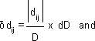
departure (or latitude) of a traverse side is proportional to its departure (or latitude). Thus, according to the transit rule, the corrections to the departure (or latitude) of a traverse side can be calculated by using

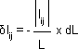
-

--

where

d_{ij} = Correction in departure of a traverse side ij l_{ij} = Correction in latitude of a traverse side ij
dD = total error in departure (or Algebric sum of the departures of all sides of the traverse) dL = total error in latitude (or Algebric sum of the latitudes of all sides of the traverse)
d_{ij} = departure of the traverse side ij l_{ij} = latitude of the traverse side ij
D = Arithmetic sum of the departures of all the sides of the traverse L = Arithmetic sum of the latitudes of all the sides of the traverse
The corrections in transit rule do not take into consideration of the algebraic nature of the eparture (or latitude) of traverse sides. This made the transit rule valid when the traverse lines are parallel with the grid system used for the traverse computations. So, further discussion regarding transit rule is being restricted in this course work.

Bowditch method:

The Bowditch's method is used when both the linear and angular measurements are compatible to each other, i.e., they are of equal precision. The corrections may be applied either analytically or may be carried out graphically. This method of balancing of traverse is widely prevalent and most commonly used.

Analytical method of correction by Bowditch's rule can be applied either to its coordinates directly or to the departure (or latitude) of a traverse side.

- The corrections to the coordinates can be calculated by using

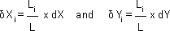

where

δ X_{i} = Correction to X_{i} coordinates of a station i;

δ Y_{i} = Correction to Y_{i} coordinates of a station i;

dX = total closure correction of the traverse in departure; dY = total closure correction of the traverse in latitude;
L_{i} = distance from the initial station to the station i, measured along the sides of the traverse; L = perimeter of the traverse

Graphical method:

For rough surveys or traverse of small area, adjustment can also be carried out graphically. In this method of balancing, the locations and thus the coordinates of the stations are adjusted directly. Thus, the amount of correction at any station is proportional to its distance from the initial station .

Let P_{o} Q_{o} R_{o} S_{o} T_{o} P' is the graphical plot of a closed-loop traverse PQRSTP. The observed length and direction of traverse sides are such that it fails to get balanced and is depicted in its graphical presentation by an amount P_{o} P'. Thus, the closing error of the traverse is P_{o} P' The error P_{o} P' is to be distributed to all the sides of the traverse in such a way that the traverse gets closed i.e., P' gets coincides with P_{o} in its plot. This is carried out by shifting the positions of the station graphically. In order to obtain the length and direction of shifting of the plotted position of stations, first a straight line is required to be drawn, at some scale, representing the perimeter of the plotted traverse. In this case, a horizontal line P_{o}P' is drawn Mark the traverse stations on this line such as Q_{o}, R_{o}, S_{o} and T_{o} in such a way that distance between them represent the length of the traverse sides at the chosen scale. At the terminating end of the line i.e., at P', a line P' P a is drawn parallel to the correction for closure and length equal to the amount of error as depicted in the plot of traverse. Now, join P_{o} to P_{a} and draw lines parallel to P' P_{a} at points Q_{o}, R_{o}, S_{o} and T_{o}. The length and direction of Q_{o} Q_{a}, R_{o} R_{a}, S_{o} S_{a} and T_{o} T_{a} represent the length and direction of errors at Q_{o}, R_{o}, S_{o} and T_{o} respectively. So, shifting equal to Q_{o} Q_{a} , R_{o} R_{a}, S_{o} S_{a} and T_{o} T_{a} and in the same direction are applied as correction to the positions of stations Q_{o}, R_{o}, S_{o} and T_{o}respectively. These shifting provide the corrected positions of the stations as to Q_{a}, R_{a}, S_{a},T_{a} and P_{a}. Joining these corrected positions of the stations provide the adjusted traverse P_{a} Q_{a} R_{a}, S_{a} T_{a} .

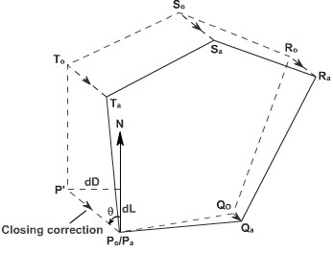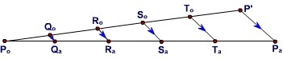

Omitted measurements:

If the length and/or bearing of any side of a closed traverse gets omitted, that can be computed analytically by applying.

S departures = (X_{n} - X₁) S latitudes = (Y_{n} - Y₁)
where (X₁ ,Y₁) and (X_{n} ,Y_{n}) are the independent coordinates of initial and terminating control stations. Thus, in any traverse, maximum two omitted parameters can be computed from two available equations. However, no check on the accuracy of the field work can be done nor can the traverse be balanced as errors, if any, present in the survey work get propagated into the computed values of the omitted quantities. So, computation of omitted measurement, if any, is done for during computation of traverses of lower order.

Types of Omitted Measurements:

The number of omitted measurement may be one i.e., the length or bearing of any side of a traverse.

  - Length and bearing of one side omitted
  - Length of one side and bearing of adjacent side omitted.

  - Lengths of two adjacent sides are omitted
  - Bearings of two adjacent sides are omitted.
  - Length or bearings of two sides or omitted(which are not adjacent to each other)

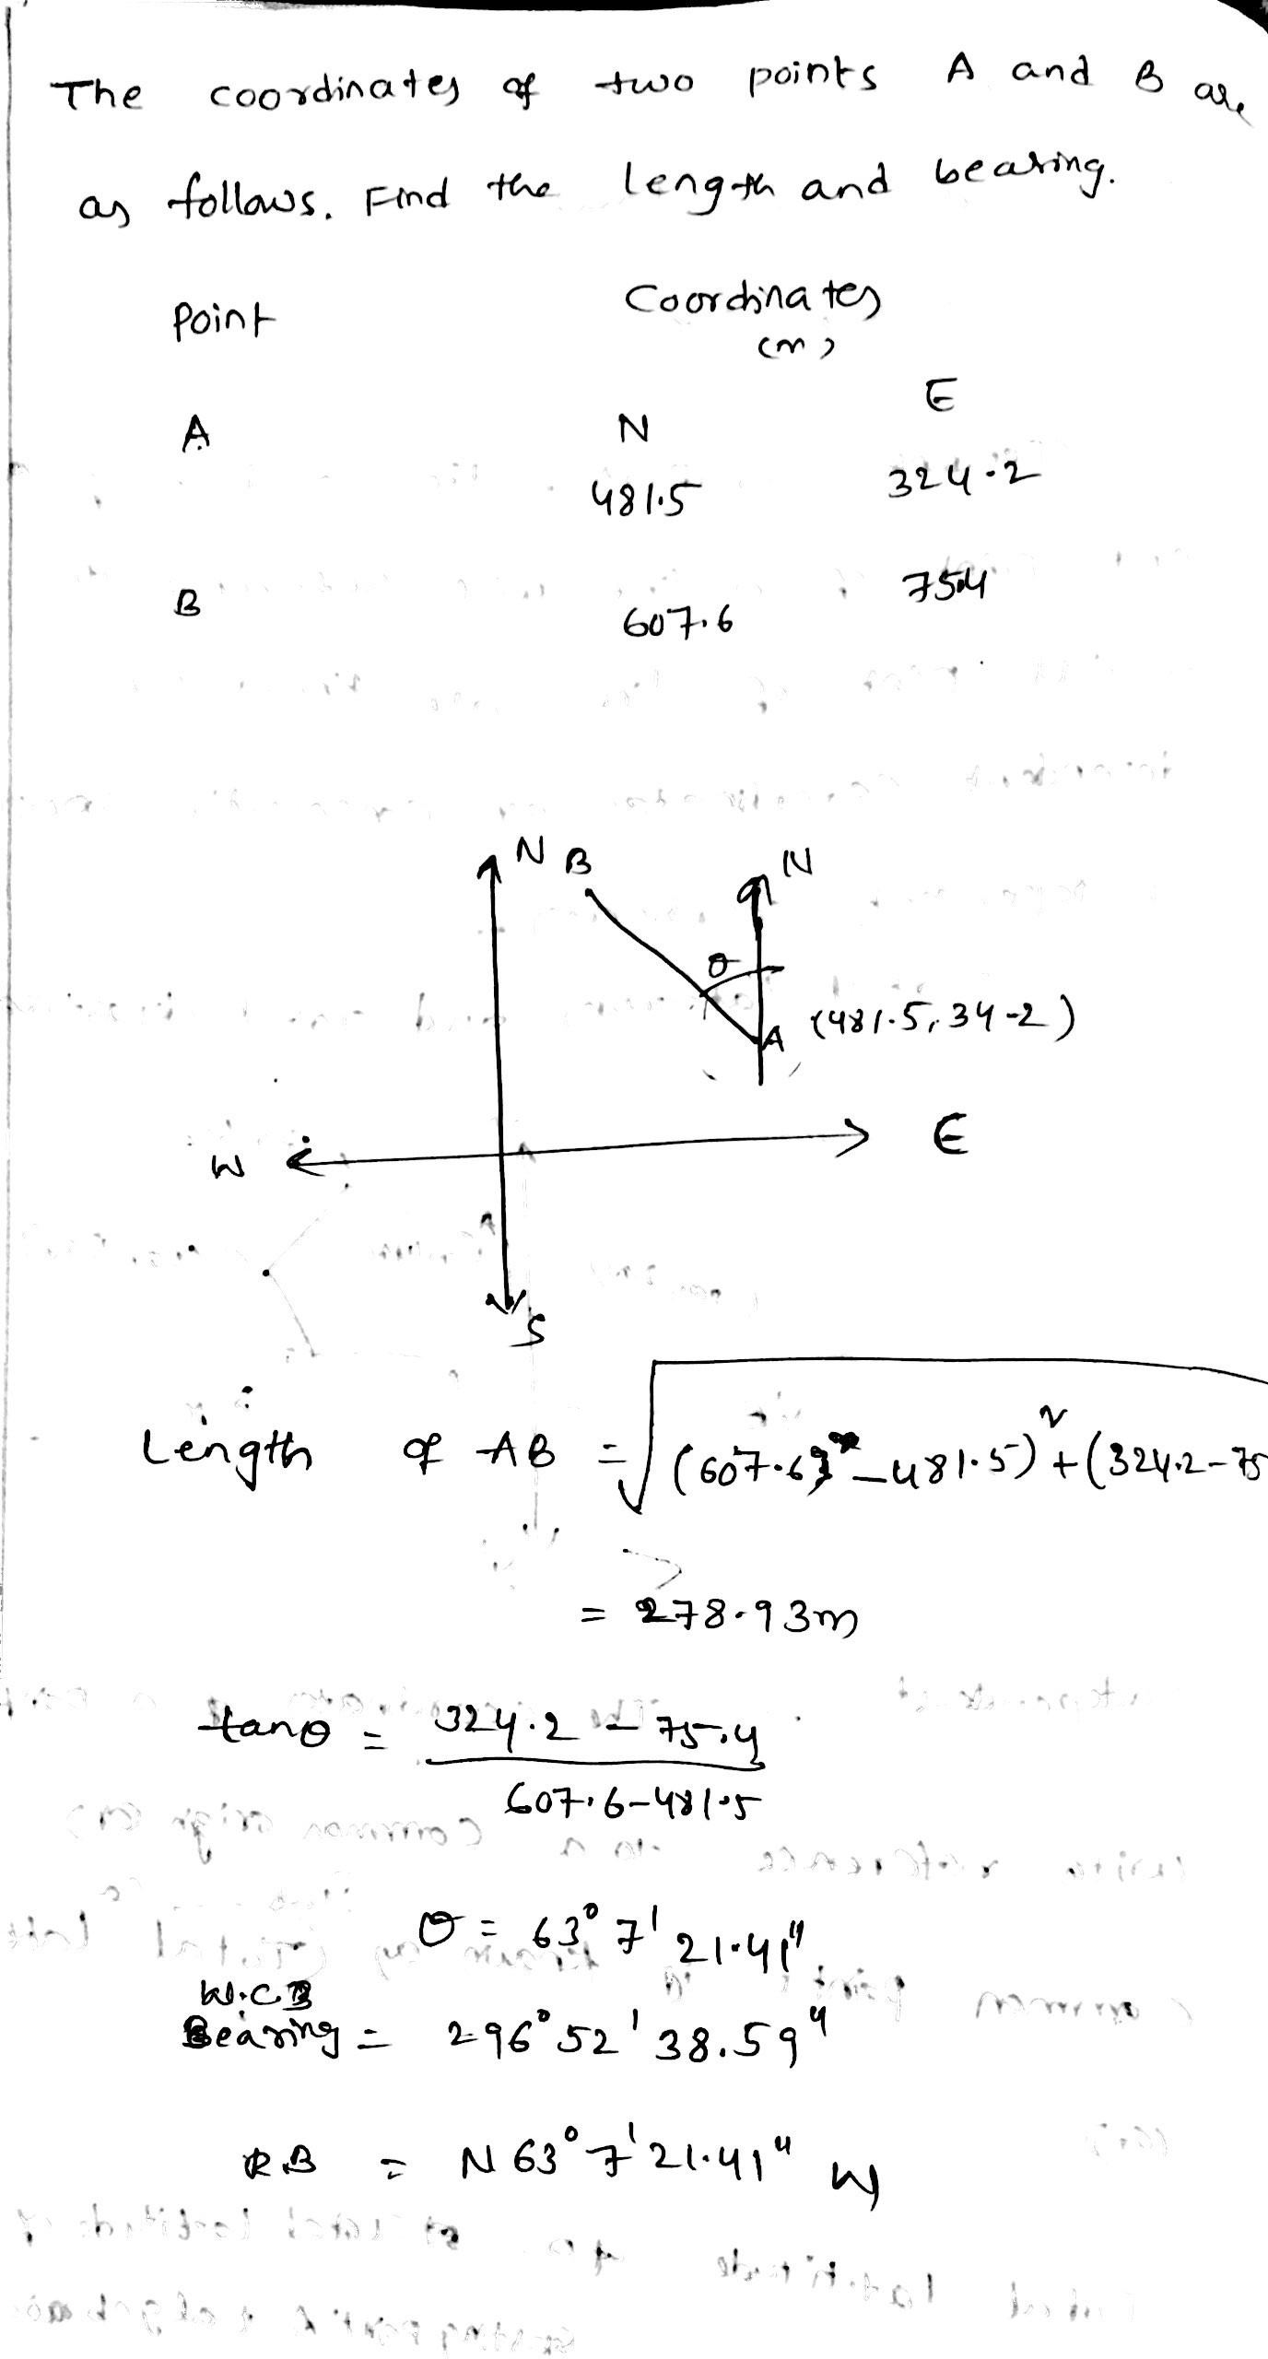

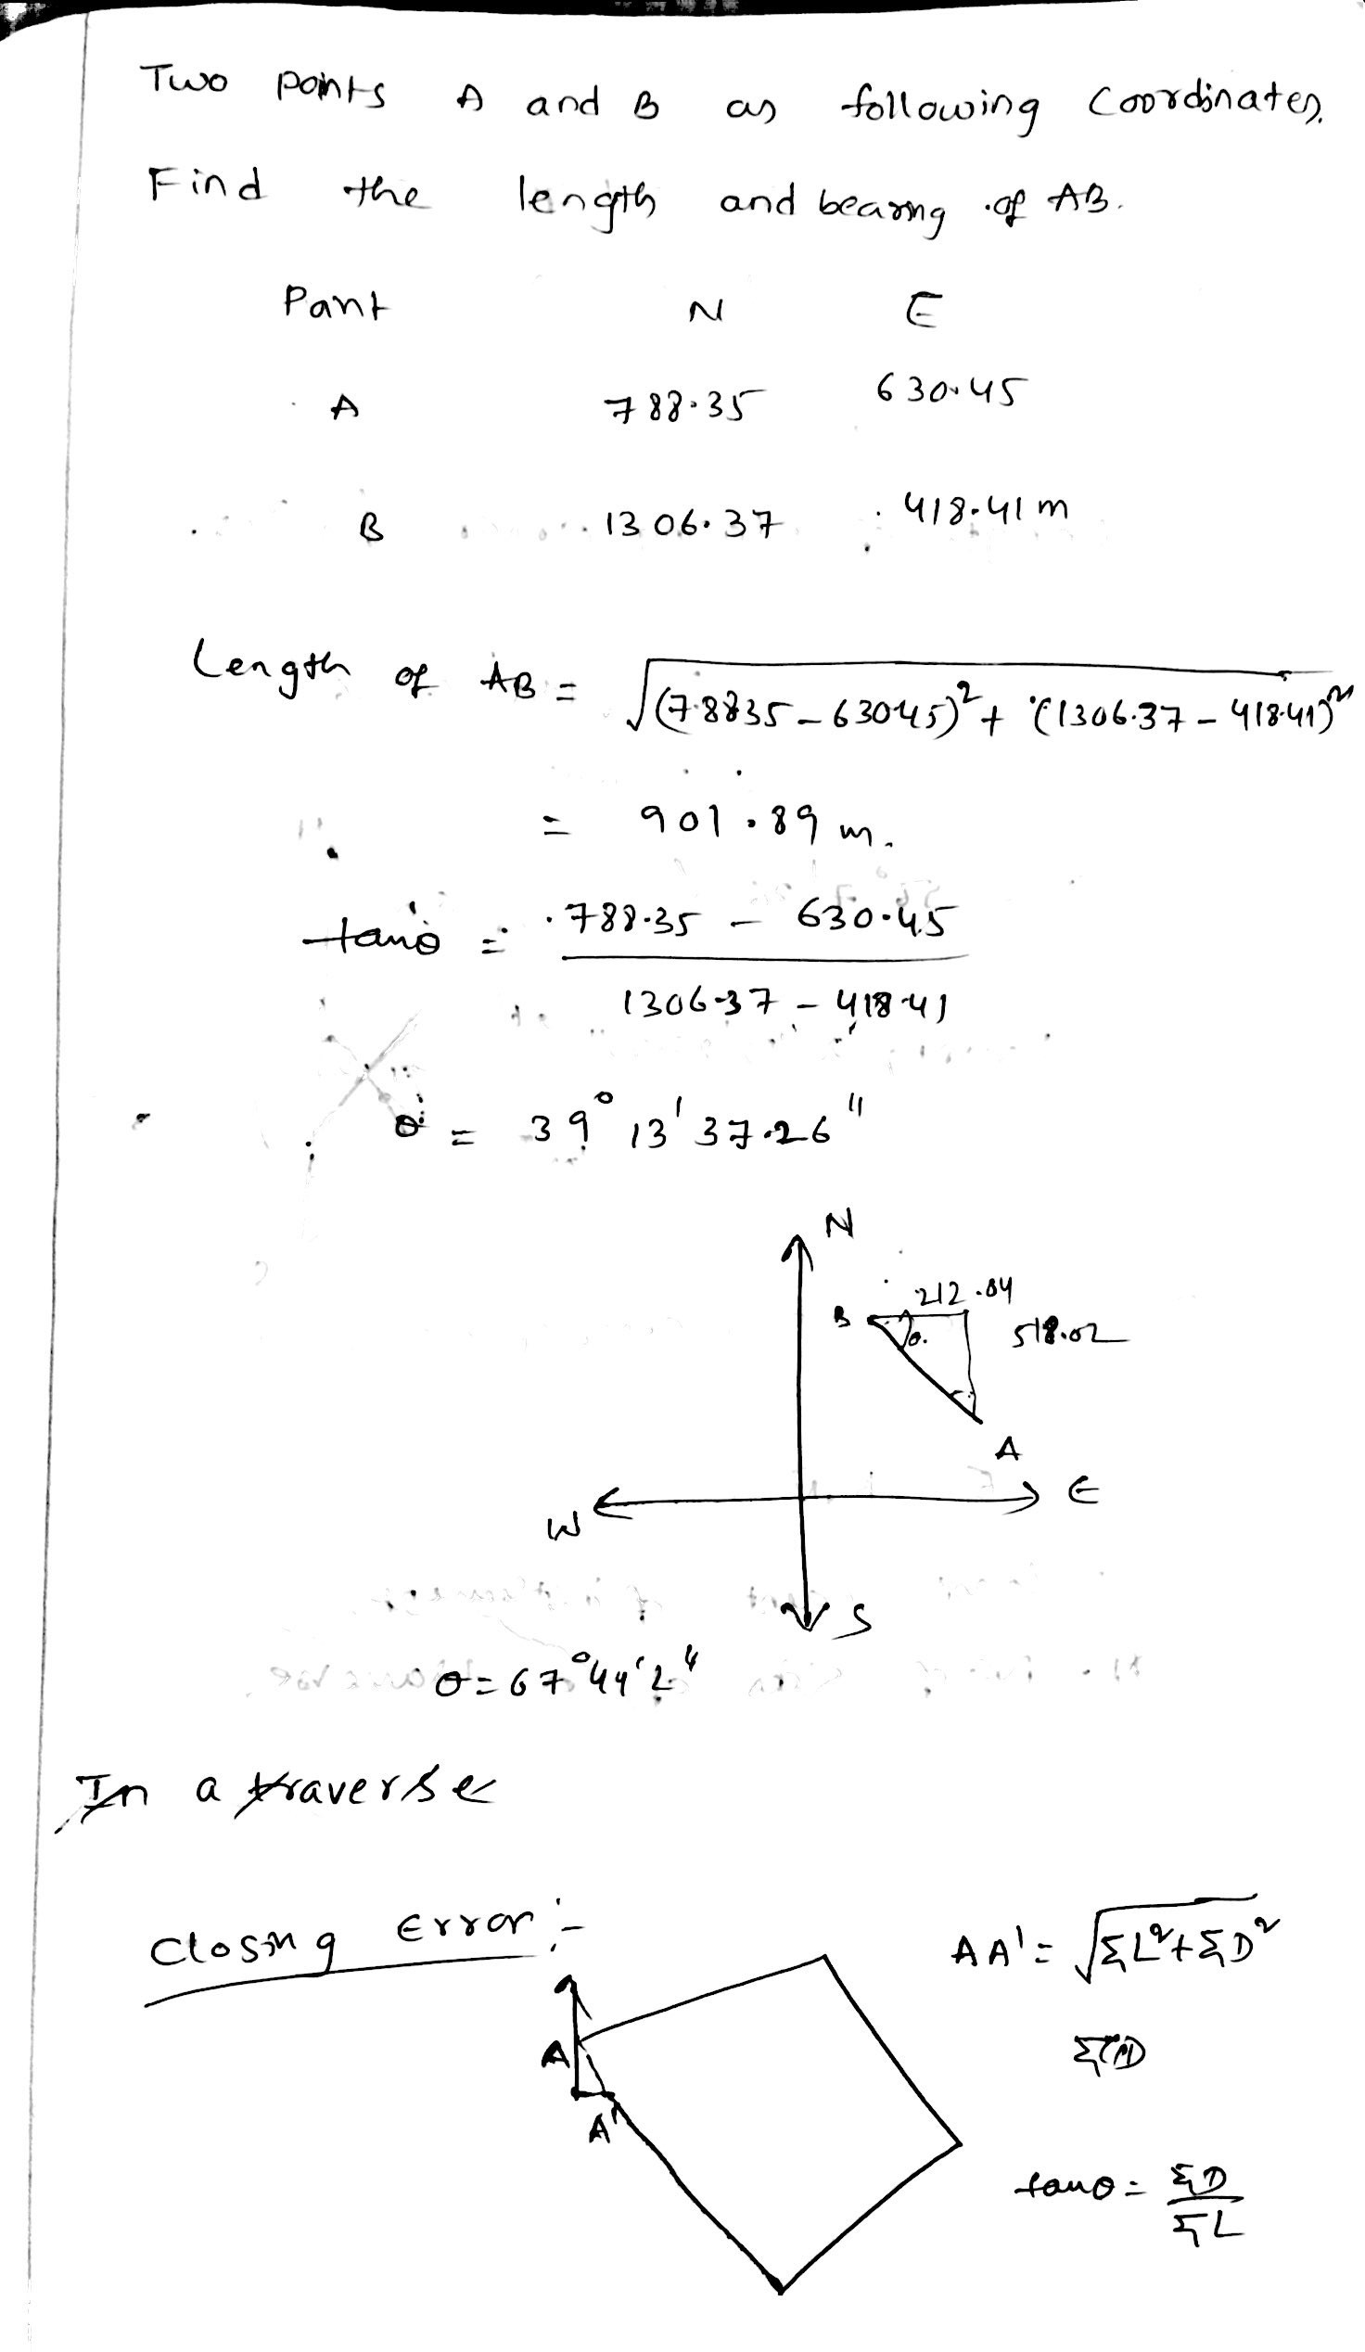

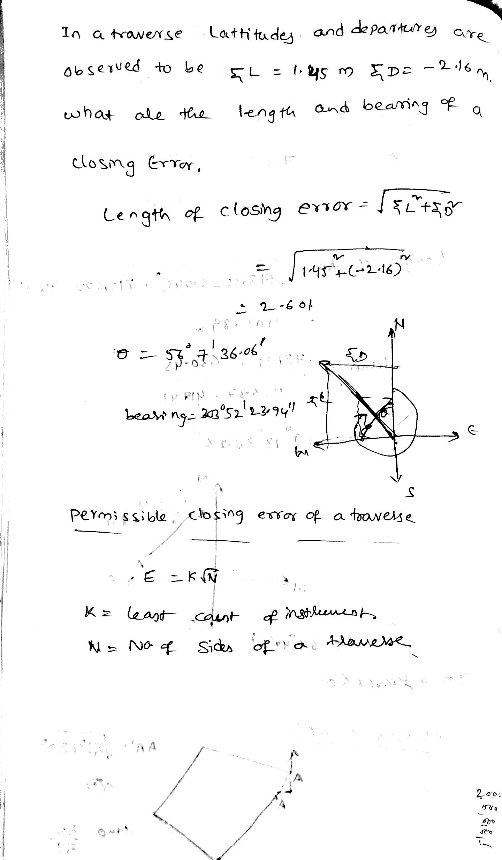

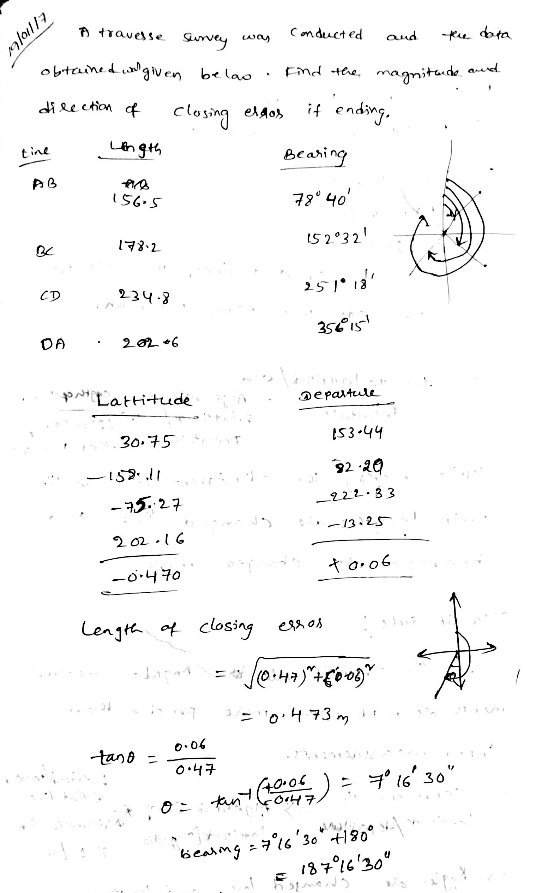

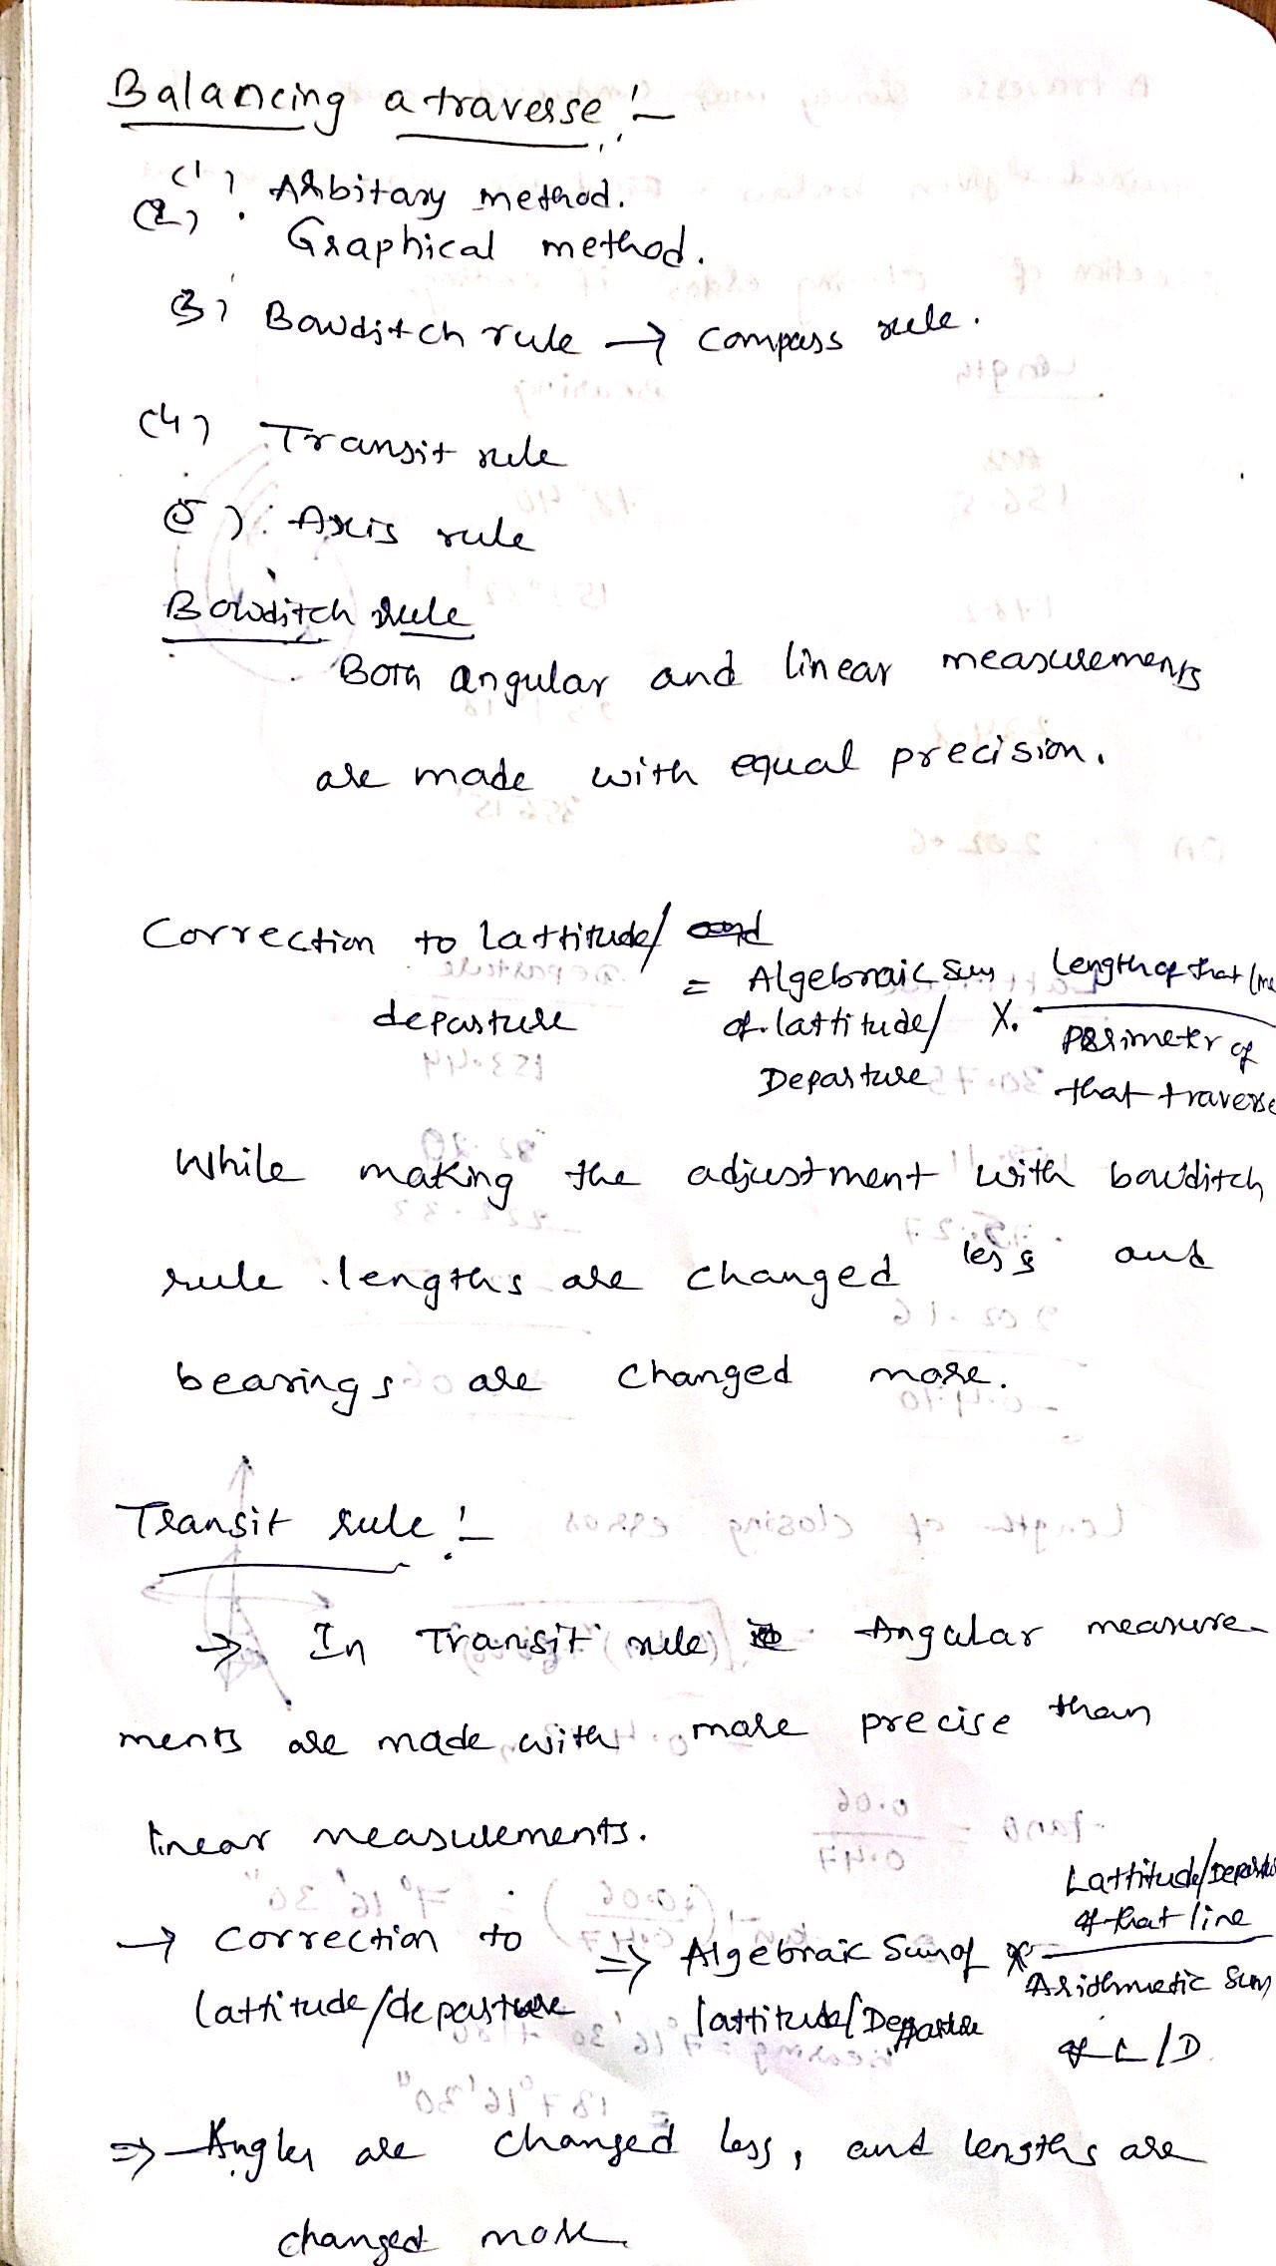

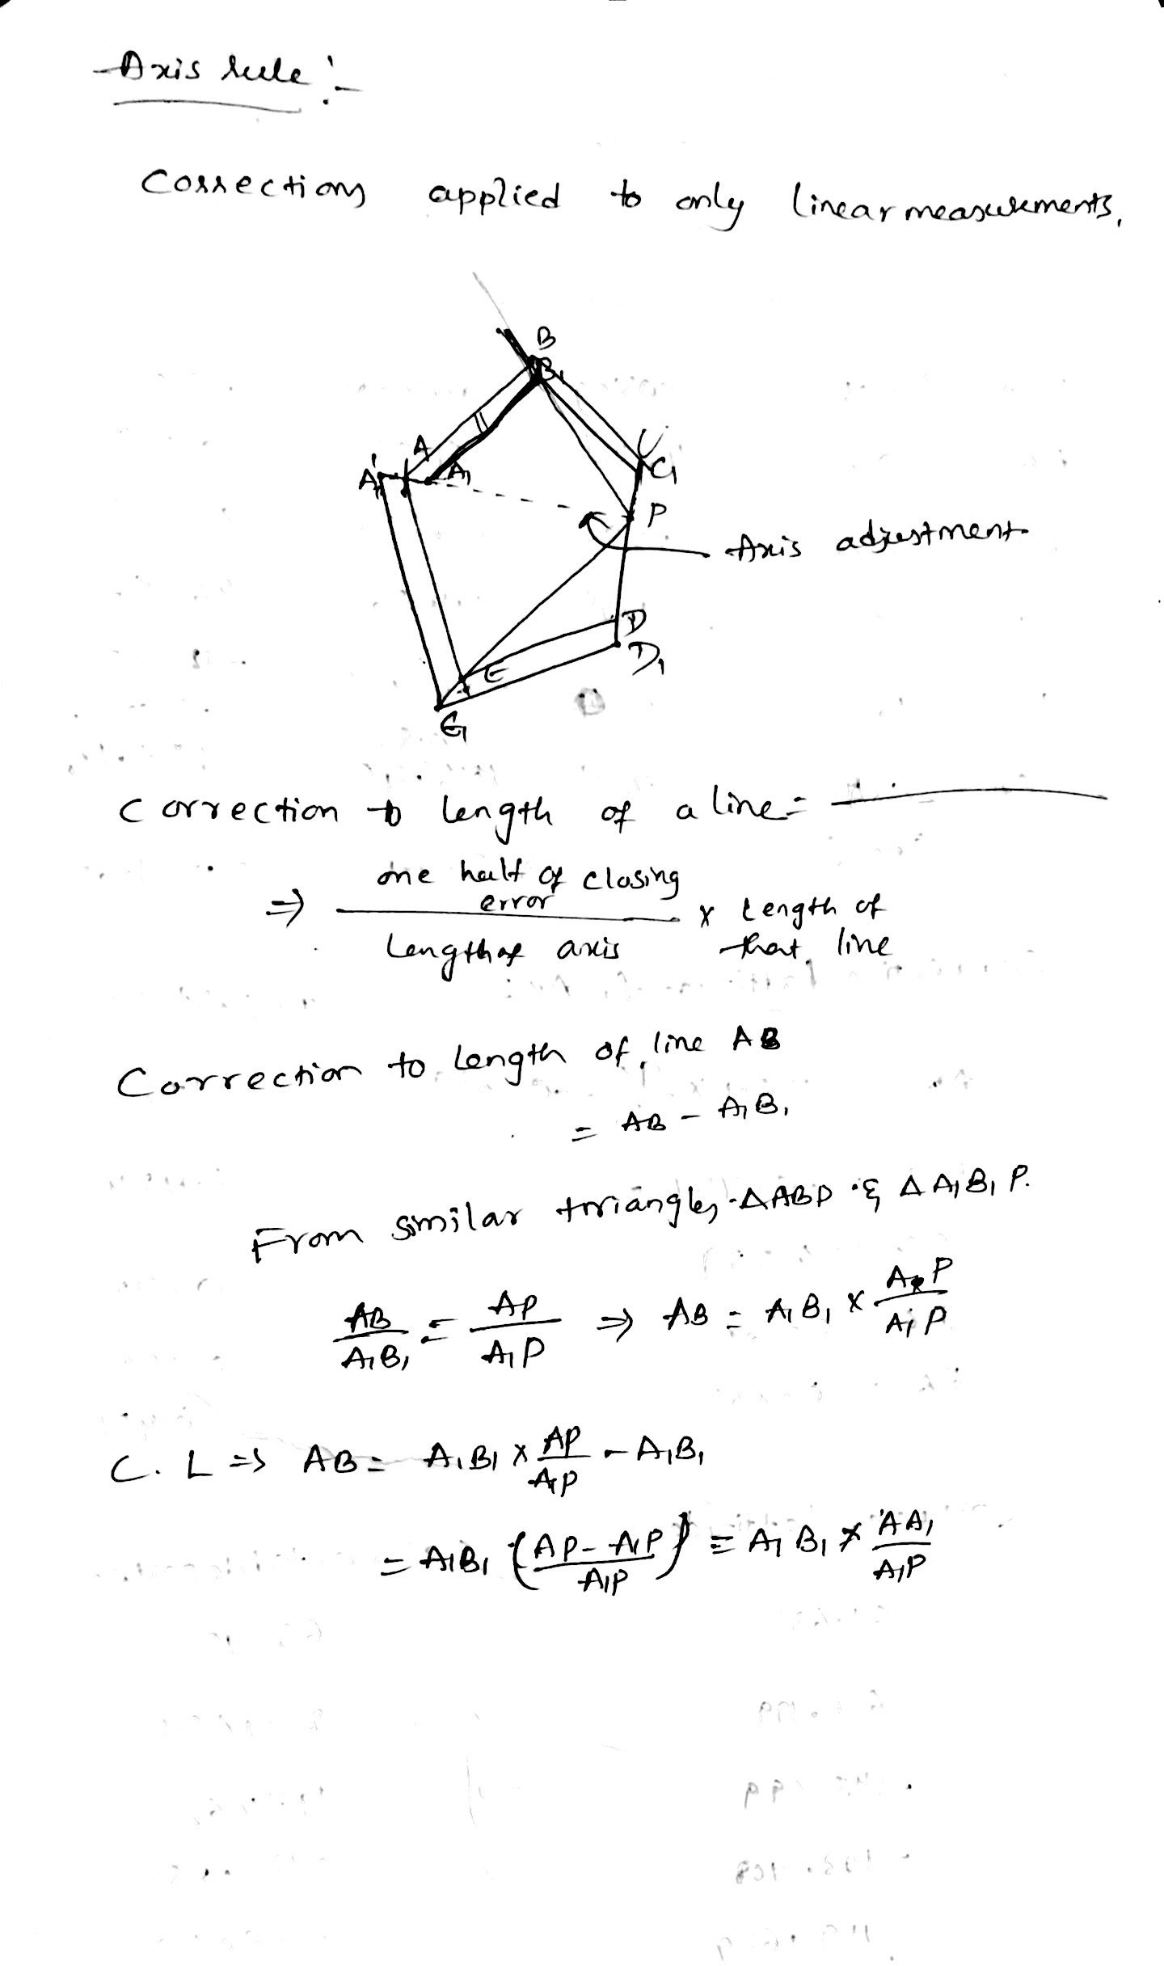

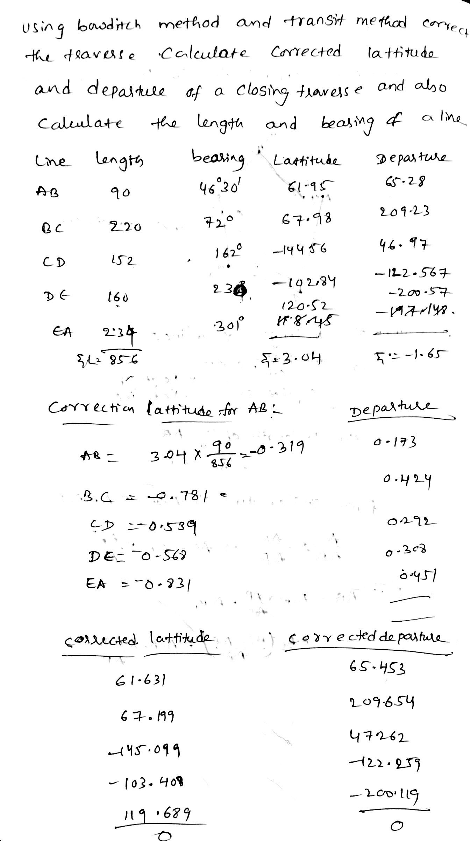

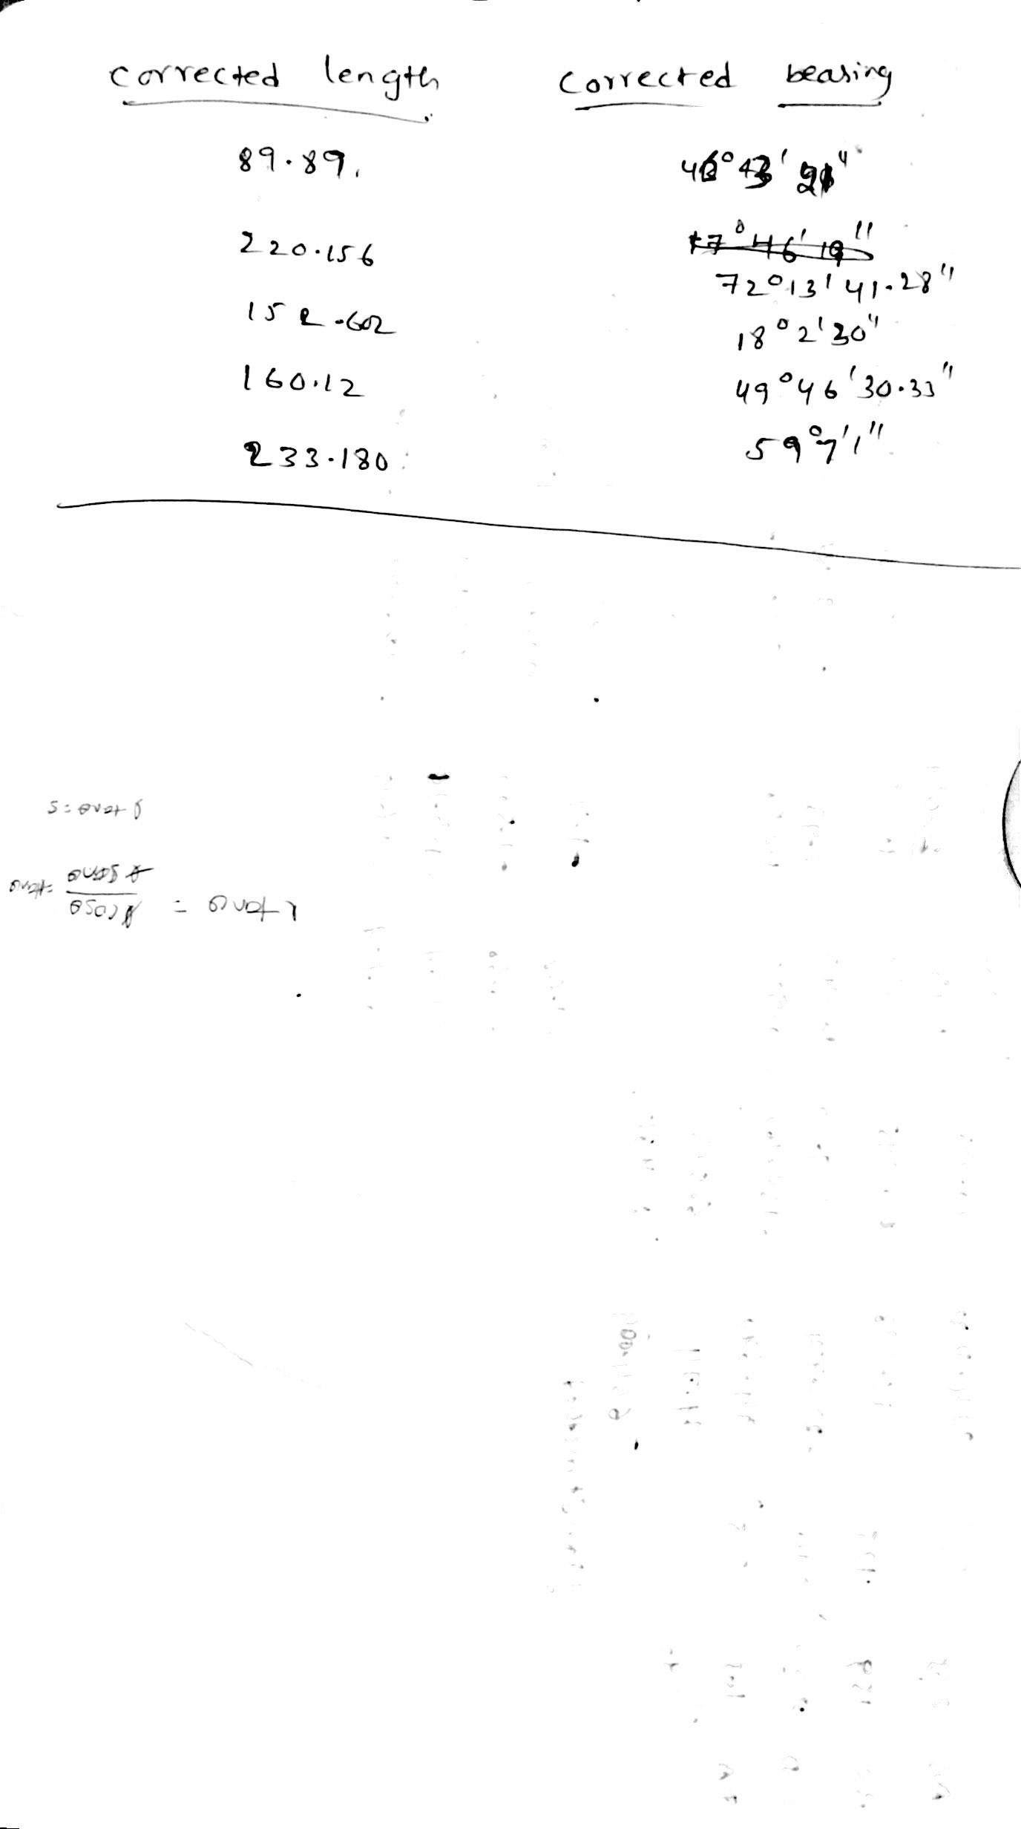

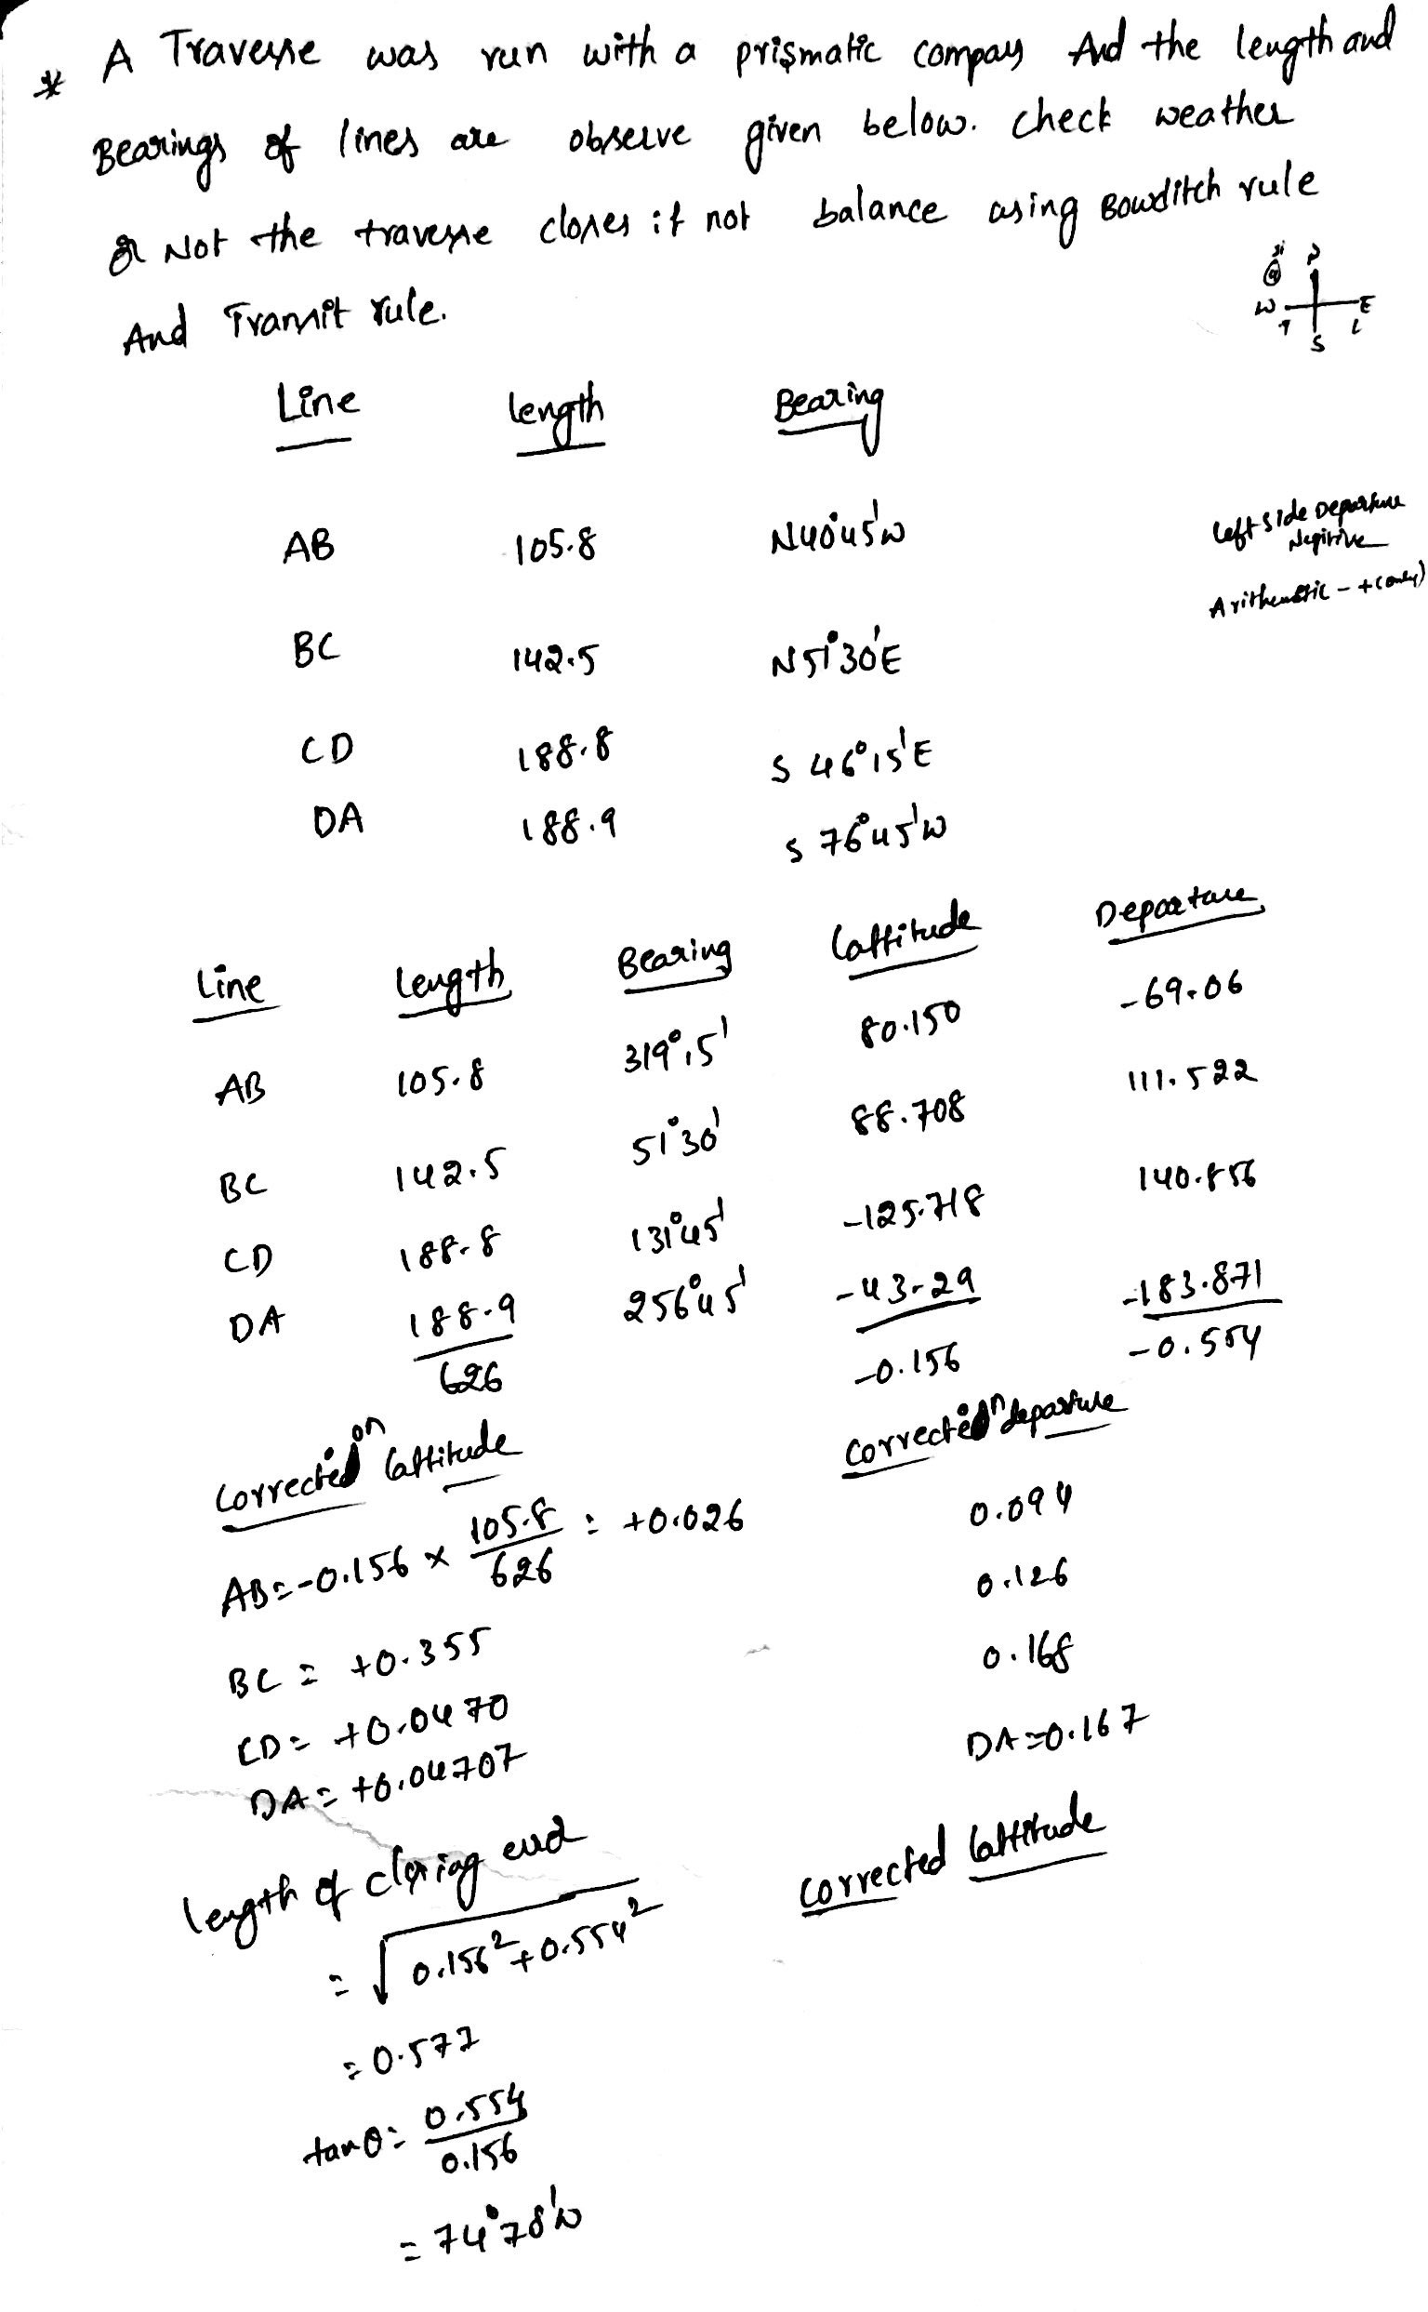

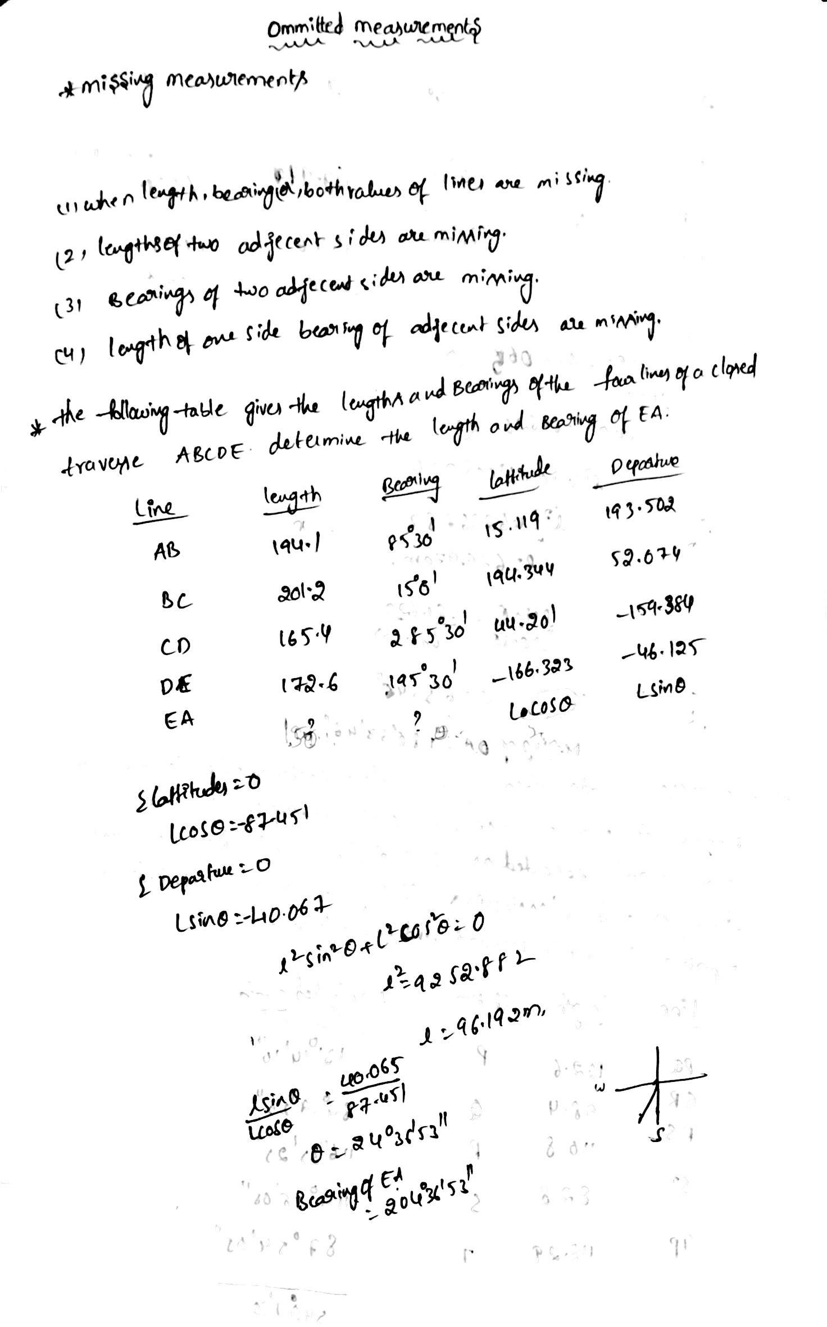

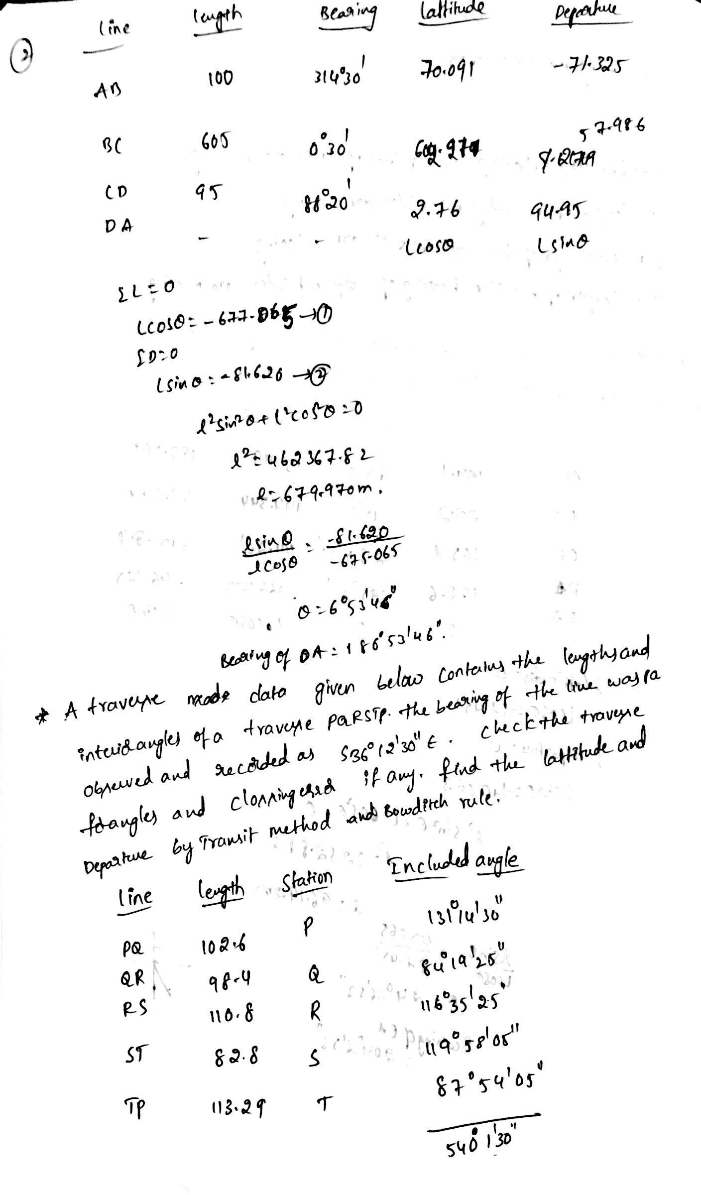

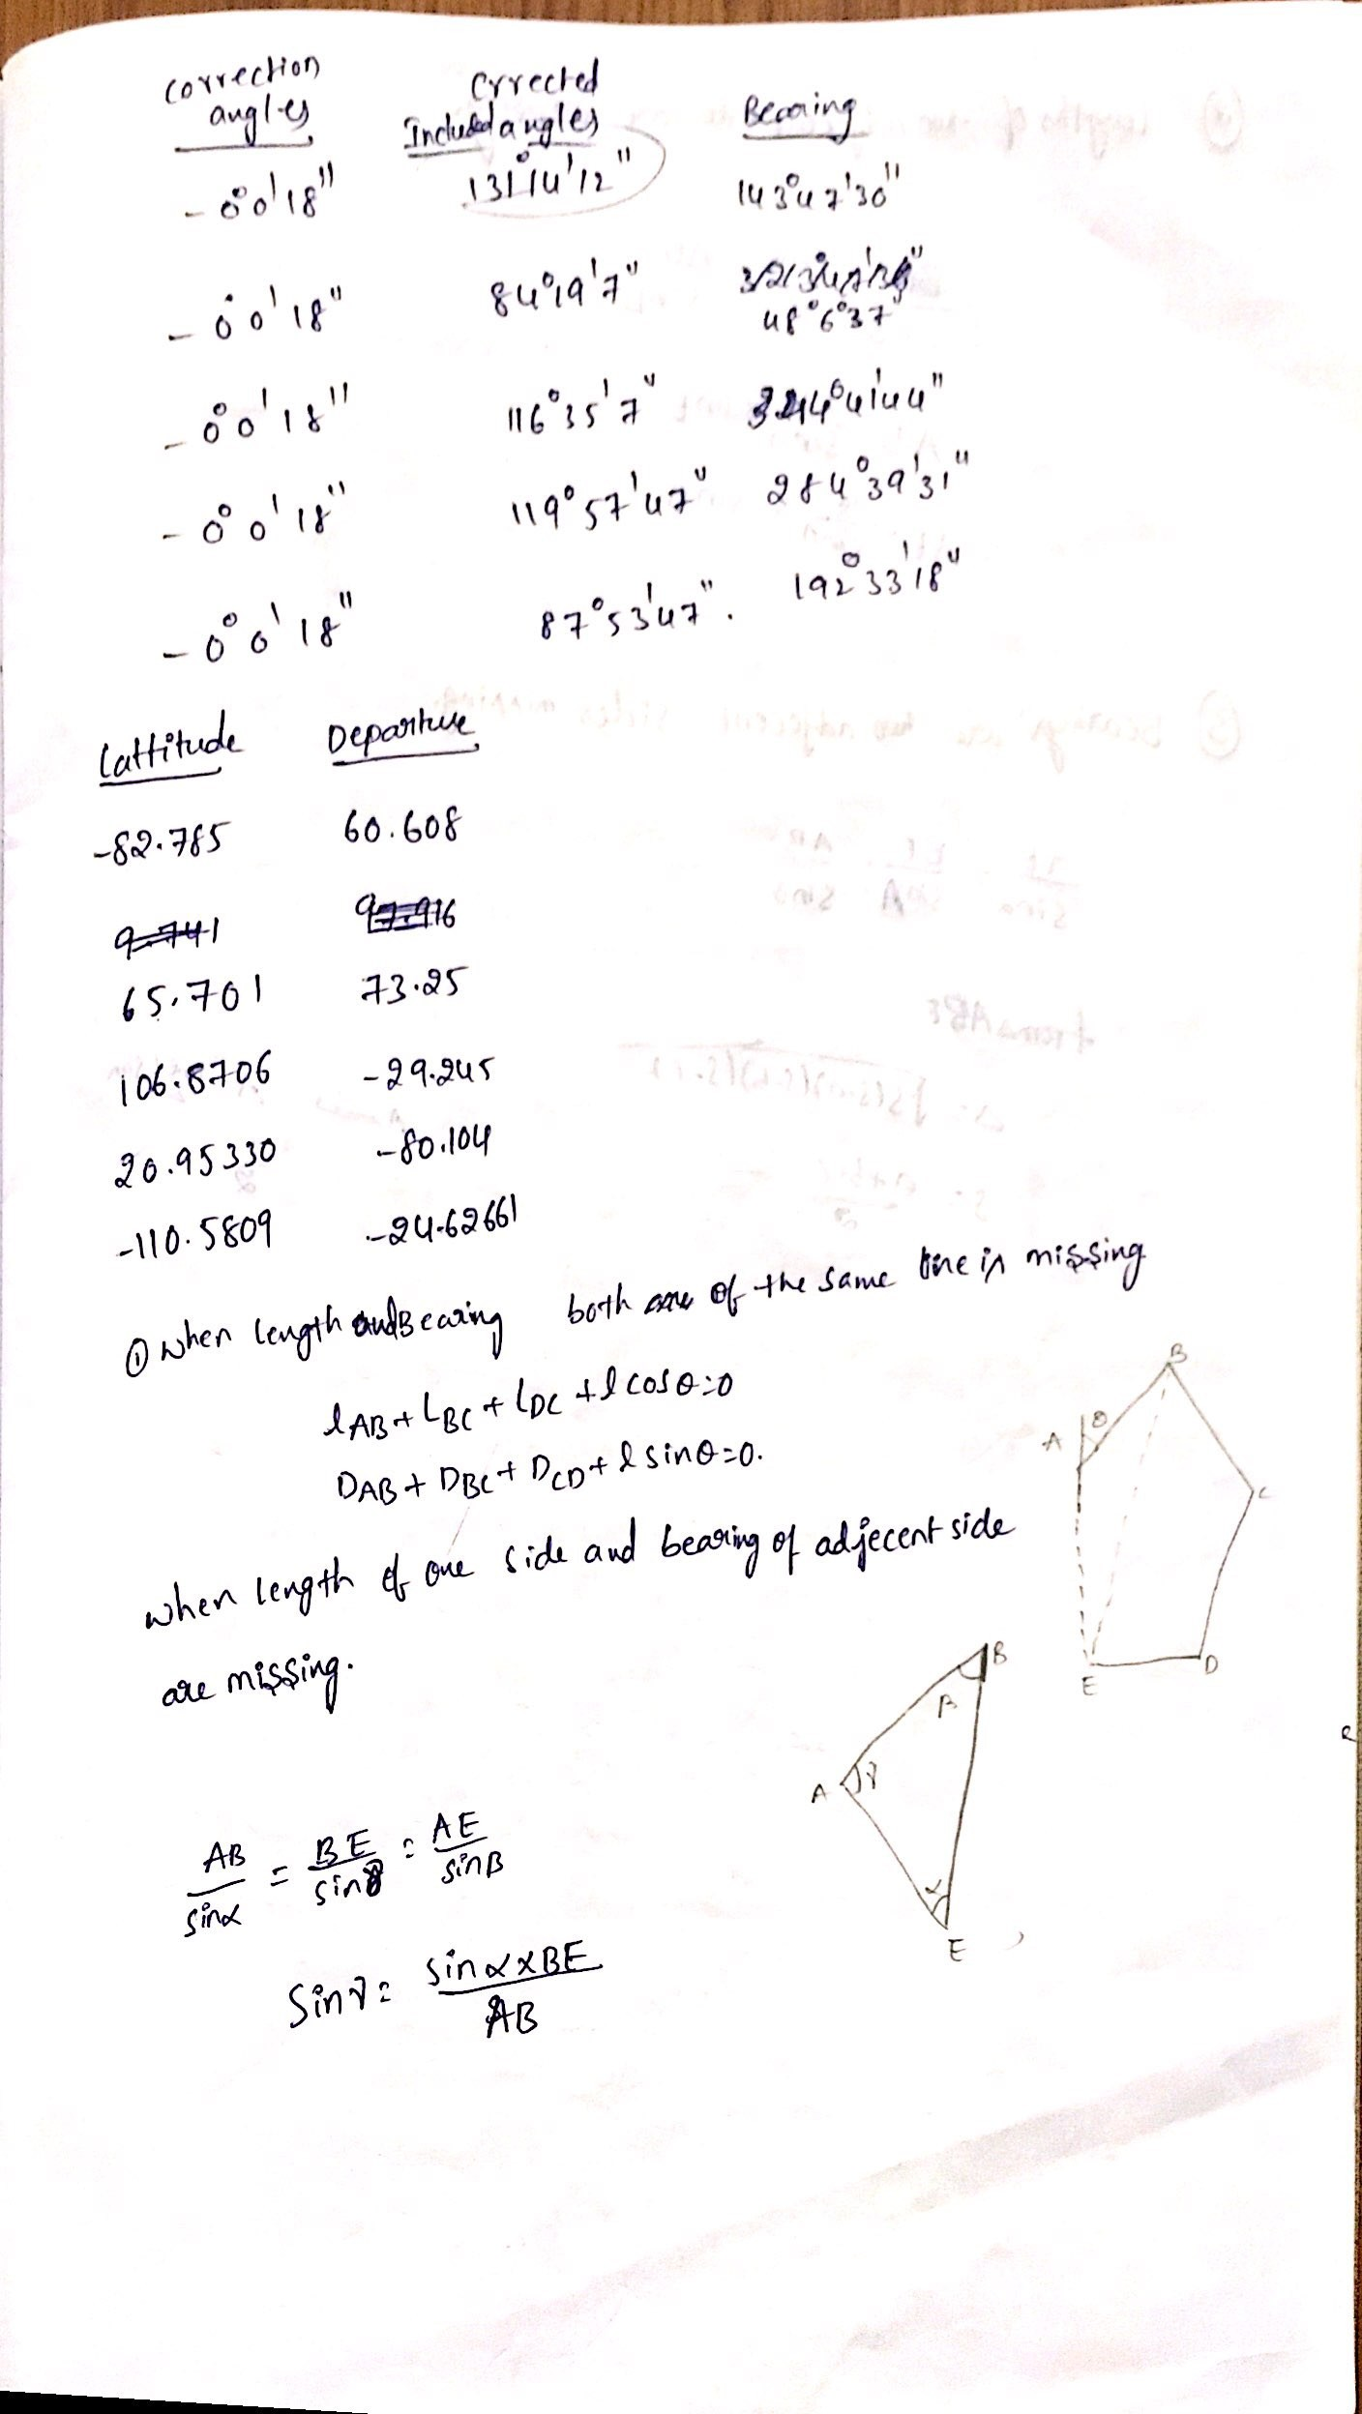

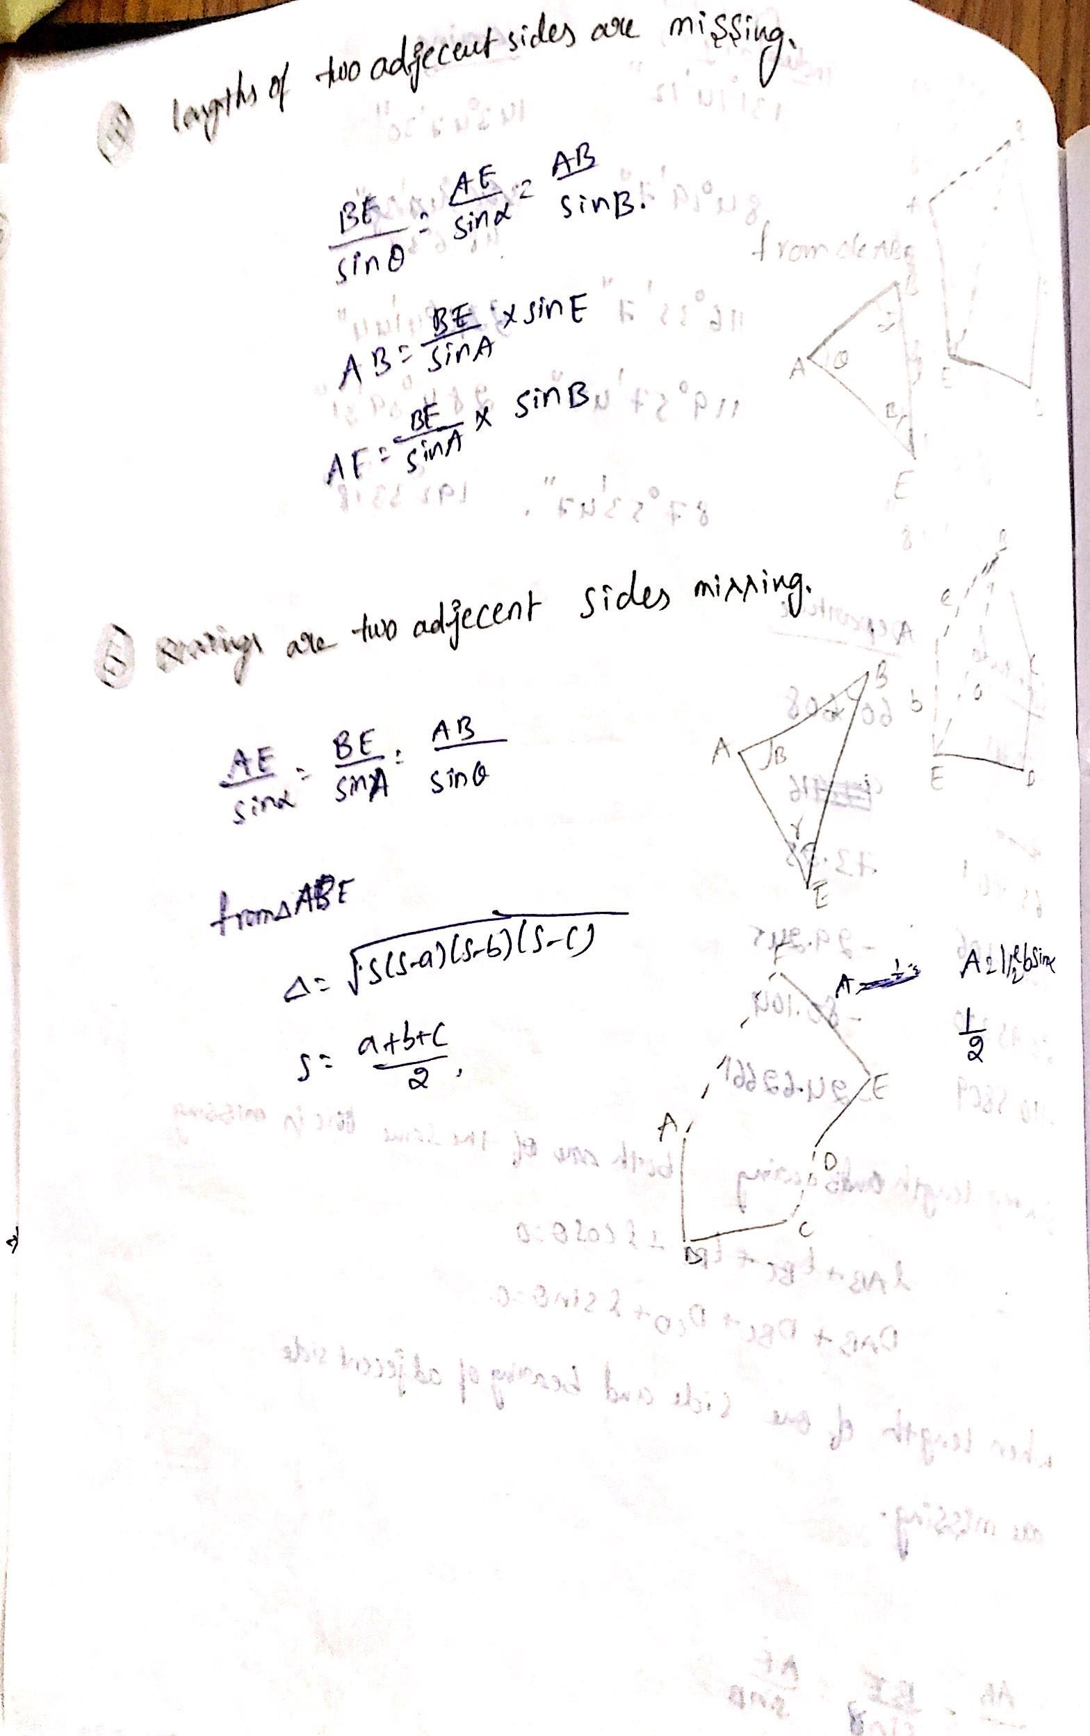

UNIT-II TACHEOMETRY

Generally, horizontal distances are measured by direct methods, i.e. laying of chains or tapes on ground. These methods are not always convenient if the ground is undulating, rough, difficult and inaccessible. Under these circumstances, indirect methods are used to obtain distances. One such method is “Tacheometry”. Using tacheometric methods, elevations can also be determined. It is in fact a branch of angular surveying in which both the horizontal and vertical positions of points are determined from the instrumental observations, the chain surveys being entirely eliminated.

Advantages of Tacheometry:

Since both the quantities viz., horizontal distances and the difference of elevations are determined indirectly in tacheometric surveying, it has a number of advantages over the direct methods of measurement of these quantities.
In terrain where direct methods are not convenient, tachometric methods can be used. Tacheometric methods are convenient for reconnaissance surveys of routes, for hydrographic surveying and for filling in details in a traverse. There is considerable saving in time and money with the use of tacheometric methods.

Tacheometer:
A tacheometer is similar to an ordinary transit theodolite, generally a vernier theodolite itself, fitted with two stadia wires in addition to the central cross-hair. The stadia diaphragm has three horizontal hairs viz., a central horizontal hair and upper and lower stadia hairs. The upper and lower stadia hairs are equidistant from the central horizontal hair. Stadia hairs are sometimes called stadia lines.
For the purpose of tacheometry, even though an ordinary transit can be employed, accuracy and speed are increased if the instrument is specially designed for the work. The magnification of the telescope in tacheometer should be at least 20 to 30 diameters, with an aperture of at least 40 mm for a sufficiently bright image. The magnifying power of the eyepiece is also greater than for an ordinary transit to produce a clearer image of a staff held far away. Further, the altitude bubble is made more sensitive, since vertical angles form an important part of the data for calculation of elevation differences. Figure 2.1 shows a more commonly used pattern of stadia diaphragm.
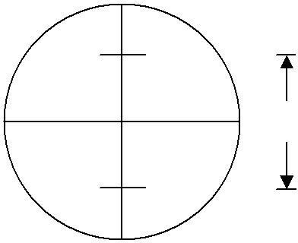
Stadia Diaphragm

Stadia Rods
For short sights of about 100 m or less, an ordinary levelling staff may be used. For long sights, special staff called stadia rod is generally used. The graduations are in bold type (face about 50 mm to 150 mm wide and 15 mm to 60 mm thick) and the stadia rod is 3 m to 5 m long. To keep the staff or stadia rod vertical, a small circular spirit level is fitted on its backside. It is hinged to fold up.

Systems of Tacheometric Measurements
The underlying principle common to various systems of tacheometry is that the horizontal distance between an instrument station P and a point Q, as well as the elevation of Q relative to the instrument, can be deduced from
    - the angle at P subtended by a known small distance at Q, and
    - the vertical angle from P to Q.

This basic principle is applied in different ways in different tacheometric methods. There are basically three systems of tacheometric measurements such as stadia system, tangential system, and substense bar system.

Stadia System
This is the more extensively used system of tacheometry particularly for detailed work, such as those required in engineering surveys. In this system, a tacheometer is first set up at a station, say P, and a staff is held at station Q. The difference of upper hair reading and lower hair reading is called staff intercept s. All the three hairs including central cross hair are read, and s is determined. Vertical angle, θ, corresponding to the central hair is also measured. These measurements enable determination of horizontal distance between P and Q and their difference in elevation. There are two different types of systems in stadia method. These are as follows :

Fixed Hair Method:
In this method, the distance between the upper hair and lower hair, i.e. stadia interval i, on the diaphragm of the lens system is fixed. The staff intercept s, therefore, changes according to the distance D and vertical angle θ.

Movable Hair Method:
In this method, the stadia interval „i‟ can be changed. The stadia hairs can be moved vertically up and down by using micro meter screws. The staff intercept s, in this case, is kept fixed. Two vanes (targets) are fixed on the staff at a fixed interval of 2 m or 3 m.
The fixed hair method is the one which is commonly used and, unless otherwise mentioned, stadia method means fixed hair method. Movable hair method is not in common use due to difficulties in determining the value of i accurately.

Tangential System
In this system, observations are not taken on stadia hairs. Instead vertical angles θ1 and θ2 to the two targets fixed on a staff are recorded (Figure 2.3). The targets are at a fixed distance s. Vertical angles θ1, θ2 and staff intercept s enable horizontal distance D and the difference of elevations to be determined. Advanced Survey In Figure 2.3, both the vertical angles θ1 and θ2 are the angles of elevations. There may be two more cases where either both the angles may be angles of depression or one of the angles is angle of elevation and another is angle of depression.

Subtense Bar System:
Subtense bar is a bar of fixed length generally 2 m fitted with two targets at the
ends. The targets are at equal distance apart from the centre. The subtense bar can be fixed on a tripod stand and is kept horizontal. angle α subtended by the two targets at station P is measured by a theodolite. The distance s between the targets and the angle α enable the distance D between station P and Q to be determined.

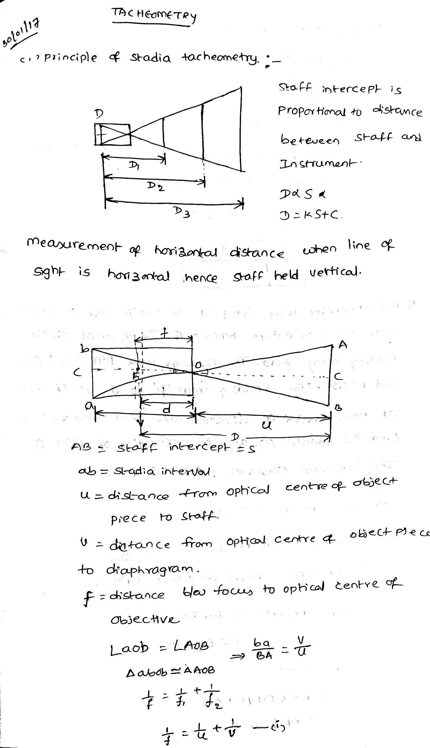

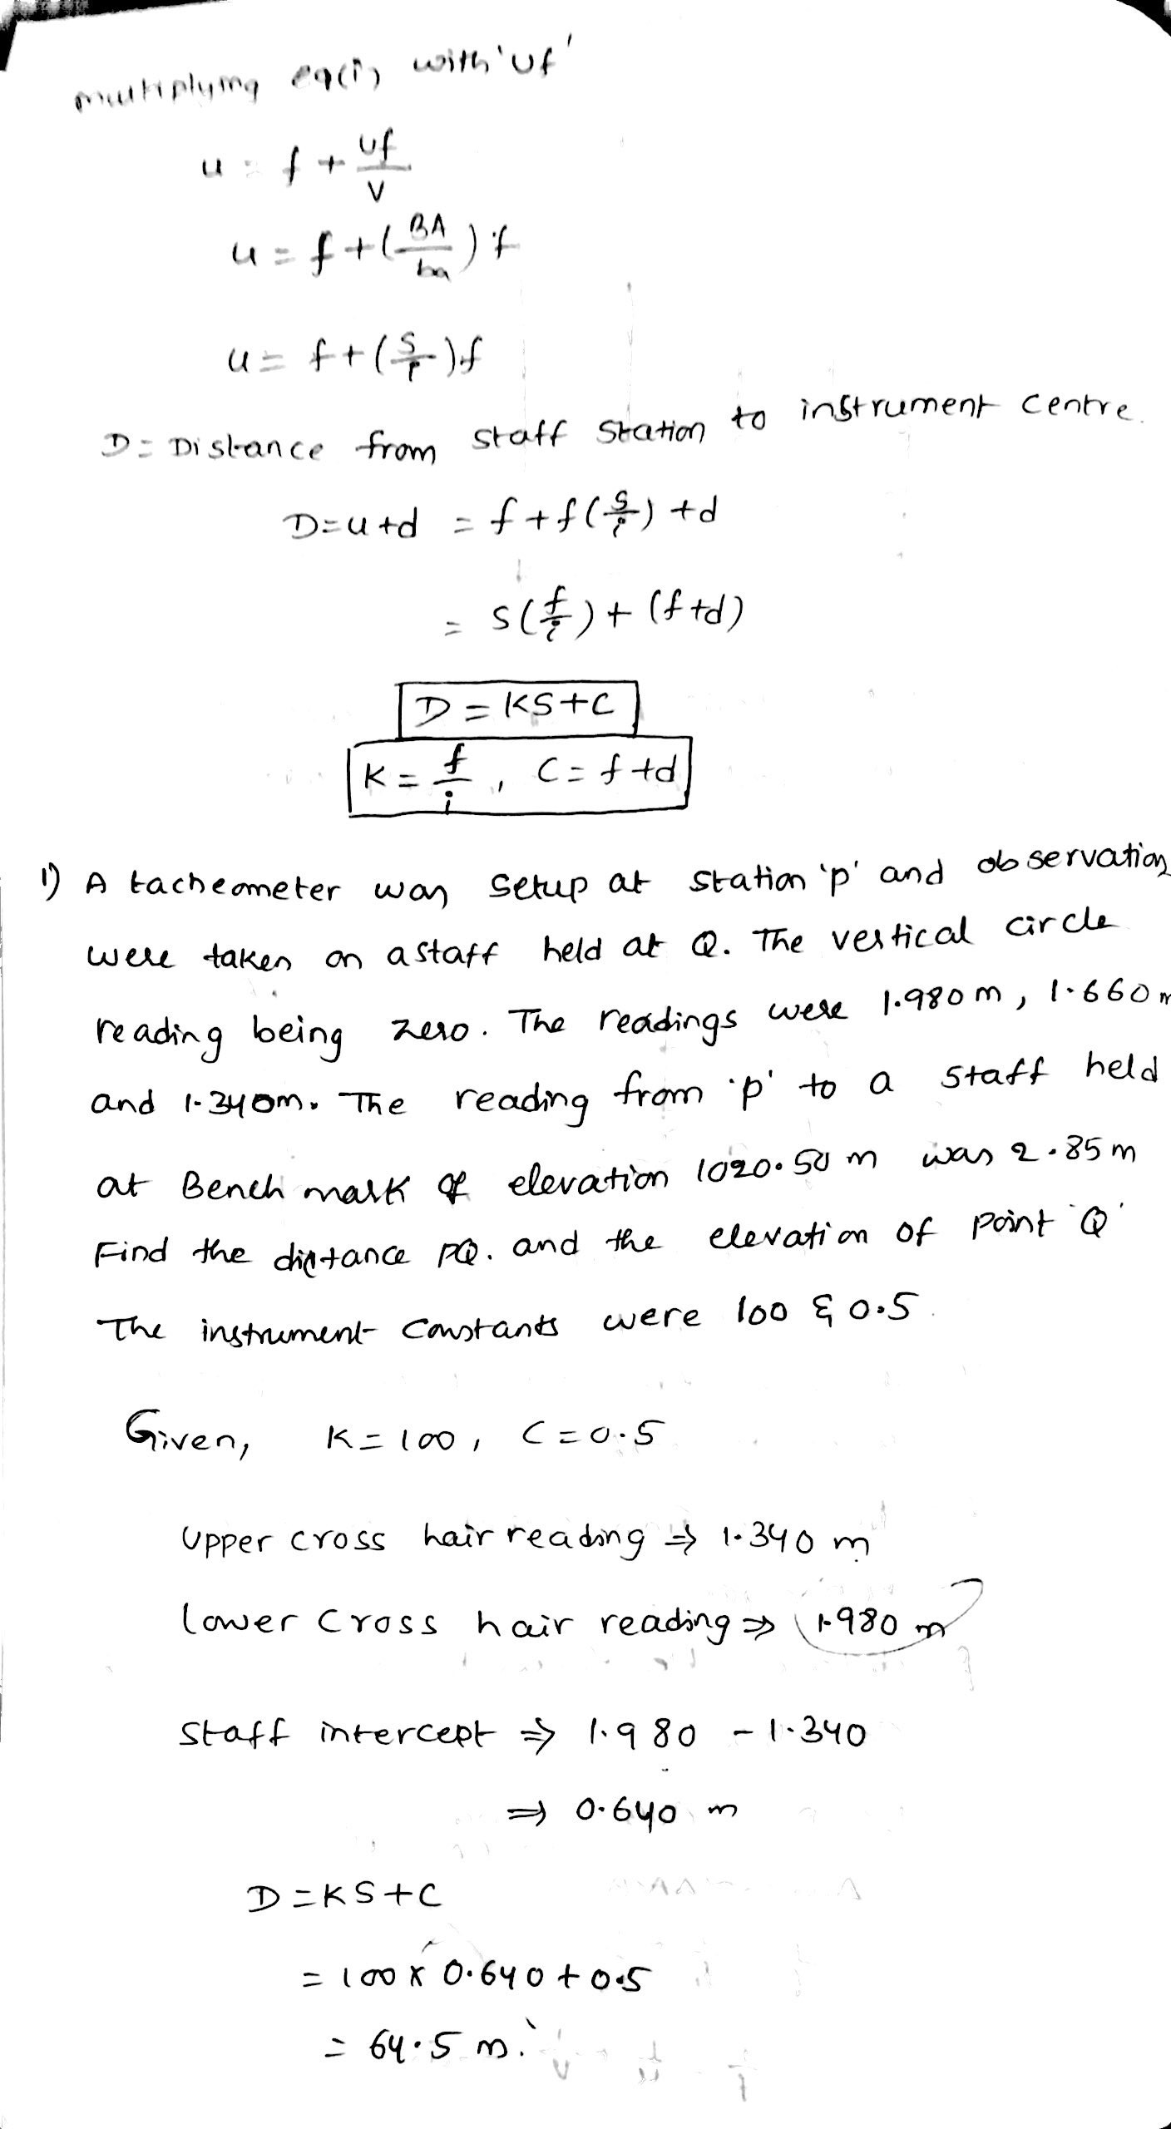

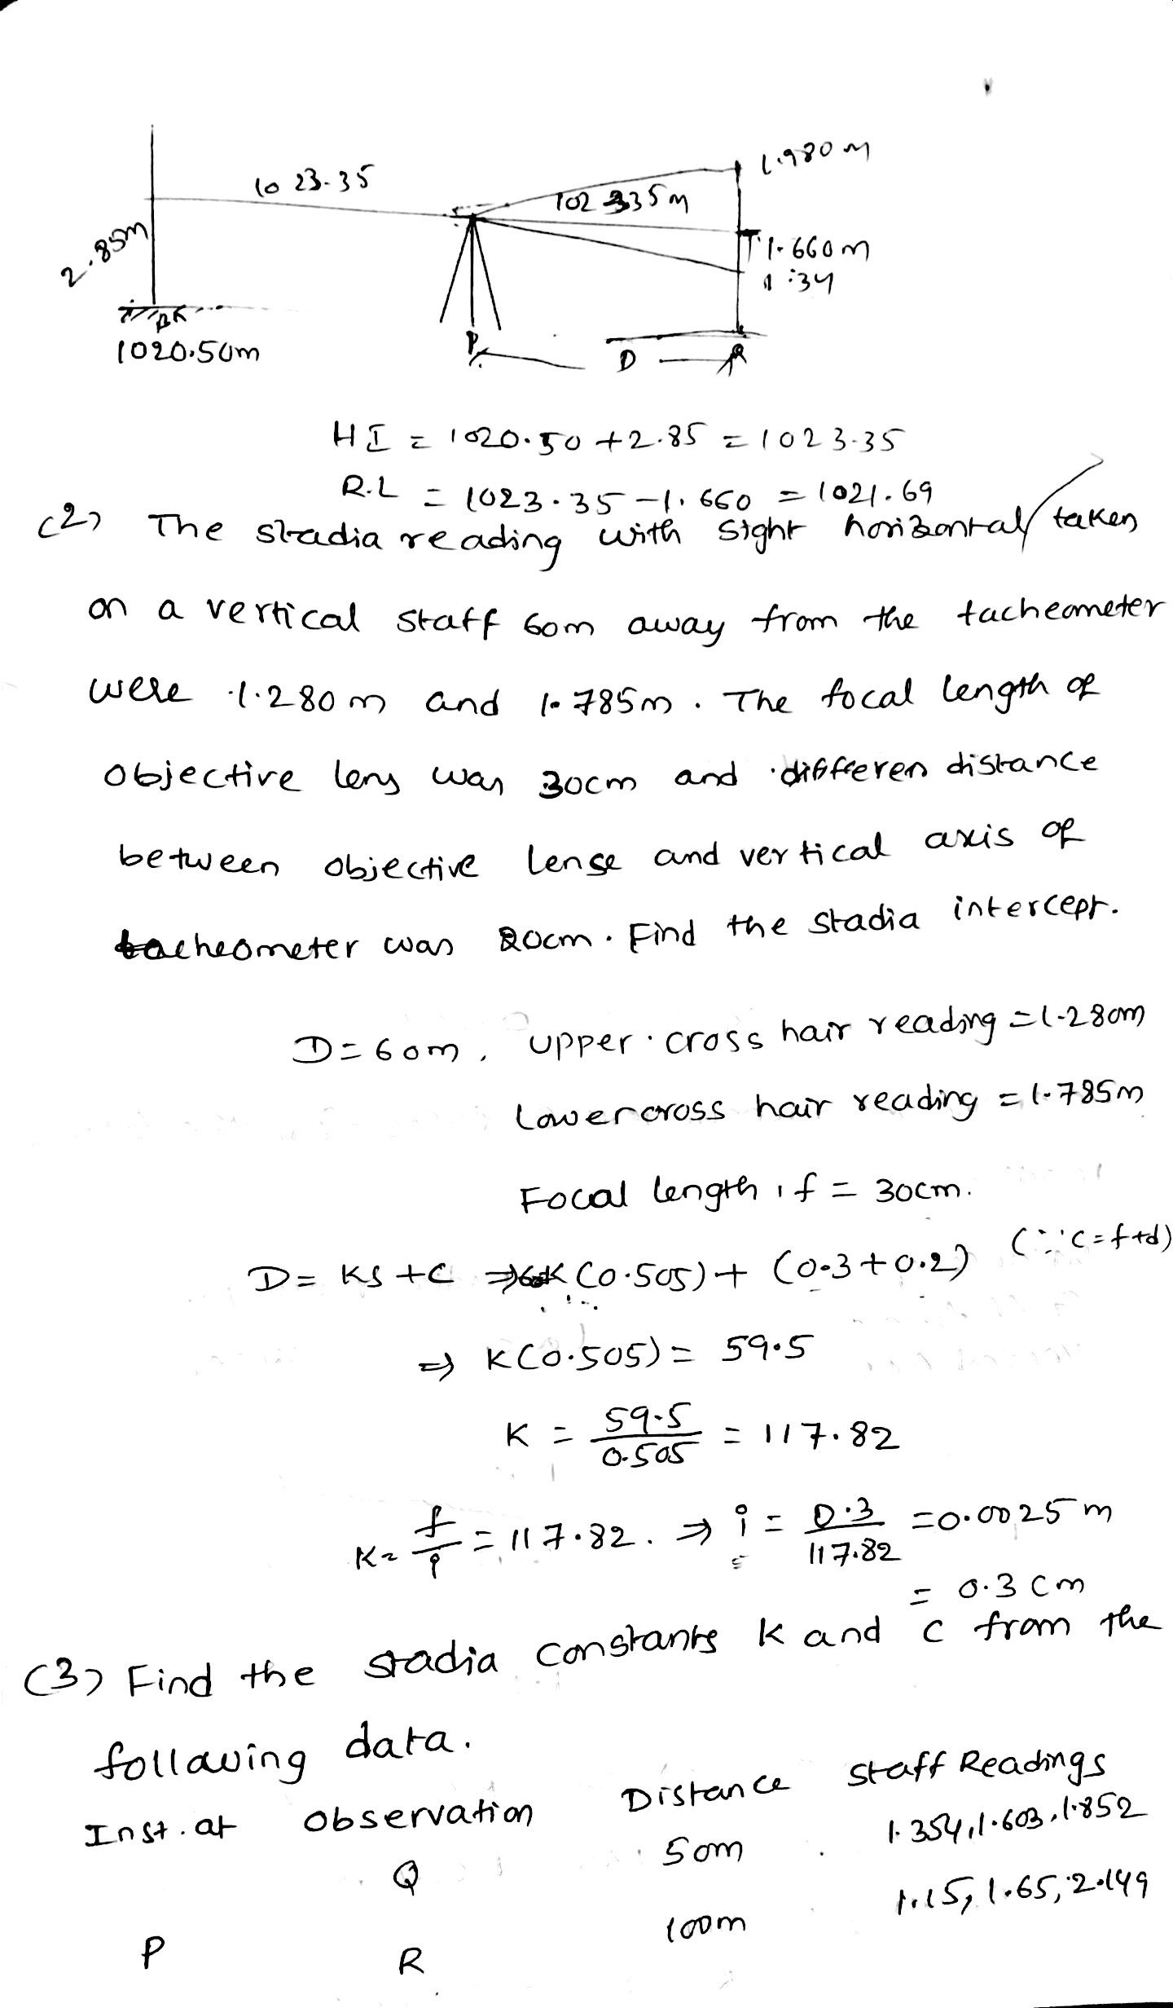

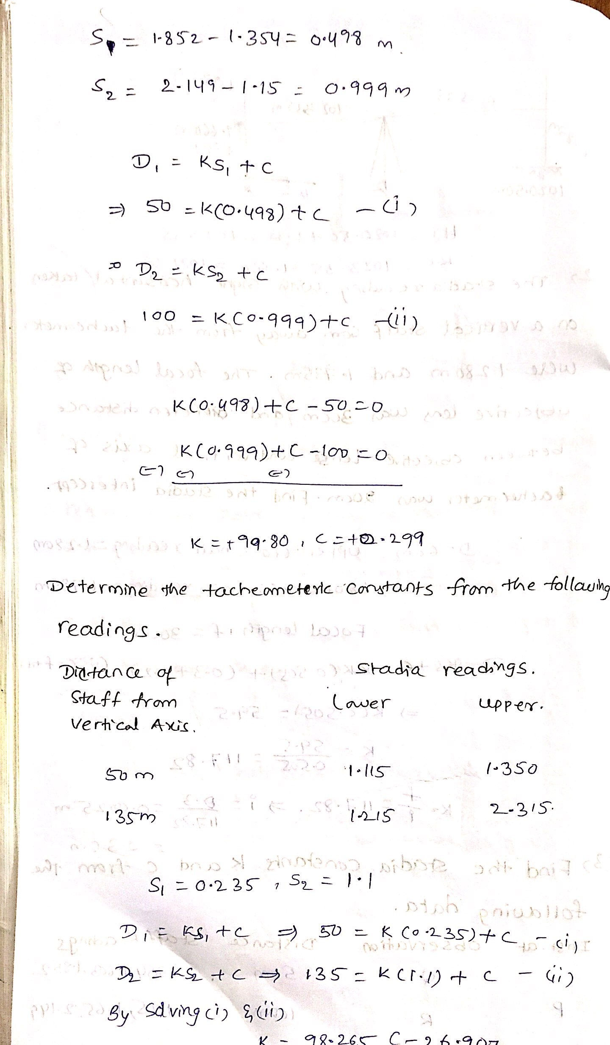

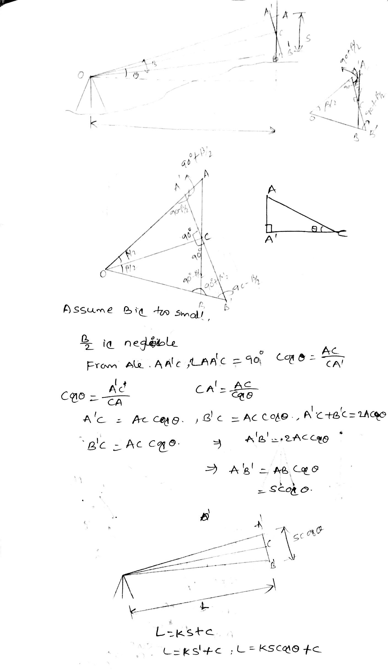

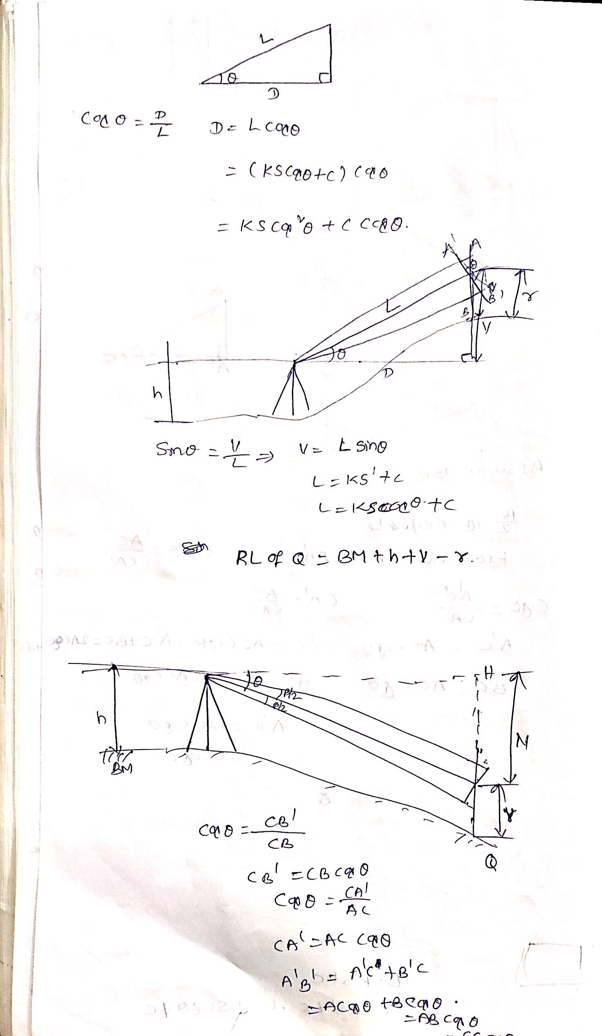

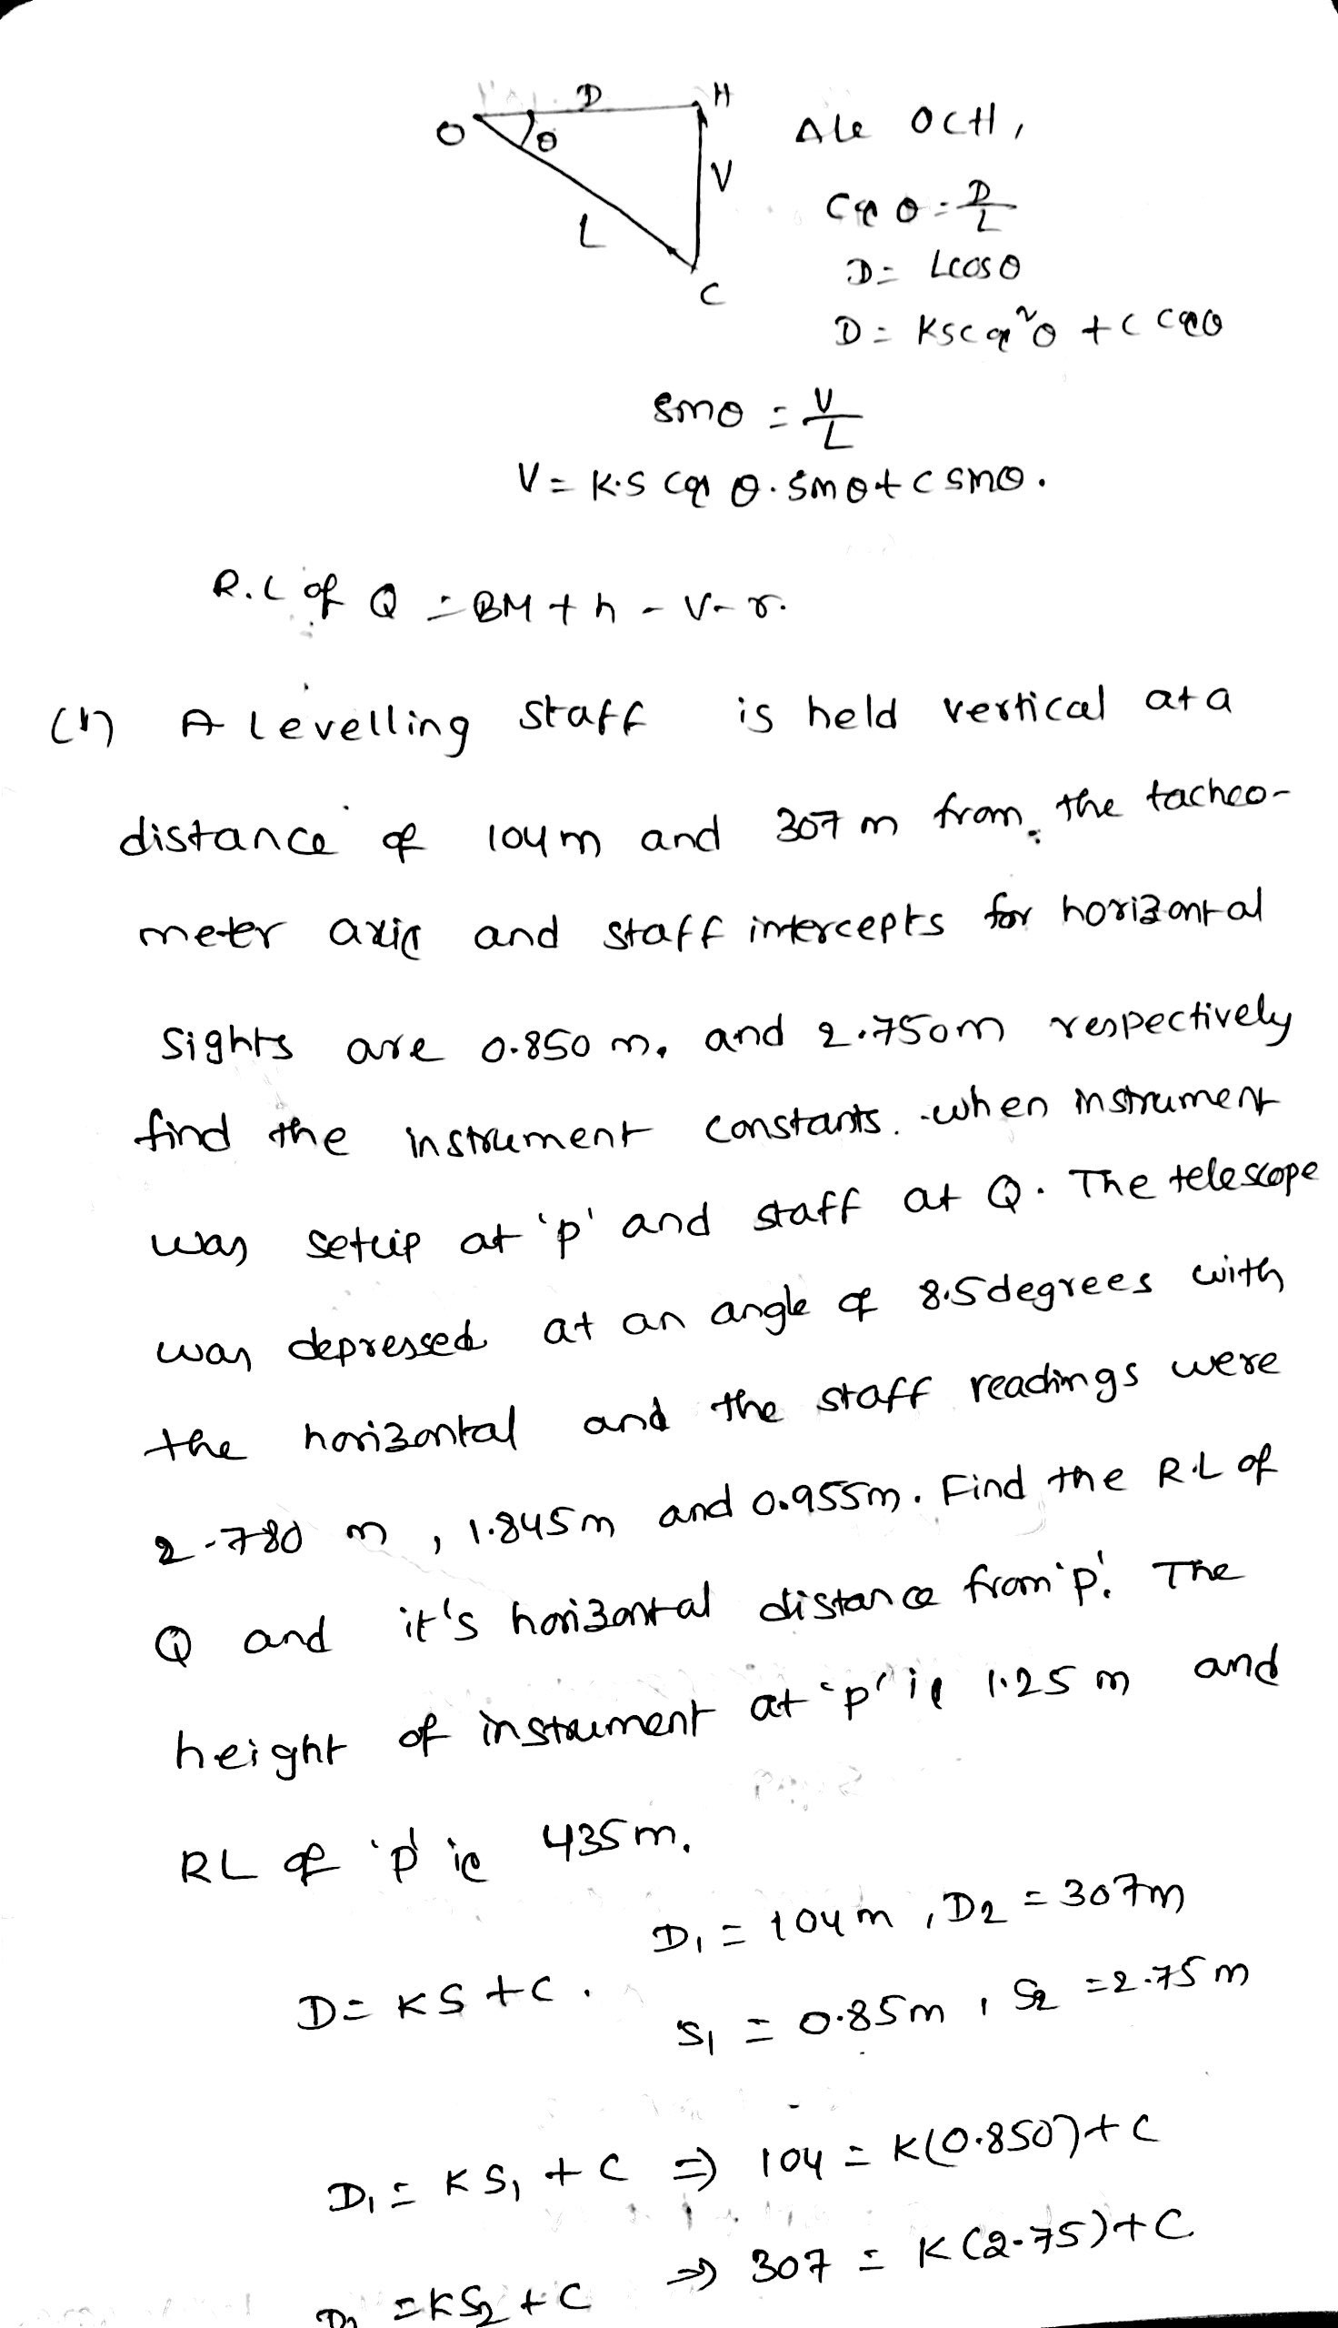

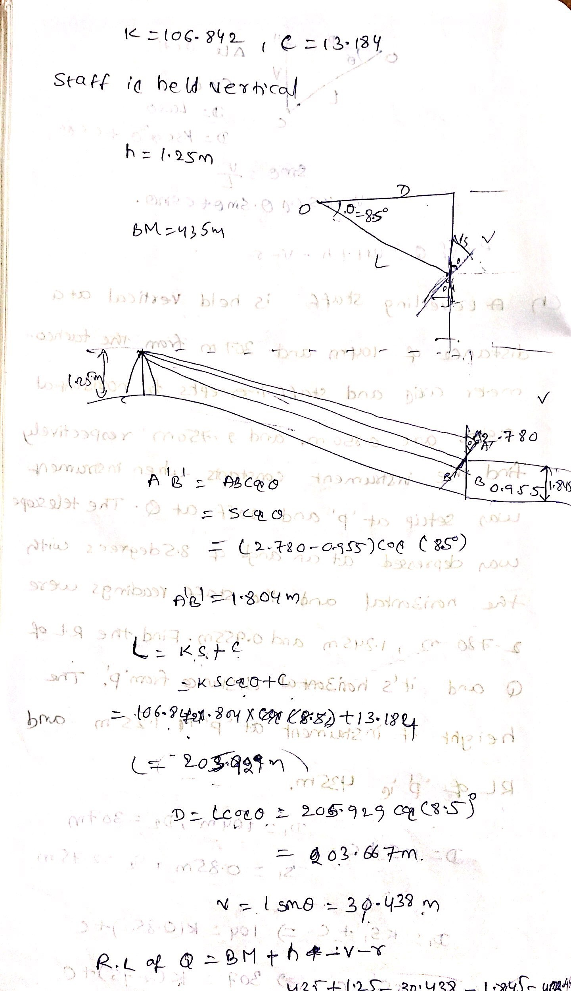

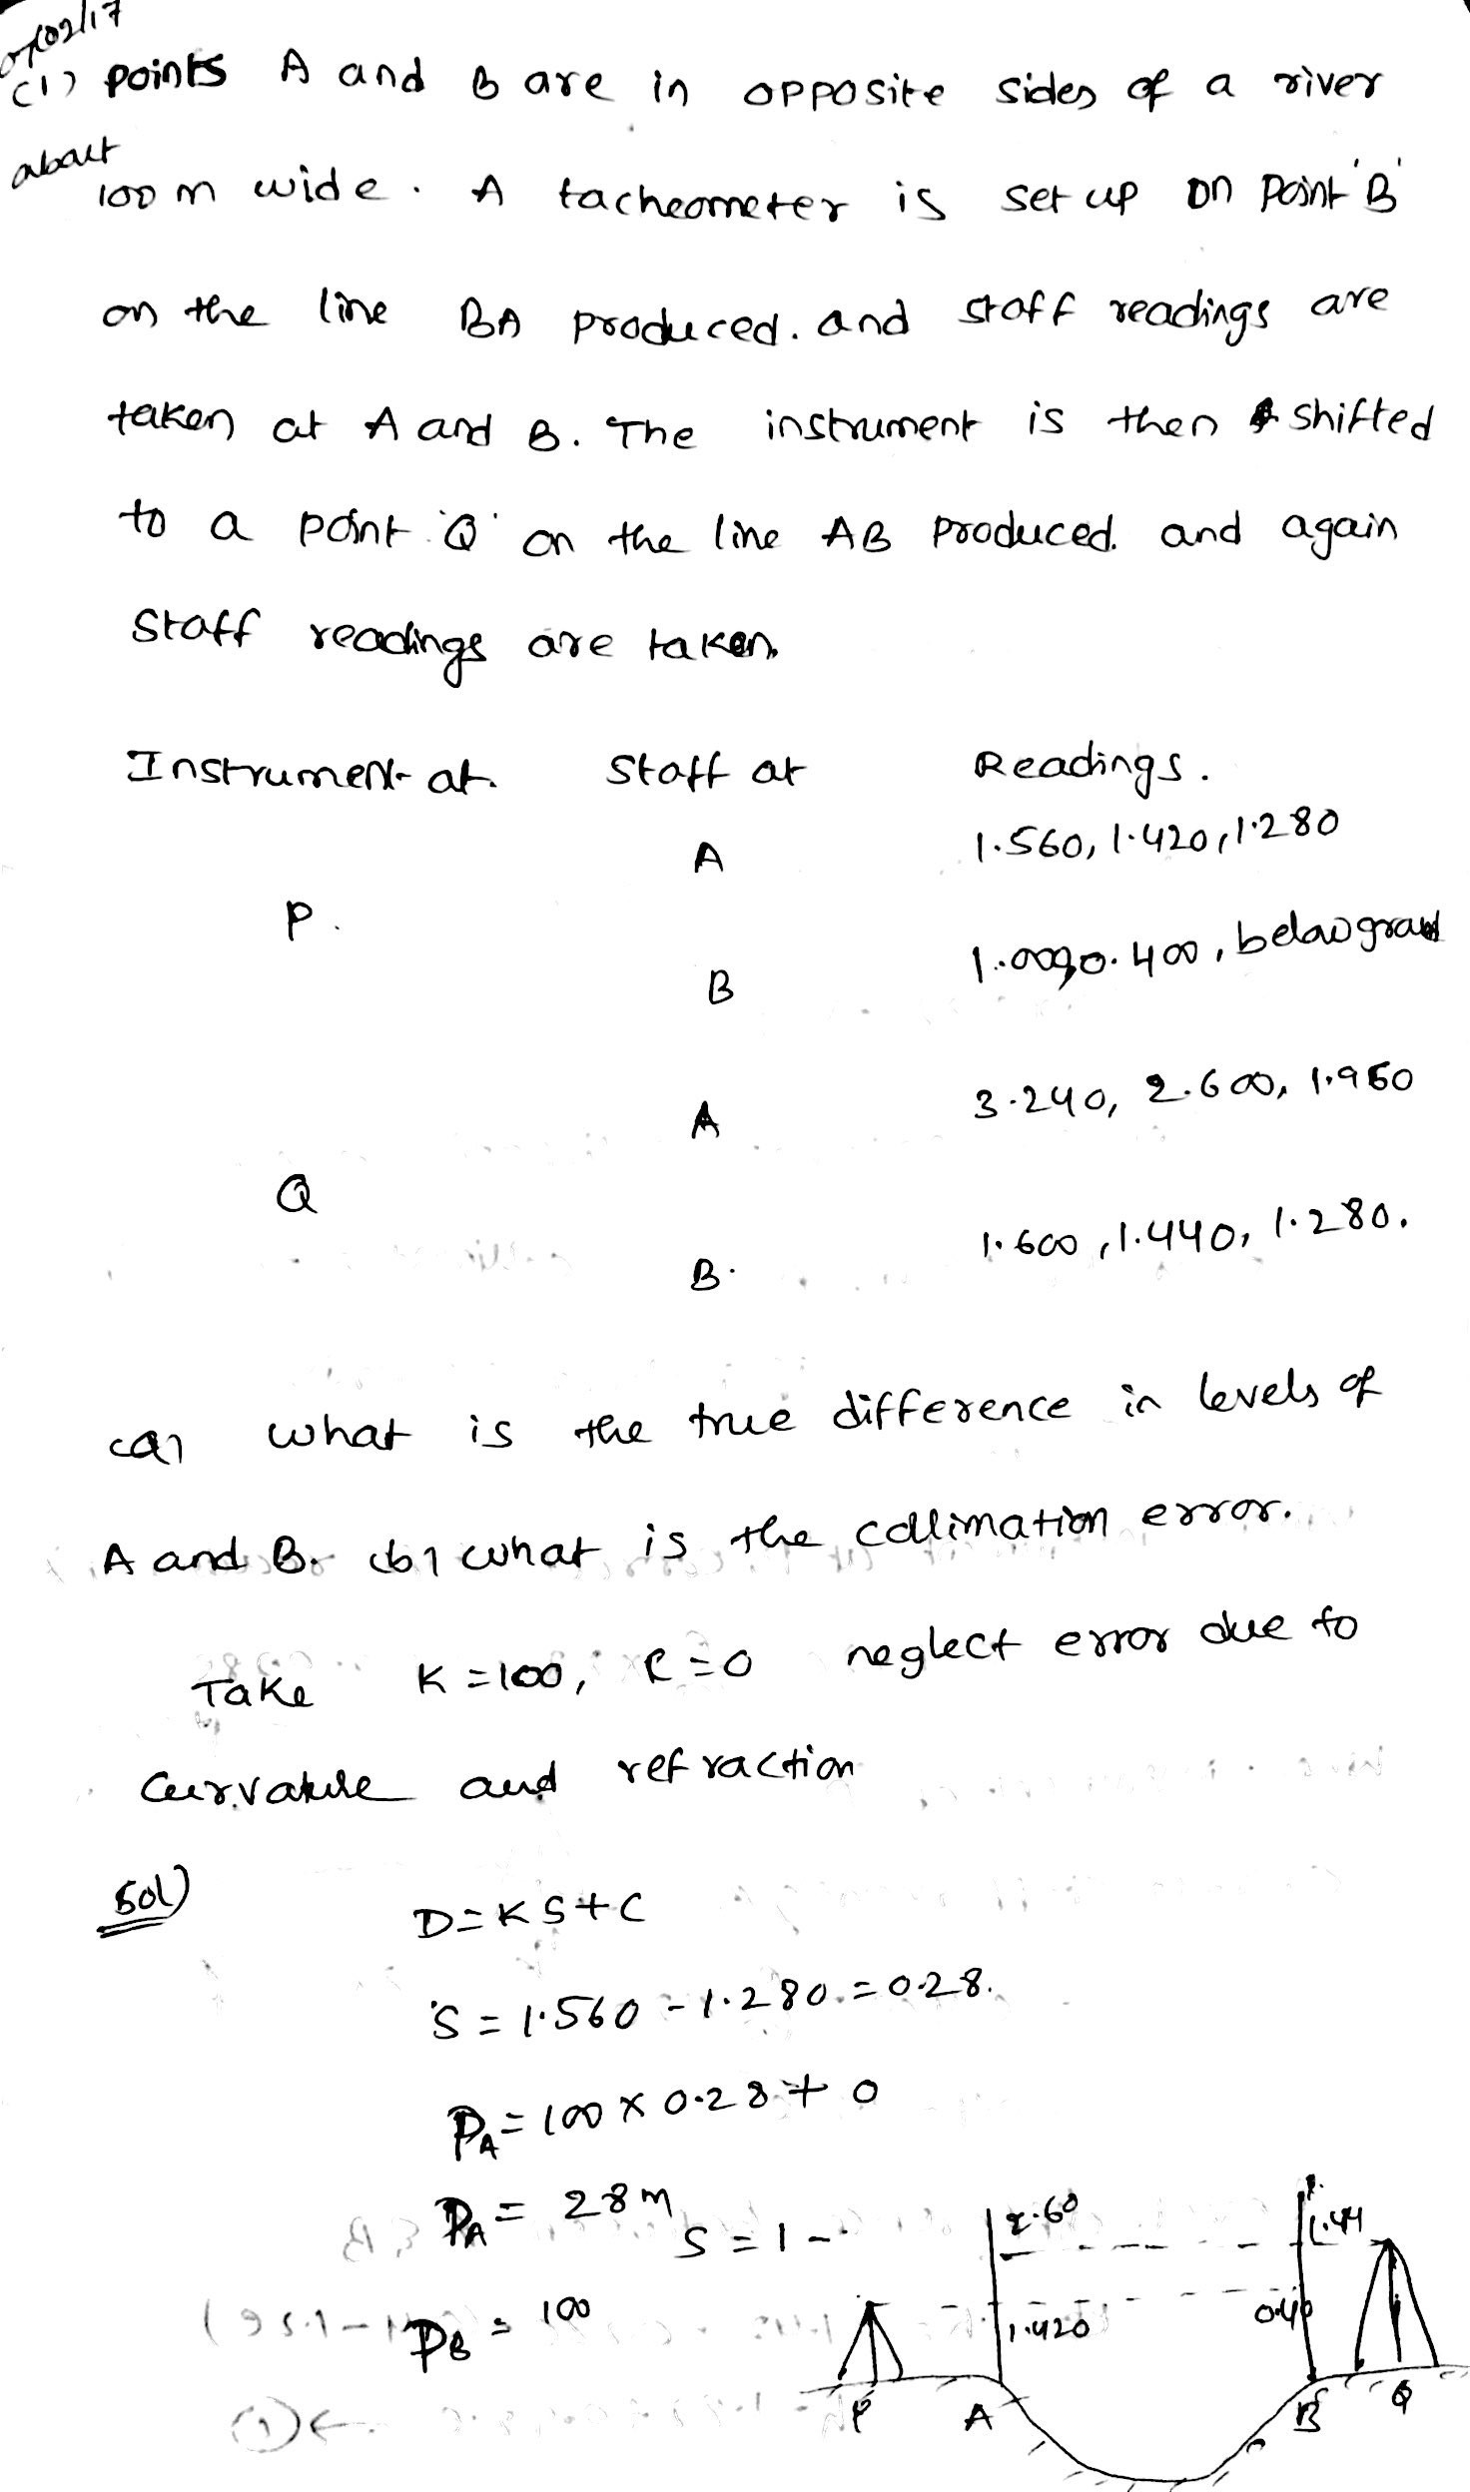

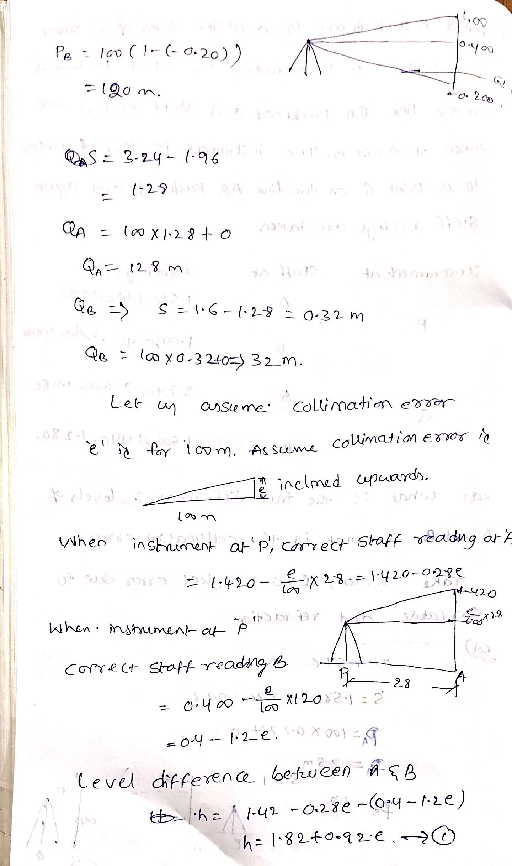

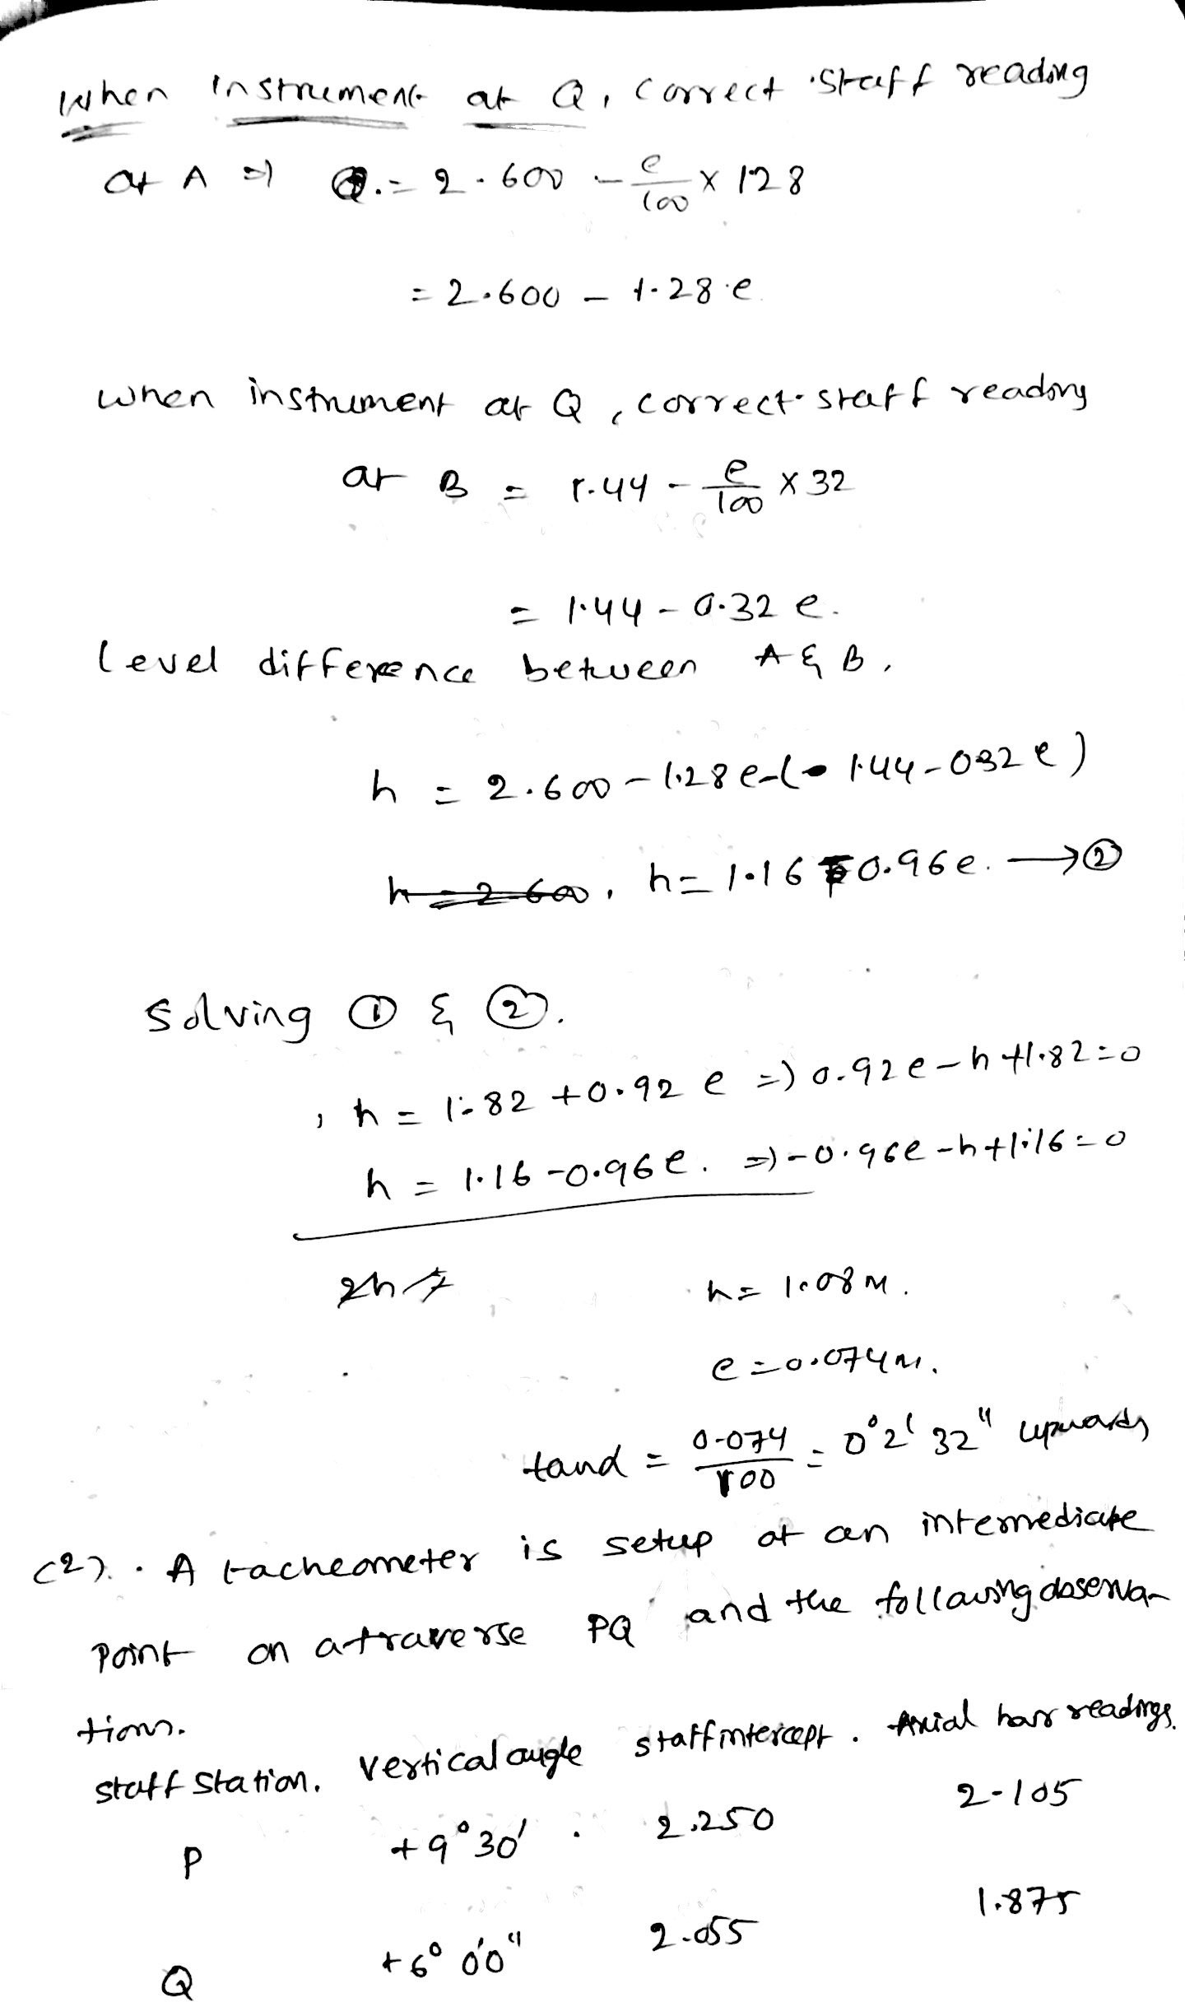

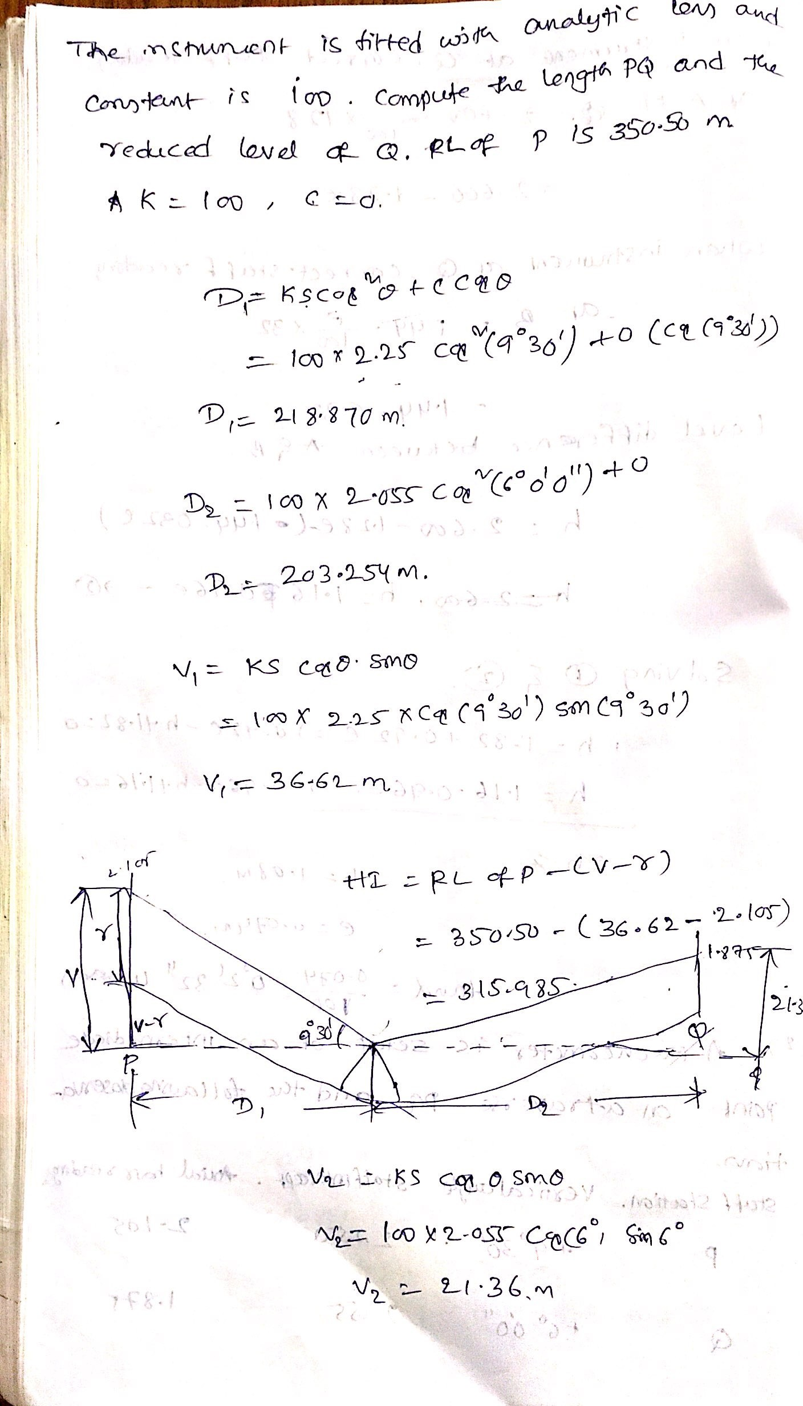

UNIT IV: AREA’S & VOLUMES’S

Introduction
Areas and Volumes are often required in the context of design, eg. we might need the surface area of a lake, the area of crops, of a car park or a roof, the volume of a dam embankment, or of a road cutting.
Volumes are often calculated by integrating the area at regular intervals eg. along a road centreline, or by using regularly spaced contours. We simply use what you already know about numerical integration from numerical methods).
Objectives
After completing this topic you should be able to
calculate the areas of polygons and irregular figures and the volumes of irregular and curved solids.
COMPUTATION OF VOLUMES
The computation of volumes of various quantities from the measurements done in
the field is required in the design and planning on many engineering works. The volume
of earth work is required for suitable alignment of road works, canal and sewer lines, soil
and water conservation works, farm pond and percolation pond consent.
The computation of volume of various materials such as coal, gravel and is
required to check the stock files, volume computations are also required for estimation of
capacities of bins tanks etc.
For estimation of volume of earth work cross sections are taken at right angles to
a fixed line, which runs continuously through the earth work. The spacing of the cross
sections will depend upon the accuracy required. The volume of earth work is computed
once the various cross-sections are known, adopting Prismoidal rule and trapezoidal rule.

- The main objective of the surveying is to compute the areas and volumes.
Generally, the lands will be of irregular shaped polygons.
There are formulae readily available for regular polygons like, triangle, rectangle, square and other polygons.
But for determining the areas of irregular polygons, different methods are used.
Earthwork computation is involved in the excavation of channels, digging of trenches for laying underground pipelines, formation of bunds, earthen embankments, digging farm ponds, land levelling and smoothening. In most of the computation the cross sectional areas at different interval along the length of the channels and embankments are first calculated and the volume of the prismoids are obtained between successive cross section either by trapezoidal or prismoidal formula.
Calculation of area is carried out by any one of the following methods:
a) Mid-ordinate method
b) Average ordinate method
c) Trapezoidal rule
d) Simpson’s rule
a) Mid-ordinate method
Let O1, O2, O3, O4……….On= ordinates at equal intervals
l=length of base line
d= common distance between ordinates
h1,h2,……..hn=mid-ordinates
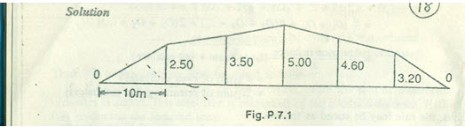
Area = common distance* sum of mid-ordinates

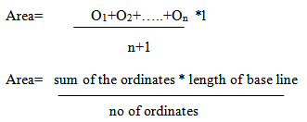
Let O1, O2, …..On=ordinates or offsets at regular intervals
l= length of base line
n= number of divisions
n+1= number of ordinates
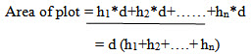

b.THE TRAPEZOIDAL RULE
While applying the trapezoidal rule, boundaries between the ends of ordinates are assumed to be straight. Thus the areas enclosed between the base line and the irregular boundary line are considered as trapezoids.
Let O1, O2, …..On=ordinate at equal intervals, and d= common distance between two ordinates
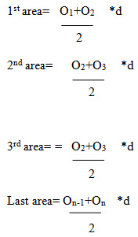
Total area=d/2{ O1+2O2+2O3+…….+2On-1+On}
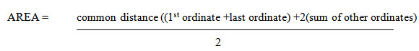
Thus the trapezoidal rule may be stated as follows:
To the sum of the first and last ordinate, twice the sum of intermediate ordinates is added. This total sum is multiplied by the common distance. Half of this product is the required area.
Limitation: There is no limitation for this rule. This rule can be applied for any number of ordinates
c.SIMPSON’S RULE
In this rule, the boundaries between the ends of ordinates are assumed to form an arc of parabola. Hence simpson’s rule is some times called as parabolic rule. Refer to figure:
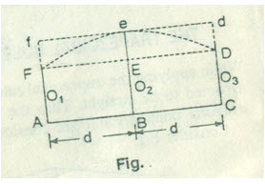
Let
O1, O2, O3= three consecutive ordinates
d= common distance between the ordinates
area AFeDC= area of trapezium AFDC+ area of segment FeDEF
Here,
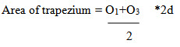
Area of segment= 2/3* area of parallelogram FfdD
= 2/3* eE*2d
= 2/3 *{ O2- O1+O3 /2 }*2d
So, the area between the first two divisions,
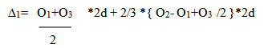
= d/3(O1+4O2+O3)
Similarly, the area of next two divisions
∆2 = d/3(O1+4O2+O3) and so on
Total area = d/3[O1+On+4(O2+O4+……) + 2(O3+O5)]
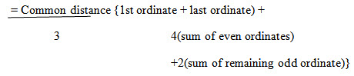
Thus the rule may be stated as the follows
To the sum of the first and the last ordinate, four times the sum of even ordinates and twice the sum of the remaining odd ordinates are added. This total sum is multiplied by the common distance. One third of this product is the required area.
Limitation: This rule is applicable only when the number divisions is even i.e. the number of ordinates is odd.
The trapezoidal rule may be compared in the following manner:
Trapezoidal rule | Simpson’s rule
The boundary between the ordinates is considered to be straight  There is no limitation. It can be applied for any number of ordinates  It gives an approximate result | The boundary between the ordinates is considered to be an arc of a parabola  To apply this rule, the number of ordinates must be odd  It gives a more accurate result.
Note: sometimes one or both the end of the ordinates may be zero. However they must be taken into account while applying these rules.
Worked- out problems
Problem 1: The following offsets were taken from a chain line to an irregular boundary line at an interval of 10 m:
0, 2.50, 3.50, 5.00, 4.60, 3.20, 0 m
Compute the area between the chain line, the irregular boundary line and the end of offsets by:
a) mid ordinate rule
b) the average –ordinate rule
c) the trapezoidal rule
d) Simpson’s rule
Solution: (Refer fig)
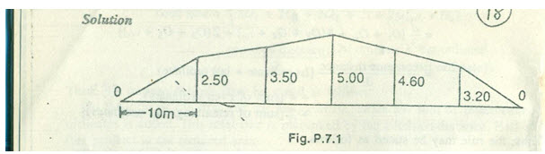
Mid-ordinate rule:
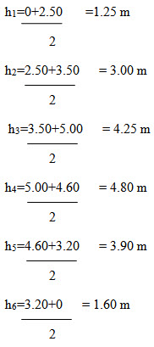
Required area= 10(1.25+3.00+4.25+3.90+1.60)
= 10*18.80=188 m2
By average-ordinate rule:
Here d=10 m and n=6(no of devices)
Base length= 10*6=60 m
Number of ordinates= 7
Required area=10((1.25+3.00+5.00+4.60+3.20+0)/7)
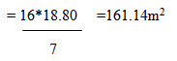
By trapezoidal rule:
Here d=10m
Required area=10/2{0+0+2(2.50+3.50+5.00+4.60+3.20+)}
= 5*37.60=188 m2
By Simpson’s rule:
d=10m
required area=10/3{0+0+4(2.50+5.00+3.20)+2(3.50+4.60)}
= 10/3{ 42.80+16.20}=10/3*59.00
10/3*59= 196.66m2

Problem 2: the following offsets are taken from a survey line to a curves boundary line, and the first and the last offsets by:
a) the trapezoidal rule
b) simpson’s rule
solution:
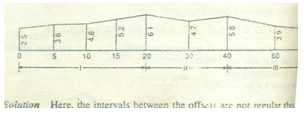
here the intervals between the offsets are not reglar through out the length.
So, the section is divided into three compartments
Let
∆I= area of the first section
∆II= area of 2nd section
∆III= area of 3rd section
Here
d1= 5 m
d2=10 m
d3=20 m
a) by trapezoidal rule
∆I= 5/2{2.50+6.10+2(3.80+4.60+5.20)} = 89.50 m2
∆II= 10/2{6.10+5.80+2(4.70)} =106.50 m2
∆III= 20/2{5.80+2.20+2(3.90)} = 158.00 m2
Total area = 89.50+106.50+158.00 = 354.00 m2
b) by simpson’s rule
∆I= 5/3{2.50+6.10+4(3.8+5.20) + 2(4.60)} = 89.66 m2
∆II= 10/3{6.10+5.80+4(4.70)} =102.33 m2
∆III= 20/3{5.80+2.20+4(3.90)} = 157.33 m2
Total area= 89.66+102.33+157.33 = 349.32 m2

FORMULA FOR CALCULATION OF VOLUME:
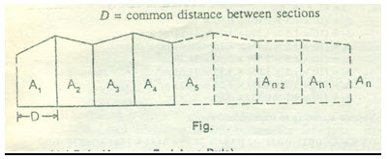
D= common distance between the sections
A. trapezoidal rule
volume (cutting or filling), V=D/2(A1+An+2(A2+A3+….+An-1))
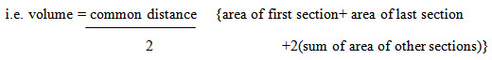
Prismoidal formula
Volume( cutting or filling), V= D/3{A1+ An +4(A2+ A4+ An-1)+ 2(A3+ A5+….+ Ann-1)}

i.e. V=common distance {area of 1st section+ area of last section+ 4(sum of areas of even sections)
3 +2(sum of areas of odd sections)
Note: the prismoidal formula is applicable whrn there is an odd number of sections. If the number of sections is even, the end strip is treated separately and the area is calculated according to the trapezoidal rule. The volume of the remaining strips is calculated in the usual manner by the prismoidal formula. Then both the results are added to obtain the total volume.
Works out problems
Problem 1: an embankment of width 10 m and side slopes 1 ½:1 is required to be made on a ground which is level in a direction transverseto the centre line. The central heights at 40 m intervals are as follows:
0.90,1.25,2.15,2.50,1.85,1.35, and 0.85
Calculate the volume of earth work according to
i) Trapezoidal formula
ii) Prismoidal formula
Solution: the c/s areas are calculated by
∆= (b+sh)*h
∆1= (10+1.5*0.90)*0.90 = 10.22 m2
∆2= (10+1.5*1.25)*0.90 = 14.84 m2
∆3= (10+1.5*1.25)*2.15 = 28.43 m2
∆4= (10+1.5*2.50)*2.50 = 34.38 m2
∆5= (10+1.5*1.85)*1.85 = 23.63 m2
∆6=(10+1.5*1.35)*1.35 = 16.23 m2
∆7=(10+1.5*0.85)*0.85= 9.58 m2
(a) Volume according to trapezoidal formula
V= 40/2{10.22+ 9.58+2(14.84+28.43+34.38+23.63+16.23)}
= 20{19.80+235.02} = 5096.4 m2
(b) Volume calculated in prismoidal formula:
V = 40/3 {10.22+9.58+4(14.84+34.38+16.23)+2(28.43+23.63)}
= 40/3 (19.80+ 261.80+104.12) = 5142.9 m2
Problem the areas enclosed by the contours in the lake are as follows:
Contour (m) | 270 | 275 | 280 | 285 | 290
Area (m2) | 2050 | 8400 | 16300 | 24600 | 31500

Calculate the volume of water between the contours 270 m and 290 m by:
i) Trapezoidal formula
ii) Prismoidal formula
Volume according to trapezoidal formula:
=5/2{2050+31500+2(8400+16300+24600)}
=330,250 m3

UNIT VI: CONSTRUCTION SURVEYS

- Setting Out a Building:
The foundation plan of the building is usually supplied or it can be prepared from the given wall plan of the building and size of foundations for different walls. It is of little use to set the pegs or stakes at the exact position of each of the comers of the building as they would be dug out while excavating the foundations.

The equipment required for the job consists of:
- A 30 m steel tape,
- Two metallic tapes (15 m or 30 m),
- A long cord,
- A plumb-bob.
- Stakes or pegs,
- Nails, and
- A hammer.

Setting out buildings by circumscribing rectangle:
The reference rectangle set outside the limits of excavation 2 to 5 meres from the building line as shown is known as circumscribing rectangle. The reference pegs P, Q, R and S will remain undisturbed during excavation.

The co-ordinates of all the corners w.r.t. the sides of the reference rectangle are calculated and shown in a tabular form given below on the foundation plan.
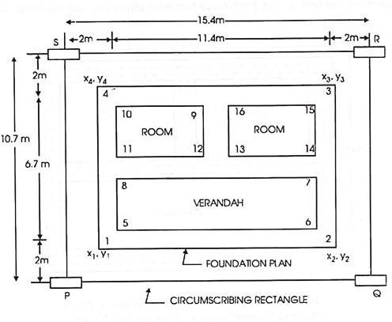

Procedure:

Two stakes P and Q are accurately driven at the required distance apart the ends P and Q being represented by wire nails driven at the centre of the pegs Stretch a cord between P and
Q. At P set out a perpendicular PS to PQ with a tape by 3, 4, 5 triangle method. Drive a stake at S, PS being the required distance (10.7 m). Check the diagonal QS.

Follow the similar procedure at Q to set the stake at R. Check the diagonal PR. The distance RS should be exactly equal to PQ. The rectangle PQRS is the reference rectangle and the comers of the foundation plan are fixed by measuring their coordinates from the sides of the reference rectangle e.g. corner 1 is fixed by measuring its co-ordinates x1 and y1 (2m, 2m) from PS and PQ respectively, and stake is driven into mark its exact position, when all the corners are staked, cord should be passed round the periphery of the figures 1, 2, 3, 4, 5, 6, 7, 8, 9, 10, 11, 12 etc. and the outline of the foundation marked by spreading lime along these lines.

Setting out building by centre line rectangle:
The reference rectangle formed by centre lines of the outside walls of the building as shown is known as center line rectangle and the corners are located by measuring their co-ordinates with references to the side of this rectangles.
The stakes put in at PQRS will be lost during excavation, therefore, reference stakes should be established on the prolongation of the sides of this rectangle stakes should be established on the prolongation of the sides of this rectangle where they remain undisturbed say about 2m from the building line.
In case of precise working i.e. for important buildings, a theodolite should be used for setting our right angles.
Bench marks should be established in convenient positions away from the site of work so that they remain undisturbed until the work is completed.
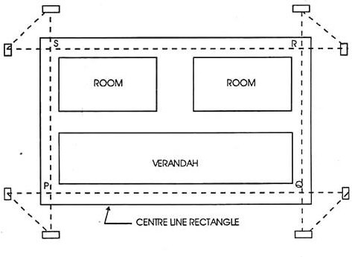

Setting out Culvert:
    - A culvert is set out by locating the corners of the abutments and wing walls at the foundation by means of their co-ordinates with reference to the centre lines of a road and a stream (nalla) crossed.
    - The centre lines of road and stream which cross each other are taken as axes of co-ordinates, thier origin being at the centre of the culvert.
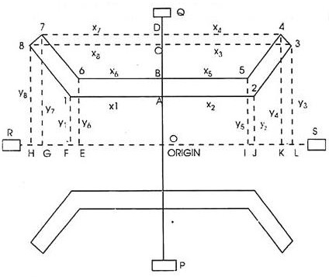
    - The co-ordinates of different points are found from the foundation plan and indicated in the tabular form.

Procedure:

    - Derive a peg at 0 and set up a theodo lite over it. Fix points A, B, C, D etc. on line POQ by arrows. The cord passing through the eyes of the arrows will define the line PQ.
    - Set out the line RS at right angles to PQ and fix the points EFGH, IJKI, etc by arrows.
    - Stretch the cords along lines PQ and Rs. Set off the distances OA, OB, OC etc on PQ and OE, OF, OI, OJ etc. on RS and fix arrows at all these points. Set out corner 1 by measuring co- ordinates x1 and y1 from A and F respectively with the help of two tapes and mark it with a peg.
    - Similarly, fix other points by their co-ordinates and drive pegs at each point.
    - Pass a cord around the periphery of abutment and wing wails as 1, 2, 3, 4, 5, 6, 7, 8 and mark the outline of the foundation with lime and by nicking i.e. cutting a narrow trench along this line.
    - Similarly fix the corners of other abutment and wing walls and mark the outline of the foundation.
    - Take levels at all pegs and determine depth and quantities of excavation.
If the wing walls are curved, the points on the curve may be set out by offsets to the chords 1- 8, 6-7 and 2-3, 4-5

Setting out Bridges:
The setting out of a culvert is quite simple because there is only one span and the flow of water is less. Even if the flow of water is more, it can be easily diverted. But in the case of Bridges and dams, the flow of water cannot be diverted and also the length may be very long. Therefore setting out is not possible from the centre of the bridge.
The setting out involves the following operations:
    - Preparation of topographic map of the bridge site.
    - Determination of the length of the bridge.
    - Location of piers.

Preparation of topographic map:
A topographic survey of the bridge site and approaches to the bridge is required for long and important bridges.

Tacheometric methods are used for the survey work and contouring and the map must indicate the following:
    - The north line
    - The name of river and the direction of flow of water,
    - The name of the nearest town or village on either side of the bridge.
    - The width of the proposed roadway.
    - The width of existing roadway if any.
    - The radius of curvature of the curve at approach road.
    - The position and description of Bench Marks and the ground levels on both the banks for a distance of about 150 m both on upstream as well as downstream sides. The normal, lowest and highest levels of water.
    - The catchment area.
    - The maximum velocity and discharge at the bridge site.
    - The detail and results of trial pits and borings etc.

Determination of the length of the bridge:
    - The length of the bridge is required to be measured along the centre line. If the bridge is short, the length may be measured directly with a steel tape but that of a large bridge is measured by method of triangulation.
    - Let A and B be the two points on opposite banks on the centre line of the road. Any one of the following methods may be adopted to find the length of the bridge

Procedure:
    - Set out the base lines AC and BD along both banks of the river.
    - Join CD, BC and AD. Then ABDC is a quadrilateral having BC and AD as their diagonals.
    - Measure the base lines AC and BD and the eight angles as shown very accurately.
    - Adjust the quadrilateral by approximate method or by method of squares.
    - Calculate the length AC from the corrected length of BD and the adjusted values of the angles and compare it with its measured value.
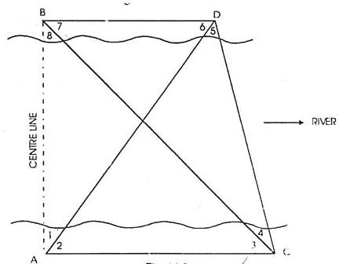

Tunnel Survey is that branch of survey that is concern with the surveying in a tunnel. This type of survey is required in mining works, deep tunnel sewerage works and underground railway works. The techniques used in this type of survey are different from those used on ground.

Tunnel Alignment:

Tunnel alignment is simply the position or layout of the tunnel on the ground; the alignment can be either horizontal or vertical. While a horizontal alignment runs along the tunnel center, a vertical alignment defines the changes in elevations of the tunnel.
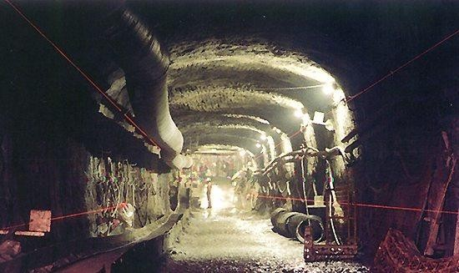

Applications of Underground Surveys:
The major application of underground surveys is in the construction of tunnels and other underground utilities. The tunnel is constructed when open excavation becomes uneconomical usually when it is more than 20 m. The following are the various applications:

- Reduces the grade
- Shortens the distance between given points separated by a dividing mountain or ridge.
- Meets the demand of-modern rapid transit in a city.
- Engineering operations to be performed
- Exact alignment
- Proper gradient
- Establishment of permanent stations marking the proposed route.

Factors affecting location of a tunnel:

- It should follow the best line adopted to the proposed traffic.
- It should be most economical in construction an operation.
- Convenience Ingress (enter) and Egress (leave)

Surveying Steps in Tunnels:

- Surface Survey
- Transferring the alignment under ground
- Transferring levels under ground

Surface Survey:
This includes:

- A preliminary survey by transit and staid for 2-3miles (3-4km) on either side of the proposed alignment.
- A plan (map) with a scale of say 1in 100 in with contours drawn at 5m (20) intervals.
- Final alignment is selected form this plan.
- A detail survey of the geological information of strata as the cost of tunneling depends upon the nature of materials to be encountered.

The proposed route having been decided upon, the following points require consideration.

- Alignment of the centre line of the tunnel.
- Gradient to be adopted.
- Determination of the exact length of tunnel.
- Establishment of permanent stations marking the line.

Transferring the alignment under ground:
vertical shafts are also sunk up to the required depth along the alignment of the tunnel at intermediate locations along the routes. The vertical alignment can be done by

- Plumb bob
- Optical collimator
- Laser
A heavy plumb bob (5 to 10 kg) is suspended on either a wire of heavy twine. Oscillations of the bob can be controlled by suspending it in a pot with high viscosity oil. The bob is suspended from a removable bracket attached to the surface side of the shaft. Optical plumbing becomes important with the increase in depth of internal shaft. Various types of plummet are available for upwards and downward sighting to allow the establishment of a vertical line and these are normally manufactured so as to be interchangeable with theodolites on their tripods. As the line of sight of a theodolite in adjustment will transit in a vertical plane, it can also be used to check perpendicularity. The advantages of an optical collimator are:

- More convenient than a plumb bob.
- Can be used to set marks directly on the floor of a completed shaft
- No wires as in case of plumb bob.
A laser equipment can be, used to, provide a vertical line of sight. The laser generates a light beam of high intensity and of low angular divergence and can be projected over long distances since the spread of the beam is very small to provide a visible line for constant reference

Transferring levels under ground:

Leveling on the surface is done in the usual way and the levels are transferred underground at the ends of the tunnel from the nearest bench mark.
In transferring levels underground, little difficulty is encountered at the ends of the tunnel, but at the shaft use is made of

- Steel tape
- Chain
- Constructed rods
- Steel wires
Now a days EDMI is also used. But in all cases the main idea is to deduct the height of the shaft measured from the top of a benchmark of known value.

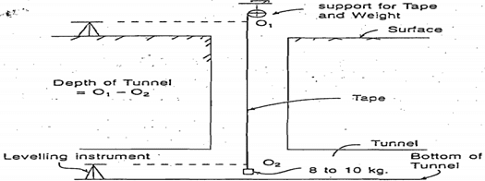

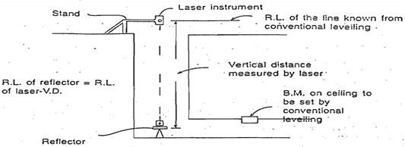
Figure showing how depth is measured by using steel tape.

Figure showing how depth is calculated by using EDM

The important features of EDM are:

- EDMI unit and reflectors should be in the same vertical line.
- Both are mounted on stable support.
- Visibility should be good for EDMI to operate.

