UNIT –IV
MOS TRANSISTORS

The metal-oxide semiconductor field-effect transistor (MOSFET) is actually a four-terminal device. In addition to the drain, gate and source, there is a substrate, or body, contact. Generally, for practical applications, the substrate is connected to the source terminal. If this is the case (and it usually is), the MOSFET may be considered a standard three-terminal device, with the drain, gate and source the terminals.

Device structure of MOSFET:

Figure.1: Structure of MOSFET
Figure .1depicts a simplified view of the basic structure of an n-channel enhancement mode transistor, which is formed on a p-type substrate of moderate doping level. As shown in the figure, the source and the drain regions made of two isolated islands of n⁺-type diffusion. These two diffusion regions are connected via metal to the external conductors. The depletion regions are mainly formed in the more lightly doped p-region. Thus, the source and the drain are separated from each other by two diodes, as shown in Figure. The region between the two diffused islands under the oxide layer is called the channel region. The channel provides a path for the majority carriers (electrons for example, in the n-channel device) to flow between the source and the drain.
There are two types of MOSFETs, called Enhancement type and Depletion type. Each of these type can be manufactured with a so called N-channel or P-Channel. i.e,
Enhancement type MOSFET: N-Channel MOSFET
P –Channel MOSFET

Depletion type MOSFET: N-Channel MOSFET
P –Channel MOSFET

1.Operation of N-Channel Enhancement MOSFET
- Positive charges accumulate in gate as a positive voltage applies to gate electrode.
- Electric field forms a depletion region by pushing holes in p‐type substrate away from the surface.
- Electrons accumulate on the substrate surface as gate voltage exceeds a threshold voltage V_{t.}
- The induced n region thus forms a channel for current flow from drain to source.
- The channel is created by inverting the substrate surface from p‐type to n‐type i.e., inversion layer.
- The field controls the amount of charge in the channel and determines the channel conductivity.
Figure.2 N- Channel MOSFET Terminal Connection

Figure .3.Drain Characteristics for constant V_{GS} values
- The MOS structure forms a parallel‐plate plate capacitor with gate oxide layer in the middle.
- Two pn junctions (S‐B and D‐B) are connected as back to back diodes.
- The source and drain terminals are isolated by two depletion regions without conducting current.

Applying a small drain voltage:

- A positive V_{GS} > V_{t} is used to induce the channel $→$ n‐channel enhancement‐type MOSFET
- Free electrons travel from source to drain through the induced n‐channel due to a small V_{DS.}
- The current iD flows from drain to source (opposite to the direction of the flow of negative charge).
- The current is proportional to the number of carriers in the induced channel.
- The channel is controlled by the effective voltage or overdrive voltage: V_{OV} = V_{GS}-V_{t} .
- The electron charge in the channel due to the overdrive voltage: |Q| = C_{OX} WL V_{OV} .
- Gate oxide capacitance Cox is defined as capacitance per unit area.
- MOSFET can be approximated as a linear resistor in this region with a resistance value inversely proportional to the excess gate voltage.

Operation as increasing drain voltage:

- As V_{DS} increases, the voltage along the channel increases from 0 to V_{DS}.
- The voltage between the gate and the points along the channel decreases from _{VGS} at the source end to (V_{GS}-V_{DS}) at the drain end.
- Since the inversion layer depends on the voltage difference across the MOS structure, increasing V_{DS} will result in a tapered channel.
- The resistance increases due to tapered channel and the i_{D}‐V_{DS} curve is no longer a straight line.
- At the point V_{DSSat} = V_{GS} – V_{t}, the channel is pinched off at the drain side
- Increasing V_{DS} beyond this value has little effect on the channel shape and i_{D} saturates at this value.
- Triode region: V_{DS} < V_{DSSat.}
- Saturation region: V_{DS}$≥$ V_{DSSat .}

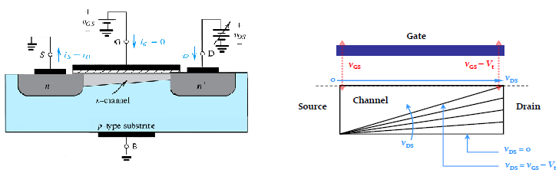
Figure .4:Drain pinch off

Figure. 5: Symbol of N-Channel MOSFET

Current‐Voltage Characteristics:
Three MOS operating regions are: Cutoff or subthreshold region, linear region and saturation region. The following equation describes all these three regions.
- Cut‐off region: (V_{GS} $≤$Vt)
- Triode region: (V_{GS}> V_{t} and V_{DS} < V_{GS} – V_{t})
$i_{D}=μ_{n} C_{ox}\frac{W}{L}[\left(V_{GS}-V_{t}\right)V_{DS}-\frac{1}{2}{V_{DS}}^{2}$]

- Saturation: ($V_{GS}$ $>V_{t}$ and$V_{DS}>V_{GS}-V_{t}$)
$$i_{D}=\frac{1}{2}μ_{n}C_{ox}\frac{W}{L}{\left(V_{GS}- V_{t}\right)}^{2}$$

Figure .6: V-I Characteristics of MOSF ET Figure 7: Relation between V_{GS}, I_{D} for fixed V_{DS}

2. Operation of P-Channel Enhancement MOSFET
- p‐channel enhanced‐type MOSFETs are fabricated on n‐type substrate with p+ source and p+ drain.
- Normally, source is connected to high voltage and drain is connected to low voltage.
- As a negative voltage applies to the gate, the resulting field pushes electrons in n‐type substrate away from the surface, leaving behind a carrier‐depletion region.
- As gate voltage exceeds a negative threshold voltage Vt , holes accumulate on the substrate surface.
- A p‐type channel (inversion layer) is induced for current flow from source to drain.
- Negative gate voltage is required to induce the channel $→$ enhancement‐type MOSFET.

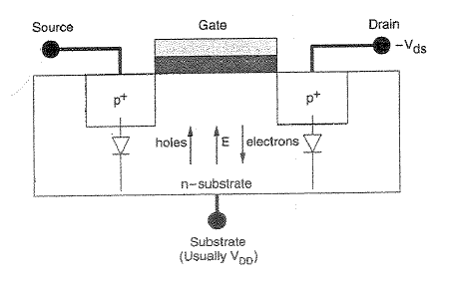
Figure 8: P-Channel MOSFET
Current‐Voltage Characteristics:
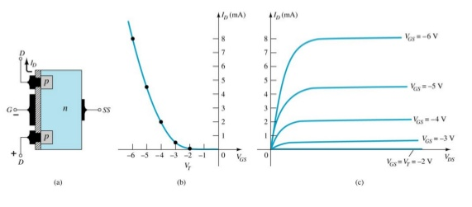
Figure 9: V-I Characteristics

Circuit Symbols of Enhancement mode N and P Channel MOSFETs:
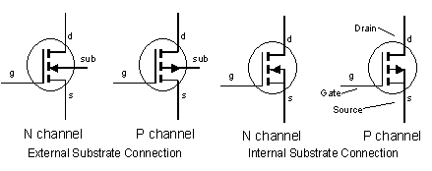
Figure.10: Circuit Symbols of N & P -Channel MOSFETs
3. Depletion Type N-channel MOSFET
In the depletion type n-channel MOSFET (D-NMOS): an n-type layer is added to the MOSFET structure and a channel is present even with no voltage applied to the gate

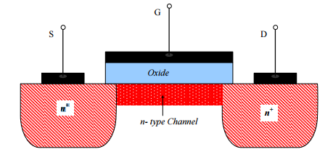
Figure 11 Depletion type N-Channel MOSFET
Operation of D-NMOS:
1. Operation with V_{GS} > 0: When V_{GS} is increased it attracts more electrons towards the channel . Channel becomes more conductive: enhance.Therfore it conducts higher current i_{D}.
2. Operation with V_{GS} < 0: When V_{GS} is decreased (becoming negative) it repels electrons from the channel. Channel becomes depleted and therefore it conducts lower current i_{D}. As V_{GS} is further decreased it reaches a negative value where the channel becomes completely depleted. This value is the threshold voltage V_{t} .
V_{GS} > 𝑉_{t} ⇒ a channel is present and it conducts a current i_{D} > 0
V_{GS} ≤ 𝑉_{t} ⇒ the channel is fully depleted no current can pass and i_{D} = 0.
It is Identical to the enhancement type NMOS.

I-V Characteristics of D-NMOS
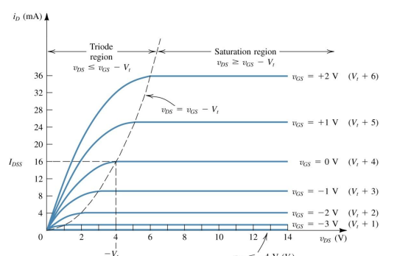
Figure.12:V-I Characteristics of Depletion Mode N-Channel MOSFET

D-NMOS Voltage –Current Equations:
I. –V_{GS} ≤ V_{t} No channel cut-off Region i_{D} = 0.
II. - V_{GS}> V_{t} Induced channel
  - V_{DS}≤ V_{GS} – V_{t}; ( V_{GD} ≥ V_{t} ) (continuous channel) Triode Region
  - $i_{D}=μ_{n} C_{ox}\frac{W}{L}[\left(V_{GS}-V_{t}\right)V_{DS}-\frac{1}{2}{V_{DS}}^{2}$]

III. ($V_{GS}$ $>V_{t}$ and$V_{DS}>V_{GS}-V_{t}$) (pinched-off channel) Saturation Region
$i_{D}=\frac{1}{2}μ_{n}C_{ox}\frac{W}{L}{\left(V_{GS}- V_{t}\right)}^{2}$.

These relations are identical to those of the E-NMOS, except that the value of V_{t} appearing in the relations is a negative number.

In Saturation Region:

At V_{GS} = 0; i_{D} = i_{DSS}
$i_{DSS}=\frac{1}{2}μ_{n}C_{ox}\frac{W}{L}{\left( V_{t}\right)}^{2}$.
Operation of D-PMOS:
In the depletion type n-channel MOSFET (D-PMOS): a P-type layer is added to the MOSFET structure and a channel is present even with no voltage applied to the gate.
Figure 11 Depletion type P-Channel MOSFET
Operaration of depleted mode P-channel Mosfet is exactly opposite to depleted mode N-Cannel Mosfet.
I-V Characteristics of D-PMOS:

Figure.14:V-I Characteristics of Depletion Mode P-Channel MOSFET

Circuit Symbols of Enhancement mode N and P Channel MOSFETs:

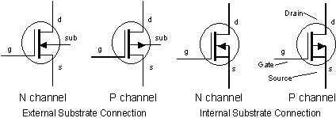
4.Complementary MOS (CMOS)
CMOS technology employs both PMOS and NMOS devices.
If substrate is p‐type, PMOS transistors are formed in n well (n‐type body needed).
If substrate is n‐type, NMOS transistors are formed in p well (p‐type body needed).
The substrate and well are connected to voltages which reverse bias the junctions for device isolation.
Figure 15.CMOS Structure

5.Second Order Effects:
Following are the list of second order effects of MOSFET.

- Threshold voltage – Body effect
- Subthreshold region
- Channel length modulation
- Mobility variation
- Fowler_Nordheim Tunneling
- Drain Punch through
- Impact Ionization – Hot Electrons

i) Threshold voltage – Body effect : The voltage at which an MOS device begins to conduct ("turn on"). The threshold voltage is a function of
- Gate conductor material
- Gate insulator material
- Gate insulator thickness
- Impurity at the silicon-insulator interface
- Voltage between the source and the substrate Vsb
- Temperature.
The change in the threshold voltage of a MOSFET, because of the voltage difference between body and source is called body effect. The expression for the threshold voltage is given by the following expression
$$V_{t}=V_{t\left(o\right) }+γ[({V_{SB}+2∅_{F)}}^{1/2} -\left({{2∅}_{F}}^{1/2}\right)$$
where $V_{t}$ is the threshold voltage
${ V}_{t\left(o\right) }is the threshold voltage$ without body effect
$γ$ is the body coefficient factor
W is the width of the transistor
L is the channel length of the transistor
$∅_{F}$ is the Fermi potential
V_{SB} is the potential difference between source and substrate.

If V_{SB} is zero, then V_{t} = V_{t(o)} that means the value of the threshold voltage will not be changed. Therefore, we short circuit the source and substrate so that, V_{SB} will be zero.

ii) Subthreshold region:

For V_{GS}<V_{t} also we will get some value of Drain current this is called as Subthreshold current and the region is called as Subthreshold region.

iii) Channel length modulation:

The channel length of the MOSFET is changed due to the change in the drain to source voltage. This effect is called as the channel length modulation. The effective channel length & the value of the drain current considering channel length modulation into effect is given by,

where λ is the channel length modulation factor.

iv) Mobility:

Mobility is the defined as the ease with which the charge carriers drift in the substrate material. Mobility decreases with increase in doping concentration and increase in temperature. Mobility is the ratio of average carrier drift velocity and electric field. Mobility is represented by the symbol μ.

v) Fowler Nordhiem tunneling:

When the gate oxide is very thin there can be a current between gate and source or drain by electron tunneling through the gate oxide. This current is proportional to the area of the gate of the transistor.

vi) Drain punch though:

When the drain is a high voltage, the depletion region around the drain may extend to the source, causing the current to flow even it gate voltage is zero. This is known as Punchthrough condition.

vii) Impact Ionization-hot electrons:

When the length of the transistor is reduced, the electric field at the drain increases. The field can become so high that electrons are imparted with enough energy we can term them as hot. These hot electrons impact the drain, dislodging holes that are then swept toward the negatively charged substrate and appear as a substrate current. This effect is known as Impact Ionization.

6. CMOS Inverter Characteristics

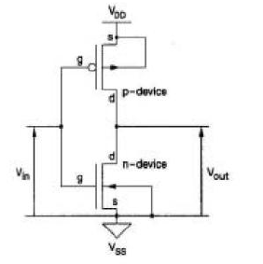
Figure 16:CMOS Inverter

CMOS inverters (Complementary NOSFET Inverters) are some of the most widely used and adaptable MOSFET inverters used in chip design. They operate with very little power loss and at relatively high speed. Furthermore, the CMOS inverter has good logic buffer characteristics, in that, its noise margins in both low and high states are large.

A CMOS inverter contains a PMOS and a NMOS transistor connected at the drain and gate terminals, a supply voltage VDD at the PMOS source terminal, and a ground connected at the NMOS source terminal, were VIN is connected to the gate terminals and VOUT is connected to the drain terminals.( given in diagram). It is important to notice that the CMOS does not contain any resistors, which makes it more power efficient that a regular resistor-MOSFET inverter. As the voltage at the input of the CMOS device varies between 0 and VDD, the state of the NMOS and PMOS varies accordingly. If we model each transistor as a simple switch activated by VIN, the inverter‘s operations can be seen very easily:
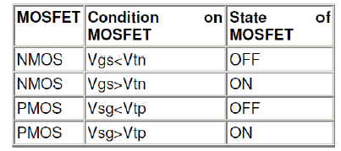
The table given, explains when the each transistor is turning on and off. When VIN is low, the NMOS is "off", while the PMOS stays "on": instantly charging VOUT to logic high. When Vin is high, the NMOS is "on and the PMOS is "off": taking the voltage at VOUT to logic low.
Inverter DC Characteristics:
The ideal characteristics of inverter is shown below. The characteristic shows that when input is zero output will high and vice versa.

Figure 17: Ideal Characteristics of CMOS Inverter

.
The actual characteristic is also given here for the reference. Here we have shown the status of both NMOS and PMOS transistor in all the regions of the characteristics.

Figure 18: Actual Characteristics of an Inverter.

Graphical Derivation of Inverter DC Characteristics:

The actual characteristics are drawn by plotting the values of output voltage for different values of the input voltage. We can also draw the characteristics, starting with the VI characteristics of PMOS and NMOS characteristics.

(a)

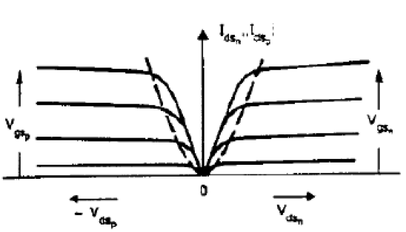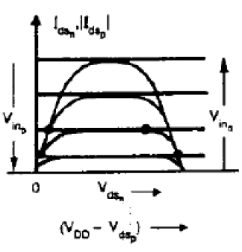
(b) (c)
Figure:19 Graphical Derivation of DC Characteristics

The characteristics given in figure 19 (a) is the V-I characteristics of the NMOS and PMOS characteristics (plot of Id vs. V_{DS} ). The figure 19(b) shows the values of drain current of PMOS transistor is taken to the positive side the current axis. This is done by taking the absolute value of the current. By superimposing both characteristics it leads to figure 19(c).The actual characteristics may be now determined by the points of common V_{GS} intersection as shown in figure 20.

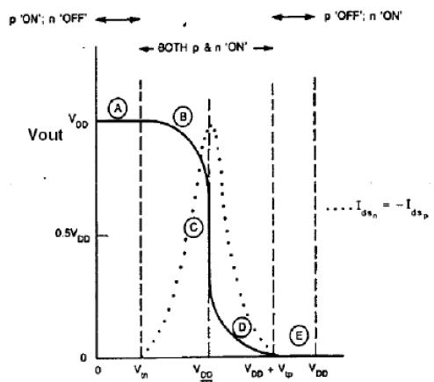
Figure: 20 CMOS Inverter Dc Characteristics.
Figure 20 shows five regions namely region A, B, C, D & E. also we have shown a dotted curve which is the current that is drawn by the inverter.
Region A: The output in this region is high because the P device is OFF and n device is ON. In region A, NMOS is cutoff region and PMOS is on, therefore output is logic high.

Region B: In this region PMOS will be in linear region and NMOS is in saturation region.
Region C: Both n and p transistors are in saturation region.
Region D: In this region NMOS will be in linear region and PMOS is in saturation region.
Region E: The output in this region is zero because the P device is OFF and n device is ON.

7. Small‐Signal Parameters of MOSFET:

Transconductance (g_{m}): It describes how i_{D} changes with V_{GS.}
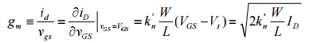

Output resistance (r_{o}): It describes how i_{D} change with V_{DS.}

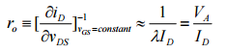

Drain current varies with V_{DS} due to channel length modulation. Finite r_{O} to model the linear dependence of i_{D} on V_{DS} .The effect can be neglected if ro is sufficiently large.

Body transconductance (gmb): It describes how i_{D} changes with V_{bs} .

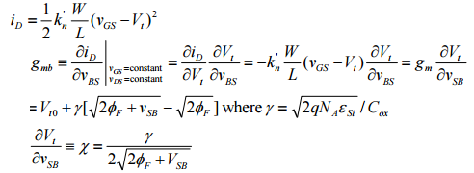

The body effect of the MOSFET is modeled by g_{mb} and it Can be neglected if body and source are connected together.

The small‐signal equivalent circuit models:

Hybrid‐πmodel

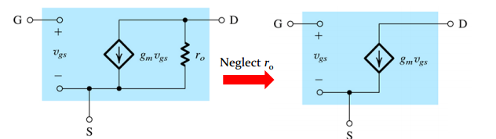

T‐model

