Unit – 5: Large Signal Amplifiers

Large signal or power amplifiers provide power amplification and are used in applications to provide sufficient power to the load or the power device. The output power delivered by these amplifiers is of the order of few watts to few tens of watts. They handle moderate-to-high levels of current and voltage signals as against small levels of current and voltage signals in the case of small signal amplifiers.

Classification of Large Signal Amplifiers

On the basis of their circuit configurations and principle of operation, amplifiers are classified into different classes.

Class A Amplifiers

A class A power amplifier is defined as a power amplifier in which output current flows for the full- cycle (360°) of the input signal. In other words, the transistor remains forward biased throughout the input cycle. The active device in a class A amplifier operates during the whole during the whole of the input cycle and the output signal is an amplified replica of the input signal with no clipping. The amplifying element is so biased that it operates over the linear region of its output characteristics during full period of the input cycle and is always conducting to some extent. Class A amplifiers offer very poor efficiency and a maximum of 50% efficiency is possible in these amplifiers

Class B Amplifier

Class B amplifiers operate only during the half of the input cycle. Class B amplifiers offer much
improved efficiency over class A amplifiers with a possible maximum of 78.5%. They also create a large amount of distortion.

Class B Amplifier

Class B amplifiers operate only during the half of the input cycle. Class B amplifiers offer much
improved efficiency over class A amplifiers with a possible maximum of 78.5%. They also reate a large amount of distortion.

Class AB Amplifier

In a class AB amplifier, the amplifying device conducts for a little more than half of the input
waveform. They sacrifice some efficiency over class B amplifiers but they offer better linearity than class B amplifier. They offer much more efficiency than class A amplifiers.

Class C Amplifiers

Class C amplifiers conducts for less than half cycle of the input signal resulting in a very high
efficiencies up to 90%. But they are associated with very high level of distortion at the output. Class C amplifiers operate in two modes, namely, the tuned mode and the unturned mode.

Class D Amplifiers

Class D amplifiers use the active device in switching mode to regulate the output power. These
amplifiers offer high efficiencies and do not require heat sinks and transformers. These amplifiers use pulse width modulation (PWM), pulse density modulation or sigma delta modulation to convert the input signal into a string of pulses. The pulse width of the PWM output waveform at any time instant is directly proportional to the amplitude of the input signal.

RC coupled Class A Power amplifier

If the collector current flows at all times during the full cycle of the signal, the power amplifier is known as class A amplifier.

With class A amplifier Q point lies middle of the load line so that signal can swing over the maximum possible range without saturating or cut off the transistor.

Common Emitter (CE) amplifiers are designed to produce a large output voltage swing from a relatively small input signal voltage of only a few mill volt's and are used mainly as “small signal amplifiers” as we saw in the previous tutorials.
However, sometimes an amplifier is required to drive large resistive loads such as a loudspeaker or to drive a motor in a robot and for these types of applications where high switching currents are needed Power Amplifiers are required.
The main function of the power amplifier, which are also known as a “large signal amplifier” is to deliver power, which is the product of voltage and current to the load. Basically a power amplifier is also a voltage amplifier the difference being that the load resistance connected to the output is relatively low, for example a loudspeaker of 4 or 8Ωs resulting in high currents flowing through the collector of the transistor.
Because of these high load currents the output transistor(s) used for power amplifier output stages such as the 2N3055 need to have higher voltage and power ratings than the general ones used for small signal amplifiers such as the BC107.
Since we are interested in delivering maximum AC power to the load, while consuming the minimum DC power possible from the supply we are mostly concerned with the “conversion efficiency” of the amplifier.
However, one of the main disadvantage of power amplifiers and especially the Class A amplifier is that their overall conversion efficiency is very low as large currents mean that a considerable amount of power is lost in the form of heat. Percentage efficiency in amplifiers is defined as the r.m.s. output power dissipated in the load divided by the total DC power taken from the supply source as shown below.

The total dc power, Pi(dc) , that an amplifier draws from the power supply :

That is 75% of the power supplied by the sources is dissipated in the transistors. This is a waste of power, and it leads to a potentially serious heating problems with the transistors.

Transformer coupled Class A amplifier

- Lower dc power loss due to very small resistance of transformer primary coil
- Impedance matching

As the Collector current, Ic is reduced to below the quiescent Q-point set up by the base bias voltage, due to variations in the base current, the magnetic flux in the transformer core collapses causing an induced emf in the transformer primary windings. This causes an instantaneous collector voltage to rise to a value of twice the supply voltage 2Vcc giving a maximum collector current of twice Ic when the Collector voltage is at its minimum. Then the efficiency of this type of Class A amplifier configuration can be calculated as follows.

The relationship between the primary and secondary values of voltage, current and impedance are summarized as:

N1, N2 = the number of turns in the primary and secondary
V1, V2 = the primary and secondary voltages
I1, I2 = the primary and secondary currents
Z1, Z2 = the primary and secondary impedance ( Z2 = RL )

Efficiency: Transformer coupled Class A amplifier

Principal advantage – lower distortion than Class C, B & AB.

Principal disadvantage – lower power efficiency than Class C, B & AB.

The transformer is subject to various power losses. Among these losses are couple loss and hysteresis loss. These transformer power losses are not considered in the derivation of the ɳ = 50% value.

AC and DC load line for Transformer coupled Class A amplifier

The nearly vertical load line of the transformer coupled amplifier is caused by the extremely
low dc resistance of the transformer primary.

Class B Power amplifier

- If the collector current flows during the half cycle of the signal only, the power
amplifier is known as class B amplifier.

- To have this kind of operation, Q point must be located at cut-off.

A 2nd class B BJT is needed to conduct for the negative v_{I} cycle.

Class B Push-Pull amplifier

To improve the full power efficiency of the previous Class A amplifier by reducing the wasted power in the form of heat, it is possible to design the power amplifier circuit with two transistors in its output stage producing what is commonly termed as a Class B Amplifier also known as a push-pull amplifier
configuration.
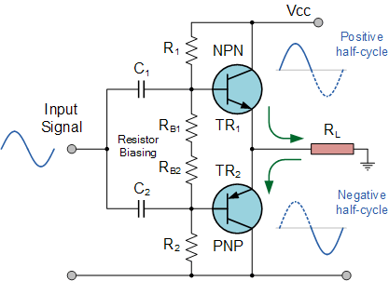

Push-pull amplifiers use two “complementary” or matching transistors, one being an NPN-type and the other being a PNP-type with both power transistors receiving the same input signal together that is equal in magnitude, but in opposite phase to each other. This results in one transistor only amplifying one half or 180º of the input waveform cycle while the other transistor amplifies the other half or remaining 180º of the input waveform cycle with the resulting “two-halves” being put back together again at the output terminal.
Then the conduction angle for this type of amplifier circuit is only 180º or 50% of the input signal. This pushing and pulling effect of the alternating half cycles by the transistors gives this type of circuit its amusing “push-pull” name, but are more generally known as the Class B Amplifier

Class B Crossover Distortion

Crossover distortion in audio power amps produces unpleasant sounds.

Efficiency: Push Pull Class B Power amplifier

COMPLEMENTARY SYMMETRY PUSH PULL AMPLIFIER
- The use of Transformers in Transformer coupled Push Pull AMPLIFIERS make it bulky and expensive especially in this age of Integrated circuits.
- Another drawback of the circuit is that it needs two out of Phase signals which necessitates an input tapped transformer or phase inverter, and thus makes the circuitary quite complicated.
The above two Drawbacks can be easily solved by using COMPLEMENTARY SYMMETRY PUSH-PULL AMPLIFIER.
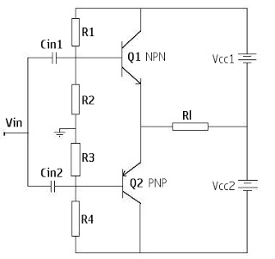
This arrangement uses two transistors having complementary symmetry (one transistor is PNP and the other is NPN). The term complementary arises from the fact that one transistor is N-P-N type and the other is P-N-P type. They have symmetry as they are made with the same material and technology and are of same maximum rating.
The resistors R1 and R2 provide the voltage divider bias to forward bias the Emitter-Base Junction of transistor Q1 and Similarly Resistors R3 and R4 provide the voltage divider bias for Emitter junction of transistor Q2. The Resistors are so selected that under zero signal condition, the operating point is cutoff and so no collector current flows.

The signal applied at the input goes to the base of both the transistors. The two transistors conduct in the opposite half cycle of input signal, the NPN transistor Q1 is forward biased and conducts while the PNP transistor Q2 is reverse biased and so does not conduct. This results in a half cycle of output voltage across the load, resistor Rl. Similarly during the negative half cycle only the PNP transistor Q2 is forward biased and conducts which develops second half cycle of the output voltage across the Load Resistor Rl. Transistor Q1 being reverse biased and does not conduct during the negative half cycle of the input signal. Thus during a complete cycle of input, a complete cycle of output will developed.

DRAWBACKS OF COMPLEMENTARY SYMMETRY PUSH PULL AMPLIFIERS
→It requires Two Supply Voltages
→It is quite Difficult to find two matched Transistors
→Harmonics will develop if there is any Unbalance in the two Transistors.

TUNED AMPLIFIER

'Tuned' amplifiers are amplifiers involving a resonant circuit, and are intended for selective amplification within a narrow band of frequencies. Radio and TV amplifiers employ tuned amplifiers to select one broadcast channel from among the many concurrently induced in an antenna or transmitted through a cable. Selected aspects of tuned amplifiers are reviewed in this note.

the various types of tuned amplifiers
(1) Small signal tuned amplifiers
a. Single tuned amplifiers
(i) Capacitive coupled
(ii) Inductively coupled (or) Transformer coupled
b. Double tuned amplifiers
c. Stagger tuned amplifiers
(2) Large signal tuned amplifiers

Usage of Parallel Resonance Circuit

• Because the collector voltage (output) is not a replica of the input, the resistively loaded class
C amplifier alone is of no value in linear applications.
• It is therefore necessary to use a class C amplifier with a parallel resonant circuit (tank).
• The short pulse of collector current on each cycle of the input initiates and sustains the
oscillation of the tank circuit so that an output sinusoidal voltage is produced.
• The tank circuit has high impedance only near the resonant frequency, so the gain is large only
at this frequency.

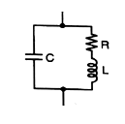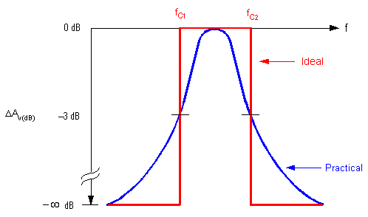

Quality Factor of Inductor

Every inductor possesses a small resistance in addition to its inductance. The lower the value of this resistance R, the better the quality of the coil. The quality factor or the Q factor of an inductor at the operating frequency ω is defined as the ratio of reactance of the coil to its resistance. Thus for a inductor, quality factor is expressed as,
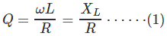
Where L is the effective inductance of the coil in Henrys and R is the effective resistance of the coil in Ohms. Obviously, Q is a dimensionless ratio. The Q factor may also be defined as
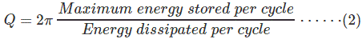
Thus, consider a sinusoidal voltage V of frequency ω radians/seconds applied to an inductor L of effective internal resistance R as shown in Figure 1(a). Let the resulting peak current through the inductor be I_{m}.
Then the maximum energy stored in the inductor
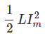

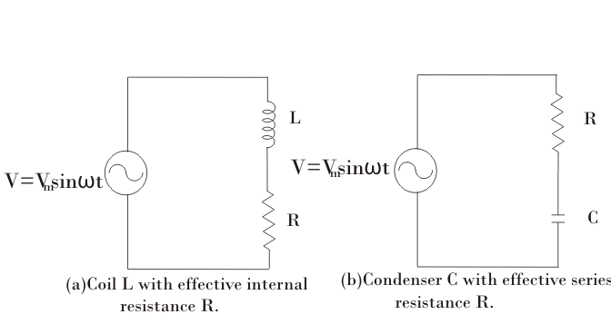
Figure 1.RL and RC circuits connected to a sinusoidal voltage sources

The average power dissipated in the inductor per cycle Hence, the energy dissipated in the inductor per cycle
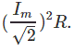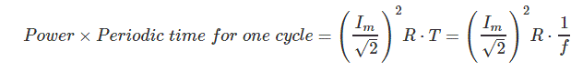
Hence,
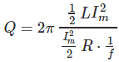

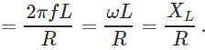

Quality Factor of a Capacitor

Figure 1(b). shows a capacitor C with small series resistance R associated within. The Q-factor or the quality factor of a capacitor at the operating frequency ω is defined as the ratio of the reactance of the capacitor to its series resistance. Thus,
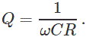
In this case also, the Q is a dimensionless quantity. Equation (2) giving the alternative definition of Q also holds good in this case. Thus, for the circuit of Figure 1(b), on application of a sinusoidal voltage of value V volts and frequency ω, the maximum energy stored in the capacitor

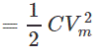
Where, V_{m} is the maximum value of voltage across the capacitance C. But if 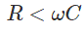
then
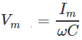

Where I_{m} is the maximum value of current through C and R. Hence, the maximum energy stored in capacitor C is

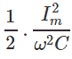

Energy dissipated per cycle
So, the quality factor of capacitor is

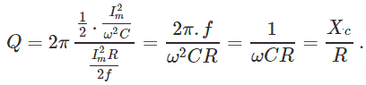
Often a lossy capacitor is represented by a capacitance C with a high resistance R_{p} in shunt as shown in Figure 2. Then for the capacitor of Figure 2, the maximum energy stored in the capacitor

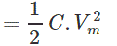
Where V_{m} is the maximum value of the applied voltage. The average power dissipated in resistance R_{p}
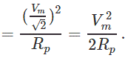

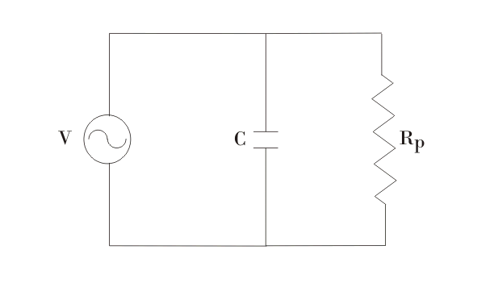
Figure 2. Alternative method of representing a lossy capacitor Energy dissipated per cycle
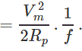
Hence,

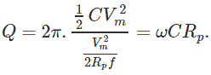

Small Signal tuned amplifier

advantages of tuned amplifiers

- They amplify defined frequencies.
- Signal to noise ratio at output is good
- They are suited for radio transmitters and receivers

disadvantages of tuned amplifiers

- The circuit is bulky and costly
- The design is complex.
- They are not suited to amplify audio frequencies.

classification of tuned amplifiers are

- Single tuned 2. Double tuned 3. Stagger tuned

Single tuned amplifier

A single tuned amplifier circuit that uses a single parallel tuned circuit as a load is called single tuned amplifier.

SIMPLIFIED EQUIVALENT CIRCUIT OF SINGLE TUNED AMPLIFIER MODEL
- Ci – input capacitance
- Ceq - output capacitance
- gce – output resistance of current generator

- Equating the admittance of series and parallel circuit.
- Admittance of series combination of RL is given as,

EFFECT OF CASCADING SINGLE TUNED AMPLIFIER

- Consider n stages of single tuned direct coupled amp. connected in cascade.
- The overall gain is the product of voltage gains of individual stages.
- The relative gain of single tuned amp. w.r.t resonance freq. is given as,

- The relative gain of n stage cascaded amplifier becomes
- The 3 dB frequencies for the n stage cascaded amplifier can be found by
equating,

Substituting for frequency deviation
Let f1 and f2 be lower 3dB and upper 3dB frequencies,

The BW on n stage identical amplifier is given as,

STAGGER TUNED AMPLIFIER

- Improves the overall frequency response.
- Overall response exhibits maximal flatness around the centre frequency.
- It needs a number of tuned circuit operating in union.
- The overall frequency response of a Stagger tuned amplifier is obtained by adding the
- individual response together.
- Since the resonant Frequencies of different tuned circuits are displaced or staggered, they are referred as STAGGER TUNED AMPLIFIER.
- INCREASED BANDWIDTH
- The stagger tuning in this circuit is achieved by resonating the tuned circuits L1,C1, L2 C2 to slightly different Frequencies.

- Single tuned amplifier with separate resonant frequencies are used in stagger tuned amplifier.

- The resonant frequencies are

- The gain of single tuned amplifier is
- According to this tuned frequencies, the selectivity function is given as,

- The overall gain is product of individual gain of the 2 stages

- Substituting for X,

