UNIT-IV
SURFACE AND SPACE WAVE PROPAGATION

Friis Transmission Equation:
The Friis Transmission Equation is used to calculate the power received from one antenna (with gain G1), when transmitted from another antenna (with gain G2), separated by a distance R, and operating at frequency f or wavelength lambda. This page is worth reading a couple times and should be fully understood.

Derivation of Friis Transmission Formula
To begin the derivation of the Friis Equation, consider two antennas in free space (no obstructions nearby) separated by a distance R:
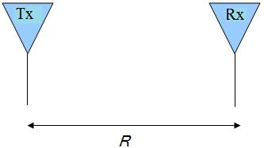
Figure 1. Transmit (Tx) and Receive (Rx) Antennas separated by R.
Assume that Watts of total power are delivered to the transmit antenna. For the moment, assume that the transmit antenna is omnidirectional, lossless, and that the receive antenna is in the far field of the transmit antenna. Then the power density p (in Watts per square meter) of the plane wave incident on the receive antenna a distance R from the transmit antenna is given by:
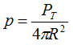
If the transmit antenna has an antenna gain in the direction of the receive antenna given by , then the power density equation above becomes:
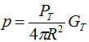
The gain term factors in the directionality and losses of a real antenna. Assume now that the receive antenna has an effective aperture given by . Then the power received by this antenna () is given by:
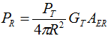
Since the effective aperture for any antenna can also be expressed as:
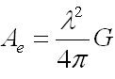
The resulting received power can be written as:
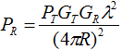 [Equation 1]
This is known as the Friis Transmission Formula. It relates the free space path loss, antenna gains and wavelength to the received and transmit powers. This is one of the fundamental equations in antenna theory, and should be remembered (as well as the derivation above).
Another useful form of the Friis Transmission Equation is given in Equation [2]. Since wavelength and frequency f are related by the speed of light c (see intro to frequency page), we have the Friis Transmission Formula in terms of frequency:
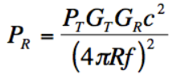 [Equation 2]
Equation [2] shows that more power is lost at higher frequencies. This is a fundamental result of the Friis Transmission Equation. This means that for antennas with specified gains, the energy transfer will be highest at lower frequencies. The difference between the power received and the power transmitted is known as path loss. Said in a different way, Friis Transmission Equation says that the path loss is higher for higher frequencies.
The importance of this result from the Friis Transmission Formula cannot be overstated. This is why mobile phones generally operate at less than 2 GHz. There may be more frequency spectrum available at higher frequencies, but the associated path loss will not enable quality reception. As a further consequence of Friss Transmission Equation, suppose you are asked about 60 GHz antennas. Noting that this frequency is very high, you might state that the path loss will be too high for long range communication - and you are absolutely correct. At very high frequencies (60 GHz is sometimes referred to as the mm (millimeter wave) region), the path loss is very high, so only point-to-point communication is possible. This occurs when the receiver and transmitter are in the same room, and facing each other.
GROUND WAVE PROPAGATION OR SURFACE WAVE PROPAGATION:
is a method of radio wave propagation that uses the area between the surface of the earth and the ionosphere for transmission. The ground wave can propagate a considerable distance over the earth's surface particularly in the low frequency and medium frequency portion of the radio spectrum. Ground wave radio propagation is used to provide relatively local radio communications coverage.
Ground wave radio signal propagation is ideal for relatively short distance propagation on these frequencies during the daytime. Sky-wave ionospheric propagation is not possible during the day because of the attenuation of the signals on these frequencies caused by the D region in the ionosphere. In view of this, lower frequency radio communications stations need to rely on the ground-wave propagation to achieve their coverage.
Typically, what is referred to as a ground wave radio signal is made up of a number of constituent waves. If the antennas are in the line of sight then there will be a direct wave as well as a reflected signal. As the names suggest the direct signal is one that travels directly between the two antennas and is not affected by the locality. There will also be a reflected signal as the transmission will be reflected by a number of objects including the earth's surface and any hills, or large buildings that may be present. In addition to this there is a surface wave. This tends to follow the curvature of the Earth and enables coverage beyond the horizon. It is the sum of all these components that is known as the ground wave. Beyond the horizon the direct and reflected waves are blocked by the curvature of the Earth, and the signal is purely made up of the diffracted surface wave. It is for this reason that surface wave is commonly called ground wave propagation.
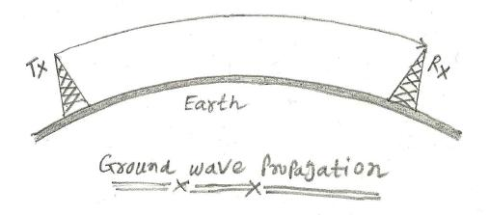
The radio signal spreads out from the transmitter along the surface of the Earth. Instead of just travelling in a straight line the radio signals tend to follow the curvature of the Earth. This is because currents are induced in the surface of the earth and this action slows down the wave-front in this region, causing the wave-front of the radio communications signal to tilt downwards towards the Earth. With the wave-front tilted in this direction it is able to curve around the Earth and be received well beyond the horizon.

Effect of frequency on ground wave propagation:
As the wavefront of the ground wave travels along the Earth's surface it is attenuated. The degree of attenuation is dependent upon a variety of factors. Frequency of the radio signal is one of the major determining factor as losses rise with increasing frequency. As a result, it makes this form of propagation impracticable above the bottom end of the HF portion of the spectrum (3 MHz). Typically a signal at 3.0 MHz will suffer an attenuation that may be in the region of 20 to 60 dB more than one at 0.5 MHz dependent upon a variety of factors in the signal path including the distance. In view of this it can be seen why even high power HF radio broadcast stations may only be audible for a few miles from the transmitting site via the ground wave.

Effect of the ground:
The surface wave is also very dependent upon the nature of the ground over which the signal travels. Ground conductivity, terrain roughness and the dielectric constant all affect the signal attenuation. In addition to this the ground penetration varies, becoming greater at lower frequencies, and this means that it is not just the surface conductivity that is of interest. At the higher frequencies this is not of great importance, but at lower frequencies penetration means that ground strata down to 100 meters may have an effect.
Despite all these variables, it is found that terrain with good conductivity gives the best result. Thus soil type and the moisture content are of importance. Salty sea water is the best, and rich agricultural, or marshy land is also good. Dry sandy terrain and city centers are by far the worst. This means sea paths are optimum, although even these are subject to variations due to the roughness of the sea, resulting on path losses being slightly dependent upon the weather. It should also be noted that in view of the fact that signal penetration has an effect, the water table may have an effect dependent upon the frequency in use.
Salient Features of Summerfield Theory:
Bohr was able to calculate the radii as well energies of the stationary orbit around the nucleus in an atom and those calculated values were found to be in a good agreement with the experimental values. He also gave the Hydrogen ion spectrum. For these reasons, his theory was widely accepted throughout the world. But a few years later, the use of high resolving power spectroscopes revealed some very fine spectral lines which Bohr was not able to explain. So from this point only, Somerfield extended Bohr Theory and gave his postulates.
According to him, the stationary orbits in which electrons are revolving around the nucleus in the atom are not circular but elliptical in shape. It is due to the influence of the centrally located nucleus. The electron revolves in elliptical path with nucleus at one of its foci. So there will be a major and a minor axis of the path. He said that with the broadening of the orbit, the lengths of the two axis approach to equal value and ultimately become equal i.e. the path become circular. So we can say the circular path is just one special case elliptical path.
As electrons travel in elliptical path, it will have an angular momentum and this angular momentum must be quantized according to the quantum theory of radiations. Bohr gave that angular momentum as m=nh/2Ω but Somerfield used another integer k instead of n. k is an integer known as azimuthally quantum number. n used by Bohr and k used by Somerfield are related as: –
n/k = length of major axis/length of minor axis
With increase in value of k, the path becomes more and more elliptical and eccentric. When k=n, the path becomes circular.
Bohr was not able to explain the reason for the fine spectral lines visible by high revolving power spectroscopes but Somerfield explained the reason for the same. He said that the energy of the stationary orbit depends not only on n but on k to some extent as well. So when a transition of electron from a higher level to a lower level occurs, it would be different from what proposed by Bohr as there may be more than one values of k. In this way Somerfield was able to explain the reason behind those fine spectral lines. Even the frequencies of some of those fine spectral lines came to be in well agreement with the frequencies by Somerfield.
Modes of Propagation:

Electromagnetic waves may travel from transmitting antenna to the receiving antenna in a number of ways.
Different propagations of electromagnetic waves are as follows,

(i) Ground wave propagation
(ii) Sky wave propagation
(iii) Space wave propagation
(iv) Tropospheric scatter propagation.

This classification is based upon the frequency range, distance and several other factors.

(i) Ground Wave Propagation

Ground wave propagation is also known as surface wave propagation. This propagation is practically important at frequencies up to 2 MHz. Ground wave propagation exists when transmitting and receiving antenna are very close to the earth's curvature. Ground wave propagation suffers attenuation while propagating along the surface of the earth.

This propagation can be subdivided into two types which are space wave and surface wave propagation

Applications
Ground wave propagation is generally used in TV, radio broadcasting etc.

(ii) Sky Wave Propagation

Sky wave propagation is practically important at frequencies between 2 to 30 MHz Here the electromagnetic waves reach the receiving point after reflection from an atmospheric layer known as ionosphere. Hence, sky wave propagation is also known as 'ionospheric wave propagation'. It can provide communication over long distances. Hence, it is also known as point-to-point propagation or point-to-point communication.

Disadvantage
Sky wave propagation suffers, from fading due to reflections from earth surface, fading can be reduced with the help of diversity reception.

Applications
1. It can provide communication over long distances.
2. Global communication is possible.

(iii) Space Wave Propagation

Space wave propagation is practically important at frequencies above 30 MHz It is also known as tropospheric wave propagation because the waves reach the receiving point after reflections from tropospheric region.

In space wave propagation, signal at the receiving point is a combination of direct and indirect rays. It provides communication over long distances with VHF .UHF and microwave frequencies. Space wave propagation is also known as "line of sight propagation".

Applications
1. Space wave propagation is used in satellite communication.
2. It controls radio traffic between a ground station and a satellite.

(iv) Troposcatter Propagation

Troposcatter propagation is also known as forward 1 scatter propagation, it is practically important at frequencies above 300 MHz.. This propagation covers long distances in the range of 160 to 1600 km.

Line-of-sight propagation :
Line-of-sight propagation is a characteristic of electromagnetic radiation or acoustic wave propagation which means waves which travel in a direct path from the source to the receiver. Electromagnetic transmission includes light emissions traveling in a straight line. The rays or waves may be diffracted, refracted, reflected, or absorbed by the atmosphere and obstructions with material and generally cannot travel over the horizon or behind obstacles.
In contrast to line-of-sight propagation, at low frequency (below approximately 3 MHz) due to diffraction radio waves can travel as ground waves, which follow the contour of the Earth. This enables AM radio stations to transmit beyond the horizon. Additionally, frequencies in the shortwave bands between approximately 1 and 30 MHz, can be reflected back to Earth by the ionosphere, called skywave or "skip" propagation, thus giving radio transmissions in this range a potentially global reach.
However, at frequencies above 30 MHz (VHF and higher) and in lower levels of the atmosphere, neither of these effects are significant. Thus, any obstruction between the transmitting antenna (transmitter) and the receiving antenna (receiver) will block the signal, just like the light that the eye may sense. Therefore, since the ability to visually see a transmitting antenna (disregarding the limitations of the eye's resolution) roughly corresponds to the ability to receive a radio signal from it, the propagation characteristic at these frequencies is called "line-of-sight". The farthest possible point of propagation is referred to as the "radio horizon".

Radio horizon:
The radio horizon is the locus of points at which direct rays from an antenna are tangential to the surface of the Earth. If the Earth was a perfect sphere and there was no atmosphere, the radio horizon would be a circle.
The radio horizon of the transmitting and receiving antennas can be added together to increase the effective communication range.
Radio wave propagation is affected by atmospheric conditions, ionospheric absorption, and the presence of obstructions, for example mountains or trees. Simple formulas that include the effect of the atmosphere give the range as:
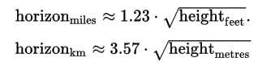
The simple formulas give a best-case approximation of the maximum propagation distance, but are not sufficient to estimate the quality of service at any location

Geometric distance to horizon
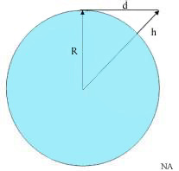
R is the radius of the Earth, h is the height of the transmitter (exaggerated), d is the line of sight distance

Assuming a perfect sphere with no terrain irregularity, the distance to the horizon from a high altitude transmitter (i.e., line of sight) can readily be calculated.
Let R be the radius of the Earth and h be the altitude of a telecommunication station. The line of sight distance d of this station is given by the Pythagorean theorem;
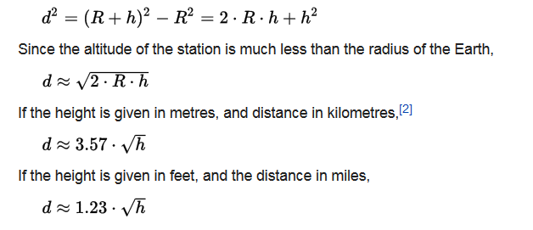

The actual service range:

The above analysis does not consider the effect of atmosphere on the propagation path of RF signals. In fact, RF signals don’t propagate in straight lines. Because of the refractive effects of atmospheric layers, the propagation paths are somewhat curved. Thus, the maximum service range of the station is not equal to the line of sight (geometric) distance. Usually, a factor k is used in the equation above
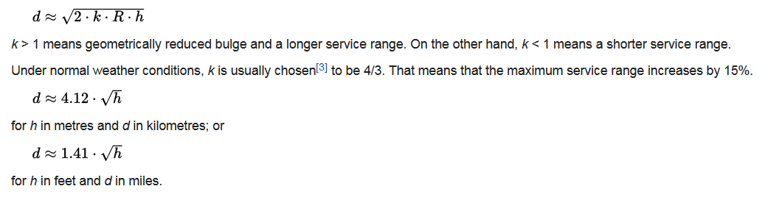
Effective Earth Radius:
