13EC3102-DIGITAL COMMUNICATIONS
Credits: 4
Lectures/Week: 4Hrs Sessional Marks: 40
End Exam Duration: 3Hrs End Exam.Marks:60
UNIT-I
Digital Communication System & Information Theory: Model Of A Digital Communication System – Unit Of Information – Entropy – Mutual Information – Channel Models And Channel Capacity – Shannon’s Theorem – Shannon-Hartley Theorem –Bandwidth – S/N Trade-Off – Source Encoding Of Discrete Memory Less Source – Shannon-Fanon coding – Huffman Coding – Coding Efficiency.
UNIT-II
Source Coding for Analog Signals: Review of Sampling Theorem – PCM System –Quantization Noise – Companding – B.W requirements of PCM – Differential PCM –Delta Modulation – Adaptive delta Modulation – Noise in PCM & Delta Modulation.
UNIT-III
Base Band Data Transmission: Characterization Of Band Limited Channels – Design of band limited signals for no Inter Symbol Interference (ISI) – The Nyquist criterion –Design of band limited signals with controlled ISI – Partial response signals –Transmitting & Receiving Filters for Optimum Performance– M-ary signaling scheme – Binary Vs M-ary – Equalization schemes – Eye diagrams.
UNIT-IV
Digital Carrier Modulation Schemes: ASK, FSK(coherent & Non coherent) – PSK –DPSK – Baseband signal receiver – Optimum & Matched Filters – Correlator – Comparison of Digital Modulation Schemes – Bandwidth requirement – Power requirement – Immunity to channel impairments – Equipment complexity – M-ary signaling schemes – synchronization methods.
UNIT-V
Error Control Coding : Linear Block Codes – Matrix Description – Hamming Codes – Decoding – Binary Cyclic Codes – Algebraic Structure – Encoding Using Shift Register – Syndrome Calculation – BCH Codes, Burst & Random Error Correcting Codes – Convolution Codes – Tree Diagram –State Diagram –Trellis Diagram– Encoders and Decoding Algorithms.

TEXT BOOKS:
- Digital Communications – Simon Haykin 2nd Edition, Tata McGraw-Hill Publishers.
- Analog & Digital Communication Systems –Sam Shanmugam,K, John Wiley & Sons
REFERENCE:
- Principles of Communication System – Taub, H & Schilling D.L, McGraw Hill.
- Communication Systems, Analog & Digital –R.P. Singh &S.D.Sapre,TMH Publishers
- Digital Communications –Proakis, J.G- McGraw Hill.

UNIT – I
DIGITAL COMMUNICATION SYSTEM & INFORMATION THEORY
Model of Digital communication system:
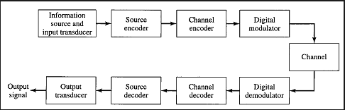

Digital Communication advantages :
Reliable communication;
Less sensitivity to changes in environmental conditions (temperature, etc.)
E asy multiplexing
Easy signaling
Hook status, address digits, call progress information
Voice and data integration
Easy processing like encryption and compression
Easy system performance monitoring „QOS monitoring
Integration of transmission and switching
Signal regeneration, operation at low SNR, superior performance
Integration of services leading to ISDN
Disadvantages:
Increased bandwidth 64 KB for a 4 KHz channel, without compression (However, less with compression)
Need for precision timing Bit, character, frame synchronization needed
Analogue to Digital and Digital to Analogue conversions
Very often non-linear ADC and DAC used, some performance degradation
Higher complexity D

Types of Digital Communication Systems
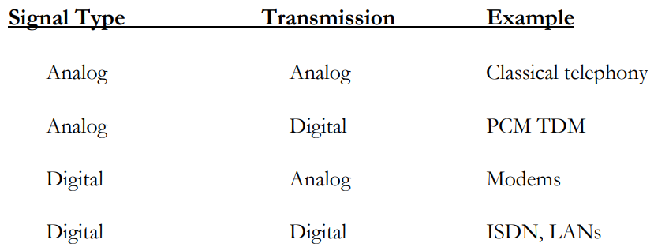

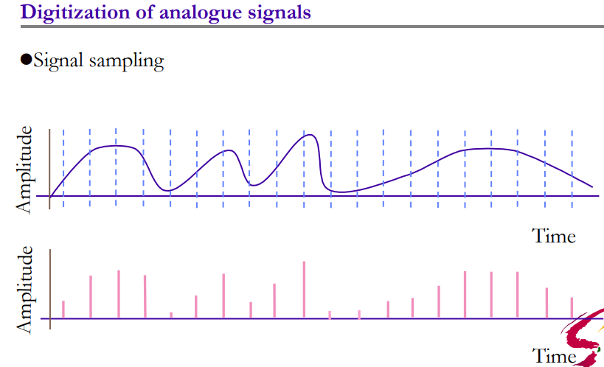
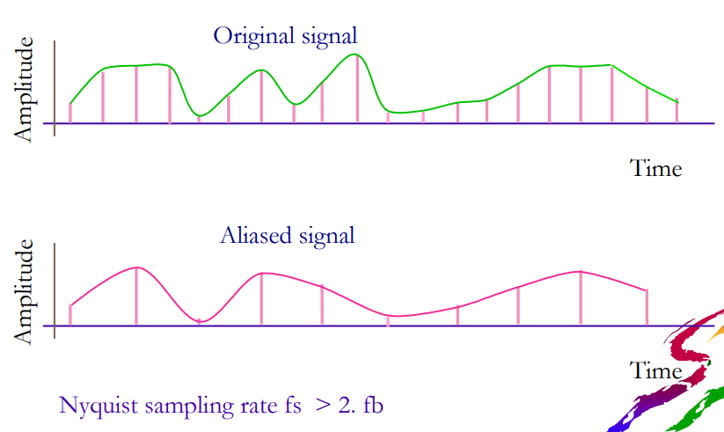
Unit of information:
unit of information is the capacity of some standard data storage system or communication channel, used to measure the capacities of other systems and channels. In information theory, units of information are also used to measure the entropy of random variables and information contained in messages.
The most commonly used units of data storage capacity are the bit, the capacity of a system that has only two states, and the byte (or octet), which is equivalent to eight bits

Advantages of Digital Communication
As the signals are digitized, there are many advantages of digital communication over analog communication, such as −
- The effect of distortion, noise, and interference is much less in digital signals as they are less affected.
- Digital circuits are more reliable.
- Digital circuits are easy to design and cheaper than analog circuits.
- The hardware implementation in digital circuits, is more flexible than analog.
- The occurrence of cross-talk is very rare in digital communication.
- The signal is un-altered as the pulse needs a high disturbance to alter its properties, which is very difficult.
- Signal processing functions such as encryption and compression are employed in digital circuits to maintain the secrecy of the information.
- The probability of error occurrence is reduced by employing error detecting and error correcting codes.
- Spread spectrum technique is used to avoid signal jamming.
- Combining digital signals using Time Division Multiplexing (TDM) is easier than combining analog signals using Frequency Division Multiplexing (FDM).
- The configuring process of digital signals is easier than analog signals.
- Digital signals can be saved and retrieved more conveniently than analog signals.
- Many of the digital circuits have almost common encoding techniques and hence similar devices can be used for a number of purposes.
- The capacity of the channel is effectively utilized by digital signals.

ELEMENTS OF DIGITAL COMMUNICATION
The elements which form a digital communication system is represented by the following block diagram.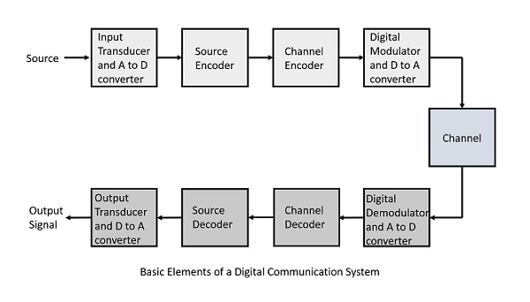
Following are the sections of the digital communication system.

Source
The source can be an analog signal. Example: A Sound signal

Input Transducer
This is a transducer which takes a physical input and converts it to an electrical signal (Example: microphone). This block also consists of an analog to digital converter where a digital signal is needed for further processes.
A digital signal is generally represented by a binary sequence.

Source Encoder
The source encoder compresses the data into minimum number of bits. This process helps in effective utilization of the bandwidth. It removes the redundant bits (unnecessary excess bits, i.e., zeroes).

Channel Encoder
The channel encoder, does the coding for error correction. During the transmission of the signal, due to the noise in the channel, the signal may get altered and hence to avoid this, the channel encoder adds some redundant bits to the transmitted data. These are the error correcting bits.

Digital Modulator
The signal to be transmitted is modulated here by a carrier. The signal is also converted to analog from the digital sequence, in order to make it travel through the channel or medium.

Channel
The channel or a medium, allows the analog signal to transmit from the transmitter end to the receiver end.

Digital Demodulator
This is the first step at the receiver end. The received signal is demodulated as well as converted again from analog to digital. The signal gets reconstructed here.

Channel Decoder
The channel decoder, after detecting the sequence, does some error corrections. The distortions which might occur during the transmission, are corrected by adding some redundant bits. This addition of bits helps in the complete recovery of the original signal.

Source Decoder
The resultant signal is once again digitized by sampling and quantizing so that the pure digital output is obtained without the loss of information. The source decoder recreates the source output.

Output Transducer
This is the last block which converts the signal into the original physical form, which was at the input of the transmitter. It converts the electrical signal into physical output (Example: loud speaker).

Output Signal
This is the output which is produced after the whole process. Example − The sound signal received.
This unit has dealt with the introduction, the digitization of signals, the advantages and the elements of digital communications.

Information is the source of a communication system, whether it is analog or digital. Information theory is a mathematical approach to the study of coding of information along with the quantification, storage, and communication of information.

Conditions of Occurrence of Events
If we consider an event, there are three conditions of occurrence.
- If the event has not occurred, there is a condition of uncertainty.
- If the event has just occurred, there is a condition of surprise.
- If the event has occurred, a time back, there is a condition of having some information.
These three events occur at different times. The difference in these conditions help us gain knowledge on the probabilities of the occurrence of events.

Entropy
When we observe the possibilities of the occurrence of an event, how surprising or uncertain it would be, it means that we are trying to have an idea on the average content of the information from the source of the event.
Entropy can be defined as a measure of the average information content per source symbol. Claude Shannon, the “father of the Information Theory”, provided a formula for it as −
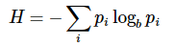

Where p_{i} is the probability of the occurrence of character number i from a given stream of characters and b is the base of the algorithm used. Hence, this is also called as Shannon’s Entropy.
The amount of uncertainty remaining about the channel input after observing the channel output, is called as Conditional Entropy. It is denoted by H(x∣y)

Mutual Information
Let us consider a channel whose output is Y and input is X
Let the entropy for prior uncertainty be X = H(x)
To know about the uncertainty of the output, after the input is applied, let us consider Conditional Entropy, given that Y = y_{k}

Now, considering both the uncertainty conditions (before and after applying the inputs), we come to know that the difference, i.e. H(x)−H(x∣y)H(x)−H(x∣y) must represent the uncertainty about the channel input that is resolved by observing the channel output.
This is called as the Mutual Information of the channel.
Denoting the Mutual Information as I(x;y)I(x;y), we can write the whole thing in an equation, as follows
I(x;y)=H(x)−H(x∣y)I(x;y)=H(x)−H(x∣y)
Hence, this is the equational representation of Mutual Information.

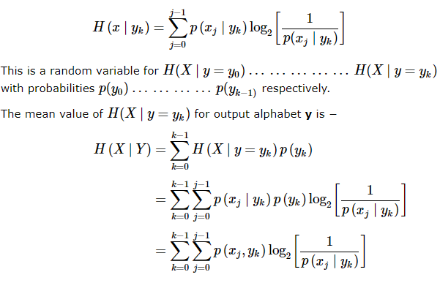
Now, considering both the uncertainty conditions (before and after applying the inputs), we come to know that the difference, i.e. H(x)−H(x∣y)H(x)−H(x∣y) must represent the uncertainty about the channel input that is resolved by observing the channel output.
This is called as the Mutual Information of the channel.
Denoting the Mutual Information as I(x;y)I(x;y), we can write the whole thing in an equation, as follows

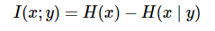

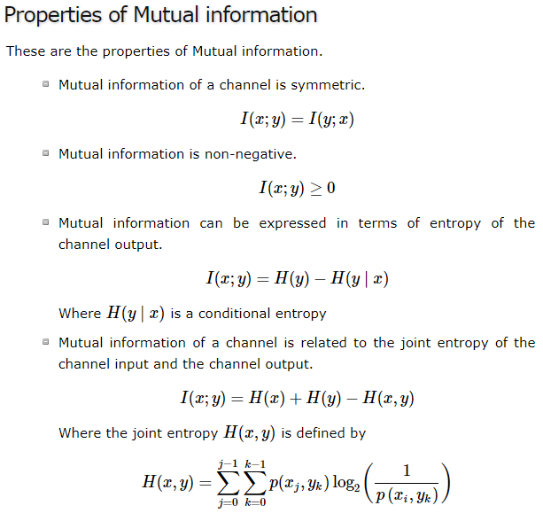

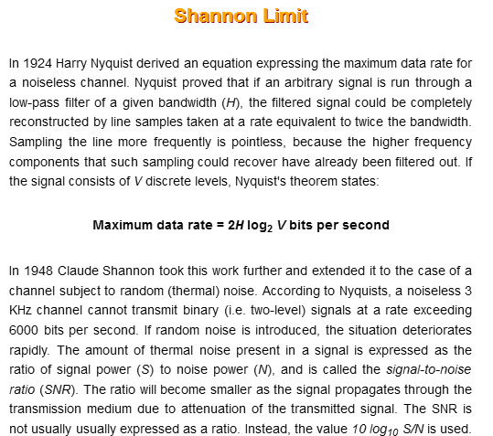

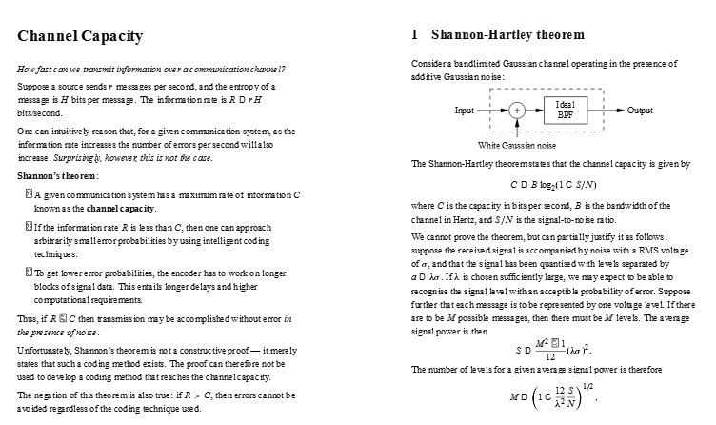

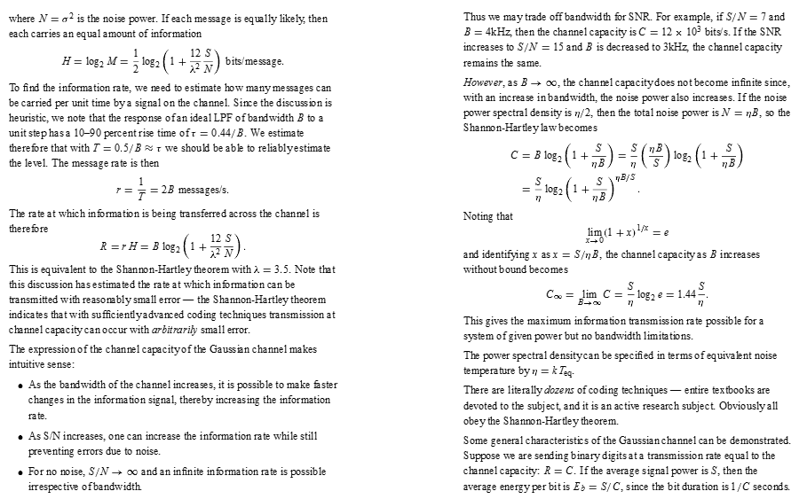

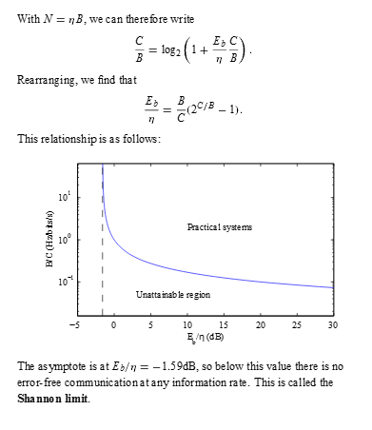

Channel Capacity
We have so far discussed mutual information. The maximum average mutual information, in an instant of a signaling interval, when transmitted by a discrete memoryless channel, the probabilities of the rate of maximum reliable transmission of data, can be understood as the channel capacity.
It is denoted by C and is measured in bits per channel use.

Discrete Memoryless Source
A source from which the data is being emitted at successive intervals, which is independent of previous values, can be termed as discrete memoryless source.
This source is discrete as it is not considered for a continuous time interval, but at discrete time intervals. This source is memoryless as it is fresh at each instant of time, without considering the previous values.

The Code produced by a discrete memoryless source, has to be efficiently represented, which is an important problem in communications. For this to happen, there are code words, which represent these source codes.
For example, in telegraphy, we use Morse code, in which the alphabets are denoted by Marks and Spaces. If the letter E is considered, which is mostly used, it is denoted by “.” Whereas the letter Q which is rarely used, is denoted by “--.-”
Let us take a look at the block diagram.
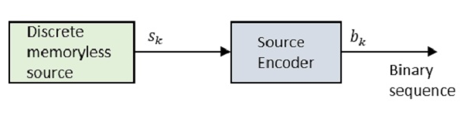
Where S_{k} is the output of the discrete memoryless source and b_{k} is the output of the source encoder which is represented by 0s and 1s.
The encoded sequence is such that it is conveniently decoded at the receiver.
Let us assume that the source has an alphabet with k different symbols and that the k^{th} symbol S_{k} occurs with the probability P_{k}, where k = 0, 1…k-1.
Let the binary code word assigned to symbol S_{k}, by the encoder having length l_{k}, measured in bits.
Hence, we define the average code word length L of the source encoder as
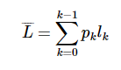
L represents the average number of bits per source symbol
¯
Then coding efficiency can be defined as
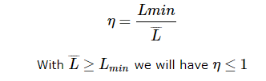
However, the source encoder is considered efficient when η=1η=1
For this, the value LminLmin has to be determined.
Let us refer to the definition, “Given a discrete memoryless source of entropy H(δ)H(δ), the average code-word length L for any source encoding is bounded as L¯¯¯¯≥H(δ)L¯≥H(δ)."
In simpler words, the code word (example: Morse code for the word QUEUE is -.- ..- . ..- . ) is always greater than or equal to the source code (QUEUE in example). Which means, the symbols in the code word are greater than or equal to the alphabets in the source code.
Hence with Lmin=H(δ)Lmin=H(δ), the efficiency of the source encoder in terms of Entropy H(δ)H(δ) may be written as

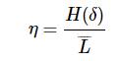

This source coding theorem is called as noiseless coding theorem as it establishes an error-free encoding. It is also called as Shannon’s first theorem.

The channel coding in a communication system, introduces redundancy with a control, so as to improve the reliability of the system. The source coding reduces redundancy to improve the efficiency of the system.
Channel coding consists of two parts of action.
- Mapping incoming data sequence into a channel input sequence.
- Inverse Mapping the channel output sequence into an output data sequence.
The final target is that the overall effect of the channel noise should be minimized.
The mapping is done by the transmitter, with the help of an encoder, whereas the inverse mapping is done by the decoder in the receiver.
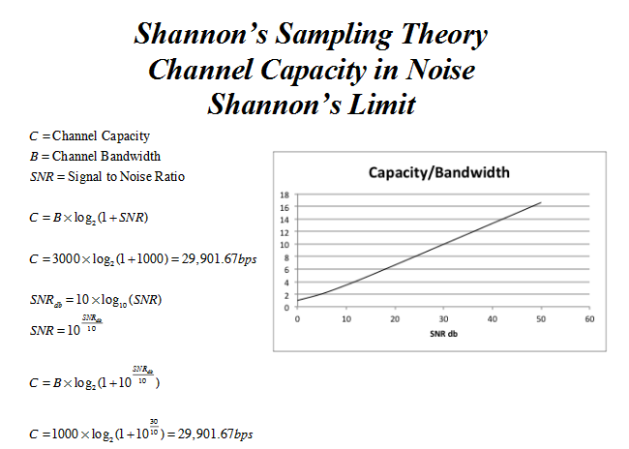

Channel Coding
Let us consider a discrete memoryless channel (δ) with Entropy H (δ)
T_{s} indicates the symbols that δ gives per second
Channel capacity is indicated by C
Channel can be used for every T_{c} secs
Hence, the maximum capability of the channel is C/T_{c}
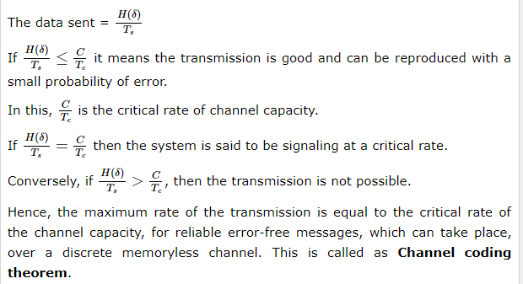

X is a random variable which has as its possible values u₁ through u_{n} where n is the number of possible values in the source language (the alphabet). For instance, in English, we have 26 letters, therefore u₁ would correspond to 'a', and u₂₆ would correspond to 'z'. Stated in more mathematical terms, we have:
X = { u₁, u₂, u₃, u₄, ... , u_{n}}, where n is the number of symbols in the source language. (for instance, in english, 1 <= n <= 26, X = { 'a', ..., 'z' } ).
P is a probability distribution of X.
P = { p₁, p₂, p₃, p₄, ..., p_{n} }, where n is the number of symbols in the source language, and each value within the distribution is less than or equal to 1.
S is a set of symbols in the coding alphabet. Note that r does not have to be the number of symbols in the source alphabet. It could be far less, and in the case of a computer, in binary code, it is much less.
S = { s₁, s₂, ..., s_{r} }, where r is the number of symbols in the code alphabet.
Every variable length code has a certain measure of how well it encodes a language. This is called the efficiency, and is simply a mathematical formula, which can be determined by the entropy (average information) of a code and the expected value of the length of the code. For a fixed length code, this is very straight forward, and is completely useless, though for a variable length code this is actually useful for comparing different codes.
A code's efficiency is determined as:
Hu
-------
<L> log r
Where Hu is the average information (Shannon's Theory of Information) of the original words, <L> is the expected value of L (a set of the lengths of each code for the alphabet), r is the number of symbols in the code alphabet.
recall: Hu is defined as: - Sum[i] ( Px(i)*log(Px(i)) )
<L> is defined as: Sum[i] ( Pl(i)*l(i) )
HUFFMAN CODING
For huffman coding one creates a binary tree of the source symbols, using the probabilities in P(x). This is first assuming that the coding alphabet is binary, as it is within the computer, a more general case will be shown after. So, what happens, is:
The probabilities of a symbol are in P and therefore we take the two least probable symbols, and combine them into a binary tree (right now with only two leafs and a root). The root is imagined to be a symbol with a probability that is the sum of the symbols in its tree. Then the algorithm recurses on the new data.
Following the construction of the tree, you must traverse the tree in order to find the new code for a given symbol. Whenever one must take a left branch, one places a zero in the new code, and whenever one must take a right branch one places a one in the new code.
In this manner the code is constructed, and typically it allows common symbols to be represented in fewer symbols than rare symbols.
Example:
X = { 'a', 'b', 'c', 'd', 'e', 'f' } (n = 6)
P = { 0.13, 0.1, 0.03, 0.15, 0.18, 0.41 }
S = { 0, 1 } (r = 2)
'a' 'b' 'c' 'd' 'e' 'f'
0.13 0.1 0.03 0.15 0.18 0.41
Here, we can combine 'b' and 'c', because they have probabilities that are less than all the other letters...
'a' u 'd' 'e' 'f'
0.13 0.13 0.15 0.18 0.41
/ \
'b' 'c'
And we can combine 'a' with the combined 'b' and 'c' (u), because they both have probabilities less than all the others...
u 'd' 'e' 'f'
0.26 0.15 0.18 0.41
/ \
'a' / \
'b' 'c'
Here though, because the combination of 'a', 'b' and 'c' has grown larger than all but 'f', we cannot combine it with anything else yet, so we pick on 'd' and 'e', because they have probabilities less than u or 'f'.
u v 'f'
0.26 0.33 0.41
/ \ / \
'a' / \ 'd' 'e'
'b' 'c'
Here both u and v are lower in probability than 'f', so they can be combined...
u 'f'
0.59 0.41
/ \
/ \ / \
'a' / \ 'd' 'e'
'b' 'c'
And lastly, there is only 'f' and u left, so they can be combined.
u
1.0
/ \
/ \ 'f'
/ / \
/ \ 'd' 'e'
'a' / \
'b' 'c'

We must go to the left four times to get to 'a', so the symbol for 'a' is 0000.
...three times to the left, once to the right and finally once to the left to get to 'b', so the symbol for 'b' is 00010.
...three times to the left and twice to the right for 'c', so the symbol for 'c' is 00011.
...once to the left, once to the right and once to the left for 'd', so the symbol for 'd' is 010.
...once to the left and twice to the right for 'e', so the symbol for 'e' is 011.
...and only once to the right for 'f', so the symbol for 'f' is 1.
Now, look at the tree. 'f' with a probability of nearly half, 0.41, is once half of the entire tree. To that end, we look and see that at 0.33, 'd' and 'e' are also half of the remaining (a little over) half. As we continue to look down the tree, we see that things that are more common are easier to get to, and therefore require less action to be taken to compute their numbers, though rare, or uncommon things can be difficult to find, as they are only sought after very infrequently.
Answer = { 'a' = 0000, 'b' = 00010, 'c' = 00011, 'd' = 010, 'e' = 011, 'f' = 1 }
Efficiency of this code (log is assumed to be base 2, because the coding alphabet consists of two symbols):
Hu = - 0.13*log(0.13) + 0.1*log(0.1) + 0.03*log(0.03) + 0.15*log(0.15) + 0.18*log(0.18) + 0.41*log(0.41)
= - (- 0.3826 + - 0.3322 + -0.1518 + -0.1972 + -0.4453 + -0.5274)
= 2.0365 (on average, there are two bits of information in a single message)
recall:
Answer = { 'a' = 0000, 'b' = 00010, 'c' = 00011, 'd' = 010, 'e' = 011, 'f' = 1 }
P = { 0.13 , 0.1 , 0.03 , 0.15 , 0.18 , 0.41 }
Now...by counting the number of symbols in each code...
L = { 4 , 5 , 5 , 3 , 2 , 1 }
<L> = 0.13*4 + 0.1*5 + 0.03*5 + 0.15*3 + 0.18*2 + 0.41*1
= 2.39
So, putting these together, we get:
2.0365/(2.39 * log 2), though since log, base 2, of 2 is simply 1...
2.0365/2.39 = 0.8521
So, this code is 85.21% efficient.

SHANNON-FANO CODING
This is a much simpler code than the Huffman code, and is not usually used, because it is not as efficient, generally, as the Huffman code, however, this is generally combined with the Shannon Method (to produce Shannon - Fano codes). The main difference, such that I have found, is that one sorts the Shannon probabilities, though the Fano codes are not sorted.
So, to code using this we make two subgroups, with almost equiprobable distributions, assign one group as a one and the other group a zero, and then subdivide each group, appending ones and zeros to each subgroups code, and continue subdividing until only one element is in each group.
As an example of this:
X = { 'a', 'b', 'c', 'd', 'e', 'f' } (n = 6)
P = { 0.13, 0.1, 0.03, 0.15, 0.18, 0.41 }
S = { 0, 1 } (r = 2)
'a' - 0.13
'b' - 0.1
'c' - 0.03
'd' - 0.15
'e' - 0.18
'f' - 0.41
Now, divide these into two almost equiprobable groups
'a' - 0.13
'c' - 0.03 ==\ 0.49
'd' - 0.15 ==/
'e' - 0.18
'b' - 0.1 ==> 0.51
'f' - 0.41
So, the second group is immeidately obvious, we simply assign that group a one and then assign 'b' a zero, and 'f' a one, so we get { 'b' = 10, 'f' = 11 }
The other group is a bit more complex, and the grouping is less equal than the previous grouping, but it can be done.
'a' - 0.13 \ 0.18
'd' - 0.15 /
'c' - 0.03 \ 0.21
'e' - 0.18 /
The first group then becomes obvious, as the group above this group is assigned 0 and this group is assigned 0, and in this group, 'a' is assigned 0 and 'd' is assigned 1, so we get { 'a' = 000, 'd' = 001 }
The other group is also, now, obvious, as the group above this group is assigned 0 and this group is assigned 1, and in this group, 'c' is assigned 0 and 'e' is assigned 1. So, we get { 'c' = 010, 'e' = 011 }
Altogether, this produces the answer:
{ 'a' = 000, 'b' = 10, 'c' = 010, 'd' = 001, 'e' = 011, 'f' = 11 }
Efficiency of this code (log is assumed to be base 2, because the coding alphabet consists of two symbols):
Hu = - 0.13*log(0.13) + 0.1*log(0.1) + 0.03*log(0.03) + 0.15*log(0.15) + 0.18*log(0.18) + 0.41*log(0.41)
= - (- 0.3826 + - 0.3322 + -0.1518 + -0.1972 + -0.4453 + -0.5274)
= 2.0365 (on average, there are two bits of information in a single message)
recall:
Answer = { 'a' = 000, 'b' = 10, 'c' = 010, 'd' = 001, 'e' = 011, 'f' = 11 }
P = { 0.13 , 0.1 , 0.03 , 0.15 , 0.18 , 0.41 }
Now...by counting the number of symbols in each code...
L = { 3 , 2 , 3 , 3 , 3 , 2 }
<L> = 0.13*3 + 0.1*2 + 0.03*3 + 0.15*3 + 0.18*3 + 0.41*2
= 2.49
So, putting these together, we get:
2.0365/(2.49 * log 2), though since log, base 2, of 2 is simply 1...
2.0365/2.49 = 0.8179
So, this code is 81.79% efficient (less than the Huffman code generated for this language above...)

UNIT II
SOURCE CODING FOR ANALOG SIGNALS
Sampling is defined as, “The process of measuring the instantaneous values of continuous-time signal in a discrete form.”
Sample is a piece of data taken from the whole data which is continuous in the time domain.
When a source generates an analog signal and if that has to be digitized, having 1s and 0s i.e., High or Low, the signal has to be discretized in time. This discretization of analog signal is called as Sampling.
The following figure indicates a continuous-time signal x (t) and a sampled signal x_{s} (t). When x (t) is multiplied by a periodic impulse train, the sampled signal x_{s} (t) is obtained.
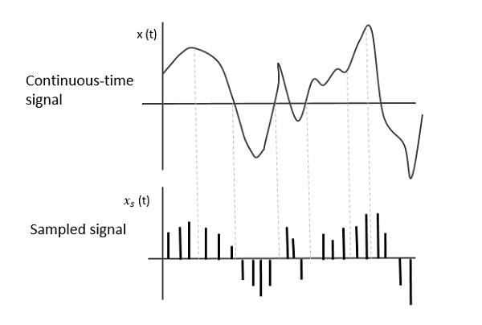

Sampling Rate
To discretize the signals, the gap between the samples should be fixed. That gap can be termed as a sampling period T_{s}.
SamplingFrequency=1Ts=fsSamplingFrequency=1Ts=fs
Where,
- TsTs is the sampling time
- fsfs is the sampling frequency or the sampling rate
Sampling frequency is the reciprocal of the sampling period. This sampling frequency, can be simply called as Sampling rate. The sampling rate denotes the number of samples taken per second, or for a finite set of values.
For an analog signal to be reconstructed from the digitized signal, the sampling rate should be highly considered. The rate of sampling should be such that the data in the message signal should neither be lost nor it should get over-lapped. Hence, a rate was fixed for this, called as Nyquist rate.

Nyquist Rate
Suppose that a signal is band-limited with no frequency components higher than W Hertz. That means, W is the highest frequency. For such a signal, for effective reproduction of the original signal, the sampling rate should be twice the highest frequency.
Which means,
fS=2W/fS=2W
Where,
- fS is the sampling rate
- W is the highest frequency
This rate of sampling is called as Nyquist rate.
A theorem called, Sampling Theorem, was stated on the theory of this Nyquist rate.

Sampling Theorem
The sampling theorem, which is also called as Nyquist theorem, delivers the theory of sufficient sample rate in terms of bandwidth for the class of functions that are bandlimited.
The sampling theorem states that, “a signal can be exactly reproduced if it is sampled at the rate f_{s} which is greater than twice the maximum frequency W.”
To understand this sampling theorem, let us consider a band-limited signal, i.e., a signal whose value is non-zero between some –W and W Hertz.
Such a signal is represented as x(f)=0for|f|>Wx(f)=0for|f|>W
For the continuous-time signal x (t), the band-limited signal in frequency domain, can be represented as shown in the following figure.
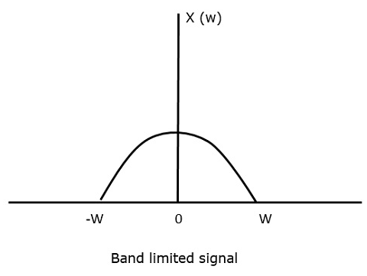
We need a sampling frequency, a frequency at which there should be no loss of information, even after sampling. For this, we have the Nyquist rate that the sampling frequency should be two times the maximum frequency. It is the critical rate of sampling.
If the signal x(t) is sampled above the Nyquist rate, the original signal can be recovered, and if it is sampled below the Nyquist rate, the signal cannot be recovered.
The following figure explains a signal, if sampled at a higher rate than 2w in the frequency domain.
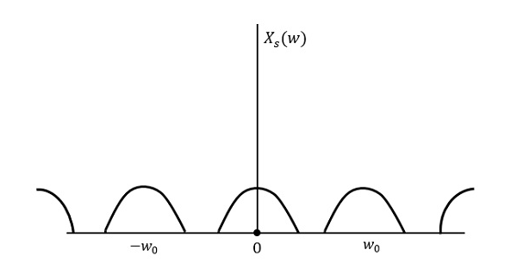
The above figure shows the Fourier transform of a signal xs(t)xs(t). Here, the information is reproduced without any loss. There is no mixing up and hence recovery is possible.
The Fourier Transform of the signal xs(t)xs(t) is
Xs(w)=1Ts∑n=−∞∞X(w−nw0)Xs(w)=1Ts∑n=−∞∞X(w−nw0)
Where TsTs = Sampling Period and w0=2πTsw0=2πTs
Let us see what happens if the sampling rate is equal to twice the highest frequency (2W)
That means,
fs=2Wfs=2W
Where,
- fsfs is the sampling frequency
- W is the highest frequency
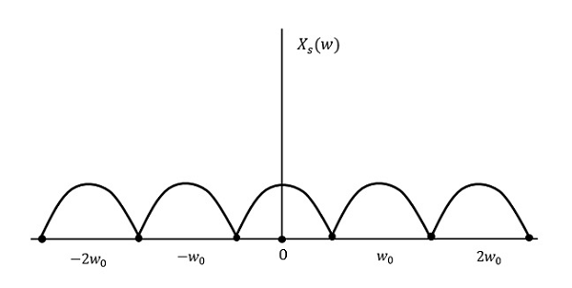
The result will be as shown in the above figure. The information is replaced without any loss. Hence, this is also a good sampling rate.
Now, let us look at the condition,
fs<2Wfs<2W
The resultant pattern will look like the following figure.
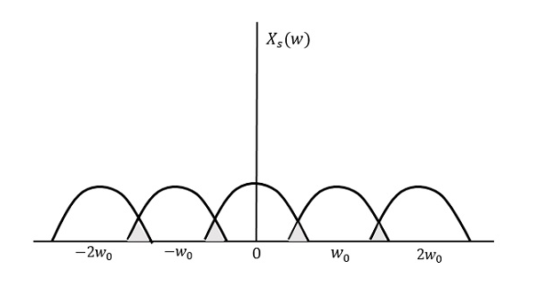
We can observe from the above pattern that the over-lapping of information is done, which leads to mixing up and loss of information. This unwanted phenomenon of over-lapping is called as Aliasing.

ALIASING
Aliasing can be referred to as “the phenomenon of a high-frequency component in the spectrum of a signal, taking on the identity of a low-frequency component in the spectrum of its sampled version.”
The corrective measures taken to reduce the effect of Aliasing are −
- In the transmitter section of PCM, a low pass anti-aliasing filter is employed, before the sampler, to eliminate the high frequency components, which are unwanted.
- The signal which is sampled after filtering, is sampled at a rate slightly higher than the Nyquist rate.
This choice of having the sampling rate higher than Nyquist rate, also helps in the easier design of the reconstruction filter at the receiver.

Scope of Fourier Transform
It is generally observed that, we seek the help of Fourier series and Fourier transforms in analyzing the signals and also in proving theorems. It is because −
- The Fourier Transform is the extension of Fourier series for non-periodic signals.
- Fourier transform is a powerful mathematical tool which helps to view the signals in different domains and helps to analyze the signals easily.
- Any signal can be decomposed in terms of sum of sines and cosines using this Fourier transform.
The digitization of analog signals involves the rounding off of the values which are approximately equal to the analog values. The method of sampling chooses a few points on the analog signal and then these points are joined to round off the value to a near stabilized value. Such a process is called as Quantization.

Quantizing an Analog Signal
The analog-to-digital converters perform this type of function to create a series of digital values out of the given analog signal. The following figure represents an analog signal. This signal to get converted into digital, has to undergo sampling and quantizing.
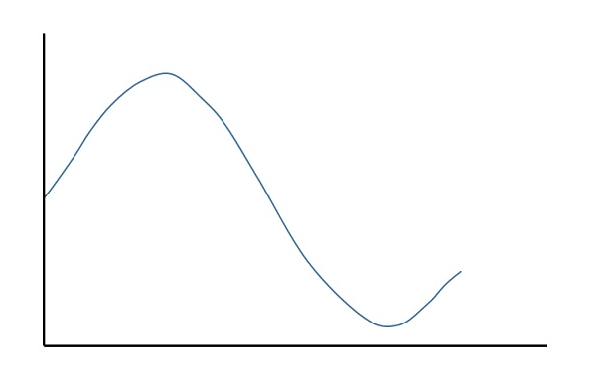
The quantizing of an analog signal is done by discretizing the signal with a number of quantization levels. Quantization is representing the sampled values of the amplitude by a finite set of levels, which means converting a continuous-amplitude sample into a discrete-time signal.
The following figure shows how an analog signal gets quantized. The blue line represents analog signal while the brown one represents the quantized signal.
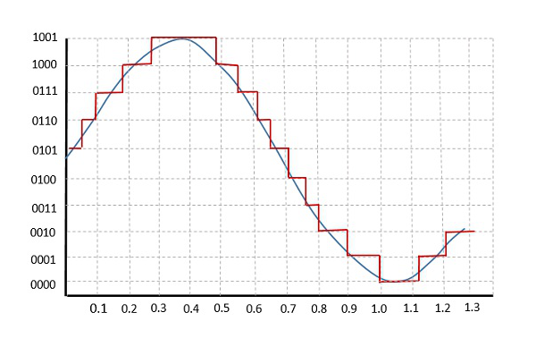
Both sampling and quantization result in the loss of information. The quality of a Quantizer output depends upon the number of quantization levels used. The discrete amplitudes of the quantized output are called as representation levels or reconstruction levels. The spacing between the two adjacent representation levels is called a quantum or step-size.
The following figure shows the resultant quantized signal which is the digital form for the given analog signal.
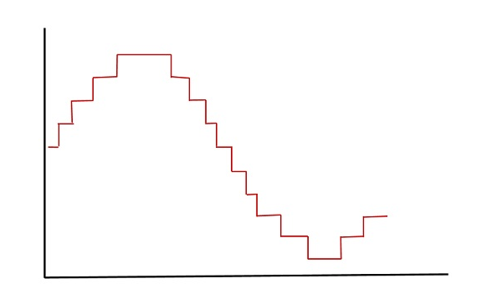
This is also called as Stair-case waveform, in accordance with its shape.

Types of Quantization
There are two types of Quantization - Uniform Quantization and Non-uniform Quantization.
The type of quantization in which the quantization levels are uniformly spaced is termed as a Uniform Quantization. The type of quantization in which the quantization levels are unequal and mostly the relation between them is logarithmic, is termed as a Non-uniform Quantization.
There are two types of uniform quantization. They are Mid-Rise type and Mid-Tread type. The following figures represent the two types of uniform quantization.
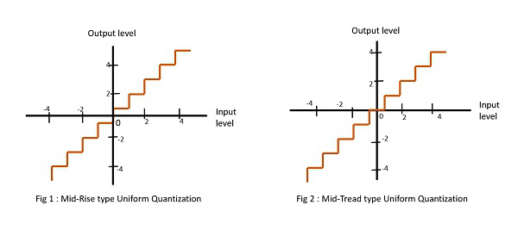
Figure 1 shows the mid-rise type and figure 2 shows the mid-tread type of uniform quantization.
- The Mid-Rise type is so called because the origin lies in the middle of a raising part of the stair-case like graph. The quantization levels in this type are even in number.
- The Mid-tread type is so called because the origin lies in the middle of a tread of the stair-case like graph. The quantization levels in this type are odd in number.
- Both the mid-rise and mid-tread type of uniform quantizers are symmetric about the origin.

Quantization Error
For any system, during its functioning, there is always a difference in the values of its input and output. The processing of the system results in an error, which is the difference of those values.
The difference between an input value and its quantized value is called a Quantization Error. A Quantizer is a logarithmic function that performs Quantization (rounding off the value). An analog-to-digital converter (ADC) works as a quantizer.
The following figure illustrates an example for a quantization error, indicating the difference between the original signal and the quantized signal.
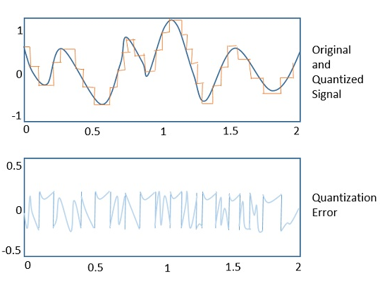

Quantization Noise
It is a type of quantization error, which usually occurs in analog audio signal, while quantizing it to digital. For example, in music, the signals keep changing continuously, where a regularity is not found in errors. Such errors create a wideband noise called as Quantization Noise.

Companding in PCM
The word Companding is a combination of Compressing and Expanding, which means that it does both. This is a non-linear technique used in PCM which compresses the data at the transmitter and expands the same data at the receiver. The effects of noise and crosstalk are reduced by using this technique.
There are two types of Companding techniques. They are −

A-law Companding Technique
- Uniform quantization is achieved at A = 1, where the characteristic curve is linear and no compression is done.
- A-law has mid-rise at the origin. Hence, it contains a non-zero value.
- A-law companding is used for PCM telephone systems.

µ-law Companding Technique
- Uniform quantization is achieved at µ = 0, where the characteristic curve is linear and no compression is done.
- µ-law has mid-tread at the origin. Hence, it contains a zero value.
- µ-law companding is used for speech and music signals.
µ-law is used in North America and Japan.

Modulation is the process of varying one or more parameters of a carrier signal in accordance with the instantaneous values of the message signal.
The message signal is the signal which is being transmitted for communication and the carrier signal is a high frequency signal which has no data, but is used for long distance transmission.
There are many modulation techniques, which are classified according to the type of modulation employed. Of them all, the digital modulation technique used is Pulse Code Modulation (PCM).
A signal is pulse code modulated to convert its analog information into a binary sequence, i.e., 1s and 0s. The output of a PCM will resemble a binary sequence. The following figure shows an example of PCM output with respect to instantaneous values of a given sine wave.
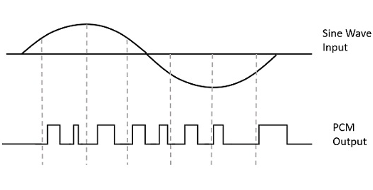
Instead of a pulse train, PCM produces a series of numbers or digits, and hence this process is called as digital. Each one of these digits, though in binary code, represent the approximate amplitude of the signal sample at that instant.
In Pulse Code Modulation, the message signal is represented by a sequence of coded pulses. This message signal is achieved by representing the signal in discrete form in both time and amplitude.

Basic Elements of PCM
The transmitter section of a Pulse Code Modulator circuit consists of Sampling, Quantizing and Encoding, which are performed in the analog-to-digital converter section. The low pass filter prior to sampling prevents aliasing of the message signal.
The basic operations in the receiver section are regeneration of impaired signals, decoding, and reconstruction of the quantized pulse train. Following is the block diagram of PCM which represents the basic elements of both the transmitter and the receiver sections.
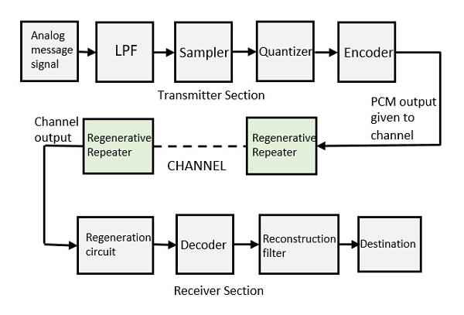
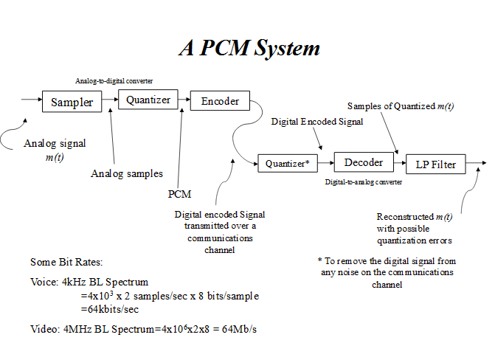

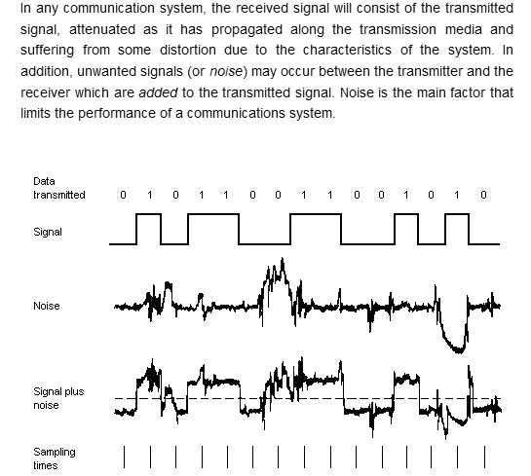

Low Pass Filter
This filter eliminates the high frequency components present in the input.
For the samples that are highly correlated, when encoded by PCM technique, leave redundant information behind. To process this redundant information and to have a better output, it is a wise decision to take a predicted sampled value, assumed from its previous output and summarize them with the quantized values. Such a process is called as Differential PCM (DPCM)technique.

DPCM Transmitter
The DPCM Transmitter consists of Quantizer and Predictor with two summer circuits. Following is the block diagram of DPCM transmitter.
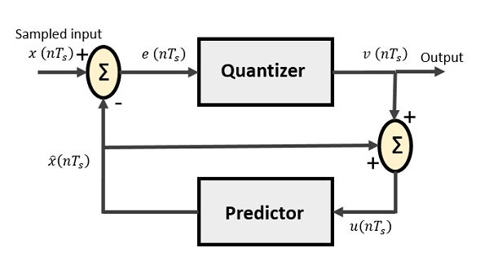
The signals at each point are named as −
- x(nTs)x(nTs) is the sampled input
- xˆ(nTs)x^(nTs) is the predicted sample
- e(nTs)e(nTs) is the difference of sampled input and predicted output, often called as prediction error
- v(nTs)v(nTs) is the quantized output
- u(nTs)u(nTs) is the predictor input which is actually the summer output of the predictor output and the quantizer output
The predictor produces the assumed samples from the previous outputs of the transmitter circuit. The input to this predictor is the quantized versions of the input signal x(nTs)x(nTs).
Quantizer Output is represented as −
v(nTs)=Q[e(nTs)]v(nTs)=Q[e(nTs)]
=e(nTs)+q(nTs)=e(nTs)+q(nTs)
Where q (nT_{s}) is the quantization error
Predictor input is the sum of quantizer output and predictor output,
u(nTs)=xˆ(nTs)+v(nTs)u(nTs)=x^(nTs)+v(nTs)
u(nTs)=xˆ(nTs)+e(nTs)+q(nTs)u(nTs)=x^(nTs)+e(nTs)+q(nTs)
u(nTs)=x(nTs)+q(nTs)u(nTs)=x(nTs)+q(nTs)
The same predictor circuit is used in the decoder to reconstruct the original input.

DPCM Receiver
The block diagram of DPCM Receiver consists of a decoder, a predictor, and a summer circuit. Following is the diagram of DPCM Receiver.
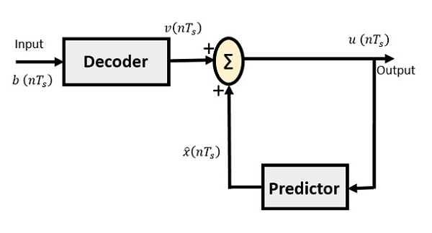
The notation of the signals is the same as the previous ones. In the absence of noise, the encoded receiver input will be the same as the encoded transmitter output.
As mentioned before, the predictor assumes a value, based on the previous outputs. The input given to the decoder is processed and that output is summed up with the output of the predictor, to obtain a better output.
The sampling rate of a signal should be higher than the Nyquist rate, to achieve better sampling. If this sampling interval in Differential PCM is reduced considerably, the sampleto-sample amplitude difference is very small, as if the difference is 1-bit quantization, then the step-size will be very small i.e., Δ (delta).

DELTA MODULATION
The type of modulation, where the sampling rate is much higher and in which the stepsize after quantization is of a smaller value Δ, such a modulation is termed as delta modulation.

Features of Delta Modulation
Following are some of the features of delta modulation.
- An over-sampled input is taken to make full use of the signal correlation.
- The quantization design is simple.
- The input sequence is much higher than the Nyquist rate.
- The quality is moderate.
- The design of the modulator and the demodulator is simple.
- The stair-case approximation of output waveform.
- The step-size is very small, i.e., Δ (delta).
- The bit rate can be decided by the user.
- This involves simpler implementation.
Delta Modulation is a simplified form of DPCM technique, also viewed as 1-bit DPCM scheme. As the sampling interval is reduced, the signal correlation will be higher.

Delta Modulator
The Delta Modulator comprises of a 1-bit quantizer and a delay circuit along with two summer circuits. Following is the block diagram of a delta modulator.
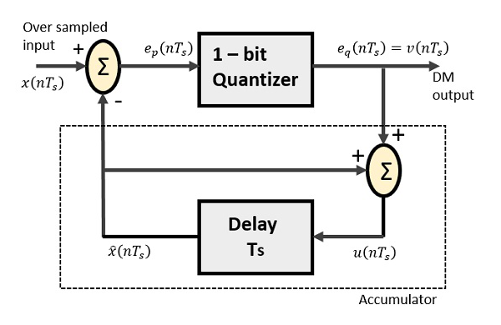
The predictor circuit in DPCM is replaced by a simple delay circuit in DM.
From the above diagram, we have the notations as −
- x(nTs)x(nTs) = over sampled input
- ep(nTs)ep(nTs) = summer output and quantizer input
- eq(nTs)eq(nTs) = quantizer output = v(nTs)v(nTs)
- xˆ(nTs)x^(nTs) = output of delay circuit
- u(nTs)u(nTs) = input of delay circuit
Using these notations, now we shall try to figure out the process of delta modulation.
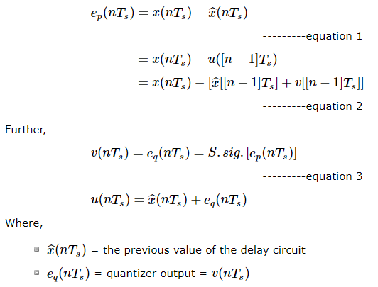

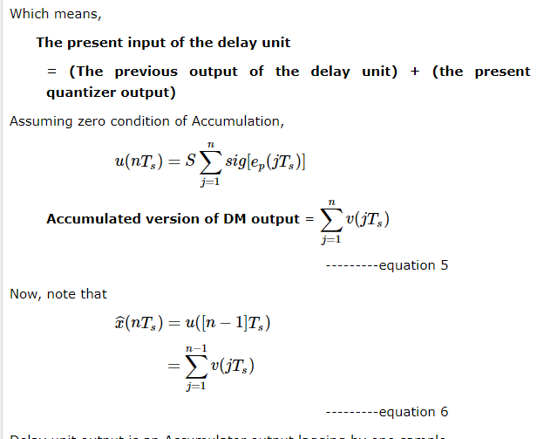

Delay unit output is an Accumulator output lagging by one sample.
From equations 5 & 6, we get a possible structure for the demodulator.
A Stair-case approximated waveform will be the output of the delta modulator with the step-size as delta (Δ). The output quality of the waveform is moderate.

Delta Demodulator
The delta demodulator comprises of a low pass filter, a summer, and a delay circuit. The predictor circuit is eliminated here and hence no assumed input is given to the demodulator.
Following is the diagram for delta demodulator.
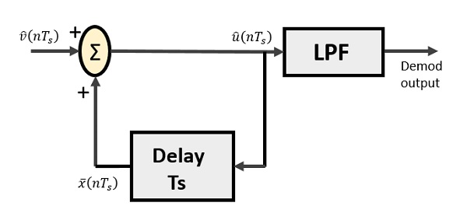
From the above diagram, we have the notations as −
- vˆ(nTs)v^(nTs) is the input sample
- uˆ(nTs)u^(nTs) is the summer output
- x¯(nTs)x¯(nTs) is the delayed output
A binary sequence will be given as an input to the demodulator. The stair-case approximated output is given to the LPF.
Low pass filter is used for many reasons, but the prominent reason is noise elimination for out-of-band signals. The step-size error that may occur at the transmitter is called granular noise, which is eliminated here. If there is no noise present, then the modulator output equals the demodulator input.

Advantages of DM Over DPCM
- 1-bit quantizer
- Very easy design of the modulator and the demodulator
However, there exists some noise in DM.
- Slope Over load distortion (when Δ is small)
- Granular noise (when Δ is large)

Adaptive Delta Modulation (ADM)
In digital modulation, we have come across certain problem of determining the step-size, which influences the quality of the output wave.
A larger step-size is needed in the steep slope of modulating signal and a smaller stepsize is needed where the message has a small slope. The minute details get missed in the process. So, it would be better if we can control the adjustment of step-size, according to our requirement in order to obtain the sampling in a desired fashion. This is the concept of Adaptive Delta Modulation.
Following is the block diagram of Adaptive delta modulator.
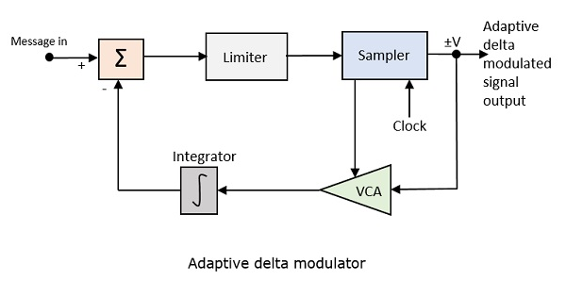
The gain of the voltage controlled amplifier is adjusted by the output signal from the sampler. The amplifier gain determines the step-size and both are proportional.
ADM quantizes the difference between the value of the current sample and the predicted value of the next sample. It uses a variable step height to predict the next values, for the faithful reproduction of the fast varying values.

og signal which is greater than the highest frequency of the message signal, to avoid aliasing of the message signal.

Sampler
This is the technique which helps to collect the sample data at instantaneous values of message signal, so as to reconstruct the original signal. The sampling rate must be greater than twice the highest frequency component Wof the message signal, in accordance with the sampling theorem.

Quantizer
Quantizing is a process of reducing the excessive bits and confining the data. The sampled output when given to Quantizer, reduces the redundant bits and compresses the value.

Encoder
The digitization of analog signal is done by the encoder. It designates each quantized level by a binary code. The sampling done here is the sample-and-hold process. These three sections (LPF, Sampler, and Quantizer) will act as an analog to digital converter. Encoding minimizes the bandwidth used.

Regenerative Repeater
This section increases the signal strength. The output of the channel also has one regenerative repeater circuit, to compensate the signal loss and reconstruct the signal, and also to increase its strength.

Decoder
The decoder circuit decodes the pulse coded waveform to reproduce the original signal. This circuit acts as the demodulator.

Reconstruction Filter
After the digital-to-analog conversion is done by the regenerative circuit and the decoder, a low-pass filter is employed, called as the reconstruction filter to get back the original signal.
Hence, the Pulse Code Modulator circuit digitizes the given analog signal, codes it and samples it, and then transmits it in an analog form. This whole process is repeated in a reverse pattern to obtain the original signal.

UNIT III
BASE BAND TRANSMISSION
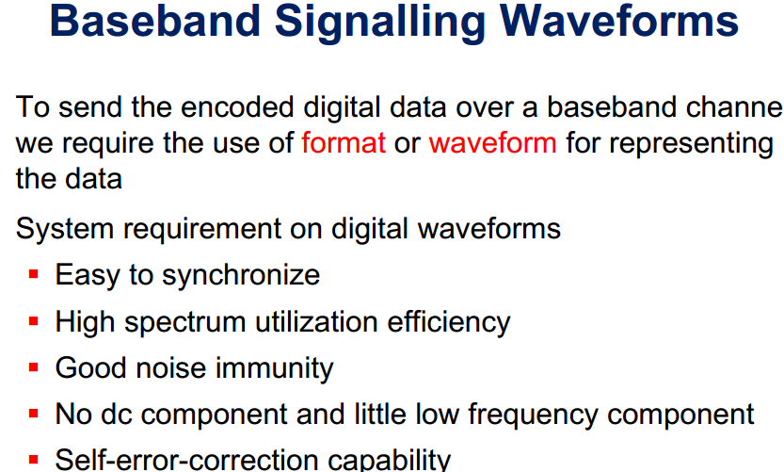
Basic waveforms:
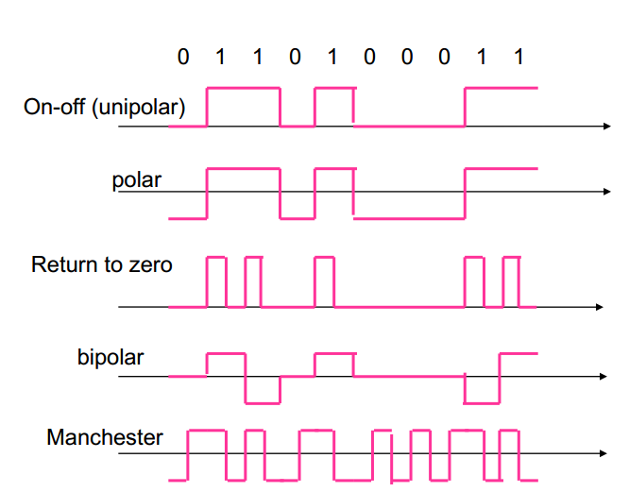
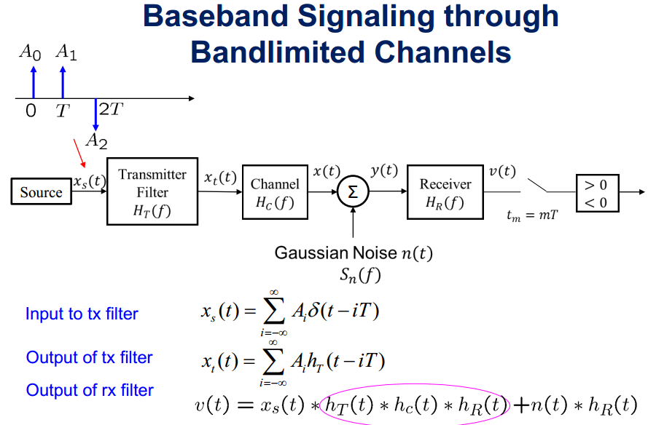
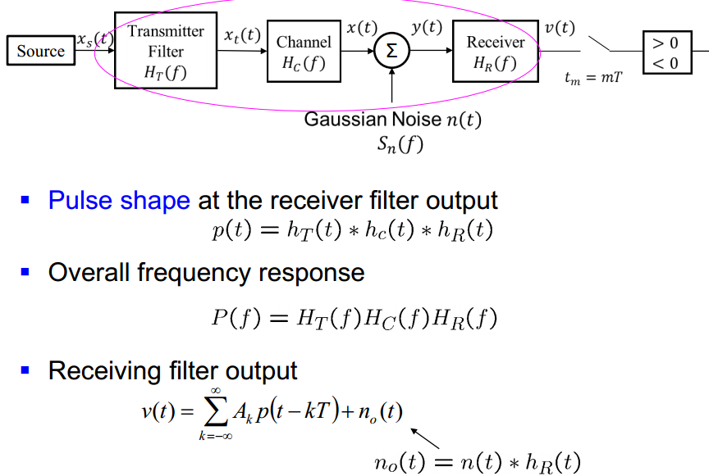
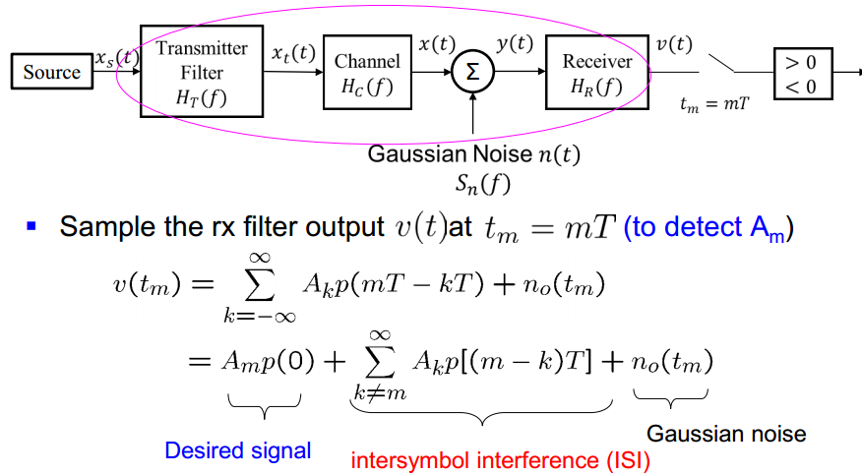

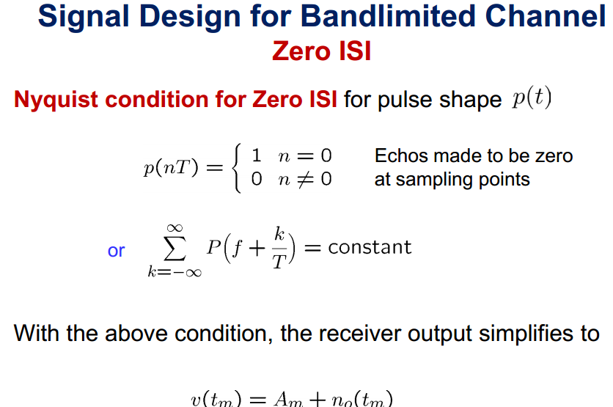
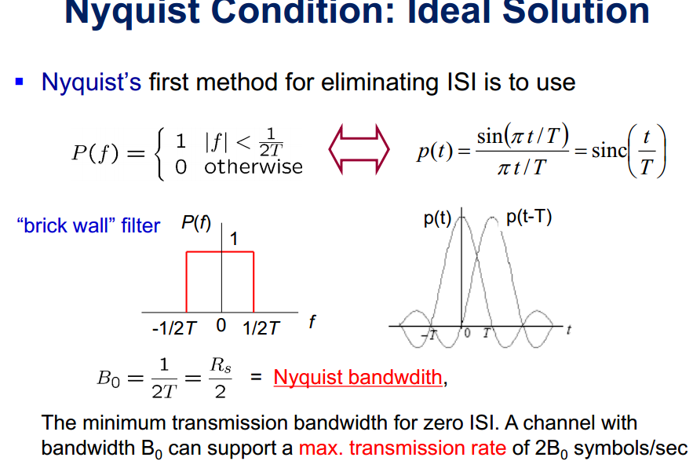
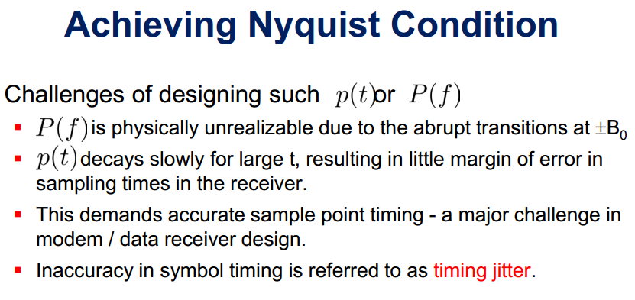
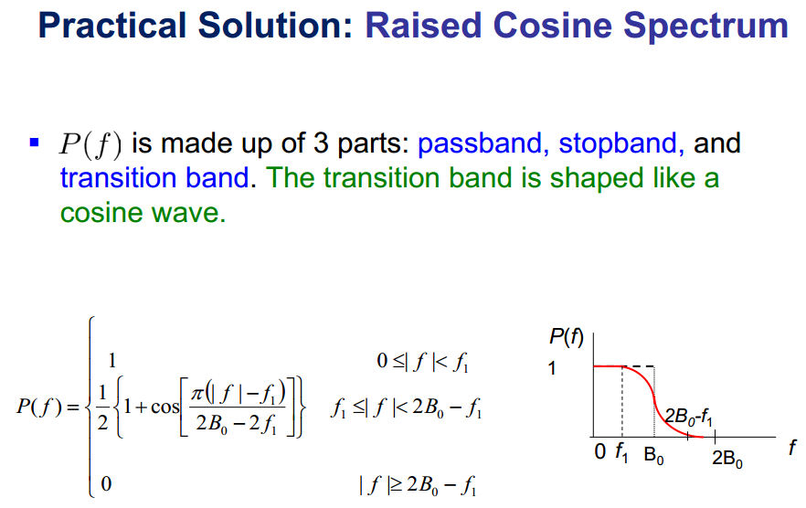
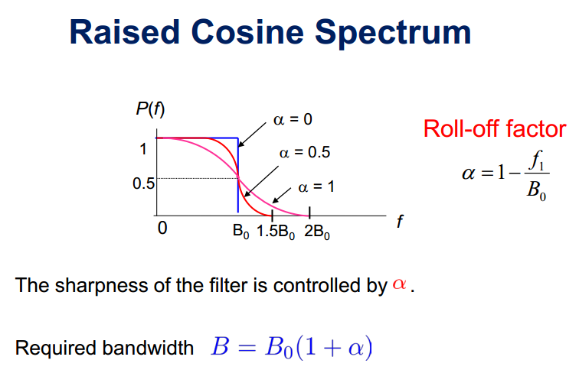
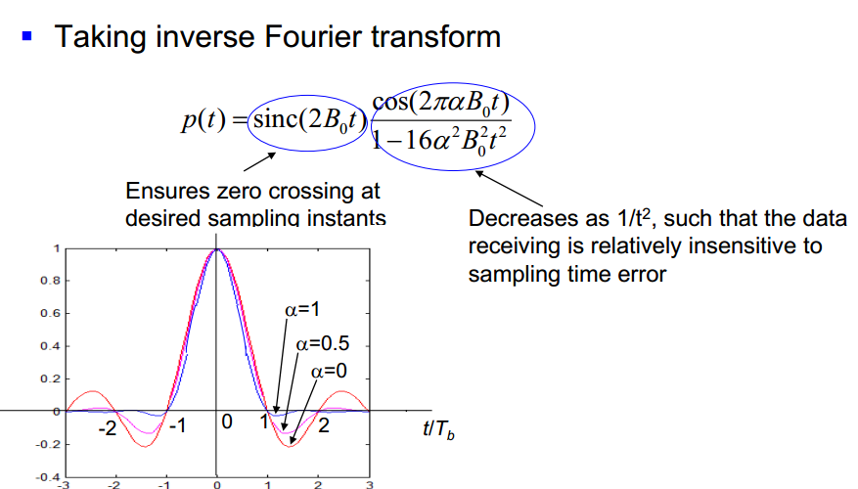

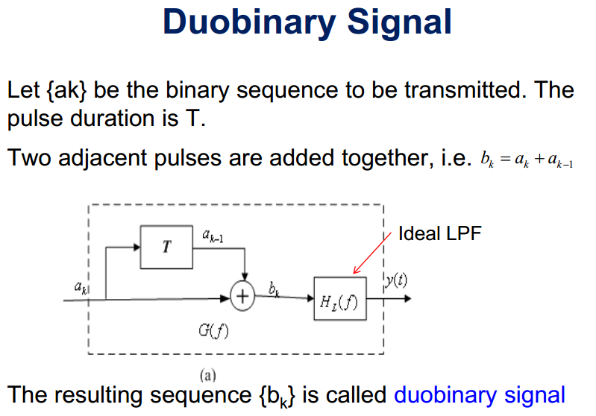
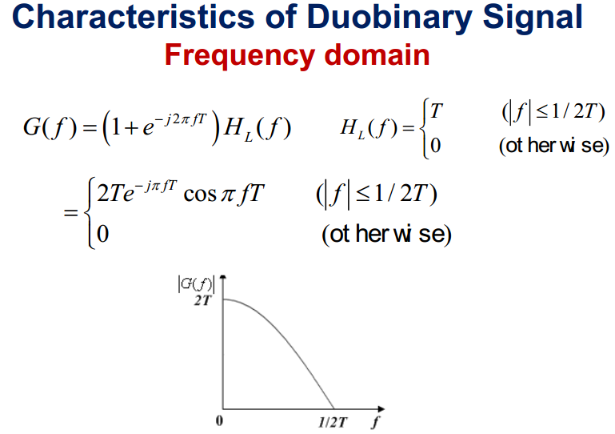
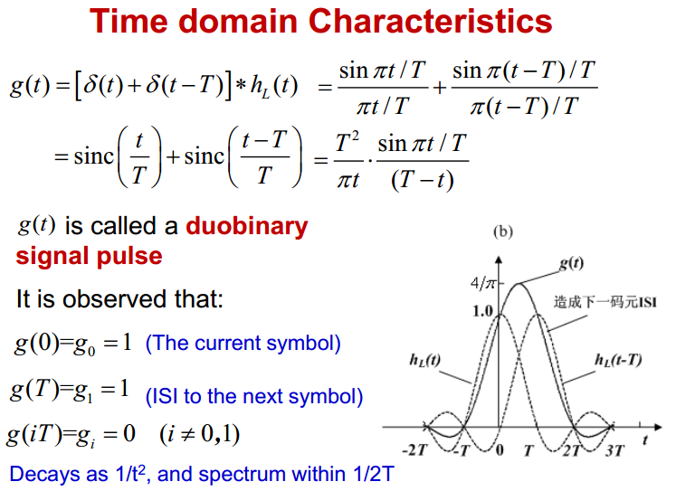

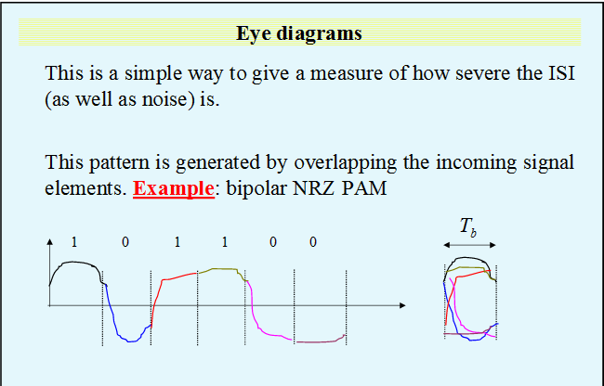

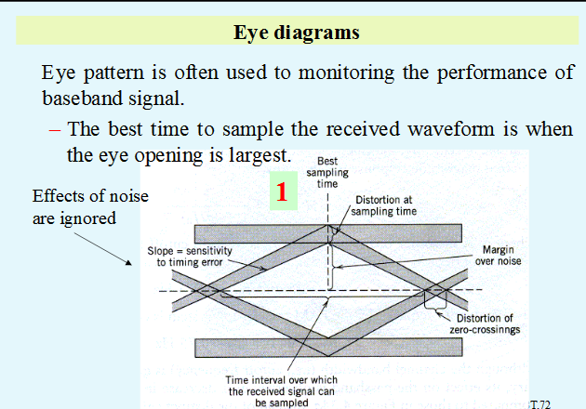

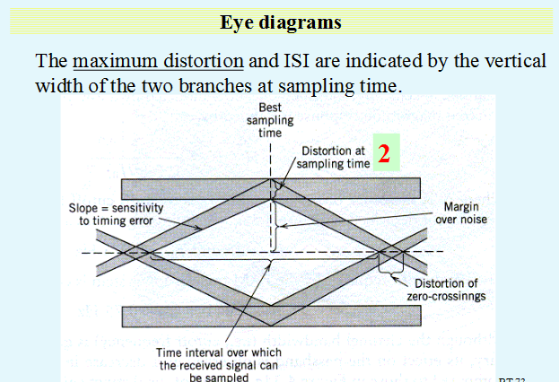

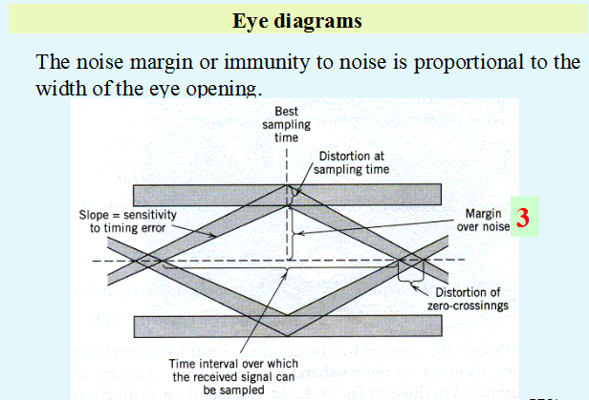

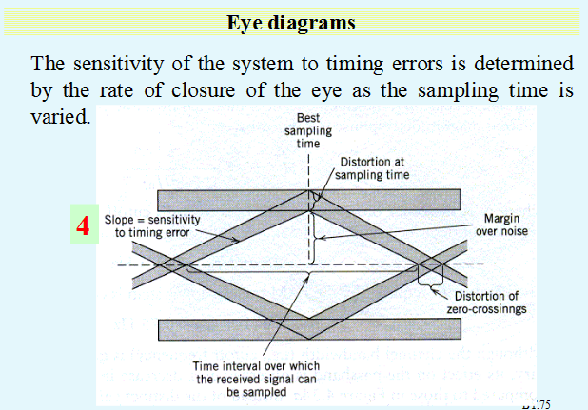

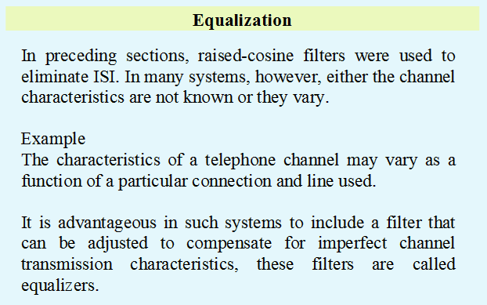

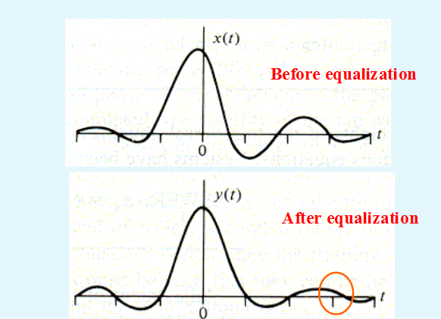

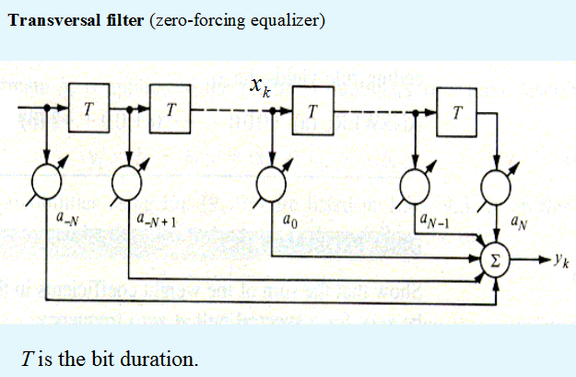

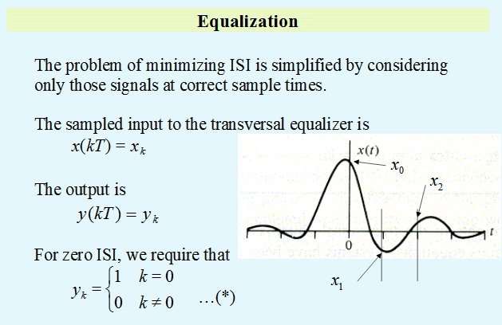

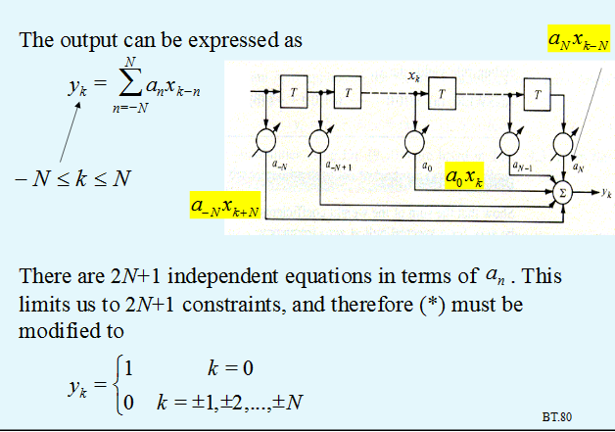

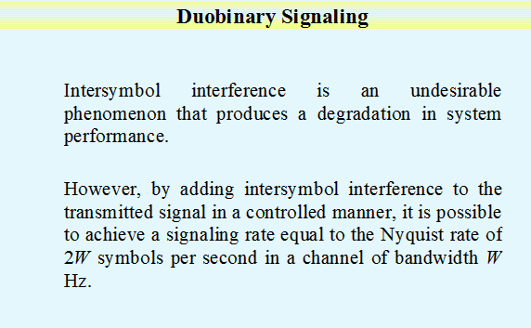

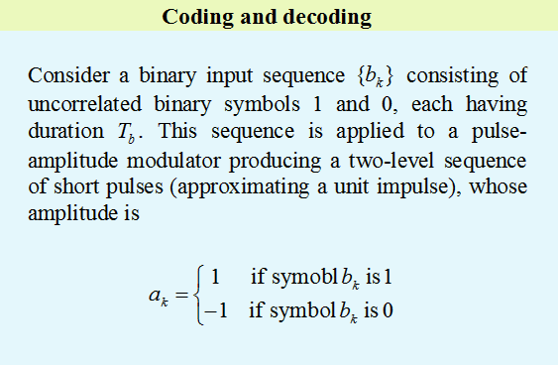

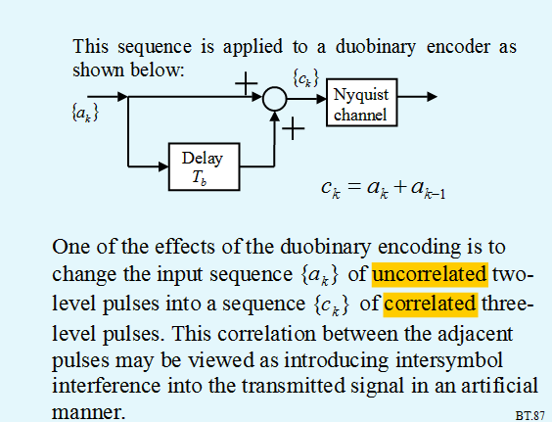

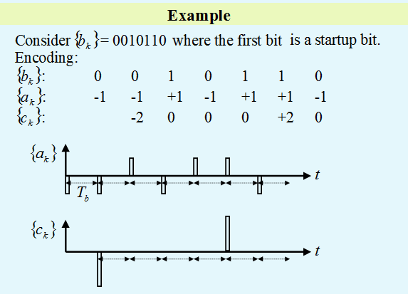

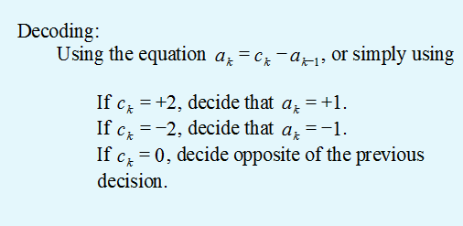

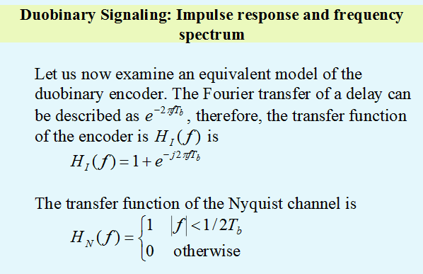

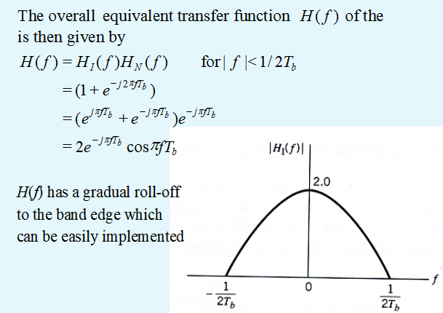

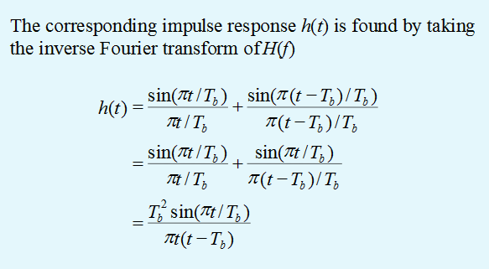

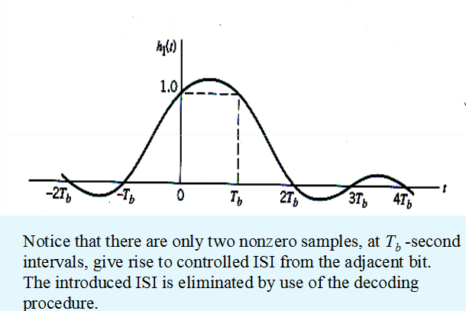

UNIT - IV
DIGITAL CARRIER MODULATION SCHEMES
AMPLITUDE SHIFT KEYING (ASK) Amplitude Shift Keying (ASK) is a type of Amplitude Modulation which represents the binary data in the form of variations in the amplitude of a signal. Any modulated signal has a high frequency carrier. The binary signal when ASK modulated, gives a zero value for Low input while it gives the carrier output for High input. The following figure represents ASK modulated waveform along with its input. 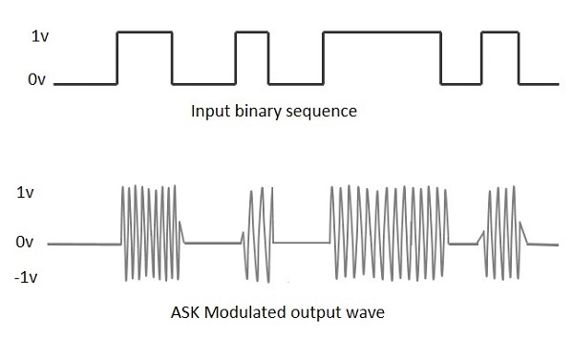
To find the process of obtaining this ASK modulated wave, let us learn about the working of the ASK modulator. ASK Modulator The ASK modulator block diagram comprises of the carrier signal generator, the binary sequence from the message signal and the band-limited filter. Following is the block diagram of the ASK Modulator. 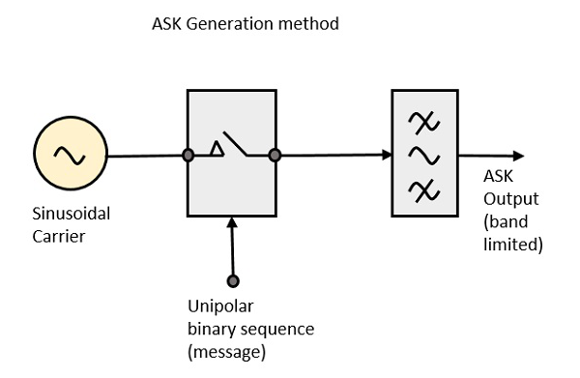 The carrier generator, sends a continuous high-frequency carrier. The binary sequence from the message signal makes the unipolar input to be either High or Low. The high signal closes the switch, allowing a carrier wave. Hence, the output will be the carrier signal at high input. When there is low input, the switch opens, allowing no voltage to appear. Hence, the output will be low. The band-limiting filter, shapes the pulse depending upon the amplitude and phase characteristics of the band-limiting filter or the pulse-shaping filter. ASK Demodulator There are two types of ASK Demodulation techniques. They are − Asynchronous ASK Demodulation/detection Synchronous ASK Demodulation/detection The clock frequency at the transmitter when matches with the clock frequency at the receiver, it is known as a Synchronous method, as the frequency gets synchronized. Otherwise, it is known as Asynchronous. Asynchronous ASK Demodulator The Asynchronous ASK detector consists of a half-wave rectifier, a low pass filter, and a comparator. Following is the block diagram for the same. 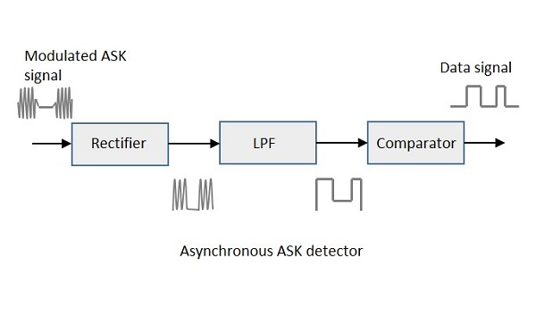
The modulated ASK signal is given to the half-wave rectifier, which delivers a positive half output. The low pass filter suppresses the higher frequencies and gives an envelope detected output from which the comparator delivers a digital output. Synchronous ASK Demodulator Synchronous ASK detector consists of a Square law detector, low pass filter, a comparator, and a voltage limiter. Following is the block diagram for the same. 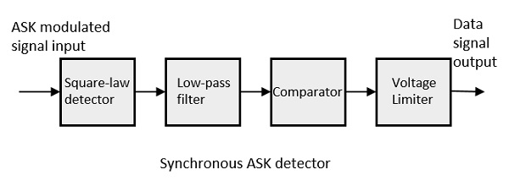 The ASK modulated input signal is given to the Square law detector. A square law detector is one whose output voltage is proportional to the square of the amplitude modulated input voltage. The low pass filter minimizes the higher frequencies. The comparator and the voltage limiter help to get a clean digital output. Frequency Shift Keying (FSK) is the digital modulation technique in which the frequency of the carrier signal varies according to the digital signal changes. FSK is a scheme of frequency modulation. The output of a FSK modulated wave is high in frequency for a binary High input and is low in frequency for a binary Low input. The binary 1s and 0s are called Mark and Space frequencies. The following image is the diagrammatic representation of FSK modulated waveform along with its input. 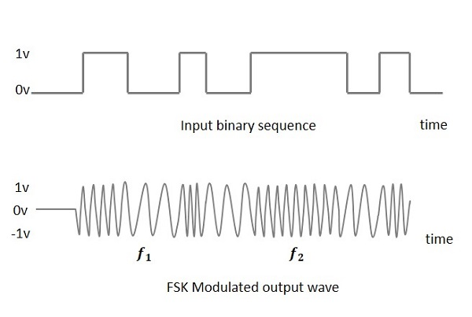 To find the process of obtaining this FSK modulated wave, let us know about the working of a FSK modulator. FSK Modulator. The FSK modulator block diagram comprises of two oscillators with a clock and the input binary sequence. Following is its block diagram. 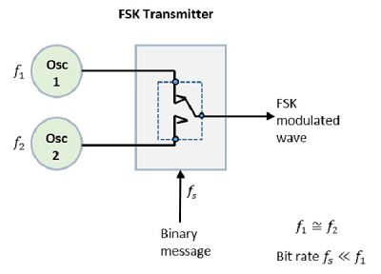
The two oscillators, producing a higher and a lower frequency signals, are connected to a switch along with an internal clock. To avoid the abrupt phase discontinuities of the output waveform during the transmission of the message, a clock is applied to both the oscillators, internally. The binary input sequence is applied to the transmitter so as to choose the frequencies according to the binary input. FSK Demodulator There are different methods for demodulating a FSK wave. The main methods of FSK detection are asynchronous detector and synchronous detector. The synchronous detector is a coherent one, while asynchronous detector is a non-coherent one. Asynchronous FSK Detector The block diagram of Asynchronous FSK detector consists of two band pass filters, two envelope detectors, and a decision circuit. Following is the diagrammatic representation. 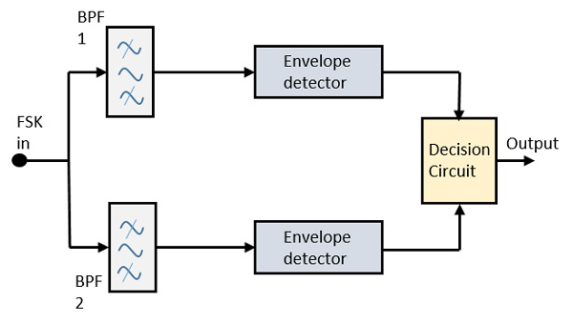 The FSK signal is passed through the two Band Pass Filters (BPFs), tuned to Space and Mark frequencies. The output from these two BPFs look like ASK signal, which is given to the envelope detector. The signal in each envelope detector is modulated asynchronously. The decision circuit chooses which output is more likely and selects it from any one of the envelope detectors. It also re-shapes the waveform to a rectangular one. Synchronous FSK Detector The block diagram of Synchronous FSK detector consists of two mixers with local oscillator circuits, two band pass filters and a decision circuit. Following is the diagrammatic representation.
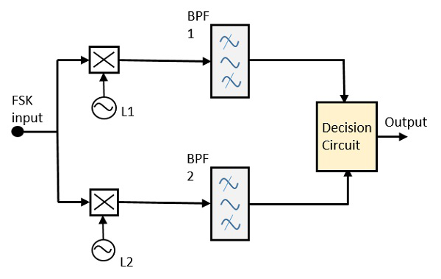
The FSK signal input is given to the two mixers with local oscillator circuits. These two are connected to two band pass filters. These combinations act as demodulators and the decision circuit chooses which output is more likely and selects it from any one of the detectors. The two signals have a minimum frequency separation. For both of the demodulators, the bandwidth of each of them depends on their bit rate. This synchronous demodulator is a bit complex than asynchronous type demodulators.
PHASE SHIFT KEYING (PSK): Phase Shift Keying (PSK) is the digital modulation technique in which the phase of the carrier signal is changed by varying the sine and cosine inputs at a particular time. PSK technique is widely used for wireless LANs, bio-metric, contactless operations, along with RFID and Bluetooth communications. PSK is of two types, depending upon the phases the signal gets shifted. They are − Binary Phase Shift Keying (BPSK) This is also called as 2-phase PSK or Phase Reversal Keying. In this technique, the sine wave carrier takes two phase reversals such as 0° and 180°. BPSK is basically a Double Side Band Suppressed Carrier (DSBSC) modulation scheme, for message being the digital information. Quadrature Phase Shift Keying (QPSK) This is the phase shift keying technique, in which the sine wave carrier takes four phase reversals such as 0°, 90°, 180°, and 270°. If this kind of techniques are further extended, PSK can be done by eight or sixteen values also, depending upon the requirement. BPSK Modulator The block diagram of Binary Phase Shift Keying consists of the balance modulator which has the carrier sine wave as one input and the binary sequence as the other input. Following is the diagrammatic representation. 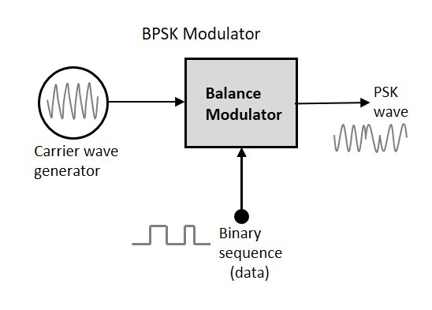 The modulation of BPSK is done using a balance modulator, which multiplies the two signals applied at the input. For a zero binary input, the phase will be 0° and for a high input, the phase reversal is of 180°. Following is the diagrammatic representation of BPSK Modulated output wave along with its given input. 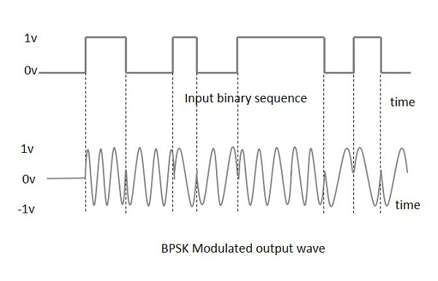
The output sine wave of the modulator will be the direct input carrier or the inverted (180° phase shifted) input carrier, which is a function of the data signal. BPSK Demodulator The block diagram of BPSK demodulator consists of a mixer with local oscillator circuit, a bandpass filter, a two-input detector circuit. 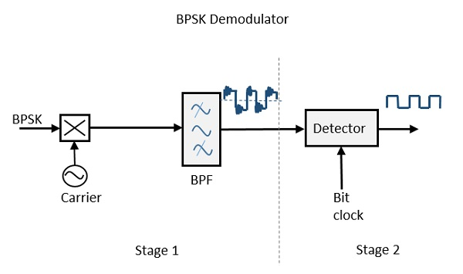 By recovering the band-limited message signal, with the help of the mixer circuit and the band pass filter, the first stage of demodulation gets completed. The base band signal which is band limited is obtained and this signal is used to regenerate the binary message bit stream. In the next stage of demodulation, the bit clock rate is needed at the detector circuit to produce the original binary message signal. If the bit rate is a sub-multiple of the carrier frequency, then the bit clock regeneration is simplified. To make the circuit easily understandable, a decision-making circuit may also be inserted at the 2nd stage of detection.
DIFFERENTIAL PHASE SHIFT KEYING (DPSK)
In Differential Phase Shift Keying (DPSK) the phase of the modulated signal is shifted relative to the previous signal element. No reference signal is considered here. The signal phase follows the high or low state of the previous element. This DPSK technique doesn’t need a reference oscillator. The following figure represents the model waveform of DPSK. 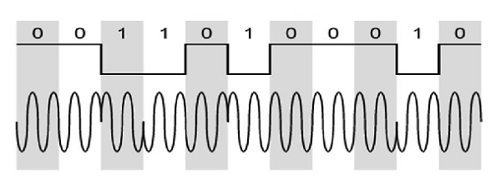
It is seen from the above figure that, if the data bit is Low i.e., 0, then the phase of the signal is not reversed, but continued as it was. If the data is a High i.e., 1, then the phase of the signal is reversed, as with NRZI, invert on 1 (a form of differential encoding). If we observe the above waveform, we can say that the High state represents an M in the modulating signal and the Low state represents a W in the modulating signal.

DPSK Modulator:
DPSK is a technique of BPSK, in which there is no reference phase signal. Here, the transmitted signal itself can be used as a reference signal. Following is the diagram of DPSK Modulator. 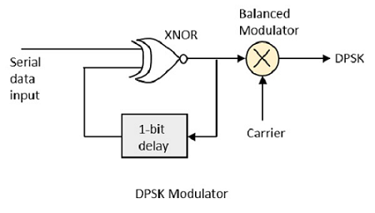 DPSK encodes two distinct signals, i.e., the carrier and the modulating signal with 180° phase shift each. The serial data input is given to the XNOR gate and the output is again fed back to the other input through 1-bit delay. The output of the XNOR gate along with the carrier signal is given to the balance modulator, to produce the DPSK modulated signal.
DPSK Demodulator:
In DPSK demodulator, the phase of the reversed bit is compared with the phase of the previous it. Following is the block diagram of DPSK demodulator. 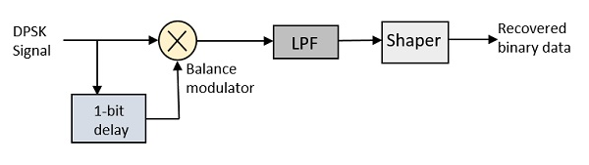 From the above figure, it is evident that the balance modulator is given the DPSK signal along with 1-bit delay input. That signal is made to confine to lower frequencies with the help of LPF. Then it is passed to a shaper circuit, which is a comparator or a Schmitt trigger circuit, to recover the original binary data as the output.

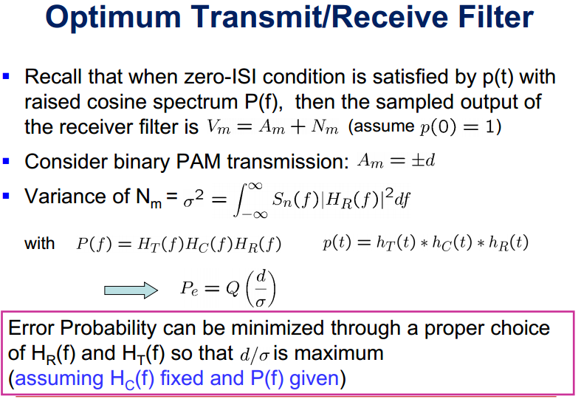

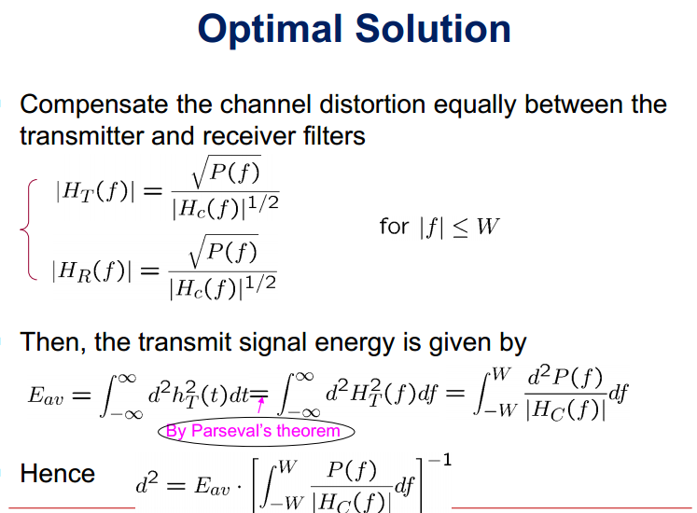

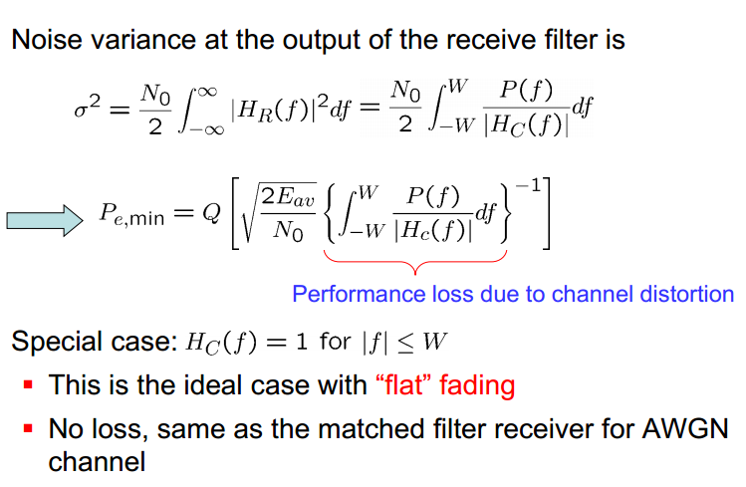
CORRELATION RECEIVER 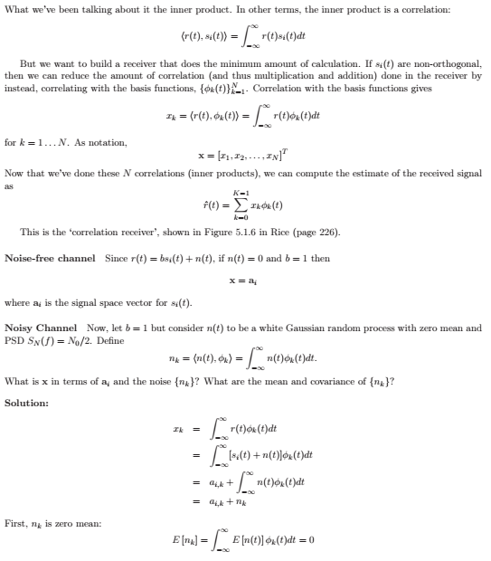 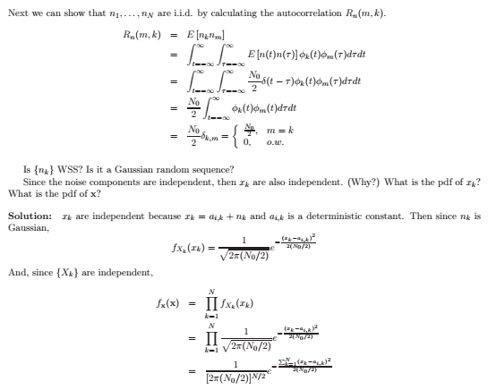
MATCHED FILTER RECEIVER
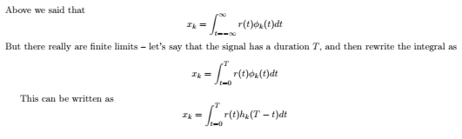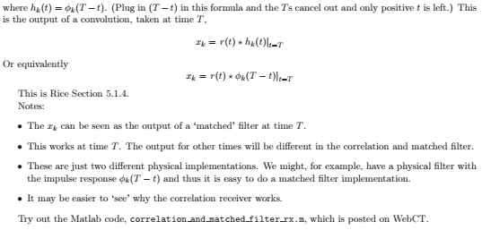

COMPARISION OF DIGITAL MODULATION SCHEMES
Bandwidth Requirement – Power Requirement – Immunity to Channel Impairments – Equipment Complexity
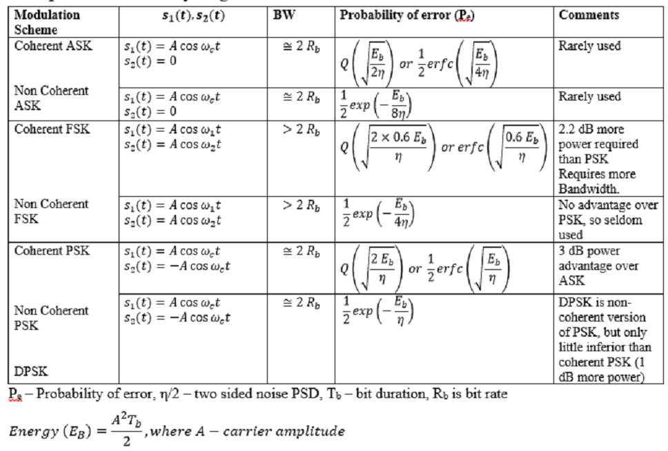
SCHEME | S/N for P_{e}=10⁻⁴ (dB) | Equipment Complexity
Coherent ASK | 14.45 | Moderate
Non Coherent FSK | 18.33 | Minor
Coherent FSK | 10.6 | Major
Non Coherent ASK | 15.33 | Minor
Coherent PSK | 8.45 | Major
DPSK | 9.30 | Moderate

M-ary - Signaling Scheme
M-ary Modulation: Instead of just varying phase, frequency or amplitude of the RF signal, modern Modulation techniques allow both envelope (amplitude frequency) of the RF carrier to vary. Because the envelope and phase provide two degrees of freedom, such modulation techniques map baseband data into four or more possible RF carrier signals. Such modulation techniques are known as M-ary modulation. In M-ary modulation scheme, two or more bits are grouped together to form symbols and one of possible signals S1(t), S2(t), …, Sm(t) is transmitted during each symbol period Ts. Normally, the number of possible signals is M = 2 n , where n is an integer. Depending on whether the amplitude, phase or frequency is varied, the modulation is referred to as M-ary ASK, M-ary PSK or M-ary FSK, respectively. M-ary modulation technique attractive for use in bandlimited channels, because these techniques achieve better bandwidth efficiency at the expense of power efficiency. For example, an 8-PSK technique requires a bandwidth that is log28 = 3 times smaller than 2-PSK (also known as BPSK) system. However, M-ary signalling results in poor error performance because of smaller distances between signals in the constellation diagram. Several commonly used M-ary signalling schemes are discussed below.
QPSK: For more efficient use of bandwidth Quadrature Phase-Shift Keying (QPSK) can be used,
Where S(t) = A cos (2πf_{c}t) for 00
A cos (2πf_{c}t+90) for 01
A cos (2πf_{c}t+180) for 10
A cos (2πf_{c}t+270) for 11
Here phase shift occurs in multiple of 90° as shown in constellation diagram below.
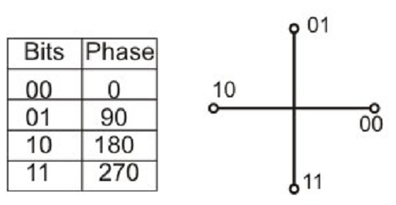
.

8-PSK: The idea can be extended to have 8-PSK.Here the phase is shifted by 45° as shown in Figure
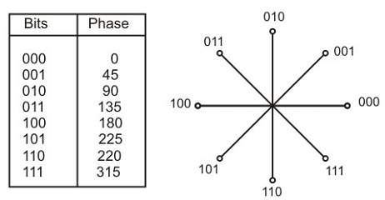
QAM (Quadrature Amplitude Modulation):
Ability of equipment to distinguish small differences in phase limits the potential bit rate. This can be improved by combining ASK and PSK. This combined modulation technique is known Quardrature Amplitude Modulation (QAM). It is possible to obtain higher data rate using QAM. The constellation diagram of a QAM signal with two amplitude levels and four phases is shown in Figure. It may be noted that M-ary QAM does not have constant energy per symbol, nor does it have constant distance between possible symbol values. 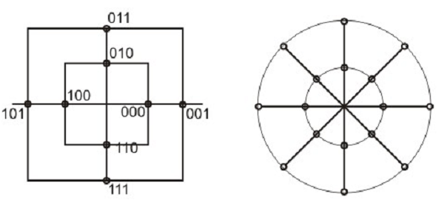
Bit rate and Baud rate: Use of different modulation techniques lead to different baud rates (number of signal elements per second) for different values of bit rates, which represents the numbers of data bits per second. Table shows how the same baud rate allows different bit rates for different modulation techniques. The baud rate, in turn, implies the bandwidth requirement of the medium used for transmission of the analog signal.
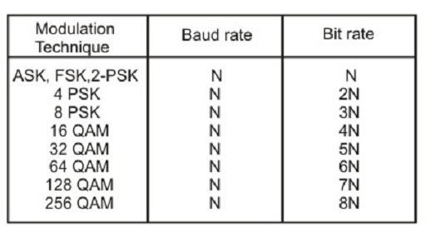

SYNCHRONIZATION METHOD
All digital communication systems requirevarious timing control measures for specific purposes. For example, timing information is needed to identify the rate at which bits are transmitted. It is also needed to identify the start and end instants of an information-bearing symbol or a sequence ofsymbols. Note that all the demodulation schemes that we have discussed are based on the principle ofsymbol-by-symbol detection scheme and we assumed that precise symbol-timing information is always available at the receiver.
Further, information, when available in binary digits, is often treated in groups called blocks. A block is a small segment of data that is treated together for the purpose of transmission and reception. Each block is added with time stamps marking the beginning and end of the block and these time stamps should also be recovered properly at the receiving end to ensure proper sequence ofblocks at the user end. In the context of radio transmission and reception, such as for communication through a satellite or in wireless LAN, a block of binary digits called ‘frame’, along with necessary overhead bits, needs synchronization.
For reliable data communication at moderate and high rates, timing information about the transmitter clock is obtained in the receiver directly or indirectly from the received signal. Such a transmission mode is known as synchronous. In this lesson, we will discuss about synchronous mode of digital transmission, primarily applicable for wireless communications. Though an additional channel may be used in a communication system to transmit the timing information, it is wastage of bandwidth. For baseband transmission schemes, it is a popular practice to insert the timing signal within the transmitted data stream by use of suitable line encoding technique.
A straight forward approach to insert the timing signal in a binary data stream is to encode the binary signal in some way to ensure a high-low (or low-high) transition with each bit. Such a transition in each bit can be used easily to recover the time reference (e.g. the clock) at the receiver.
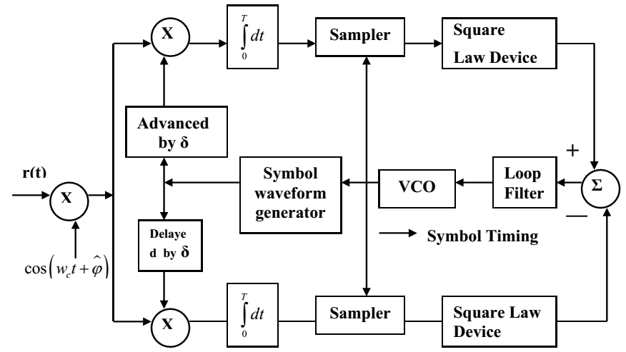

UNIT - V
ERROR CONTROL CODING
LINEAR BLOCK CODES
In coding theory, a linear code is an error-correcting code for which any linear combination of codewords is also a codeword. Linear codes are traditionally partitioned into block codes and convolutional codes, although turbo codes can be seen as a hybrid of these two types.[1] Linear codes allow for more efficient encoding and decoding algorithms than other codes (syndrome decoding).
Linear codes are used in forward error correction and are applied in methods for transmitting symbols (e.g., bits) on a communications channel so that, if errors occur in the communication, some errors can be corrected or detected by the recipient of a message block. The codewords in a linear block code are blocks of symbols that are encoded using more symbols than the original value to be sent.[2] A linear code of length n transmits blocks containing n symbols. For example, the [7,4,3] Hamming code is a linear binary code which represents 4-bit messages using 7-bit codewords. Two distinct codewords differ in at least three bits. As a consequence, up to two errors per codeword can be detected while a single error can be corrected.[3] This code contains 24=16 codewords.

MATRIX DESCRIPTION OF LINEAR BLOCK CODES
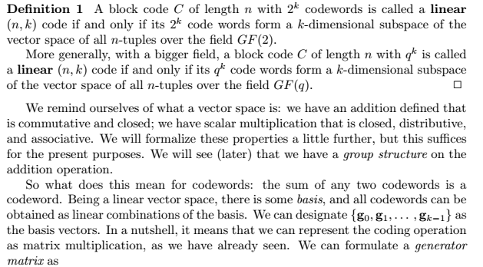
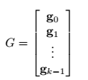
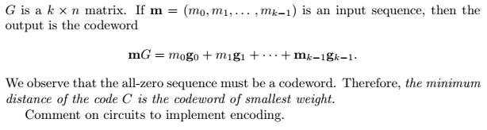
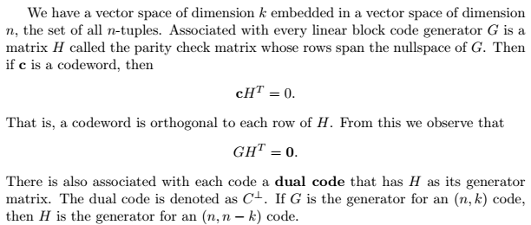
HAMMING CODES
Hamming code can be generated by
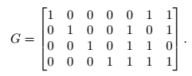
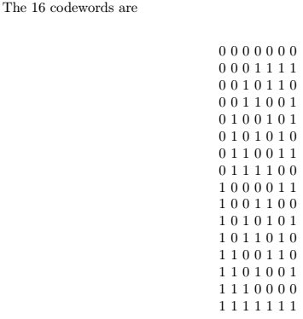
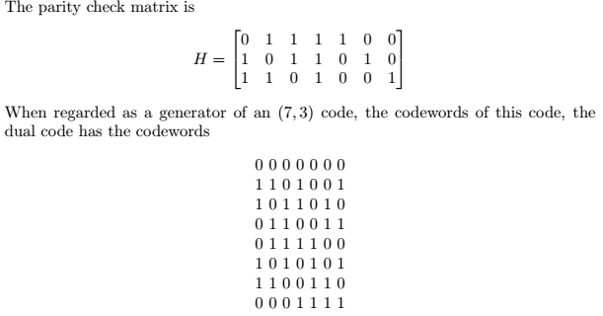
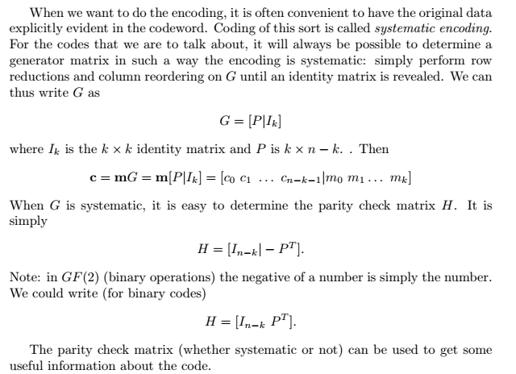

BINARY CYCLIC CODES
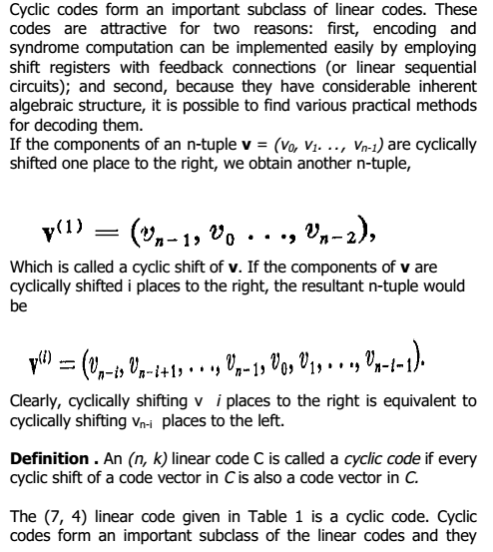

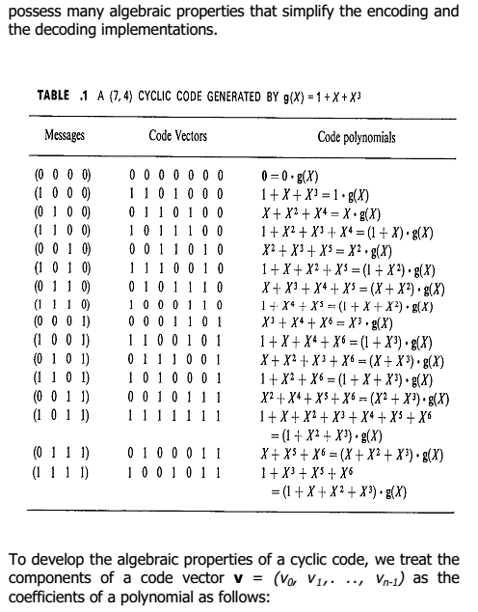

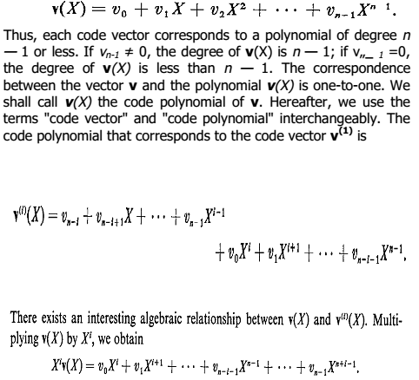

ENCODING USING SHIFT REGISTERS
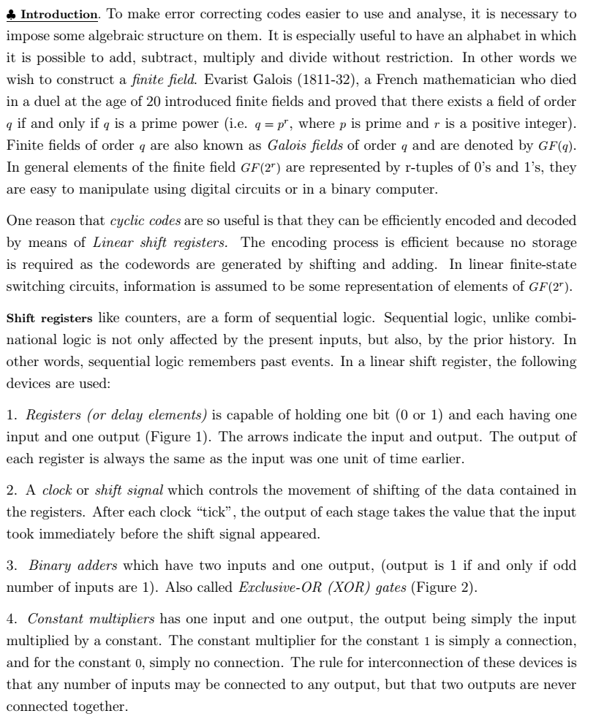
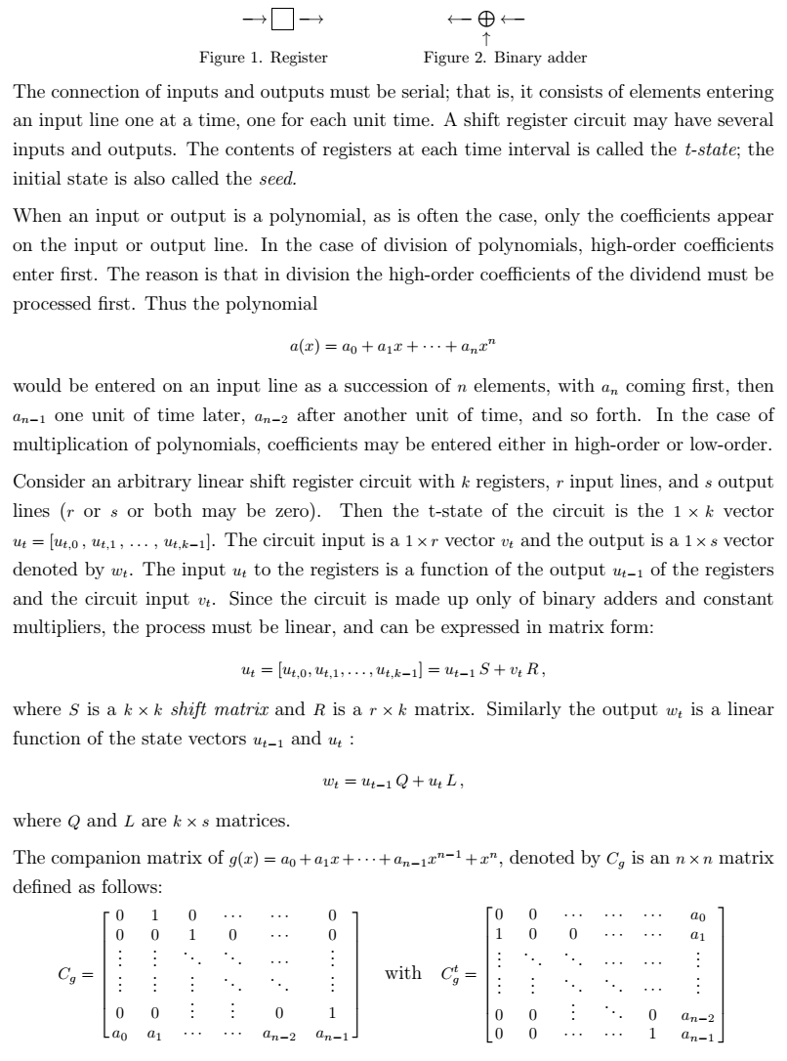
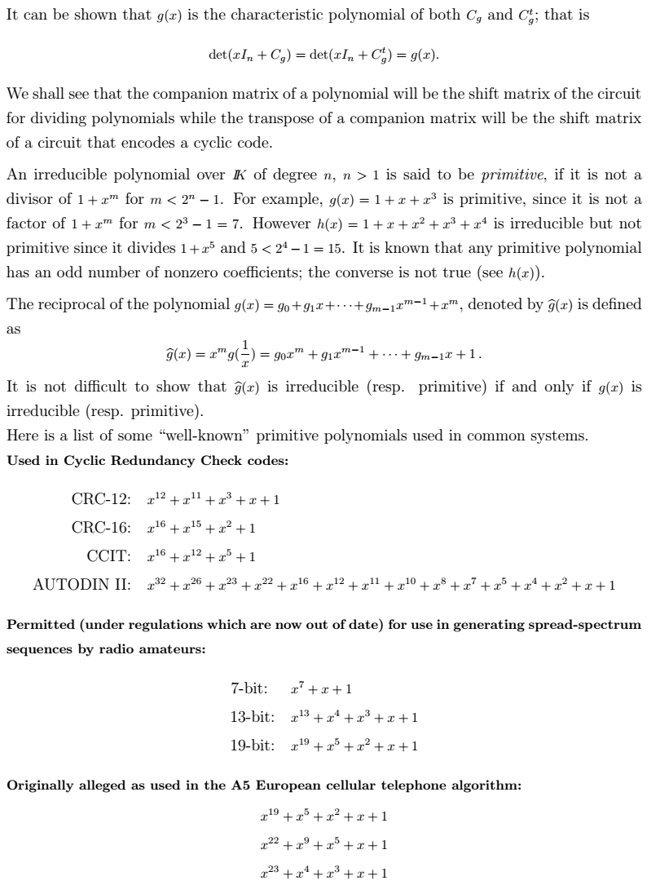
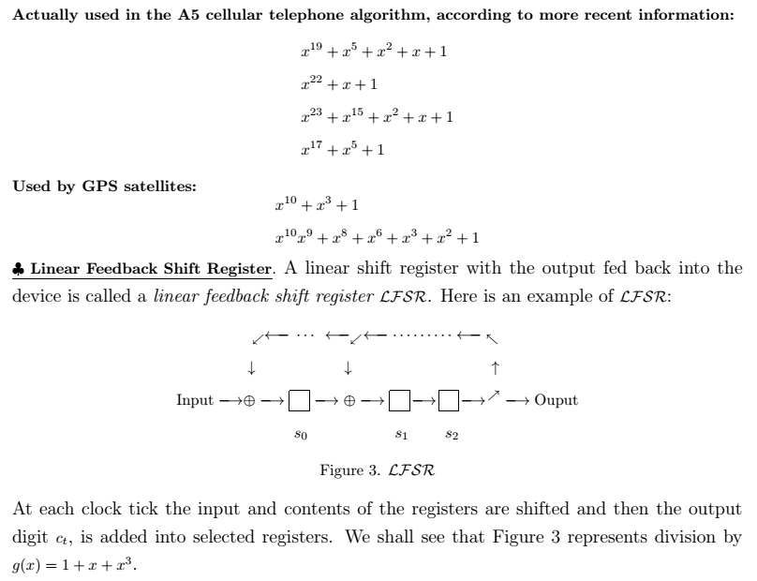

BCH CODES
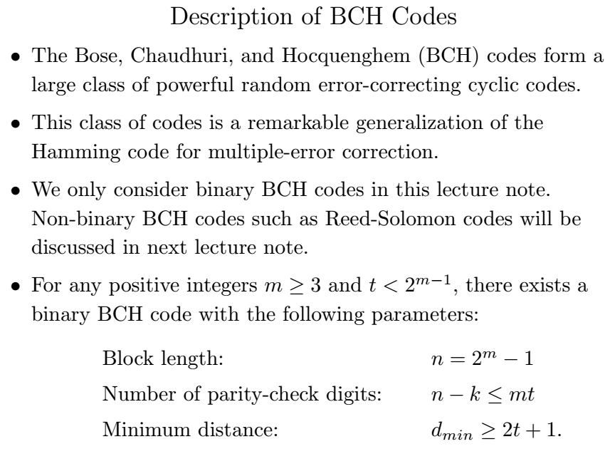
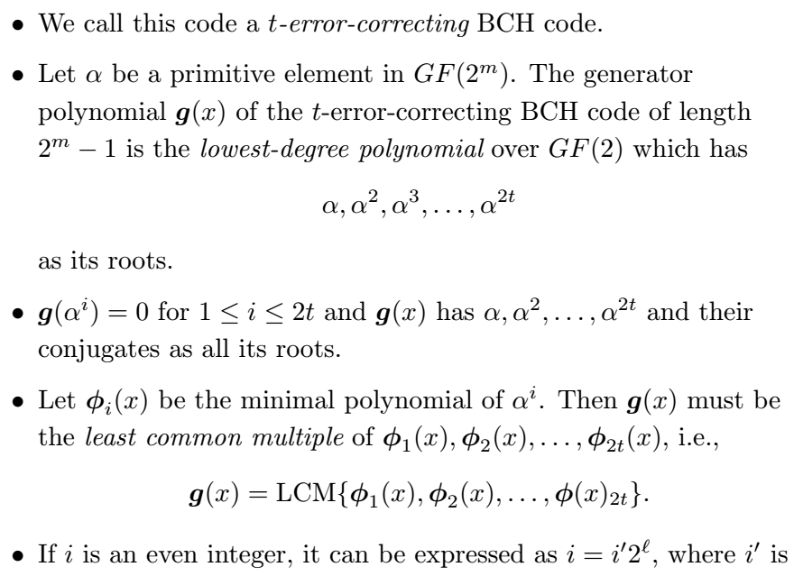
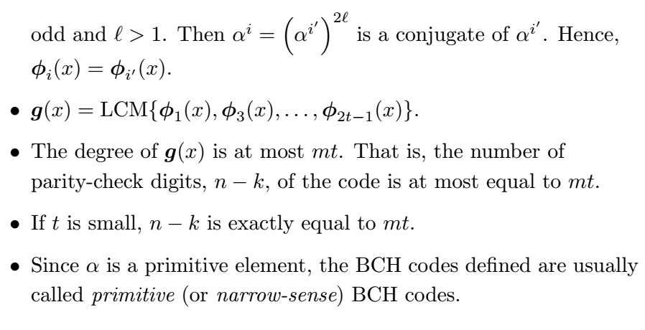

BURST AND RANDOM ERROR CORRECTING CODES
The codes we have considered so far have been designed to correct random errors. In general, a t-error correcting code corrects all error patterns of weight t or less in a codeword of block length n. It may be, however, that certain channels introduce errors localized in short intervals rather than at random. For example, in storage mediums, errors resulting from physical irregularities or structural alteration, perhaps flaws in the original medium or damage due to wear and tear, are not independent, but rather tend to be spatially concentrated. Similarly, interference over short time intervals in serially transmitted radio signals causes errors to occur in bursts. There exist codes for correcting such burst errors. Many of these codes are cyclic. We briefly consider burst-error correcting codes in this section.
Cyclic Burst Errors
A cyclic burst error of length t is a vector whose non-zero components are contained within a cyclic run of length t, the first and last components in the run being non-zero.
Examples:
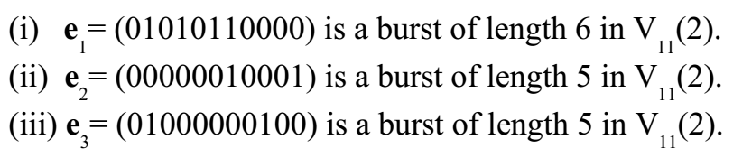
Polynomial Description
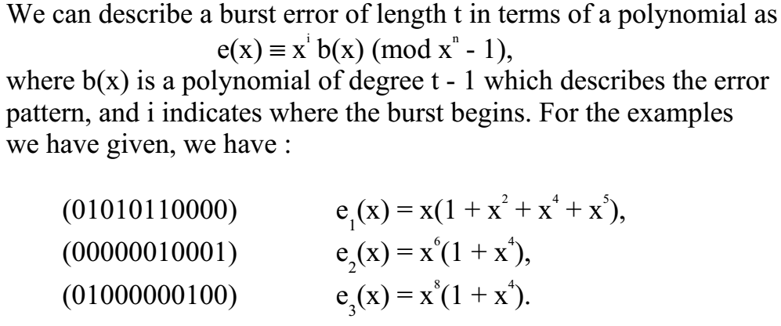

Correcting Burst Errors
Consider a linear code C. If all burst errors of length t or less occur in distinct cosets of a standard array for C, then each can be uniquely identified by its syndrome, and all such errors are then correctable. Furthermore, if Cis a linear code capable of correcting all burst errors of length t or less, then all such errors must occur in distinct cosets.
Correcting Burst Errors
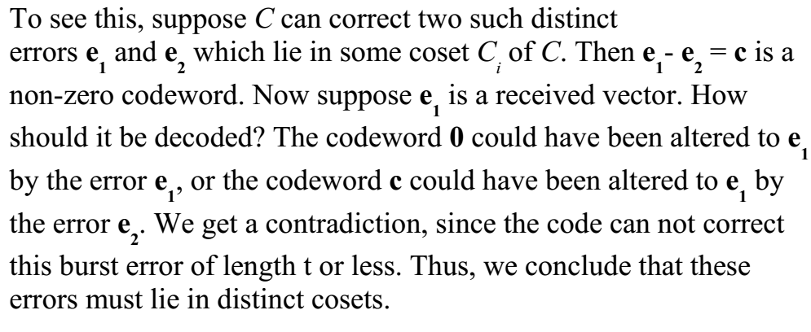
Theorem: A linear code C can correct all burst errors of length t or less if and only if all such errors occur in distinct cosets of C.

CONVOLUTIONAL CODES
