ENVIRONMENTAL STUSDIES-LECTURE NOTES

SYLLABUS:

- Environmental Studies

—A Multidisciplinary Subject
UNIT

Environment:

‘Environment’ is derived from the French word Environner which means to encircle or surround. All the biological and non-biological things surrounding an organism are thus included in environment.
Thus environment is sum total of water, air and land, inter-relationships among themselves and also with the human beings, other living organ-isms and property. The above definition given in Environment (Protection) Act, 1986 clearly indicates that environment includes all the physical and biological surroundings and their interactions.

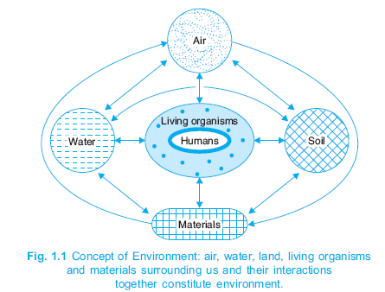

Types of environment :

- Natural environment
- Man-made environment

- Natural environment :

- It includes components such as air,water,soil,land,forest,wildlife,flora,fauna….
- This environment operates through a self-regulating mechanism.
- It is never static,so that the changes may be negligible or drastic.
- These changes may be either beneficial or harmful to the living organisms in the environment.
- The Natural environment on the earth is devided into four realms.

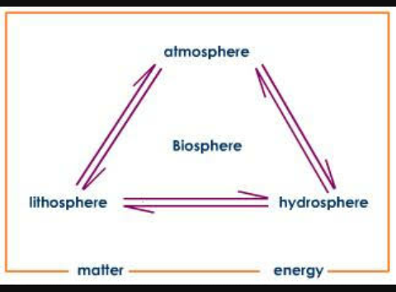

- Atmosphere :

The layer of gases surrounding earth is called the atmosphere.
The atmosphere of earth is composed of several distinct layers such as troposphere, stratosphere, mesosphere,and ionosphere.

- Troposphere

- It is the lower portion of the atmosphere and extends from 0-18 kms.
- It contains 75% of the atmospheric air mass.
- The temperature of the troposphere changes from 15°C to -56°C.
- The chemical constituents are O_{2,} CO₂, N₂ water.

- Stratosphere:

- It lies above the troposphere and extends from 18-50 kms.
- The temperature of which changes from -2°C to -56°C.
- The main chemical constituent is ozone.

- Mesosphere:

- It lies above the stratosphere and extends from 50-85 kms.
- The temperature of which drops to about -95°C.
- The main chemical constituents are N₂, O₂, O₂⁺, NO⁺.

- Ionosphere:

- It lies above the mesosphere and extends upto 500 kms above the earth surface.
- The temperature of which raises upto 1200°C.
- It contains the charged particles like O₂⁺, O⁺, NO⁺.

- Hydrosphere:
The Hydrosphere comprises all types of water resources oceans, seas, lakes, rivers, streams, reserviour, polar icecaps, glaciers, and ground water.

(i) Nature 97% of the earth’s water supply is in the oceans,

(ii) About 2% of the water resources is locked in the polar icecaps and glaciers.

(iii) Only about 1% is available as fresh surface water-rivers, lakes streams, and ground
water fit to be used for human consumption and other uses.
(iv) The presence of water on earth gives it the name “ blue planet”
(v) Due to the range of surface temparatures and presusures, water exists in all three states; solid(ice), liquid(water), and gas(water vapour) on earth.

- Biosphere :

- The biosphere is that part of earth which includes air, land, surface rocks, water, and all components within which life occurs.
- It is the life-zone of the earth and includes all living organisms. The biosphere can be devided into distinct ecosystems that represent interactions between different groups of organisms.

- Lithosphere :

- The lithosphere includes the solid part of earth’s crust.
- It has two parts, the crust and upper mantle.
- The crust includes rocks, minerals, and soil.
- Directly below the crust is called mantle.

- Man-made environment :
Humanbeings are the most powerful environment agents and are capable of modifying the environment to a great extent according to their needs by the application of modern technology.
It is classified further as physical, chemical, and biological environments.

1.Physical environment :
- It includes all the matter which the universe is made of and excludes the biotic components.
- It includes radiation, temperature, humidity, rain, soil and other physical factors which directly influence the organisms and determine the existence of life on earth.
Ex: solar energy

2.Chemical environment :
- It includes all the chemical components of earth.
- It include gases, acids, water, inorganic elements and organic substances.
- The chemical environment may be different for different group of organisms.

3.Biological environment :

- It includes all life on earth.
- It covers all living organisms found on earth.
- These can be bacteria, virus, microbes, algae, shrubs, mammals……
- All these are influence factors and act as reservoirs for various infectious diseases.

Components of Environment :

All major components of the environment namely, air, water, land, energy, living beings including humans, are inter related and inter-connected in many ways.
The components of environments are broadly classified as abiotic and biotic components.

- Abiotic / Non-living components :
The way in which plants and animals grow and carryout their activities is a result of several abiotic factors. They include all the physical and chemical factors that influence living organisms.
Ex : air, water, rocks, soil…..
Abiotic components are essential for living world, as life cannot exist without factors such as sunlight, water, air and minerals. The quality of abiotic environment is a critical factor for life.
It is believed that primitive organisms drastically changed the abiotic components of the planet and affected. Human activities are currently resulting in considerable changes in the abiotic environment hence causing harmful effects such as global warming.

- Biotic / Living components :
These are living components of environment such as microbes, plants, animals and human beings. They are classified as either producers or consumers depending their food habits.

- Producers/Autotrophs :

- These include green plants and algae which manufacture their own food.
- Green plants capture solar energy with the help of chlorophyll pigment present in their leaves, make their own food in the form of sugars.
- This process is known as photosynthesis and the plants are known as photo-autotrophs.
- Bacteria that utilize the oxidation of inorganic compounds such as hydrogen sulphide, ammonia as energy source to manufacture their food by the process of chemosynthesis and are known as chemo-autotrophs.

- Consumers/Heterotrophs :

- The organisms of this group are not capable of manufacturing food.
- They depend upon autotrophs to meet their food requirements.
- They depend upon autotrophs for both energy and raw materials to make complex organic molecules.
- These are further classified depending on their food habits.
- Based on the food habits they are
  - Herbivores
  - Carnivores
  - Omnivores
  - decomposers

Scope of environmental studies:
The scope of environmental studies is broad based and it encompasses a large number of areas and aspects .
- Natural Resources—their conservation and management

- Ecology and biodiversity

- Environmental pollution and control

- Social issues in relation to development and environment

- Human population and environment

These are the basic aspects of Environmental Studies which have a direct relevance to every section of the society. Environmental studies can be highly specialized also which may concentrate on more technical aspects like Environmental Science, Environmental Engineering, Environmental Management, Environmental Biotechnology etc.

Environment belongs to all and is thus important for all. Whatever be the occupation or age of a person, he or she will be affected by environment and will also affect the environment by his or her deeds. Thus, environment is one subject that is actually global in nature.

For example, atmosphere has no boundaries and the pollutants produced at one place can be dispersed and transported to another place. The river water polluted by industrial or municipal discharge at one point would seriously affect the downstream aquatic life.

There are some environmental problems which may be of localized importance but there are some major issues like global warming, depletion of ozone layer, dwindling forests and energy resources, loss of global biodiversity etc. that are going to affect the mankind as a whole and for that we have to think globally. For dealing with local environmental issues, e.g. the impacts of mining or hydro-electric projects, solid waste management etc. we have to think and act locally. In order to make the people aware about those aspects of environment with which they are so intimately associated, it is very important to make every one environmentally educated.

Importance of environmental studies:

The environment studies enlighten us, about the importance of protection and conservation of our indiscriminate release of pollution into the environment.
At present a great number of environment issues, have grown in size and complexity day by day, threatening the survival of mankind on earth. We study about these issues besides and effective suggestions in the Environment Studies. Environment studies have become significant for the following reasons:
1. Environment Issues Being of International Importance

It has been well recognised that environment issues like global warming and ozone depletion, acid rain, marine pollution and biodiversity are not merely national issues but are global issues and hence must be tackled with international efforts and cooperation.

2. Problems Cropped in The Wake of Development

Development, in its wake gave birth to Urbanization, Industrial Growth, Transportation Systems, Agriculture and Housing etc. However, it has become phased out in the developed world. The North, to cleanse their own environment has, fact fully, managed to move ‘dirty’

factories of South. When the West developed, it did so perhaps in ignorance of the environmental impact of its activities. Evidently such a path is neither practicable nor desirable, even if developing world follows that.

3. Explosively Increase in Pollution

World census reflects that one in every seven persons in this planted lives in India. Evidently with 16 per cent of the world's population and only 2.4 per cent of its land area, there is a heavy pressure on the natural resources including land. Agricultural experts have recognized soils health problems like deficiency of micronutrients and organic matter, soil salinity and damage of soil structure.

4. Need for An Alternative Solution

It is essential, specially for developing countries to find alternative paths to an alternative goal. We need a goal as under:

  - A goal, which ultimately is the true goal of development an environmentally sound and sustainable development.

  - A goal common to all citizens of our earth.

  - A goal distant from the developing world in the manner it is from the over-consuming wasteful societies of the “developed” world.

Need To Save Humanity From Extinction
It is incumbent upon us to save the humanity from exinction. Consequent to our activities constricting the environment and depleting the biosphere, in the name of development.

6. Need For Wise Planning of Development

Our survival and sustenance depend. Resources withdraw, processing and use of the product have all to by synchronised with the ecological cycles in any plan of development our actions should be planned ecologically for the sustenance of the environment and development.

- Need for Public Awareness:

As the earth’s natural resources are dwindling and our environment is being increasingly degraded by human activities, it is evident that something needs to be done. We often feel that managing all this is something that the Government should do. But if we go on endangering our environment, there is no way in which the Government can perform all these clean-up functions. It is the prevention of environment degradation in which we must all take part that must become a part of all our lives. Just as for any disease, prevention is better than cure. To prevent ill-effects on our environment by our actions, is economically more viable than cleaning up the environment once it is damaged. Individually we can play a major role in environment management. We can reduce wasting natural resources and we can act as watchdogs that inform the Government about sources that lead to pollution and degradation of our environment.

This can only be made possible through mass public awareness. Mass media such as newspapers, radio, television, strongly influence public opinion. However, someone has to bring this about. If each of us feels strongly about the environment, the press and media will add to our efforts. Politicians in a democracy always respond positively to a strong publicly supported movement. Thus if you join an NGO that sup-ports conservation, politicians will make green policies. We are living on spaceship earth with a limited supply of resources. Each of us is responsible for spreading this message to as many people as possible.
Suggested further activities for concerned students:

- Join a group to study nature, such as WWF-I or BNHS, or another environmental group.

- Begin reading newspaper articles and periodicals such as ‘Down to Earth’, WWF-I newsletter, BNHS Hornbill, Sanctuary magazine, etc. that will tell you more about our environment. There are also several environmental websites.

- Lobby for conserving resources by taking up the cause of environmental issues during discussions with friends and relatives. Practice and promote issues such as saving paper, saving water, reducing use of plastics, practicing the 3Rs principle of reduce, reuse, recycle, and proper waste disposal.

- Join local movements that support activities such as saving trees in your area, go on nature treks, recycle waste, buy environmentally friendly products.

- Practice and promote good civic sense such as no spitting or tobacco chewing, no throwing garbage on the road, no smoking in public places, no urinating or defecating in public places.

- Take part in events organized on World Environment Day, Wildlife Week, etc.

- Visit a National Park or Sanctuary, or spend time in whatever nature you have near your home.

- MULTIDISCIPLINARY NATURE OF ENVIRONMENTAL STUDIES :

Environment is complex and has multifarious aspects.

Keeping in view the complex nature of the environment, knowledge and information from various disciplines os science, social science, law and engineering have to be included in environmental studies to understand it completely.

- Life sciences including botony, zoology, microbiology, genetics and biochemistry help in understanding the biotic components and their interactions.
- For understanding the physical and chemical structure of abiotic components of environment along with mass and energy transfers we have to make use of basic concepts of physics, chemistry,geology, atmospheric science and geography.
- Mathematics, statistics and computer science serve as effective tools in environmental modeling.
- Subjects like economics, management and sociology provide the inputs for dealing with socio-economic aspects associated with various development activities.

- A synthesis of civil engineering, hydraulics, chemical engg, nano- technology provide the technical solutions to environmental pollution control and waste treatment.
- Environmental education and mass communication are two important subjects that are instrumental in dissiminating environmental awareness.
- Environmental ethics provide the guidelines for a sustainable lifestyle.

Environmental sciences, therefore is a multidisciplinary subject where we deal with different aspects using a holistic approach.

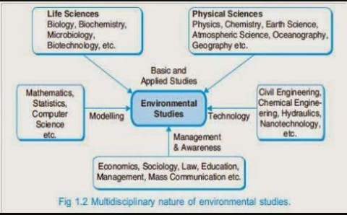

Institutions in Environment:

- Bombay Natural History Society (BNHS),Mumbai:
The BNHS began as a small society of six members in 1883. It grew from a group of shikaris and people from all walks of life into a major research organization that substantially influenced conservation policy in the country. The influence on wildlife policy building, re-search, popular publications and peoples action have been unique features of the multi-faceted society. Undoubtedly its major contribution has been in the field of wildlife research. It is India’s oldest conservation research based NGO and one that has acted at the forefront of the battle for species and ecosystems. The BNHS publishes a popular magazine called Hornbill and also an internationally well-known Journal on Natural History. The BNHS has over the years helped Government to frame wildlife related laws and has taken up battles such as the ‘Save the Silent Valley’ campaign.

- World Wide Fund for Nature (WWF-I), New Delhi:
The WWF-I was initiated in 1969 in Mumbai after which the headquarters were shifted to Delhi with several branch offices all over India. The early years focused attention on wildlife education and awareness. It runs several programs including the Nature Clubs of India program for school children and works as a think tank and lobby force for environment and development issues.

- Center for Science and Environment (CSE),New Delhi:
Activities of this Center include organizing campaigns, holding workshops and conferences, and producing environment related publications. It published a major document on the ‘State of India’s Environment’, the first of its kind to be produced as a Citizen’s Report on the Environment. The CSE also publishes a popular magazine, ‘Down to Earth’, which is a Science and Environment fortnightly. It is involved in the publication of material in the form of books, posters, video films and also conducts workshops and seminars on biodiversity related issues.

- Botanical Survey of India (BSI):
The Botanical Survey of India (BSI) was established in 1890 at the Royal Botanic Gardens, Calcutta. How-ever it closed down for several years after 1939 and was reopened in 1954. In 1952 plans were made to reorganize the BSI and formulate its objectives. By 1955 the BSI had its headquarters in Calcutta with Circle Offices at Coimbatore, Shillong, Pune and Dehra Dun. Between 1962 and 1979, offices were established in Allahbad, Jodhpur, Port Blair, Itanagar and Gangtok. The BSI currently has nine regional centres. It carries out surveys of plant resources in different regions.

- Zoological Survey of India (ZSI):
The ZSI was established in1916. Its mandate was to do a systematic survey of fauna in India. It has over the years collected ‘type specimens’ on the bases of which our animal life has been studied over the years. Today it has over a million specimens! This makes it one of the largest collections in Asia. It has done an enormous amount of work on taxonomy and ecology. It currently operates from 16 regional centers.

- Centre for Environment Education (CEE),Ahmedabad:
The Centre for Environment Education, Ahmedabad was initiated in 1989. It has a wide range of programs on the environment and produces a variety of educational material. CEE’s Training in Environment Education {TEE} program has trained many environment educators.

- Wildlife Institute of India (WII), Dehradun:
This Institution was established in 1982, as a major training establishment for Forest Officials and Research in Wildlife Management. Its most significant publication has been ‘Planning A Wildlife Protected Area Network for India’ (Rodgers and Panwar, 1988). The organisation has over the years added an enormous amount of information on India’s biological wealth. It has trained a large number of Forest Department Officials and Staff as Wildlife Managers. Its M.Sc. Program has trained excellent wildlife scientists. It also has an Environment Impact Assessment (EIA) cell. It trains personnel in eco-development, wildlife biology, habitat management and Nature interpretation.

Natural Resources

Life on this planet earth depends upon a large number of things and services provided by the nature, which are known as Natural resources. Thus water, air, soil, minerals, coal, forests, crops and wild life are all examples of natural resources.

Renewable and Non-renewable Resources

On the basis of continuity, the resources are classified as under:

- Renewable Resources

- Non-renewable Resources.

- Renewable Resources:
Renewable resources which are inexhaustive and can be regenerated within a given span of time. e.g. forests, wildlife, wind energy, biomass energy, tidal energy, hydro power etc. Solar energy is also a renewable form of energy as it is an inexhaustible source of energy.

- Non-renewable Resources:
Non-renewable resources which cannot be regenerated e.g. Fossil fuels like coal, petroleum, minerals etc. Once we exhaust these reserves, the same cannot be replenished.

Even our renewable resources can become non-renewable if we exploit them to such extent that their rate of consumption exceeds their rate of regeneration.
It is very important to protect and conserve our natural resources and use them in a judicious manner so that we don’t exhaust them. It does not mean that we should stop using most of the natural resources. Rather, we should use the resources in such a way that we always save enough of them for our future generations. In this unit we shall discuss the major natural resources:

- Forest resources
- Water resources
- Mineral resources
- Food resources
- Energy resources
- Land resources

Natural resources and associated problems:

Human population is growing day-by-day. Continuous increase in population caused an increasing demand for natural resources. Due to urban expansion, electricity need and industrialization, man started utilizing natural resources at a much larger scale. Non-renewable resources are limited.
They cannot be replaced easily. After some time, these resources may come to an end. It is a matter of much concern and ensures a balance between population growth and utilization of resources. There are many problems associated with natural resources:

- Forest resources and associated problems:

- Use and over-exploitation.
- Deforestation
- Timber extraction.
- Mining and its effects on forest
- Dams and their effects on forests and tribal people
- Water resources and associated problems:

- Use and overutilization of water.
- Floods, droughts etc.
- Conflicts over water.
- Dams and problems.

- Mineral resource and associated problems:
- Use and exploitation.
- Environmental effects of extracting and using minerals.

- Food resources and associated problems:
- World food problems.
- Changes caused by agriculture and over grazing.
- Effects of modern agriculture.
- Fertilizer-pesticide problems.
- Water logging and salinity.

- Energy resources and associated problems:
- Growing energy needs.
- Land resources and associated problems
- Land degradation.
- Man-induced landslides.
- Soil erosion and desertification.

FOREST RESOURCES

Forests are one of the most important natural resources on this earth. Covering the earth like a green blanket these forests not only produce innumerable material goods, but also provide several environmental services which are essential for life.

About 1/3rd of the world’s land area is forested which includes closed as well as open forests. Former USSR accounts for about a 5th of the world’s forests, Brazil for about a 7th and Canada and USA each for 6-7%. But it is a matter of concern that almost everywhere the cover of the natural forests has declined over the years. The greatest loss occurred in tropical Asia where one third of the forest resources have been destroyed.

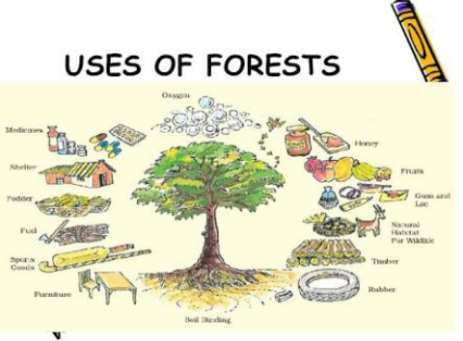

USES OF FORESTS:

- Commercial uses: Forests provide us a large number of commercial goods which include timber, firewood, pulpwood, food items, gum, resins, non-edible oils, rubber, fibers, lac, bamboo canes, fodder, medicine, drugs and many more items, the total worth of which is estimated to be more than $ 300 billion per year.
Half of the timber cut each year is used as fuel for heating and cooking. One third of the wood harvest is used for building materials as lumber, plywood and hardwood, particle board and chipboard. One sixth of the wood harvest is converted into pulp and used for paper industry. Many forest lands are used for mining, agriculture, grazing, and recreation and for development of dams.

- Ecological uses:
- Production of oxygen: The trees produce oxygen by photo-synthesis which is so vital for life on this earth. They are rightly called as earth’s lungs.

- Reducing global warming: The main greenhouse gas car-bon dioxide (CO₂) is absorbed by the forests as a raw material for photosynthesis. Thus forest canopy acts as a sink for CO₂ thereby reducing the problem of global warming caused by greenhouse gas CO₂.

- Wild life habitat: Forests are the homes of millions of wild animals and plants. About 7 million species are found in the tropical forests alone.

- Regulation of hydrological cycle: Forested watersheds act like giant sponges, absorbing the rainfall, slowing down the runoff and slowly releasing the water for recharge of springs. About 50-80 %of the moisture in the air above tropical forests comes from their transpiration which helps in bringing rains.

- Soil Conservation: Forests bind the soil particles tightly in their roots and prevent soil erosion. They also act as wind-breaks.

- Pollution moderators: Forests can absorb many toxic gases and can help in keeping the air pure. They have also been reported to absorb noise and thus help in preventing air and noise pollution.

OVER EXPLOITATION OF FORESTS:
Since time immemorial, humans have depended heavily on forests for food, medicine, shelter, wood and fuel. With growing civilization the demands for raw material like timber, pulp, minerals, fuel wood etc. shooted up resulting in large scale logging, mining, road-building and clearing of forests. Excessive use of fuel wood and charcoal, expansion of urban, agricultural and industrial areas and overgrazing have together led to over-exploitation of our forests leading to their rapid degradation.

DEFORESTATION:

Deforestation is the process of felling trees indiscriminately resulting in nude or semi-nude surface of the hill hitherto covered by thick forests.

Major Causes of Deforestation:

(i) Shifting cultivation: There are an estimated 300 million people living as shifting cultivators who practice slash and burn agriculture and are supposed to clear more than 5 lakh ha of forests for shifting cultivation annually.

(ii) Fuel requirements: Increasing demands for fuel wood by the growing population in India alone has shooted up to 300-500 million tons in 2001 as compared to just 65 million tons during independence, thereby increasing the pressure on forests.

(iii) Raw materials for industrial use: Wood for making boxes, furniture, railway-sleepers, plywood, match-boxes, pulp for paper industry etc. have exerted tremendous pressure on forests. Plywood is in great demand for packing tea for Tea industry of Assam while fir tree wood is exploited greatly for packing apples in J&K.

(iv) Development projects: Massive destruction of forests occur for various development projects like hydroelectric projects, big dams, road construction, mining etc.

(v) Growing food needs: In developing countries this is the main reason for deforestation. To meet the demands of rapidly growing population, agricultural lands and settlements are created permanently by clearing forests.

(vi) Overgrazing: The poor in the tropics mainly rely on wood as a source of fuel leading to loss of tree cover and the cleared lands are turned into the grazing lands. Overgrazing by the cattle leads to further degradation of these lands.

Major Consequences of Deforestation:

Deforestation has far reaching consequences, which may be outlined as follows:

    - It threatens the existence of many wild life species due to destruction of their natural habitat.
    - Biodiversity is lost and along with that genetic diversity is eroded.
    - Hydrological cycle gets affected, thereby influencing rainfall.
    - Problems of soil erosion and loss of soil fertility increase.
    - In hilly areas it often leads to landslides.

Major Activities in Forests:

- Timber Extraction:
Logging for valuable timber, such as teak and Mahogany not only involves a few large trees per hectare but about a dozen more trees since they are strongly interlocked with each other by vines etc. Also road construction for making approach to the trees causes further damage to the forests.

- Mining:
Mining operations for extracting minerals and fossil fuels like coal often involves vast forest areas. Mining from shallow deposits is done by surface mining while that from deep deposits is done by sub-surface mining. More than 80,000 ha of land of the country is presently under the stress of mining activities. Mining and its associated activities require removal of vegetation along with underlying soil mantle and overlying rock masses. This results in defacing the topography and destruction of the landscape in the area.

Large scale deforestation has been reported in Mussorie and Dehradun valley due to indiscriminate mining of various minerals over a length of about 40 Km. The forested area has declined at an average rate of 33% and the increase in non-forest area due to mining activities has resulted in relatively unstable zones leading to landslides.

Indiscriminate mining in forests of Goa since 1961 has destroyed more than 50,000 ha of forest land. Coal mining in Jharia, Raniganj and Singrauli areas have caused extensive deforestation in Jharkhand. Mining of magnesite and soap- stones have destroyed 14 ha of forest in the hill slopes at Khirakot, Kosi valley, Almora. Mining of radioactive minerals in Kerala, Tamilnadu and Karnataka are posing similar threats of deforestation. The rich forests of Western Ghats are also facing the same threat due to mining projects for excavation of copper, chromite, bauxite and magnetite.

- Dams and their effects on forests and tribal people :

Big dams and river valley projects have multi-purpose uses and have been referred to as “Temples of modern India”. However, these dams are also responsible for the destruction of vast areas of forests. India has more than 1550 large dams, the maximum being in the state of Maharashtra (more then 600), followed by Gujarat (more then 250) and Madhya Pradesh (130). The highest one is Tehri dam, on river Bhagirathi in Uttaranchal and the largest in terms of capacity is Bhakra dam on river Satluj in H.P. Big dams have been in sharp focus of various environmental groups all over the world which is mainly because of several ecological problems including deforestation and socio-economic problems related to tribal or native people associated with them.
The Silent Valley hydroelectric project was one of the first such projects situated in the tropical rain forest area of Western Ghats which attracted much concern of the people. The crusade against the ecological damage and deforestation caused due to Tehri dam was led by Sh. Sunder lal Bahuguna, the leader of Chipko movement.
For building big dams, large scale devastation of forests takes place which breaks the natural ecological balance of the region. Floods, droughts and landslides become more prevalent in such areas.

CASE STUDY - Joint Forest Management

The need to include local communities in Forest Management has become a growing concern. Local people will only support greening an area if they can see some economic benefit from conservation. An informal arrangement between local communities and the Forest Department began in 1972, in Midnapore District of West Bengal.
JFM has now evolved into a formal agreement which identifies and respects the local community’s rights and benefits that they need from forest resources. Under JFM schemes, Forest Protection Committees from local community members are formed. They participate in restoring green cover and protect the area from being over exploited.

Major Projects

The major projects which have generated much controversy are as under:

(i) Sardar Sarovar Project, Gujrat.

(ii) Narmada Sagar Project, M.P.

(iii) Tehri Dam Project in U.P.

Although the above projects have been given environment clearance, struggle is still on the force of the Govt. to drop these projects. A brief description of these projects and their possible effects are as under:

1. Sardar Sarovar (SS) Project

This project is near Navagam in Bharuch district of Gujrat.

It is one of the costliest projects affecting villages in three states—M.P., Maharashtra and Gujrat. If it is carried out, its effects would be as under:

(i) About 245 villages will be submerged, of which about 193 in M.P. alone.

(ii) Over 75,000 (nearly 50,000 in M.P. alone) people will be evicted.

(iii) Additional displacements is likely to be caused during social and environment rehabilitation work undertaken to repair the dislocation and damages caused by the project.

It is evident that compensatory afforestation and setting of wildlife sanctuary will displace or affect other villagers in the area. The relevancy is evident from the fact that it has been officially admitted that nearly 43,000 ha of land will be needed for rehabilitation of SS oustees.

2. Narmada Valley Project (NVP)

It claims to be the world’s largest river valley project. It has attracted the greatest attention. The 30 big dams and over 3,000 medium and minor dams are envisaged at cost of Rs. 25,000 crore. Its effects are anticipated as under:

(i) It would displace over one million people, mostly tribals.

(ii) It would submerge 56,000 ha fertile agriculture land.

(iii) Total forest areas nearly 60,000 ha. will be destroyed.

(iv) Nearly 25 species of birds will be deprived of their habitats.

3. Tehri Dam

This Dam is proposed on the Bhagirathi river in U.P. at the foothills of Himalayas. It is Soviet-financed and challenged in the Supreme Court. Its effects are envisaged as under:

(i) This Dam will displace over 85,000 people.

(ii) It will totally immerse the Tehri town and completely or partly submerge nearly 100 villages.
(iii) The site of the Dam is prone to intense seismic activity.

(iv) The 3,200 million ton of water that the Dam would impound, could cause a major earth tempor.

(v) In the event of a disaster, the entire religious townships of Deoprayag, Hardwar and Rishikesh would be devastated.

(vi) Thousand of hectares of rich, agriculture land will be drowned.

WATER RESOURCES

Water is an indispensable natural resource on this earth on which all life depends. About 97% of the earth’s surface is covered by water and most of the animals and plants have 60-65% water in their body.

Water is characterized by certain unique features which make it a marvellous resource:

(i) It exists as a liquid over a wide range of temperature i.e. from 0° to100°C.

(ii) It has the highest specific heat, due to which it warms up and cools down very slowly without causing shocks of temperature jerks to the aquatic life.

(iii) It has a high latent heat of vaporization Hence, it takes a huge amount of energy for getting vaporized. That’s why it produces a cooling effect as it evaporates.

(iv) It is an excellent solvent for several nutrients. Thus, it can serve as a very good carrier of nutrients, including oxygen, which are essential for life. But, it can also easily dissolve various pollutants and become a carrier of pathogenic microorganisms.

(v) Due to high surface tension and cohesion it can easily rise through great heights through the trunk even in the tallest of the trees like Sequoia.

(vi) It has an anamolous expansion behaviour i.e. as it freezes, it expands instead of contracting and thus becomes lighter. It is because of this property that even in extreme cold, the lakes freeze only on the surface. Being lighter the ice keeps floating, whereas the bottom waters remain at a higher temperature and therefore, can sustain aquatic organisms even in extreme cold.

WATER USE AND OVER-EXPLOITATION

Water is absolutely essential for life. Most of the life processes take place in water contained in the body. Uptake of nutrients, their distribution in the body, regulation of temperature, and removal of wastes are all mediated through water.

Human beings depend on water for almost every developmental activity. Water is used for drinking, irrigation, transportation, washing and waste disposal for industries and used as a coolant for thermal power plants. Water shapes the earth’s surface and regulates our climate.

Water use by humans is of two types:

water withdrawal: taking water from groundwater or surface water resource
water consumption: the water which is taken up but not returned for reuse.

Globally, only about 60 percent of the water withdrawn is consumed due to loss through evaporation.

With increasing human population and rapid development, the world water withdrawal demands have increased many folds and a large proportion of the water withdrawn is polluted due to anthropogenic activities.

On a global average 70 percent of the water withdrawn is used for agriculture. In India, we use 93% of water in agricultural sector.

Water: A Precious Natural Resource

Although water is very abundant on this earth, yet it is very precious. Out of the total water reserves of the world, about 97% is salty water(marine) and only 3% is fresh water. Even this small fraction of fresh water is not available to us as most of it is locked up in polar ice caps and just 0.003% is readily available to us in the form of groundwater and surface water.

Overuse of groundwater for drinking, irrigation and domestic pur-poses has resulted in rapid depletion of groundwater in various regions leading to lowering of water table and drying of wells. Pollution of many of the groundwater aquifers has made many of these wells unfit for consumption.

Rivers and streams have long been used for discharging the wastes. Most of the civilizations have grown and flourished on the banks of rivers, but unfortunately, growth in turn, has been responsible for pollution of the rivers.

As per the United Nations estimates (2002), at least 101 billion people do not even have access to safe drinking water and 2.4 billion do not have adequate sanitation facilities. Increasing population and expanding development would further increase the demands for wastes. It is estimated that by 2024, two-thirds of the world population would be suffering from acute water shortage.

1.Groundwater :

About 9.86% of the total fresh water resources is in the form of groundwater and it is about 35-50 times that of surface water supplies. Till some time back groundwater was considered to be very pure. However, of late, even groundwater aquifers have been found to be contaminated by leachates from sanitary landfills etc.

A layer of sediment or rock that is highly permeable and contains water is called an aquifer. Layers of sand and gravel are good aquifers while clay and crystalline rocks (like granite) are not since they have low permeability. Aquifers may be of two types:

Unconfined aquifers which are overlaid by permeable earth materials and they are recharged by water seeping down from above in the form of rainfall and snow melt.

Confined aquifers which are sandwitched between two impermeable layers of rock or sediments and are recharged only in those areas where the aquifer intersects the land surface. Sometimes the recharged area is hundreds of kilometers away from the location of the well.

Effects of Groundwater Usage

(i) Subsidence: When groundwater withdrawal is more than its recharge rate, the sediments in the aquifer get compacted, a phenomenon known as ground subsidence. Huge economic losses may occur due to this phenomenon because it results in the sinking of overlying land surface. The common problems associated with it include structural damage in buildings, fracture in pipes, reversing the flow of sewers and canals and tidal flooding.

(ii) Lowering of water table: Mining of groundwater is done extensively in arid and semi-arid regions for irrigating crop fields. However, it is not advisable to do excessive mining as it would cause a sharp decline in future agricultural production, due to lowering of water table.

(iii) Water logging: When excessive irrigation is done with brackish water it raises the water table gradually leading to water-logging and salinity problems.

2.Surface Water :

The water coming through precipitation (rainfall, snow) when does not percolate down into the ground or does not return to the atmosphere as evaporation or transpiration loss, assumes the form of streams, lakes, ponds, wetlands or artificial reservoirs known as surface water. The surface water is largely used for irrigation, industrial use, public water supply, navigation etc. A country’s economy is largely dependent upon its rivers.

FLOODS

In some countries like India and Bangladesh rainfall does not occur throughout the year, rather, 90% of it is concentrated into a few months (June-September). Heavy rainfall often causes floods in the low-lying coastal areas. Prolonged downpour can also cause the over-flowing of lakes and rivers resulting into floods.

Deforestation, overgrazing, mining, rapid industrialization, global warming etc. have also contributed largely to a sharp rise in the incidence of floods, which otherwise is a natural disaster.

Floods have been regular features of some parts of India and Bangladesh causing huge economic loss as well as loss of life. People of Bangladesh are accustomed to moderate flooding during monsoon and they utilize the flood water for raising paddy. But, severe floods like that in 1970, 1988 and 1991 resulting from excessive Himalayan runoff and storms, had very disastrous consequences causing massive deaths and damages. In 1970, about one million people were drowned while 1,40,000 people died in 1991. Networking of rivers is being proposed at national level to deal with the problems of floods.

DROUGHTS

There are about 80 countries in the world, lying in the arid and semi-arid regions that experience frequent spells of droughts, very often extending up to year long duration. When annual rainfall is below normal and less than evaporation, drought conditions are created.

Ironically, these drought- hit areas are often having a high population growth which leads to poor land use and makes the situation worse.

Anthropogenic causes: Drought is a meteorological phenomenon, but due to several anthropogenic causes like over grazing, deforestation, mining etc. there is spreading of the deserts tending to convert more areas to drought affected areas. In the last twenty years, India has experienced more and more desertification, thereby increasing the vulnerability of larger parts of the country to droughts.

Erroneous and intensive cropping pattern and increased exploitation of scarce water resources through well or canal irrigation to get high productivity has converted drought - prone areas into desertified ones. In Maharashtra there has been no recovery from drought for the last 30 years due to over-exploitation of water by sugarcane crop which has high water demands.

Conflicts over water:
With this in mind, we can describe a drought scenario to be ‘A relatively long time where there is not enough water than there usually is, as a result of dry weather, to support human, animal and plant life.
Droughts may not be an issue just because there is less or no precipitation. However, it becomes an issue when it begins to affect water supply for irrigation, municipal, industrial, energy, and ecosystem function. People often do not see droughts as natural disasters like tornadoes, hurricanes or floods, because they do not have usual immediate destructive ability, but they can be very catastrophic in the long run. Server droughts can have very serious consequences. Conflict can be defined as disagreement over the appropriate
Sources of Conflict:
Conflict can result from many factors. The sources of conflicts must be understood in order to manage water resources effectively. Three basic sources of conflict are conflicting goals, factual disagreements, and ineffective relationships (distrust and power struggles).
Conflicting Goals:
Water planning and management activities are undertaken for the purpose of solving problems such as inadequate water supplies or poor water quality. For water planning efforts to be undertaken, the problem to be solved must be clearly identified and understood.

Once a problem is identified, possible courses of action to address the problem can be enumerated and then the best course of action can be chosen and implemented.

Traditional Water Management System

In India, even today, there are several villages where water management is done not by the Irrigation Department, but by local managers. In south India, a neerkatti manages the traditional tanks very efficiently based on his/her knowledge of the terrain, drainage and irrigation needs. They usually give preference to the tail end fields and decide per capita allocation of water based on the stock of available water in the tank and crop needs. In Maharashtra, the water mangers are called havaldars or jaghyas who manage and resolve conflicts by overseeing the water channels from main canal to the distributory canals.
In Ladakh, the water manager is known as churpun who has got complete charge with full powers over allocation of available water. The major source of water is melt water from glaciers and snow supplementary by water from springs and marshes. The water is distributed to different fields through an intricate network of earthen channels.

In traditional water management, innovative arrangements ensure equitable distribution of water, which are democratically implemented. The ‘gram-sabhas’ approve these plans publicly. While water disputes between states and nations often assume battle like situations, our traditional water managers in villages prove to be quite effective.

BIG DAMS- BENEFITS AND PROBLEMS :

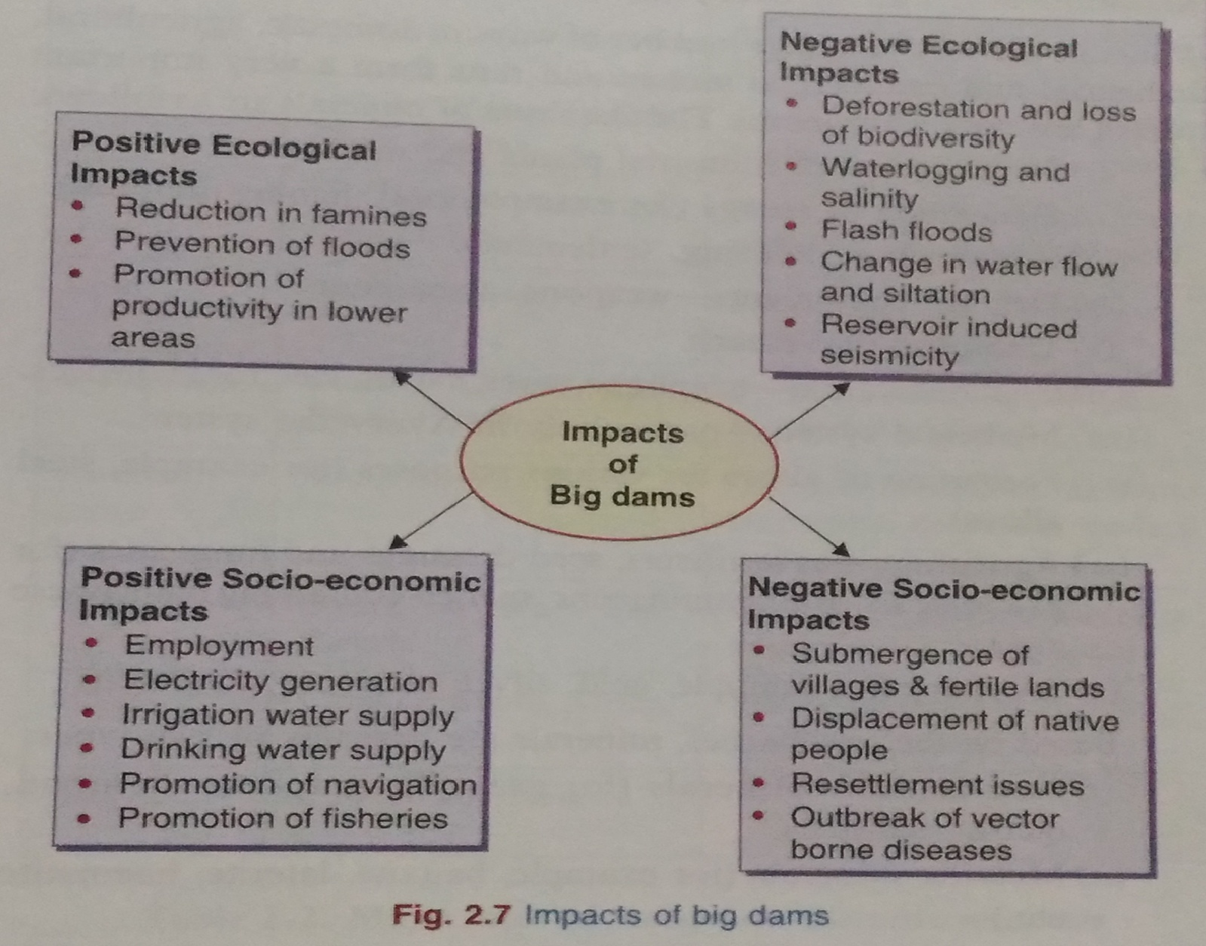

Benefits

River valley projects with big dams have usually been considered to play a key role in the development process due to their multiple uses. India has the distinction of having the largest number of river-valley projects. These dams are often regarded as a symbol of national development. The tribals living in the area pin big hopes on these projects as they aim at providing employment and raising the standard and quality of life. The dams have tremendous potential for economic upliftment and growth. They can help in checking floods and famines, generate electricity and reduce water and power shortage, provide irrigation water to lower areas, provide drinking water in remote areas and promote navigation, fishery etc.

Environmental Problems

The environmental impacts of big-dams are also too many due to which very often the big dams become a subject of controversy. The impacts can be at the upstream as well as downstream levels.

- The upstream problems include the following:

(i) Displacement of tribal people

(ii) Loss of forests, flora and fauna

(iii) Changes in fisheries and the spawning grounds
(iv) Siltation and sedimentation of reservoirs

(v) Loss of non-forest land

(vi) Stagnation and waterlogging near reservoir

(vii) Breeding of vectors and spread of vector-borne diseases
(viii) Reservoir induced seismicity (RIS) causing earthquakes
(ix) Growth of aquatic weeds.

(x) Microclimatic changes.

- The downstream impacts include the following:

(i) Water logging and salinity due to over irrigation

(ii) Micro-climatic changes

(iii) Reduced water flow and silt deposition in river
(iv) Flash floods

(v) Salt water intrusion at river mouth

(vi) Loss of land fertility along the river since the sediments carry-ing nutrients get deposited in the reservoir

(vii) Outbreak of vector-borne diseases like malaria

Thus, although dams are built to serve the society with multiple uses, but it has several serious side-effects.

VARIOUS DAMS IN THE COUNTRY AND BENEFITS THEREFROM

(1) Damodar River Valley Project

Damodar River Valley Project serves several objectives. This huge dam is, in fact, a series of small dams built on a river and its tributaries, serves as man-made lake that is now able to impound huge amount of rain water. In this way, it helps in flood control and soil protection. This water is used for irrigation during dry periods. Since catchments areas of dam are afforested, there is available additional wild land that helps to preserve ecosytems.

The water stored here is used for power generation i.e. hydle power or hydro-electricity. These projects also provide for inland water navigation, cheapest means of transport for heavy goods. They are also used to develop fish hatcheries and nurseries.

Damodar Valley Project consists of series of small dams of the tributaries of Damodar, flowing from Chotanagpur in South Bihar to West Bengal. The hydle power has been integrated in a common grid.

(2) Bhakra Nangal Project

This project has been built where two hills on either side of Satluj are very close to each other. It claims to be highest gravity dam in the world (height 226 metres from river bed). The project serves the states of Himachal Pradesh, Punjab, Harayana, Rajasthan and U.T. of Delhi.

(3) Indira Gandhi Rajasthan Canal Project

It is ambitious plan to bring new areas under irrigation. The water of the Beas and Ravi has to be diverted to Satluj. The Pong Dam on the Beas impounds 6,90,000 ha metres water. This dam helped in the division of Beas into Satluj in a regulated manner. It enabled Rajasthan canal to irrigation Ganganagar, Bikaner and Jaiselmer Districts. The main canal is 468 km long.

(4) Kosi Project

Kosi Project or river Kosi in North Bihar has a main canal to irrigate 8,73,000 ha of land in Bihar.

(5) Hirakud Dam

Hirakud Dam in Orissa is longest serves Karnataka and Andhra Pradesh. This 2.5 km long dam irrigates nearly 4,00,000 ha land.

(6) The Tungbhadra
The Tungbhadra Project serves Karnataka and Andhra Pradesh. This 2.5 km long dam irrigates nearly 4,00,000 ha land.

MINERAL RESOURCES

Minerals are naturally occurring, inorganic, crystalline solids having a definite chemical composition and characteristic physical properties. There are thousands of minerals occurring in different parts of the world. However, most of the rocks, we see everyday are just composed of a few common minerals like quartz, feldspar, biotite, dolomite, calcite, laterite etc. These minerals, in turn, are composed of some elements like silicon, oxygen, iron, magnesium, calcium, aluminium etc.

USES AND EXPLOITATION

Minerals find use in a large number of ways in everyday use in domestic, agricultural, industrial and commercial sectors and thus form a very important part of any nation’s economy. The main uses of minerals are as follows:

- Development of industrial plants and machinery.
- Generation of energy e.g. coal, lignite, uranium.
- Construction, housing, settlements.

- Defence equipments-weapons, armaments.
- Transportation means.

- Communication- telephone wires, cables, electronic devices.
- Medicinal system- particularly in Ayurvedic System.

- Formation of alloys for various purposes (e.g. phosphorite).
- Agriculture–as fertilizers, seed dressings and fungicides
- Jewellery– e.g. Gold, silver, platinum, diamond.

Based on their properties, minerals are basically of two types:

  - Non metallic minerals : Non metallic minerals are the one from which various non-metallic compound can be extracted.
e.g. graphite, diamond, quartz, feldspar.

(ii) Metallic minerals : Metallic minerals are the one from which various metals can be extracted.
e.g. Bauxite, laterite, haematite etc.

Use of metals by human beings has been so extensive since the very beginning of human civilization that two of the major epochs of human history are named after them as Bronze Age and Iron Age. The reserves of metals and the technical know-how to extract them have been the key elements in determining the economy and political power of nations.

Out of the various metals, the one used in maximum quantity is Iron and steel (740 million metric tons annually) followed by manganese, copper, chromium, aluminium and Nickel.

Major reserves and important uses of some of the major metals
Metal | Major World Reserves |  |  | Major Uses
Aluminium | Australia, Guinea, |  |  | Packaging food items, transpor-
 | Jamaica |  |  | tation, utensils, electronics
Chromium | CIS, South Africa |  |  | For making high strength steel
 |  |  |  | alloys, In textile/tanning
 |  |  |  | industries
Copper | U.S.A., Canada, CIS, |  |  | Electric and electronic goods,
 | Chile, Zambia |  |  | building, construction, vessels
Iron | CIS, South America, |  |  | Heavy machinery, steel produc-
 | Canada, U.S.A. |  |  | tion transportation means
Lead | North America, U.S.A., |  |  | Leaded gasoline, Car batteries,
 | CIS |  |  | paints, ammunition
Manganese | South | Africa, | CIS, | For making high strength, heat-
 | Brazil, Gabon |  |  | resistant steel alloys
Platinum | South Africa, CIS |  |  | Use in automobiles, catalytic
group |  |  |  | converters, electronics, medical
 |  |  |  | uses.
Gold | South | Africa, | CIS, | Ornaments, medical use, elec-
 | Canada |  |  | tronic use, use in aerospace
Silver | Canada, South Africa, |  |  | Photography, electronics
 | Mexico |  |  | jewellery
Nickel | CIS, Canada, New |  |  | Chemical industry, steel alloys
 | Caledonia

Major uses of some non-metallic minerals

Non-metal Mineral | Major Uses
Silicate minerals | Sand and gravel for construction, bricks, paving etc.
Limestone | Used for concrete, building stone, used in agriculture
 | for neutralizing acid soils, used in cement industry
Gypsum | Used in plaster wall-board, in agriculture
Potash, phosphorite | Used as fertilizers
Sulphur pyrites | Used in medicine, car battery, industry.

ENVIRONMENTAL IMPACTS OF MINERAL EXTRACTION AND USE

The issue related to the limits of the mineral resources in our earth’s crust or in the ocean is not so significant. More important environ-mental concern arises from the impacts of extraction and processing of these minerals during mining, smelting etc.

Indian Scenario: India is the producer of 84 minerals the annual value of which is about Rs. 50,000 crore. At least six major mines need a mention here which are known for causing severe problems:
(i) Jaduguda Uranium Mine, Jharkhand—exposing local people to radioactive hazards.

(ii) Jharia coal mines, Jharkhand—underground fire leading to land subsidence and forced displacement of people.

(iii) Sukinda chromite mines, Orissa—seeping of hexavalent chromium into river posing serious health hazard, Cr⁶⁺ being highly toxic and carcinogenic.

(iv) Kudremukh iron ore mine, Karnataka—causing river pollution and threat to biodiversity.

(v) East coast Bauxite mine, Orissa—Land encroachment and issue of rehabilitation unsettled.

(vi) North-Eastern Coal Fields, Assam—Very high sulphur contamination of groundwater.

Impacts of mining:

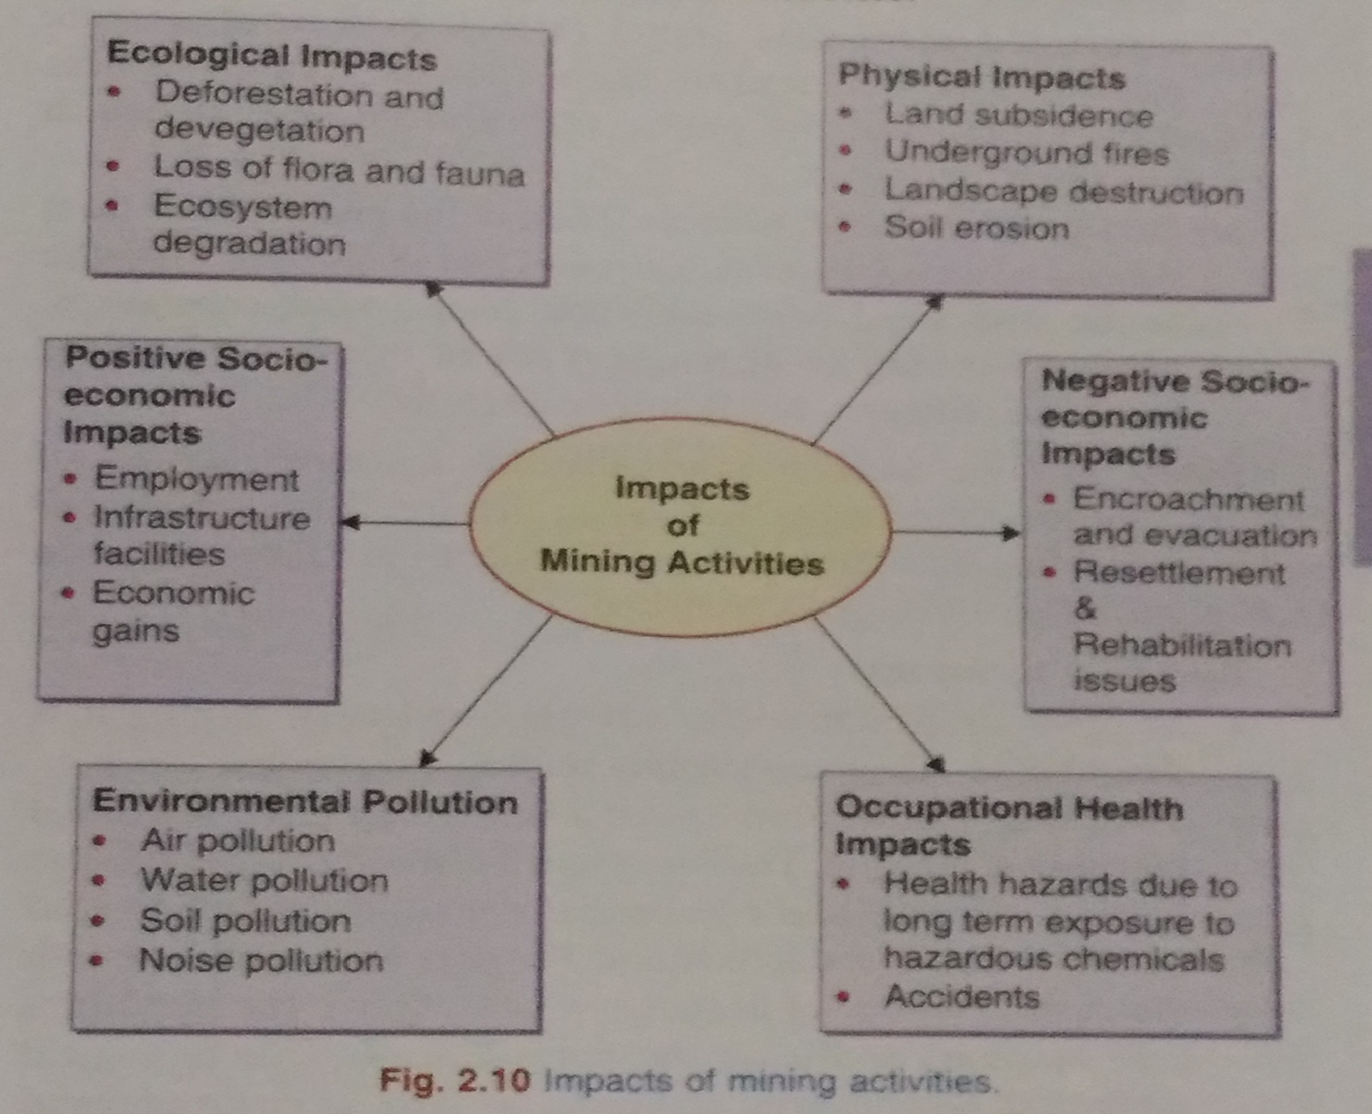

Mining is done to extract minerals (or fossil fuels) from deep deposits in soil by using sub-surface mining or from shallow deposits by surface mining. The former method is more destructive, dangerous and expensive including risks of occupational hazards and accidents.

Surface mining can make use of any of the following three types:
(a) Open-pit mining in which machines dig holes and remove the ores (e.g. copper, iron,gravel, limestone, sandstone, marble,granite).

(b) Dredging in which chained buckets and draglines are used which scrap up the minerals from under-water mineral deposits.

(c) Strip mining in which the ore is stripped off by using bulldozers, power shovels and stripping wheels (e.g. phosphate rocks).

The environmental damage caused by mining activities are as follows:

(i) Devegetation and defacing of landscape: The topsoil as well as the vegetation are removed from the mining area to get access to the deposit. While large scale deforestation or devegetation leads to several ecological losses as already discussed in the previous section, the landscape also gets badly affected. The huge quantities of debris and tailings along with big scars and disruptions spoil the aesthetic value of the region and make it prone to soil erosion.

(ii) Subsidence of land: This is mainly associated with underground mining. Subsidence of mining areas often results in tilting of buildings, cracks in houses, buckling of roads, bending of rail tracks and leaking of gas from cracked pipe-lines leading to serious disasters.
(iii) Groundwater contamination: Mining disturbs the natural hydrological processes and also pollutes the groundwater. Sulphur, usually present as an impurity in many ores is known to get converted into sulphuric acid through microbial action, thereby
making the water acidic. Some heavy metals also get leached into the groundwater and contaminate it posing health hazards.
(iv) Surface water pollution: The acid mine drainage often contaminates the near streams and lakes. The acidic water is detrimental to many forms of aquatic life. Sometimes radio-active substances like uranium also contaminate the water bodies through mine wastes and kill aquatic animals. Heavy metal pollution of water bodies near the mining areas is a common feature creating health hazards.

(v) Air pollution: In order to separate and purify the metal from other impurities in the ore, smelting is done which emits enormous quantities of air pollutants damaging the vegetation nearby and has serious environmental health impacts. The suspended particulate matter (SPM), SOx, soot, arsenic particles, cadmium, lead etc. shoot up in the atmosphere near the smelters and the public suffers from several health problems.

(vi) Occupational Health Hazards: Most of the miners suffer from various respiratory and skin diseases due to constant exposure to the suspended particulate matter and toxic substances. Miners working in different types of mines suffer from asbestosis, silicosis, black lung disease etc.

CASE STUDIES

- Mining and quarrying in Udaipur

About 200 open cast mining and quarrying centers in Udaipur, about half of which are illegal are involved in stone mining including soapstone, building stone, rock phosphate and dolomite. The mines spread over 15,000 hectares in Udaipur have caused many adverse impacts on environment. About 150 tonnes of explosives are used per month in blasting. The overburden, washoff, discharge of mine water etc. pollute the water. The Maton mines have badly polluted the Ahar river. The hills around the mines are devoid of any vegetation except a few scattered patches and the hills are suffering from acute soil erosion. The waste water flows towards a big tank of “Bag Dara”. Due to scarcity of water people are compelled to use this effluent for irrigation purpose. The blasting activity has adversely affected the fauna and the animals like tiger, lion, deer and even hare, fox, wild cats and birds have disappeared from the mining area.

- Uranium Mining in Nalgonda, A.P.—The public hearing

The present reserves of Uranium in Jaduguda mines, Jharkhand can supply the yellow cake only till 2004. There is a pressing need for mining more uranium to meet the demands of India’s nuclear programme. The Uranium Corporation of India (UCIL) proposes to mine uranium from the deposits in Lambapur and Peddagattu villages of Nalgonda district in Andhra Pradesh and a processing unit at about 18 kms at Mallapur. The plan is to extract the ore of 11.02 million tons in 20 years. The IUCL is trying its best to allure the villagers through employment opportunities. But, experts charge the company for keeping silence on the possible contamination of water bodies in the area. The proposed mines are just 1 km from human habitation and hardly 10 km from Nagarjun Sagar Dam and barely 4 km from the Akkampalli reservoir which is Hyderabad’s new source of drinking water.

It is estimated that 20 years of mining would generate about 7.5 million metric tones of radioactive waste of which 99.9% will be left behind. The villagers are very likely to be affected by the radioactive wastes. Though IUCL claims that there won’t be any such accidents, but no one can deny
that it is a highly hazardous industry and safety measures cannot be overlooked. The pathetic condition of Jaduguda Uranium mines in Jharkhand where there is a black history of massive deaths and devastation have outraged the public, who don’t want it to be repeated for Nalgonda. The public hearing held just recently in February, 2004 witnessed strong protests from NGOs and many villagers. The fate of the proposed mining is yet to be decided.

FOOD RESOURCES

We have thousands of edible plants and animals over the world out of which only about three dozen types constitute the major food of humans. The main food resources include wheat, rice, maize, potato, barley, oats, cassava, sweet potato, sugarcane, pulses, sorghum, millet, about twenty or so common fruits and vegetables, milk, meat, fish and seafood.

Amongst these rice, wheat and maize are the major grains, about 1500 million metric tons of which are grown each year, which is about half of all the agricultural crops. About 4 billion people in the developing countries have wheat and rice as their staple food.

Meat and milk are mainly consumed by more developed nations of North America, Europe and Japan who consume about 80% of the total. Fish and sea-food contribute about 70 million metric tons of high quality protein to the world’s diet.

The Food and Agriculture Organization (FAO) of United Nations estimated that on an average the minimum caloric intake on a global scale is 2,500 calories/day. People receiving less than 90% of these minimum dietary calories are called undernourished and if it is less than 80% they are said to be seriously undernourished. Besides the minimum caloric intake we also need proteins, minerals etc. Deficiency or lack of nutrition often leads to malnutrition resulting in several diseases as shown in Table.

Impacts of malnutrition

Deficiency | Health Effect | No. of Cases | Deaths per year
 |  |  | (in millions)
Proteins and | Stunted growth, | 750 | 15-20
Calories | Kwashiorkor, | 1 million
 | Marasmus
Iron | Anemia | 350 million | 0.75-1
Iodine | Goitre, Cretinism | 150 million,
 |  | 6 million
Vitamin A | Blindness | 6 million

WORLD FOOD PROBLEMS

During the last 50 years world grain production has increased almost three times, thereby increasing per capita production by about 50%. But, at the same time population growth increased at such a rate in LDCs (Less developed countries) that it outstripped food production. Every year 40 million people (fifty percent of which are young children between 1 to 5 years) die of undernourishment and malnutrition. This means that every year our food problem is killing as many people as were killed by the atomic bomb dropped on Hiroshima during World War II.

These startling statistical figures more than emphasize the need to increase our food production, equitably distribute it and also to control population growth.

Indian Scenario: Although India is the third largest producer of staple crops, an estimated 300 million Indians are still undernourished. India has only half as much 1and as USA, but it has nearly three times population to feed. Our food problems are directly related to population.

The World Food Summit, 1996 has set the target to reduce the number of undernourished to just half by 2015, which still means 410 million undernourished people on the earth.

IMPACTS OF OVERGRAZING AND AGRICULTURE:

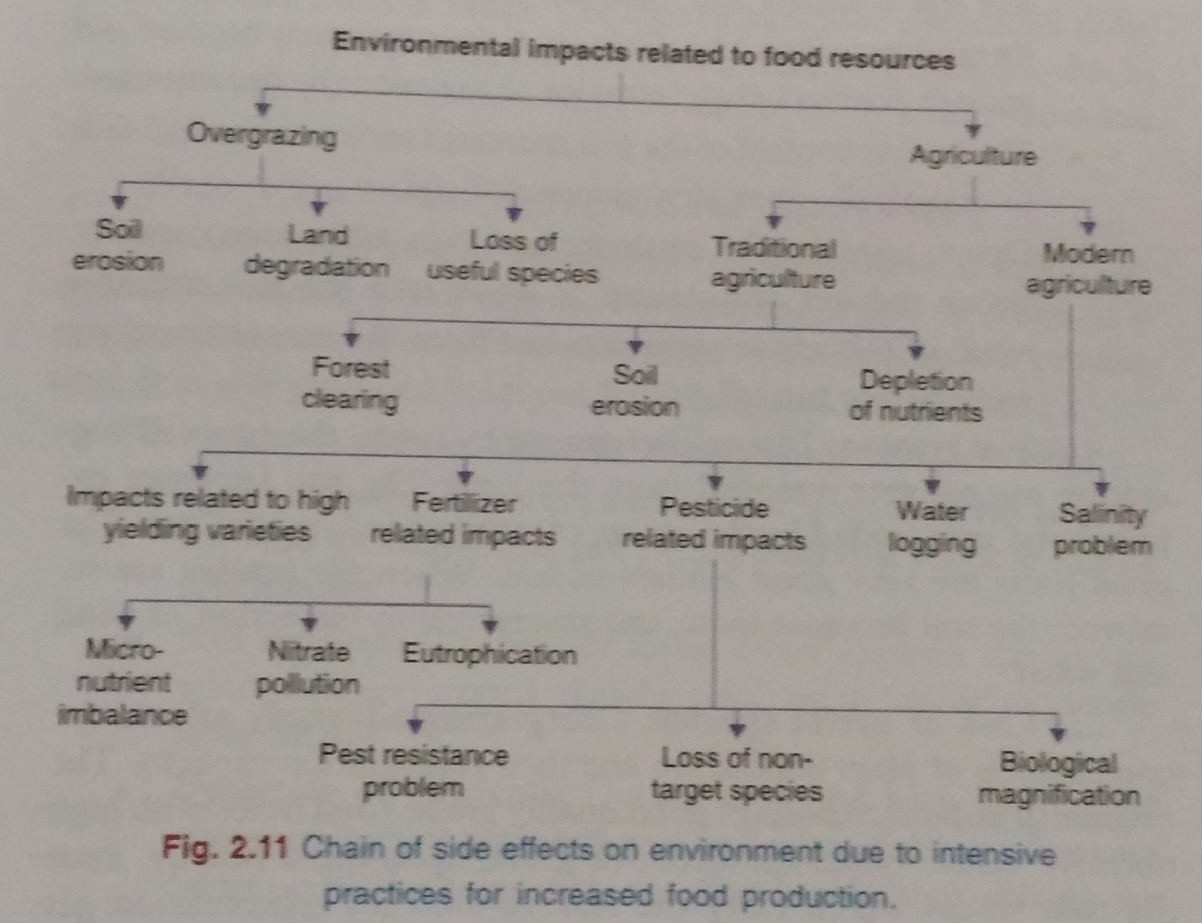

(A) Overgrazing :

Overgrazing is a process of “eating away the forest vegetation without giving it a chance to regenerate.”
Livestock wealth plays a crucial role in the rural life of our country. India leads in live stock population in the world. The huge population of livestock needs to be fed and the grazing lands or pasture areas are not adequate. Very often we find that the live stock grazing on a particular piece of grassland or pasture surpass the carrying capacity.

Impact of Overgrazing

(i) Land Degradation: Overgrazing removes the vegetal cover over the soil and the exposed soil gets compacted due to which the operative soil depth declines. So the roots cannot go much deep into the soil and adequate soil moisture is not available. The humus content of the soil decreases and overgrazing leads to organically poor, dry, compacted soil. Thus over grazing leads to multiple actions resulting in loss of soil structure, hydraulic conductivity and soil fertility.
(ii) Soil Erosion: Due to overgrazing by cattle, the cover of vegetation almost gets removed from the land. The soil becomes exposed and gets eroded by the action of strong wind, rainfall etc. The grass roots are very good binders of soil. When the grasses are removed, the soil becomes loose and susceptible to the action of wind and water.
(iii) Loss of useful species: Overgrazing adversely affects the composition of plant population and their regeneration capacity. The original grassland consists of good quality grasses and forbs with high nutritive value. When the livestock graze upon them heavily, even the root stocks which carry the reserve food for regeneration get destroyed. Now some other species appear in their place. These secondary species are hardier and are less nutritive in nature.

(B) Agriculture :

“Agriculture is an art,science and industry of managing the growth of plants and animals for human use.”

1.Traditional agriculture :

It usually involves a small plot, simple tools, naturally available water, organic fertilizer and a mix of crops. It is more near to natural conditions and usually it results in low production. It is still practiced by about half the global population.

Impacts of Traditional agriculture

(i) Deforestation: The slash and burn of trees in forests to clear the land for cultivation and frequent shifting result in loss of forest cover.

(ii) Soil erosion: Clearing of forest cover exposes the soil to wind, rain and storms, thereby resulting in loss of top fertile layer of soil.

(iii) Depletion of nutrients: During slash and burn the organic matter in the soil gets destroyed and most of the nutrients are taken up by the crops within a short period, thus making the soil nutrient poor which makes the cultivators shift to another area.

- Modern Agriculture and its impacts:

It makes use of hybrid seeds of selected and single crop variety, high-tech equipments and lots of energy subsidies in the form of fertilizers, pesticides and irrigation water. The food production has increased tremendously, evidenced by “green revolution”. However, it also gave rise to several problematic off-shoots as discussed below:

- Fertilizer related problems :

- Micronutrient imbalance: Most of the chemical fertilizers used in modern agriculture have nitrogen, phosphorus and potassium (N, P, K) which are essential macronutrients.

Farmers usually use these fertilizers indiscriminately to boost up crop growth. Excessive use of fertilizers cause micronutrient imbalance.

(b) Nitrate Pollution: Nitrogenous fertilizers applied in the fields often leach deep into the soil and ultimately contaminate the ground water. The nitrates get concentrated in the water and when their concentration exceeds 25 mg/L, they become the cause of a serious health hazard called “Blue Baby Syndrome” or methaemoglobinemia. This disease affects the infants to the maximum extent causing even death.

(c) Eutrophication: Excessive use of N and P fertilizers in the agricultural fields leads to another problem, which is not related to the soil, but relates to water bodies like lakes. A large proportion of nitrogen and phosphorus used in crop fields is washed off and along with runoff water reach the water bodies causing over nourishment of the lakes, a process known as Eutrophication (eu=more, trophic=nutrition). Due to eutrophication the lakes get invaded by algal blooms. These algal species grow very fast by rapidly using up the nutrients. They are often toxic and badly affect the food chain. The algal species quickly complete their life cycle and die thereby adding a lot of dead organic matter. The fishes are also killed and there is a lot of dead matter that starts getting decomposed. Oxygen is consumed in the process of decomposition and very soon the water gets depleted of dissolved oxygen.

- Pesticide related problems :
Thousands of types of pesticides are used in agriculture. The first generation pesticides include chemicals like sulphur, arsenic, lead or mercury and DDT (Dichlorodiphenyl trichloroethane) to kill the pests. Although these pesticides have gone a long way in protecting our crops from huge losses occurring due to pests, yet they have a number of side-effects, as discussed below:

(a) Creating resistance in pests and producing new pests: Some individuals of the pest species usually survive even after pesticide spray. The survivors give rise to highly resistant generations. About 20 species of pests are now known which have become immune to all types of pesticides and are known as “Super pests”.

(b) Death of non-target organisms: Many insecticides are broad spectrum poisons which not only kill the target species but also several non-target species that are useful to us.

(c) Biological magnification: Many of the pesticides are non-biodegradable and keep on accumulating in the food chain, a process called biological magnification. Since human beings occupy a high trophic level in the food chain, hence they get the pesticides in a bio-magnified form which is very harmful.

- Water Logging:
Over irrigation of croplands by farmers for good growth of their crop usually leads to waterlogging. Inadequate drainage causes excess water to accumulate underground and gradually forms a continuous column with the water table. Under water-logged conditions, pore-spaces in the soil get fully drenched with water and the soil-air gets depleted. The water table rises while the roots of plants do not get adequate air for respiration. Mechanical strength of the soil declines, the crop plants get lodged and crop yield falls.

Preventing excessive irrigation, sub-surface drainage technology and bio-drainage with trees like Eucalyptus are some of the remedial measures to prevent water-logging.

- Salinity problem:
At present one third of the total cultivable land area of the world is affected by salts. In India about seven million hectares of land are estimated to be salt—affected which may be saline or sodic. Saline soils are characterized by the accumulation of soluble salts like sodium chloride, sodium sulphate, calcium chloride, magnesium chloride etc. in the soil profile. Their electrical conductivity is more than 4 dS/m. Sodic soils have carbonates and bicarbonates of sodium, the pH usually exceeds 8.0 and the exchangeable sodium percentage (ESP) is more than 15%.

CASE STUDY

Salinity and water logging in Punjab, Haryana and Rajasthan :

The first alarming report of salt-affected wasteland formation in connection with irrigation practices came from Haryana (then Punjab) in 1858. It was reported that several villages in Panipat, Rohtak and Delhi lying in command area of Western Yamuna Canal were suffering from destructive saline efflorescence. The “Reh Committee” in 1886 drew the attention of the government on some vital points showing a close relationship between irrigation, drainage and spread of “reh” and “usar” soils.
The floods of 1947, 1950, 1952, 1954-56 in Punjab resulted in aggravated water logging with serious drainage problems. Introduction of canal irrigation in 1.2 m ha in Haryana resulted in rise in water-table followed by water-logging and salinity in many irrigated areas causing huge economic losses as a result of fall in crop productivity. Rajasthan too has suffered badly in this regard following the biggest irrigation project “Indira Gandhi Canal Project” and the sufferings of a big area in Western Rajasthan have changed from a condition of “water-starved wasteland” to that of a “water soaked wasteland”.

CASE STUDY

Israel began using drip irrigation systems as it is short of water. With this technique, farmers have been able to improve the efficiency of irrigation by 95%. Over a 20-year period, Israel’s food production doubled without an increase in the use of water for agriculture
In India, some traditional communities in urban and semi urban towns used to grow their own vegetables in backyards on waste-water from their own homes. Calcutta re-leases its waste water into surrounding la-goons in which fish are reared and the water is used for growing vegetables.

ENERGY RESOURCES

Energy consumption of a nation is usually considered as an index of its development. This is because almost all the developmental activities are directly or indirectly dependent upon energy. We find wide disparities in per capita energy use between the developed and the developing nations.
Most of the energy we use today come from fossil fuels (stored solar energy). But fossils fuels have a disadvantage in that they are non-renewable on a human time scale, and cause other potentially harmful effects on the environment. In any event, the exploitation of all energy sources (with the possible exception of direct solar energy used for heating), ultimately rely on materials on planet Earth.
GROWING ENERGY NEEDS:

Development in different sectors relies largely upon energy. Agriculture, industry, mining, transportation, lighting, cooling and heating in buildings all need energy. With the demands of growing population the world is facing further energy deficit. The fossil fuels like coal, oil and natural gas which at present are supplying 95% of the commercial energy of the world resources and are not going to last for many more years. Our life style is changing very fast and from a simple way of life we are shifting to a luxurious life style. If you just look at the number of electric gadgets in your homes and the number of private cars and scooters in your locality you will realize that in the last few years they have multiplied many folds and all of them consume energy.

Developed countries like U.S.A. and Canada constitute about 5% of the world’s population but consume one fourth of global energy resources. An average person there consumes 300 GJ (Giga Joules, equal to 60 barrels of oils) per year. By contrast, an average man in a poor country like Bhutan, Nepal or Ethiopia consumes less than 1 GJ in a year. So a person in a rich country consumes almost as much energy in a single day as one person does in a whole year in a poor country. This clearly shows that our life-style and standard of living are closely related to energy needs.

Types of energy: There are two main types of energy.

- RENEWABLE ENERGY SOURCES :

Renewable Resources which can be generated continuously in nature and are inexhaustible.
e.g. wood, solar energy, wind energy, tidal energy, hydropower, biomass energy, bio-fuels, geo-thermal energy and hydrogen.
They are also known as non-conventional sources of energy and they can be used again and again in an endless manner.

- NON-RENEWABLE ENERGY SOURCES :

Non-renewable Resources which have accumulated in nature over a long span of time and cannot be quickly replenished when exhausted.
e.g. coal, petroleum, natural gas and nuclear fuels like uranium and thorium.

(a) Renewable Energy Resources

- Solar energy:

Sun is the ultimate source of energy, directly or indirectly for all other forms of energy. The nuclear fusion reactions occurring inside the sun release enormous quantities of energy in the form of heat and light. The solar energy received by the near earth space is approximately 1.4 kilojoules/second/m² known as solar constant.

Traditionally, we have been using solar energy for drying clothes and food-grains, preservation of eatables and for obtaining salt from sea-water. Now we have several techniques for harnessing solar energy. Some important solar energy harvesting devices are discussed here.

(i) Solar heat collectors: These can be passive or active in nature. Passive solar heat collectors are natural materials like stones, bricks etc. or material like glass which absorb heat during the day time and release it slowly at night. Active solar collectors pump a heat absorbing medium (air or water) through a small collector which is normally placed on the top of the building.

(ii) Solar cells: They are also known as photovoltaic cells or PV cells. Solar cells are made of thin wafers of semi conductor materials like silicon and gallium. When solar radiations fall on them, a potential difference is produced which causes flow of electrons and produces electricity. Silicon can be obtained from silica or sand, which is abundantly available and inexpensive. By using gallium arsenide, cadmium sulphide or boron, efficiency of the PV cells can be improved. The potential difference produced by a single PV cell of 4 cm² size is about 0.4-0.5 volts and produces a current of 60 milli amperes. Fig. 2.5.2 (a) shows the structure of a solar cell.

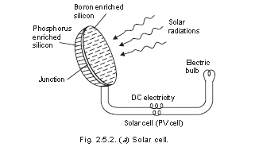

A group of solar cells joined together in a definite pattern form a solarpanel which can harness a large amount of solar energy and can produce electricity enough to run street-light, irrigation water pump etc. (Fig. 2.5.2).

Solar cells are widely used in calculators, electronic watches, street lighting, traffic signals, water pumps etc. They are also used in artificial satellites for electricity generation. Solar cells are used for running radio and television also. They are more in use in remote areas where conventional electricity supply is a problem.

(iii) Solar cooker: Solar cookers make use of solar heat by reflecting the solar radiations using a mirror directly on to a glass sheet, which covers the black insulated box within which the raw food is kept as shown in Fig. 2.5.3. A new design of solar cooker is now available which involves a spherical reflector (concave or parabolic reflector) instead of plane mirror that has more heating effect and hence greater efficiency.

The food cooked in solar cookers is more nutritious due to slow heating. However it has the limitation that it cannot be used at night or on cloudy days. Moreover, the direction of the cooker has to be adjusted according to the direction of the sun rays.

(iv) Solar water heater: It consists of an insulated box painted black from inside and having a glass lid to receive and store solar heat. Inside the box it has black painted copper coil through which cold water is made to flow in, which gets heated and flows out into a storage tank. The hot water from the storage tank fitted on roof top is then supplied through pipes into buildings like hotels and hospitals.

(v) Solar furnace: Here thousands of small plane mirrors are arranged in concave reflectors, all of which collect the solar heat and produce as high a temperature as 3000°C.

(vi) Solar power plant: Solar energy is harnessed on a large scale by using concave reflectors which cause boiling of water to produce steam. The steam turbine drives a generator to produce electricity. A solar power plant (50 K Watt capacity) has been installed at Gurgaon, Haryana.

- WIND ENERGY

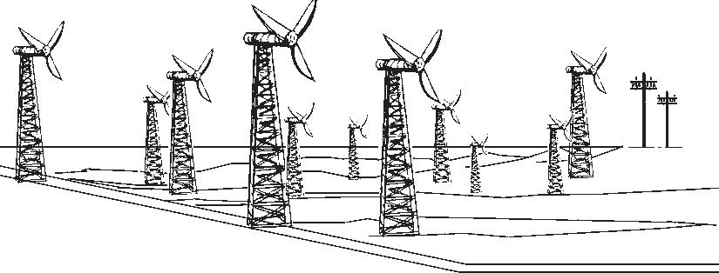

The high speed winds have a lot of energy in them as kinetic energy due to their motion. The driving force of the winds is the sun. The wind energy is harnessed by making use of wind mills. The blades of the wind mill keep on rotating continuously due to the force of the striking wind. The rotational motion of the blades drives a number of machines like water pumps, flour mills and electric generators. A large number of wind mills are installed in clusters called wind farms, which feed power to the utility grid and produce a large amount of electricity. These farms are ideally located in coastal regions, open grasslands or hilly regions, particularly mountain passes and ridges where the winds are strong and steady. The minimum wind speed required for satisfactory working of a wind generator is 15 km/hr.

The wind power potential of our country is estimated to be about 20,000 MW, while at present we are generating about 1020 MW. The largest wind farm of our country is near Kanyakumari in Tamil Nadu generating 380 MW electricity.

Wind energy is very useful as it does not cause any air pollution. After the initial installation cost, the wind energy is very cheap. It is believed that by the middle of the century wind power would supply more than 10% of world’s electricity

HYDROPOWER ENERGY :

The water flowing in a river is collected by constructing a big dam where the water is stored and allowed to fall from a height. The blades of the turbine located at the bottom of the dam move with the fast moving water which in turn rotate the generator and produces electricity. We can also construct mini or micro hydel power plants on the rivers in hilly regions for harnessing the hydro energy on a small scale, but the minimum height of the water falls should be 10 metres.

The hydropower potential of India is estimated to be about 4 × 10¹¹

KW-hours. Till now we have utilized only a little more than 11% of this potential.

Hydropower does not cause any pollution, it is renewable and normally the hydro power projects are multi-purpose projects helping in controlling floods, used for irrigation, navigation etc. However, big dams are often associated with a number of environmental impacts which have already been discussed in the previous section.

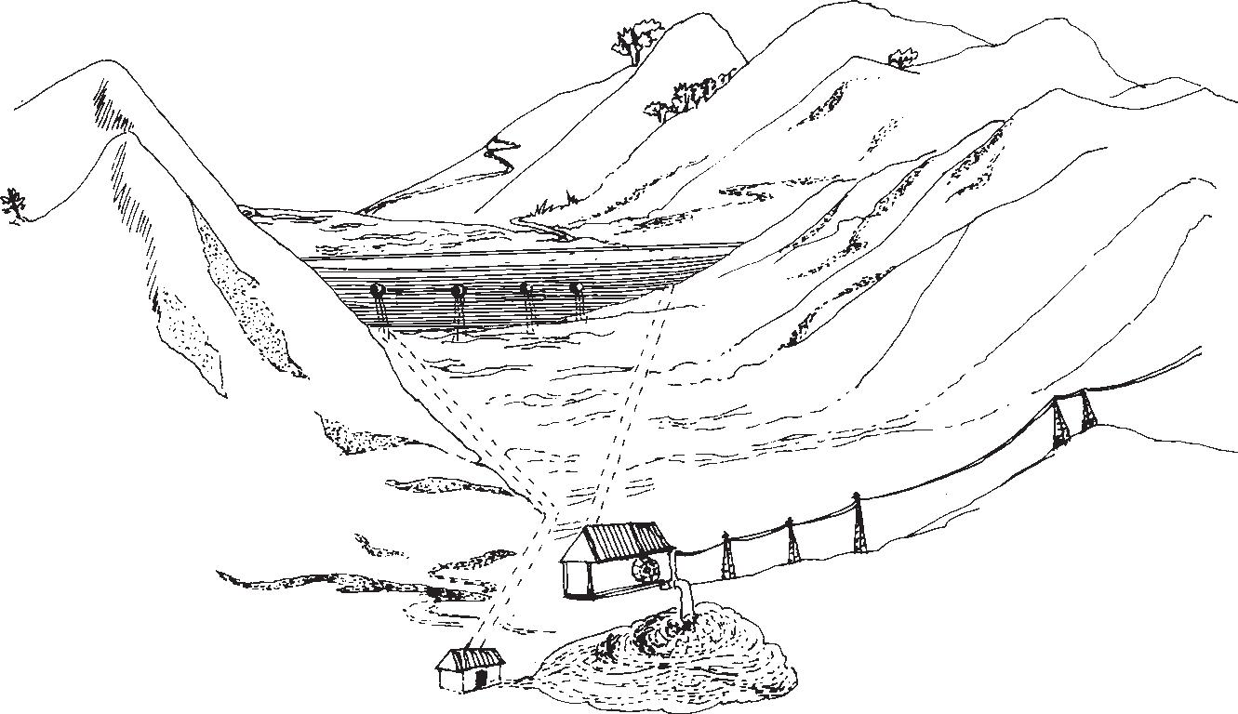

- BIOMASS ENERGY

Biomass is the organic matter produced by the plants or animals which include wood, crop residues, cattle dung, manure, sewage, agricultural wastes etc. Biomass energy is of the following types :

(a) Energy Plantations: Solar energy is trapped by green plants through photosynthesis and converted into biomass energy. Fast growing trees like cottonwood, poplar and Leucaena, non-woody herbaceous grasses, crop plants like sugarcane, sweet sorghum and sugar beet, aquatic weeds like water hyacinth and sea-weeds and carbohydrate rich potato, cereal etc. are some of the important energy plantations. They may produce energy either by burning directly or by getting converted into burnable gas or may be converted into fuels by fermentation.

(b) Agricultural and Urban Waste biomass: Crop residues, bagasse (sugarcane residues), coconut shells, peanut hulls, cotton stalks etc. are some of the common agricultural wastes which produce energy by burning. Animal dung, fishery and poultry waste and even human refuse are examples of biomass energy. In Brazil 30 % of electricity is obtained from burning bagasse. In rural India, animal dung cakes are burnt to produce heat. About 80 % of rural heat energy requirements are met by burning agricultural wastes, wood and animal dung cakes.
In rural areas these forms of waste biomass are burned in open furnaces called ‘Chulhas’ which usually produce smoke and are not so efficient (efficiency is <8 %). Now improved Chulhas with tall chimney have been designed which have high efficiency and are smokeless.

The burning of plant residues or animal wastes cause air pollution and produce a lot of ash as waste residue. The burning of dung destroys essential nutrients like N and P. It is therefore, more useful to convert the biomass into biogas or bio fuels.

- BIOGAS :

Biogas is a mixture of methane, carbon dioxide, hydrogen and hydrogen sulphide, the major constituent being methane. Biogas is produced by anaerobic degradation of animal wastes (sometimes plant wastes) in the presence of water. Anaerobic degradation means break down of organic matter by bacteria in the absence of oxygen.

Biogas is a non-polluting, clean and low cost fuel which is very useful for rural areas where a lot of animal waste and agricultural waste are available. India has the largest cattle population in the world (240 million) and has tremendous potential for biogas production. From cattle dung alone, we can produce biogas of a magnitude of 22,500 Mm³ annually. A sixty cubic feet gobar gas plant can serve the needs of one average family.

Biogas advantages :

- It is clean, non-polluting and cheap.
- There is direct supply of gas from the plant and there is no storage problem.
- The sludge left over is a rich fertilizer containing bacterial biomass with most of the nutrients preserved as such.
- Air-tight digestion/degradation of the animal wastes is safe as it eliminates health hazards which normally occur in case of direct use of dung due to direct exposure to faecal pathogens and parasites

- BIOFUELS :

Biomass can be fermented to alcohols like ethanol and methanol which can be used as fuels. Ethanol can be easily produced from carbohydrate rich substances like sugarcane. It burns clean and is non-polluting. However, as compared to petrol its calorific value is less and therefore, produces much less heat than petrol.

Gasohol is a common fuel used in Brazil and Zimbabwe for running cars and buses. In India too gasohol is planned to be used on trial basis in some parts of the country, to start with in Kanpur. Gasohol is a mixture of ethanol and gasoline.

Methanol is very useful since it burns at a lower temperature than gasoline or diesel. Thus the bulky radiator may be substituted by sleek designs in our cars. Methanol too is a clean, non-polluting fuel.

Methanol can be easily obtained from woody plants and ethanol from grain-based or sugar-containing plants.

- GEOTHERMAL ENERGY

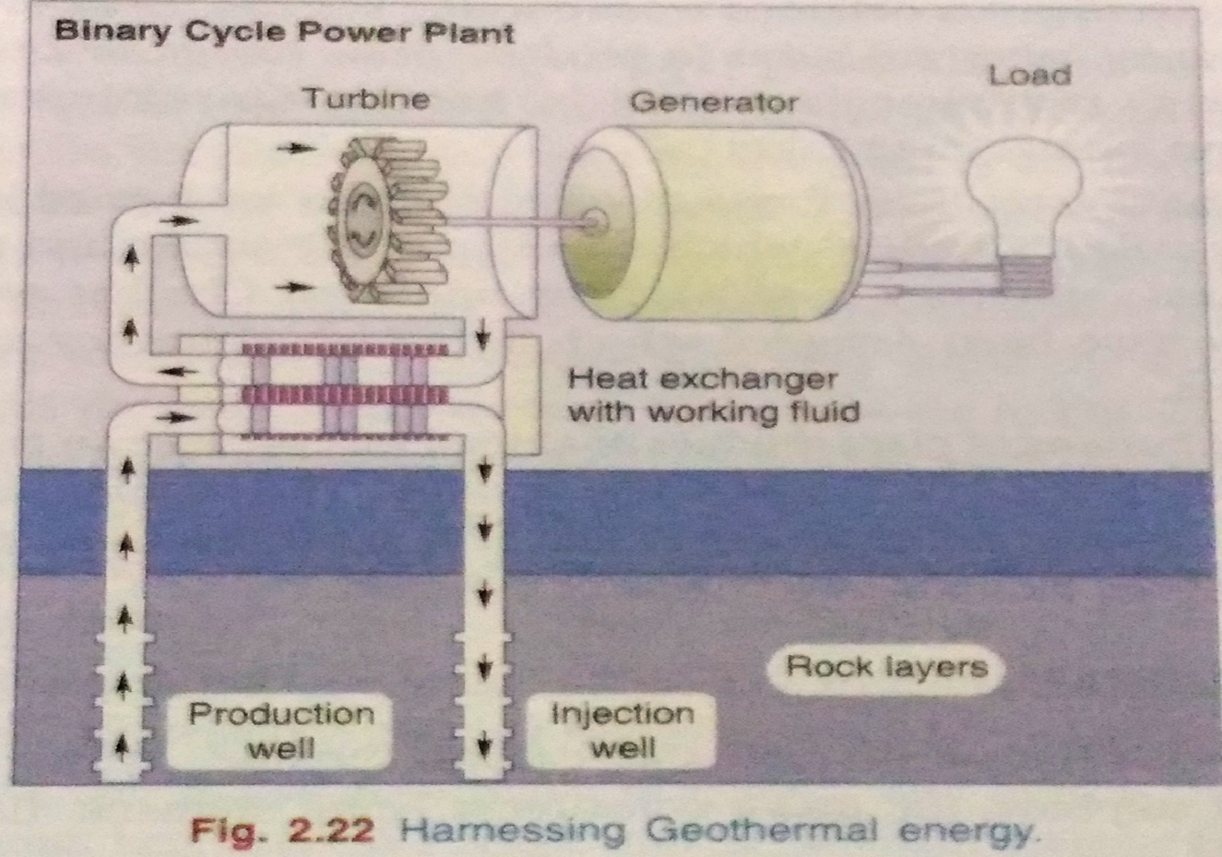

The energy harnessed from the hot rocks present inside the earth is called geothermal energy. High temperature, high pressure steam fields exist below the earth’s surface in many places. This heat comes from the fission of radioactive material naturally present in the rocks. In some places, the steam or the hot water comes out of the ground naturally through cracks in the form of natural geysers as in Manikaran, Kullu and Sohana, Haryana. Sometimes the steam or boiling water underneath the earth do not find any place to come out. We can artificially drill a hole up to the hot rocks and by putting a pipe in it make the steam or hot water gush out through the pipe at high pressure which turns the turbine of a generator to produce electricty. In USA and New Zealand, there are several geothermal plants working successfully.

- Non-Renewable Energy Sources :

These are the fossil fuels like coal, petroleum, natural gas and nuclear fuels. These were formed by the decomposition of the remains of plants and animals buried under the earth millions of years ago.
The fuels are very precious because they have taken such a long time to be formed and if we exhaust their reserves at such a fast rate as we have been doing, ever since we discovered them, then very soon we will lose these resources forever.

- Coal :

It is the non-renewable, commercial or conventional source of energy. Coal is the first fossil fuel to be exploited on a large scale, so individual revolution enabled coal to be mined at even greater depths.

About 6 lakh billion tones of coal lies under the earth and now over to 200 billion tones
have been used.
If coal is used at this rate it may lost in one or two decades.
Types of coal :

- Peat coal :
- It contains 5% carbon,5% volatile matter,and 90% moisture.
- It is having low calorific value.
- It is generally in dry condition.

- Lignite coal :
- It is lowest form of coal.
- It is brown in colour hence it is called brown coal.
(iii)It has 38% carbon, 19% volatile matter and 43% moisture.

- Bituminous coal :
- It is called as soft coal.
- It contains 3% of water, 65% carbon, 32% volatile matter.
(iii)It is highly inflammable.

- Anthracite coal:
- It is hard and dense coal.
- It contains 96% carbon,1% volatile matter,3% moisture.
(iii)It is called as hard or metamorphic coal.
(iv)It is used for space heating and generating electricity.

- Oil / Petrolium :

Oil provides 45%of world energy consumption.
Petroleum is an inflammable liquid composed of hydrocarbons majority and remainder is organic compounds like O₂, N₂, S and traces of organic metallic compounds.

Occurrence : The fossil fuel was formed by the decomposition of dead animals and plants, that were buried under lake and ocean at high temperature and pressure for million of years.
It is pumped to the earth’s surface as crude oil and refined to get the desired products like petrol, diesel, lubricants, gasoline, furnace oil…..

- Petroleum gas :
It is a mixture of three hydrocarbons such as butane, propane and ethane. The main constituent is being butane. The above gases are in gaseous state in ordinary pressure but they can be liquefied under high pressure. So it is called LPG(Liquified Petrolium Gas).
A domestic cylinder contains 14 kgs of LPG. A strong smelting substance called Ethyl mercaptane is added to LPG gas cylinder to help in the detection of gas leakage.

- Natural gas :
It consist of methane with small quantities of ethane and propane. It is available in deep undercrust of the earth, either alone or along with oil above the petroleum deposits.
Natural gas is a by product to petroleum mining. Natural gas is formed under the earth by decomposition of materials by anaerobic organisms in the absence of oxygen.

- NUCLEAR ENERGY

Nuclear energy is known for its high destructive power as evidenced from nuclear weapons. The nuclear energy can also be harnessed for providing commercial energy. Nuclear energy can be generated by two types of reactions:

(i) Nuclear Fission: It is the nuclear change in which nucleus of certain isotopes with large mass numbers are split into lighter nuclei on bombardment by neutrons and a large amount of energy is released through a chain reaction as shown in Fig. 2.5.7 (a).

Nuclear Reactors make use of nuclear chain reaction. In order to control the rate of fission, only 1 neutron released is allowed to strike for splitting another nucleus. Uranium-235 nuclei are most commonly used in nuclear reactors.

(ii) Nuclear fusion: Here two isotopes of a light element are forced together at extremely high temperatures (1 billion °C) until they fuse to form a heavier nucleus releasing enormous energy in the process. It is difficult to initiate the process but it releases more energy than nuclear fission. (Fig. 2.5.7 (b))

Two hydrogen-2 (Deuterium) atoms may fuse to form the nu-cleus of Helium at 1 billion °C and release a huge amount of energy. Nuclear fusion reaction can also take place between one Hydrogen-2 (Deuterium) and one Hydrogen-3 (Tritium) nucleus at 100 million °C forming Helium-4 nucleus, one neutron and a huge amount of energy.

Nuclear energy has tremendous potential but any leakage from the reactor may cause devastating nuclear pollution. Disposal of the nuclear waste is also a big problem.

LAND RESOURCES

LAND AS A RESOURCE :

Land is a finite and valuable resource upon which we depend for our food, fibre and fuel wood, the basic amenities of life. Soil, especially the top soil, is classified as a renewable resource because it is continuously regenerated by natural process though at a very slow rate. About 200-1000 years are needed for the formation of one inch or 2.5 cm soil, depending upon the climate and the soil type. But, when rate of erosion is faster than rate of renewal, then the soil becomes a non-renewable resource.
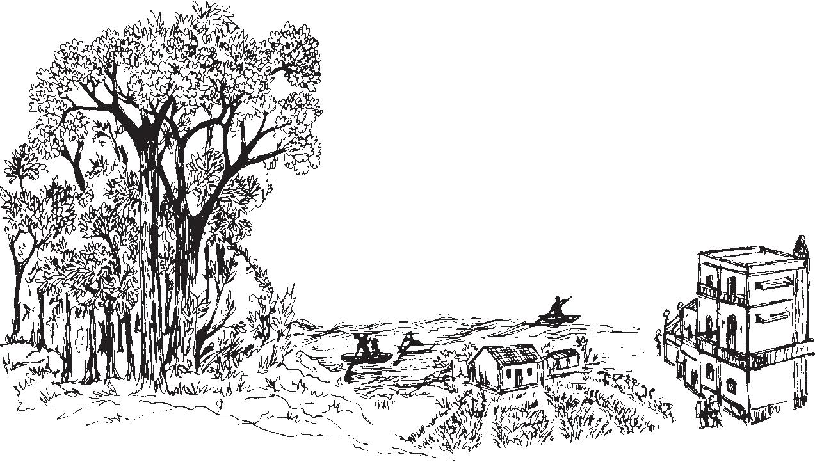

Changes in land use



LAND DEGRADATION

With increasing population growth the demands for arable land for producing food, fibre and fuel wood is also increasing. Hence there is more and more pressure on the limited land resources which are getting degraded due to over-exploitation. Soil degradation is a real cause of alarm because soil formation is an extremely slow process as discussed above and the average annual erosion rate is 20-100 times more than the renewal rate.

Soil erosion, water-logging, salinization and contamination of the soil with industrial wastes like fly-ash, press-mud or heavy metals all cause degradation of land.

SOIL EROSION

The literal meaning of ‘soil erosion’ is wearing away of soil. Soil ero-sion is defined as the movement of soil components, especially surface-litter and top soil from one place to another. Soil erosion results in the loss of fertility because it is the top soil layer which is fertile. If we look at the world situation, we find that one third of the world’s cropland is getting eroded. Two thirds of the seriously degraded lands lie in Asia and Africa.

Soil Conservation Practices :

In order to prevent soil erosion and conserve the soil the following conservation practices are employed:

(i) Conservational till farming: In traditional method the land is ploughed and the soil is broken up and smoothed to make a planting surface. However, this disturbs the soil and makes it susceptible to ero-sion when fallow (i.e. without crop cover). Conservational till farm-ing, popularly known as no-till-farming causes minimum disturbance to the top soil. Here special tillers break up and loosen the subsurface soil without turning over the topsoil. The tilling machines make slits in the unploughed soil and inject seeds, fertilizers, herbicides and a little water in the slit, so that the seed germinates and the crop grows suc-cessfully without competition with weeds.

(ii) Strip cropping: Here strips of crops are alternated with strips of soil saving covercrops like grasses or grass-legume mixture. Whatever run-off comes from the cropped soil is retained by the strip of cover-crop and this reduces soil erosion. Nitrogen fixing legumes also help in restoring soil fertility (Plate I, b).
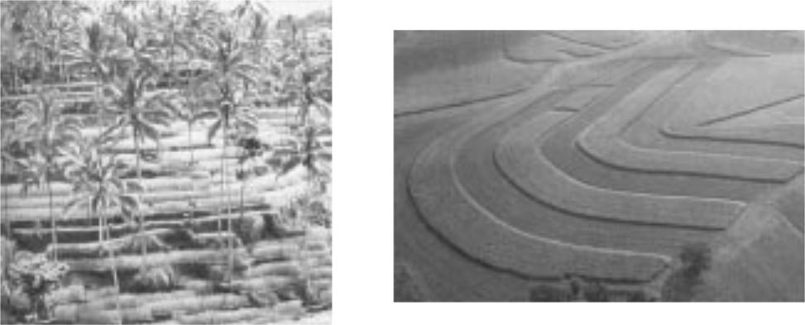

Plate I(a) Terrace farming Plate I(b) Strip cropping

(iii) Terracing: It is used on still steeper slopes are converted into a series of broad terraces which run across the contour. Terracing retains water for crops at all levels and cuts down soil erosion by controlling run off. In high rainfall areas, ditches are also provided behind the terrace to permit adequate drainage (Plate I, a).
(iv) Contour farming: On gentle slopes, crops are grown in rows across, rather than up and down, a practice known as contour farming. Each row planted horizontally along the slope of the land acts as a small dam to help hold soil and slow down loss of soil through run-off water.

Water Logging :

In order to provide congenial moisture to the growing crops, farmers usually apply heavy irrigation to their farmland. Also, in order to leach down the salts deeper into the soil, the farmer provides more irrigation water. However, due to inadequate drainage and poor quality irrigation water there is accumulation of water underground and gradually it forms a continuous column with the water table. We call these soils as waterlogged soils which affect crop growth due to inhibition of exchange of gases. The pore-spaces between the soil particles get fully drenched with water through the roots.

Water logging is most often associated with salinity because the water used for irrigation contains salts and the soils get badly degraded due to erroneous irrigation practices.

DESERTIFICATION :

Desertification is a process whereby the productive potential of arid or semiarid lands falls by ten percent or more. Moderate desertification is 10-25% drop in productivity, severe desertification causes 25-50% drop while very severe desertification results in more than 50% drop in productivity and usually creates huge gullies and sand dunes.
Desertification leads to the conversion of rangelands or irrigated croplands to desert like conditions in which agricultural productivity falls. Desertification is characterized by devegetation and loss of vegetal over, depletion of groundwater, salinization and severe soil erosion.
Desertification is not the literal invasion of desert into a non-desert area. It includes degradation of the ecosystems within as well as outside the natural deserts. The Sonoran and Chihuahuan deserts are about a million years old, yet they have become more barren during the last 100 years. So, further desertification has taken place within the desert.

Causes of Desertification:

Formation of deserts may take place due to natural phenomena like climate change or may be due to abusive use of land. Even the climate change is linked in many ways to human activities. The major anthropogenic activities responsible for desertification are as follows:

- Deforestation: The process of denuding and degrading a forested land initiates a desert producing cycle that feeds on itself. Since there is no vegetation to hold back the surface run-off, water drains off quickly before it can soak into the soil to nourish the plants or to replenish the groundwater. This increases soil erosion, loss of fertility and loss of water.

(b) Overgrazing: The regions most seriously affected by desertification are the cattle producing areas of the world. This is because the increasing cattle population heavily graze in grasslands or forests and as a result denude the land area. When the earth is denuded, the
microclimate near the ground becomes inhospitable to seed germination. The dry barren land becomes loose and more prone to soil erosion. The top fertile layer is sun’s heat, changing wind patterns, driving away moisture laden clouds leading to further desertification.

(c) Mining and quarrying: These activities are also responsible for loss of vegetal cover and denudation of extensive land areas leading to desertification. Deserts are found to occur in the arid and semi-arid areas of all the continents . During the last 50 years about 900 million hectares of land have undergone desertification over the world.

CONSERVATION OF NATURAL RESOURCES: ROLE OF AN INDIVIDUAL

Different natural resources like forests, water, soil, food, mineral and energy resources play a vital role in the development of a nation. However, overuse of these resources in our modern society is resulting in fast depletion of these resources and several related problems. If we want our mankind to flourish there is a strong need to conserve these natural resources.

While conservation efforts are underway at National as well as International level, the individual efforts for conservation of natural resources can go a long way.

Environment belongs to each one of us and all of us have a responsibility to contribute towards its conservation and protection.

“Small droplets of water together form a big ocean”. Similarly, with our small individual efforts we can together help in con-serving our natural resources to a large extent.

Let us see how can individuals help in conservation of different resources.

- Conserve Water

- Don’t keep water taps running while brushing, shaving, washing or bathing.

- In washing machines fill the machine only to the level required for your clothes.

- Install water-saving toilets that use not more than 6 liters per flush.

- Check for water leaks in pipes and toilets and repair them promptly. A small pin-hole sized leak will lead to the wastage of 640 liters of water in a month.

- Reuse the soapy water of washings from clothes for washing off the courtyards, driveways etc.

- Water the plants in your kitchen-garden and the lawns in the evening when evaporation losses are minimum. Never water the plants in mid-day.

- Use drip irrigation and sprinkling irrigation to improve irrigation efficiency and reduce evaporation.

- Install a small system to capture rain water and collect normally wasted used water from sinks, cloth-washers, bath-tubs etc. which can be used for watering the plants.

- Build rain water harvesting system in your house. Even the President of India is doing this.

- Conserve energy

- Turn off lights, fans and other appliances when not in use.

- Obtain as much heat as possible from natural sources. Dry the clothes in sun instead of drier if it is a sunny day.

- Use solar cooker for cooking your food on sunny days which will be more nutritious and will cut down on your LPG ex-penses.

- Build your house with provision for sunspace which will keep your house warmer and will provide more light.

- Grow deciduous trees and climbers at proper places outside your home to cut off intense heat of summers and get a cool breeze and shade. This will cut off your electricity charges on coolers and air-conditioners. A big tree is estimated to have a cooling effect equivalent to five air conditioners. The decidu-ous trees shed their leaves in winter. Therefore they do not put any hindrance to the sunlight and heat.

- Drive less, make fewer trips and use public transportations whenever possible. You can share by joining a car-pool if you regularly have to go to the same place.
- Add more insulation to your house. During winter close the windows at night. During summer close the windows during days if using an A.C. Otherwise loss of heat would be more, consuming more electricity.

- Instead of using the heat convector more often wear adequate woolens.

- Recycle and reuse glass, metals and paper.

- Try riding bicycle or just walk down small distances instead of using your car or scooter.

- Lower the cooling load on an air conditioner by increasing the thermostat setting as 3-5 % electricity is saved for every one degree rise in temperature setting.

- Protect the soil

- While constructing your house, don’t uproot the trees as far as possible. Plant the disturbed areas with a fast growing native ground cover.

- Grow different types of ornamental plants, herbs and trees in your garden. Grow grass in the open areas which will bind the soil and prevent its erosion.

- Make compost from your kitchen waste and use it for your kitchen-garden or flower-pots.

- Do not irrigate the plants using a strong flow of water, as it would wash off the soil.

- Better use sprinkling irrigation.

- Use green manure and mulch in the garden and kitchen-garden which will protect the soil.

- If you own agricultural fields, do not over-irrigate your fields without proper drainage to prevent water logging and salinisation.

- Use mixed cropping so that some specific soil nutrients do not get depleted.

- Promote Sustainable Agriculture

- Do not waste food. Take as much as you can eat.

- Reduce the use of pesticides.

- Fertilize your crop primarily with organic fertilizers.

- Use drip irrigation to water the crops.

- Eat local and seasonal vegetables. This saves lot of energy on transport, storage and preservation.

EQUITABLE USE OF RESOURCES FOR SUSTAINABLE LIFESTYLES :

Reduction of the unsustainable and unequal use of resources, and control of our population growth are essential for the survival of our nation and indeed of human kind everywhere. Our environment provides us with a variety of goods and services necessary for our day-to-day lives, but the soil, water, climate and solar energy which form the ‘abiotic’ support that we derive from nature, are in themselves not distributed evenly throughout the world or within countries.
A new economic order at the global and at national levels must be based on the ability to distribute benefits of natural resources by sharing them more equally among the countries as well as among communities within countries such as our own.
It is at the local level where people subsist by the sale of locally collected resources, that the disparity is greatest. ‘Development’ has not reached them and they are often unjustly accused of ‘exploiting’ natural resources. They must be adequately compensated for the removal of the sources to distant regions and thus develop a greater stake in protecting natural resources.
There are several principles that each of us can adopt to bring about sustainable lifestyles. This primarily comes from caring for our Mother Earth in all respects. A love and respect for Nature is the greatest sentiment that helps bring about a feeling for looking at how we use natural resources in a new and sensitive way.

Think of the beauty of a wilderness, a natural forest in all its magnificence, the expanse of a green grassland, the clean water of a lake that sup-ports so much life, the crystal clear water of a hill stream, or the magnificent power of the oceans, and we cannot help but support the conservation of nature’s wealth. If we respect this we cannot commit acts that will deplete our life supporting systems.

