UNIT-II
SIGNAL GENERATORS

Signal generator provides variety of different signals for testing various electronic circuits at low powers. The signal generator is an instrument which provides several different output waveforms including sine wave, square wave, triangular wave, pulse train and an amplitude modulated waveform. A signal generator is a vital component in a test setup, and in electronic troubleshooting and development, whether on a service bench or in a research laboratory. Signal generators have a variety of applications, such as checking the stage gain, frequency response, and alignment in receivers and in a wide range of other electronic equipment. They provide a variety of waveforms for testing electronic circuits, usually at low powers. The term oscillator is used to describe an instrument that provides only a sinusoidal output signal, and the term generator to describe an instrument that provides several output waveforms, including sine wave, square- wave, triangular
wave and pulse trains, as well as an amplitude modulated waveform. When we say that the oscillator generates a signal, it is important to note that no energy is created; it is simply converted from a DC source into AC energy at some specific frequency. There are various types of signal generator but several requirements are common to all types.
• The frequency of the signal should be known and stable.
• The amplitude should be controllable from very small to relatively large values.
• Finally, the signal should be distortion-free.
The above mentioned requirements vary for special generators, such as function
generators, pulse, and sweep generators. Various kinds of signals, at both audio and radio frequencies, are required at various times in an instrumentation system. In most cases a particular signal required by the instrument is internally generated by a self-contained oscillator. The oscillator circuit commonly appears in a fixed frequency form. (e.g. when it provides a 1000 Hz excitation source for an ac bridge). In other cases, such as in a Q-meter, oscillators in the form of a variable frequency arrangement for covering Q-measurements over a wide range of frequencies, from a few 100 kHz to the MHz range, are used. In contrast with self-contained oscillators that generate only the specific signals required by the instrument, the class of generators that are available as separate instruments to provide signals for general test purposes are usually
designated as signal generators. These AF and RF generators are designed to provide extensive and continuous coverage over as wide a range of frequencies as is practical. In RF signal generators, additional provision is generally made to modulate the continuous wave signal to provide a modulated RF signal. The frequency band limits are listed in Table below.
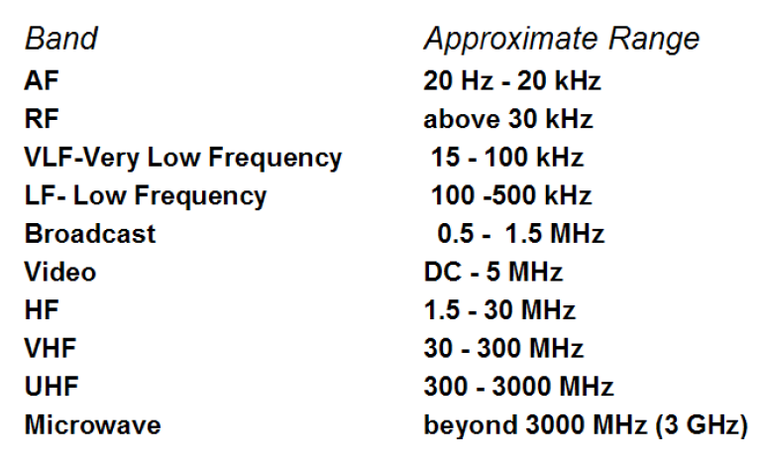
Most of the service type AF generators commonly cover from 20 Hz to 200 kHz, which is far beyond the AF range. In more advanced laboratory types of AF generators, the frequency range extends quite a bit further e.g. a Hewlett Packard model covers 5 Hz - 600 kHz and a Marconi model generates both sine and square waves and has a very wide range of 10Hz – 100 MHz.

Fixed Frequency AF Oscillator
In many cases, a self-contained oscillator circuit is an integral part of the instrument circuitry and is used to generate a signal at some specified audio frequency. Such a fixed frequency might be a 400 Hz signal used for audio testing or a 1000 Hz signal for exciting a bridge circuit. Oscillations at specified audio frequencies are easily generated by the use of an iron core transformer to obtain positive feedback through inductive coupling between the primary and secondary windings.

Variable AF Oscillator
Variable AF Oscillators used for general lab purpose should cover at least full audio range i.e., from 20 Hz to 20kHz and have a constant pure sine wave output. They are of RC feedback oscillator type or Beat Frequency Oscillator type (BFO).

Requirements of Laboratory Type Signal Generator: There are different types of signal generator. But the requirements are common to all the types.
- The output frequency of signal generator should be very stable.
- The amplitude of output signal of signal generator should be controllable from low values to relatively large values.
- The amplitude of output signal must be stable.
- The harmonic contents in the output should be as low as possible. The output signal should be distortion free.
- The signal generator should provide very low spurious output; that means effect of hum, noise, jitter and modulation should be negligible.
Basic Standard Signal Generator (Sine wave):
The sine wave generator represents the largest single category of signal generator. This instrument covers a frequency range from a few Hertz to many Giga-Hertz. The sine wave generator in its simplest form is given in Fig.
The simple sine wave generator consists of two basic blocks, an oscillator and an attenuator. The accuracy of the frequency, stability, and freedom from distortion depend on the design of the oscillator, while the amplitude depends on the design of the attenuator.
Standard Signal Generator:
A standard signal generator produces known and controllable voltages. It is used as power source for the measurement of gain, signal to noise ratio (S/N), bandwidth, standing wave ratio and other properties. It is extensively used in the testing of radio receivers and transmitters. The instrument is provided with a means of modulating the carrier frequency, which is indicated by the dial setting on the front panel (see Fig. below). The modulation is indicated by a meter. The output signal can be Amplitude Modulated (AM) or Frequency Modulated FM. Modulation may be done by a sine wave, square wave, triangular wave or a pulse.
The carrier frequency is generated by a very stable RF oscillator using an LC tank circuit, having a constant output over any frequency range. The output voltage is read by an output meter. Buffer Amplifiers provided in high frequency oscillators to isolate the oscillator circuit from the output circuit.
Modern Signal Generator:
In a modern signal generator (see Fig. below) to improve frequency stability, a single master oscillator is used with frequency dividers for lower ranges. The master oscillator is insensitive to temperature variations, design of succeeding stages, etc. The other components are B1 –Untuned buffer amplifier; B2, B3 additional buffers for isolation of master oscillator from power amplifier to avoid loading effects. The master oscillator is fine-tuned by a motor driven variable capacitor –programmable automatic frequency control circuits.
AF Sine and Square Wave Generator:
A wien bridge oscillator (suitable for AF range) is used in this generator (refer Fig. below). The frequency of the oscillations can be changed by varying the capacitance in the oscillator or in steps by switching in resistors of different values.
The output of the oscillator goes to a function switch which directs the oscillator output to either sine wave amplifier or to the square wave shaper. The attenuator varies the amplitude of the output which is taken through a push-pull amplifier.

The front panel of the signal generator consists of the following:
Frequency selector: It selects the frequency in different ranges and varies it continuously in a ratio of 1:10. The scale is non-linear.
Frequency multiplier: It selects the frequency range over 5 decades, from 10 Hz to 1 MHz.
Amplitude multiplier: It attenuates the sine wave in 3 decades, x 1, x 0.1 and x 0.01.
Variable amplitude: It attenuates the sine wave amplitude continuously.

Symmetry control: It varies the symmetry of the square wave from 30% to 70%.
Amplitude: It attenuates the square wave output continuously.
Function switch: It selects either sine wave or square wave output.
Output available: This provides sine wave or square wave output.
Sync This terminal is used to provide synchronization of the internal signal with
an external signal.
On-Off Switch
Function Generator:
A function generator produces different waveforms of adjustable frequency. The common output waveforms are the sine, square, triangular and saw tooth waves. The frequency may be adjusted, from a fraction of a Hertz to several hundred kHz lie various outputs of the generator can be made available at the same time. For example, the generator can provide a square wave to test the linearity of a rectifier and simultaneously provide a saw tooth to drive the horizontal deflection amplifier of the CRO to provide a visual display.
Capability of Phase Lock:
The function generator can be phase locked to an external source. One function generator can be used to lock a second function generator, and the two output signals can be displaced in phase by adjustable amount. In addition, the fundamental frequency of one generator can be phase locked to a harmonic of another generator, by adjusting the amplitude and phase of the harmonic; almost any waveform can be generated by addition.
The function generator can also be phase locked to a frequency standard and its output waveforms will then have the same accuracy and stability as the standard source.

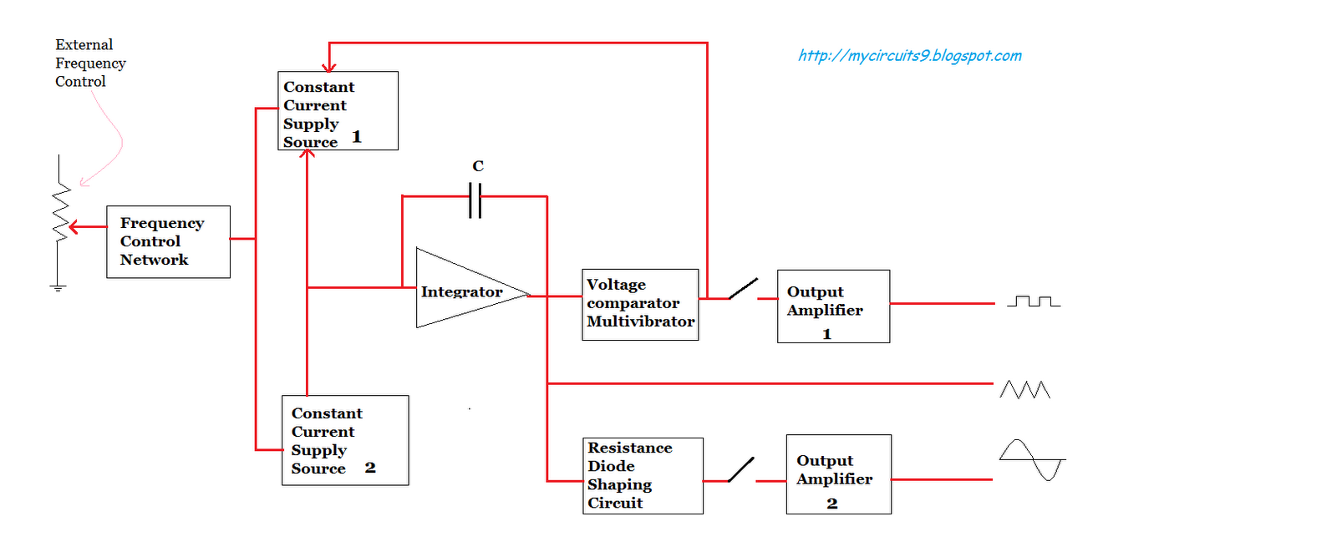

The block diagram of a function generator is illustrated in fig. Usually the frequency is controlled by varying the capacitor in the LC or RC circuit. In the instrument the frequency is controlled by varying the magnitude of current which drives the integrator. The instrument produces sine, triangular and square waves with a frequency range of 0.01 Hz to 100 kHz.

The frequency controlled voltage regulates two current sources. The upper current source supplies constant current to the integrator whose output voltage increases linearly with time, according to the equation of the output signal voltage. An increase or decrease in the current increases or decreases the slope of the output voltage and hence controls the frequency. The voltage comparator multi-vibrator changes states at a pre-determined maximum level of the integrator output voltage. This change cuts off the upper current supply and switches on the lower current supply. The lower current source supplies a reverse current to the integrator, so that its output decreases linearly with time. When the output reaches a pre-determined minimum level, the voltage comparator again changes state and switches on the Lower current source. The output of the integrator is a triangular waveform whose frequency is determined by the magnitude of the current supplied by the constant current sources. The comparator output delivers a square wave voltage of the same frequency. The resistance diode network alters the slope of the triangular wave as its amplitude changes and produces a sine wave with less than 1% distortion.

Pulse & Square Wave Generator:

These generators are used as measuring devices in combination with a CRO. They provide both quantitative and qualitative information of the system under test. They are made use of in transient response testing of amplifiers. The fundamental difference between a pulse generator and a square wave generator is in the duty cycle. A square wave generator has a 50% duty cycle.

Requirements of a Pulse
- The pulse should have minimum distortion, so that any distortion, in the display is solely due to the circuit under test.

- The basic characteristics of the pulse are rise time, overshoot, ringing, sag, and undershoot.

- The pulse should have sufficient maximum amplitude, if appreciable output power is required by the test circuit, e.g. for magnetic core memory. At the same time, the attenuation range should be adequate to produce small amplitude pulses to prevent over driving of some test circuit.

- The range of frequency control of the pulse repetition rate (PRR) should meet the needs of the experiment. For example, a repetition frequency of 100 MHz is required for testing fast circuits. Other generators have a pulse-burst feature which allows a train of pulses rather than a continuous output.

- Some pulse generators can be triggered by an externally applied trigger signal; conversely, pulse generators can be used to produce trigger signals, when this output is passed through a differentiator circuit.

- The output impedance of the pulse generator is another important consideration. In a fast pulse system, the generator should be matched to the cable and the cable to the test circuit. A mismatch would cause energy to be reflected back to the generator by the test circuit, and this may be rereflected by the generator, causing distortion of the pulses.

- DC coupling of the output circuit is needed, when dc bias level is to be maintained.

The basic circuit for pulse generation is the asymmetrical multi-vibrator. A laboratory type square wave and pulse generator is shown in Fig below. The frequency range of the instrument is covered in seven decade steps from 1Hz to 10 MHz, with a linearly calibrated dial for continuous adjustment on all ranges.
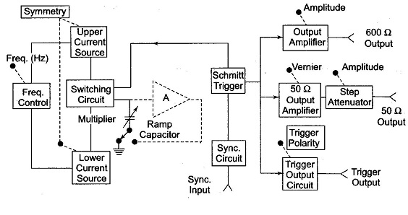
The duty cycle can be varied from 25 - 75%. Two independent outputs are available, a 50Ω source that supplies pulses with a rise and fall time of 5 ns at 5V peak amplitude and a 600Ω source which supplies pulses with a rise and fall time of 70 ns at 30 V peak amplitude. The instrument can be operated as a free running generator or, it can be synchronized with external signals.
The basic generating loop consists of the current sources, the ramp capacitor, and the Schmitt trigger and the current switching circuit as shown in the fig below.

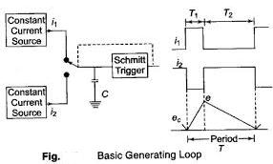
The upper current source supplies a constant current to the capacitor and the capacitor voltage increases linearly. When the positive slope of the ramp voltage reaches the upper limit set by the internal circuit components, the Schmitt trigger changes state. The trigger circuit output becomes negative and reverses the condition of the current switch. The capacitor discharges linearly, controlled by the lower current source.
When the negative ramp reaches a predetermined lower level, the Schmitt trigger switches back to its original state. The entire process is then repeated. The ratio i1/i2 determines the duty cycle, and is controlled by symmetry control. The sum of i1 and i2 determines the frequency. The size of the capacitor is selected by the multiplier switch. The unit is powered by an internal supply that provides regulated voltages for all stages of the instrument.

Random Noise Generator:

The spectrum of random noise covers all frequencies the lower density spectrum tells us how the energy of the signal is distributed in frequency, but it does not specify the signal uniquelynor does it tell us very much about how the amplitude of the signal varies with time The spectrum does not specify the signal uniquely because it contains no phase information.
The method of generating noise is usually to use a semiconductor noise which delivers frequencies in a band roughly extending from 80 – 220 KHz The output from the noise diode is amplified and heterodyned down to audio frequency band by means of a balanced symmetrical modulator.
The filter arrangement controls the bandwidth and supplies an output signal in three spectrum choices, white noise, pink noise and Usasi noise.
From the Fig, it is seen that white noise is flat from 20Hz to 20 KHz and has upper cutoff frequency of 50 kHz with a cutoff slope of -12 dbs/ octave. Pink noise is so called because the lower frequencies have larger amplitude, similar to red light. Pink noise has a voltage spectrum which is inversely proportional to the square root of frequency and is used in band analysis.
Usasi noise ranging simulates the energy distribution of speech and music frequencies and is used for testing audio amplifiers and loud speakers.

Sweep Generator:

It provides a sinusoidal output voltage whose frequency varies smoothly and continuously over an entire frequency band, usually at an audio rate. The process of frequency modulation may be accomplished electronically or mechanically. It is done electronically by using the modulating voltage to vary the reactance of the oscillator tank circuit component, and mechanically by means of a motor driven capacitor, as provided for in a modern laboratory type signal generator.
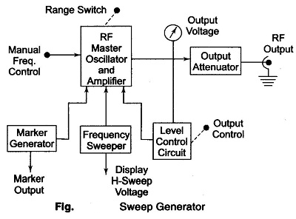

Figure shows a basic block diagram of a sweep generator. The frequency sweeper provides a variable modulating voltage which causes the capacitance of the master oscillator to vary. A representative sweep rate could be of the order of 20 sweeps/second. A manual control allows independent adjustment of the oscillator resonant frequency. The frequency sweeper provides a varying sweep voltage synchronization to drive the horizontal deflection plates of the CRO. Thus the amplitude of the response of a test device will be locked and displayed on the screen.

To identify a frequency interval, a marker generator provides half sinusoidal waveforms at any frequency within the sweep range. The marker voltage can be added to the sweep voltage of the CRO during alternate cycles of the sweep voltage, and appears superimposed on the response curve.
The automatic level control circuit is a closed loop feedback system which monitors the RF level at some point in the measurement system. This circuit holds the power delivered to the load or test circuit constant and independent o frequency and impedance changes. A constant power level prevents any source mismatch and also provides a constant readout calibration with frequency.

Arbitrary Wave Form Generator:

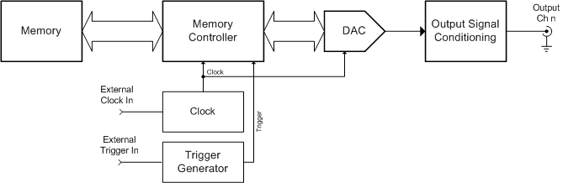

An arbitrary waveform generator (AWG) is a piece of electronic test equipment used to generate electrical waveforms. These waveforms can be either repetitive or single-shot (once only) in which case some kind of triggering source is required (internal or external). The resulting waveforms can be injected into a device under test and analyzed as they progress through it, confirming the proper operation of the device or pinpointing a fault in it.
Unlike function generators, AWGs can generate any arbitrarily defined wave shape as their output. The waveform is usually defined as a series of "waypoints" (specific voltage targets occurring at specific times along the waveform) and the AWG can either jump to those levels or use any of several methods to interpolate between those levels.
For example, a 50% duty cycle square wave is easily obtained by defining just two points: At t0, set the output voltage to 100% and at t50%, set the output voltage back to 0. Set the AWG to jump (not interpolate) between these values and the result is the desired square wave. By comparison, a triangle wave could be produced from the same data simply by setting the AWG to linearly interpolate between these two points.
Because AWGs synthesize the waveforms using digital signal processing techniques, their maximum frequency is usually limited to no more than a few gigahertz. The output connector from the device is usually a BNC connector and requires a 50 or 75 ohm termination.
AWGs, like most signal generators, may also contain an attenuator, various means of modulating the output waveform, and often contain the ability to automatically and repetitively "sweep" the frequency of the output waveform (by means of a voltage-controlled oscillator) between two operator-determined limits. This capability makes it very easy to evaluate the frequency response of a given electronic circuit.
Some AWGs also operate as conventional function generators. These can include standard waveforms such as sine, square, ramp, triangle, noise and pulse. Some units include additional built-in waveforms such as exponential rise and fall times, sinx/x, and cardiac. Some AWGs allow users to retrieve waveforms from a number of digital and mixed-signal oscilloscopes. Some AWG's may display a graph of the waveform on their screen - a graph mode. Some AWGs have the ability to output a pattern of words on a multiple-bit connector to simulate data transmission, combining the properties of both AWGs and digital pattern generators.
One feature of DDS-based arbitrary waveform generators is that their digital nature allows multiple channels to be operated with precisely controlled phase offsets or ratio-related frequencies. This allows the generation of poly phase sine waves, I-Q constellations, or simulation of signals from geared mechanical systems such as jet engines. Complex channel-channel modulations are also possible.
Some AWG models include various detection schemes to adjust output waveforms in real time based on different kind of measurement results obtained for instance by signal demodulation, photon counting or triggering with an oscilloscope. The integration for signal generation and detection helps to minimize feedback times for demanding applications as for example in certain implementations of quantum error correction and quantum teleportation.

Wave Analyzers:
Analysis of the waveform means determination of the values of amplitude, frequency and sometime phase angle of the harmonic components.
A wave analyzer is an instrument designed to measure relative amplitude of signal frequency components in a complex waveform .basically a wave instruments acts as a frequency selective voltmeter which is tuned to the frequency of one signal while rejecting all other signal components.
Types of wave analyzers:
There are two types of wave analyzers, depending upon the frequency ranges used,
a) Frequency selecting wave analyzer.
b) Heterodyne wave analyzer.
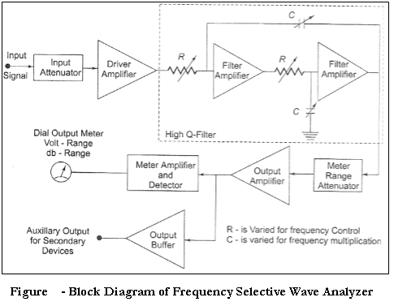
The wave analyzer consists of a very narrow pass-band filter section which can be tuned to a particular frequency within the audible frequency range (20Hz to 20 KHz)). The complex wave to be analyzed is passed through an adjustable attenuator which serves as a range multiplier and permits a large range of signal amplitudes to be analyzed. The output of the attenuator is then fed to a selective amplifier, which Amplifies the selected frequency. The driver amplifier applies the attenuated input signal to a high-Q active filter. This high-Q filter is a low pass filter which allows the frequency which is selected to pass and reject all others. The magnitude of this selected frequency is indicated by the meter and the filter section identifies the frequency of the component.
The filter circuit consists of a cascaded RC resonant circuit and amplifiers. For selecting the frequency range, the capacitors generally used are of the closed tolerance polystyrene type and the resistances used are precision potentiometers. The capacitors are used for range changing and the potentiometer is used to change the frequency within the selected pass-band, hence this wave analyzer is also called a Frequency selective voltmeter. The entire AF range is covered in decade steps by switching capacitors in the RC section. The selected signal output from the final amplifier stage is applied to the meter circuit and to an unturned buffer amplifier. The main function of the buffer amplifier is to drive output devices, such as recorders or electronics counters. The meter has several voltage ranges as well as decibel scales marked on it. It is driven by an average reading rectifier type detector. The wave analyzer must have extremely low input distortion, undetectable by the analyzer itself. The band width of the instrument is very narrow typically about 1% of the selective band given by the following response characteristics shows in below fig.
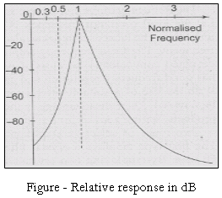

Heterodyne Wave Analyzer:
Analysis of the waveform means determination of the values of amplitude, frequency and sometime phase angle of the harmonic components.
A wave analyzer is an instrument designed to measure relative amplitude of signal frequency components in a complex waveform .basically a wave instruments acts as a frequency selective voltmeter which is tuned to the frequency of one signal while rejecting all other signal components.
It is well known that any periodic waveform can be represented as the sum of a D.C. component and a series of sinusoidal harmonics. Analysis of a waveform consists of determination of the values of amplitude, frequency, and sometime phase angle of the harmonic components. Graphical and mathematical methods may be used for the purpose but these methods are quite laborious. The analysis of a complex waveform can be done by electrical means using a band pass filter network to single out the various harmonic components. Networks of these types pass a narrow band of frequency and provide a high degree of attenuation to all other frequencies.
A wave analyzer, in fact, is an instrument designed to measure relative amplitudes of single frequency components in a complex waveform. Basically, the instrument acts as a frequency selective voltmeter which is used to the frequency of one signal while rejecting all other signal components. The desired frequency is selected by a frequency calibrated dial to the point of maximum amplitude. The amplitude is indicated either by a suitable voltmeter or CRO.
This instrument is used in the MHz range. The input signal to be analyzed is heterodyned to a higher IF by an internal local oscillator. Tuning the local oscillator shifts various signal frequency components into the pass band of the IF amplifier. The output of the IF amplifier is rectified and is applied to the metering circuit. The instrument using the heterodyning principle is called a heterodyning tuned voltmeter.
The block schematic of the wave analyzer using the heterodyning principle is shown in fig. above. The operating frequency range of this instrument is from 10 kHz to 18 MHz in 18 overlapping bands selected by the frequency range control of the local oscillator. The bandwidth is controlled by an active filter and can be selected at 200, 1000, and 3000 Hz.
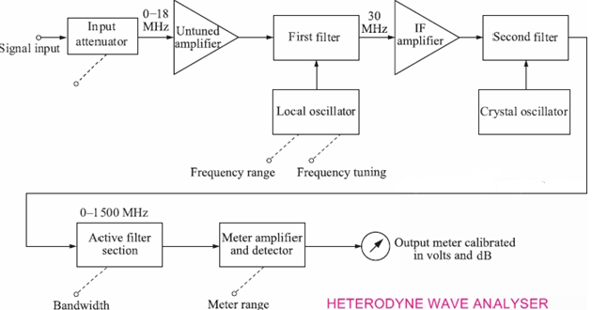

Applications of Wave Analyzers:
Wave analyzers have very important applications in the following fields:
1) Electrical measurements
2) Sound measurements and
3) Vibration measurements.
The wave analyzers are applied industrially in the field of reduction of sound and vibrations generated by rotating electrical machines and apparatus. The source of noise and vibrations is first identified by wave analyzers before it can be reduced or eliminated. A fine spectrum analysis with the wave analyzer shows various discrete frequencies and resonances that can be related to the motion of machines. Once, these sources of sound and vibrations are detected with the help of wave analyzers, ways and means can be found to eliminate them.

DISTORTION ANALYZER
Distortion refers to the deviation in any parameter (like amplitude, frequency. shape) of a signal from that of an ideal signal. The non-linear characteristics of the elements of an electronic circuit give rise to harmonics in the output signal which in turn causes distortion of the output signal.
The distortion caused due to harmonics is known as harmonic distortion.
The different types of harmonic distortions caused by an electronic circuit (for example, electronic amplifier are as follows,
- Amplitude distortion
- Frequency distortion
- Phase distortion
- Crossover distortion
- Inter modulation distortion.

(i) Amplitude Distortion
When the amplitude of the output signal is not a linear function of the amplitude and input signal is distorted under specific conditions then such type of distortion are known as Amplitude distortion. Amplitude distortion occurs when the amplifier gives rise to harmonics of the fundamental frequency of the input signal.

(ii) Frequency distortion
Frequency distortion of a signal takes place when the signal is amplified by different amounts at different frequencies. This is caused mainly due to the combination of active devices and components in an amplifier.
For Example, the non-uniform frequency response of RC-coupled cascade amplifier refers to frequency distortion.

(iii) Phase Distortion:
Is different from the phase of the input signal then such distortion is known as phase distortion. If different amounts of phase shifts occur at different frequencies of an output signal than it becomes necessary to compensate for such phase distortions. While if same amount of phase shift occurs at all frequencies then such phase distortion cannot be ignored .the phase distortion arises due to presence of storage elements in the circuit.

(iv) Crossover Distortion
The improper biasing voltages of the electromagnetic components of an amplifier (for example push-pull amplifier give rise to crossover distortion)

(v) Inter modulation Distortion
When two signals of different frequencies are mixed together (i.e., heterodyned) the resultant signal will be a sum or difference of the actual frequencies of the signals. Thus, when the signals are heterodyned, additional frequencies are generated which are undesirable and thereby leads to distortion. The distortion caused by heterodyning of frequencies is known as inter modulation distortion. The various distortions in the signal can be analyzed using a distortion analyzer (for example, harmonic distortion analyzer).

Harmonic Distortion Analyzer
They calculate the total distortion introduced by all the harmonics of the fundamental frequency wave. In most cases THD is the amount required to be calculated, rather than distortion caused by individual harmonics. This type of analysis is very important in systems (e.g. Audio) in which filters with extremely small pass band/ stop band are desired, such as a notch filter in a parametric equalizer
This is a specific type of THD analyzer, in which basically the fundamental frequency of the input wave is suppressed so as to remove it from the spectra of the meters used for distortion measurement, and the total gain of all the harmonics is calculated, thus obtaining the total distortion caused by the harmonics. The frequency response of a Fundamental Suppression Analyzer
A block diagram of a Fundamental Suppression Analyzer is shown in Fig.1. This basic construction consists of three main sections: Input section with impedance matcher, a rejection amplifier section and an output metering circuit. Notice the feedback from the bridge amplifier to the pre-amp section that enables the rejection circuit to work more accurately.

Working
The applied input wave is impedance matched with the rejection circuit with the help of an attenuator and an impedance matcher. This signal is then applied to a pre-amplifier which raises the signal level to a desired value. The following section consists of a Wien bridge. The bridge is tuned to the fundamental frequency by frequency control and it is balanced for zero output by adjusting the bridge controls, thus giving a notch in the frequency response of the rejection section. After the Wien Bridge, a bridge amplifier follows that simply amplifies low harmonic voltage levels to measurable higher levels. A feedback loop is formed from Bridge Amp o/p to the Pre-Amp i/p thus eliminating even the slightest effect of fundamental frequency. This filtered output is then applied to a meter amplifier which can be an instrumentation amplifier. This amp raises the voltage levels to the compatibility of the meter scale/digital meter which follows. Thus the total voltage obtained at the meter output shows the amount of distortion present in the wave due to harmonics of fundamental.
- Fundamental Suppression Type
Distortion analyzer measures the total harmonic power present in the test wave rather than the distortion caused by each component. The simplest method is to suppress the fundamental frequency by means of a high pass filter whose cut off frequency is a little above the fundamental frequency. This high pass allows only the harmonics to pass and the total harmonic distortion can then be measured. Other types of harmonic distortion analyzers based on fundamental suppression are as follows.
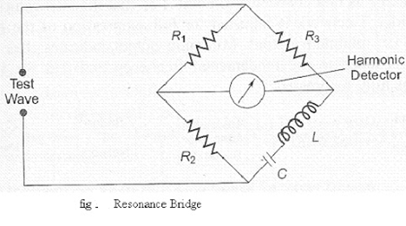
- Wien Bridge Method
The bridge is balanced for the fundamental frequency. The fundamental energy is dissipated in the bridge circuit elements. Only the harmonic components reach the output terminals .The harmonic distortion output can then be measured with a meter.
For balance at the fundamental frequency
C1=C2=C, R1=R2=R, R3=2R4.
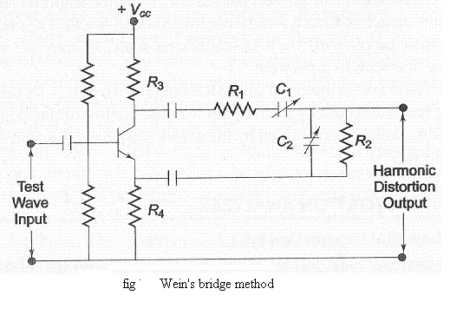
- Bridged T-Network Method:
The L and C’s are tuned to the fundamental frequency, and R is adjusted to bypass fundamental frequency. The tank circuit being tuned to the fundamental frequency, the fundamental energy will circulate in the tank and is bypassed by the resistance. Only harmonic components will reach the output terminals and the distorted output can be measured by the meter. The Q of the resonant circuit must be at least 3-5.
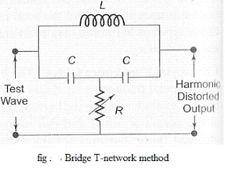
One way of using a bridge T-network is given in Fig. The switch S is first connected to point A so that the attenuator is excluded and the bridge T-network is adjusted for full suppression of the fundamental frequency, i.e. Minimum output indicates that the bridged T network is tuned to the fundamental frequency and that fundamental frequencies is fully suppressed.
The switch is next connected to terminal B, i.e. the bridge T- network is excluded. Attenuation is adjusted until the same reading is obtained on the meter. The attenuator reading indicates the total RMS distortion. Distortion measurement can also be obtained by means of a wave analyzer, knowing the amplitude and the frequency of each component, the harmonic distortion can be calculated.
However, distortion meters based on fundamental suppression are simpler to design and less expensive than wave analyzers. Their advantage is that give only the total distortion and not the amplitude of individual distortion components.

Basic Spectrum Analyzer:

The most common way of observing signals is to display them on an oscilloscope with time as the X-axis (i.e. amplitude of the signal versus time). This is the time domain. It is also useful to display signals in the frequency domain. The providing this frequency domain view is the spectrum analyzer.
A spectrum analyzer provides a calibrated graphical display on its CRT, with frequency on the horizontal axis and amplitude (voltage) on the vertical axis.
Displayed as vertical lines against these coordinates are sinusoidal components of which the input signal is composed. The height represents the absolute magnitude, and the horizontal location represents the frequency. These instruments provide a display of the frequency spectrum a given frequency band. Spectrum analyzers use either parallel filter bank or a swept frequency technique.
In a parallel filter in a parallel filter bank analyzer, the frequency range is covered by a series of filters whose central frequencies and bandwidth are so selected that they overlap each other, as shown in above fig. Typically, an audio analyzer has 32 of these filters, each covering one third of an octave. For wide band narrow resolution analysis, particularly at RF or microwave signals, the swept Technique is preferred.
Basic Spectrum Analyzer Using Swept Receiver Design Referring to the block diagram of fig. below, the saw tooth generator provides the saw tooth voltage which drives the horizontal axis element of the scope and this saw tooth voltage is the frequency controlled element of the voltage tuned oscillator. As the oscillator sweeps from fmin to fmax of its frequency band at a linear recurring rate, it beats with the frequency component of the input signal and produce an IF, whenever a frequency component is met during its sweep. The frequency component and voltage tuned oscillator frequency beats together to produce a difference frequency, i.e. The IF corresponding to the component is amplified and detected if necessary and then applied to the vertical plates of the CRO, producing a display of amplitude versus frequency.
One of the principal applications of spectrum analyzers has been in the study of the RF spectrum produced in microwave instruments. In a microwave instrument, the horizontal axis can display as a wide a range as 2 - 3 GHz for a broad survey and as narrow as 30 kHz, for a highly magnified view of any small portion of the spectrum. Signals at microwave frequency separated by only a few KHz can be seen individually. The frequency range covered by this instrument is from I MHz to 40 GHz,
The basic block diagram is of a spectrum analyzer covering the range 500 kHz to 1 GHz, which is representative of a super heterodyne type.
The input signal is fed into a mixer which is driven by a local oscillator. This oscillator is linearly tunable electrically over the range 2 - 3 GHz. The mixer provides two signals at its output that are proportional in amplitude to the input signal but of frequencies which are the sum and difference of the input signal and local oscillator frequency.
The IF amplifier is tuned to a narrow band around 2 GH4 since the local oscillator is tuned over the range of 2 - 3 GHz, only inputs that are separated from the local oscillator frequency by 2GHz will be converted to IF frequency band, pass through the IF frequency amplifier, get rectified and produce a vertical deflection on the CRT. From this, it is observed that as the saw tooth signal sweeps, the local oscillator also sweeps linearly from 2 - 3 GHz.
The tuning of the spectrum analyzer is a swept receiver, which sweeps linearly from 0 to 1 GHz. The saw tooth-scanning signal is also applied to the horizontal plates of the CRT to form the frequency axis. (The spectrum analyzer is also sensitive to signals from 4 - 5 GHz referred to as the image frequency of the super heterodyne. A low pass filter with a cutoff frequency above 1 GHz at the input suppresses these spurious signals.) Spectrum analyzers are widely used in radars, oceanography, and bio-medical fields.

