Block Diagram of Oscilloscope:
The major Block Diagram of Oscilloscope shown in Fig, of a general purpose Oscilloscope, is as follows:
- CRT
- Vertical amplifierx
- Delay line
- Time base
- Horizontal amplifier
- Trigger circuit
- Power Supply
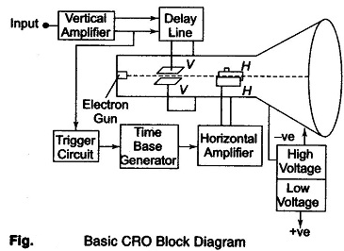
The function of the various blocks are as follows.
- CRT
This is the cathode ray tube which emits electrons that strikes the phosphor screen internally to provide a visual display of signal.
- Vertical Amplifier
This is a wide band amplifier used to amplify signals in the vertical section.
- Delay Line
It is used to delay the signal for some time in the vertical sections.
- Time Base
It is used to generate the sawtooth voltage required to deflect the beam in the horizontal section.
- Horizontal Amplifier
This is used to amplify the sawtooth voltage before it is applied to horizontal deflection plates.
- Trigger Circuit
This is used to convert the incoming signal into trigger pulses so that the input signal and the sweep frequency can be synchronised
- Power Supply
There are two power supplies, a —ve High Voltage (HV) supply and a +ve Low Voltage (LV) supply. Two voltages are generated in the CRO. The +ve volt supply is from + 300 to 400 V. The —ye high voltage supply is from — 1000 to — 1500 V. This voltage is passed through a bleeder resistor at a few mA. The intermediate voltages are obtained from the bleeder resistor for intensity, focus and positioning controls.

Advantages of using —ve HV Supply:
- The accelerating anodes and the deflection plates are close to ground The ground potential protects the operator from HV shocks when making connections to the plates.
- The deflection voltages are measured wrt ground, therefore HV blocking or coupling capacitor are not needed, but low voltage rating capacitors can be used for connecting the HV supply to the vertical and horizontal
Less insulation is needed between positioning controls and chasis.

Typical CRT Connections:
The below Figure shows various controls and Typical CRT Connections. The following controls are available on CRO panel.
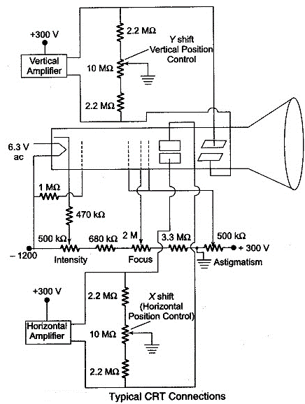
- Intensity It controls the magnitude of emission of the electron, beam, i.e. the electron beam is adjusted by varying the cathode-to-grid bias voltage. This adjustment is (folk by the 500 KΩ potentiometer
- Focus The focusing anode potential is adjusted with respect to the first and final accelerating anodes. This is done by the 2 MΩ It adjusts the negative voltage on the focus ring between —500 V and —900 V.
- Astigmatism It adjusts the voltage on the acceleration anode with respect to the VDP of the CRT. This arrangement forms a cylindrical lens that corrects any defocusing that might be present. This adjustment is made to obtain the roundest spot on the screen.
- X-shift or Horizontal Position Control The X-position of the spot is adjusted by varying the voltage between the horizontal plates. When the spot i$ in the centre position, the two horizontal plates have the same
- Y-shift or Vertical Position Control The X-position of the spot is adjusted by varying the voltage between the vertical plates. When the spot is in the centre position, the two vertical plates have the same potential.
- Time Base Control This is obtained by varying the C_{T} and R_{T} of the time base generator.
- Sync Selector It can synchronise the sweep to signals coming internally from the vertical amplifier or an external signal or the line supply Int Ext-Line switch.

Horizontal Deflecting System:
The Horizontal Deflecting System consist of a Time Base Generator and an output amplifier.

Sweep or Time Base Generator
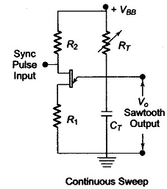
A continuous sweep CRO using a UJT as a time base generator is shown in above fig. The UJT is used to produce the sweep. When the power is first applied, the UJT is off and the C_{T} changes exponentially through R_{T} The UJT emitter voltage V_{E} rises towards V_{BB} and when V_{E} reaches the peak voltage V_{P}, as shown in below fig., the emitter to base ‘1’ (B₁) diode becomes forward biased and the UJT triggers ON. This provides a low resistance discharge path and the capacitor discharges rapidly. The emitter voltage V_{E} reaches the minimum value rapidly and the UJT goes OFF. The capacitor recharges and the cycle repeats.
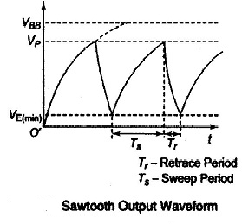
To improve sweep linearity, two separate voltage supplies are used, a low voltage supply for UJT and a high voltage supply for the R_{T}C_{T} circuit.
R_{T} is used for continuous control of frequency within a range and C_{T} is varied or changed in steps for range changing. They are sometimes called as timing resistor and timing capacitor respectively.
The sync pulse enables the sweep frequency to be exactly equal to the input signal frequency, so that the signal is locked on the screen and does not drift.

Triggered Sweep Circuit:
Figure 1 shows a Delay Line in Triggered Sweep Circuit. Figure 2 indicates the amplitude of the signal w.r.t. time and the relative position of the sweep generator output signal.
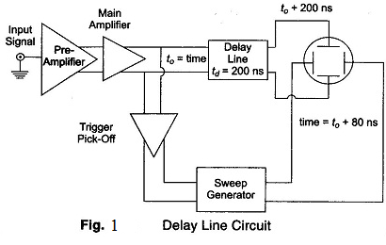
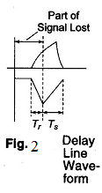
The diagram shows that when the delay line is not used, the initial part of the signal is lost and only part of the signal is displayed. To counteract this disadvantage the signal is not applied directly to the vertical plates but is passed through a delay line circuit, as shown in Fig. 1. This gives time for the sweep to start at the horizontal plates before the signal has reached the vertical plates. The trigger pulse is picked off at a tune t₀ after the signal has passed through the main amplifier. The sweep generator delivers the sweep ti; the horizontal amplifier and the sweep starts at the HDP at time t₀ + 80 ns. Hence the sweep starts well in time, since the signal arrives at the VDP at time t₀ + 200 ns.

Sync Selector for Continuous Sweep CRO
The sync selector is a 3-position switch, Int-Ext-Line. Therefore horizontal sweep can be synchronized with the signals coming from any of the three sources, as shown in Fig. 7.15.
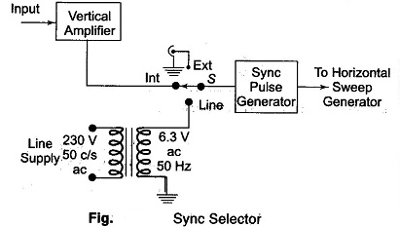

Triggered Sweep CRO:
Triggered Sweep CRO – The continuous sweep is of limited use in displaying periodic signals of constant frequency and amplitude. When attempting to display voice or music signals, the pattern falls in and out of sync as the frequency and amplitude of the music varies resulting in an unstable display.
A triggered sweep can display such signals, and those of short duration, e.g. narrow pulses. In triggered mode, the input signal is used to generate substantial pulses that trigger the sweep. Thus ensuring that the sweep is always in step with the signal that drives it.
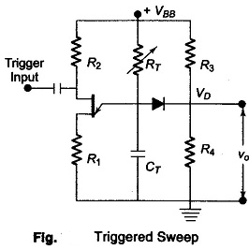
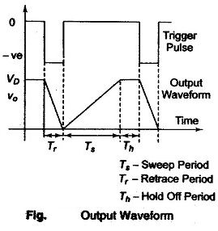
As shown in Fig., resistance R₃ and R₄ form a voltage divider such that the voltage V_{D} at the cathode of the diode is below the peak voltage V_{P} for UJT conduction. When the circuit is switched on, the UJT is in the non-conducting stage, and C_{T} charges exponentially through R_{T} towards V_{BB} until the diode becomes forward biased and conducts; the capacitor voltage never reaches the peak voltage required for UJT conduction but is clamped at V_{D}. If now a –ve pulse of sufficient amplitude is applied to the base and the peak voltage V/_{P} is momentarily lowered, the UJT fires. As a result, the C_{T} discharges rapidly through the UJT until the maintaining voltage of the UJT is reached; at this point the UJT switches off and the C_{T} charges towards V_{BB}, until it is clamped again at V_{D}. Figure shows the output waveform.
Dual Beam Oscilloscope:
Another method of studying two voltages simultaneously on the screen is to use special cathode ray tube having two separate electron guns generating two separate beams. Each electron beam has its own vertical deflection plates. But the two beams are deflected horizontally by the common set of horizontal plate\ the time base circuit may be same or different. Such an oscilloscope is called Dual Beam Oscilloscope.

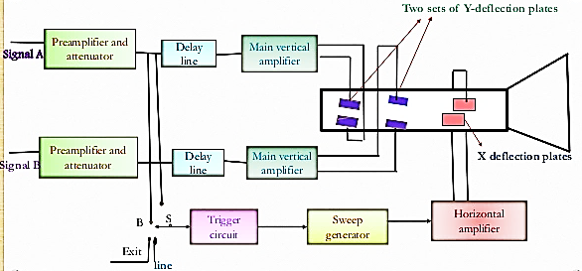
The oscilloscope has two vertical deflection plates and two separate channels A and B for the two separate input signals. Each channel consists of a preamplifier and an attenuator. A delay line, main vertical amplifier and a set of vertical deflection plates together forms a single channel. There is a single set of horizontal plates and single time base circuit. The sweep generator drives the horizontal amplifier which in turn drives the plates. The horizontal plates sweep both the beams across the screen at the same rate. The sweep generator can be triggered internally by the channel A signal or .channel B signal. Similarly it' can also be triggered from an external signal or line frequency signal. This is possible with the help of trigger selector switch, a front panel control. Such an oscilloscope may have separate time base circuit for separate channel. This allows different sweep rates for the two channels but increases the size and weight of the oscilloscope.

Multiple beam oscilloscope has a single tube but several beam producing systems inside. Each system has separate vertical deflecting pair of plates and generally (l common time base system. The triggering can be done internally using eith.er of the multiple inputs or externally by an external signal or line voltages.

Dual Trace Oscilloscope:

The comparison of two or more voltages is very much necessary in the analysis and study of many electronic circuits and systems. This is possible by using more than one oscilloscope but in such a case it is difficult to trigger the sweep of each oscilloscope precisely at the same time. A common and less costly method to solve this problem is to use dual trace or multi trace oscilloscopes. In this method, the same electron beam is used to generate two traces which can be deflected from two independent vertical sources. The methods are used to generate two independent traces which the alternate sweep method and other is chop method.
The block diagram of dual trace oscilloscope is shown in the Fig.
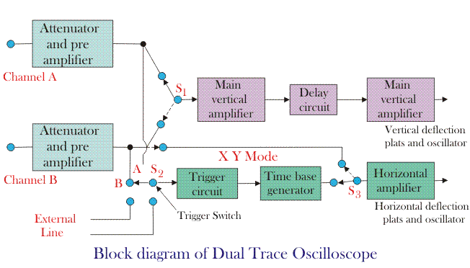

There are two separate vertical input channels A and B. A separate preamplifier and - attenuator stage exists for each channel. Hence amplitude of each input can be individually controlled. After preamplifier stage, both the signals are fed to an electronic switch. The switch has an ability to pass one channel at a time via delay line to the vertical amplifier. The time base circuit uses a trigger selector switch S2 which allows the circuit to be triggered on either A or B channel, on line frequency or on an external signal. The horizontal amplifier is fed from the sweep generator or the B channel via switch S3 and S1. The X-Y mode means, the oscilloscope operates from channel A as the vertical signal and the channel B as the horizontal signal. Thus in this mode very accurate X-Y measurements can be done.

There are two common operating modes for the electronic switch, called alternate and chop, and these are selected from the instrument's front panel. The alternate mode is illustrated in below fig. In this the electronic switch alternates between channels A and B, letting each through for one cycle of the horizontal sweep. The display is blanked during the fly back and hold-off periods, as in a conventional oscilloscope. Provided the sweep speed is much greater than the decay time of the CRT phosphor, the screen will show a stable display of both the waveform at channels A and B. The alternate mode cannot be used for displaying very low frequency signals.

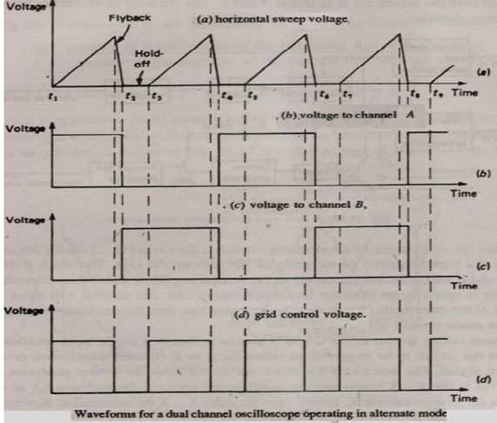

Chopped Operating mode
In this mode the electronic switch free runs at a high frequency of the order of 100 kHz to 500 kHz. The result is that small segments from channels A and B are connected alternately to the vertical amplifier, and displayed on the screen. Provided the chopping rate is much faster than the horizontal sweep rate, the display will show a continuous line for each channel. If the sweep rate approaches the chopping rate then the individual segments will be visible, and the alternate mode should now be used. The time base circuit shown in main block diagram, is similar to that of a single input oscilloscope. Switch S2 allows the circuit to be triggered on either the A or B channel waveforms, or on line frequency, or on an external signal. The horizontal amplifier can be fed from the sweep generator or the B channel via switch S1. This is the X - Y mode and the oscilloscope operates from channel A as the vertical signal and channel B as the horizontal signal, giving very accurate X - Y measurements.
Several operating modes can be selected from the front panel for display, such as channel A only, channel B only, channels A and B as two traces, and signals A + B, A - B, B - A or - (A + B) as a single trace.

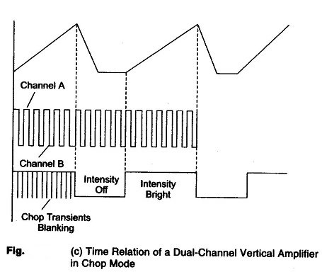

Measurements of Voltage:
Consider the circuit in below Fig. The signal generator is used to produce a 1000 hertz sine wave. To determine the size of the voltage signal appearing at the output of terminals of
the signal generator, an AC (Alternating Current) voltmeter is connected in parallel across these terminals. The AC voltmeter is designed to read the dc "effective value" of the voltage.

Lissajous Method of frequency and phase measurements:

When both pairs of the deflection plates (horizontal deflection plates and vertical deflection plates) of CRO (Cathode Ray Oscilloscope) are connected to two sinusoidal voltages, the patterns appear at CRO screen are called the Lissajous pattern. Shape of these Lissajous pattern changes with changes of phase difference between signal and ration of frequencies applied to the deflection plates (traces) of CRO. Which makes these Lissajous patterns very useful to analysis the signals applied to deflection plated of CRO. These lissajous patterns have two Applications to analysis the signals. To calculate the phase difference between two sinusoidal signals having same frequency. To determine the ratio frequencies of sinusoidal signals applied to the vertical and horizontal deflecting plates.

Calculation of the phase difference between two Sinusoidal Signals having same frequency
When two sinusoidal signals of same frequency and magnitude are applied two both pairs of deflecting plates of CRO, the Lissajous pattern changes with change of phase difference between signals applied to the CRO.
For different value of phase differences, the shape of Lissajous patterns is shown in figure below,
S. No. | Phase angle difference ‘ø’ | Lissajous Pattern appeared at CRO Screen
1 | 0º & 360º | 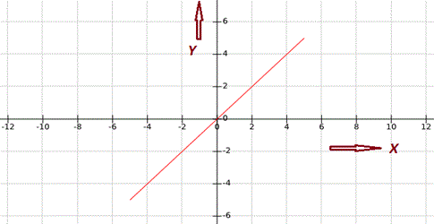
2 | 30º or 330º | 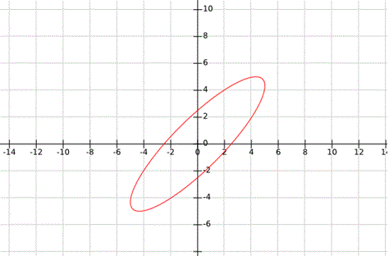
3 | 45º or 315º | 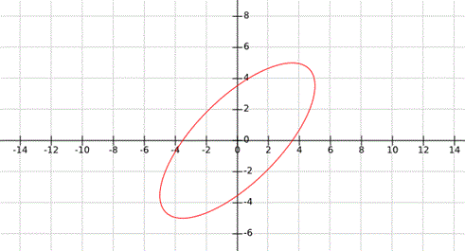
4 | 60º or 300º | 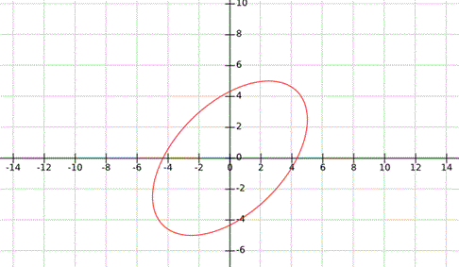
5 | 90º or 270º | 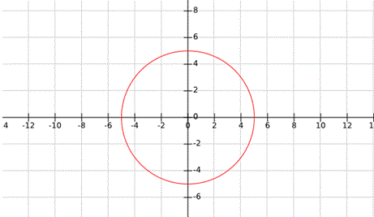
6 | 120º or 240º | 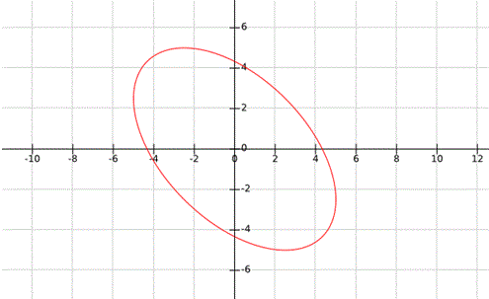
7 | 150º or 210º | 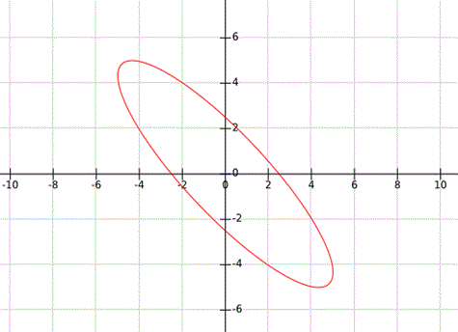
8 | 180º | 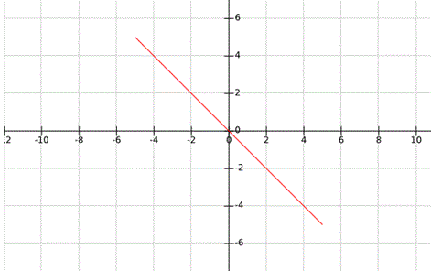
There are two cases to determine the phase difference ø between two signals applied to the horizontal & vertical plates,
Case - I: When, 0 < ø < 90º or 270º < ø < 360º : -
As we studied above it clear that when the angle is in the range of 0 < ø < 90º or 270º < ø < 360º, the Lissajous pattern is of the shape of Ellipse having major axis passing through origin from first quadrant to third quadrant:
Let’s consider an example for 0 < ø < 90º or 270º < ø < 360º, as shown in figure below,
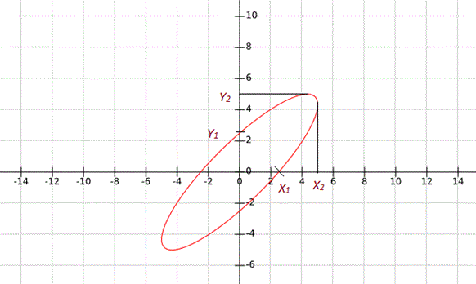
In this condition the phase difference will be
,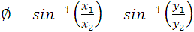
Another possibility of phase difference
From Above given Lissajous pattern
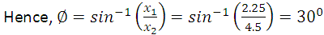
Another Possibility of Phase Difference,
Case - II: When 90º < ø < 180º or 180º < ø < 270º
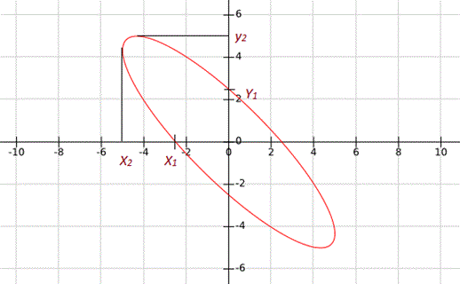
As we studied above it Clear that when the angle is in the range of 0º < ø < 90º or 270º < ø < 360º, the Lissajous Pattern is of the shape of Ellipse having major axis passing through origin from second quadrant to fourth quadrant:
Let’s consider an example for
When, 90º < ø < 180º or 180º < ø < 270º, as shown in figure below, In this condition the phase difference will be,
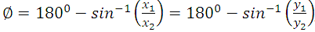
Another possibility of phase difference,
From Above given Lissajous pattern
Another Possibility of Phase Difference,

Frequency Measurement by Lissajous Method:
The oscilloscope is a sensitive indicator for frequency and phase measurements. This Frequency Measurement by Lissajous Method techniques used are simple and dependable, and measurement may be made at any frequency in the response range of the oscilloscope.
One of the quickest methods of determining frequency is by using Lissajous patterns produced on a screen. This particular pattern results when sine waves are applied simultaneously to both pairs of the deflection plates. If one frequency is an integral multiple (harmonic) of the other, the pattern will be stationary, and is called a Lissajous figure.
In this Frequency Measurement by Lissajous Method a standard frequency is applied to one set of deflection plates of the CRT tube while the unknown frequency (of approximately the same amplitude) is simultaneously applied to the other set of plates. However, the unknown frequency is presented to the vertical plates and the known frequency (standard) to the horizontal plates. The resulting patterns depend on the integral and phase relationship between the two frequencies. (The horizontal signal is designated as f_{h} and the vertical signal as f_{v})
Typical Lissajous figures are shown in below Figs for sinusoidal frequencies which are equal, integral and in ratio.

Measurement Procedure
Set up the oscilloscope and switch off the internal sweep (change to Ext). Switch off sync control. Connect the signal source as given in Fig. 7.33. Set the horizontal and vertical gain control for the desired width and height of the pattern. Keep frequency f_{v} constant and vary frequency f_{h}, noting that the pattern spins in alternate directions and changes shape. The pattern stands still whenever f_{v} and f_{h} are in an integral ratio (either even or odd). The f_{v} = f_{h} pattern stands still and is a single circle or ellipse. When f_{v} = 2 f_{h}, a two loop horizontal pattern is obtained as shown in below Fig.
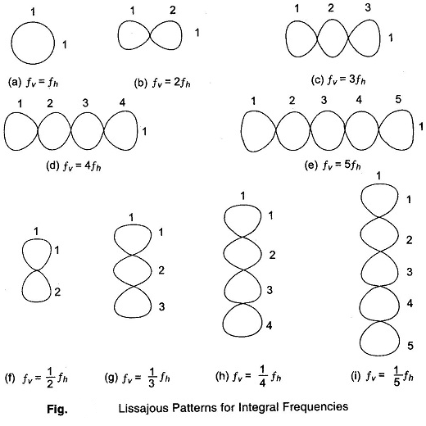
To determine the frequency from any Lissajous figure, count the number of horizontal loops in the pattern, divide it by the number of vertical loops and multiply this quantity by f_{h} (known or standard frequency).
In above fig., there is one horizontal loop and 3 vertical loops, giving a fraction of 1/3. The unknown frequency f_{v} is therefore 1/3 f_{h}. An accurately calibrated, variable frequency oscillator will supply the horizontal search frequency for Frequency Measurement. For the case where the two frequencies are equal and in phase, the pattern appears as a straight line at an angle of 45° with the horizontal. As the phase between the two alternating signals changes, the pattern changes cyclically, i.e. an ellipse (at 45° with the horizontal) when the phase difference is π/4, a circle when the phase difference is π/2 and an ellipse (at 135° with horizontal) when the phase difference is 3π/4, and a straight line pattern (at 135° with the horizontal) when the phase difference is π radians.
As the phase angle between the two signals changes from π to 2π radians, the pattern changes correspondingly through the ellipse-circle-ellipse cycle to a straight line. Hence the two frequencies, as well as the phase displacement can be compared using Lissajous figures techniques.
When the two frequencies being compared are not equal, but are fractionally related, a more complex stationary pattern results, whose form is dependent on the frequency ratio and the relative phase between the two signals, as in below Fig.
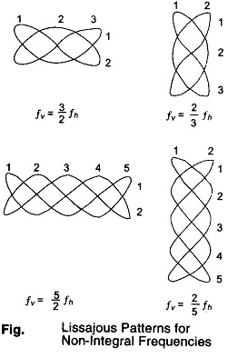
The fractional relationship between the two frequencies is determined by counting the number of cycles in the vertical and horizontal.
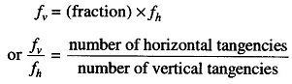
Sampling Oscilloscopes:
An ordinary oscilloscope has a B.W. of 10 MHz the HF performance can be improved by means of sampling the input waveform and reconstructing its shape from the sample, i.e. the signal to be observed is sampled and after a few cycles sampling point is advanced and another sample is taken.
The shape of the wave form is reconstructed by joining the sample levels together. The sampling frequency may be as low as 1/10th of the input signal frequency (if the input signal frequency is 100 MHz, the bandwidth of the CRO vertical amplifier can be as low as 10 MHz).
As many as 1000 samples are used to reconstruct the original waveform.
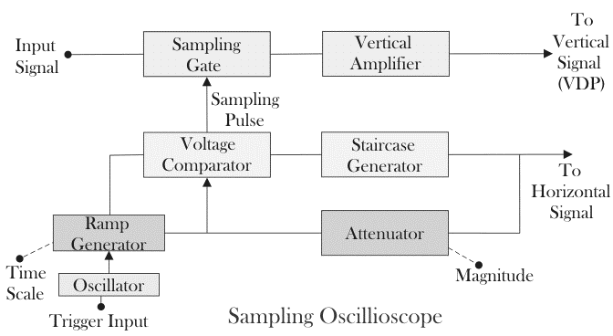
The input is applied to the sampling gate. The input waveform is sampled whenever a sampling pulse opens the sampling gate. The sampling must be synchronized with the input signal frequency. The signal is delayed in the vertical amplifier, allowing the horizontal sweep to be initiated by the input signal. The waveforms are shown in fig

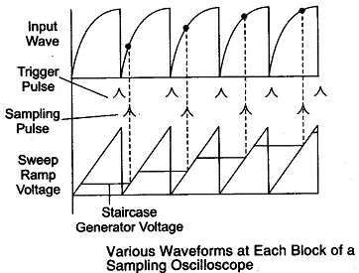
At the beginning of each sampling cycle, the trigger pulse activates an oscillator and
a linear ramp voltage is generated. This ramp voltage is applied to a voltage comparator which compares the ramp voltage to a staircase generate-When the two voltages are equal in amplitude, the staircase advances one step and a sampling pulse is generated, which opens the sampling gate for a sample of input voltage.
Resolution of the final image depends upon the size of the steps of the staircase generator. The smaller the size of the steps the larger the number of samples and higher the resolution of the image.

Storage Oscilloscope:
Two storage techniques are used in oscilloscope CRTs as,
- Mesh storage
- Phosphor storage

The Storage targets can be distinguished from standard phosphor targets by their ability to retain a waveform pattern for a long time, independent of phosphor persistence.
A mesh-storage CRT uses a dielectric material deposited on a storage mesa as the storage
target. This mesh is placed between the deflection plates and the standard phosphor target in the CRT.
The writing beam, which is the focused electron beam of the standard CRT, charges the dielectric material positively e where hit. The storage target is then bombarded with low velocity electrons from a flood gun and the positively charged areas of the storage target allow these electrons to pass through to the standard phosphor target and thereby reproduced the stored image on the screen.
Thus the mesh storage has both a storage target and a phosphor display target. The phosphor storage CRT uses a thin layer of phosphor to serve both as the storage and the display element.
Mesh Storage It is used to display Very Low Frequencies (VLF) signals an: finds many applications in mechanical and biomedical fields. The convention-scope has a display with a phosphor persistence ranging from a few microseconds to a few seconds.
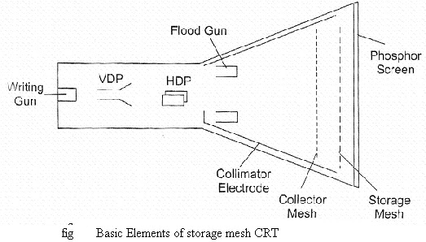

A mesh storage CRT, contains a dielectric material deposed on a storage mesh, a collector mesh, flood guns and a collimator, in addition BO all the elements of a standard CRT. The storage target, a thin deposition of a dielectric material such as Magnesium Fluoride on the storage mesh, makes use of a property known as secondary emission. The writing gun etches a positively charged pattern on the storage mesh or target by knocking off secondary emission electrons.
Because of the excellent insulating property of the Magnesium fluoride coating, this positively charged pattern remains exactly in the position where it is deposited. In order to make a pattern visible, a special electron gun, called the flood gun, is switched on (even after many hours).
The electron paths are adjusted by the collimator electrode, which constitutes a low voltage electrostatic lens system (to focus the electron beam), Most of the electrons are stopped and collected by the collector mesh. Only electrons near the stored positive charge are pulled to the storage target with sufficient force to hit the phosphor screen.
The CRT will now display the signal and it will remain visible as long as the flood guns operate. To erase the pattern on the storage mesh, a negative voltage is applied to neutralize the stored positive charge.

Since the storage mesh makes use of secondary emission, between the first and second crossover more electrons are emitted than are absorbed by the material, and hence a net positive charge results. Below the first crossover a net negative charge results, since the impinging electrons do not have sufficient energy to force an equal number to be emitted.

In order to store a trace, assume that the storage surface is uniformly charged; and write gun (beam emission gun) will hit the storage target. Those areas of the storage surface hit by the deflecting beam lose electrons, which are collects by the collector mesh. Hence, the write beam deflection pattern is traced on the storage surface as a positive charge pattern.
Since the insulation of the dielectric material is high enough to prevent any loss of charge for a considerable length of time, the pattern is stored. To view, the stored trace, a flood gun is used when the write gun is turned off. The flood gun, biased very near the storage mesh potential, emits flood of electrons which move towards the collector mesh, since it is biased slightly more positive than the deflection region.
The collimator ,a conductive coating on the CRT envelope with an applied potential, helps to align the flood electrons so that they approach the storage target perpendicularly When the electrons penetrate beyond the collector mesh, they encounter either a positively charged region on the storage surface or a negatively charged region where no trace has been stored.
The positively charged areas allow the electrons to pass through to the post accelerator region and the display target phosphor. The negatively charged region repels the flood electrons back to the collector mesh. Thus the charge pattern on the storage surface appears reproduced on the CRT display phosphor just as though it were being traced with a deflected beam.

Digital Storage Oscilloscope:

Storage cathode ray tube has several limitations as follows,
- There is a short duration of time, in which it can preserve a stored waveform, so the waveform may lose.
- Trace of storage tube is not as fine as that of a normal CRT.
- Writing rate of the storage tube is less than that of a conventional CRT which in turn limits the speed of the analog storage oscilloscope.
- It is more expensive than a conventional CRT and requires additional power supplies.
- Only one image can be stored. For comparing two traces they are to be superimposed on the same and displayed together.

Digital storage oscilloscope is used to limit these limitations. In DSO, the waveform to be stored is digitized, stored in a digital memory and retrieved for display on the storage oscilloscope.
Stored waveform is continuously displayed by repeatedly scanning it. Therefore a conventional CRT can also be used for the display. The stored display can be displayed continuously as long as the power is applied to the memory which can be supplied from a small battery.
Digitized waveform can be analyzed by oscilloscope or by reading the contents of the memory into the computer. Display of the stored data is possible in both amplitude versus time and x-y modes.
In DSO, fast memory readout is used for CRT display in addition to this a slow readout is also possible which is used for development of hard copy externally.

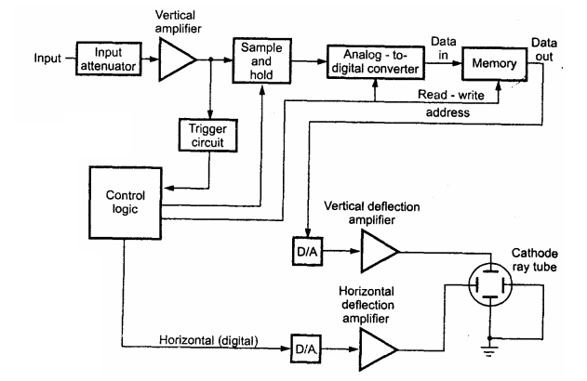

Figure shows the block diagram of DSO as consists of,
1. Data acquisition
2. Storage
3. Data display.
Data acquisition is earned out with the help of both analog to digital and digital to analog converters, which is used for digitizing, storing and displaying analog waveforms. Overall operation is controlled by control circuit which is usually consists of microprocessor.

Data acquisition portion of the system consist of a Sample-and-Hold (S/H) circuit and an analog to digital converter (ADC) which continuously samples and digitizes the input signal at a rate determined by the sample clock and transmit the digitized data to memory for storage. The control circuit determines whether the successive data points are stored in successive memory location or not, which is done by continuously updating the memories.

When the memory is full, the next data point from the ADC is stored in the first memory location writing over the old data.
The data acquisition and the storage process is continues till the control circuit receive a trigger signal from either the input waveform or an external trigger source. When the triggering occurs, the system stops and enters into the display mode of operation in which all or some part of the memory data is repetitively displayed on the cathode ray tube.

In display operation, two DACs are used which gives horizontal and vertical deflection voltage for the CRT Data from the memory gives the vertical deflection of the electron beam, while the time base counter gives the horizontal deflection in the form of staircase sweep signal.
The screen display consist of discrete dots representing the various data points but the number of dot is very large as 1000 or more that they tend to blend together and appear to be a smooth continuous waveform.
The display operation ends when the operator presses a front-panel button and commands the digital storage oscilloscope to begin a new data acquisition cycle.
Digital Storage Oscilloscope:- (DSO )
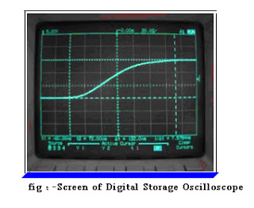
- DSO use the digital memory. It can store data as required without degradation.
- DSO also uses for complex processing of the signal with high speed with the help of digital signal processing circuits.
- in this A/D converter use to create the data that is stored in microprocessors memory, and data sent to display on screen
- DSO convert analog data into digital form using A/D convertor, it stores digital data in memory.
- Then processes the signals and to be display on screen.
- The wave form is stored in digital, advantage of using DSO, that stored data can be used to visualize the signal at any time.

Advantages:-
- Allows for automation.
- In this, slow traces like the temperature variation across a day can be recorded
- With colour Bigger and brighter display, to distinguish multiple traces
- peak detection
Disadvantage:-
Digital Oscilloscope is the limited refresh rate of the screen.
Comparison:

Conventional Storage Oscilloscope | Digital Storage Oscilloscope
1. It can store the given signal indefinitely as long as the small amount of power is supplied to the memory. | 1. In this oscilloscope heavy amount-of power is to be supplied to the storage CRT.
2. It always collects the data and stops when triggered. | 2. It collects the data only after triggering.
3. It employs normal CRT, hence the cost of the tube is much cheaper than the storage tube used in ASO. | 3. The cost of the tube is costlier than the storage tube used in DSO.
4. It can produce bright image even for high frequency signals. | 4. It cannot produce bright image for high frequency signals.
5. In this oscilloscope, time base is generated, by a crystal clock. | 5. In this oscilloscope, time base is generated by a ramp circuit.
6. It has higher resolution than ASO. | 6. It has lower resolution than DSO.
7. It has less operating speed than ASO. | 7. It has high operating speed than DSO.
8. Because of aliasing effect the useful storage ' bandwidth is limited. | 8. It doesn't have aliasing effect

Digital Readout Oscilloscope:
The Digital Readout Oscilloscope instrument has a CRT display and a counter display. The below diagram shown is of an instrument where the counter measures the time.
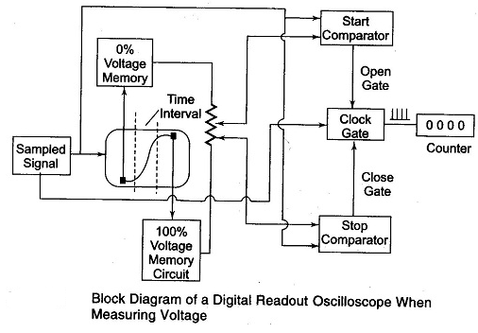

The input waveform is sampled and the sampling circuit advances the sampling position in fixed increments, a process called strobing. The equivalent time between each sample depends on the numbers of sample taken per cm and on the sweep time/cm, e.g. a sweep rate of 1 nano-sec/cm and a sampling rate of 100 samples/cm gives a time of 10 pico-sec/sample.
The above figure shows a block diagram of a digital read out oscilloscope when measuring voltage.
Two intensified portions of the CRT trace identify 0% and 100% zones position. Each zone can be shifted to any part of the display. The voltage divider taps between the 0% and 100% memory voltage are set for start and stop timing. The coincidence of any of the input Waveforms with the selected percentage point is sensed by this voltage comparator. The numbers of the clock pulse which correspond to the actual sample taken are read out digitally in a Nixie display tube in ns, µs, ms or seconds.
Below figure shows a block diagram of a digital readout CRO when used for voltage to time conversion.
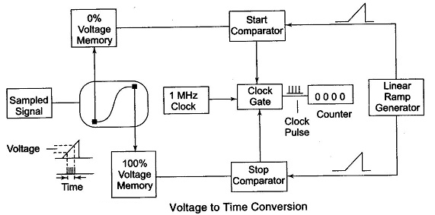
The CRT display is obtained by sampling the 0% reference voltage as chosen by the memory circuit. A linear ramp generator produces a voltage; when the ramp voltage equals the 0% reference the gate opens. When the ramp equals 100% reference the gate closes. The number of clock pulses that activate the counter is directly proportional to the voltage between the selected references and is read out in mV or volts by the Nixie tube display.

Basic Circuit for Frequency Measurement
The basic circuit for frequency measurement is as shown in below Fig. The output of the unknown frequency is applied to a Schmitt trigger, producing positive pulses at the output. These pulses are called the counter signals and are present at point A of the main gate. Positive pulses from the time base selector are present at point B of the START gate and at point B of the STOP gate.

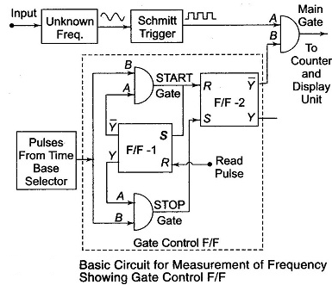
Initially the Flip-Flop (F/F-1) is at its logic 1 state. The resulting voltage from output Y is applied to point A of the STOP gate and enables this gate. The logic 0 stage at the output Y of the F/F-1 is applied to the input A of the START gate and disables the gate.
As the STOP gate is enabled, the positive pulses from the time base pass through the STOP gate to the Set (S) input of the F/F-2 thereby setting F/F-2 to the 1 state and keeping it there.
The resulting 0 output level from Y of F/F-2 is applied to terminal B of the main gate. Hence no pulses from the unknown frequency source can pass through the main gate.
In order to start the operation, a positive pulse is applied to (read input) reset input of F/F-1, thereby causing its state to change. Hence Y = 1, Y= 0, and as a result the STOP gate is disabled and the START gate enabled. This same read pulse is simultaneously applied to the reset input of all decade counters, so that they are reset to 0 and the counting can start.
When the next pulse from the time base arrives, it is able to pass through the START gate to reset F/F-2, therefore, the F/F-2 output changes state from 0 to 1, hence Y changes from 0 to 1. This resulting positive voltage from Y called the gating signal, is applied to input B of the main gate thereby enabling the gate.
Now the pulses from the unknown frequency source pass through the main gate to the counter and the counter starts counting. This same pulse from the START gate is applied to the set input of F/F-1, changing its state from 0 to 1. This disables the START gate and enables the STOP gate. However, till the main gate is enabled, pulses from the unknown frequency continue to pass through the main gate to the counter.
The next pulse from the time base selector passes through the enabled STOP gate to the set input terminal of F/F-2, changing its output back to 1 and fi = 0. Therefore the main gate is disabled, disconnecting the unknown frequency signal from the counter. The counter counts the number of pulses occurring between two successive pulses from the time base selector. If the time interval between this two successive pulses from the time base selector is 1 second, then the number of pulses counted within this interval is the frequency of the unknown frequency source, in Hertz.
The assembly consisting of two F/Fs and two gates is called a gate control F/F. The block diagram of a digital frequency meter is shown in below Fig.
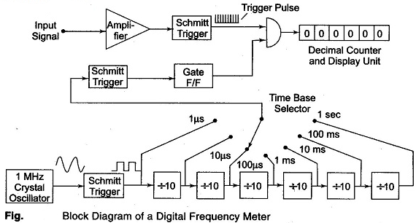
The input signal is amplified and converted to a square wave by a Schmitt trigger circuit. In this diagram, the square wave is differentiated and clipped to produce a train of pulses, each pulse separated by the period of the input signal. The time base selector output is obtained from an oscillator and is similarly converted into positive pulses.
The first pulse activates the gate control F/F. This gate control F/F provides an enable signal to the AND gate. The trigger pulses of the input signal are allowed to pass through the gate for a selected time period and counted. The second pulse from the decade frequency divider changes the state of the control F/F and removes the enable signal from the AND gate, thereby closing it. The decimal counter and display unit output corresponds to the number of input pulses received during a precise time interval; hence the counter display corresponds to the frequency.

High Frequency Measurement (Extending the Frequency Range)
The direct count range of digital frequency meter (DFM) extends from dc to a few 100 MHz. The limitations arises because of the counters used along with the DFM. The counters cannot count at the speed demanded by high frequency measurement.
This range of a few 100 MHz covers only a small portion of the frequency spectrum. Therefore, techniques other than direct counting have been used to extend the range of digital frequency meters to above 40 GHz. The input frequency is reduced before it is applied to a digital counter. This is done by special techniques. Some of the techniques used are as follows.
- Prescaling
The high frequency signal by the use of high speed is divided by the integral numbers such as 2, 4, 6, 8 etc. divider circuits, to get it within the frequency range of DFM (for example synchronous counters).
- Heterodyne Converter
The high frequency signal is reduced in frequency to a range within that of the meter, by using heterodyne techniques.
- Transfer Oscillator
A harmonic or tunable LF continuous wave oscillator is zero beat (mixed to produce zero frequency) with the unknown high frequency signal. The LF oscillator frequency is measured and multiplied by an integer which is equal to the ratio of the two frequencies, in order to determine the value of the unknown HF.
- Automatic Divider
The high frequency signal is reduced by some factor, such as 100:1, using automatically tuned circuits which generated an output frequency equal to 1/100th or 1/1000th of the input frequency.

Digital Measurement of Time:
The Principle of Operation of Digital Measurement of Time is given by the beginning of the time period is the start pulse originating from input 1, and the end of the time period is the stop pulse coming from input 2.
The oscillator runs continuously, but the oscillator pulses reach the output only during the period when the control F/F is in the 1 state. The number of output pulses counted is a measure of the time period.

Time Base Selector
It is clear that in order to know the value of frequency of the input signal, the time interval between the start and stop of the gate must be accurately known. This is called time base.
The time base consist of a fixed frequency crystal oscillator, called a clock oscillator, which has to be very accurate. In order to ensure its accuracy, the crystal is enclosed in a constant temperature oven. The output of this constant frequency oscillator is fed to a Schmitt trigger, which converts the input sine wave to an output consisting of a train of pulses at a rate equal to the frequency of the clock oscillator. The train of pulses then passes through a series of frequency divider decade assemblies connected in cascade. Each decade divider consists of a decade counter and divides the frequency by ten. Outputs are taken from each decade frequency divider by means of a selector switch; any output may be selected.
The circuit shown in below fig. consists of a clock oscillator having a 1 MHz frequency. The output of the Schmitt trigger is 10⁶ pulses per second and this point corresponds to a time of 1 microsecond. Hence by using a 6 decade frequency divider, a time base with a range of 1 μs — 10 μs — 100 μs — 1 ms —10 ms — 100 ms — 1 s can be selected using a selector switch.
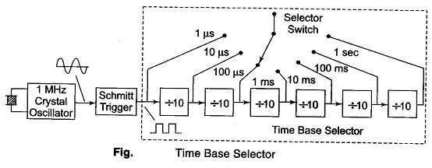

Measurement of Time (Period Measurement)
In some cases it is necessary to measure the time period rather than the frequency. This is especially true in the measurement of frequency in the low frequency range. To obtain good accuracy at low frequency, we should take measurements of the period, rather than make direct frequency measurements. The circuit used for measuring frequency can be used for the measurement of time period if the counted signal and gating signal are interchanged.
Below figure shows the circuit for measurement of time period. The gating signal is derived from the unknown input signal, which now controls the enabling and disabling of the main gate. The number of pulses which occur during one period of the unknown signal are counted and displayed by the decade counting assemblies. The only disadvantage is that for measuring the frequency in the low frequency range, the operator has to calculate the frequency from the time by using the equation f = 1/T.
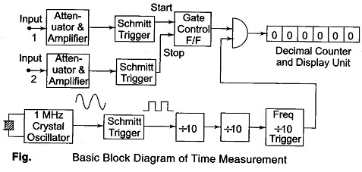
For example, when measuring the period of a 60 Hz frequency, the electronic counter might display 16.6673 ms, whence the frequency is

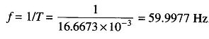
The accuracy of the period measurement and hence of frequency can be greatly increased by using the multiple period average mode of operation. In this mode, the main gate is enabled for more than one period of the unknown signal. This is obtained by passing the unknown signal through one or more decade divider assemblies (DDAs) so that the period is extended by a factor of 10,000 or more.
Hence the digital display shows more digital of information, thus increasing accuracy. However, the decimal point location and measurement units are usually changed each time an additional decade divider is added, so that the display is always in terms of the period of one cycle of the input signal, even though the measurements may have lasted for 10,100 or more cycles.
Below figure show the multiple average mode of operation. In this circuit, five more decade dividing assemblies are added so that the gate is now enabled for a much longer interval of time than it was with single DDA.
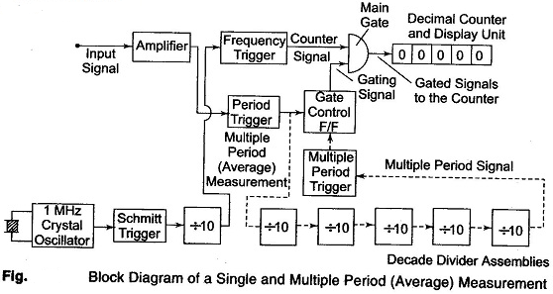

Ratio and Multiple Ratio Measurement
The ratio measurement involves the measurement of the ratio of two frequencies. The measurement in effect is a period measurement. A low frequency is used as gating signal while the high frequency is the counted signal. Hence the low frequency takes the place of the time base. The block diagram for the ratio measurements are multiple ratio is shown in below fig.
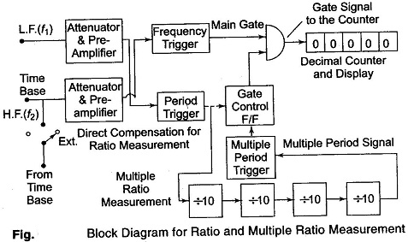
The number of cycles of high frequency signal f₁ which occur during the period of lower frequency signal f₂ are counted and displayed by the decimal counter and display unit. In multiple ratio measurements the period of low frequency signal is extended by a factor of 10,100, etc. by using DDAs.

