BRIDGE CIRCUITS
Introduction: Bridges are often used for the precision measurement of component values, like resistance, inductance, capacitance, etc. The simplest form of a bridge circuit consists of a network of four resistance arms forming a closed circuit as shown in below Fig. A source of current is applied to two opposite junctions and a current detector is connected to other two junctions. The bridge circuit operates on null detection principle and uses the principle of comparison measurement methods.
It compares the value of an unknown component with that of an accurately known standard component. Thus, the accuracy of measurement depends on the bridge and not on the null detector. When no current flows through the null detector, the bridge is said to be balanced. The relationship between the component values of the four arms of the bridge at the balancing is called balancing condition or balancing equation. Balancing equation gives up the value of the unknown component.
Advantages of Bridge Circuit: The various advantages of the bridge circuit are,
- The balance equation is independent of the magnitude of the input voltage or its source impedance. These quantities do not appear in the balance equation expression.
- The measurement accuracy is high as the measurement is done by comparing the unknown value with the standard value.
- The accuracy is independent of the characteristics of a null detector and is dependent on the component values.
- The balance equation is independent of the sensitivity of the null detector, the impedance of the detector or any impedance shunting the detector.
- The balance condition remains unchanged if the source and detector are interchanged.

Wheatstone’s bridge is the most accurate method available for measuring resistances and is popular for laboratory use. The circuit diagram of a Wheatstone bridge is given in below Fig. The source of emf and switch is connected to points A and S, while a sensitive current indicating meter, the galvanometer, is connected to points C and D. The galvanometer is a sensitive micro ammeter a zero center scale. When there is no current through the meter, the galvanometer pointer rests at 0, i.e. mid-scale. Current in one direction causes the points deflect on one side and current in the opposite direction to the other side.
When SW1 is closed, current flows and divides into the two arms at point A i.e. I1 and I2. The bridge is balanced when there is no current through the galvanometer, or when the potential difference at points C and D is equal, i.e. the potential across the galvanometer is zero
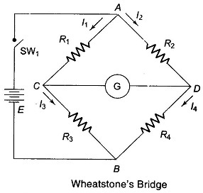
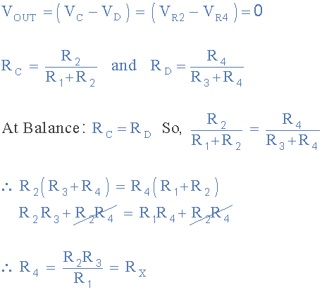
This is the equation for the bridge to be balanced.
If the bridge is not balanced, some little bit current pass through the galvanometer. To detect this it is better to apply Thevinin’s theorem.
In a practical Wheatstone’s bridge, at least one of the resistance is made adjustable, to permit balancing. When the bridge is balanced, the unknown resistance (normally connected at R4) may be determined from the setting of the adjustable resistor, which is called a standard resistor because it is a precision device having very small tolerance.

Errors in WS bridge measurements
- Limiting errors: In a WS bridge PQRS, the percentage limiting error in the measurand resistance, R is equal to the sum of the percentage limiting errors in the bridge arm resistances P, Q and S.
- Errors due to heating of elements in the bridge arms: Rt = R₀ [1+ αt]; P = I²R Watts; Heat= I²R_{t} Joules The I²R loss occurring in the resistors of each arm might tend to increase the temperature, which in turn can result in a change in the resistance value, different from the normal value.
- Errors due to the effect of the connecting wires and lead resistors: the connecting lead wire resistance will affect the value of the unknown resistance, especially when it is a low resistance value. Thus, the connecting lead wire resistances have to be accounted for while measuring a low resistance.
- Contact resistance errors: The contact resistance of the leads also affects the value of the measurand resistance, just as in point (iii) above. This resistance value depends on the cleanliness of the contact surfaces and the pressure applied to the circuit.

Limitations of WS Bridge
The WS bridge method is used for measurement of resistances that are numerically in the range of a few ohms to several kilo-ohms. The upper limit is set by the reduction in sensitivity to unbalance caused by the high resistances.

AC BRIDGES AND THEIR APPLICATIONS
An ac bridge similar to dc bridges consists of four arms, an ac source of excitation at the desired frequency and a null detector. For measurements at low frequencies the power line may be used as a source of excitation whereas at higher frequencies generally, an oscillator is used as a source. The operating frequencies of these oscillators are constant and easily adjustable. A typical oscillator has a frequency range of 40 Hz to 125 kHz with a power output of 7W headphones, vibrational galvanometer and tunable amplifier circuits are generally used as a null detector for ac bridges. The headphones are used as a detector at the frequency of 250 Hz to 3-4 kHz. While working with single frequency a tuned detector is the most sensitive detector. Vibrational galvanometers are useful for low audio frequency range from 5 Hz to 1 kHz, but are commonly used below 200 Hz. Tunable amplifier detectors are used for frequency range of 10 Hz to 100 Hz.
General Equation for Bridge Balance
Let us consider a general form of an ac bridge as shown in below Fig. The bridge circuit consists of a network of four impedance arms z1, z2, z3 and z4 respectively, forming a closed circuit. For bridge balance, the potential of point b must be same as the potential of point d. These potentials must be equal in terms of amplitude as well as phase. Thus, the voltage drop from a to b must be equal to voltage drop across a to d, in both magnitude and phase for the bridge balance, i.e.
Also at balance
Equation is the equation for balance of Ac Bridge in the impedance form. The balance
equation in the admittance (reciprocal of impedance) form can be expressed as
In the polar form the impedance Z can be written as
Where Z represents the impedance and θ represents the phase angle of complex impedance Z.
Hence, the bridge arm impedances in polar form can be expressed as

Where Z1, Z2, Z3 and Z4 are the magnitudes and θ1, θ2, θ3, and θ4 are the phase angles. Hence, the balance equation in polar form representation will be

Since, in complex number multiplication the magnitudes are multiplied and the phase angles
are added, the equation can be written as

Hence, from above equation, the two conditions must be satisfied for bridge balance.
(i) The product of the magnitudes of the opposite arms must be equal.
(ii) The sum of phase angles of the opposite arms must be equal.
The value of phase angles depends on the type of components of individual impedance. For inductive impedance the phase angles are positive and for capacitive impedance the phase angles are negative, i.e.,

Schering Bridge (Measurement of Capacitance):
This is the most common bridge used for measurement of unknown capacitance, dielectric loss, relative permittivity and power factor. The below Figure shows the basic circuit arrangement of the bridge and its phasor diagram under balance conditions.

Two branches consist of non-inductive resistance R3 and a standard capacitor C2. The standard capacitor is usually a high-quality mica capacitor (low-loss) for general measurement or an air capacitor (having very stable value and a very small elastic field) for insulation measurement. One of the arms consists of a variable capacitor connected in parallel with a variable non-inductive resistance R4. The remaining arm consists of unknown capacitor CX whose capacitance is to be determined. Connected in series with a resistance RX to represent loss in the capacitance CX, the impedance of four arms are

we obtain that the dissipation factor is the reciprocal of the quality factor Q and therefore
Hence, the dissipation factor tells us about the quality of the capacitor, i.e., how close the phase angle of the capacitor is to the ideal value 90º. Substituting the value of Cx and Rx in below Eqn. we have

If the frequency and resistor R4 in Schering Bridge is fixed, the capacitor C4 can be calibrated to read the dissipation factor directly.

WIEN’S BRIDGE:

Circuit and derives the expression for the unknown element at balance, Wien Bridge has a series RC combination in one and a parallelcombination in the adjoining arm. Wien's bridge shown in fig 2.1. its basic form is designed to measure frequency. It can also be used for the instrument of an unknown capacitor with great accuracy, the impedance of one arm is
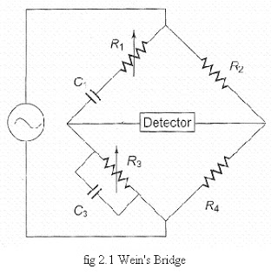

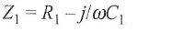
The admittance of the parallel arm is
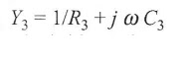
Using the bridge balance equation, we have

We have
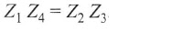
Therefore
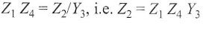

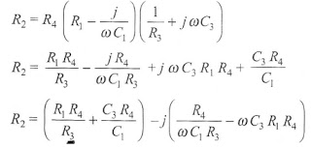
Equating the real and imaginary terms we have as,

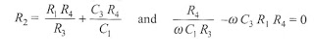
Therefore,
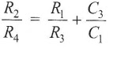
.................. (1.1)

And,

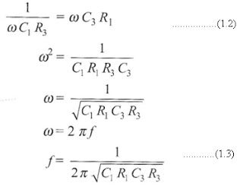

The two conditions for bridge balance, (1.1) and (1.3), result in an expression determining the required resistance ratio R2/R4 and another express determining the frequency of the applied voltage. If we satisfy Eq. (1.1) an also excite the bridge with the frequency of Eq. (1.3), the bridge will be balanced. In most Wien bridge circuits, the components are chosen such that R 1 = R3 = R and C1 = C3 = C. Equation (1.1) therefore reduces to R₂/R₄ =2 at Eq. (1.3) to f= 1/2ПRC, which is the general equation for the frequency of f_{l} bridge circuit.
The bridge is used for measuring frequency in the audio range. Resistances R1 and R3 can be ganged together to have identical values. Capacitors C₁ and C₃ are normally of fixed values. The audio range is normally divided into 20 - 200 - 2 k - 20 kHz range In this case, the resistances can be used for range changing and capacitors, and C3 for fine frequency control within the range.
The bridge can also be used for measuring capacitance. In that case, the frequency of operation must be known.
The bridge is also used in a harmonic distortion analyzer, as a Notch filter, an in audio frequency and radio frequency oscillators as a frequency determine element.
An accuracy of 0.5% - 1% can be readily obtained using this bridge. Because it is frequency sensitive, it is difficult to balance unless the waveform of the applied voltage is purely sinusoidal.

Maxwell Bridge (Measurement of Inductance):
Maxwell Bridge can be used to measure inductance by comparison either with a variable standard self-inductance or with a standard variable capacitance. These two measurement methods can be done by using two different Maxwell bridge forms.
Maxwell Inductance Bridge
In this bridge arrangement the value of unknown inductance is measured by comparison with a variable standard self-inductance. The below Figure shows the circuit arrangement and phasor diagram for Maxwell’s inductance bridge under balance condition. Two branches bc and cd consist of non-inductive resistance R3 and R4. One of the arms ad consists of variable inductance L2 of fixed internal resistance r2 connected in series with variable resistance R2. The remaining arm ab consists of unknown inductance Lx of resistance Rx. A source of current is applied to two opposite junctions across ac and a null detector is connected to the other two junctions b and d.
Hence, the impedances of four arms are

At balance we get

Equating real and imaginary term in the above equation, we have
We observe that the two conditions for above bridge balance Equations result in an expression determining the unknown inductance value by comparison with variable inductance L2 of fixed resistance r2. The resistance r2 is a decade resistance box.

Maxwell Inductance Capacitance Bridge
In this bridge arrangement, the value of unknown inductance is measured by comparison with a variable standard capacitor. The below Figure shows its circuit arrangement and phasor diagram. Two arms bc and ad consist of non-inductive resistance R2 and R3. One of the arms ac consists of variable standard capacitor C4 connected in parallel to a non-inductive resistance R4. The remaining arm ab consists of unknown inductance Lx of effective resistance Rx. A source of current is applied to two opposite junctions across ac and a null detector is connected to the other two junctions b and d. Hence, the impedances of four arms are
At balance we get

Equating real and imaginary terms in above Eqn. we have
Hence, from the above condition for bridge balance the unknown inductance value can be determined by comparison with variable standard capacitor. The quality factor of the coil is given by

Advantages
1. The balance equation is independent of losses associated with inductance.
2. The frequency does not appear in any of the two balance equations.
3. The scale of resistance can be calibrated to read inductance directly.
4. It is very useful for measurement of wide range of inductances at power and audio frequency.

Q-METER:
Every inductor coil has a certain amount of resistance and the coil should have lowest possible resistance. The ratio of the inductive reactance to the effective resistance of the coil is called the quality factor or Q-factor of the coil. So Q = X_{L}/ R = ωL / R
A high value of Q is always desirable as it means high inductive reactance and low resistance. A low value of Q indicates that the resistance component is relatively high and so there is a comparatively large loss of power.

The effective resistance of the coil differs from its dc resistance because of eddy current and skin effects and varies in a highly complex manner with the frequency. For this reason Q is rarely computed by determination of R and L
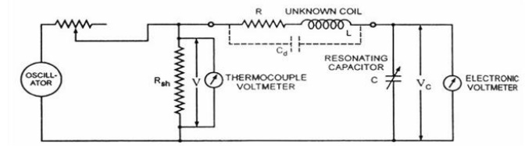

One possible way for determination of Q is by using the inductance bridge but such bridge circuits are rarely capable of giving accurate measurements, when Q is high. So special meters are used for determination of Q accurately.

The Q-meter is an instrument designed for the measurement of Q-factor of the coil as well as for the measurement of electrical properties of coils and capacitors. -This instrument operates on the principle of series resonance i.e. at resonate condition of an ac series circuit voltage across the capacitor is equal to the applied voltage times of Q of the circuit. If the voltage applied across the circuit is kept-constant then voltmeter connected across the capacitor can be calibrated to indicate Q directly.

Circuit diagram of a Q-meter is shown is figure. A wide-range oscillator with frequency range from 50 kHz to 50 MHz is used as a power supply to the circuit. The output of the oscillator is shorted by a low-value resistance, R_{sh} usually of the order of 0.02 ohm. So it introduces almost no resistance into the oscillatory circuit and represents a voltage source with a very small or of almost negligible internal resistance. The voltage across the low-value shunt resistance R_{sh}, V is measured by a thermo-couple meter and the voltage across the capacitor, V_{c} is measured by an electronic voltmeter.

For carrying out the measurement, the unknown coil is connected to the test terminals of the instrument, and the circuit is tuned to resonance either by varying the frequency of the oscillator or by varying the resonating capacitor C. Readings of voltages across capacitor C and shunt resistance R_{sh} are obtained and Q-factor of the coil is determined as follows :
By definition Q-factor of the coil, Q = X_{L}/ R
And when the circuit is under resonance condition X_{L}= X_{C} or IX_{L}= IX_{C}= V_{C}
And the voltage applied to the circuit. V = IR So, Q = X_{L}/ R = IX_{L}/ R = V_{C}/ V This Q-factor is called the circuit Q because this measurement includes the losses of the resonating capacitor, voltmeter and the shunt resistor R_{sh}. So, the actual Q-factor of the coil will be somewhat greater than the calculated Q-factor. This difference is usually very small and maybe neglected except when the resistance of the coil under test is relatively small in comparison to the shunt resistance R_{sh}. The inductance of the coil can also be computed from the known values of frequency f and resonating capacitor C as follows. At resonance, X_{L}= X_{C} or 2πfL = 1/2πfC or L = 1/ (2πf)² Henry.

