TRANSDUCERS

INTODUCTION
A device which converts a physical quantity into the proportional electrical signal is called a transducer. The electrical signal produced may be a voltage, current or frequency. A transducer uses many effects to produce such conversion. The process of transforming signal from one form to other is called transduction. A transducer is also called pick up. The transduction element transforms the output of the sensor to an electrical output, as shown in the Fig.

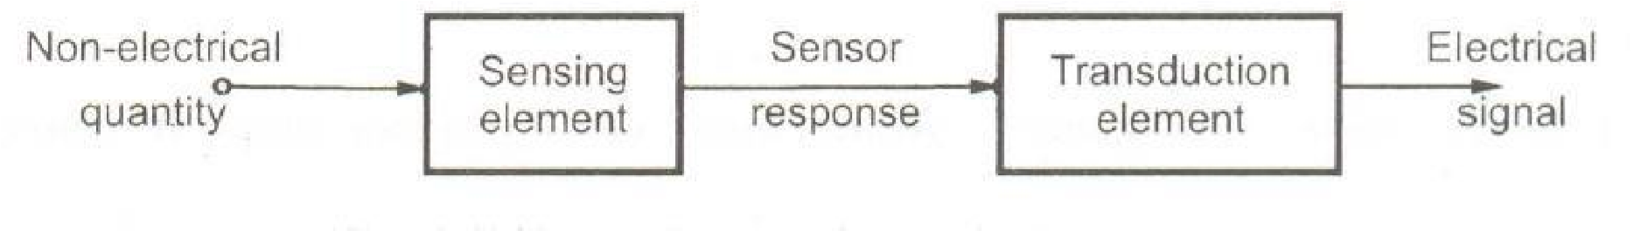

A transducer will have basically two main components. They are
- Sensing Element
The physical quantity or its rate of change is sensed and responded to by this part of the transistor.
- Transduction Element
The output of the sensing element is passed on to the transduction element. This element is responsible for converting the non-electrical signal into its proportional electrical signal.
There may be cases when the transduction element performs the action of both transduction and sensing. The best example of such a transducer is a thermocouple. A thermocouple is used to generate a voltage corresponding to the heat that is generated at the junction of two dissimilar metals.
Classification of Transducers
The Classification of Transducers is done in many ways. Some of the criteria for the classification are based on their area of application, Method of energy conversion, Nature of output signal, According to Electrical principles involved, Electrical parameter used, principle of operation, & typical applications. The transducers can be classified broadly i. On the basis of transduction form used ii. As primary and secondary transducers iii. As active and passive transducers iv. As transducers and inverse transducers.
Broadly one such generalization is concerned with energy considerations wherein they are classified as active & passive transducers. A component whose output energy is supplied entirely by its input signal
(Physical quantity under measurement) is commonly called a „passive transducer‟. In other words the passive transducers derive the power required for transduction from an auxiliary source. Active transducers are those which do not require an auxiliary power source to produce their output. They are also known as self-generating type since they produce their own voltage or current output. Some of the passive transducers (electrical transducers), their electrical parameter (resistance, capacitance, etc), principle of operation and applications are listed below.
Resistive Transducers
- Resistance Strain Gauge – The change in value of resistance of metal semi-conductor due to elongation or compression is known by the measurement of torque, displacement or force.
- Resistance Thermometer – The change in resistance of metal wire due to the change in temperature known by the measurement of temperature.
- Resistance Hygrometer – The change in the resistance of conductive strip due to the change of moisture content is known by the value of its corresponding humidity.
- Hot Wire Meter – The change in resistance of a heating element due to convection cooling of a flow of gas is known by its corresponding gas flow or pressure.
- Photoconductive Cell – The change in resistance of a cell due to a corresponding change in light flux is known by its corresponding light intensity.
- Thermistor – The change in resistance of a semi-conductor that has a negative co-efficient of resistance is known by its corresponding measure of temperature.
- Potentiometer Type – The change in resistance of a potentiometer reading due to the movement of the slider as a part of an external force applied is known by its corresponding pressure or displacement.
Capacitance Transducers
  - Variable capacitance pressure gage -
Principle of operation: Distance between two parallel plates is varied by an externally applied force Applications: Measurement of Displacement, pressure
  - Capacitor microphone
Principle of operation: Sound pressure varies the capacitance between a fixed plate and a movable diaphragm. Applications: Speech, music, noise
  - Dielectric gauge
Principle of operation: Variation in capacitance by changes in the dielectric. Applications: Liquid level, thickness.

Inductance Transducers
- Magnetic circuit transducer
Principle of operation: Self-inductance or mutual inductance of ac-excited coil is varied by changes in the magnetic circuit. Applications: Pressure, displacement
- Reluctance pickup
Principle of operation: Reluctance of the magnetic circuit is varied by changing the position of the iron core of a coil. Applications: Pressure, displacement, vibration, position
- Differential transformer
Principle of operation: The differential voltage of two secondary windings of a transformer is varied by positioning the magnetic core through an externally applied force. Applications: Pressure, force, displacement, position
- Eddy current gage
Principle of operation: Inductance of a coil is varied by the proximity of an eddy current plate.
Applications: Displacement, thickness
- Magnetostriction gauge
Principle of operation: Magnetic properties are varied by pressure and stress. Applications: Force, pressure, sound
Voltage and current Transducers
- Hall effect pickup
Principle of operation: A potential difference is generated across a semiconductor plate (germanium) when magnetic flux interacts with an applied current. Applications: Magnetic flux, current
- Ionization chamber
Principle of operation: Electron flow induced by ionization of gas due to radioactive radiation. Applications: Particle counting, radiation
- Photo emissive cell
Principle of operation: Electron emission due to incident radiation on photoemissive surface. Applications: Light and radiation
- Photomultiplier tube
Principle of operation: Secondary electron emission due to incident radiation on photosensitive cathode. Applications: Light and radiation, photo-sensitive relays

Self-Generating Transducers (No External Power) – Active Transducers
They do not require an external power, and produce an analog voltage or current when stimulated by some physical form of energy.
- Thermocouple and thermopile
Principle of operation: An emf is generated across the junction of two dissimilar metals or semiconductors when that junction is heated. Applications: Temperature, heat flow, radiation.
- Moving-coil generator
Principle of operation: Motion of a coil in a magnetic field generates a voltage. Applications: Velocity. Vibration
- Piezoelectric pickup
An emf is generated when an external force is applied to certain crystalline materials, such as quartz Sound, vibration. acceleration, pressure changes
- Photovoltaic cell
Principle of operation: A voltage is generated in a semi-conductor junction device when radiant energy stimulates the cell Applications: Light meter, solar cell

Primary Transducers and Secondary Transducers- Bourdon tube acting as a primary detector senses the pressure and converts the pressure into a displacement of its free end. The displacement of the free end moves the core of a linear variable differential transformer (LVDT) which produces an output voltage.
Analog Transducers-These transducers convert the input quantity into an analog output which is a continuous function of time. ◦ Strain Gauge ◦ LVDT ◦ Thermocouple ◦ Thermistor
Digital Transducers-These transducers convert the input quantity into an electrical output which is in the form of pulses. ◦ Glass Scale can be read optically by means of a light source, an optical system and photocells
Transducers and Inverse Transducers- -A Transducer can be broadly defined as a device which converts a non-electrical quantity into an electrical quantity. Ex:-Resistive, inductive and capacitive transducers -An inverse transducer is defined as a device which converts an electrical quantity into a non-electrical quantity. Ex:-Piezoelectric crystals

Advantages of Electrical transducers
Mostly quantities to be measured are non-electrical such as temperature, pressure, displacement, humidity, fluid flow, speed etc., but these quantities cannot be measured directly. Hence such quantities are required to be sensed and changed into some other form for easy measurement. Electrical quantities such as current, voltage, resistance, inductance and capacitance etc. can be conveniently measured, transferred and stored, and, therefore, for measurement of the non-electrical quantities these are to be converted into electrical quantities first and ten measured. The function of converting non-electrical quantity into electrical one is accomplished by a device called the electrical transducer.
Basically an electrical transducer is a sensing device by which a physical, mechanical or optical quantity to be measured is transformed directly, with a suitable mechanism, into an electrical signal (current, voltage and frequency). The production of these signals is based upon electrical effects which may be resistive, inductive, capacitive etc. in nature. The input versus output energy relationship takes a definite reproducible function. The output to input and the output to time behavior is predictable to a known degree of accuracy, sensitivity and response, within the specified environmental conditions. Electrical transducers have numerous advantages. Modern digital computers have made use of electrical transducers absolutely essential.
Electrical transducers suffer due to some draw-backs too, such as low reliability in comparison to that of mechanical transducers due to the ageing and drift of the active components and comparative high cost of electrical transducers and associated signal conditioners. In some cases the accuracy and resolution attainable are not as high as in mechanical transducers.
Some of the advantages are:
- Electrical amplification and attenuation can be done easily and that to with a static device.
- The effect of friction is minimized.
- The electric or electronic system can be controlled with a very small electric power.
- The electric power can be easily used, transmitted and process for the purpose of measurement.

Factors to be considered while selecting transducer:

- It should have high input impedance and low output impedance, to avoid loading effect.
- It should have good resolution over is entire selected range.
- It must be highly sensitive to desired signal and insensitive to unwanted signal.
- Preferably small in size.
- It should be able to work n corrosive environment.
- It should be able to withstand pressure, shocks, vibrations etc..
- It must have high degree of accuracy and repeatability.
- Selected transducer must be free from errors.
- The transducer circuit should have overload protection so that it will withstand overloads.

Requirements of a good transducers

- Smaller in size and weight.
- High sensitivity.
- Ability to withstand environmental conditions.
- Low cost.
RESISTIVE TRANSDUSERS:
Resistance of an electrical conductor is given by,

R=ρl/A

Where ,
R = Resistance in “Ω”
Ρ = Resistivity of the conductor (Ω - cm)
l = Length of the conductor in cm.
A = Cross-sectional area of the metal conductor in cm²

It is clear from the equation that, the electrical resistance can be varied by varying,
  - Length
  - Cross-sectional area and
  - Resistivity or combination of these.

Principle:-
A change in resistance of a circuit due to the displacement of an object is the measure of displacement of that object, method of changing the resistance and the resulting devices are summarized in the following

Method of changing resistance-
Length - Resistance can be changed varying the length of the conductor,(linear and rotary).

Dimensions - When a metal conductor is subjected to mechanical strain, change in dimensions of the conductor occurs, that changes the resistance of the conductor.

Resistivity -
When a metal conductor is subjected to a change in temperature and change in resistivity occurs which changes resistance of the conductor.

Resulting device:-
Resistance potentiometers or sliding contact devices displacements, Electrical resistance strain gauges. Thermistor and RTD

Use:- the resistive transducer used for the measurement of linear and angular, and used for the temperature mechanical strain measurement.

Potentiometer working
A potentiometer is a resistive sensor used to measure linear displacements as well as rotary motion. In a potentiometer an electrically conductive wiper slides across a fixed resistive element. A voltage is applied across the resistive element. Thus a voltage divider circuit is formed. The output voltage (V_{out}) is measured as shown in the figure below. The output voltage is proportional to the distance travelled.
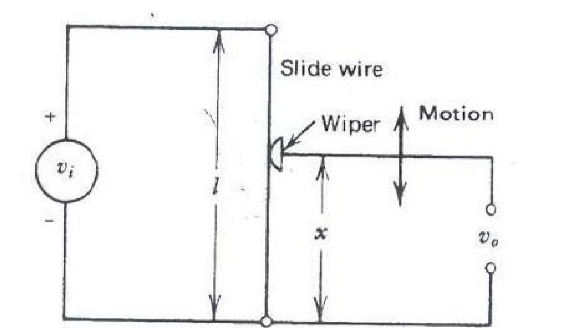
There are two types of potentiometer, linear and rotary potentiometer. The linear potentiometer has a slide or wiper. The rotary potentiometer can be a single turn or multi turn.
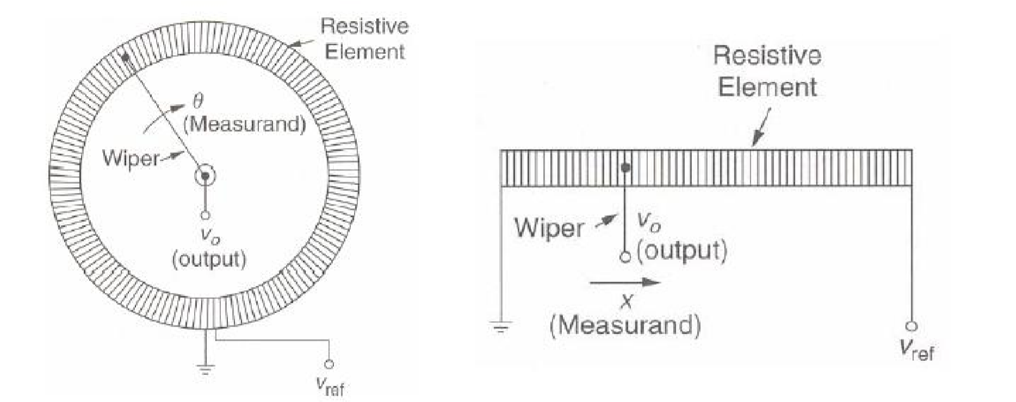

The important parameters while selecting a potentiometer are
- Operating temperature
- Shock and vibration
- Humidity
- Contamination and seals
- life cycle
- dither
Types of Potentiometer:
WireWound type potentiometer
- The resistance range between 10Ω and 10M Ω
- The resistance increase in a stepwise manner.
- It is possible to construct potentiometers with 100 –200 turns per cm length (The resolution range between 0.1 to 0.05 mm).
- Linear potentiometers are available in many lengths up to 1m.
- Helical potentiometers are commercially available with 50 to 60 turns (The angular displacement is between 18000 – 21600 degree)
- Potentiometer life exceed 1 million cycles.
Thin film type potentiometer
- Higher resolution.
- Lower noise.
- Longer life (exceed 10 million cycles)
- Resistance of 50 to 100 Ω/mm can be obtained with conductive plastic film.
- Commercially available resolution is 0.001 mm.
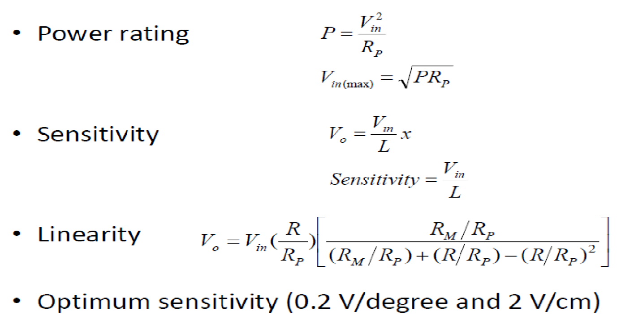
Some of the advantages of the potentiometer are
- Easy to use
- low cost
- High amplitude output
- Proven technology
- Easily available
Some of the disadvantages of the potentiometer are
- Since the wiper is sliding across the resistive element there is a possibility of friction and wear. Hence the number of operating cycles are limited.
- Limited bandwidth
- Inertial loading

Some of the applications of the potentiometer are
- Linear displacement measurement
- Rotary displacement measurement
- Volume control
- Brightness control
- Liquid level measurements using float
STRAIN GAUGE:
Strain gage is one of the most popular types of transducer. It has got a wide range of applications. It can be used for measurement of force, torque, pressure, acceleration and many other parameters. The basic principle of operation of a strain gage is simple: when strain is applied to a thin metallic wire, its dimension changes, thus changing the resistance of the wire. Let us first investigate what are the factors, responsible for the change in resistance.

Gauge Factor
Let us consider a long straight metallic wire of length l circular cross section with diameter d (fig). When this wire is subjected to a force applied at the two ends, a strain will be generated and as a result, the dimension will change (l changing to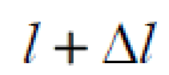, d changing to  and A changing to). For the time being, we are considering that all the changes are in positive direction. Now the resistance of the wire:

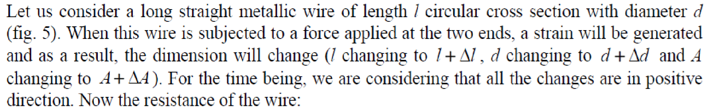
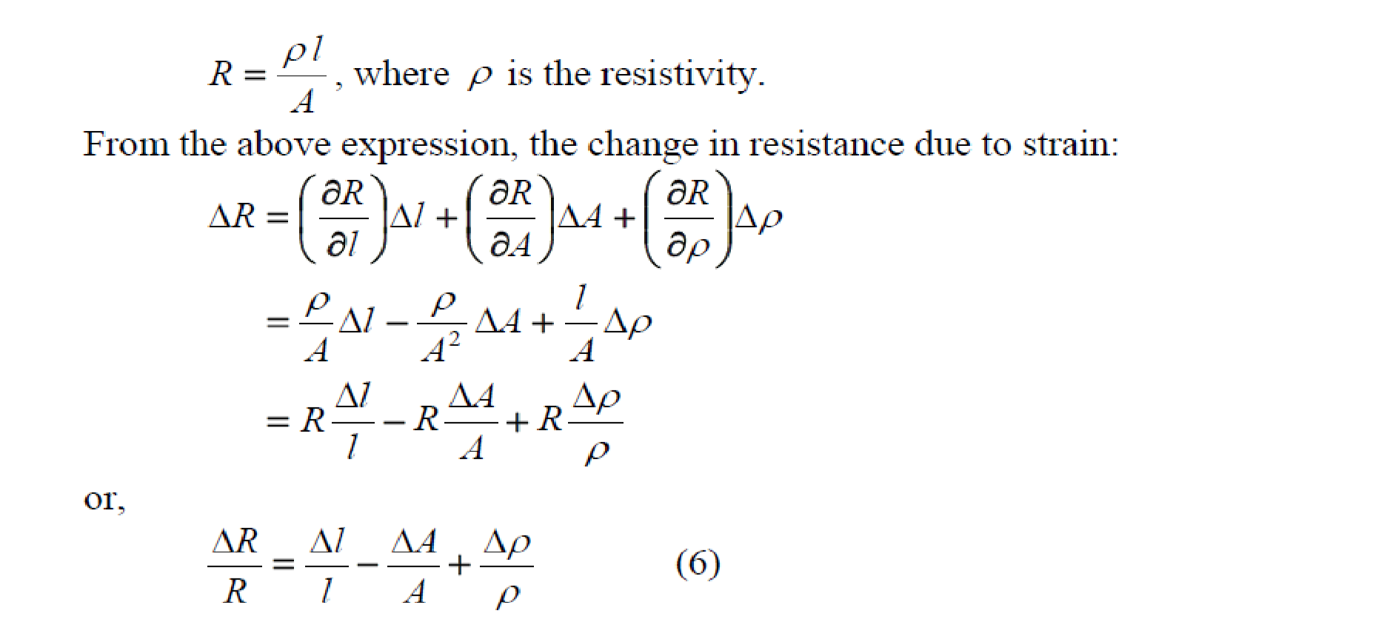
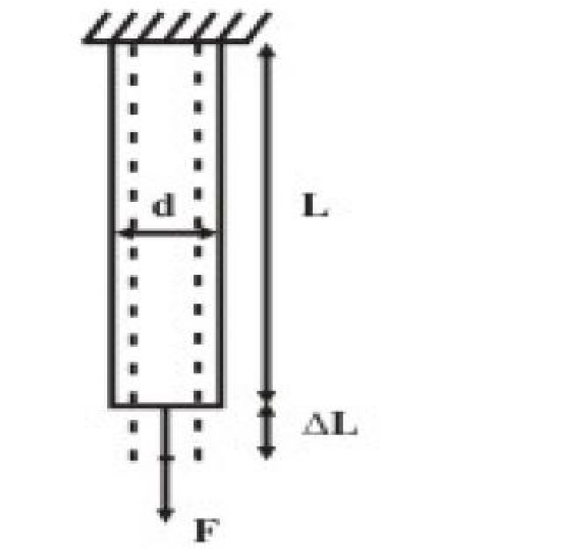

Fig:Change of Resistance with strain

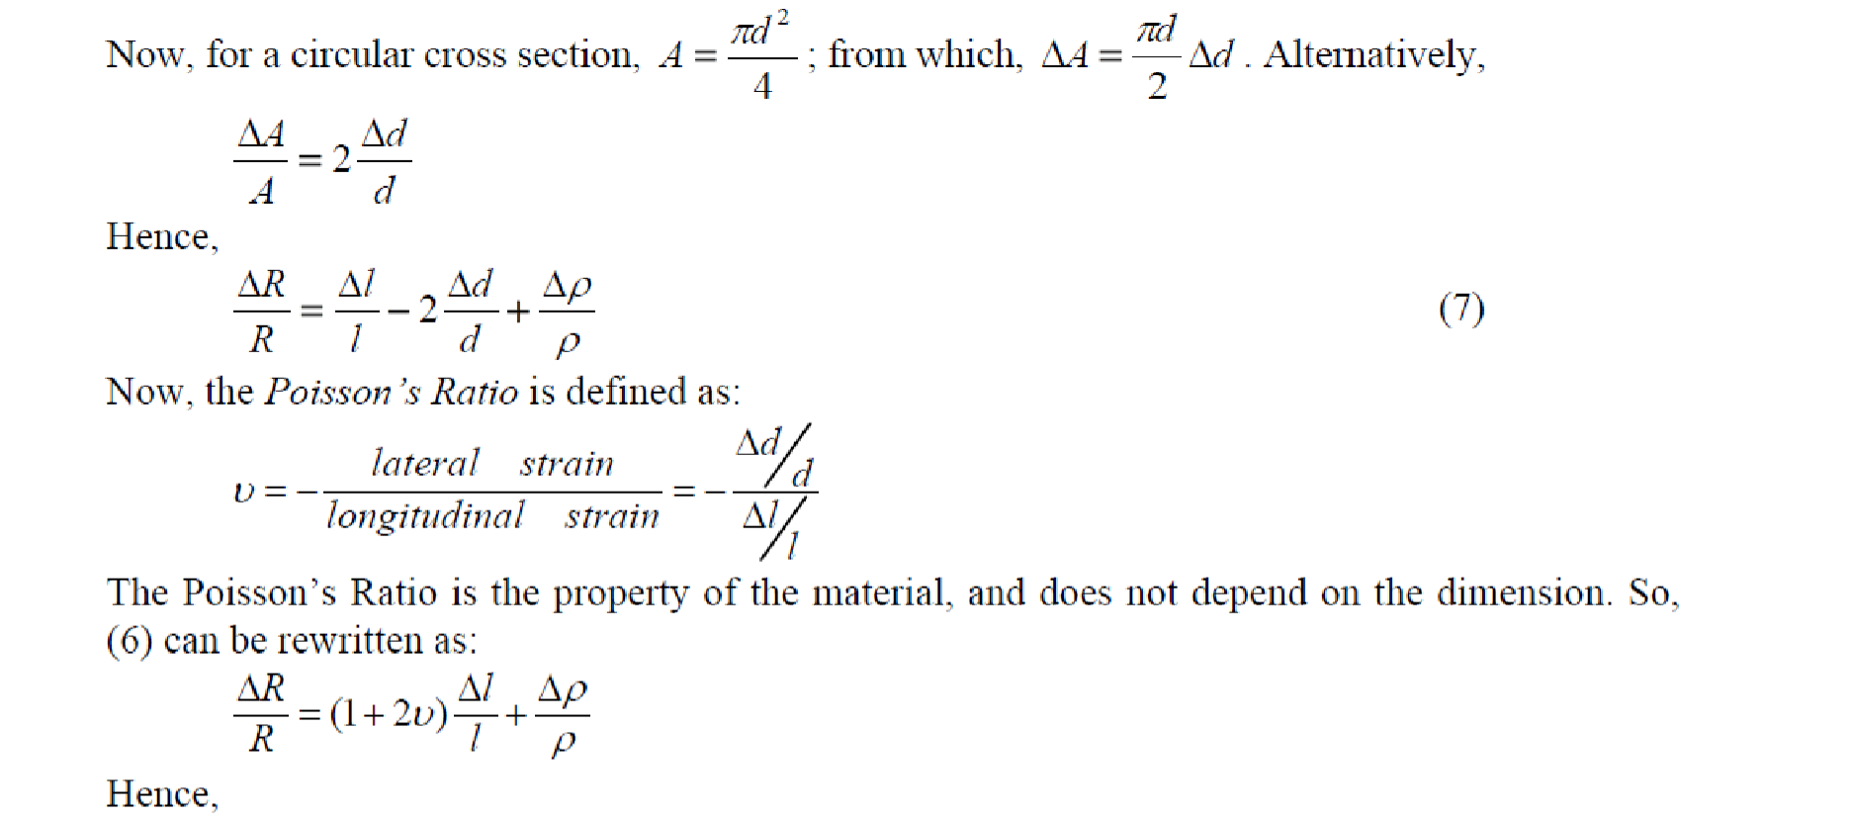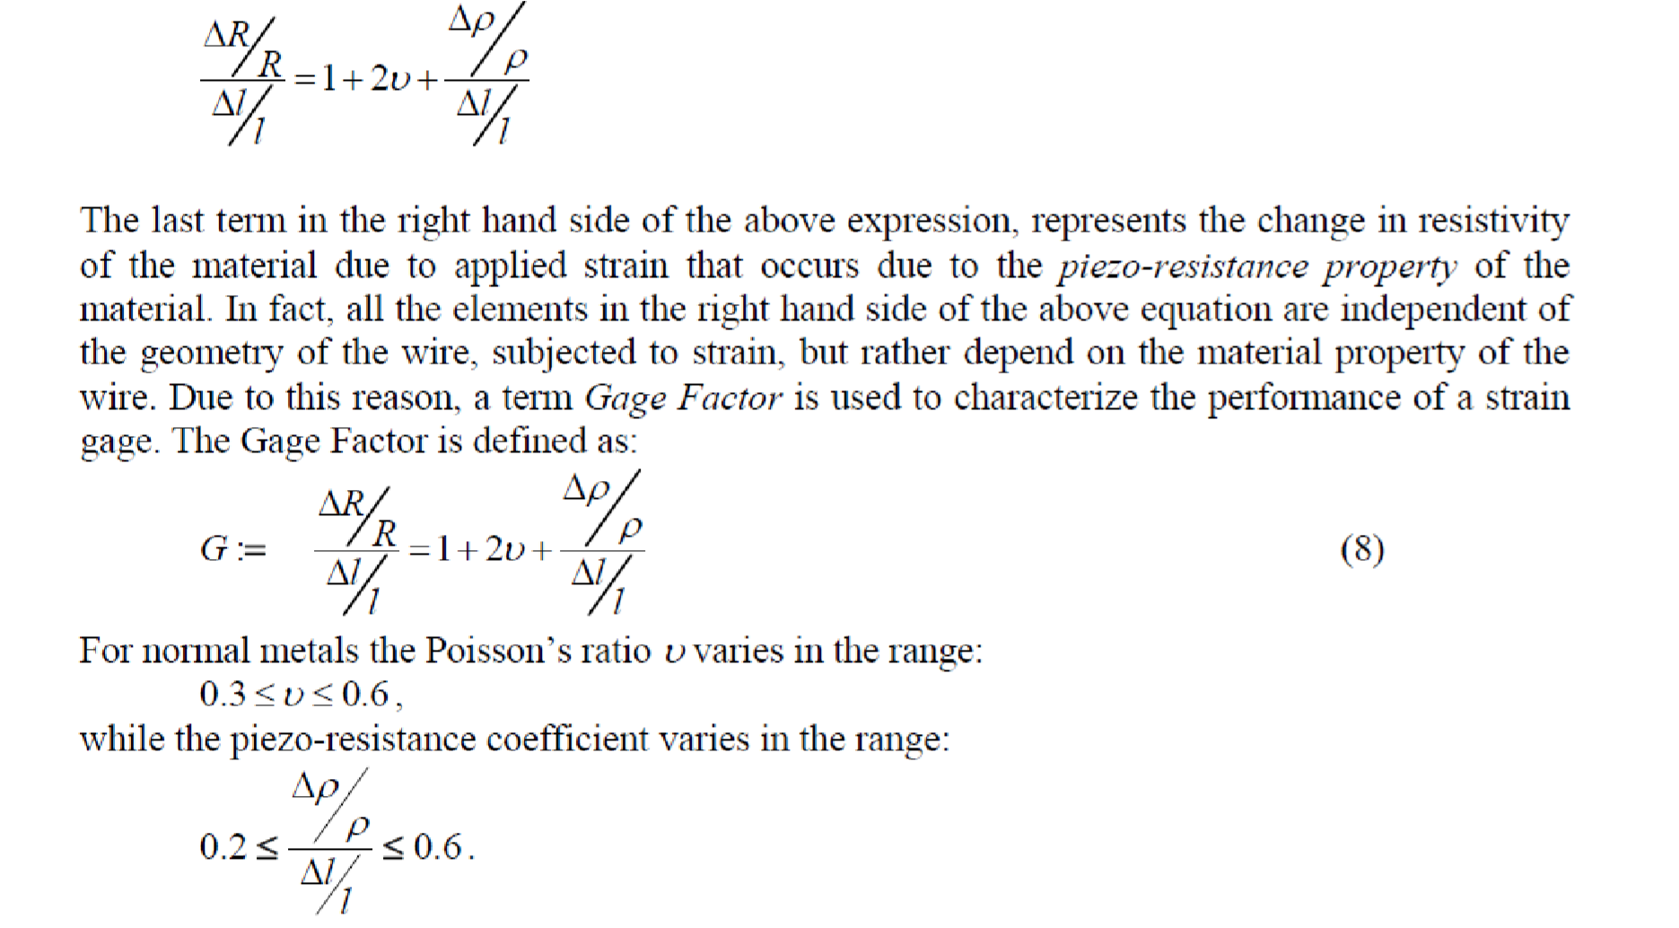
Thus,
the
Gage
Factor
of
metallic
strain
gages
varies
in
the
range
1.
8

to
2.6
.
However,
the
semiconductor type strain gages have a very large Gage Factor, in the range of 100-150. This is attained due to dominant piezo-resistance property of semiconductors. The commercially available strain gages have certain fixed resistance values, such as, 120Ω, 350 Ω, 1000 Ω, etc. The manufacturer also specifies the Gage Factor and the maximum gage current to avoid self-heating (normally in the range 15 mA to 100 mA).
The choice of material for a metallic strain gage should depend on several factors. The material should have low temperature coefficient of resistance. It should also have low coefficient for thermal expansion. Judging from all these factors, only few alloys qualify for a commercial metallic strain gage. They are:
Advance (55% Cu, 45% Ni): Gage Factor between 2.0 to 2.2
Nichrome (80% Ni, 20% Co): Gage Factor between 2.2 to 2.5
Apart from these two, Isoelastic -another trademarked alloy with Gage Factor around 3.5 is also in use. Semiconductor type strain gages, though having large Gage Factor, find limited use, because of their high sensitivity and nonlinear characteristics.
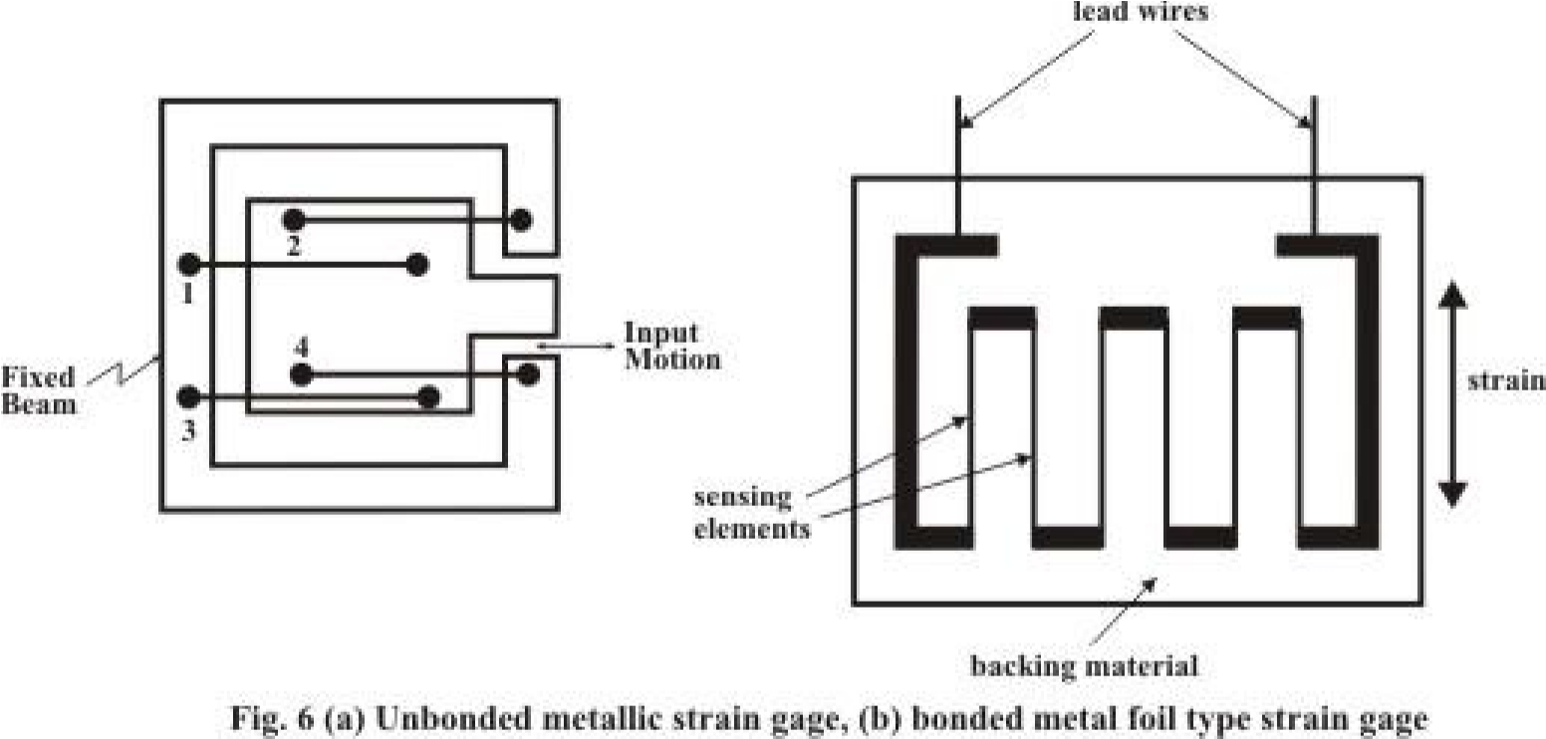

Metallic Strain Gage
Most of the strain gages are metallic type. They can be of two types: unbonded and bonded. The unbonded strain gage is normally used for measuring strain (or displacement) between a fixed and a moving structure by fixing four metallic wires in such a way, so that two are in compression and two are in tension, as shown in fig. 6 (a). On the other hand, in the bonded strain gage, the element is fixed on a backing material, which is permanently fixed over a structure, whose strain has to be measured, with adhesive. Most commonly used bonded strain gages are metal foil type. The construction of such a strain gage is shown in fig. 6(b). The metal foil type strain gage is manufactured by photo-etching technique. Here the thin strips of the foil are the active elements of the strain gage, while the thick ones are for providing electrical connections. Because of large area of the thick portion, their resistance is small and they do not contribute to any change in resistance due to strain, but increase the heat dissipation area. Also it is easier to connect the lead wires with the strain gage. The strain gage in fig. 6(b) can measure strain in one direction only. But if we want to measure the strain in two or more directions at the same point, strain gage rosette, which is manufactured by stacking multiple strain gages in different directions, is used. Fig. 7 shows a three-element strain gage rosette stacked at 45⁰ .
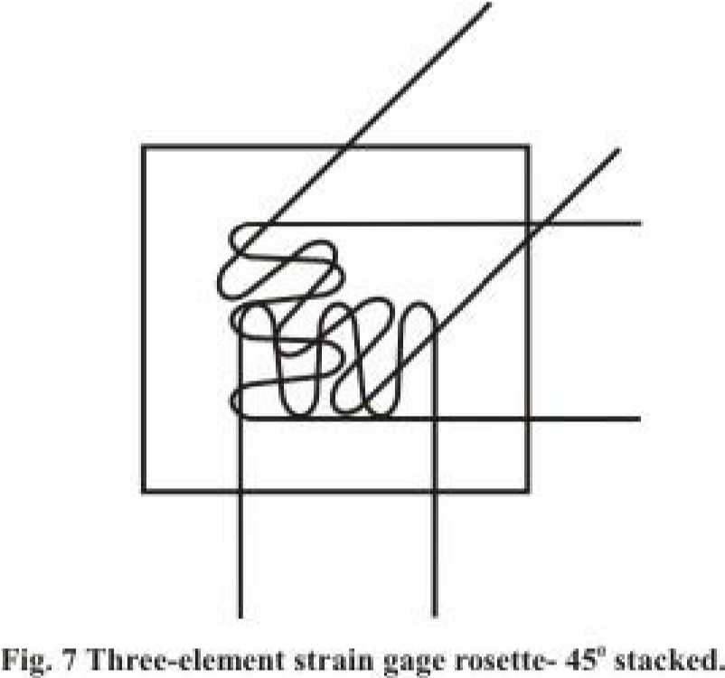
The backing material, over which the strain gage is fabricated and which is fixed with the strain measuring structure has to satisfy several important properties. Firstly, it should have high mechanical strength; it should also have high dielectric strength. But the most important it should have is that it should be non-hygroscopic, otherwise, absorption of moisture will cause bulging and generate local strain. The backing materials normally used are impregnated paper, fibre glass, etc. The bonding material used for fixing the strain gage permanently to the structure should also be nonhygroscopic. Epoxy and Cellulose are the bonding materials normally used.

Semiconductor type Strain Gage

Semiconductor type strain gage is made of a thin wire of silicon, typically 0.005 inch to 0.0005 inch, and length 0.05 inch to 0.5 inch. They can be of two types: p-type and n-type. In the former the resistance increases with positive strain, while, in the later the resistance decreases with temperature. The construction and the typical characteristics of a semiconductor strain gage are shown in fig.8.
MEMS pressure sensors is now a days becoming increasingly popular for measurement of pressure. It is made of a small silicon diagram with four piezo-resistive strain gages mounted on it. It has an inbuilt signal conditioning circuits and delivers measurable output voltage corresponding to the pressure applied. Low weight and small size of the sensor make it suitable for measurement of pressure in specific applications.
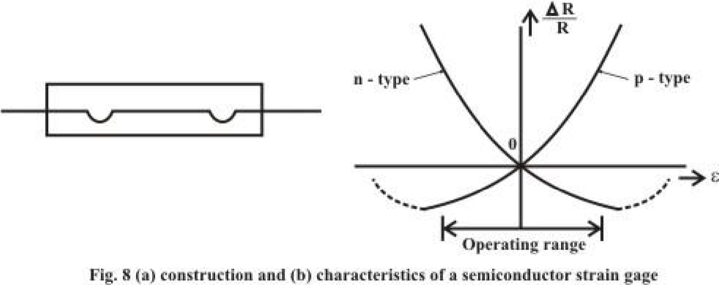

RESISTANCE THERMOMETERS:

It is well known that resistance of metallic conductors increases with temperature, while that of semiconductors generally decreases with temperature. Resistance thermometers employing metallic conductors for temperature measurement are called Resistance Temperature Detector (RTD), and those employing semiconductors are termed as Thermistors. RTDs are more rugged and have more or less linear characteristics over a wide temperature range. On the other hand Thermistors have high temperature sensitivity, but nonlinear characteristics.
Resistance Temperature Detector

Copper, Nickel and Platinum are mostly used as RTD materials. The range of temperature measurement is decided by the region, where the resistance-temperature characteristics are approximately linear. The resistance versus temperature characteristics of these materials is shown in fig.1, with tº as 0ºC. Platinum has a linear range of operation upto 650ºC, while the useful range for Copper and Nickel are 120ºC and 300ºC respectively.

Construction
For industrial use, bare metal wires cannot be used for temperature measurement. They must be protected from mechanical hazards such as material decomposition, tearing and other physical damages. The salient features of construction of an industrial RTD are as follows:
- The resistance wire is often put in a stainless steel well for protection against mechanical hazards. This is also useful from the point of view of maintenance, since a defective sensor can be replaced by a good one while the plant is in operation.
- Heat conducting but electrical insulating materials like mica is placed in between the well and the resistance material.
- The resistance wire should be carefully wound over mica sheet so that no strain is developed due to length expansion of the wire.
Fig. 2 shows the cut away view of an industrial RTD.

Signal conditioning
The resistance variation of the RTD can be measured by a bridge, or directly by volt-ampere method. But the major constraint is the contribution of the lead wires in the overall resistance measured. Since the length of the lead wire may vary, this may give a false reading in the temperature to be measured. There must be some method for compensation so that the effect of lead wires is resistance measured is eliminated. This can be achieved by using either a three wire RTD, or a four wire RTD. Both the schemes of measurement are shown in fig. 3. In three wire method one additional dummy wire taken from the resistance element and connected in a bridge (fig. 3(a)) so that the two lead wires are connected to two adjacent arms of the bridge, thus canceling each other’s effect. In fig. 3(b) the four wire method of measurement is shown. It is similar to a four terminal resistance and two terminals are used for injecting current, while two others are for measuring voltage.

THERMISTORS:
Basically thermistor is a contraction of a word 'thermal resistors', The resistors depending on temperature are thermal resistors. Thus resistance thermometers are also thermistors having positive -temperature coefficients. But generally the resistors having negative temperature coefficients (NTC) are called thermistors. The resistance of a thermistor decreases as temperature increases. The NTC of thermistors can be as large as few percent per degree celcius change in temperature. Thus the thermistors are very sensitive and can detect very small changes in temperature too.

Construction of thermistor:
Thermistors are composed of a sintered mixture of metallic oxides, such as manganese, nickel, cobalt, copper, iron, and uranium. Their resistances at ambient temperature may range from 100 n to 100 ill. Thermistors are available in a wide variety of shapes and sizes as shown in the Fig. Smallest in size are the beads with a diameter of 0.15 mm to 1.25 mm. Beads may be sealed in the tips of solid glass rods to form probes. Disks and washers are made by pressing thermistor materia~ under high pressure into Hat cylindrical shapes. Washers can be placed in series or in parallel to increase power dissipation rating.
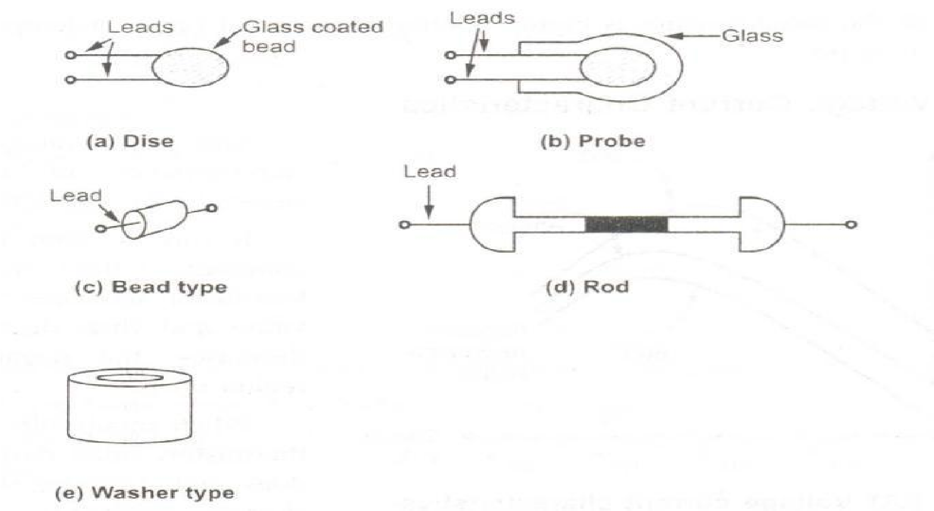
Thermistors are well suited for precision temperature measurement, temperature control, and temperature compensation, because of their. Very large change in resistance with temperature. They are widely used for measurements in the temperature range -1000 C to +2000 C. The measurement of the change in resistance with temperature is carried out with a Wheatstone bridge.

Inductive Transducer

Inductive transducers work on the principle of inductance change due to any appreciable change in the quantity to be measured i.e. measured. For example, LVDT, a kind of inductive transducers, measures displacement in terms of voltage difference between its two secondary voltages. Secondary voltages are nothing but the result of induction due to the flux change in the secondary coil with the displacement of the iron bar. Anyway LVDT is discussed here briefly to explain the principle of inductive transducer. LVDT will be explained in other article in more detail. For the time being let’s focus on basic introduction of inductive transducers. Now first our motive is to find how the inductive transducers can be made to work. This can be done by changing the flux with the help of measured and this changing flux obviously changes the inductance and this inductance change can be calibrated in terms of measured. Hence inductive transducers use one of the following principles for its working.
- Change of self-inductance
- Change of mutual inductance
- Production of eddy current

Change of Self Inductance of Inductive Transducer
We know very well that self-inductance of a coil is given by 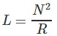Where, N = number of turns. R = reluctance of the magnetic circuit. Also we know that reluctance R is given by
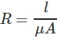
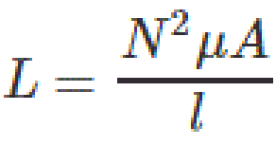

Where μ = effective permeability of the medium in and around the coil.
Where, G = A/l and called geometric form factor. A = area of cross-section of coil. l = length of the coil. So, we can vary self-inductance by
- Change in number of turns, N,
- Changing geometric configuration, G,
- Changing permeability
For the sake of understanding we can say that if the displacement is to be measured by the inductive transducers, it should change any of the above parameter for causing in the change in self-inductance.
Change of Mutual Inductance of Inductive Transducer
Here transducers, which work on change of mutual inductance principle, use multiple coils. We use here two coils for the sake of understanding. Both coils have their self-inductance as well. So let’s denote their self-inductance by L₁ and L₂. Mutual inductance between these two coils is given by
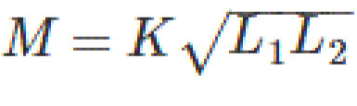
Thus mutual inductance can be changed by varying self-inductance or by varying coefficient of coupling, K. The methods of changing self-inductance we already discussed. Now coefficient of coupling depends on the distance and orientation between two coils. Thus for the measurement of displacement we can fix one coil and make other movable which moves with the source whose displacement is to be measured. With the change in distance in displacement coefficient of coupling changes and it causes the change in mutual inductance. This change in mutual inductance can be calibrated with the displacement and measurement can be done.
Production of Eddy Current of Inductive Transducer
We know that when a conducting plate is placed near a coil carrying alternating current, a circulating current is induced in the plate called “EDDY CURRENT”. This principle is used in such type of inductive transducers. Actually what happens? When a coil is placed near to coil carrying alternating current, a circulating current is induced in it which in turn produces its own flux which try to reduce the flux of the coil carrying the current and hence inductance of the coil changes. Nearer the plate is to the coil, higher will be eddy current and higher is the reduction in inductance and vice versa. Thus inductance of coil varied with the variation of distance between coil and plate. Thus the movement of the plate can be calibrated in terms of inductance change to measure the quantity like displacement.
Real Life Application of Inductive Transducer
Inductive transducers find application in proximity sensors which are used for position measurement, dynamic motion measurement, touch pads etc. Particularly inductive transducer is used for the detection of type of metal, finding missing parts or counting the number of objects.

LINEAR VARIABLE DIFFERENTIAL TRANSFORMER (LVDT):
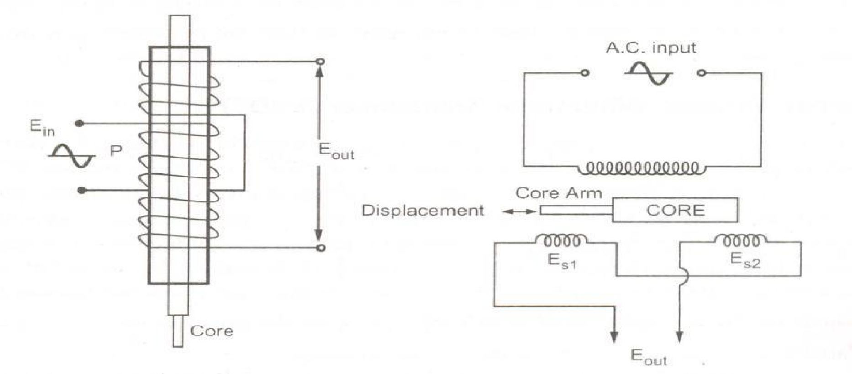
When an externally applied force moves the core to the left-hand position, more magnetic flux links the left-hand coil than the righthand coil. The emf induced in the left-hand coil, E_{S1}], is therefore larger than the induced emf of the right-hand coil, E_{S2}'. The magnitude of the output voltage is then equal to the difference between the two secondary voltages and it is in phase with the voltage of the left-hand coil.

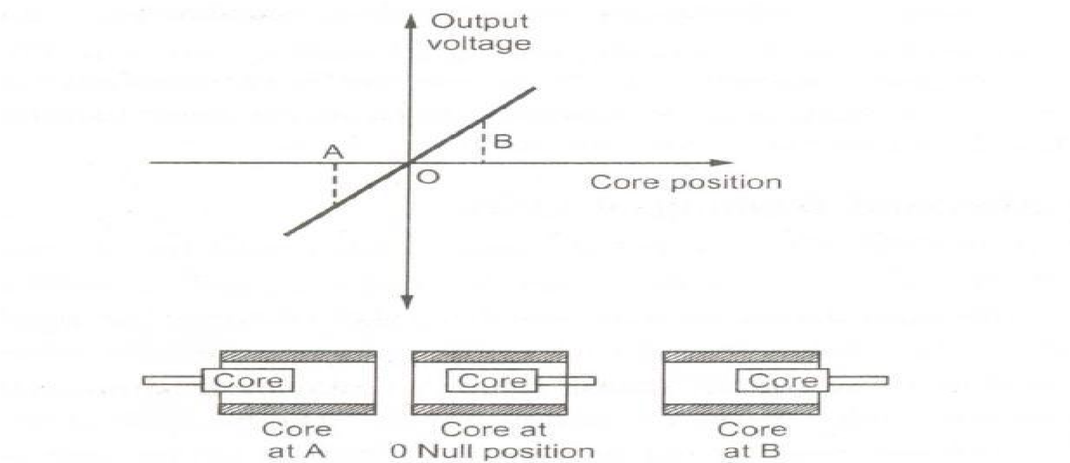

Main Features of Construction are as,
- The transformer consists of a primary winding P and two secondary winding S1 and S2 wound on a cylindrical former(which is hollow in nature and will contain core).
- Both the secondary windings have equal number of turns and are identically placed on the either side of primary winding
- The primary winding is connected to an AC source which produces a flux in the air gap and voltages are induced in secondary windings.
- A movable soft iron core is placed inside the former and displacement to be measured is connected to the iron core.
- The iron core is generally of high permeability which helps in reducing harmonics and high sensitivity of LVDT.
- The LVDT is placed inside a stainless steel housing because it will provide electrostatic and electromagnetic shielding.
- The both the secondary windings are connected in such a way that resulted output is the difference of the voltages of two windings.

Principle of Operation and Working
As the primary is connected to an AC source so alternating current and voltages are produced in the secondary of the LVDT. The output in secondary S₁ is e₁ and in the secondary S₂ is e₂. So the differential output is, e_{out} = e₁ - e₂ This equation explains the principle of Operation of LVDT.
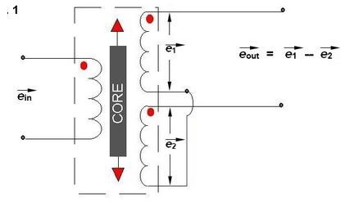
Now three cases arise according to the locations of core which explains the working of LVDT are discussed below as,
- CASE I When the core is at null position (for no displacement) When the core is at null position then the flux linking with both the secondary windings is equal so the induced emf is equal in both the windings. So for no displacement the value of output e_{out} is zero as e₁ and e₂ both are equal. So it shows that no displacement took place.
- CASE II When the core is moved to upward of null position (For displacement to the upward of reference point) In the this case the flux linking with secondary winding S₁ is more as compared to flux linking with S₂. Due to this e₁ will be more as that of e₂. Due to this output voltage e_{out} is positive.
- CASE III When the core is moved to downward of Null position (for displacement to the downward of reference point) In this case magnitude of e₂ will be more as that of e₁. Due to this output e_{out} will be negative and shows the output to downward of reference point.

Output V_{S} Core Displacement A linear curve shows that output voltage varies linearly with displacement of core.
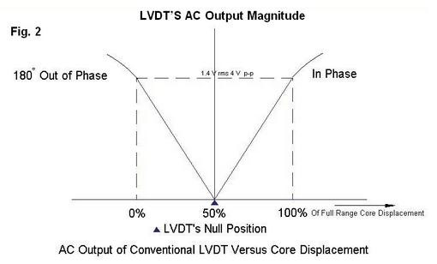
Some important points about magnitude and sign of voltage induced in LVDT
- The amount of change in voltage either negative or positive is proportional to the amount of movement of core and indicates amount of linear motion.
- By noting the output voltage increasing or decreasing the direction of motion can be determined.
- The output voltage of an LVDT is linear function of core displacement.

Advantages of LVDT
- High Range - The LVDTs have a very high range for measurement of displacement. They can used for measurement of displacements ranging from 1.25mm to 250mm
- No Frictional Losses - As the core moves inside a hollow former so there is no loss of displacement input as frictional loss so it makes LVDT as very accurate device.
- High Input and High Sensitivity - The output of LVDT is so high that it doesn’t need any amplification. The transducer possesses a high sensitivity which is typically about 40V/mm.
- Low Hysteresis - LVDTs show a low hysteresis and hence repeatability is excellent under all conditions
- Low Power Consumption - The power is about 1W which is very as compared to other transducers.
- Direct Conversion to Electrical Signals - They convert the linear displacement to electrical voltage which are easy to process

Disadvantages of LVDT
- LVDT is sensitive to stray magnetic fields so they always require a setup to protect them from stray magnetic fields.
- They are affected by vibrations and temperature.
It is concluded that they are advantageous as compared than any other inductive transducers.
Applications of LVDT
- They are used in applications where displacements ranging from fraction of mm to few cm are to be measured. The LVDT acting as a primary Transducer converts the displacement to electrical signal directly.
- They can also acts as the secondary transducers. E.g. the Bourbon tube which acts as a primary transducer and covert pressure into linear displacement. Then LVDT coverts this displacement into electrical signal which after calibration gives the ideas of the pressure of fluid.

CAPACITIVE TRANSDUCERS:
A capacitor consists of two conductors (plates) that are electrically isolated from one another by a nonconductor (dielectric). When the two conductors are at different potentials (voltages), the system is capable of storing an electric charge. The storage capability of a capacitor is measured in farads.The principle of operation of capacitive transducers is based upon the equation for capacitance of a parallel plate capacitor as shown in Fig.
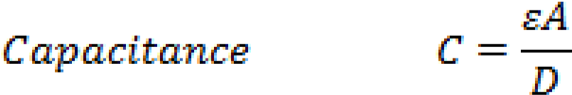
Where, A = Overlapping area of plates; m²,
d = Distance between two plates; m,
ϵ= Permittivity (dielectric constant); F/m.
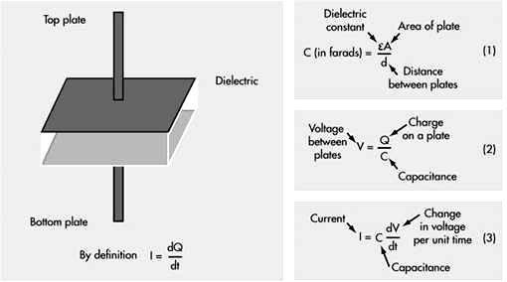
Fig. Parallel plate capacitor
The capacitance is measured with a bridge circuits. The output impedance Z of a capacitive transducer is:
Z = 1/2πfC
Where: Z = Impedance
f = frequency, 50 Hz.
C = capacitance
In general, the output impedance of a capacitive transducer is high. This fact calls for a careful design of the output circuit. The capacitive transducer work on the principle of change in capacitance of the capacitor. This change in capacitance could be caused by change in overlapping area A, change in the distance d between the plates and change in dielectric constant ϵ.
In most of the cases the above changes are caused by the physical variables, such as, displacement, force or pressure. Variation in capacitance is also there when the dielectric medium between the plates changes, as in the case of measurement of liquid or gas levels. Therefore, the capacitive transducers are commonly used for measurement of linear displacement, by employing the following effects as shown in Fig a and fig b.
- Change in capacitance due to change in overlapping area of plates.
- Change in capacitance due to change in distance between the two plates.
- Change in capacitance due to change in dielectric between the two plates
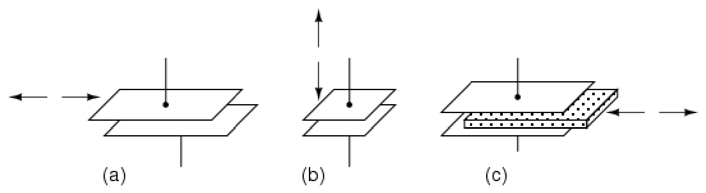
Fig.a Variable capacitive transducer varies; (a) area of overlap, (b) distance between plates, (c) amount of dielectric between plates

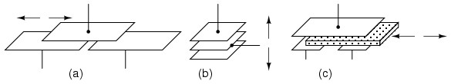
Fig.b Differential capacitive transducer varies capacitance ratio by changing: (a) area of overlap, (b) distance between plates, (c) dielectric between plates
As may be seen in Fig b, all of the differential devices have three wire connections rather than two: one wire for each of the end plates and one for the common plate. As the capacitance between one of the endplates and the common plate changes, the capacitance between the other end plate and the common plate also changes in the opposite direction.

a) Transducers Using Change in Area of Plates
Examining the equation for capacitance, it is found that the capacitance is directly proportional to the area, A of the plates. Thus, the capacitance changes linearly with change in area of plates. Hence this type of capacitive transducer is useful for measurement of moderate to large displacements say from 1 mm to several cm. The area changes linearly with displacement and also the capacitance.
For a parallel plate capacitor, the capacitance is:
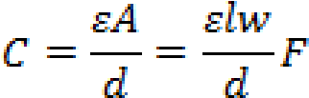
Where, l = length of overlapping part of plates; m, and w = width of overlapping part of plates; m.
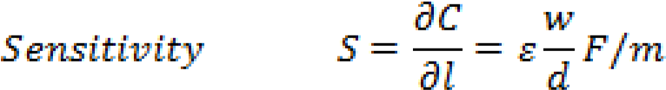
The sensitivity is constant and therefore there is linear relationship between capacitance and displacement.
This type of a capacitive transducer is suitable for measurement of linear displacement ranging from 1 to 10 cm. The accuracy is as high as 0.005%.

b) Transducers Using Change in Distance between Plates
Fig. 17.2(b) shows the basic form of a capacitive transducer employing change in distance between the two plates to cause the change in capacitance. One plate is fixed and the displacement to be measured is applied to the other plate which is movable. Since, the capacitance, C, varies inversely as the distance d, between the plates the response of this transducer is not linear. Thus this transducer is useful only for measurement of extremely small displacements.
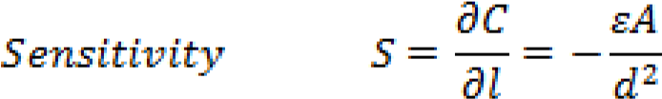
Thus the sensitivity of this type of transducer is not constant but varies over the range of the transducer. The relationship between variations of capacitance with variation of distance between plates is hyperbolic and is only approximately linear over a small range of displacement. The linearity can be closely approximated by use of a piece of dielectric material like mica having a high dielectric constant, such as, a thin piece of mica.

Transducers Using Change in dielectric constant between Plates
If the area (A) of and the distance (d) between the plates of a capacitor remain constant, capacitance will vary only as a function of the dielectric constant () of the substance filling the gap between the plates. If the space between the plates of a capacitor is filled with an insulator, the capacitance of the capacitor will change compared to the situation in which there is vacuum between the plates. The change in the capacitance is caused by a change in the electric field between the plates.
The value of dielectric constant is initially set by design in the choice of dielectric material used to make the capacitor. Many factors will cause the  to change, and this change in will vary for different materials. The major factors that will cause a change in  are moisture, voltage, frequency, and temperature. The dielectric constant of a process material can change due to variations in temperature, moisture, humidity, material bulk density, and particle size etc. The  in the basic formula is the effective dielectric constant of the total space between the electrodes. This space may consist of the dielectric material, air, and even moisture, if present. The figure shows that how in a capacitor the position of the dielectric is varied to vary the capacitance. Physical variables, such as, displacement, force or pressure can cause the movement of dielectric material in the capacitor plates, resulting in changes in the effective dielectric constant, which in turn will change the capacitance.
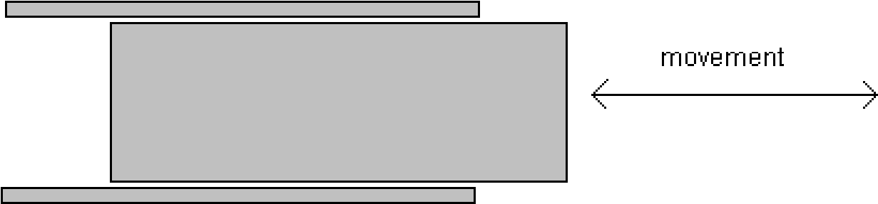
Fig. Change in capacitance due to movement of dielectric between plates
The major advantages of capacitive transducers are that they require extremely small forces to operate them and hence are very useful for use in small systems. They are extremely sensitive and require small power to operate them. Owing to their good frequency response they are very useful for dynamic studies.
The disadvantages of capacitive transducers include their non-linear behaviour on account of edge effects and the effects of stray capacitances especially when the transducers have a low value of capacitance. Therefore guard rings must be used to eliminate this effect. The metallic parts of the capacitive transducers must be insulated from each other. In order to reduce the effects of stray capacitances, the frames must be earthed.
Capacitive transducers can be used for measurement of both linear and angular displacements. The capacitive transducers are highly sensitive and can be used for measurement of extremely small displacements down to the order of molecular dimensions, i.e., 0.1x10⁻⁶ mm. On the other hand, they can be used for measurement of large displacements up to about 30 m as in aeroplane altimeters. The change in area method is used for measurement of displacements ranging from 10 to 100 mm. Capacitive transducers can be used for the measurement of force and pressure. The force and pressure to be measured are first converted to displacement which causes a change of capacitance. Capacitive transducers can also be used directly as pressure transducers in all those cases where the dielectric constant of a medium changes with pressure. They can be used for measurement of humidity in gases and moisture content in soil / food products etc.

THERMOCOUPLES:
Basically thermocouple consists of two different metals which are placed in contact with each other as shown in the diagram.
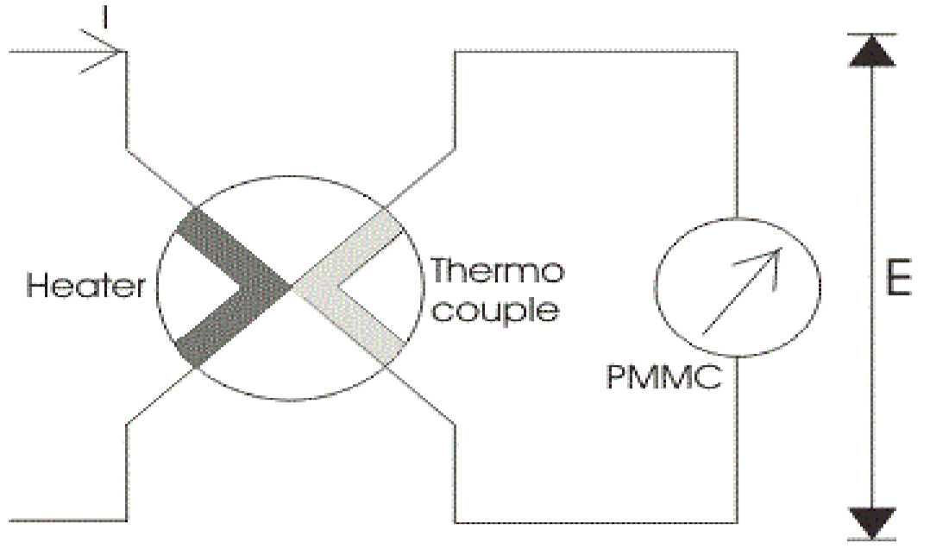
First part is called the heater element because when the current will flow through this, a heat is produced and thus the temperature will increased at the junction. At this junction an emf is produced which is approximately proportional to the temperature difference of hot and cold junctions.
The emf produced is a DC voltage which is directly proportional to root mean square value of electric current. A permanent magnet moving coil instrument is connected with the second part to read the current passing through the heater. One question must be arise in our mind that why we have used only a permanent magnet coil instrument? Answer to this question is very easy it is because PMMC instrument has greater accuracy and sensitivity towards the measurement of DC value. The thermocouple type instruments employ thermocouple in their construction. Thermocouple type instruments can be used for both ac and DC applications. Also thermocouple type of instruments has greater accuracy in measuring the current and voltages at very high frequency accurately.
Now we will look how the temperature difference is mathematically related to generated emf at the junction in thermocouple type of instruments. Let us consider temperature of the heater element be T_{a} and the temperature of cold metal be T_{b}. Now it is found that the generated emf at the junction is related to temperature difference as:
Where a and b are constant whose values completely depends upon the type of metal we are using. The above equation represents parabolic function. The approximated value of a is from 40 to 50 micro volts or more per degree Celsius rise in temperature and value of constant b is very small and can be neglected if the air gap field of permanent magnet moving coil is uniform. Thus we can approximate the above temperature emf relation as e = a(T_{a} - T_{b}), here we have assume b = 0. The current flowing through the heater coil produces heat as I²R where I is the root mean square value of current, if we assume the temperature of cold junction is maintained at room temperature then the rise in the temperature of the hot junction will be equal to temperature rise at the junction. Hence we can write (Ta-Tb)is directly proportional to I²R or we can say (T_{a} - T_{b}) = kI²R. Now the deflection angle x in moving coil instrument is equal to; x = Ke or x = K[a(T_{a} - T_{b})] hence we can write k.K.a.I²R = k₁I², where k₁ is some constant. From the above equation we see that the instrument shows the square law response.
Construction of Thermocouple Type Instrument
Now let us look at the construction of Thermocouple type Instruments. Broadly speaking the thermocouple type of instruments consists of two major parts which are written below: (a) Thermo electric elements: The thermocouple type of instruments consists of thermo electric elements which can be of four types:
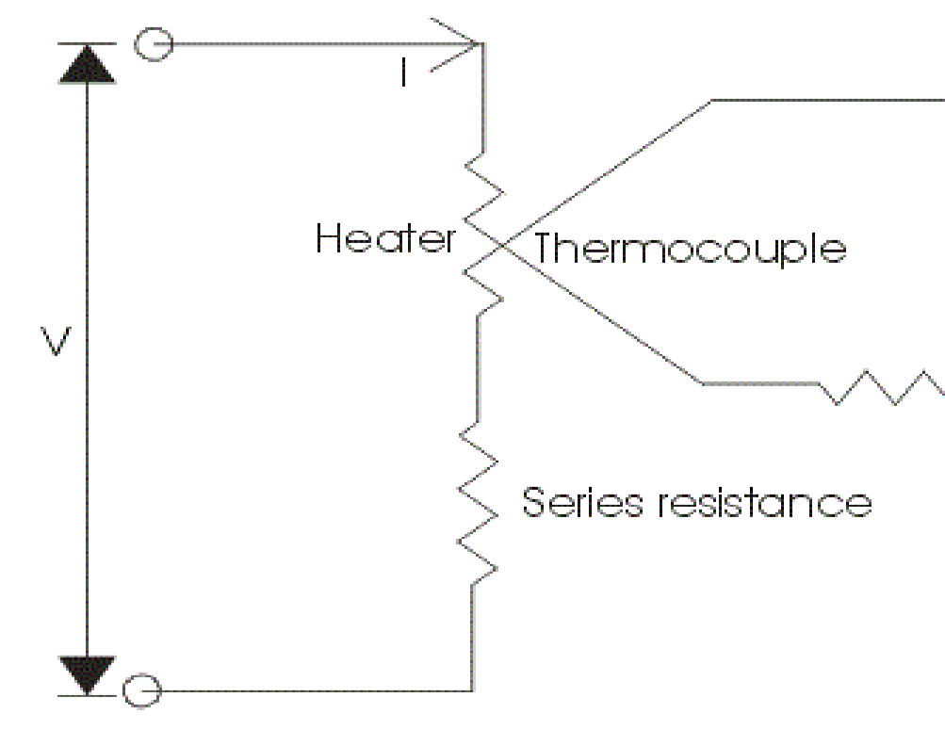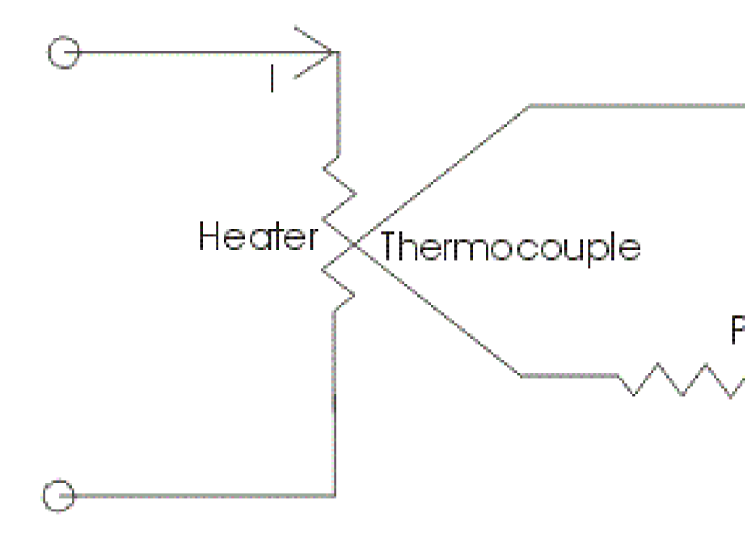
1.

Contact Type:

It has a separate heater which is shown in the diagram.

The action of thermocouple type instruments can be explained briefly as,
- At the junction the electrical energy is being converted to thermal energy in the heater element. A portion of the heat is transferred to the hot junction while most of the heat energy is dissipated away.
- The heat energy which is transferred to hot junction is again converted to electrical due to Seebeck effect. Only a portion of electrical energy is converted into mechanical energy which is used to produce a deflecting torque. The overall efficiency of the system is low thus the instrument consumes high power. So there is a requirement of highly accurate and sensitive DC instrument.
- Non-Contact Type: In non-contact type there is insulation between the heating element and the thermocouple i.e. there no direct contact between two. Due to this these instruments are not much sensitive as compared contact type.
- Vacuum Thermo-elements: These types of instruments are mostly employed for the measurement of electric current at very high frequency of the order of 100 Megahertz or more as these instruments retain their accuracy even at such high frequency.
- Bridge Type: These bridges are manufactured on the ac ratings usually from 100 mili amperes to 1 amperes. In this two thermocouple are connected to form a bridge which is shown in the figure given below:
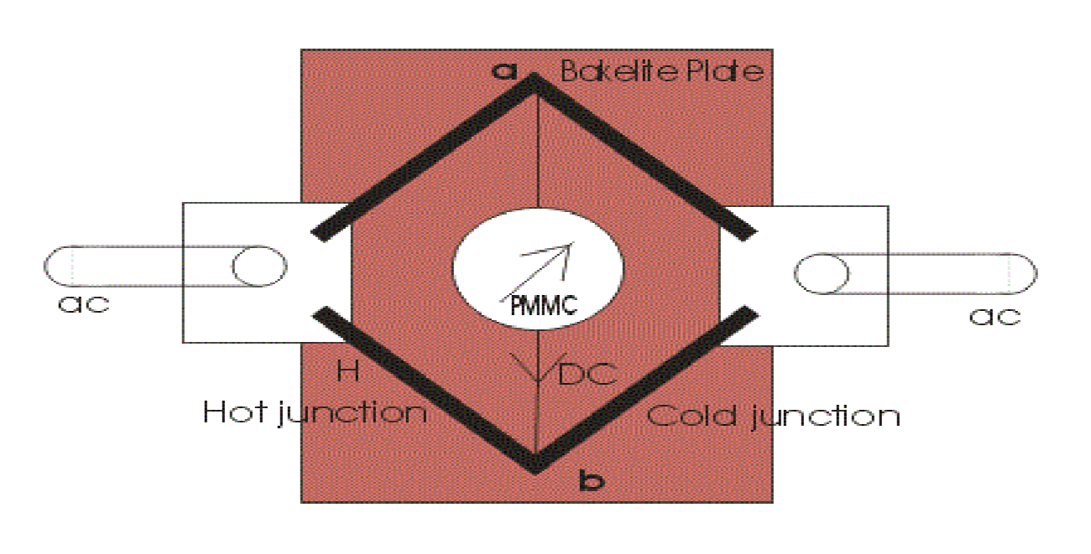
- There is no requirement of heating element, the electric current which directly passing through the thermocouple raises the temperature which is directly proportional to the I²R losses. The bridge works on balanced condition at which there will be no current in the arm ab. The connected meter will show the potential difference between the junctions a and b.

Advantages of Thermocouple Type Instruments
Following are advantages of Thermocouple type of instruments,
- The thermocouple type of instruments accurately indicates the root mean square value of current and voltages irrespective of the waveform. There is a wide varieties of range of thermocouple instruments are available in the market.
- Thermocouple type of instruments give very accurate reading even at high frequency, thus these types of instruments are completely free from frequency errors.
- The measurement of quantity under these instruments is not affected by stray magnetic fields.
- These instruments are known for their high sensitivity.
- Usually for measuring the low value of current bridge type of arrangement is used i.e. ranging from 0.5 Amperes to 20 Amperes while for measuring the higher value of current heater element is required to retain accuracy.

Disadvantages of Thermocouple Type Instruments
Instead of many advantages these type of instruments possess one disadvantage, The over load capacity of thermocouple type of instrument is small, even fuse is not able to the heater wire because heater wire may burn out before the fuse blows out.

Piezoelectric transducer:
When some pressure or stress is applied to the surface of the piezo-electric crystal, the dimensions of the crystal change and an electric charge voltage will be developed across certain surfaces of the piezo-electric crystal. Conversely, when an electric charge voltage or potential is applied to the crystal, the crystal get deformed and hence, the dimensions of it will change. This effect is
referred as piezoelectric effect.
All the piezo-electric transducers work on the principle of piezo-electric effect. The piezoelectric materials or the materials used in the construction of piezoelectric crystal are quartz, rochelle salt, dipotassium titrate, lithium sulphate, barium titanate, potassium dihydrogen phosphate, ammonium dihydrogen phosphate etc. A piezoelectric crystal subjected to force is illustrated in figure.

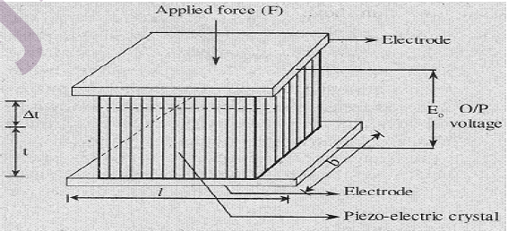

Piezoelectric pressure transducers depend on the principle of ‘piezoelectric effect’ i.e., when some pressure or stress is applied to the surface of the piezoelectric crystal, an electric charge voltage will be developed by the crystal. The materials used in the construction of piezoelectric crystals are quartz, Rochelle salt, dipotassium titrate, lithium sulphate, barium titanate etc.
A piezoelectric pressure transducer is formed by connecting a diaphragm to the piezoelectric crystals and this assembly is shown below.
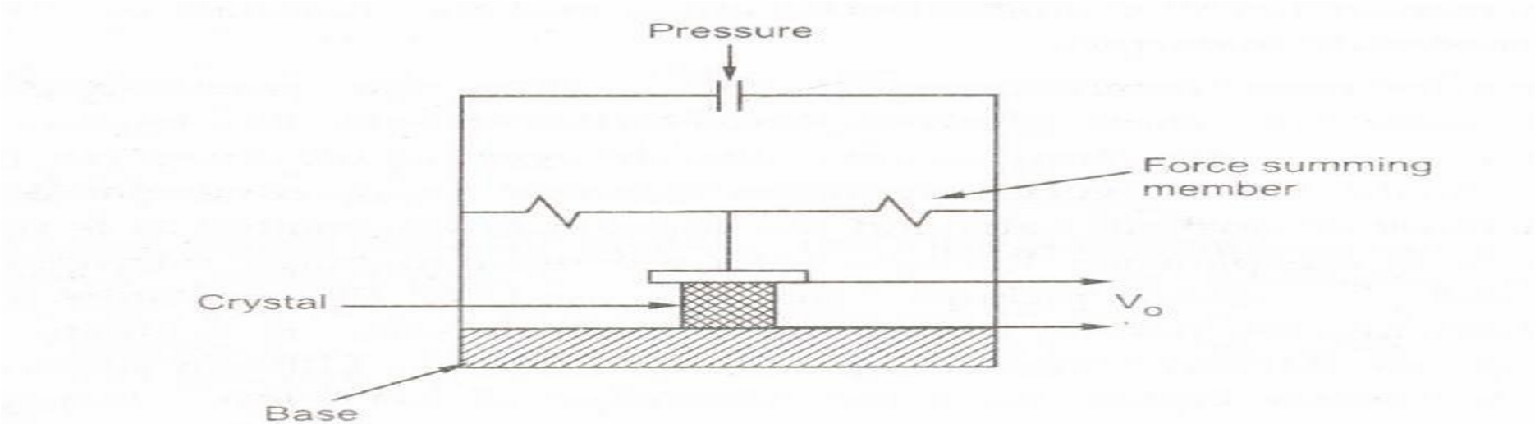
The pressure which is to be measured is applied to corrugated metal diaphragm. The diaphragm deflects depending on the applied pressure, and this deflection signal is transmitted to the crystal through the mechanical link. In other words, the pressure is applied to the crystal through the diaphragm and the link. When the crystal senses the pressure it will generate some voltage corresponding to the applied pressure, and is measured in the output voltage measuring device which is calibrated in terms of applied pressure.
Applications
(a) These can be used in the process which requires measurement of high pressure.
(b) Can be applied in those systems which requires measured variable in electrical form.
Merits
1. Provides electrical output.
2. This transducer does not require any external power supply.
3. Size in small.
4. Rugged construction.
Demerits
1. It cannot be used for static pressure measurements.
2. The response will get affected by the variations in temperature.
3. In some cases it requires signal conditioning circuitry which is complex.
4. Cost is high.

DISPLACEMENT & PROXIMITY MEASUREMENT:
Broadly speaking, displacement measurement can be of two types: contact and noncontact types. Besides the measurement principles can be classified into two categories: electrical sensing and optical sensing. In electrical sensing, passive electrical sensors are used variation of either inductance or capacitance with displacement is measured. On the other hand the optical method mainly works on the principle of intensity variation of light with distance. Interferometric technique is also used for measurement of very small displacement in order of nanometers. But this technique is more suitable for laboratory purpose, not very useful for industrial applications.
Potentiometer
Potentiometers are simplest type of displacement sensors. They can be used for linear as well as angular displacement measurement, as shown in below Fig. They are the resistive type of transducers and the output voltage is proportional to the displacement and is given by:

where x_{i} is the input displacement, x_{t} is the total displacement and E is the supply voltage.
The major problem with potentiometers is the contact problem resulting out of wear and tear between the moving and the fixed parts. As a result, though simple, application of potentiometers is limited.
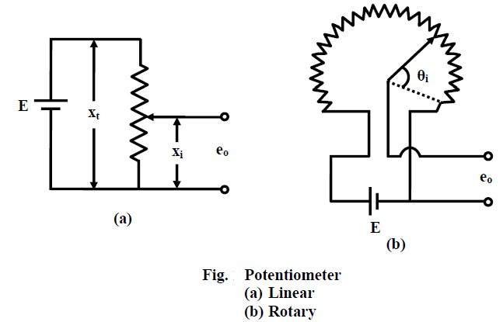
Linear Variable Differential transformer (LVDT)
LVDT works on the principle of variation of mutual inductance. It is one of the most popular types of displacement sensor. It has good linearity over a wide range of displacement. Moreover the mass of the moving body is small, and the moving body does not make any contact with the static part, thus minimizing the frictional resistance. Commercial LVDTs are available with full scale displacement range of 0.25mm to ±±25mm. Due to the low inertia of the core, the LVDT has a good dynamic characteristics and can be used for time varying displacement measurement range.
The construction and principle of operation of LVDT can be explained with Fig. 2(a) and Fig. 2(b). It works on the principle of variation of the mutual inductance between two coils with displacement. It consists of a primary winding and two identical secondary windings of a transformer, wound over a tubular former, and a ferromagnetic core of annealed nickel-iron alloy moves through the former. The two secondary windings are connected in series opposition, so that the net output voltage is the difference between the two. The primary winding is excited by 1-10V r.m.s. A.C. voltage source, the frequency of excitation may be anywhere in the range of 50 Hz to 50 KHz. The output voltage is zero when the core is at central position (voltage induced in both the secondary windings are same, so the difference is zero), but increasing as the core moves away from the central position, in either direction. Thus, from the measurement of the output voltage only, one cannot predict, the direction of the core movement. A phase sensitive detector (PSD) is a useful circuit to make the measurement direction sensitive. It is connected at the output of the LVDT and compares the phase of the secondary output with the primary signal to judge the direction of movement. The output of the phase sensitive detector after low pass filtering becomes a d.c voltage for a steady deflection. The output voltage after PSD vs. displacement characteristics is shown in Fig. 2(c).

Inductive type Sensors
LVDT works on the principle of variation of mutual inductance. There are inductive sensors for measurement of displacement those are based on the principle of variation of self inductance. These sensors can be used for proximity detection also. Such a typical scheme is shown in Fig. 3. In this case the inductance of a coil changes as a ferromagnetic object moves close to the magnetic former, thus change the reluctance of the magnetic path. The measuring circuit is usually an a.c. bridge.

Rotary Variable Differential Transformer (RVDT)
Its construction is similar to that of LVDT, except the core is designed in such a way that when it rotates the mutual inductance between the primary and each of the secondary coils changes linearly with the angular displacement. Schematic diagram of a typical RVDT is shown in Fig. 4.

Capacitance Sensors
The capacitance type sensor is a versatile one; it is available in different size and shape. It can also measure very small displacement in micrometer range. Often the whole sensor is fabricated in a silicon base and is integrated with the processing circuit to form a small chip. The basic principle of a capacitance sensor is well known. But to understand the various modes of operation, consider the capacitance formed by two parallel plates separated by a dielectric. The capacitance between the plates is given by:
A capacitance sensor can be formed by either varying (i) the separation (d), or, (ii) the area (A), or (iii) the permittivity (rε). A displacement type sensor is normally based on the first two (variable distance and variable area) principles, while the variable permittivity principle is used for measurement of humidity, level, etc. Fig.6 Shows the basic constructions of variable gap and variable area types of capacitance sensors mentioned above. Fig. 6(a) shows a variable distance type sensor, where the gap between the fixed and moving plates changes. On the other hand, the area of overlap between the fixed plate and moving plate changes in Fig. 6(b), maintaining the gap constant. The variable area type sensor gives rise to linear variations of capacitance with the input variable, while a variable separation type sensor follows inverse relationship.

Capacitance sensors are also used for proximity detection. Such a typical scheme is shown in Fig. 4. Capacitive proximity detectors are small in size, noncontact type and can detect presence of metallic or insulating objects in the range of approximately 0-5cm. For detection of insulating objects, the dielectric constant of the insulating object should be much larger than unity. Fig. 7 shows the construction of a proximity detector. Its measuring head consists of two electrodes, one circular (B) and the other an annular shaped one (A); separated by a small dielectrical spacing. When the target comes in the closed vicinity of the sensor head, the capacitance between the plates A and B would change, which can be measured by comparing with a fixed reference capacitor.
The measuring circuits for capacitance sensors are normally capacitive bridge type. But it should be noted that, the variation of capacitance in a capacitance type sensor is generally very small (few pF only, it can be even less than a pF in certain cases). These small changes in capacitor, in presence of large stray capacitance existing in different parts of the circuit are difficult. So the output voltage would generally be noisy, unless the sensor is designed and shielded carefully, the measuring circuit should also be capable of reducing the effects of stray fields.

SPEED MEASUREMENT
The simplest way for speed measurement of a rotating body is to mount a tachogenerator on the shaft and measure the voltage generated by it that is proportional to the speed. However this is a contact type measurement. There are other methods also for noncontact type measurements. The first method is an optical method shown in Fig. 9. An opaque disc with perforations or transparent windows at regular interval is mounted on the shaft whose speed is to be measured. A LED source is aligned on one side of the disc in such a way that its light can pass through the transparent windows of the disc. As the disc rotates the light will alternately passed through the transparent windows and blocked by the opaque sections. A photo detector fixed on the other side of the disc detects the variation of light and the output of the detector after signal conditioning would be a square wave (as shown) whose frequency is decided by the speed and the number of holes (transparent windows) on the disc.
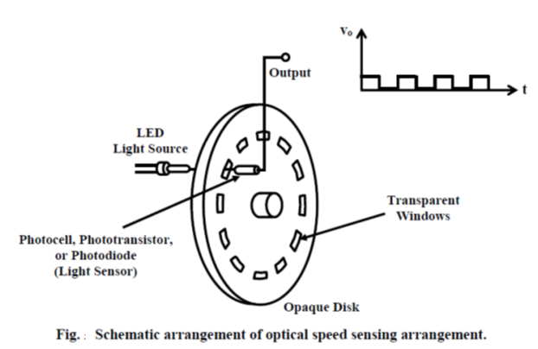

The below fig. shows another scheme for speed measurement. It is a variable reluctance type speed sensor. A wheel with projected teethes made of a ferromagnetic material is mounted on the shaft whose speed is to be measured. The static sensor consists of a permanent magnet and a search coil mounted on the same assembly and fixed at a closed distance from the wheel. The flux through the permanent magnet completes the path through the teeth of the wheel and cut the search coil. As the wheel rotates there would be change in flux cut and a voltage will be induced in the search coil. The variation of the flux can be expressed as:

where N is the number of turns in the search coil. So both the amplitude and frequency of the induced voltage is dependent on the speed of rotation. This voltage is fed to a comparator circuit that gives a square wave type voltage whose amplitude is constant, but frequency is proportional to the speed. A frequency counter is used to count the number of square pulses during a fixed interval and displays the speed.

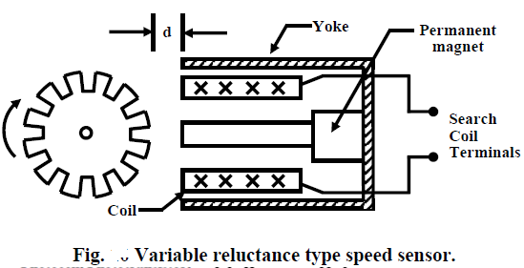

VELOCITY MEASUREMENT:

The main elements of a velocity transducer are coil and a permanent magnet. In such type of transducers velocity is measured based upon electromagnetic induction principle. These two elements can be arranged in two different configurations (i.e., electrodynamic and electromagnetic) to measure the velocity.
In electrodynamics velocity transducer, moving coil scheme is employed. In this configuration the coil and the magnet are arranged in housing such that the magnet is attached to the base of the housing and the coil is attached to the other side (top) of the housing with the help of a spring so that the coil is suspended in the magnetic field as shown in the figure below. The body whose velocity is too measured is connected to the base of the housing.
Due to the displacement of the body, the housing also gets displaced which in turn caused a displacement of the coil in the magnetic field. This movement of the coil causes a change in the flux linkages between the Magnet and the coil, and thus according to the electromagnetic induction principle an electrical voltage gets induced in the coil. This induced voltage is proportional to the relative velocity of the spring and is given by the equation.

e = BLVr X 10⁻⁸

Where,
e-Induced voltage
B-Flux density
L-Length of coil
Vr=dx/dt=relative velocity of coil with respect to magnet (cm/s)

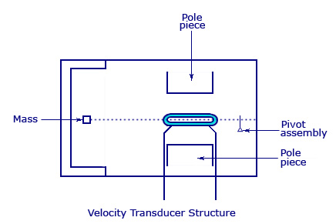

FORCE MEASUREMENT:

The principles used for the measurement 'of force by non-electrical techniques are,
1. Balance principle
2. Force to pressure conversion principle.
In balance principle, the force to be measured is balanced by a known certain quantity and then the value of unknown force is determined from the amount of balancing quantity required to balance the force. In force to pressure conversion principle, the unknown force is converted into pressure. This pressure is measured and then the value of unknown force is determined from the measure of this pressure. Based on the above principles, the nonelectrical devices used for measurement of force are as follows,
(i) Balance type force measuring device
(ii) Hydraulic and pneumatic load cell.

Balance type force measuring device: The force measuring device based upon the principle of balance is usually a simple lever system as shown in figure (8.2) below. This system consists of a rod resting on a pivot at a certain point along its length.
The force to be measured is applied on one of the rod, at a distance T from the pivot. This makes the lever system to be unbalanced. To balance the system, a mass of known value «m' is placed on the other end of the rod, at a distance T from the pivot. At balance, the lever system satisfies the following condition.
F_{L} = mgl
Where,
g = Acceleration due to gravity/gravitational constant.
The unknown force F can be calculated from the above balance equation.
(ii)Hydraulic and Pneumatic Load Cells
The hydraulic and pneumatic load cells are non-electric type force measuring devices, which provide the measure of force in terms of pressure.
In a hydraulic load cell, a chamber is filled with a liquid (usually oil) and the top/mouth of the chamber is filled with a diaphragm (i.e., the internal edge of the diaphragm is in contact with the oil). The force to be measured is applied on top of 'the diaphragm. Due to the application of force, the diaphragm gets deflected and downwards, thereby produces pressure on the liquid.

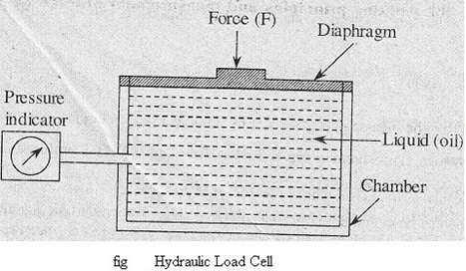

The pressure indicator connected to the chamber indicates the amount of liquid pressure created by the force. Very large forces of the order of mega Newton’s can be measured by a hydraulic cell.
The pneumatic load cell consists of a diaphragm at one end of its chamber and a nozzle at the other end as shown in the figure below. The chamber is provided with a supply of air, under pressure. When unknown, force is applied on the diaphragm, the diaphragm deflects. Due to deflection of the diaphragm, the gap between the nozzle and the diaphragm changes. As a result the air pressure in the chamber also changes. As the gap reduces, the pressure in the chamber increases. A pressure indicator attached to the chamber indicates the air pressure in the chamber. The unknown force can then be evaluated from the measure of the air pressure. Forces up to 20KN can be measured by pneumatic load cell.
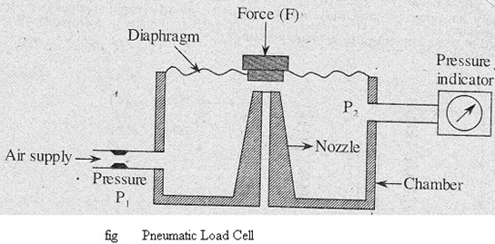

PRESSURE MEASUREMENT:

Measurement of pressure inside a pipeline or a container in an industrial environment is a challenging task, keeping in mind that pressure may be very high, or very low (vacuum); the medium may be liquid, or gaseous. We will not discuss the vacuum pressure measuring techniques; rather try to concentrate on measurement techniques of pressure higher than the atmospheric. They are mainly carried out by using elastic elements: diaphragms, bellows and Bourdon tubes. These elastic elements change their shape with applied pressure and the change of shape can be measured using suitable deflection transducers. Force summing devices serve as primary transducers and convert the pressure applied at the input into displacement, which then can be measured by means of secondary transducer. The lists of most widely used force summing devices are
1. Diaphragms
2. Bellows
3. Bourdon tubes
1. Diaphragms
Any thin metal whose ends are fixed between two parallel plates is referred to as diaphragm. It is one of the pressure measuring elements. The operating principle is the applied pressure is converted into proportional displacement. The materials used to make diaphragms are phosphor bronze, nickel, beryllium copper, stainless steel, etc. These can be available in flat or corrugated shapes.
When two corrugated diaphragms are joined together at their ends a capsule is formed. When compared to flat diaphragms corrugated diaphragms produce greater displacements. Since the capsule is a combination of two diaphragms it generates more displacement which is twice that of the single corrugated diaphragm. This generated displacement is proportional to the applied pressure.
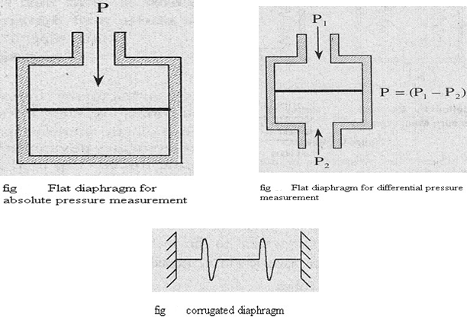
2. Bellows
Bellows, the pressure measuring elements are formed by the series combination of capsules. The working principle of bellows is same as that of diaphragms i.e., the applied displacement is converted into proportionate mechanical displacement. The materials used to construct bellows are beryllium copper, brass, monel, stainless steel and nickel.
Whenever the pressure to be measured is applied the sealed end of bellow suffers displacement. The generated displacement can be known by attaching a pointer scale arrangement to the sealed end or by transmitting the displacement to the secondary transducer.
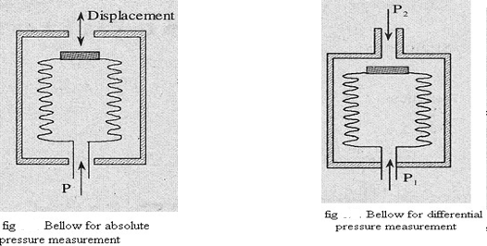
3. Bourdon Tubes
The bourdon tubes are available in different shapes such as spiral, helical, twisted and C shaped. However all the tubes have non-circular cross-section. Also the materials used and working of all these types are same. The materials used in the construction of bourdon tubes are brass, steel and rubber.
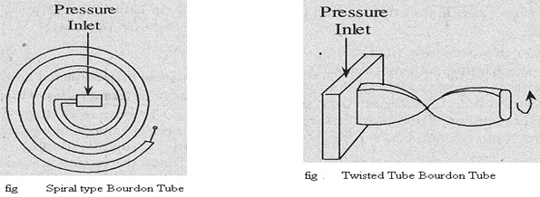
The working principle of bourdon tube is same as that of diaphragms and bellows i.e., the applied pressure is converted into mechanical displacement.
The displacement generated by the above force summing devices can be converted into electrical form by transmitting it to LVDT. The output voltage generated by LVDT is proportional to displacement and hence applied pressure.

Their basic constructions and principle of operation are explained below.
Diaphragms
Diaphragms may be of three types: Thin plate, Membrane and Corrugated diaphragm. This classification is based on the applied pressure and the corresponding displacements. Thin plate (fig. 1(a)) is made by machining a solid block and making a circular cross sectional area with smaller thickness in the middle. It is used for measurement of relatively higher pressure. In a membrane the sensing section is glued in between two solid blocks as shown in fig. 1(b). The thickness is smaller; as a result, when pressure is applied on one side, the displacement is larger. The sensitivity can be further enhanced in a corrugated diaphragm (fig. 1(c)), and a large deflection can be obtained for a small change in pressure; however at the cost of linearity. The materials used are Bronze, Brass, and Stainless steel. In recent times, Silicon has been extensively used the diaphragm material in MEMS (Micro Electro Mechanical Systems) pressure sensor. Further, the natural frequency of a diaphragm can be expressed as:
where meq = equivalent mass, and
k= elastic constant of the diaphragm. The operating frequency of the pressure to be measured must be less than the natural frequency of the diaphragm.

DATA ACQUISITION SYSTEM:

The block diagram of a general Data Acquisition System (DAS) is shown in the figure below.
It consists of the following elements.
      - Transducer
      - Signal conditioner
      - Multiplexer
      - Analog to Digital Converter
      - Recorders and Display devices
1. Transducer
A transducer is used to convert the physical parameters corning from the field into electrical signals or it is used to measure directly the electrical quantities such as resistance, voltage, frequency, etc.
2. Signal Conditioner
Usually the output signals of the transducer will be of very low level (weak) signals which cannot be used for further processing. In order to make the signals strong enough to drive the other elements signal conditioners such as amplifiers, modifiers, filters etc., are used.
3. Multiplexer
The function of the multiplexer is to accept multiple analog inputs (after signal conditioning) and provide a single output sequentially according to the requirements.
4. A/D Converter
The analog-to-digital (A/D) converter is generally used to convert the analog data into digital form. The digital data is used for the purpose of easy processing, transmission, digital display and storage.
Processing involves various operations on data such as comparison, mathematical manipulations, data is collected, converted into useful form and utilized for various purposes like for control operation and display etc.
The transmission of data in digital form is possible over short distances as well as long distances of and has advantages over transmission in analog form. The data can be stored permanently or temporarily and can be displayed on a CRT or digital panel.
5. Recorders and Display Devices
In display devices the data is displayed in a suitable form in order to monitor the input signals. Examples of display devices are oscilloscopes, numerical displays, panel meters, etc.
In order to have either a temporary or permanent record of the useful data recorders are used. The analog data can be recorded either graphically or on a magnetic tape. Optical recorders, ultraviolet recorders, styles-and-ink recorders are some of its examples. The digital data can be recorded through digital recorders. The digital data is first converted into a suitable form for recording by means of a coupling unit and then recorded on a magnetic tape, punched cards or a perforated paper tape.

