What is Frequency Response?
The response of a system can be partitioned into both the transient response and the steady state response. We can find the transient response by using Fourier integrals. The steady state response of a system for an input sinusoidal signal is known as the frequency response. In this chapter, we will focus only on the steady state response.
If a sinusoidal signal is applied as an input to a Linear Time-Invariant (LTI) system, then it produces the steady state output, which is also a sinusoidal signal. The input and output sinusoidal signals have the same frequency, but different amplitudes and phase angles.
Let the input signal be −
r(t)=Asin(ω0t)r(t)=Asin⁡(ω0t)
The open loop transfer function will be −
G(s)=G(jω)G(s)=G(jω)
We can represent G(jω)G(jω) in terms of magnitude and phase as shown below.
G(jω)=|G(jω)|∠G(jω)G(jω)=|G(jω)|∠G(jω)
Substitute, ω=ω0ω=ω0 in the above equation.
G(jω0)=|G(jω0)|∠G(jω0)G(jω0)=|G(jω0)|∠G(jω0)
The output signal is
c(t)=A|G(jω0)|sin(ω0t+∠G(jω0))c(t)=A|G(jω0)|sin⁡(ω0t+∠G(jω0))

The amplitude of the output sinusoidal signal is obtained by multiplying the amplitude of the input sinusoidal signal and the magnitude of G(jω)G(jω) at ω=ω0ω=ω0 .
- The phase of the output sinusoidal signal is obtained by adding the phase of the input sinusoidal signal and the phase of G(jω)G(jω) at ω=ω0ω=ω0 .
Where,
- A is the amplitude of the input sinusoidal signal.
- ω₀ is angular frequency of the input sinusoidal signal.
We can write, angular frequency ω0ω0 as shown below.
ω0=2πf0ω0=2πf0
Here, f0f0 is the frequency of the input sinusoidal signal. Similarly, you can follow the same procedure for closed loop control system.

Frequency Domain Specifications
The frequency domain specifications are resonant peak, resonant frequency and bandwidth.
Consider the transfer function of the second order closed loop control system as,
T(s)=C(s)R(s)=ω2ns2+2δωns+ω2nT(s)=C(s)R(s)=ωn2s2+2δωns+ωn2
Substitute, s=jωs=jω in the above equation.
T(jω)=ω2n(jω)2+2δωn(jω)+ω2nT(jω)=ωn2(jω)2+2δωn(jω)+ωn2
⇒T(jω)=ω2n−ω2+2jδωωn+ω2n=ω2nω2n(1−ω2ω2n+2jδωωn)⇒T(jω)=ωn2−ω2+2jδωωn+ωn2=ωn2ωn2(1−ω2ωn2+2jδωωn)
⇒T(jω)=1(1−ω2ω2n)+j(2δωωn)⇒T(jω)=1(1−ω2ωn2)+j(2δωωn)
Let, ωωn=uωωn=u Substitute this value in the above equation.
T(jω)=1(1−u2)+j(2δu)T(jω)=1(1−u2)+j(2δu)
Magnitude of T(jω)T(jω) is -
M=|T(jω)|=1(1−u2)2+(2δu)2−−−−−−−−−−−−−−√M=|T(jω)|=1(1−u2)2+(2δu)2
Phase of T(jω)T(jω) is -
∠T(jω)=−tan−1(2δu1−u2)∠T(jω)=−tan−1(2δu1−u2)

Resonant Frequency
It is the frequency at which the magnitude of the frequency response has peak value for the first time. It is denoted by ωrωr . At ω=ωrω=ωr , the first derivate of the magnitude of T(jω)T(jω) is zero.
Differentiate MM with respect to uu .
dMdu=−12[(1−u2)2+(2δu)2]−32[2(1−u2)(−2u)+2(2δu)(2δ)]dMdu=−12[(1−u2)2+(2δu)2]−32[2(1−u2)(−2u)+2(2δu)(2δ)]
⇒dMdu=−12[(1−u2)2+(2δu)2]−32[4u(u2−1+2δ2)]⇒dMdu=−12[(1−u2)2+(2δu)2]−32[4u(u2−1+2δ2)]
Substitute, u=uru=ur and dMdu==0dMdu==0 in the above equation.
0=−12[(1−u2r)2+(2δur)2]−32[4ur(u2r−1+2δ2)]0=−12[(1−ur2)2+(2δur)2]−32[4ur(ur2−1+2δ2)]
⇒4ur(u2r−1+2δ2)=0⇒4ur(ur2−1+2δ2)=0
⇒u2r−1+2δ2=0⇒ur2−1+2δ2=0
⇒u2r=1−2δ2⇒ur2=1−2δ2
⇒ur=1−2δ2−−−−−−√⇒ur=1−2δ2
Substitute, ur=ωrωnur=ωrωn in the above equation.
ωrωn=1−2δ2−−−−−−√ωrωn=1−2δ2
⇒ωr=ωn1−2δ2−−−−−−√⇒ωr=ωn1−2δ2

Resonant Peak
It is the peak (maximum) value of the magnitude of T(jω)T(jω) . It is denoted by MrMr .
At u=uru=ur , the Magnitude of T(jω)T(jω) is -
Mr=1(1−u2r)2+(2δur)2−−−−−−−−−−−−−−−√Mr=1(1−ur2)2+(2δur)2
Substitute, ur=1−2δ2−−−−−−√ur=1−2δ2 and 1−u2r=2δ21−ur2=2δ2 in the above equation.
Mr=1(2δ2)2+(2δ1−2δ2−−−−−−√)2−−−−−−−−−−−−−−−−−−√Mr=1(2δ2)2+(2δ1−2δ2)2
⇒Mr=12δ1−δ2−−−−−√⇒Mr=12δ1−δ2
Resonant peak in frequency response corresponds to the peak overshoot in the time domain transient response for certain values of damping ratio δδ . So, the resonant peak and peak overshoot are correlated to each other.

Bandwidth
It is the range of frequencies over which, the magnitude of T(jω)T(jω) drops to 70.7% from its zero frequency value.
At ω=0ω=0 , the value of uu will be zero.
Substitute, u=0u=0 in M.
M=1(1−02)2+(2δ(0))2−−−−−−−−−−−−−−−−√=1M=1(1−02)2+(2δ(0))2=1
Therefore, the magnitude of T(jω)T(jω) is one at ω=0ω=0 .
At 3-dB frequency, the magnitude of T(jω)T(jω) will be 70.7% of magnitude of T(jω)T(jω) at ω=0ω=0 .
i.e., at ω=ωB,M=0.707(1)=12√ω=ωB,M=0.707(1)=12
⇒M=12–√=1(1−u2b)2+(2δub)2−−−−−−−−−−−−−−−√⇒M=12=1(1−ub2)2+(2δub)2
⇒2=(1−u2b)2+(2δ)2u2b⇒2=(1−ub2)2+(2δ)2ub2
Let, u2b=xub2=x
⇒2=(1−x)2+(2δ)2x⇒2=(1−x)2+(2δ)2x
⇒x2+(4δ2−2)x−1=0⇒x2+(4δ2−2)x−1=0
⇒x=−(4δ2−2)±(4δ2−2)2+4−−−−−−−−−−−√2⇒x=−(4δ2−2)±(4δ2−2)2+42
Consider only the positive value of x.
x=1−2δ2+(2δ2−1)2+1−−−−−−−−−−−√x=1−2δ2+(2δ2−1)2+1
⇒x=1−2δ2+(2−4δ2+4δ4)−−−−−−−−−−−−√⇒x=1−2δ2+(2−4δ2+4δ4)
Substitute, x=u2b=ω2bω2nx=ub2=ωb2ωn2
ω2bω2n=1−2δ2+(2−4δ2+4δ4)−−−−−−−−−−−−√ωb2ωn2=1−2δ2+(2−4δ2+4δ4)
⇒ωb=ωn1−2δ2+(2−4δ2+4δ4)−−−−−−−−−−−−√−−−−−−−−−−−−−−−−−−−−−−√⇒ωb=ωn1−2δ2+(2−4δ2+4δ4)
Bandwidth ωbωb in the frequency response is inversely proportional to the rise time trtr in the time domain transient response.
The Bode plot or the Bode diagram consists of two plots −
- Magnitude plot
- Phase plot
In both the plots, x-axis represents angular frequency (logarithmic scale). Whereas, yaxis represents the magnitude (linear scale) of open loop transfer function in the magnitude plot and the phase angle (linear scale) of the open loop transfer function in the phase plot.
The magnitude of the open loop transfer function in dB is -
M=20log|G(jω)H(jω)|M=20log⁡|G(jω)H(jω)|
The phase angle of the open loop transfer function in degrees is -
ϕ=∠G(jω)H(jω)ϕ=∠G(jω)H(jω)
Note − The base of logarithm is 10.

Basic of Bode Plots
The following table shows the slope, magnitude and the phase angle values of the terms present in the open loop transfer function. This data is useful while drawing the Bode plots.
Type of term | G(jω)H(jω) | Slope(dB/dec) | Magnitude (dB) | Phase angle(degrees)
Constant | KK | 00 | 20logK20log⁡K | 00
Zero at origin | jωjω | 2020 | 20logω20log⁡ω | 9090
‘n’ zeros at origin | (jω)n(jω)n | 20n20n | 20nlogω20nlog⁡ω | 90n90n
Pole at origin | 1jω1jω | −20−20 | −20logω−20log⁡ω | −90or270−90or270
‘n’ poles at origin | 1(jω)n1(jω)n | −20n−20n | −20nlogω−20nlog⁡ω | −90nor270n−90nor270n
Simple zero | 1+jωr1+jωr | 2020 | 0forω<1r0forω<1r  20logωrforω>1r20log⁡ωrforω>1r | 0forω<1r0forω<1r  90forω>1r90forω>1r
Simple pole | 11+jωr11+jωr | −20−20 | 0forω<1r0forω<1r  −20logωrforω>1r−20log⁡ωrforω>1r | 0forω<1r0forω<1r  −90or270forω>1r−90or270forω>1r
Second order derivative term | ω2n(1−ω2ω2n+2jδωωn)ωn2(1−ω2ωn2+2jδωωn) | 4040 | 40logωnforω<ωn40logωnforω<ωn  20log(2δω2n)forω=ωn20log(2δωn2)forω=ωn  40logωforω>ωn40logωforω>ωn | 0forω<ωn0forω<ωn  90forω=ωn90forω=ωn  180forω>ωn180forω>ωn
Second order integral term | 1ω2n(1−ω2ω2n+2jδωωn)1ωn2(1−ω2ωn2+2jδωωn) | −40−40 | −40logωnforω<ωn−40logωnforω<ωn  −20log(2δω2n)forω=ωn−20log(2δωn2)forω=ωn  −40logωforω>ωn−40logωforω>ωn | −0forω<ωn−0forω<ωn  −90forω=ωn−90forω=ωn  −180forω>ωn−180forω>ωn
Consider the open loop transfer function G(s)H(s)=KG(s)H(s)=K .
Magnitude M=20logKM=20log⁡K dB
Phase angle ϕ=0ϕ=0 degrees
If K=1K=1 , then magnitude is 0 dB.
If K>1K>1 , then magnitude will be positive.
If K<1K<1 , then magnitude will be negative.
The following figure shows the corresponding Bode plot.
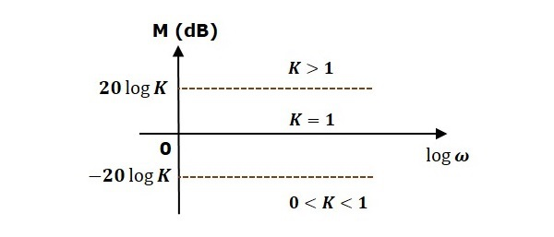
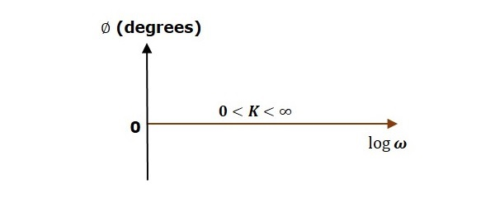
The magnitude plot is a horizontal line, which is independent of frequency. The 0 dB line itself is the magnitude plot when the value of K is one. For the positive values of K, the horizontal line will shift 20logK20log⁡K dB above the 0 dB line. For the negative values of K, the horizontal line will shift 20logK20log⁡K dB below the 0 dB line. The Zero degrees line itself is the phase plot for all the positive values of K.
Consider the open loop transfer function G(s)H(s)=sG(s)H(s)=s .
Magnitude M=20logωM=20log⁡ω dB
Phase angle ϕ=900ϕ=900
At ω=0.1ω=0.1 rad/sec, the magnitude is -20 dB.
At ω=1ω=1 rad/sec, the magnitude is 0 dB.
At ω=10ω=10 rad/sec, the magnitude is 20 dB.
The following figure shows the corresponding Bode plot.
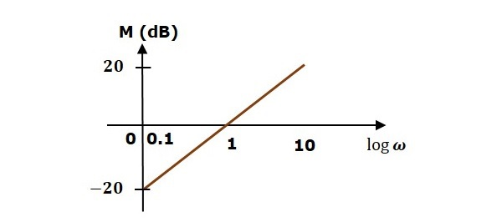
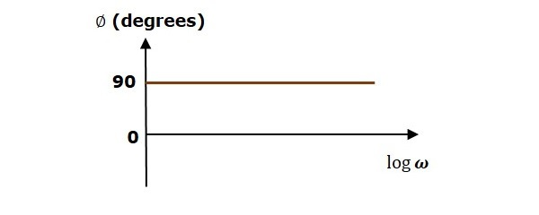
The magnitude plot is a line, which is having a slope of 20 dB/dec. This line started at ω=0.1ω=0.1 rad/sec having a magnitude of -20 dB and it continues on the same slope. It is touching 0 dB line at ω=1ω=1 rad/sec. In this case, the phase plot is 90⁰ line.
Consider the open loop transfer function G(s)H(s)=1+sτG(s)H(s)=1+sτ .
Magnitude M=20log1+ω2τ2−−−−−−−√M=20log1+ω2τ2 dB
Phase angle ϕ=tan−1ωτϕ=tan−1⁡ωτ degrees
For ω<1τω<1τ , the magnitude is 0 dB and phase angle is 0 degrees.
For ω>1τω>1τ , the magnitude is 20logωτ20log⁡ωτ dB and phase angle is 90⁰.
The following figure shows the corresponding Bode plot.
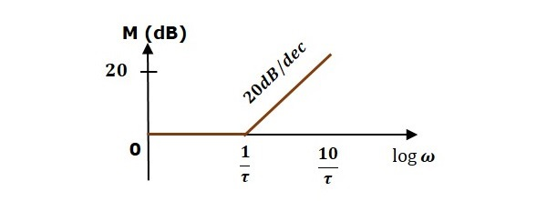
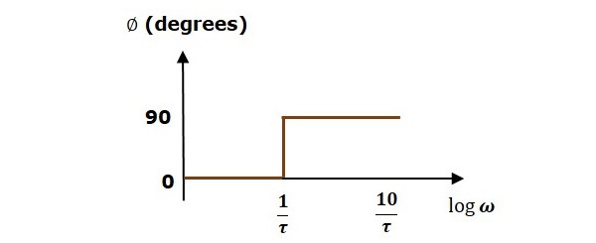
The magnitude plot is having magnitude of 0 dB upto ω=1τω=1τ rad/sec. From ω=1τω=1τ rad/sec, it is having a slope of 20 dB/dec. In this case, the phase plot is having phase angle of 0 degrees up to ω=1τω=1τ rad/sec and from here, it is having phase angle of 90⁰. This Bode plot is called the asymptotic Bode plot.
As the magnitude and the phase plots are represented with straight lines, the Exact Bode plots resemble the asymptotic Bode plots. The only difference is that the Exact Bode plots will have simple curves instead of straight lines.
Similarly, you can draw the Bode plots for other terms of the open loop transfer function which are given in the table.
In this chapter, let us understand in detail how to construct (draw) Bode plots.

Rules for Construction of Bode Plots
Follow these rules while constructing a Bode plot.
- Represent the open loop transfer function in the standard time constant form.
- Substitute, s=jωs=jω in the above equation.
- Find the corner frequencies and arrange them in ascending order.
- Consider the starting frequency of the Bode plot as 1/10th of the minimum corner frequency or 0.1 rad/sec whichever is smaller value and draw the Bode plot upto 10 times maximum corner frequency.
- Draw the magnitude plots for each term and combine these plots properly.
- Draw the phase plots for each term and combine these plots properly.
Note − The corner frequency is the frequency at which there is a change in the slope of the magnitude plot.

Example
Consider the open loop transfer function of a closed loop control system
G(s)H(s)=10s(s+2)(s+5)G(s)H(s)=10s(s+2)(s+5)
Let us convert this open loop transfer function into standard time constant form.
G(s)H(s)=10s2(s2+1)5(s5+1)G(s)H(s)=10s2(s2+1)5(s5+1)
⇒G(s)H(s)=s(1+s2)(1+s5)⇒G(s)H(s)=s(1+s2)(1+s5)
So, we can draw the Bode plot in semi log sheet using the rules mentioned earlier.

Stability Analysis using Bode Plots
From the Bode plots, we can say whether the control system is stable, marginally stable or unstable based on the values of these parameters.
- Gain cross over frequency and phase cross over frequency
- Gain margin and phase margin

Phase Cross over Frequency
The frequency at which the phase plot is having the phase of -180⁰ is known as phase cross over frequency. It is denoted by ωpcωpc . The unit of phase cross over frequency is rad/sec.

Gain Cross over Frequency
The frequency at which the magnitude plot is having the magnitude of zero dB is known as gain cross over frequency. It is denoted by ωgcωgc . The unit of gain cross over frequency is rad/sec.
The stability of the control system based on the relation between the phase cross over frequency and the gain cross over frequency is listed below.
- If the phase cross over frequency ωpcωpc is greater than the gain cross over frequency ωgcωgc , then the control system is stable.
- If the phase cross over frequency ωpcωpc is equal to the gain cross over frequency ωgcωgc , then the control system is marginally stable.
- If the phase cross over frequency ωpcωpc is less than the gain cross over frequency ωgcωgc , then the control system is unstable.

Gain Margin
Gain margin GMGM is equal to negative of the magnitude in dB at phase cross over frequency.
GM=20log(1Mpc)=20logMpcGM=20log⁡(1Mpc)=20logMpc
Where, MpcMpc is the magnitude at phase cross over frequency. The unit of gain margin (GM) is dB.

Phase Margin
The formula for phase margin PMPM is
PM=1800+ϕgcPM=1800+ϕgc
Where, ϕgcϕgc is the phase angle at gain cross over frequency. The unit of phase margin is degrees.
The stability of the control system based on the relation between gain margin and phase margin is listed below.
- If both the gain margin GMGM and the phase margin PMPM are positive, then the control system is stable.
- If both the gain margin GMGM and the phase margin PMPM are equal to zero, then the control system is marginally stable.
- If the gain margin GMGM and / or the phase margin PMPM are/is negative, then the control system is unstable.
In the previous chapters, we discussed the Bode plots. There, we have two separate plots for both magnitude and phase as the function of frequency. Let us now discuss about polar plots. Polar plot is a plot which can be drawn between magnitude and phase. Here, the magnitudes are represented by normal values only.
The polar form of G(jω)H(jω)G(jω)H(jω) is
G(jω)H(jω)=|G(jω)H(jω)|∠G(jω)H(jω)G(jω)H(jω)=|G(jω)H(jω)|∠G(jω)H(jω)
The Polar plot is a plot, which can be drawn between the magnitude and the phase angle of G(jω)H(jω)G(jω)H(jω) by varying ωω from zero to ∞. The polar graph sheet is shown in the following figure.
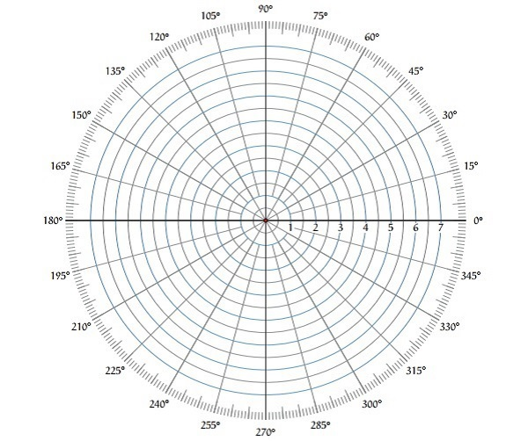
This graph sheet consists of concentric circles and radial lines. The concentric circles and the radial lines represent the magnitudes and phase angles respectively. These angles are represented by positive values in anti-clock wise direction. Similarly, we can represent angles with negative values in clockwise direction. For example, the angle 270⁰ in anti-clock wise direction is equal to the angle −90⁰ in clockwise direction.

Rules for Drawing Polar Plots
Follow these rules for plotting the polar plots.
- Substitute, s=jωs=jω in the open loop transfer function.
- Write the expressions for magnitude and the phase of G(jω)H(jω)G(jω)H(jω) .
- Find the starting magnitude and the phase of G(jω)H(jω)G(jω)H(jω) by substituting ω=0ω=0 . So, the polar plot starts with this magnitude and the phase angle.
- Find the ending magnitude and the phase of G(jω)H(jω)G(jω)H(jω) by substituting ω=∞ω=∞ . So, the polar plot ends with this magnitude and the phase angle.
- Check whether the polar plot intersects the real axis, by making the imaginary term of G(jω)H(jω)G(jω)H(jω) equal to zero and find the value(s) of ωω .
- Check whether the polar plot intersects the imaginary axis, by making real term of G(jω)H(jω)G(jω)H(jω) equal to zero and find the value(s) of ωω .
- For drawing polar plot more clearly, find the magnitude and phase of G(jω)H(jω)G(jω)H(jω) by considering the other value(s) of ωω .

Example
Consider the open loop transfer function of a closed loop control system.
G(s)H(s)=5s(s+1)(s+2)G(s)H(s)=5s(s+1)(s+2)
Let us draw the polar plot for this control system using the above rules.
Step 1 − Substitute, s=jωs=jω in the open loop transfer function.
G(jω)H(jω)=5jω(jω+1)(jω+2)G(jω)H(jω)=5jω(jω+1)(jω+2)
The magnitude of the open loop transfer function is
M=5ω(ω2+1−−−−−√)(ω2+4−−−−−√)M=5ω(ω2+1)(ω2+4)
The phase angle of the open loop transfer function is
ϕ=−900−tan−1ω−tan−1ω2ϕ=−900−tan−1⁡ω−tan−1⁡ω2
Step 2 − The following table shows the magnitude and the phase angle of the open loop transfer function at ω=0ω=0 rad/sec and ω=∞ω=∞ rad/sec.
Frequency (rad/sec) | Magnitude | Phase angle(degrees)
0 | ∞ | -90 or 270
∞ | 0 | -270 or 90
So, the polar plot starts at (∞,−90⁰) and ends at (0,−270⁰). The first and the second terms within the brackets indicate the magnitude and phase angle respectively.
Step 3 − Based on the starting and the ending polar co-ordinates, this polar plot will intersect the negative real axis. The phase angle corresponding to the negative real axis is −180⁰ or 180⁰. So, by equating the phase angle of the open loop transfer function to either −180⁰ or 180⁰, we will get the ωω value as 2–√2 .
By substituting ω=2–√ω=2 in the magnitude of the open loop transfer function, we will get M=0.83M=0.83 . Therefore, the polar plot intersects the negative real axis when ω=2–√ω=2 and the polar coordinate is (0.83,−180⁰).
So, we can draw the polar plot with the above information on the polar graph sheet.
Nyquist plots are the continuation of polar plots for finding the stability of the closed loop control systems by varying ω from −∞ to ∞. That means, Nyquist plots are used to draw the complete frequency response of the open loop transfer function.

Nyquist Stability Criterion
The Nyquist stability criterion works on the principle of argument. It states that if there are P poles and Z zeros are enclosed by the ‘s’ plane closed path, then the corresponding G(s)H(s)G(s)H(s) plane must encircle the origin P−ZP−Z times. So, we can write the number of encirclements N as,
N=P−ZN=P−Z

If the enclosed ‘s’ plane closed path contains only poles, then the direction of the encirclement in the G(s)H(s)G(s)H(s) plane will be opposite to the direction of the enclosed closed path in the ‘s’ plane.
- If the enclosed ‘s’ plane closed path contains only zeros, then the direction of the encirclement in the G(s)H(s)G(s)H(s) plane will be in the same direction as that of the enclosed closed path in the ‘s’ plane.
Let us now apply the principle of argument to the entire right half of the ‘s’ plane by selecting it as a closed path. This selected path is called the Nyquist contour.
We know that the closed loop control system is stable if all the poles of the closed loop transfer function are in the left half of the ‘s’ plane. So, the poles of the closed loop transfer function are nothing but the roots of the characteristic equation. As the order of the characteristic equation increases, it is difficult to find the roots. So, let us correlate these roots of the characteristic equation as follows.
- The Poles of the characteristic equation are same as that of the poles of the open loop transfer function.
- The zeros of the characteristic equation are same as that of the poles of the closed loop transfer function.
We know that the open loop control system is stable if there is no open loop pole in the the right half of the ‘s’ plane.
i.e.,P=0⇒N=−ZP=0⇒N=−Z
We know that the closed loop control system is stable if there is no closed loop pole in the right half of the ‘s’ plane.
i.e.,Z=0⇒N=PZ=0⇒N=P
Nyquist stability criterion states the number of encirclements about the critical point (1+j0) must be equal to the poles of characteristic equation, which is nothing but the poles of the open loop transfer function in the right half of the ‘s’ plane. The shift in origin to (1+j0) gives the characteristic equation plane.

Rules for Drawing Nyquist Plots
Follow these rules for plotting the Nyquist plots.
- Locate the poles and zeros of open loop transfer function G(s)H(s)G(s)H(s) in ‘s’ plane.
- Draw the polar plot by varying ωω from zero to infinity. If pole or zero present at s = 0, then varying ωω from 0+ to infinity for drawing polar plot.
- Draw the mirror image of above polar plot for values of ωω ranging from −∞ to zero (0⁻ if any pole or zero present at s=0).
- The number of infinite radius half circles will be equal to the number of poles or zeros at origin. The infinite radius half circle will start at the point where the mirror image of the polar plot ends. And this infinite radius half circle will end at the point where the polar plot starts.
After drawing the Nyquist plot, we can find the stability of the closed loop control system using the Nyquist stability criterion. If the critical point (-1+j0) lies outside the encirclement, then the closed loop control system is absolutely stable.

Stability Analysis using Nyquist Plots
From the Nyquist plots, we can identify whether the control system is stable, marginally stable or unstable based on the values of these parameters.
- Gain cross over frequency and phase cross over frequency
- Gain margin and phase margin

Phase Cross over Frequency
The frequency at which the Nyquist plot intersects the negative real axis (phase angle is 180⁰) is known as the phase cross over frequency. It is denoted by ωpcωpc .

Gain Cross over Frequency
The frequency at which the Nyquist plot is having the magnitude of one is known as the gain cross over frequency. It is denoted by ωgcωgc .
The stability of the control system based on the relation between phase cross over frequency and gain cross over frequency is listed below.
- If the phase cross over frequency ωpcωpc is greater than the gain cross over frequency ωgcωgc , then the control system is stable.
- If the phase cross over frequency ωpcωpc is equal to the gain cross over frequency ωgcωgc , then the control system is marginally stable.
- If phase cross over frequency ωpcωpc is less than gain cross over frequency ωgcωgc , then the control system is unstable.

Gain Margin
The gain margin GMGM is equal to the reciprocal of the magnitude of the Nyquist plot at the phase cross over frequency.
GM=1MpcGM=1Mpc
Where, MpcMpc is the magnitude in normal scale at the phase cross over frequency.

Phase Margin
The phase margin PMPM is equal to the sum of 180⁰ and the phase angle at the gain cross over frequency.
PM=1800+ϕgcPM=1800+ϕgc
Where, ϕgcϕgc is the phase angle at the gain cross over frequency.
The stability of the control system based on the relation between the gain margin and the phase margin is listed below.
- If the gain margin GMGM is greater than one and the phase margin PMPM is positive, then the control system is stable.
- If the gain margin GMGM is equal to one and the phase margin PMPM is zero degrees, then the control system is marginally stable.
- If the gain margin GMGM is less than one and / or the phase margin PMPM is negative, then the control system is unstable.

N and M Circles
M circles are called constant magnitude loci while N circles are called as constant phase angle loci. At first we will discuss about the m -circles. The open loop transfer function G(jω) of a unity feedback control system is a complex quantity and can be expressed as,
G(jω).1 = x + jy
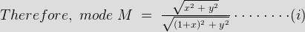
On squaring both sides on the equation i and simplifying we get,
For different values of M, the equation (ii) represents a family of circles with center at x = M² / ( 1-M²) , y = 0 and radius as M /(1-M²). On a particular circle the value of M (magnitude of closed loop transfer function ) is constant, therefore, these circles are called M - CIRCLES. In G(jω) plane the Nyquist plot is superimposed on M-circle and the points of intersection give the magnitude of C( jω) / R(jω) at different values of ω.
.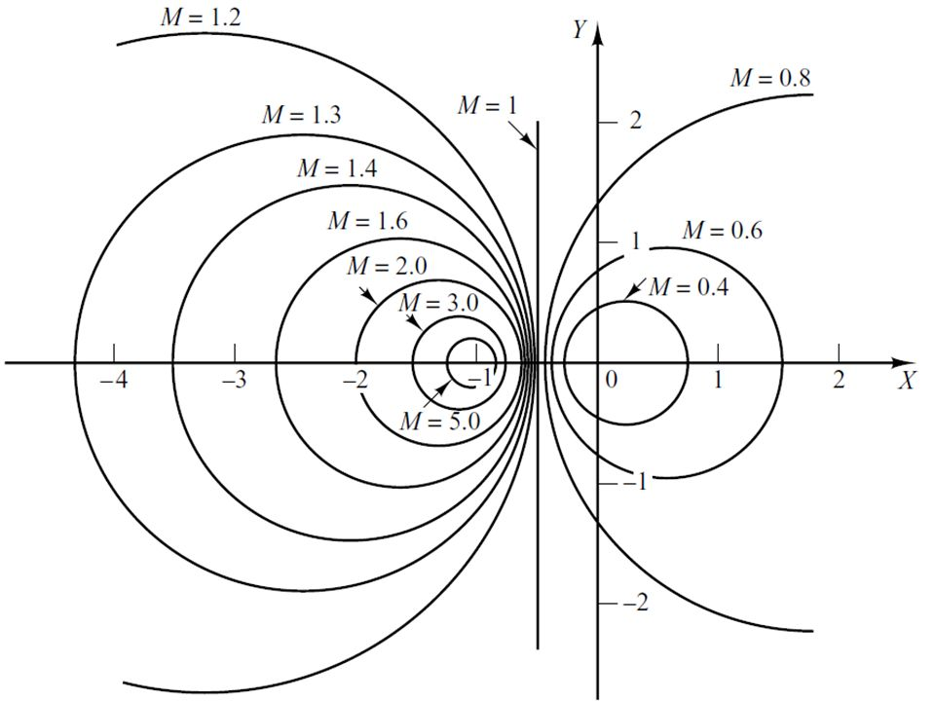 Nichols plot
Constant magnitude loci that are M-circles and constant phase angle loci that are N-circles are the fundamental components in designing the Nichols chart. The constant M and constant N circles in G (jω) plane can be used for the analysis and design of control systems. However the constant M and constant N circles in gain phase plane are prepared for system design and analysis as these plots supply information with fewer manipulations. Gain phase plane is the graph having gain in decibel along the ordinate (vertical axis) and phase angle along the abscissa (horizontal axis). The M and N circles of G (jω) in the gain phase plane are transformed into M and N contours in rectangular co-ordinates. A point on the constant M loci in G (jω) plane is transferred to gain phase plane by drawing the vector directed from the origin of G (jω) plane to a particular point on M circle and then measuring the length in db and angle in degree.
The critical point in G (jω), plane corresponds to the point of zero decibel and -180º in the gain phase plane. Plot of M and N circles in gain phase plane is known as Nichols chart /plot.
The Nichols plot is named after the American engineer N.B Nichols who formulated this plot. Compensators can be designed using Nichols plot. Nichols plot technique is however also used in designing of dc motor. This is used in signal processing and control design. Nyquist plot in complex plane shows how phase of transfer function and frequency variation of magnitude are related. We can find out the gain and phase for a given frequency. Angle of positive real axis determines the phase and distance from origin of complex plane determines the gain. There are some advantages of Nichols plot in control system engineering. They are: Gain and phase margin can be determined easily and also graphically. Closed loop frequency response is obtained from open loop frequency response. Gain of the system can be adjusted to suitable values. Nichols chart provides frequency domain specifications.
There are some drawbacks of Nichols plot also. Using Nichols plot small changes in gain cannot be encountered easily. Constant M and N circles in the Nichols chart are deformed into squashed circles. The complete Nichols chart extends for the phase angle of G (jω) from 0 to -360º. The region of ∠G(jω) used for analysis of systems in between -90º to -270º. These curves repeat after every 180º interval. If the open loop T.F of unity feedback system G(s) is expressed as

Closed loop T.F is 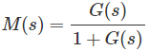

Substituting s = jω in the above eq. frequency functions are,
and
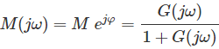
Eliminating G(jω) from above two eq.
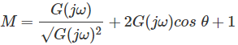
and

