UNIT 5
- Compensator design using Bode plot

A compensator or controller is added to a system to improve its steady state as well as dynamic responses.

Nyquist plot is difficult to modify after introducing controller.

Instead Bode plot is used since two important design criteria, phase margin and gain crossover frequency are visible from the Bode plot along with gain margin.

Points to remember

- Low frequency asymptote of the magnitude curve is indicative of one of the error constants Kp,Kv,Ka depending on the system types.

- Specifications on the transient response can be translated into phase margin (PM), gain margin (GM), gain crossover frequency, bandwidth etc.

- Design using bode plot is simple and straight forward.

- Reconstruction of Bode plot is not a difficult task.

Phase lead, Phase lag and Lag-lead compensators

Phase lead, phase lag and lag-lead compensators are widely used in frequency domain design.

Before going into the details of the design procedure, we must remember the following.

- Phase lead compensation is used to improve stability margins. It increases system bandwidth thus improving the speed of the response.

- Phase lag compensation reduces the system gain at high frequencies without reducing low frequency gain. Thus the total gain/low frequency gain can be increased which in turn will improve the steady state accuracy. High frequency noise can also be attenuated. But stability margin and bandwidth reduce.

- Using a lag lead compensator, where a lag compensator is cascaded with a lead compensator, both steady state and transient responses can be improved.

Bi-linear transformation transfers the loop transfer function in z -plane to w -plane.

Since qualitatively w -plane is similar to s -plane, design technique used in s -plane can be employed to design a controller in w -plane.

Once the design is done in w -plane, controller in z -plane can be determined by using the inverse transformation from w -plane to z -plane.

In the next two lectures we will discuss compensator design in s -plane and solve examples to design digital controllers using the same concept.

Phase lead compensator

If we look at the frequency response of a simple PD controller, it is evident that the magnitude of the compensator continuously grows with the increase in frequency.

The above feature is undesirable because it amplifies high frequency noise that is typically present in any real system.

In lead compensator, a first order pole is added to the denominator of the PD controller at frequencies higher than the corner frequency of the PD controller. Frequency response of a lead compensator is shown in the figure 1.1.

A typical lead compensator has the following transfer function.
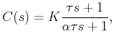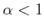

Is the ratio between the pole zero break point (corner) frequencies. Magnitude of the lead compensator is
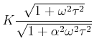

And the phase contributed by the lead compensator is given by
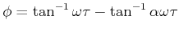

Thus a significant amount of phase is still provided with much less amplitude at high frequencies.

The frequency response of a typical lead compensator is shown in Figure 1 where the magnitude varies from

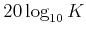
to 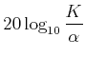
and maximum phase is always less than 90° (around 60° in general).

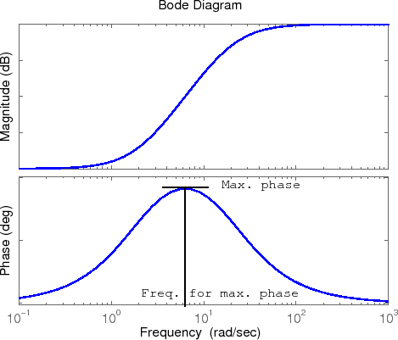

Figure 1.1: Frequency response of a lead compensator

It can be seen that the frequency where the phase is maximum is given by
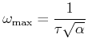

The maximum phase corresponds to

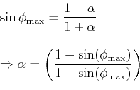

The magnitude of
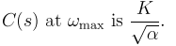

Lag Compensator Design

In the previous lecture we discussed lead compensator design. In this lecture we would see how to design a phase lag compensator

Phase lag compensator

The essential feature of a lag compensator is to provide an increased low frequency gain, thus decreasing the steady state error, without changing the transient response significantly.

For frequency response design it is convenient to use the following transfer function of a lag compensator.
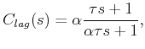

Where
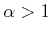

The above expression is only the lag part of the compensator. The overall compensator is
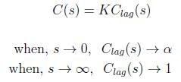

Frequency response of a lag compensator is shown in fig: 1.2. Typical objective of lag compensator design is to provide an additional gain of α in the low frequency region and to leave the system with sufficient phase margin.

The frequency response of a lag compensator, with α=4 and τ=3, is shown in Figure 1 where the magnitude varies from

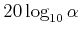 dB to 0 dB.
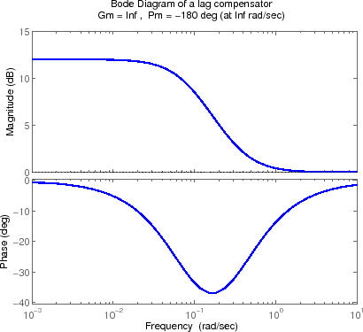

Figure 1.2: Frequency response of a lag compensator

Since the lag compensator provides the maximum lag near the two corner frequencies, to maintain the PM of the system, zero of the compensator should be chosen such that ω = 1/ τ is much lower than the gain crossover frequency of the uncompensated system.

In general, τ is designed such that 1/ τ is at least one decade below the gain crossover frequency of the uncompensated system. Following example will be comprehensive to understand the design procedure.

Lag -lead Compensator

When a single lead or lag compensator cannot guarantee the specified design criteria, a lag- lead compensator is used.
Frequency response of a lag-lead compensator is shown in fig: 1.3 .In lag-lead compensator the lag part precedes the lead part. A continuous time lag-lead compensator is given by

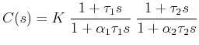

where,

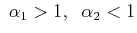
The corner frequencies are 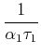, , , 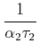.
The frequency response is shown in Figure 1.
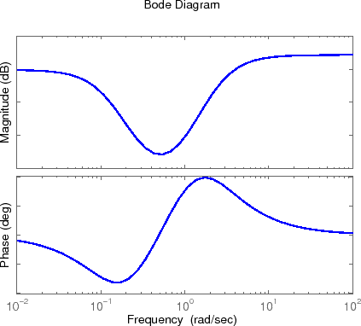

Figure 1.3: Frequency response of a lag-lead compensator

- If it is not specified which type of compensator has to be designed, one should first check the PM and BW of the uncompensated system with adjustable gain K.

- If the BW is smaller than the acceptable BW one may go for lead compensator. If the BW is large, lead compensator may not be useful since it provides high frequency amplification.

- One may go for a lag compensator when BW is large provided the open loop system is stable.

- If the lag compensator results in a too low BW (slow speed of response), a lag-lead compensator may be used.

Lead or Phase-Lead Compensator Using Root Locus

A first-order lead compensator can be designed using the root locus. A lead compensator in root locus form is given by

where the magnitude of z is less than the magnitude of p. A phase-lead compensator tends to shift the root locus toward the left half plane. This results in an improvement in the system's stability and an increase in the response speed.

When a lead compensator is added to a system, the value of this intersection will be a larger negative number than it was before. The net number of zeros and poles will be the same (one zero and one pole are added), but the added pole is a larger negative number than the added zero. Thus, the result of a lead compensator is that the asymptotes' intersection is moved further into the left half plane, and the entire root locus will be shifted to the left. This can increase the region of stability as well as the response speed.

Lag or Phase-Lag Compensator Using Root Locus

A first-order lag compensator can be designed using the root locus. A lag compensator in root locus form is given by

where the magnitude of z is greater than the magnitude of p. A phase-lag compensator tends to shift the root locus to the right, which is undesirable. For this reason, the pole and zero of a lag compensator must be placed close together (usually near the origin) so they do not appreciably change the transient response or stability characteristics of the system.

When a lag compensator is added to a system, the value of this intersection will be a smaller negative number than it was before. The net number of zeros and poles will be the same (one zero and one pole are added), but the added pole is a smaller negative number than the added zero. Thus, the result of a lag compensator is that the asymptotes' intersection is moved closer to the right half plane, and the entire root locus will be shifted to the right.

Lead-lag Compensator using either Root Locus or Frequency Response

A lead-lag compensator combines the effects of a lead compensator with those of a lag compensator. The result is a system with improved transient response, stability and steady- state error. To implement a lead-lag compensator, first design the lead compensator to achieve the desired transient response and stability, and then add on a lag compensator to improve the steady-state response

Feedback compensation:

  - Necessary of Compensation
- In order to obtain the desired performance of the system, we use compensating networks. Compensating networks are applied to the system in the form of feed forward path gain adjustment.
- Compensate an unstable system to make it stable.
- A compensating network is used to minimize overshoot.
- These compensating networks increase the steady state accuracy of the system. An important point to be noted here is that the increase in the steady state accuracy brings instability to the system.
- Compensating networks also introduces poles and zeros in the system thereby causes changes in the transfer function of the system. Due to this, performance specifications of the system change.

Methods of Compensation
1. Connecting compensating circuit between error detector and plants known as series compensation as shown in fig 1.7

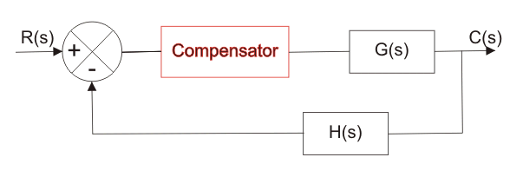
Fig 1.7: Series Compensator

When a compensator used in a feedback manner as shown in fig 1.8 it is called feed back compensation

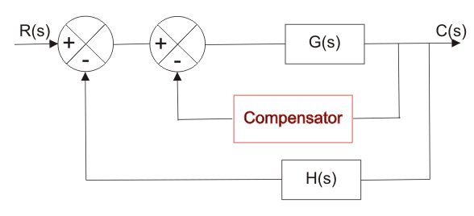

Fig 1.8 feedback compensator

A combination of series and feedback compensator is called load compensator as shown in fig 1.9

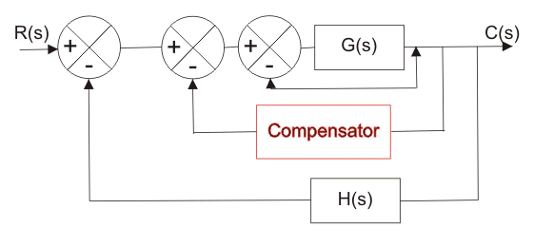

Fig 1.9 Load compensator

