Computer Organization

UNIT-IV

Input/outputorganization

• Peripheral Devices
• I/O Interface
• Modes of transfer
• Priority Interrupt
• Direct Memory Access
• I/O Processor
• Serial Communication

Introduction About Input Output Organization:-
A peripheral device connects to a computer system to add functionality. Examples are a mouse, keyboard, monitor, printer and scanner. Learn about the different types of peripheral devices and how they allow you to do more with your computer.

Definition of Peripheral Devices
Say you just bought a new computer and, with excitement, you unpack it and set it up. Then, the first thing you want to do is print out some photographs of the last family party. So it's time to head back to the store to buy a printer. A printer is known as aperipheral device.
A computer peripheral is a device that is connected to a computer but is not part of the core computer architecture. The core elements of a computer are the central processing unit, power supply, motherboard and the computer case containing these three components. Technically speaking, everything else is considered a peripheral device; however, this is a somewhat narrow view, since various other elements are required for a computer to actually function, such as a hard drive and random-access memory (RAM).
Most people use the term peripheral more loosely to refer to a device external to the computer case. You connect the device to the computer to expand the functionality of the system. For example, consider a printer. Once the printer is connected to a computer, you can print out documents. Another way to look at peripheral devices is that they are dependent on the computer system. For example, most printers can't do much on their own, and they only become functional when connected to a printer.

Types Of Peripheral Devices
There are many different peripheral devices, but they fall into three general categories:
- Input devices, such as a mouse and a keyboard
- Output devices, such as a monitor and a printer
- Storage devices, such as a hard drive or flash drive
Some devices fall into more than one category. Consider a CD-ROM drive; you can use it to read data or music (input) and you can use it to write data to a CD (output).
Peripheral devices can be external or internal. For example, a printer is an external device that you connect using a cable, while an optical disc drive is typically located inside the computer case. Internal peripheral devices are also referred to as integrated peripherals. When most people refer to peripherals they typically mean external ones.
The concept of what exactly is 'peripheral' is therefore somewhat fluid. For a desktop computer, a keyboard and a monitor are considered peripherals - you can easily connect and disconnect them and replace them if needed. For a laptop computer, these components are built into the computer system and can't be easily removed.
The term 'peripheral' also does not mean it is not essential to the functioning of the computer. Some devices, such as a printer, can be disconnected and the computer will keep on working just fine; however, remove the monitor of a desktop computer, and it becomes pretty much useless.

Examples Of Peripheral Devices
The figure below shows a typical desktop computer system with a number of common peripheral devices. The central processing unit (2), motherboard (8) and power supply are the core computer system. Expansion slots (4) on the motherboard make it possible to connect internal peripherals, such as a video card or sound card (not shown). Other internal peripherals shown are a hard disk drive (7) and an optical disc drive (6). External input peripherals are a scanner (1), display monitor (10), keyboard (13) and mouse (14). External output peripherals are a set of speakers (9) and a printer (16). Note: labels 11 and 12 in the figure refer to software and are not peripherals.

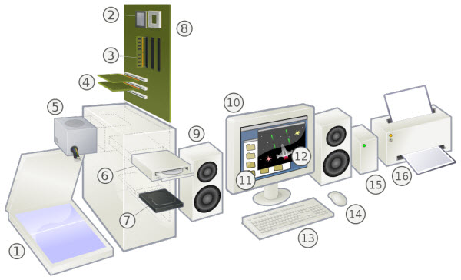
Desktop computer system with examples of typical peripherals
There are many other examples of peripherals, such as a microphone, web camera, head phones, external hard drive and flash drive. Most computer users have at least several of these peripheral devices.

How Peripherals Are Connected
Internal peripherals are directly connected to the motherboard using one of the different types of slots on the motherboard. External devices can be connected using a wired connection or a wirelessconnection. As the name suggests, a wired connection uses a cable that needs to be plugged into the computer using a connector. The most widely used connector is a Universal Serial Bus (USB) connection, but several other types are used depending on the specific computer system and the type of peripheral. A wireless connection does not require a cable. The most widely used wireless connections are Bluetooth and WiFi. Bluetooth is good for very short distances, so peripherals such as a wireless mouse and keyboard typically use a Bluetooth connection. WiFi is good for longer distances. If you have set up a wireless network in your home or office, you may be able to print wirelessly to printer if it is also connected to the network.

Peripheral devices

• Peripherals – Input or output devices attached to the computer
– Keyboard as input device, display unit as common output device
• Magnetic tapes are used mostly for storing files of data
• Three basic types of character printers are daisywheel, dot matrix and laser printers
• Standard binary code for the alphanumeric characters is ASCII (American
Standard Code for Information Interchange)
• ASCII uses 7 bits to code 128 characters (94 printable characters and 34 non printable characters)
– A to Z – 26 uppercase letters, a to z – 26 lowercase letters, 0 through 9 – 10 numerals, 32 printable characters such as %, *, and $

Input‐output interface

• I/O interface – provides a method for transferring information between internal storage and external i/o devices
• Purpose of i/o interface – to resolve differences between CPU and the peripherals
• I/O bus and interface modules
– Control Command – activates the peripheral and informs it what to do
– Status command – tests various status conditions in the interface and the peripherals
– Data input command – receives a data item from the peripheral and places it in its buffer register
– Data output command – causes the interface to respond by transferring data from the bus into one of its registers

I/O interface

• 3 ways of communication between Processor with memory and I/O
using buses

– 2 separate buses – 1 each for memory and I/O

– 1 common bus and separate control lines

– 1 common bus with common control lines
• Isolated I/O ‐ CPU has distinct I/O instructions ; each instruction is associated with the address of interface register
• Memory Mapped I/O – Same address space for memory and I/O; computer treats an interface register as being part of the memory system.

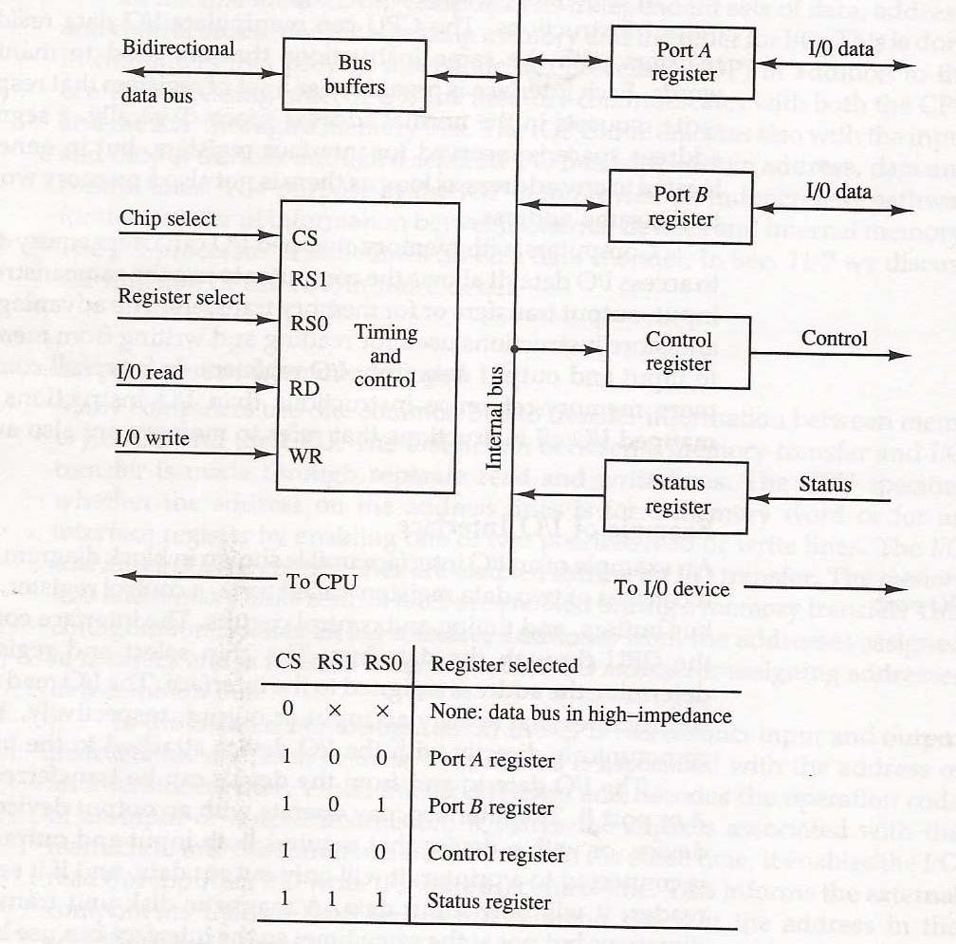i/o interface unit

Modes of transfer

• Programmed I/O

– I/O device does not have direct access to memory

– Requires execution of several instructions by the CPU

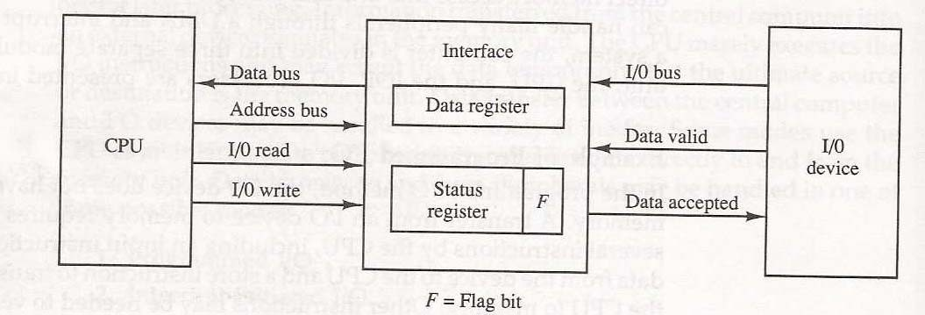

Interrupt initiated i/o

• Interrupt – refers to the transfer of control from a currently running program to another service program as a result of an external/internal generated request
• CPU detects interrupt from a set flag (when a interface is ready to transfer data)
• Upon detection CPU deviates its attention to another program
• Two types namely vectored interrupt and non vectored interrupt are available

Priority interrupt

• System that establishes a priority over the various sources to determine which condition is to be serviced first when two or more requests arrive simultaneously

• Polling – used to identify the highest priority source by software means

• Daisy chaining priority – establishing priority consists of serial connection of all devices that request an interrupt

• Devices are placed in the order of highest priority first

• VAD – Vector address in the data bus used by the CPU during the device interrupt cycle.

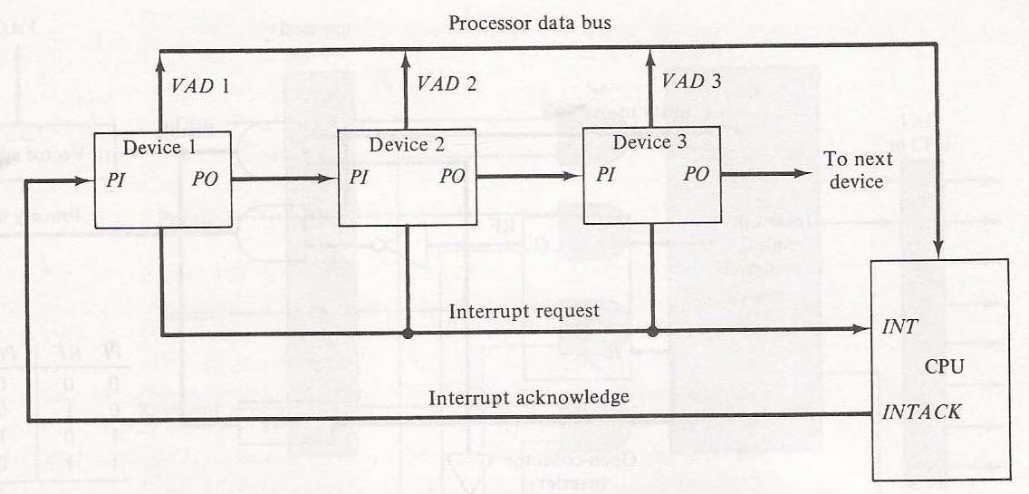Daisy chain priority interrupt

Direct memory access (DMA)

• Transfer of data between a fast storage device and memory is limited by the speed of CPU
• Remove CPU from the path of communication and the technique is DMA
• DMA controller takes over the buses to manage the transfer directly between the
I/O device and memory
• Bus Request (BR) – used by the DMA controller to request the CPU to relinquish control of the buses
• CPU activates bus grant to inform the external DMA that the buses are in high impedance state
• Burst transfer – block sequence consisting of memory words is transferred in a continuous bus when DMA controller is the master
• Cycle Stealing – allows DMA controller to transfer one data word at a time after which it must return control of the buses to the CPU

Input output processor (iop)

• Processor with DMA capability that communicates with I/O devices
• IOP takes care of input and output tasks relieving the CPU from the housekeeping chores involved in I/O transfers
• IOP can fetch and execute its own instructions
• IOP instructions are specifically designed to facilitate I/O transfers

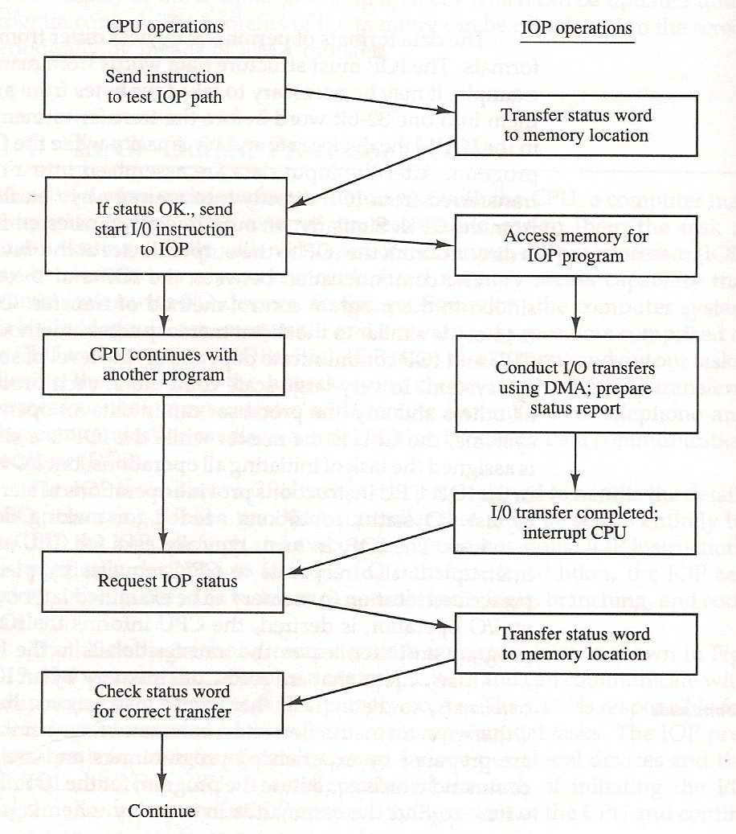Cpu‐iop communication

Serial communication

• Data communication processor – communicates with each terminal through a single pair of wires

• Data and control information are transferred in a serial fashion

• Modems – converts digital signals into audio tones to be transmitted over telephone lines and also converts audio tones from the line to digital signals for
machine use

• Transmission modes – Simplex, Half‐duplex, Full‐
duplex

• Data link control protocol – set of rules that are followed by interconnecting computers and terminals

