UNIT – II
Digital Integrated circuits:
Evaluation of ICs,
Advantages and classification of ICs.
Digital IC characteristics,
Digital IC families- DTL, HTL, ECL, MOS, CMOS,
TTL-Totem-pole, Open collector and Tristate outputs and IC packaging’s.

UNIT – II
DIGITAL INTEGRATED CIRCUITS

Classification of IC’s :
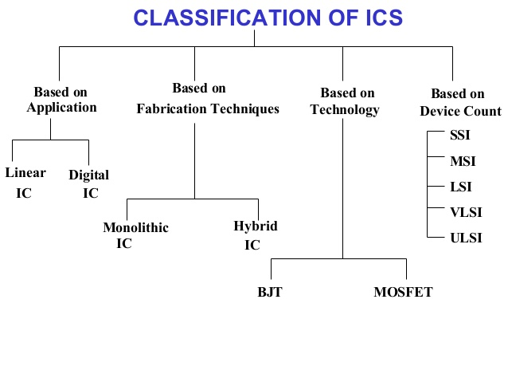
Based on application:
Based on on application IC’s are classified into two categories
- Linear IC’S
- Digital IC’S
(1) Linear IC’s: Linear IC’s requires external components like resistors and capacitors for the
satisfactory performance purpose apart from the input
Eg:op-amps,DAC’s,ADC’s,555 timer.
(2) Digital IC’S: digital IC’s only require digital input and doesn’t require any other external
components for the operation
Eg: Logic gates ,comparators, adders
Based on device count:
Based on devise count IC’s are classified into several categories.
- SSI (small scale integration)
- MSI (medium scale integration)
- LSI (large scale integration)
- VLSI (very large scale integration)
- ULSI (ultra large scale integration)
- WSI (wapper scale integration)

S.No | Integration level | Logical function | Density range
1 | SSI | op-amps, logic gates | 1-100
2 | MSI | resistors, filters | 100-1000
3 | LSI | microprocessors | 1000-10000
4 | VLSI | memories ,computers, signal processers | 10^5-10^6
5 | ULSI | Ultra large scale integration devices used in japan | 10^6
6 | WSI | - | -

Based on technology:
Based on technology IC’s are classified into two categories:
(1) Bipolar devices
(2) Uni-polar devices
- Bipolar devices :
Basically bipolar devices uses the properties of both majority charge carriers for the conduction purpose.
Eg: ECL (emitter coupled logic),TTL(transistor-transistor logic),IIL(integrated injection logic).
- Unipolar devices:
Metal oxide semiconductor FET’s are important class of these unipolar devices. These MOSFET devices are mainly
- NMOS (b) PMOS (c) CMOS (d) BICMOS
- NMOS: NMOS refers to the N-channel MOSFET . this N-channel MOSFET excellent density and performance.

- PMOS: PMOS refers to the P- channel MOSFET .this PMOS is a dual of NMOS.

- CMOS : The full form of complementary metal oxide semiconductor .this CMOS offers better performance to when compared with the NMOS.
Basically CMOS comprises of both PMOS and NMOS

- BICMOS :As the name itself the BICMOS is a combination of bipolar devices and CMOS because it contains advantages of both bipolar and CMOS devices
Based on fabrication:
IC’s are classified into two categories based on fabrication
(1) Monolithic IC’s.
(2) Hhybrid IC’s.
(1) Monolithic IC’S:
All the active components and passive components of a circuit with the fabricated on
single piece of silicon
(2) Hybrid IC’S:
Separate component parts are attached to a ceramic substrate are interconnected by means
of either metallization pattern (or )wire bonds
Evolution of IC’s:
The first electronic digital computer ENIAC development in the late 40’s was based on vacuum tube ,thermionic tubes circuitary. the concept of the stored program was introduced by von Newman around the same time advantages of vacuum tubes:
- Vacuum tubes were the only electronic components available at that time
- This technology made possible the advent of electronic digital computers
- These vacuum tubes were the fastest calculating devices of their type
- These vacuum tubes could perform calculations in milliseconds disadvantages of

vacuum tubes:

(1) very big in size
(2) occupies large space
(3) High heat production
(4) high power consumed
(5) high cost
(6) no reliability
(7)Non portable
(8) Need constant maintenance
(9)proved their frequent hard ware failure
(10)limited commercial use

To overcome these disadvantages the transistors were introduced

Advantages of transistors:

John Bardeen invented a new electronic device called transistor.
1. small in size
2. better reliability
3. computational time is micro seconds
4. less heat generated
5. better speed
6. better portability
7. less prove to hardware failure

Disadvantages:

1. frequent maintenance is required
2. need air conditioning
3. manual assembly of individual components into the functioning unit is required.
4. high cost
5. commercial production was difficult

To overcome a this disadvantages ics were introduced in the mid-60s these ics based on tiny micro miniaturized circuits. These ic chips were made of silicon the properties of silicon on where charged through series of manufacturing steps thus creating a means of controlling the electrical signals.

The ics provided vast internal storage on increased the operational efficiency.
Advantages of ics:

1. small in size
2. mare reliability
3. less heat generated
4. computational time is Nano seconds
5. less hardware failure
6. low maintenance cost
7. easily potable
8. less power is required
9.commercial production was easier and cheaper.

Digital IC characteristics:
1.Threshold voltage
2.Propagation delay
3.Power dissipation
4.Fan-in
5.Fan-out
6.Noise margin
7.Speed power product
1. Threshold voltage:-
It is defined as the voltage at the input of the gate which causes changes in the state of
output from one logical level to the another logical level then such voltage is termed as
threshold voltage.
It is designated as Vt.
2. Propagation delay:-
Propagation delay is defined as time taken by the pulse to propagate from input to output.
The units of propagation delay are ns.
3. Power dissipation:-
It is defined as the required power by the gate to operate with 50% duty cycle at a specified
at frequency. The units of power dissipation are milli watts.
4. FAN-IN:-
It is defined as allowable number of input gates.
5. FAN-OUT:-
It is defined as the maximum number of similar gates that output of gate can drive without
implying its normal operation.
6. Noise margin:-
The another name of noise margin is noise immunity. It is defined as the allowable input gate
so that output cannot be corrupted.
The following two parameters are used to describe noise margin
*Low noise margin:-
It is defined as the difference between maximum low input voltage (V_{ilmax} ) and maximum
low output voltage (Vo_{lmax}) then such noise margin is termed as low noise margin. It is
designated by the symbol(NMl).
NMl=V_{ilmax}-V_{olmax}
*High noise margin:-
It is defined as difference between minimum high output voltage (V_{ohmin}), minimum input
voltage (V_{ihmin}) then such noise margin is known as high noise margin.
NMh= V_{ohmin} – V_{ihmin}
7. Speed power product:-
It is defined as the product between average propagation delay and average power
dissipation.
Speed power product= average propagation delay * average power dissipation.

DIGITAL IC FAMILIES:
1. DTL (Diode Transistor logic):
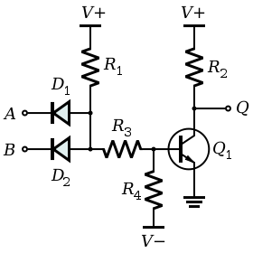
Fig1: DTL
A | B | D1 | D2 | Transistor | output
Logic 0 | Logic0 | Forward biased | Forward biased | Cut-off | Logic1
Logic 0 | Logic1 | Forward biased | Reverse biased | Cut-off | Logic1
Logic1 | Logic0 | Reverse biased | Forward biased | Cut-off | Logic1
Logic 1 | Logic 1 | Reverse biased | Reverse biased | saturation | Logic0

Fig 2: operation of DTL

A | B | Y
0 | 0 | 1
0 | 1 | 1
1 | 0 | 1
1 | 1 | 0

Fig3: operation of two input NAND DTL
The diode transistor logic bias representation representing the two inputs A &B at the positions of input diodes D1 &D2. Here the operation of DTL NAND gate involves following 4 cases
Case I:-
If A=B=logic0 then corresponding input diodes D1 &D2 will be act as in forward biased and the transistor will be in cut-off region and the output is logic 1.
Case II:-
If A=0, B=1 then diode D1 will be FB and diode D@ will be RB and corresponding transistor will be in cut-off region and output is logic1.

Case III:-
If A=1,B=0 then diode D1 will be RB &diode D2 will be FB corresponding transistor will be in
cut-off region and output is logic 1
Case IV:-
If both A=B=1 then diodes D1, D2 will be RB & diodes D3,D4 will be FB. Current passing
through diodes D3,D4 to the base of transistor, then transistor will turn on position and acts in
saturation region. Thus the output is logic 0
Advantages:-
1 Fan-out is high
2. Power dissipation is in the range of 8 to 12 mW
3 Noise margin is good.
Disadvantages:-
- More no. of components are required.
- Propagation delay is high and hence speed of operation is low.

HIGHER THRESHOLD LOGIC:-
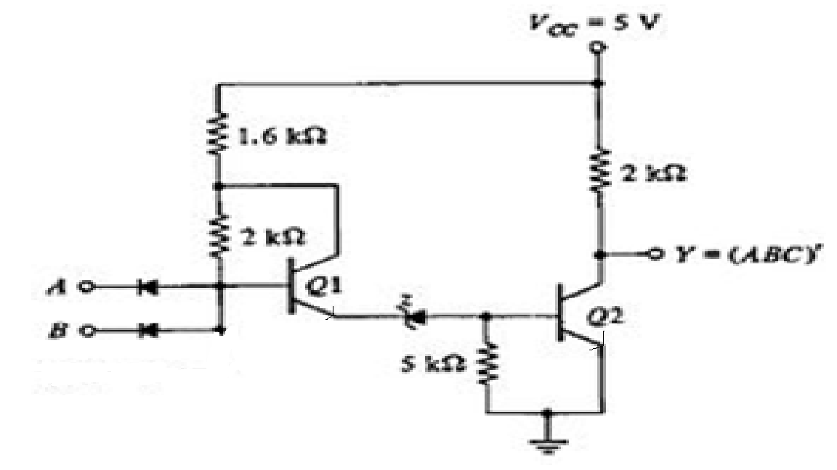
Fig: HTL
The full form of HTL is high threshold logic. This HTL is a variant of DTL. It means HTL gate is a modification of DTL gate . The above diagram illustrates the logic diagram of two input HTL NAND gate.
The HTL gate is designed for industrial purpose by providing large noise margin. This HTL
has been designed with high supply voltage of 15v. This HTL NAND gate utilizes a zenor diode
of breakdown voltage of 6.9v The transistor T2 will conduct when the emitter of T1 is at 7.5v as
the sum of 6.9v zenor voltage and BE voltage of t2 is 0.6.
The low output level of the HTLK gate will be 0.2v and the high output voltage level of HTL
gate will be about 15V.
Case(i):
When both the i/p’s are at low i.e., A=B=0 or when any one of the i/p is at low i.e., A=0,B=0, in this case T2 is operated in OFF state.
Case(ii):
When both the i/p’s are at high i.e., A=B=1 then T2 is operated in saturation state.

MOS LOGIC FAMILY:
The full form of MOSFET logic is “ METALOXIDE SEMICONDUCTOR FIELD EFFECT TRANSISTER LOGIC” . Basically, MOSFET devices are very popular devices due to its low power dissipation and its high density.
MOSFET devices are categorized into 3 types.
1.PMOS
2.NMOS
3. CMOS
1). PMOS:
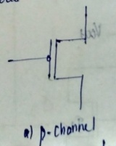
It refers to p-channel MOSFET as compared with NMOS device this PMOS device is slow. Hence PMOS devices are not used for new designs.
2). NMOS:
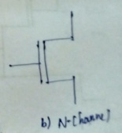
It refers to N-channel MOSFET. The following diagrams describes the representation of NMOS inverter and its operation through table.
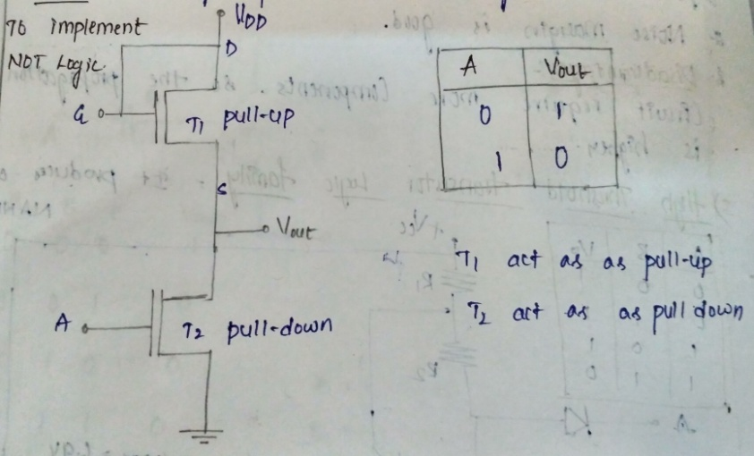
CASE(1):
If the i/p voltage is low then Q2 is in OFF state and no current flows through circuit and o/p is pulled up to Vcc.
i.e .., When V0=+Vcc or 5V => vin =0V
CASE(2):
If the i/p voltage is high then Q2 is in ON state and current flows through drain terminal and o/p is pulled down to 0v.
i.e.., V0 = 0V =>Vin =+5V
Characteristics of NMOS:-
S.NO | PARAMETER SYMBOL | PARAMETER NAME | Its value
1. | VIH | High i/p voltage | 2.0 v
2. | VIL | Low i/p voltage | 0.8 v
3. | VOH | High o/p voltage | 2.4 v
4. | VOL | Low o/p voltage | 0.45 v
5. | IOH | High o/p voltage | -400 UA
6. | IOL | Low o/p voltage | 2mA
7. | P.D | Power dissipation | 0.1mW

3). CMOS:-
The full form of CMOS is COMPLEMENTARY METAL OXIDE SEMICONDUCTORS. It compares of both PMOS & NMOS . it means CMOS logic uses N-channel MOSFET and P-channel MOSFET .In this CMOS logic PMOS & NMOS devices are fabricated on the same chip which makes its fabrication complicated but it reduces the packaging density and have a small power consumption. Hence CMOS logic is ideally suited for battery operated system. The following diagram describes the basic representation of CMOS inverter and its operation table.
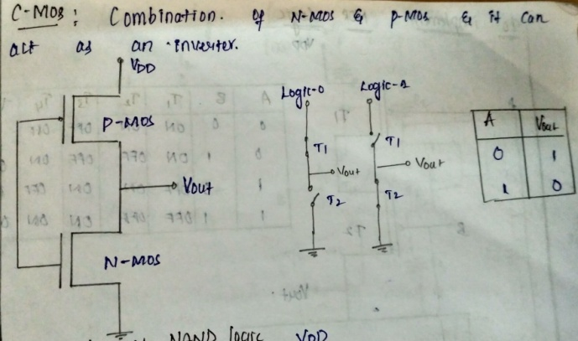
CASE(1):-
If i/p is low then Q1 is in ON state and Q2 is in OFF state ; then o/p is pulled up to vcc.
V0 =1 ; when vin =0
CASE(2):-
If i/p is high then Q1 is in OFF state and Q2 is in ON state ; then o/p is pulled down to 0.
V0 =0 ; when vin =1
Characteristics of CMOS:-
S.NO | PARAMETER SYMBOL | PARAMETER NAME | Its value
1. | VIH | High i/p voltage | 3.5v
2. | VIL | Low i/p voltage | 1.5v
3. | VOH | High o/p voltage | 4.5v
4. | VOL | Low o/p voltage | 0.5v
5. | IOH | High o/p voltage | -100uA
6. | IOL | Low o/p voltage | -360UA
7. | P.D | Power dissipation | 10mW

Emitter coupled logic:
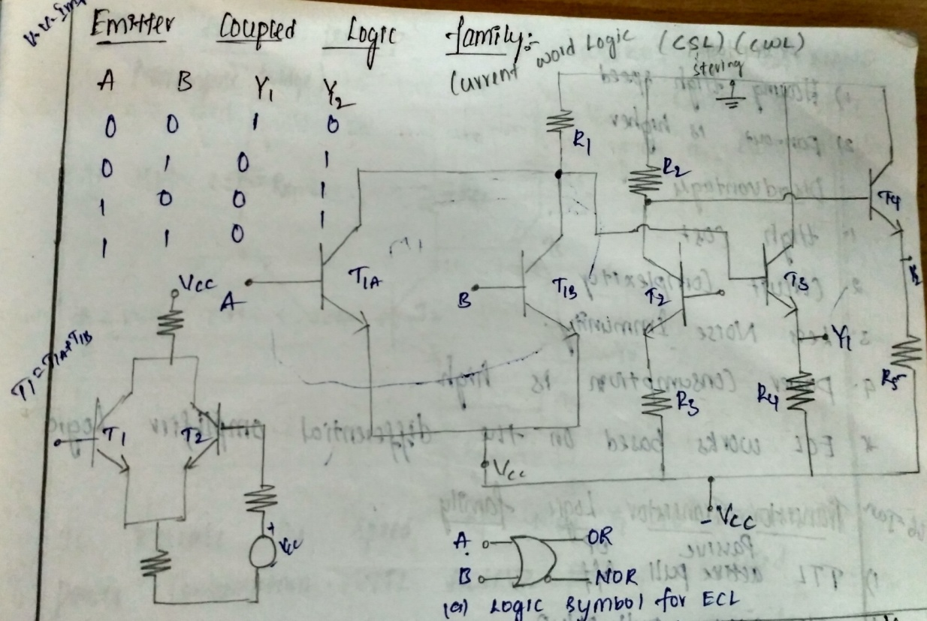
The circuit consists of different amplifiers and emitter followers. the emitter terminates of transistors *(T1 & T2) are connected together then it has been given a name emitter coupled logic.
This ECL family is faster than the TTL family. The transistors of ECL family are operated in either active region or cut-off region but not in saturation region i.e.., the transistors of ECL never goes in saturation region. Due this reason the storage time is eliminated on ECL family.
Operation:-
From fig 1 we can notice that ECL consists of 2i/ps designated as Y1 &Y2. Y1 corresponding to OR gate & y2 corresponding to NOR gate.
CASE(1):-
If A = B = 0 then T1 &T1’ operate in cut off region . T2 is operates in active region .here V01 is high & V02 is low then T3 is operated in active region & T4 is operated in cut off region . Thus o/p Y1 is logic 0 and o/p Y2 is logic 1.
CASE(2):-
If any one i/p is logic 1 then corresponding transistor is operated in active region and other transistor operates in cutoff state due to logic 0 applied i/p.
Here T2 is operated in cutoff region. V01 is low & v02 is high then T3 i8s operates in cut of f region and T4 is operates in active region, thus o/p Y1 is logic 1 & y2 is logic 0.
CASE(3):-
If A =B =1 then T1’ & T1 operates in active region. T2 is operated in cutoff region .
Here V02 is low v02 mis high then then 3 & T4 operates in cutoff region and active region respectively . thus o/p Y1 is logic 1 and Y2 is logic 0.

TTL(Transistor Transistor Logic devices):-

Here the transistor is the basic element of TTL logic family. The first version of TTL is known as standard TTL’S
The standard TTL’S are available in following 4 forms
- TTL with passive pull up
- TTL with totem pole output
- TTL with open collector output
- Tristate TTL
(I) TTL with passive pull up:-
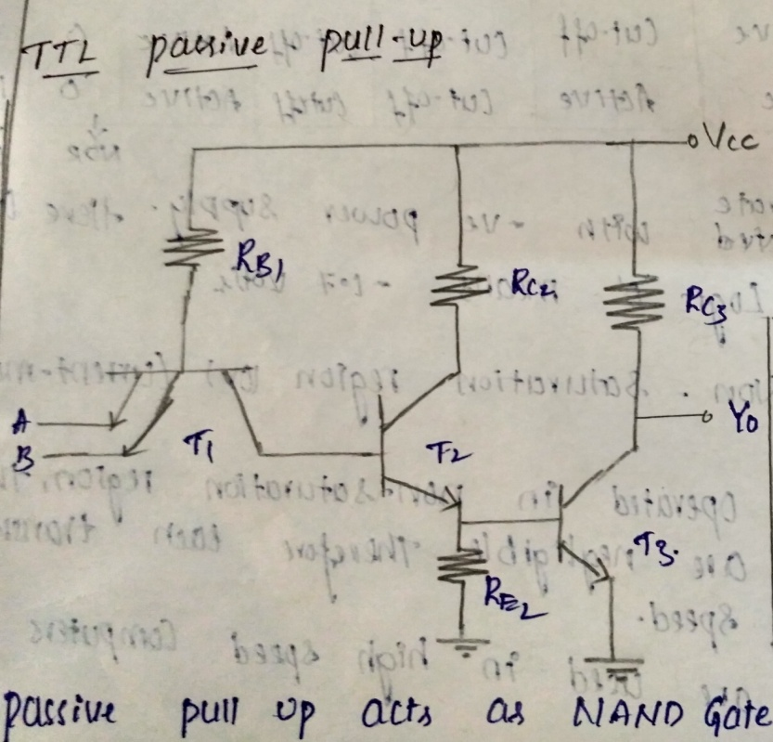

A | B | Transistor(t1) |  | T2 | T3 | Output
 |  | Emitter junction A | Emitter junction B
Logic0 | Logic0 | FB | FB | Cut-off | Cut-off | Logic1
Logic0 | Logic1 | FB | RB | Cut-off | Cut-off | Logic1
Logic1 | Logic0 | FB | FB | Cut-off | Cut-off | Logic1
Logic1 | Logic1 | RB | RB | saturation | saturation | Logic0

Fig 2 operation of TTL with passive pull up

Va | Vb | Vy
0 | 0 | 1
0 | 1 | 1
1 | 0 | 1
1 | 1 | 0

Fig 3 operation of TTL NAND
The operation of passive pull up involves the following cases. From the diagram we can notice that transistor T1 has two emitter junctions i.e., A & B.
Case (i):
If both emitter junctions A and B are equal to logic 0 then the status of emitter junction A and emitter junction B is in FB condition.

The minimum voltage at the base of T1 i.e.,
VB1 = V0 + VBE
= 0.2 +0.7
VB1 = 0.9 v
This is the available voltage at the base of T1.But to conduct T2& T3 the required voltage at the base of T1 is
=VBEcutin+ VBEcutin + 0.7
=0.5 + 0.5 + 0.7
=1.7 v
It is the required voltage at the base of T1 to conduct T2 & T3.but the minimum voltage at the base of T1 is less than the required voltage at the base of T1.hence T2 & T3 will be in cut-off region .thus the output is logic 1.
Case (ii):
If the emitter junction A is logic 0 & emitter junction B is logic 1 then status at A will be FB and status at B will be RB and transistors T2 & T3 will be in cut-off region and output is logic 1.
Case (iii):
If the emitter junction A is logic 1 & emitter junction B is logic 0 then status at A will be RB and status at B will be FB and transistors T2 & T3 will be in cut-off region and output is logic 1.
Case (iv):
If both the emitter junction A & B is logic 1 then status at A and B will be RB and current passing through transistor T1 by the source is sufficient to conduct T2 & T3.
Hence T2 & T3 will be in saturation region and hence o/p is logic 0.
(ii) TTL with totem pole output:-
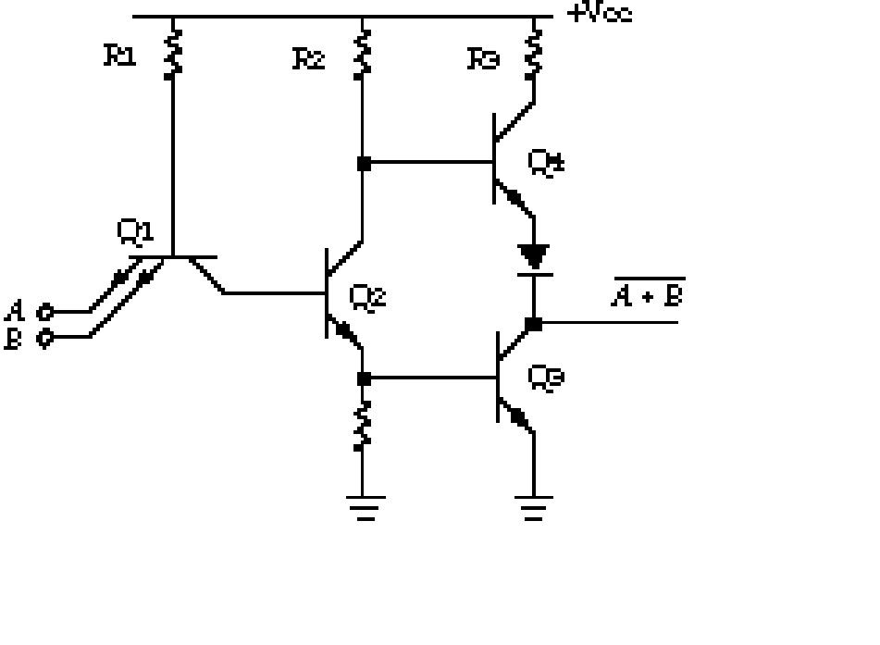
Fig(1). 2 input TTL with Totem pole output
Inputs |  | Transistors T1 |  | Transistors |  | Output
A | B | Emitter junction A | Emitter junction B | T2 | T3 | Y
0 | 0 | FB | FB | cutoff | cutoff | Logic 1
0 | 0 | FB | RB | cutoff | cutoff | Logic 1
1 | 0 | RB | FB | cutoff | cutoff | Logic 1
1 | 1 | RB | RB | saturation | saturation | Logic 0
Fig (2):- operation of TTL NAND gate with totem pole output.

A | B | Y
0 | 0 | 1
0 | 1 | 1
1 | 0 | 1
1 | 1 | 0
Fig (3):- operation of TTL NAND gate.
Operation:-
TTL with totem pole o/p configuration defines the TTL with active pull-up. it means it is possible in TTL to totem pole the speed of operation by reducing the time constant without increasing the power dissipation with the help of TTL with active pull up.
Here TTL with active pull up is termed as the configuration of TTL with totem pole o/p.
The operation of TTL with totem pole output involves the following four cases
Case (i):
If both inputs at T1 are equal to logic 0 i.e., A=B=0 then the emitter junction A & emitter junction B of T1 will act in FB. But here the required voltage at the base of T1 is greater than the available voltage at the base of T1.due to this reason T2 & T3 will be in cutoff region. it means the available voltage at the base of T1 is
VB1 = V0 + VBE
=0.2 +0.7
VB1 =0.9 v
But the required voltage at the base of T1 is
=VBEcutin+ VBEcut + 0.7
=0.5 + 0.5 + 0.7
=1.7 v
When T2 operates in cutoff region then current supplied by source Vcc is sufficient to operate T4 in saturation region. Thus the o/p is equal to the Vcc that means Y=logic 1.

Case (ii):
If one i/p is logic 0 and logic 1 i.e., A=0, B=1 then the emitter junction A of T1 will be in FB and emitter junction B of T1 will be in RB. due to the reason of available voltage at the base of T1 is less than the required voltage at the base of T1, both the transistors T2 & T3 operates in cutoff region and T4 operates in saturation region thus o/p = logic 1.
Case (iii):
If one i/p is logic 1 and logic 0 i.e., A=1, B=0 then the emitter junction A of T1 will be in RB and emitter junction B of T1 will be in FB.due to the reason of available voltage at the base of T1 is less than the required voltage at the base of T1, both the transistors T2 & T3 operates in cutoff region and T4 operates in saturation region thus o/p = logic 0.
Case (iv):
If both inputs are equal to logic 1 i.e., A=B=1 then the emitter junction A & emitter junction B operates in RB.the current supplied by the source is sufficient to operate T2 & T3 in saturation region while T4 operates in cutoff region. Thus o/p= logic 0.

(iii)TTL with open collector output:
The main drawback of TTL with totem pole o/p is the two o/p’s of the two gates cannot be connected together. The TTL with open collector o/p configuration is to be useful to overcome the drawback of TTL with totem pole o/p. the collector terminal of T3 is available outside the integrated ckt where the external resistor is to be connected. This TTL with open collector o/p configuration will act as passive pull up also.
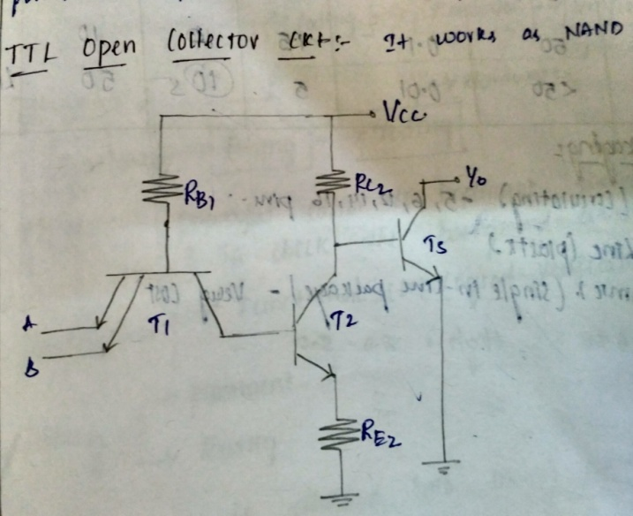
(iii):- Tristate TTL:
Basically normal digital ckt is having two o/p states i.e., low o/p state & high o/p state. Suppose if the o/p is not in low state then definitely it is ion the high state.
But tri state TTL has three o/p states
- Low o/p state
- High o/p state
- High impedance o/p state

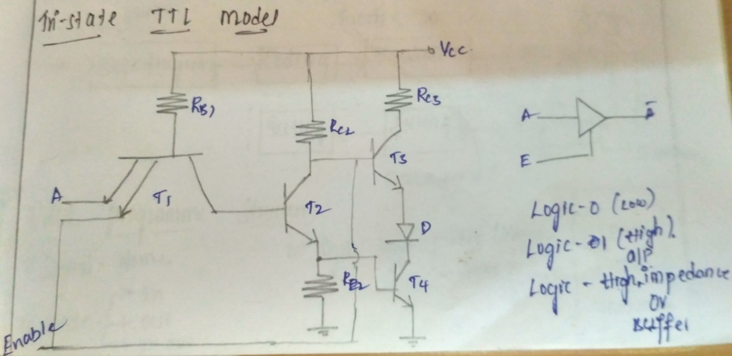
(a) low output state:
If the tristate TTL o/p is low then driver gate the load current as shown in fig.
(b) High output state:
If tri-state TTL o/p is high then, the driver gate supplies the current to the load as shown in fig
(c) High impedance o/p state:
If tri-state TTL o/p is high impedance then it acts as open and there is no sink & source as
showen in fig
The operation of tri state TTL inverter is described in the following two cases.
CASE(1):
If enable is high then corresponding emitter junction of T1 is operate in reverse bias.
a). If A is high then corresponding emitter junction of T1 is operated in reverse biase and current supplied through the collector terminal of T1 which forces T2 &T3 to operate in saturation region.
Then the O/P is low and t4 is operated in out-off region.
B).If A is low then corresponding emitter junction of T1 is operated in F.B and then T2 & T3 operate in cut-off region.Then the o/p is high and t4 is operated in saturation region.
CASE(2):
If enable is low then corresponding emitter junction of T1 is operate in F.B.
Now T2 &T3 to operate in cut-off region due to low enable i/p E and D2 operates in F.B then T4 also operates in cut-off region. Thus o/p is the high impedance state.
IC Packages:-
These are mainly classified into three types. They are:
- Metal can package.
- Dual in line package.
- flat package.
1. metal can package:-
The metal can package are available with 3,5,8,10,12 pins. The metal sealing plane is at the bottom over which the chip is bounded. The plane is efficient for heat dissipation.

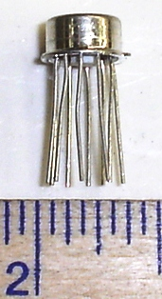
It also permits the external heat sink. it is also called as transistor pack.

2. dual in line package:-
It is available with 8,12,14,16,20 pins. as the no. of components are required on the same chip increases the no. of pins also increases.

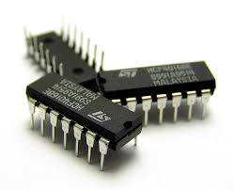

3. flat package:-
In this flat package the chip is enclosed in an rectangular ceramic case. This flat package will be available in 8,10,14,16 pins.

