UNIT-I
DATA COMMUNICATIONS
1. Introduction about Data Communication
2. Network
3. Topologies
4. Network Types
5. Switching
6. Data rate limits
7. Transmission Media
8. Applications of Network
9. Network goals
10. Protocol hierarchies
11. Design issues of layers
12. OSI Reference Model
13. Handshake
14. Multiplexing
15. Switching Techniques
16. Modes
17. Transmission Modes
18. Modulation (ANALOG-TO-ANALOG CONVERSION)
19. Keying alternatives (Digital-to-Analog Conversion)
20. IEEE Standards

1. Introduction about Data Communication
- When we communicate, we are sharing information. This sharing can be local or remote. Between individuals
- Local communication usually occurs face to face, while remote communication takes place over distance.
- Ex: Telephony, telegraphy and television
- The word data refers to information presented in whatever form is agreed by the parties creating and using the data
- Data communications are the exchange of data between two devices via some form of medium such as a wire.
- The effectiveness of a data communications system depends on four fundamental characteristics:
1. Delivery. The system must deliver data to the correct destination. Data must be received by the intended device or user and only by that device or user.
2. Accuracy. The system must deliver the data accurately. Data that have been altered in transmission and left uncorrected are unusable.
3. Timeliness. The system must deliver data in a timely manner. Data delivered late are useless.
4. Jitter. Jitter refers to the variation in the packet arrival time. For example, let us assume that video packets are sent every 30 ms. If some of the packets arrive with 30-ms delay and others with 40-ms delay, an uneven quality in the video is the result.
1.1 Components:
A data communications system has five components (see Figure 1.1).
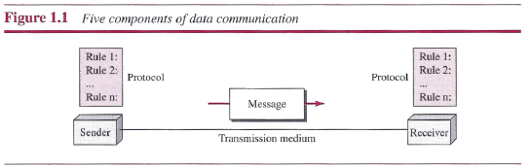
1. Message. The message is the information (data) to be communicated. Popular forms of information include text, numbers, pictures, audio, and video.
2. Sender. The sender is the device that sends the data message.
3. Receiver. The receiver is the device that receives the message.
4. Transmission medium. The transmission medium is the physical path by which a message travels from sender to receiver. Some examples of transmission media include twisted-pair wire, coaxial cable, fiber-optic cable, and radio waves.
5. Protocol. A protocol is a set of rules that govern data communications. It represents an agreement between the communicating devices. Without a protocol, two devices may be connected but not communicating, just as a person speaking French cannot be understood by a person who speaks only Japanese.
1.2 Data Representation
Information today comes in different forms such as text, numbers, images, audio, and video.
1.3 Data Flow
Communication between two devices can be simplex, half-duplex, or full-duplex as shown in Figure 1.2.
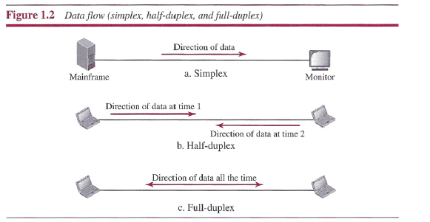
1. Simplex
In simplex mode, the communication is unidirectional, as on a one-way street. Keyboards and traditional monitors are examples of simplex devices. The keyboard can only introduce input; the monitor can only accept output.
2. Half-Duplex
In half-duplex mode, each station can both transmit and receive, but not at the same time.
Example: Walkie-talkies
3. Full-Duplex
In full-duplex mode (also called duplex), both stations can transmit and receive simultaneously
Example: When two people are communicating by a telephone line, both can talk and listen at the same time.
2. NETWORKS (Network goals)
A network is the interconnection of a set of devices capable of communication. The network may connect the laptop, workstations, Desktop, router, modem and switch.
2.1 Network Criteria
A network must be able to meet a certain number of criteria. The most important of these are performance, reliability, and security
Performance
Performance can be measured in many ways, including transit time and response time. Performance is often evaluated by two networking metrics: throughput and delay.
However, these two criteria are often contradictory. If we try to send more data to the network, we may increase throughput but we increase the delay because of traffic congestion in the network.
Reliability
Network reliability is measured by the frequency of failure, the time it takes to recover from a failure.
Security
Network security issues include protecting data from unauthorized access, protecting data from damage and procedures for recovery from data losses.
2.2 Physical Structures
Type of Connection:
There are two possible types of connections: point-to-point and multipoint.
Point-to-Point
A point-to-point connection provides a dedicated link between two devices. The entire capacity of the link is reserved for transmission between those two devices.
Example: When we change television channels by infrared remote control, we are establishing a point-to-point connection between the remote control and the television's control system.
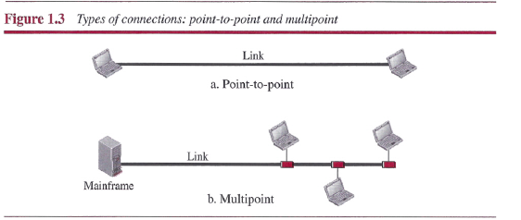
Multipoint
A multipoint (also called multidrop) connection is one in which more than two specific devices share a single link (see Figure 1.3b).
3. Physical Topology
The term physical topology refers to the way in which a network is laid out physically.
- There are four basic topologies possible: mesh, star, bus, and ring.
1. Mesh Topology
In a mesh topology, every device has a dedicated point-to-point link to every other device.
- In mesh topology, we need n (n - 1) / 2 duplex-mode links. To accommodate that many links, every device on the network must have n - 1 input/output (I/O) ports
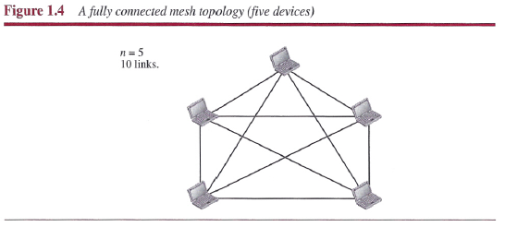
Advantages
1. Each Connection can carry its own data load, Thus eliminating the traffic problems.
2. Mesh topology is robust. If one link becomes unusable, it does not incapacitate the entire system.
3. Privacy or security. When every message travels along a dedicated line, only the intended recipient sees it.
Disadvantages
Mesh is related to the amount of cabling and the number of I/O ports required.
- One practical example is the connection of telephone regional offices in which each regional office needs to be connected to every other regional office.
2. Star Topology
- In a star topology, each device has a dedicated point-to-point link only to a central controller,
usually called a hub
- The devices are not directly linked to one another. Unlike a mesh topology, a star topology does not allow direct traffic between devices.
- The controller acts as an exchange: If one device wants to send data to another, it sends the
data to the controller, which then relays the data to the other connected device
- A star topology is less expensive than a mesh topology.
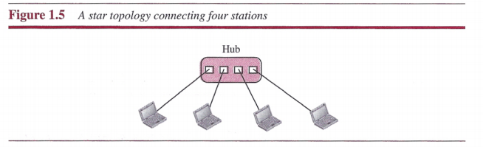
Advantages:
Robustness.
- If one link fails, only that link is affected. All other links remain active.
- Easy fault identification and fault isolation.
Disadvantages:
- The dependency of the whole topology on one single point, the hub. If the hub goes down, the whole system is dead.
3. Bus topology
A bus topology is multipoint. One long cable acts as a backbone to link all the devices in a
network.
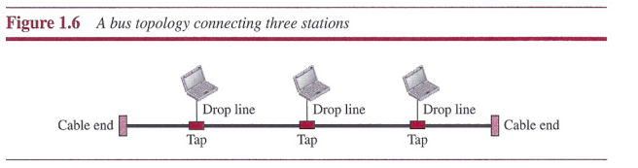
- Nodes are connected to the bus cable by drop lines and taps. A drop line is a connection running between the device and the main cable.
- A tap is a connector that either splices into the main cable or punctures the sheathing of a cable to create a contact with the metallic core.
Advantages:
- Ease of installation
- A bus uses less cabling than mesh or star topologies.
Disadvantages:
- It is difficult reconnection and fault isolation.
- Adding new devices may therefore require modification or replacement of the backbone.
- A fault or break in the bus cable stops all transmission.
4. Ring Topology
- In a ring topology, each device has a dedicated point-to-point connection with only the two devices on either side of it.
- A signal is passed along the ring in one direction, from device to device, until it reaches its destination.
- To add or delete a device requires changing only two connections.
- If one device does not receive a signal within a specified period, it can issue an alarm. The alarm alerts the network operator to the problem and its location.
Disadvantages:
Unidirectional traffic.
- In a simple ring, a break in the ring (such as a disabled station) can disable the entire network. This weakness can be solved by using a dual ring
4. NETWORK TYPES
We use a few criteria such as size, geographical coverage, and owner ship to make this distinction.
1. Local Area Network
- A local area network (LAN) is usually privately owned and connects some hosts in a
single office, building, or campus.
- Each host in a LAN has an identifier, an address, that uniquely defines the host in the LAN. A packet sent by a host to another host carries both the source host's and the destination host's addresses.
- In the past, all hosts in a network were connected through a common cable, which
meant that a packet sent from one host to another was received by all hosts. The intended
recipient kept the packet; the others dropped the packet.
- Today, most LANs use a smart connecting switch, which is able to recognize the destination address of the packet and guide the packet to its destination without sending it to all other hosts.
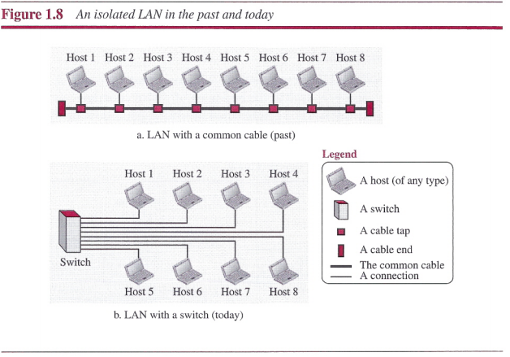

2. Wide Area Network
LAN | WAN
A LAN is normally limited in size, spanning an office, a building, or a campus; | WAN has a wider geographical span, spanning a town, a state, a country, or even the world.
A LAN interconnects hosts; | WAN interconnects connecting devices such as switches, routers, or modems.
A LAN is normally privately owned by the organization that uses it; | WAN is normally created and run by communication companies and leased by an organization that uses it.

Point-to-Point WAN
A point-to-point WAN is a network that connects two communicating devices through a transmission media (cable or air).
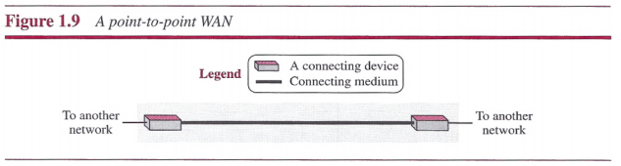
Switched WAN
A switched WAN is a network with more than two ends. A switched WAN, is used in the backbone of global communication today.
We can say that a switched WAN is a combination of several point-to-point WANs that are connected by switches.
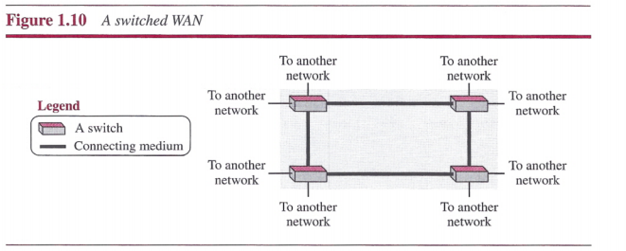
Internetwork
When two or more networks are connected, they make an internet work, or internet.(networks of network).
Example:
- Assume that an organization has two offices, one on the east coast and the other on the west coast. Each office has a LAN that allows all employees in the office to communicate with each other.
- To make the communication between employees at different offices possible, the management leases a point-to-point dedicated WAN from a service provider, such as a telephone company, and connects the two LANs. Now the company has an internetwork, or a private internet (with lowercase i). Communication between offices is now possible.
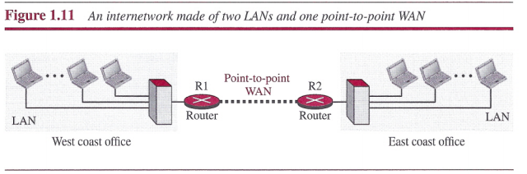
5. SWITCHING
- An internet is a switched network in which a switch connects at least two links
together. A switch needs to forward data from a network to another network when required.
- The two most common types of switched networks are
1. Circuit-switched networks
2.Packet-switched networks.
1. Circuit-switched net works:
- In a circuit-switched network, a dedicated connection, called a circuit, is always available between the two end systems; the switch can only make it active or inactive.
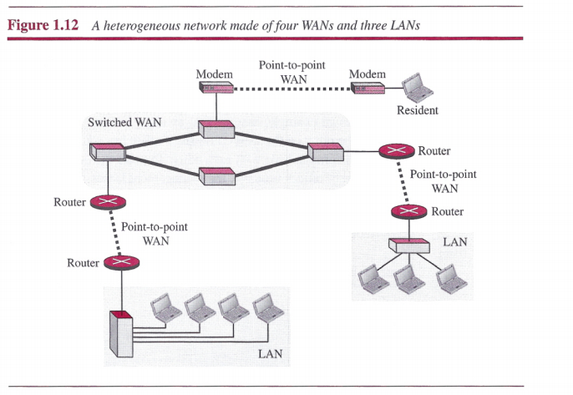
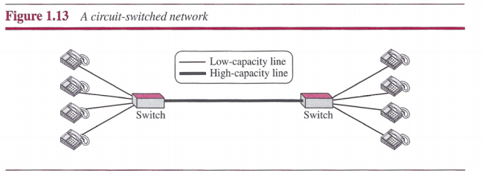
In Figure 1.13, the four telephones at each side are connected to a switch. The
switch connects a telephone set at one side to a telephone set at the other side.
- The thick line connecting two switches is a high-capacity communication line that can handle four voice communications at the same time; the capacity can be shared between all pairs of telephone sets.
- The switches used in this example have forwarding tasks but no
storing capability.(The thick line is fully used or partially used Based on that we decide the capacity.
2 .Packet-Switched Network
- In a computer network, the communication between the two ends is done in blocks of
data called packets.
- Instead of the continuous communication between two telephone sets , we see the exchange of individual data packets between the two computers.
- This allows us to make the switches function for both storing and forwarding.
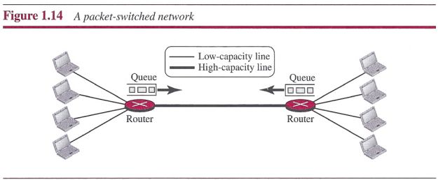
- Packet-switched network is more efficient than a circuit switched network, but the packets may encounter some delays.

6. DATA RATE LIMITS
A very important consideration in data communications is how fast we can send data, in bits per second, over a channel.
Data rate depends on three factors
1. The bandwidth available
2. The level of the signals we use
3. The quality of the channel (the level of noise)
Two theoretical formulas were developed to calculate the data rate:
- Nyquist for a noiseless channel 2. Shannon for a noisy channel.
1. Noiseless Channel: Nyquist Bit Rate
For a noiseless channel, the Nyquist bit rate formula defines the theoretical maximum bit rate
BitRate = 2 x bandwidth x log₂L
In this formula, bandwidth is the bandwidth of the channel, L is the number of signal levels used to represent data, and BitRate is the bit rate in bits per second.
Note: Increasing the levels of a signal may reduce the reliability of the system.
2. Noisy Channel: Shannon Capacity
In 1944 Shannon introduced a formula, called the Shannon capacity, to determine the
theoretical highest data rate for a noisy channel:
Capacity=bandwidth x log₂(1+SNR)
In this formula, bandwidth is the bandwidth of the channel, SNR is the signal-to-noise ratio, and capacity is the capacity of the channel in bits per second.
7. Transmission Media
Transmission media are actually located below the physical layer and are directly controlled by the physical layer.
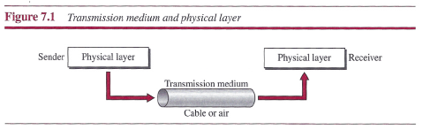
Transmission media can be divided into two broad categories: guided and unguided.
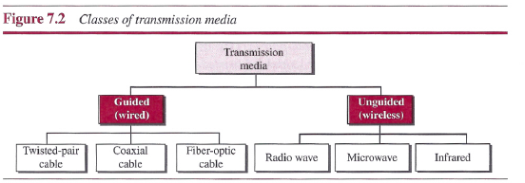
- Twisted-pair and coaxial cable use metallic (copper) conductors that accept and transport signals in the form of electric current.
- Optical fiber is a cable that accepts and transports signals in the form of light.
1. Twisted-Pair Cable
- A twisted pair consists of two conductors (normally copper), each with its own plastic insulation, twisted together, as shown in Figure 7.3.
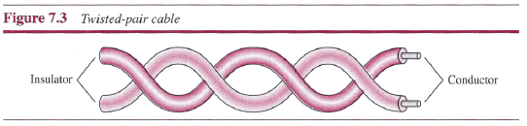
- One of the wires is used to carry signals to the receiver, and the other is used only as a ground reference.
- In addition to the signal sent by the sender on one of the wires, interference (noise) and crosstalk may affect both wires and create unwanted signals.
- If the two wires are parallel, the effect of these unwanted signals is not the same in both wires because they are at different locations relative to the noise or crosstalk sources (e.g., one is closer and the other is farther). This results in a difference at the receiver.
- By twisting the pairs, a balance is maintained.
- The number of twists per unit of length (e.g., inch) has some effect on the quality of the cable.

Unshielded (UTP) Versus Shielded Twisted-Pair Cable(STP)
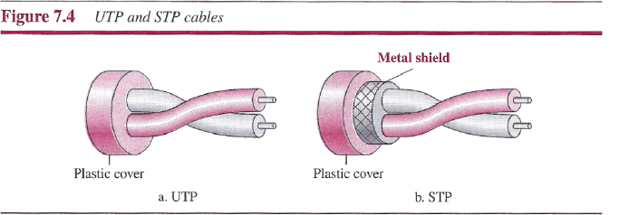
Categories
- The Electronic Industries Association (EIA) has developed standards to classify unshielded twisted-pair (UTP) cable into seven categories.
- Categories are determined by cable quality, with 1 as the lowest and 7 as the highest.
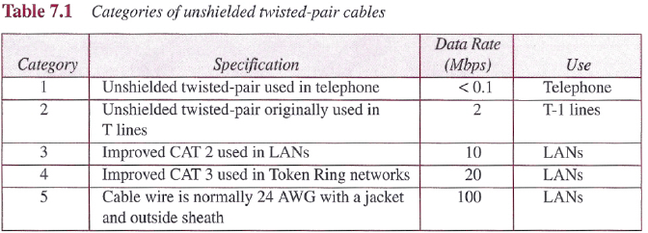
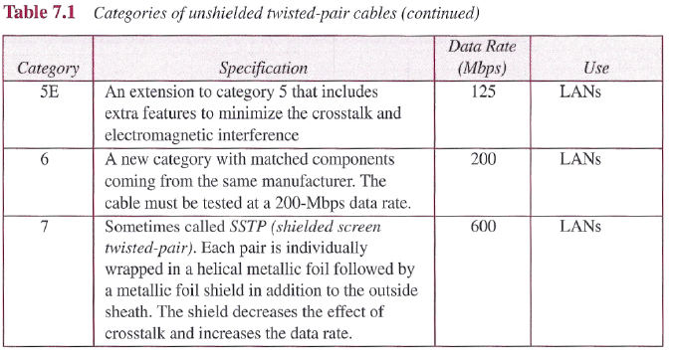
Connectors
- The most common UTP connector is RJ45 (RJ stands for registered jack), as shown in Figure 7.5. The RJ45 is a keyed connector, meaning the connector can be inserted in only one way.
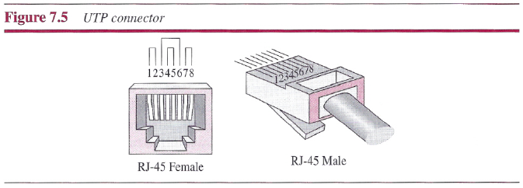
Applications:
- Twisted-pair cables are used in telephone lines to provide voice and data channels.
- Local-area networks, such as lO Base-T and lOO Base-T, also use twisted-pair cables.
2. Coaxial Cable
Coaxial cable (or coax) carries signals of higher frequency ranges than those in twisted pair cable.
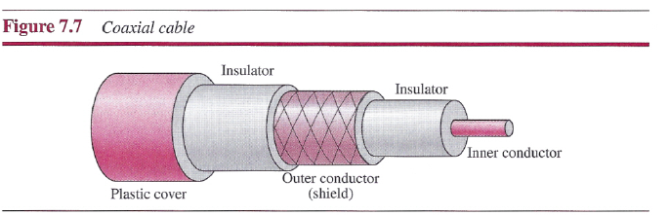
Coaxial cables are categorized by their Radio Government (RG) ratings.
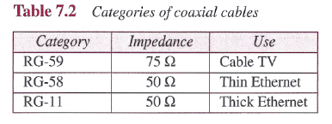
Applications
- Coaxial cable was widely used in analog telephone networks where a single coaxial network could carry 10,000 voice signals.
- Later it was used in digital telephone networks where a single coaxial cable could carry digital data up to 600 Mbps.
- Cable TV networks also use coaxial cables.

3. Fiber-Optic Cable
A fiber-optic cable is made of glass or plastic and transmits signals in the form of light.
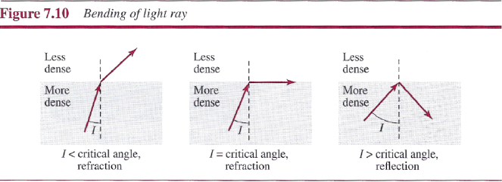
- As the figure shows, if the angle of incidence I is less than the critical angle, the ray refracts and moves closer to the surface.
- If the angle of incidence is equal to the critical angle, the light bends along the interface.
- If the angle is greater than the critical angle, the ray reflects (makes a turn) and travels again in the denser.
Optical fibers use reflection to guide light through a channel.
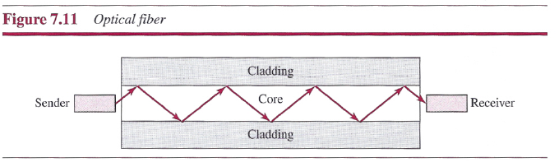
Propagation Modes
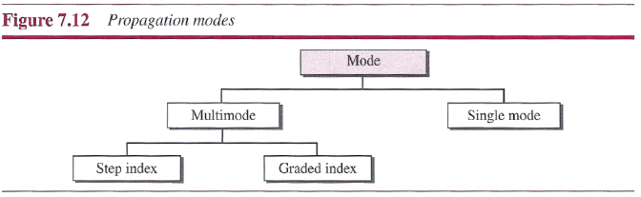
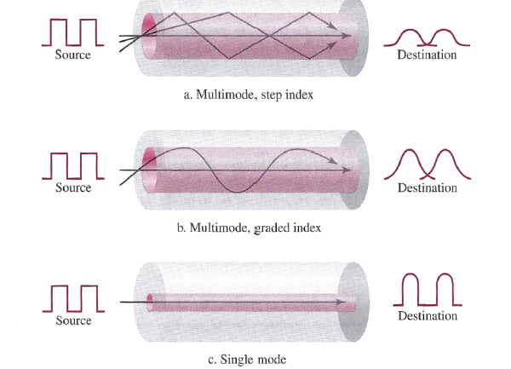

Fiber-Optic Cable Connectors
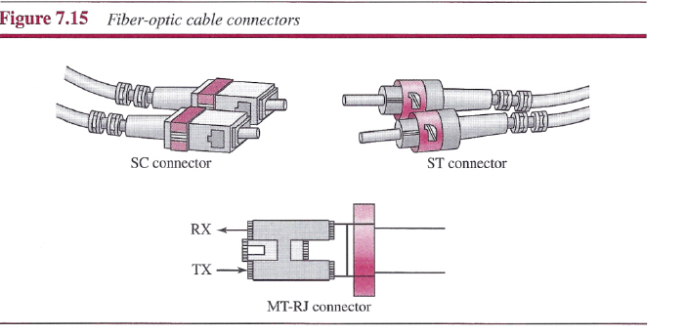
- The subscriber channel (SC) connector is used for cable TV. It uses a push/pull locking system.
- The straight-tip (ST) connector is used for connecting cable to networking devices.
- MT-RJ is a connector that is the same size as RJ45.
Advantages of Optical Fiber
Higher bandwidth: Fiber-optic cable can support dramatically higher bandwidths (and hence data rates) than either twisted-pair or coaxial cable.
Less signal attenuation. Fiber-optic transmission distance is significantly greater than that of other guided media. A signal can run for 50 km without requiring regeneration. We need repeaters every 5 km for coaxial or twisted-pair cable.
Immunity to electromagnetic interference: Electromagnetic noise cannot affect fiber-optic cables.
Resistance to corrosive materials: Glass is more resistant to corrosive materials than copper.
Light weight: Fiber-optic cables are much lighter than copper cables.
Greater immunity to tapping: Fiber-optic cables are more immune to tapping than copper cables.
Disadvantages
- Installation and maintenance: Fiber-optic cable is a relatively new technology. Its installation and maintenance require expertise that is not yet available everywhere.
- Unidirectional light propagation: Propagation of light is unidirectional. If we need bidirectional communication, two fibers are needed.
- Cost: The cable and the interfaces are relatively more expensive than those of other guided media.
UNGUIDED MEDIA: WIRELESS
Unguided medium transport electromagnetic waves without using a physical conductor. This type of communication is often referred to as wireless communication.
- Radio Waves
Demarcation between radio waves and microwaves, electromagnetic waves ranging in frequencies between 3 kHz and 1 GHz are normally called radio waves; waves ranging in frequencies between I and 300 GHz are called microwaves.
Omni directional Antenna
Radio waves use Omni directional antennas that send out signals in all directions. Based on the wavelength, strength, we have use different types of antennas.
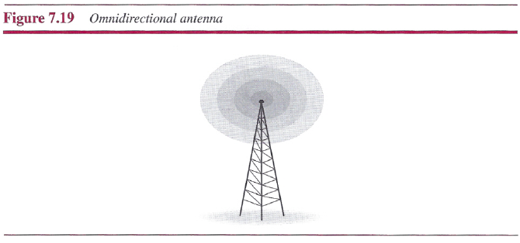
Applications
Radio waves are used for multicast communications, such as radio and television.
2. Microwaves
- Electromagnetic waves having frequencies between 1 and 300 GHz are called microwaves.
- Microwaves are unidirectional.
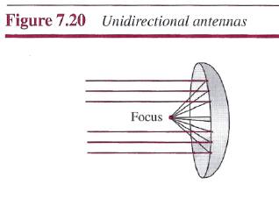
Applications:
Microwaves are used for unicast communication such as cellular telephones, satellite networks, and wireless LANs.
3. Infrared
- Infrared waves, with frequencies from 300 GHz to 400 THz (wavelengths from 1 mm to 770 nm), can be used for short-range communication.
- Infrared waves cannot penetrate walls.
Applications:
TV Remote
8. Applications of networks:
A computer network is a telecommunications network which allows computers to exchange data. It is a collection of computers and other devices (nodes) that use a common network protocol to share information and resources with each other over a network medium. The network medium may be copper wire, fiber optics, microwave, infrared or even communication satellites.
  - Business Applications
  - Home Applications
  - Mobile Users(Portable devices like laptop, PDA)
  - Social Issues(Facebook)

Business Applications
- Resource sharing:- Computer Network is used in Resource sharing. The Same Device in a network can be accessed by the different computer which is connected to the same network like the printer, fax, scanner, etc.
- Information sharing:- Information sharing is the exchange of data between various organizations, people, and technologies. Different information and data can be shared like the file, videos, etc.
- High Reliability:- Having alternative sources of supply i.e. data should be placed on 2 or 3 machines such that if one goes down other copies will be used.
- Saving Money: Small computers have a much better price than large ones. Mainframes are 1000 times costlier than PC’s. This imbalance is solved by building a model called client / server model.

A network with two clients and one server
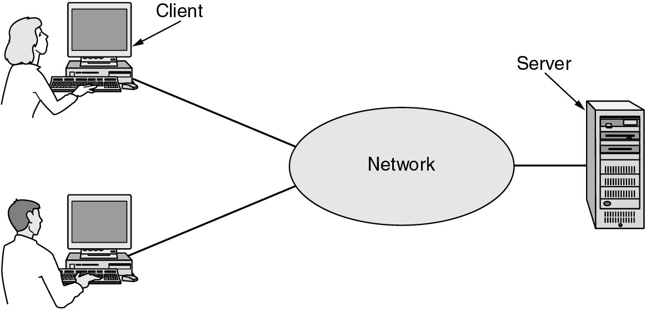
The client-server model involves requests and replies.
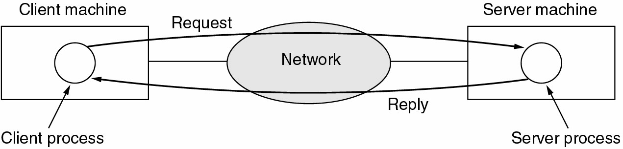
- Scalability: - Ability to increase system performance gradually as workload grows just by adding processors.

Home Applications
- Access to remote information:- Computer Network facilitates users to access information that is distant away by staying at home remotely. Ex: Google search, etc.
- Person-to-person communication:- Users can use Computer Network in their home to communicate with other peoples by telephone, video chat, etc.
- Interactive entertainment: - Computer Network is used in multiplayer gaming. It is also used in social networking sites like face book, twitter, etc to connect people.
Live television may also become interactive, with the audience participating in quiz shows, choosing among contestants, and so on.
- E-commerce: - The capability of buying/ selling products through an internet without any paper document is called E-commerce. Computer Network is also used in E-commerce where users can pay bills, transfer cash, buy good, etc using the computer. The most popular E- commerce categories are
B2C- Business to Consumer- Ordering books online
B2B- Business to Business- Car manufacturers ordering tiers from suppliers
G2C- Government to Consumer – Government distributing income tax forms through online
C2C- Consumer to Consumer- Auctioning second hand products online
P2P- Peer to Peer- File sharing

Mobile Users
- Computer Network is used in the mobile device like telephone, Smartphone, tablets, PDA’s, laptops etc for communication, the internet, file sharing, etc.
Social Issues: Politics, education, news papers ect. comes under social issues.

9. Network goals
- Resource and load sharing
  - Programs do not need to run on a single machine
- Reduced cost
  - Several machines can share printers, tape drives, etc.
- High reliability
  - If a machine goes down, another can take over
- Communication(E-mail, videoconference)
- E-business: Many companies are doing business electronically with other companies, especially suppliers and customers.
- For example, manufacturers of automobiles, aircraft, and computers, among others, buy subsystems from a variety of suppliers and then assemble the parts.
- E-Commerce: Doing business with consumers over the Internet.
10. Protocol hierarchies

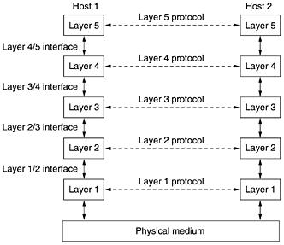
- To reduce their design complexity, most networks are organized as a stack of layers or levels, each one built upon the one below it.
- The number of layers, the name of each layer, the contents of each layer, and the function of each layer differ from network to network.
- The purpose of each layer is to offer certain services to the higher layers.
- Layer n on one machine carries on a conversation with layer n on another machine.
- Basically, a protocol is an agreement between the communicating parties on how communication is to proceed.
- Below layer 1 is the physical medium through which actual communication occurs. In Fig. Virtual communication is shown by dotted lines and physical communication by solid lines.
- A set of layers and protocols is called network architecture.
Figure: Example information flow supporting virtual communication in layer 5
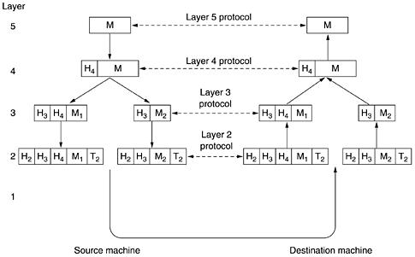

11. Design Issues
There are some key design issues occur in computer networks are present in several layers
- Addressing
- Error control
- Flow control
- Multiplexing
- Demultiplexing
- Routing
Addressing
Every layer needs a mechanism to identify senders and receivers.
Error control
It’s an important issue because physical communication circuits are not perfect. Many error detecting and error correcting codes are available. Both sending and receiving ends are must agree to use any one code.
Flow control
This property leads to mechanisms for disassembling, transmitting and then reassembling messages.

Routing
When there are multiple paths between source and destination, a route must be chosen.
Multiplexing and Demultiplexing
These two are must for improving the network system.
*OSI Reference model:
The Open Systems Interconnection (OSI) Model partitions networking functions into seven layers. Industry standards have been (or are being) defined at each layer. Each layer provides services needed by the next higher layer.
Follow class notes for explanation
Fig.: The OSI reference model.

Summary:
- The Open Systems Interconnection Model partitions networking functions into seven layers
- Industry standards have been (or are being) defined at each layer
- Each layer provides services needed by the next higher layer
Layer 1 - Physical Layer
  - Responsible for transmission of raw data over a communication medium
Layer 2 - Data Link Layer
  - Detects and corrects any errors that may occur in the physical layer transmission
Layer 3 - Network Layer
  - Responsible for relaying and routing information to its destination
Layer 4 - Transport Layer
  - Provides a consistent interface for ``end-to-end'' communications
  - Frees upper layers from the concerns of achieving data transfer
Layer 5 - Session Layer
  - Provides the services needed to coordinate dialogue and manage data exchange
Layer 6 - Presentation Layer
  - Responsible for the selection of an agreed syntax to be used for the transfer of information
Layer 7 - Application Layer
  - Window into the OSI environment
  - Provides common elements for management of OSI resources
  - Some elements provide:
    - File transfer
    - Distributed processing
- The seven layers can be grouped into three groups - Network, Transport and Application.
- Layer 1, 2 and 3 i.e. physical, data link, and network are network support layers.
- Layer 4, Transport layer provides end to end reliable data transmission.
Layer 5, 6 and 7 i.e. Session, Presentation, and Application layer are user support layers.

*TCP/IP REFERENCE MODEL: Follow class notes

* Comparison between OSI & TCP/IP Reference Models: Follow class notes

*3 Way Handshake Procedures (SYN, SYN-ACK, ACK)
- Host A sends a TCP SYNchronize packet to Host B
- Host B receives A's SYN
- Host B sends a SYNchronize-ACKnowledgement
- Host A receives B's SYN-ACK
- Host A sends ACKnowledge
- Host B receives ACK.
TCP socket connection is ESTABLISHED.
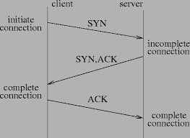

*MULTIPLEXING
- In a multiplexed system, n lines share the bandwidth of one link. Figure 6.1 shows the basic format of a multiplexed system.
- The lines on the left direct their transmission streams to a multiplexer (MUX), which combines them into a single stream (many-to one).
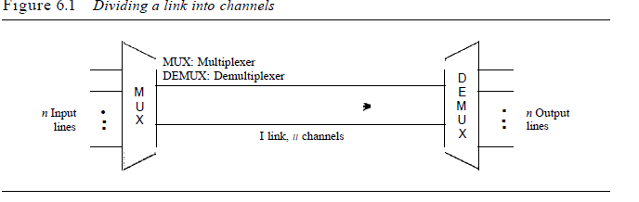
- At the receiving end, that stream is fed into a demultiplexer (DEMUX), which separates the stream back into its component transmissions (one-to-many)
- There are three basic multiplexing techniques: frequency-division multiplexing, wavelength-division multiplexing, and time-division multiplexing. The first two are techniques designed for analog signals, the third, for digital signals
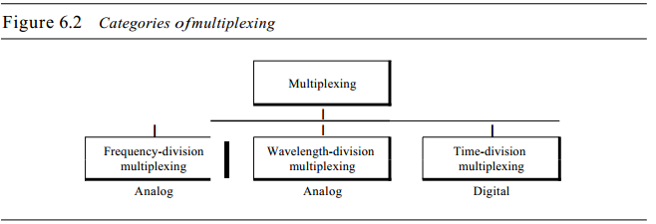
1. Frequency Division Multiplexing (FDM):
- A number of signals can be transmitted at the same time. Each source is allotted a frequency range in which it can transfer it's signals, and a suitable frequency gap is given between two adjacent signals to avoid overlapping
- This is type of multiplexing is commonly seen in the cable TV networks.
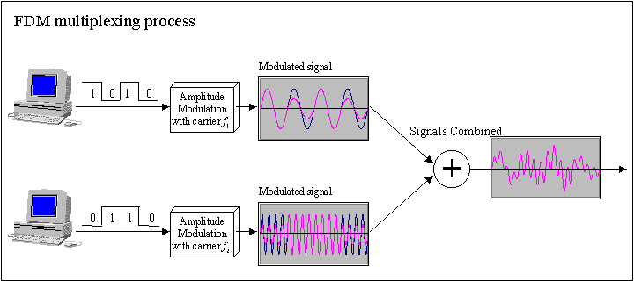
2. Wavelength-Division Multiplexing (WDM)
- Wavelength-division multiplexing (WDM) is designed to use the high-data-rate capability of fiber-optic cable.
- The optical fiber data rate is higher than the data rate of metallic transmission cable.
- Using a fiber-optic cable for one single line wastes the available bandwidth. Multiplexing allows us to combine several lines into one.
- WDM is conceptually the same as FDM, except that the multiplexing and demultiplexing involve optical signals transmitted through fiber-optic channels
- Figure 6.10 gives a conceptual view of a WDM multiplexer and demultiplexer. Very narrow bands of light from different sources are combined to make a wider band of light. At the receiver, the signals are separated by the demultiplexer.
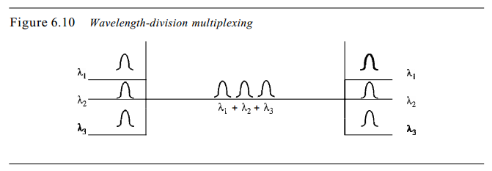
3. Time Division Multiplexing (TDM):
- Multiple signals can be transmitted if each signal is allowed to be transmitted for a definite amount of time.
- These time slots are so small that all transmissions appear to be in parallel.
Synchronous TDM:
- Time slots are pre assigned and are fixed.
- Each source is given it's time slot at every turn due to it. This turn may be once per cycle, or several turns per cycle
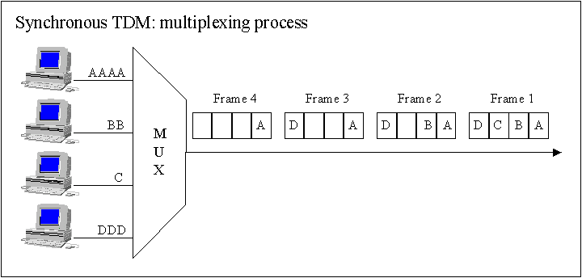
Asynchronous TDM:
In this method, slots are not fixed. They are allotted dynamically depending on speed of sources, and whether they are ready for transmission.
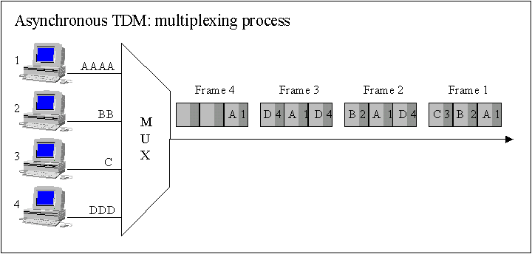

*Switching Techniques
- A network consists of many switching devices. In order to connect multiple devices, one solution could be to have a point to point connection in between pair of devices. But this increases the number of connection.
- The other solution could be to have a central device and connect every device to each other via the central device which is generally known as Star Topology.
- Both these methods are wasteful and impractical for very large network. Hence a better solution for this situation is SWITCHING.
- A switched network is made up of a series of interconnected nodes called switches.
Types of Switching Techniques
There are basically three types of switching methods are made available
1) Circuit Switching
2) Packet Switching (VC and Datagram)
3) Message Switching
1. Circuit Switching
- When two nodes communicate with each other over a dedicated communication path, it is called circuit switching.
- There 'is a need of pre-specified route from which data will travel and no other data is permitted.
- In circuit switching, to transfer the data, circuit must be established so that the data transfer can take place.
- Circuit switching may have to go through three phases:
1. Establish a circuit 2. Transfer the data 3. Disconnect the circuit
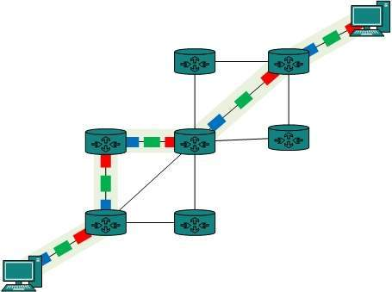
- Circuit switching was designed for voice applications. Telephone is the best suitable example of circuit switching. Before a user can make a call, a virtual path between caller and callee is established over the network.
Advantages
The communication channel (once established) is dedicated.
Disadvantages
1. Possible long wait to establish a connection, (10 seconds, more on long- distance or international calls.) during which no data can be transmitted.
2. More expensive than any other switching techniques, because a dedicated path is required for each connection.
2. Packet Switching
- The entire message is broken down into smaller chunks called packets. The switching information is added in the header of each packet and transmitted independently.
- It is easier for intermediate networking devices to store small size packets
- The internet uses packet switching technique.
- Packets are stored and forwarded according to their priority to provide quality of service.
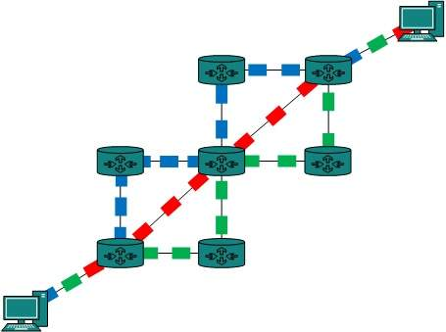
3. Message Switching
- Receives the whole message and buffers it until there are resources available to transfer it to the next hop.
If the next hop is not having enough resource to accommodate large size message, the message is stored and switch waits
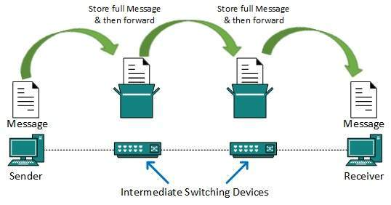
Drawbacks:
- Every switch in transit path needs enough storage to accommodate entire message.
- Because of store-and-forward technique and waits included until resources are available, message switching is very slow.
- Message switching was not a solution for streaming media and real-time applications.
*Modems
- Traditional modems used on dialup networks convert data between the analog form used on telephone lines and the digital form used on computers.
- Standard dial-up network modems transmit data at a maximum rate of 56,000 bits per second (56 Kbps).
- A dial-up connection is fixed internet connection that uses a voice band modem and telephone lines to transport data between your computer and your ISP( Internet Service Provider)
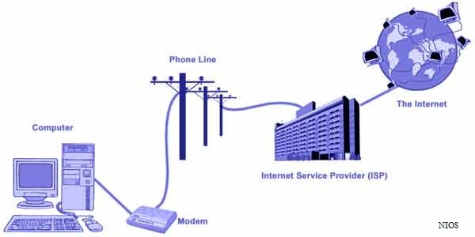
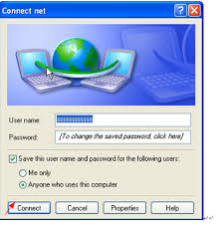
- You were charged for every second that you connected to the internet.
- Dial up internet access is very slow. It is OK for browsing web sites, but you would not be able to watch movies on a dial-up connection
Types of modems
- Internal Modem: (Narrow band dial-up) internal modem is a circuit board that is inserted into an expansion slot on the motherboard.
- Internal modem cannot be moved from one computer to anther easily. It is difficult to setup than other types of modem.
- It is less expensive than external modem.
- They do not require a power supply
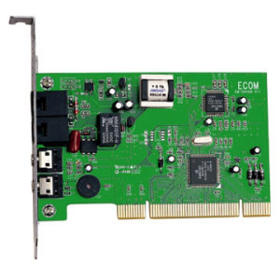
External Modem (Broad band modem)
- External modem is attached to the system unit as an external device through telephone line.
- It requires external power supply.
- It is easy to setup.
- External modem is expensive.
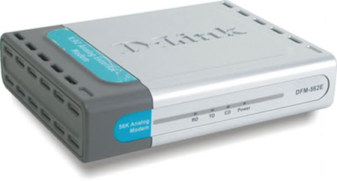
Broader, wider- more bandwidth
- More bandwidth than narrow band dial up(56kbps)
- Greater than 128 kbps.
- Higher bandwidths of 256, 512, 1024 kbps and above.
- Always on
- Use various mediums:
- 1. Copper 2. Coaxial 3. Wireless (Microwave, satellite etc) 4. Optical Fiber.
- Wireless modem transmits the data signals through air instead of cable.
- It also known as radio-frequency modem. It is designed to work with cellular technology and wireless local area networks.
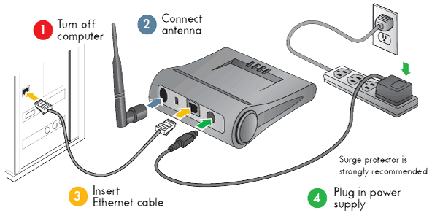

* TRANSMISSION MODES
The transmission of binary data across a link can be accomplished in either parallel or serial mode. In parallel mode, multiple bits are sent with each clock tick. In serial mode, 1 bit is sent with each clock tick. While there is only one way to send parallel data, there are three subclasses of serial transmission: asynchronous, synchronous, and isochronous (see Figure 4.31).
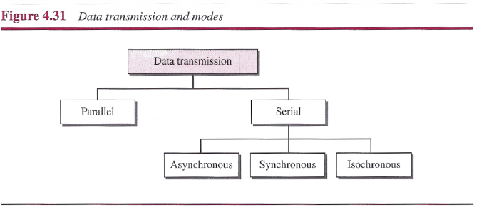
1. Parallel Transmission
- In parallel transmission, all the bits of data are transmitted simultaneously on separate communication lines.
- In order to transmit n bits, n wires or lines are used. Thus each bit has its own line.
- All n bits of one group are transmitted with each clock pulse from one device to another i.e. multiple bits are sent with each clock pulse.
- Parallel transmission is used for short distance communication.
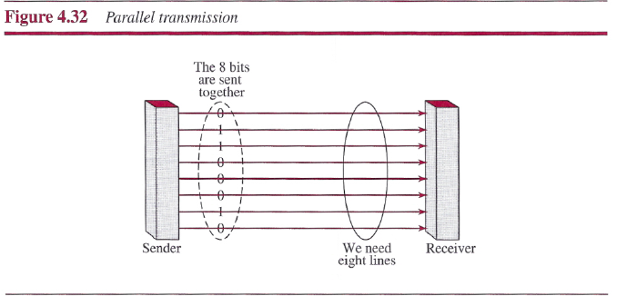

Advantage of parallel transmission
- It is speedy way of transmitting data as multiple bits are transmitted simultaneously with a single clock pulse.
Disadvantage of parallel transmission
- It is costly method of data transmission as it requires n lines to transmit n bits at the same time.
2. Serial Transmission
- In serial transmission, the various bits of data are transmitted serially one after the other.
- It requires only one communication line rather than n lines to transmit data from sender to receiver.
- Thus all the bits of data are transmitted on single line in serial fashion.
- In serial transmission, only single bit is sent with each clock pulse.
- Serial transmission is used for long distance communication.
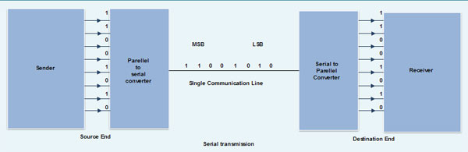
Advantage of Serial transmission
- Use of single communication line reduces the transmission line cost by the factor of n as compared to parallel transmission.
Disadvantages of Serial transmission
- 1. Use of conversion devices at source and destination end may lead to increase in overall transmission cost.
- 2. This method is slower as compared to parallel transmission as bits are transmitted serially one after the other.

Types of Serial Transmission
1. Asynchronous Transmission
- Asynchronous transmission sends only one s one byte of data at a time.
- Start bit indicates the beginning of data.
- Stop bit indicates the end of data .
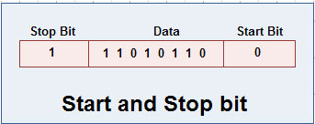
Start and stop increase the number of data bits. Hence more bandwidth is consumed in asynchronous transmission.
- There is an idle time between the transmissions of different data bytes. This idle time is also known as Gap.
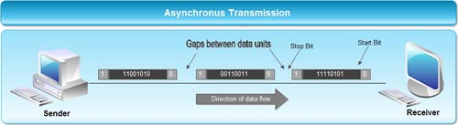
- Synchronous Transmission
- Synchronous transmission does not use start and stop bits.
- In this method bit stream is combined into longer frames that may contain multiple bytes.
- There is no gap between the various bytes in the data stream.
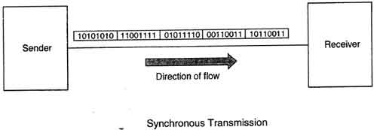
Comparison between Serial and Parallel transmission
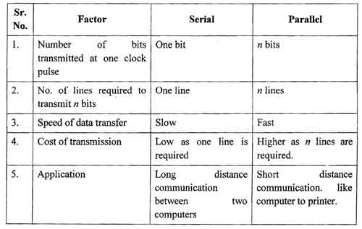
Comparison between Asynchronous and Synchronous
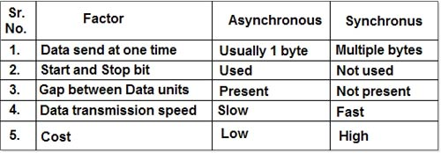

*Modulation (ANALOG-TO-ANALOG CONVERSION)
Analog-to-analog conversion can be accomplished in three ways: amplitude modulation (AM), frequency modulation (FM), and phase modulation (PM).
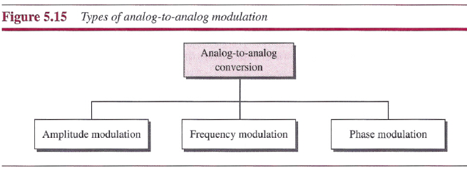
- Amplitude modulation (AM): In which the height (i.e., the strength or intensity) of the signal carrier is varied to represent the data being added to the signal.
- Frequency modulation (FM): In which the frequency of the carrier waveform is varied to reflect the frequency of the data.
- Phase modulation (PM): In which the frequency of the carrier waveform is varied to reflect changes in the frequency of the data (similar but not the same as FM).
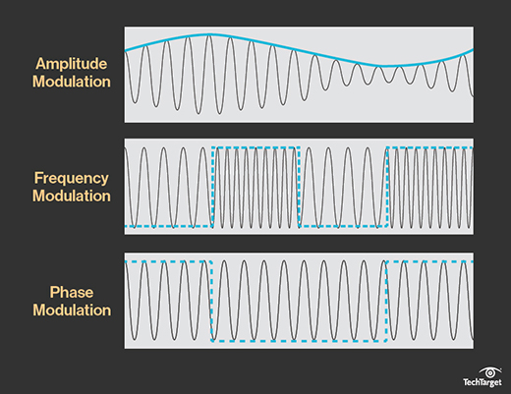

* Keying alternatives (Digital-to-Analog Conversion)
When data from one computer is sent to another via some analog carrier, it is first
converted into analog signals. Analog signals are modified to reflect digital data.
An analog signal is characterized by its amplitude, frequency, and phase. There are
three kinds of digital-to-analog conversions:
1. Amplitude Shift Keying
In this conversion technique, the amplitude of analog carrier signal is modified to reflect binary data.
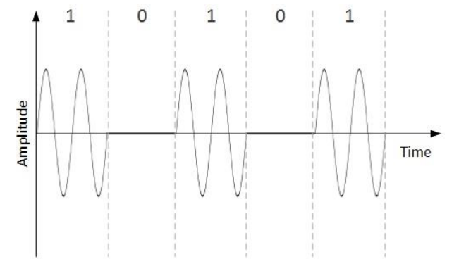
When binary data represents digit 1, the amplitude is held; otherwise it is set to 0.
Both frequency and phase remain same as in the original carrier signal.
2. Frequency Shift Keying
In this conversion technique, the frequency of the analog carrier signal is modified to
reflect binary data.
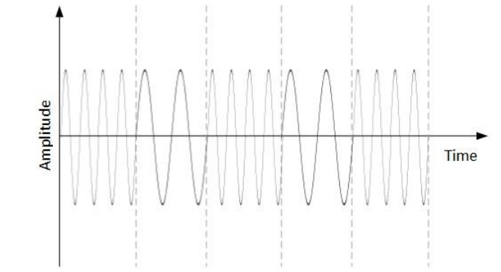
This technique uses two frequencies, f1 and f2. One of them, for example f1, is
chosen to represent binary digit 1 and the other one is used to represent binary digit
0. Both amplitude and phase of the carrier wave are kept intact.
3. Phase Shift Keying
In this conversion scheme, the phase of the original carrier signal is altered to reflect the binary data.
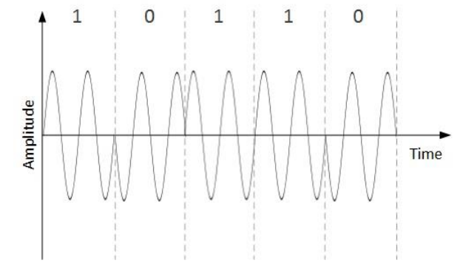
When a new binary symbol is encountered, the phase of the signal is altered.
Amplitude and frequency of the original carrier signal is kept intact.
4. Quadrature Phase Shift Keying
QPSK alters the phase to reflect two binary digits at once. This is done in two different
phases. The main stream of binary data is divided equally into two sub-streams. The
serial data is converted in to parallel in both sub-streams and then each stream is
converted to digital signal using NRZ technique. Later, both the digital signals are
merged together.
* IEEE (Network) standards
A set of network standards developed by the IEEE. They include:
        - IEEE 802.1(Network)
        - IEEE 802.2 (Logical Link Control)
        - IEEE 802.3 (Ethernet)
        - IEEE 802.4 (Token Bus)
        - IEEE 802.5 (Token Ring)
        - IEEE 802.6 (MAN)
        - IEEE 802.11 (Wireless LAN)
        - IEEE 802.15(Blue tooth)
IEEE 802.1
- IEEE 802.1: Standards related to network management.
- Network management covers a wide area, including:
    - Security: Ensuring that the network is protected from unauthorized users.
    - Performance: Eliminating bottlenecks in the network.
    - Reliability: Making sure the network is available to users and responding to hardware and software malfunctions.
IEEE 802.2
- IEEE 802.2: General standard for the data link layer in the OSI Reference Model.
- The IEEE divides this layer into two sub layers:
    - The logical link control (LLC) layer and
    - The media access control (MAC) layer.
- The Media Access Control Layer is one of two sub layers that make up the Data Link Layer of the OSI model.
- The MAC layer varies for different network types and is defined by standards IEEE 802.3 through IEEE 802.5.
- The MAC layer is responsible for moving data packets to and from one Network Interface Card (NIC) to another across a shared channel.
- The MAC sub layer uses MAC protocols to ensure that signals sent from different stations across the same channel don't collide.

IEEE 802.3: Defines the MAC layer for bus networks that use CSMA/CD.
IEEE 802.4: Defines the MAC layer for bus networks that use a token-passing mechanism (token bus networks).
Token bus networks
- A type of local-area network (LAN) that has a bus topology and uses a token -passing mechanism to regulate traffic on the bus.
- A token bus network is very similar to a token ring network, the main difference being that the endpoints of the bus do not meet to form a physical ring.
- Token bus networks are defined by the IEEE 802.4 standard.
IEEE 802.5: Defines the MAC layer for token-ring networks.
IEEE 802.6: Standard for Metropolitan Area Networks (MANs).
IEEE 802.11:
It refers to a family of specifications developed by the IEEE for wireless LAN technology. 802.11 specifies an over-the-air interface between a wireless client and a base station or between two wireless clients. The IEEE accepted the specification in 1997.
802.11 Family Members
There are several specifications in the 802.11 family:
802.11
Applies to wireless LANs and provides 1 or 2 Mbps transmission in the 2.4 GHz band using either frequency hopping spread spectrum (FHSS) or direct sequence spread spectrum (DSSS).
802.11a
An extension to 802.11 that applies to wireless LANs and provides up to 54 Mbps in the 5GHz band. 802.11a uses an orthogonal frequency division multiplexing encoding scheme rather than FHSS or DSSS.
802.11b
(also referred to as 802.11 High Rate or Wi-Fi) is an extension to 802.11 that applies to wireless LANs and provides 11 Mbps transmission (with a fallback to 5.5, 2 and 1 Mbps) in the 2.4 GHz band. 802.11b uses only DSSS. 802.11b was a 1999 ratification to the original 802.11 standard, allowing wireless functionality comparable to Ethernet.
802.11g
Applies to wireless LANs and provides 20+ Mbps in the 2.4 GHz band.
IEEE 802.15(Bluetooth)
A Personal Area Network (PAN) is smallest network which is very personal to a user. This may include Bluetooth enabled devices or infra-red enabled devices. PAN has connectivity range up to 10 meters. PAN may include wireless computer keyboard and mouse, Bluetooth enabled headphones, wireless printers, and TV remotes.
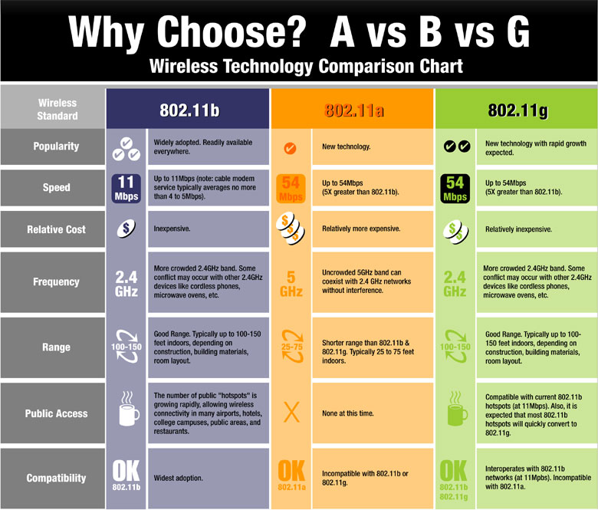
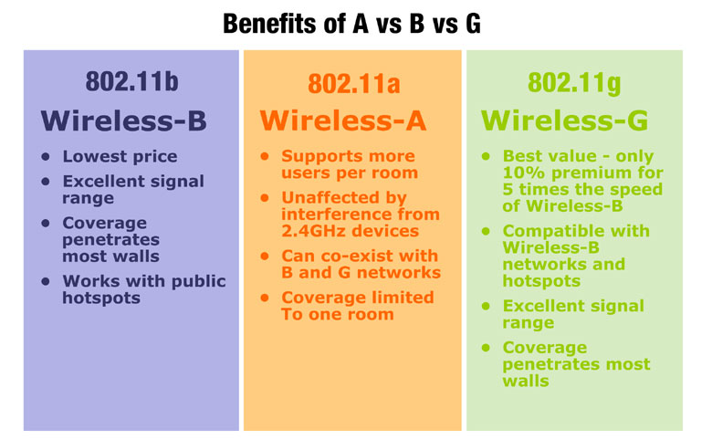

Assignment
- Explain RS-232 and Rs-449 interface
- Explain V.14 & X.21

