UNIT-II
Local Area Networks: Local communication alternatives, static and dynamic channel allocation in LANs, the ALOHA protocols, LAN protocols: IEEE logical link control (802.2), Ethernet (802.3), Token bus (802.4) and Token ring (802.5) protocols. Data link layer: Design issues, Error detection and correction, sliding window protocols. Wide area network standards, SDLC, HDLC, X 25 protocols.
1. Local Area Networks: Local communication alternatives
A Local Area Network is a data communication system which allows a number of independent devices in moderate geographic proximity to communicate with each other.
Local Area Networks(LANs) are employed to interconnect computers, terminals, printers, file servers, etc. located in the same building or within a group of buildings. Metropolitan Area Networks covers larger groups of buildings or a metropolitan area up to 50 km in diameter.
Because the cable lengths in a LAN do not generally exceed about 3km, it is possible for a LAN to transmit data at much higher data rates than a WAN. Error rates are much lower on local area networks than on WAN and transmission delays are much lower.
Local Area Network began in the mid 1970s, the main motivations being
- To provide users with access to several computers.
- To share files.
- To share hard disks and printers between users.
- To share access to wide area networks.
- To provide electronic mail and other communications services in office systems.
The most significant classes of LAN which have evolved are:
- Broadband
- CSMA/CD
- Token bus
- Token ring
- Fiber optic
- Low-cost LANs for personal computers.
Broadband LANs provide many separate data channels for point-to-point or multiple access use together with analog channels such as speech or video. Broadband LANs have become popular for industrial applications and, particularly in the USA, for large office and business complexes.
CSMA/CD: Ethernet uses CSMA/CD access control and is ideal for office systems where the load is unpredictable and transmission delays do not need to be tightly controlled. It is standards of IEEE 802.3 standards.
IEEE 803.4 standard, token bus LANs have been developed to meet the needs of manufacturing automation systems. Many LANs are developed based on a ring topology.
Fiber Optics: Fiber optic offer the high data rate(100mbps).
Four types of transmission media are commonly employed for local area networks:
- Twisted-Pair electrical cable which is limited to data rates of around 3 mbps.
- Base band coaxial cable for data rates up to 50mbps.
- Broadband coaxial cable for data rates over 300mbps.
- Fiber optic cable for total data rates of more than 150 mbps and extremely low error rates.
IEEE set up the 802 project which has defined a reference model and a set of standards for the major forms of LAN with data rates below 40 mbps. These standards include:
- IEEE 802.1 standards for network management
- IEEE 802.2 standards for Logical Link Control
- IEEE 802.3 standards for Ethernet(CSMA/CD)
- IEEE 802.4 standards for Token bus
- IEEE 802.5 standards for Token ring
- IEEE 802.6 standards for Metropolitan Area Network
- IEEE 802.7 Broadband Local Area Network standards
h) IEEE 802.8 Fiber optics standards

2. Channel Allocation Protocol
When multiple nodes connected by a network use a common link to send or receive data, the protocol used to determine who is going to access the next channel is called CHANNEL ALLOCATION PROTOCOL. Here the channel is allocated to only one of the Competing users at a time. There are two types of channel allocation:
1. Static channel Allocation
2. Dynamic Channel Allocation
1. Static channel Allocation
A single channel can be shared among multiple users by using FDM(Frequency Division Multiplexing) or TDM(Time Division Multiplexing). The bandwidth of the channel is divided into n parts of equal size & is kept fixed for specific users. It is known as Fixed or Static because once the channel is allocated to a port or a user it does not change for the entire course of operation. It is used in all digital cellular mobile networks as number of frequency carriers in each cell stays fixed and does not depend on traffic load.
It is a time insensitive solution, as with the passage of time allocation of the channels to nodes does not change. If a static condition is considered there is most likely a chance to get good performance with this channel allocation algorithm. A wireless example is FM radio stations. Each station gets a portion of the FM band and uses it most of the time to broadcast its signal.
When the number of senders is large and varying or the traffic is bursty, FDM presents some problems. If the spectrum is cut up into N regions and fewer than N users are currently interested in communicating, a large piece of valuable spectrum will be wasted. And if more than N users want to communicate, some of them will be denied permission for lack of bandwidth, even if some of the users who have been assigned a frequency band hardly ever transmit or receive anything.
2. Dynamic Channel Allocation
Underlying all the work done in this area are the following five key assumptions:
1. Independent Traffic
The model consists of N independent stations generate frames for transmission. Once a frame has been generated, the station is blocked and does nothing until the frame has been successfully transmitted.
2. Single Channel
A single channel is available for all communication. All stations can transmit on it and all can receive from it.
3. Collision Assumption
If two frames are transmitted simultaneously, they overlap in time and the resulting signal is garbled. This
Event is called a collision. All stations can detect that a collision has occurred. A collided frame must be transmitted again later.
4. Transmission Discipline
Continuous time
Frames can be transmitted at any time. No time division.
Slotted time
Frames can be transmitted at particular time point. Transmission always begins at start of the slot.
5. Sensing capability
No carrier sense: Station cannot sense the channel before trying to use it.
Carrier sense: Stations can tell if the channel is in use before trying to use it.

3. Media Access Control (MAC)
Introduction
When nodes or stations are connected and use a common link, called a multipoint or broadcast link, we need a multiple-access protocol to coordinate access to the link. The problem of controlling the access to the medium is similar to the rules of speaking in an assembly. The procedures guarantee that the right to speak is upheld and ensure that two people do not speak at the same time, do not interrupt each other, do not monopolize the discussion, and so on. Many protocols have been devised to handle access to a shared
link. All of these protocols belong to a sub layer in the data-link layer called media access control (MAC). We categorize them into three groups, as shown in Figure 12.1.
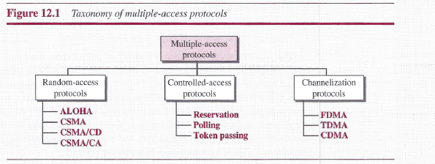
1. RANDOM ACCESS
In random access or contention methods, no station is superior to another station and none is assigned the control over another. No station permits, or does not permit, another station to send. At each instance, a station that has data to send uses a procedure defined by the protocol to make a decision on whether or not to send.
In a random-access method, each station has the right to the medium without being controlled by any other station. However, if more than one station tries to send, there is an access conflict-collision-and the frame will be either destroyed or modified.
An interesting protocol known as ALOHA, which used a multiple access (MA).Each station to sense the medium before transmitting. This was called carrier sense multiple access (CSMA). This method later evolved into two parallel methods:
- Carrier Sense Multiple Access with Collision Detection (CSMA/CD), which tells the station what to do when a collision is detected.
- Carrier Sense Multiple Access with Collision Avoidance (CSMA/CA), which tries to avoid the collision.
12.1.1 ALOHA
- It is the Simplest Collision Resolution Protocol.
- It is the earliest Random access method, which was devised in University of Hawaii in 1970.
- It was originally designed for Radio i.e. wireless LAN.
- It can be used by any Shared Medium.
When a frame arrives for transmission:
- Transmit the frame
- If Acknowledgement arrived-done
- Else
- Wait a random time & go to 1
End
- When a station sends data, another station may attempt to do so at the same time. The data from the two stations collide and become garbled.
Pure ALOHA
The original ALOHA protocol is called pure ALOHA. The idea is that each station sends a frame whenever it has a frame to send. However, since there is only one channel to share, there is the possibility of collision between frames from different stations. Figure 12.2 shows an example of frame collisions in pure ALOHA.
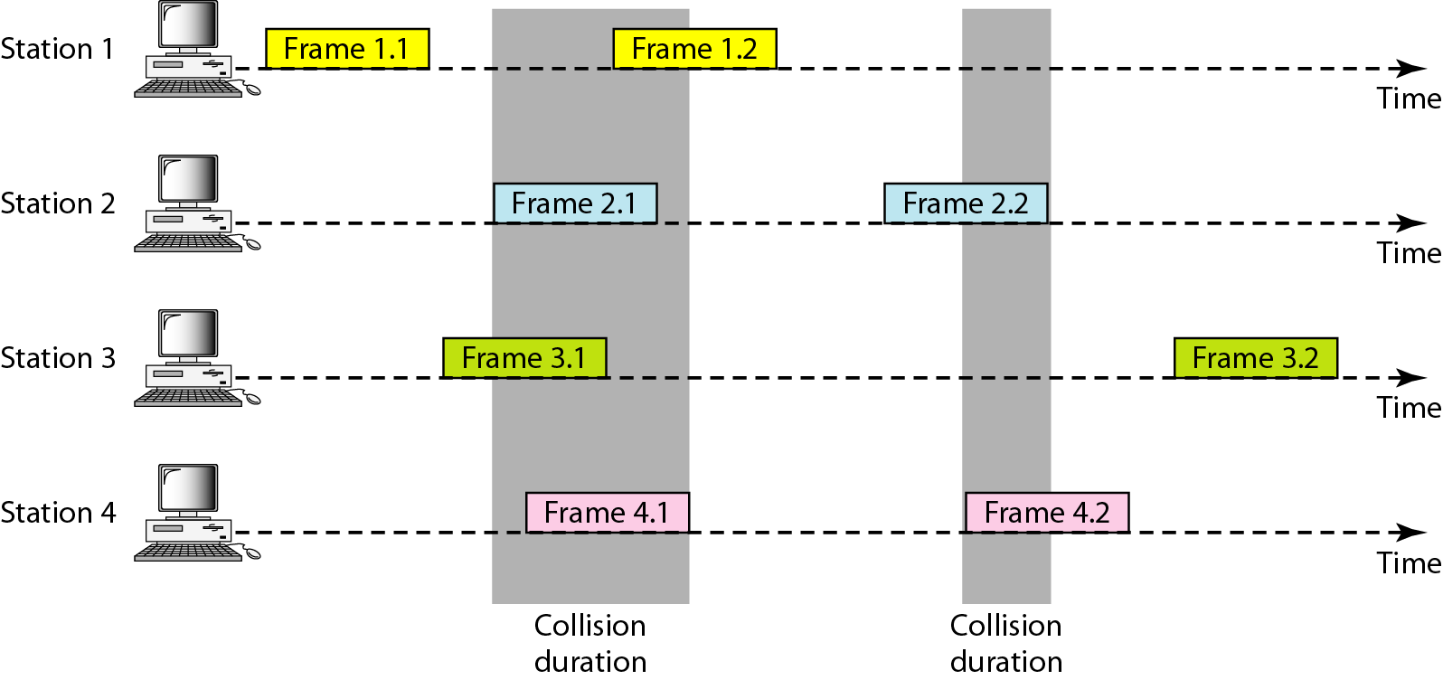
The figure shows that each station sends two frames; there are a total of eight frames on the shared medium. Some of these frames collide because multiple frames are in contention for the shared channel. Figure 12.2 shows that only two frames survive: one frame from station 1 and one frame from station 3.
The pure ALOHA protocol relies on acknowledgments from the receiver. When a station sends a frame, it expects the receiver to send an acknowledgment. If the acknowledgment does not arrive after a time-out period, the station assumes that the frame (or the acknowledgment) has been destroyed and resends the frame.
A collision involves two or more stations. If all these stations try to resend their frames after the time-out, the frames will collide again. Pure ALOHA dictates that when the time-out period passes, each station waits a random amount of time before resending its frame. The randomness will help avoid more collisions. We call this time the back off time T_{B.} Figure 12.3 shows the procedure for pure ALOHA based on the above strategy.
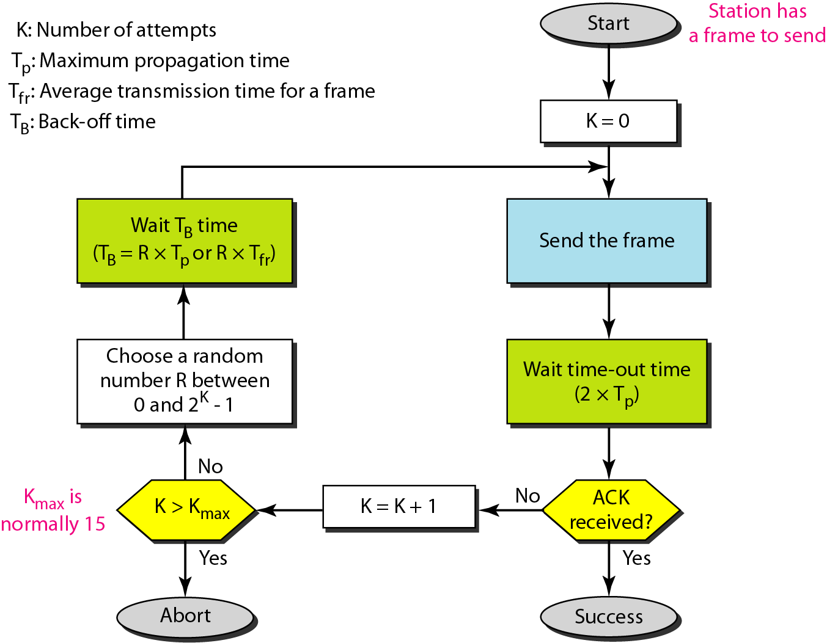
Throughput
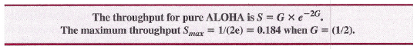
Slotted ALOHA
- Slotted ALOHA was invented to improve the efficiency of pure ALOHA.
- In slotted ALOHA we divide the time into slots of T_{fr} seconds and force the station to send only at the beginning of the time slot. Figure 12.5 shows an example of frame collisions in slotted ALOHA.
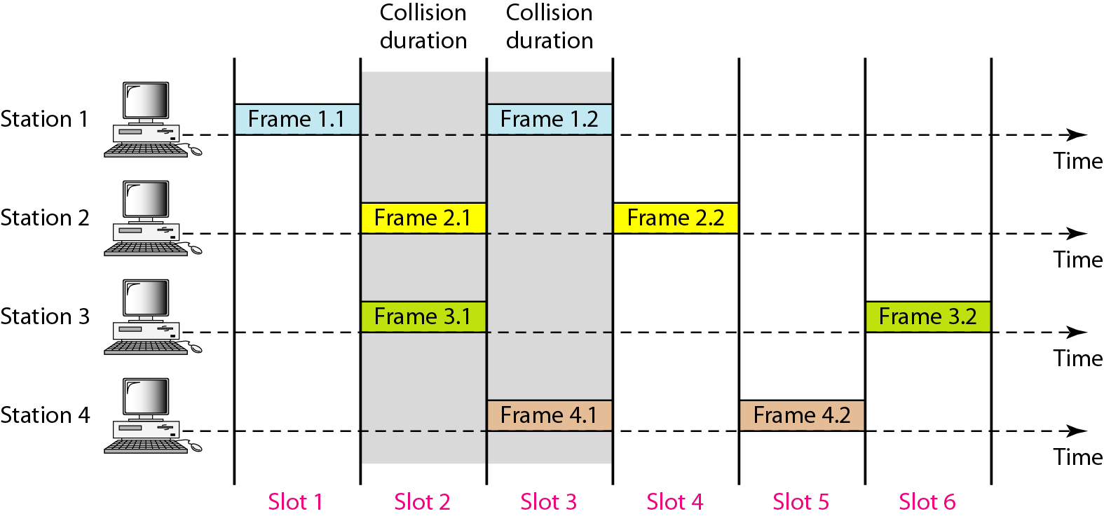
If a station misses this moment, it must wait until the beginning of the next time slot. Of course, there is still the possibility of collision if two stations try to send at the beginning of the same time slot. Figure 12.6 shows the situation.
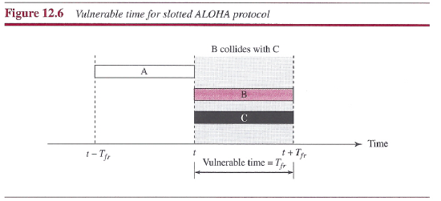
Throughput
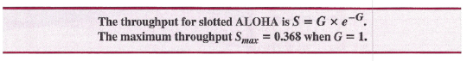
12.1.2 CSMA (Carrier Sense Multiple Access)
- To minimize the chance of collision and, therefore, increase the performance, the CSMA method was developed.
- The chance of collision can be reduced if a station senses the medium before trying to use it. Carrier sense multiple access (CSMA) is based on the principle "sense before transmit" or "listen before talk."
CSMA can reduce the possibility of collision, but it cannot eliminate it. Because of propagation time.
(A station may sense the medium and find it idle, only because the first bit sent by another station has not yet been received). Therefore, vulnerable time is equal to propagation time in this protocol.
Vulnerable time of CSMA
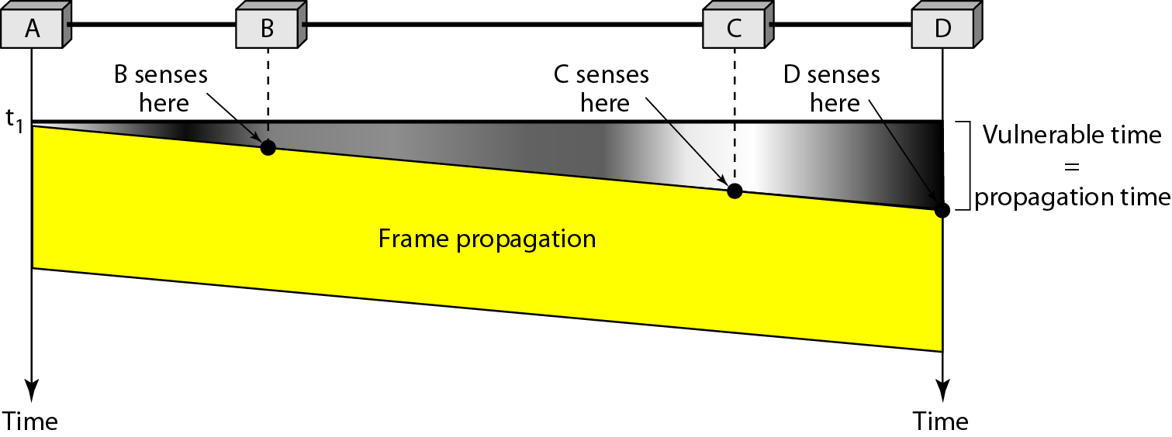
Persistence Methods
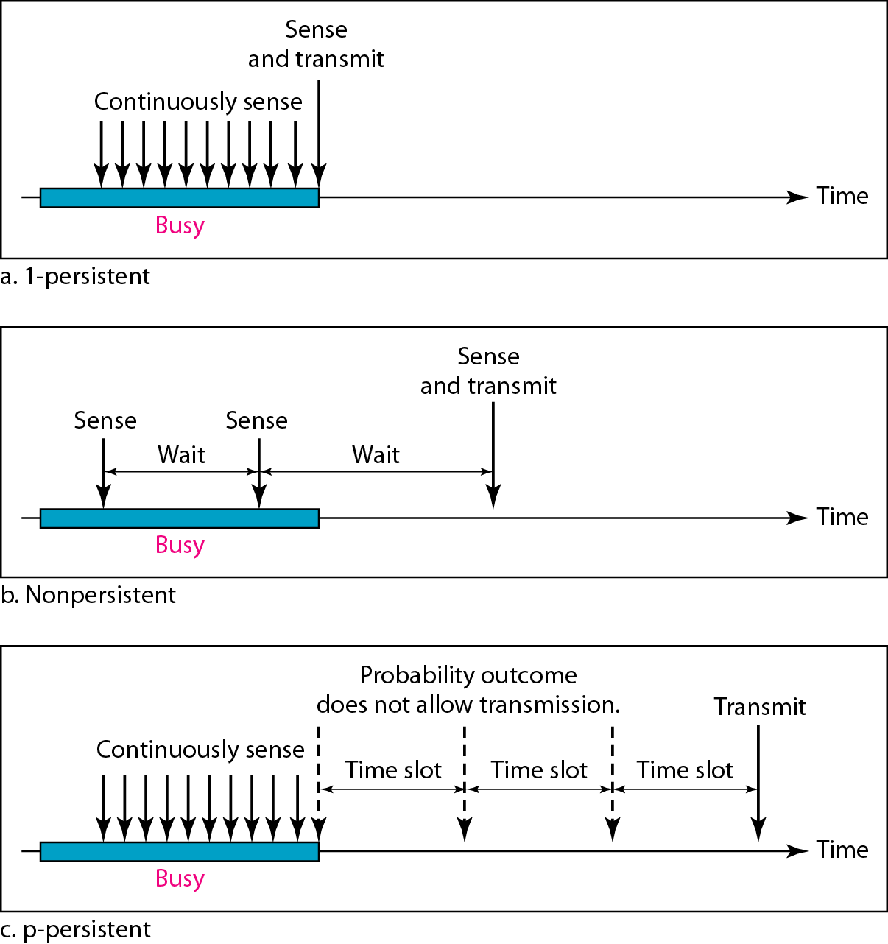

Persistent Methods-flow
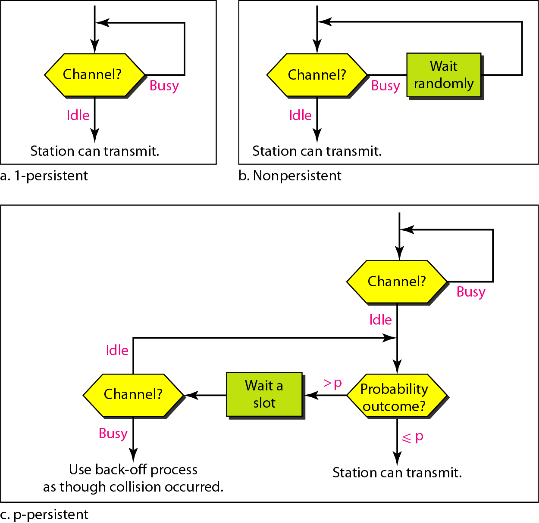
12.1.3 CSMA/CD (Carrier Sense Multiple Access/Collision Detection)
- It is a refinement of CSMA protocol. It not only sense the channel before transmission but also during the frame transmission.
- Stations can sense the medium while transmitting.
- If error occurs, it resends the data.
- A station aborts its transmission if it senses another transmission is also happening (that is, it detects collision).
- Error should be detected before it sends its last bit.
- Sends using persistence method.
- It constantly monitors while sending the frames.
- It sends a short jamming signal to notify a collision.
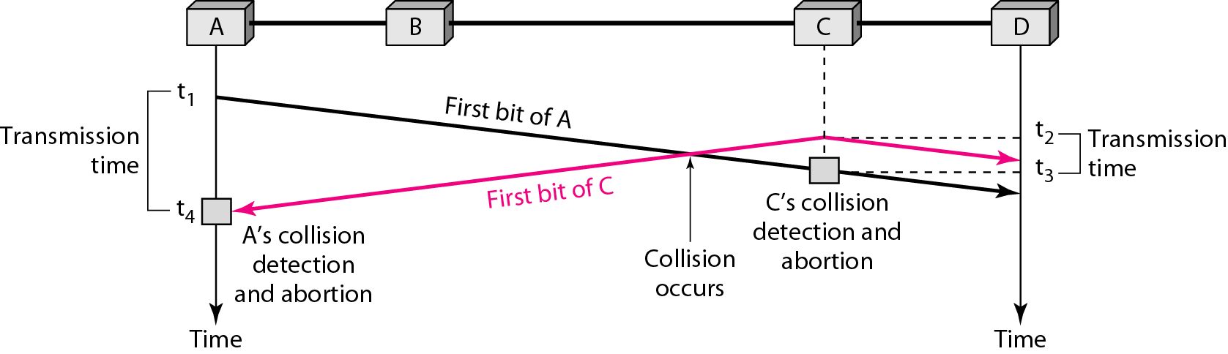

At time t1, station A has executed its persistence procedure and starts sending the bits of its frame. At time t2, station C has not yet sensed the first bit sent by A. Station C executes its persistence procedure and starts sending the bits in its frame, which propagate both to the left and to the right. The collision occurs sometime after time t2' Station C detects a collision at time t3 when it receives the first bit of A's frame. Station C immediately (or after a short time, but we assume immediately) aborts transmission. Station A detects collision at time t4 when it receives the first bit of C's frame; it also immediately aborts transmission.
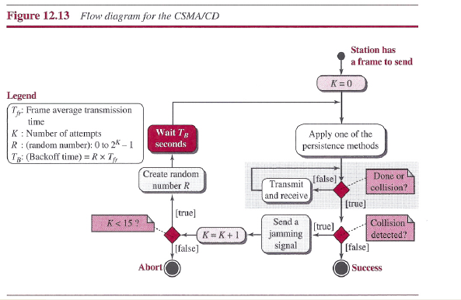
Throughput
The throughput of CSMA/CD is greater than that of pure or slotted ALOHA. The maximum throughput occurs at a different value of G and is based on the persistence method and the value of p in the p-persistent approach. For the l-persistent method, the maximum throughput is around 50 percent when
G = 1. For the non persistent method, the maximum throughput can go up to 90 percent when G is between 3 and 8.

12.1.4 CSMA/CA (Carrier sense multiple access with collision avoidance)
Carrier sense multiple access with collision avoidance (CSMA/CA) was invented for wireless networks. Collisions are avoided through the use of CSMA/CA's three strategies:
1. The inter frame space 2.The Contention window 3.Acknowledgments
1. The inter frame space
When an idle channel is found, the station does not send immediately. It waits for a period of time called the inter frame space or IFS.
2. Contention Window
The contention window is an amount of time divided into slots. A station that is ready to send chooses a random number of slots as its wait time. The number of slots in the window changes according to the binary exponential back off strategy.
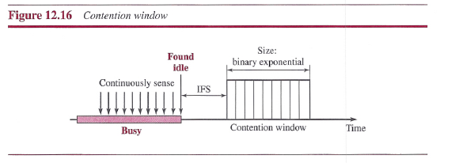
3. Acknowledgments
With all these precautions, there still may be a collision resulting in destroyed data. In addition, the data may be corrupted during the transmission. The positive acknowledgment and the time-out timer can help guarantee that the receiver has received the frame.
12.2 CONTROLLED ACCESS
In controlled access, the stations consult one another to find which station has the right to send. A station cannot send unless it has been authorized by other stations. There are three controlled-access methods.
12.2.1 Reservation
A station needs to make a reservation before sending data.
Time is divided into intervals. In each interval, a reservation frame precedes the data
frames sent in that interval.
Figure 12.18 shows a situation with five stations and a five-minislot reservation
frame. In the first interval, only stations 1, 3, and 4 have made reservations. In the second interval, only station 1 has made a reservation.

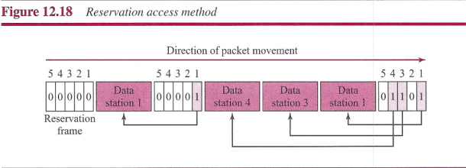
Polling
Best suited to centrally controlled data communications networks using multipoint topology

4. Data Link Control Protocol (DLCP)(IEEE 802.2)
A set of rules implementing and governing an orderly exchange of data between OSI Protocol Layer 2 devices. Perform certain network functions that ensure a coordinated transfer of data.
TYPES OF NETWORK
PRIMARY/SECONDARY (MASTER/SLAVE )
A centrally controlled network where a primary station (master) enacts procedures that determine which station is transmitting and which is receiving at any given instant. All the rest of the stations are secondary stations (slaves) whose data communication actions are controlled by the primary.
PEER-TO-PEER
A type of network where all connected stations are equal (peers), and share equal access to the network. When a station wishes to transmit on this network, it has to contend with all the rest of the stations with intent to transmit.
FUNCTIONS OF DLCP
LINE DISCIPLINE
The process of coordinating half-duplex transmission on a data communications network by:
  - Establishing logical continuity between source and destination stations before data transfer
  - Ensuring that the destination station is ready and capable of receiving data
  - Fundamental Methods of implementation
  - Enquiry/ Acknowledgement (ENQ/ACK)
  - Poll/ Selection (POLL/SELECT)
ENQ/ACK
Best suited to simple network environments like two-point networks
ENQUIRY
A frame or packet of data which identifies the receiving station and solicits the receiving station to determine if it is ready to receive data
ACKNOWLEDGEMENT
ACK. Positive Acknowledgment (Ready to receive)
NAK. Negative Acknowledgement (Not ready to receive, Message received with error)

POLL/SELECT
Best suited to centrally controlled data communications networks using multipoint topology
POLL
A solicitation sent from the primary to the secondary to determine if the secondary has data to transmit
Sent to one station at a time. Secondary responds with either a message or a negative acknowledgement (NAK).
SELECTION
How the primary designates a secondary as a destination, a query if the destination is ready to receive data
Can be broadcast to all secondary stations
Secondary stations respond with either a positive acknowledgement (ACK) or a negative acknowledgement (NAK)
2. FLOW CONTROL
Defines a set of procedures that tells the transmitting station how much data it can send before it must stop transmitting and wait for an acknowledgement from the destination. Fundamental Methods of implementation
Stop-and-wait
Sliding Window

3.ERROR CONTROL
A process encoding overhead codes into a message frame for the detection of errors when they occur and the provision for the correction of the said errors. Error detection may be achieved by various error codes like LRC, VRC, or CRC. Error correction in the OSI Layer 2 is implemented by Automatic Request for Retransmission (ARQ). Errors that cannot be resolved by ARQ are referred for resolution to the higher OSI layers
TYPES OF ARQ
Stop-and-Wait ARQ
  - A message frame is retransmitted if the source receives a negative acknowledgment from the destination
Sliding Window ARQ
  - Go-back-n-frames
    - The error frame and all frames transmitted after it are retransmitted even if the subsequent frames have no error
  - Selective Reject (SREJ)
Only the error frames are retransmitted

5. Token Bus (IEEE 802.4)

Bus Topology is the simplest of network topologies. In this type of topology, all the nodes (computers as well as servers) are connected to the single cable (called bus), by the help of interface connectors. This central cable is the backbone of the network and is known as Bus (thus the name). Every workstation communicates with the other device through this Bus.
A signal from the source is broadcasted and it travels to all workstations connected to bus cable. Although the message is broadcasted but only the intended recipient, whose MAC address or IP address matches, accepts it. If the MAC /IP address of machine doesn’t match with the intended address, machine discards the signal. A terminator is added at ends of the central cable, to prevent bouncing of signals. A barrel connector can be used to extend it. Below I have given a basic diagram of a bus topology and then have discussed advantages and disadvantages of Bus Network Topology.
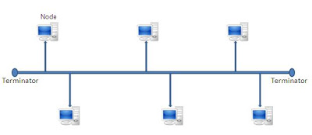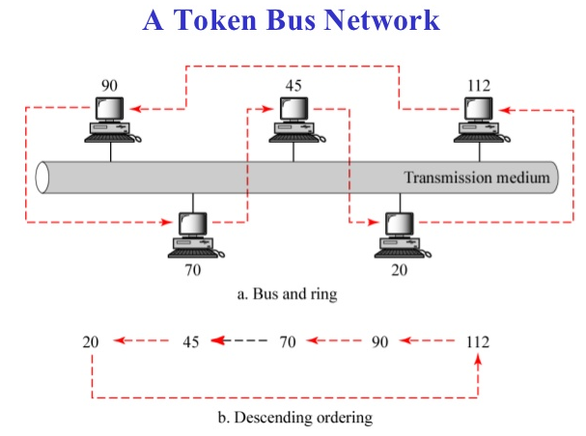
Token bus is a network implementing the token ring protocol over a "virtual ring" on a coaxial cable. A token is passed around the network nodes and only the node possessing the token may transmit. If a node doesn't have anything to send, the token is passed on to the next node on the virtual ring.

Advantages
1) It is easy to set-up and extend bus network.
2) Cable length required for this topology is the least compared to other networks.
3) Bus topology costs very less.
4) Linear Bus network is mostly used in small networks. Good for LAN.
Disadvantages
1) There is a limit on central cable length and number of nodes that can be connected.
2) Dependency on central cable in this topology has its disadvantages. If the main cable(i.e.bus)encounters some problem, whole network breaks down.
3) Proper termination is required to dump signals. Use of terminators is must.
4) It is difficult to detect and troubleshoot fault at individual station.
5) Maintenance costs can get higher with time.
6) Efficiency of Bus network reduces, as the number of devices connected to it increases.
7) It is not suitable for networks with heavy traffic.
8) Security is very low because all the computers receive the sent signal from the source.
Token-bus transmission frame Format
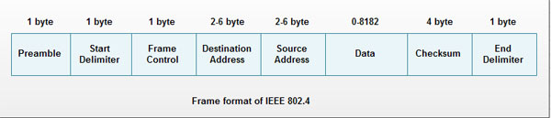
1. Preamble: This. Field is at least 1 byte long. It is used for bit synchronization.
2. Start Delimiter: This one byte field marks the beginning of frame.
3. Frame Control: This one byte field specifies the type of frame. It distinguishes data frame from control frames. For data frames it carries frame's priority. For control frames, it specifies the frame type. The control frame types include. Token passing and various ring maintenance frames, including the mechanism for letting new station enter the ring, the mechanism for allowing stations to leave the ring.
4. Destination address: It specifies 2 to 6 bytes destination address.
5. Source address: It specifies 2 to 6 bytes source address.
6. Data: This field may be up to 8182 bytes long when 2 bytes addresses are used & upto 8174 bytes long when 6 bytes address is used.
7. Checksum: This 4 byte field detects transmission errors.
8. End Delimiter: This one byte field marks the end of frame.
The various control frames used in token bus are:
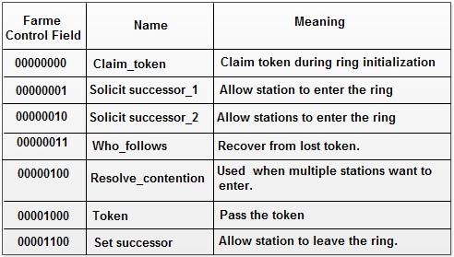

6. Token Ring (IEEE 802.5)
In Ring Topology, all the nodes are connected to each-other in such a way that they make a closed loop. Each workstation is connected to two other components on either side, and it communicates with these two adjacent neighbors. Data travels around the network, in one direction. Sending and receiving of data takes place by the help of TOKEN.
Token Passing : Token contains a piece of information which along with data is sent by the source computer. This token then passes to next node, which checks if the signal is intended to it. If yes, it receives it and passes the empty to into the network, otherwise passes token along with the data to next node. This process continues until the signal reaches its intended destination.
The nodes with token are the ones only allowed to send data. Other nodes have to wait for an empty token to reach them. This network is usually found in offices, schools and small buildings.
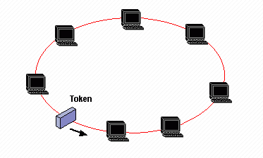[Or]
The Token Ring protocol was developed by IBM in the mid-1980s. The access method used involves token-Passing. In Token Ring, the computers are connected so that the signal travels around the network from one computer to another in a logical ring. A single electronic token moves around the ring from one computer to the next. If a computer does not have information to transmit, it simply passes the token on to the next workstation. If a computer wishes to transmit and receives an empty token, it attaches data to the token. The token then proceeds around the ring until it comes to the computer for which the data is meant. At this point, the data is captured by the receiving computer.
The token ring protocol requires a star-wired ring using twisted pair or fiber optic cable. It can operate at transmission speeds of 4 Mbps or 16Mbps. Due to the increasing popularity of Ethernet, the use of token ring in school environments has decreased.
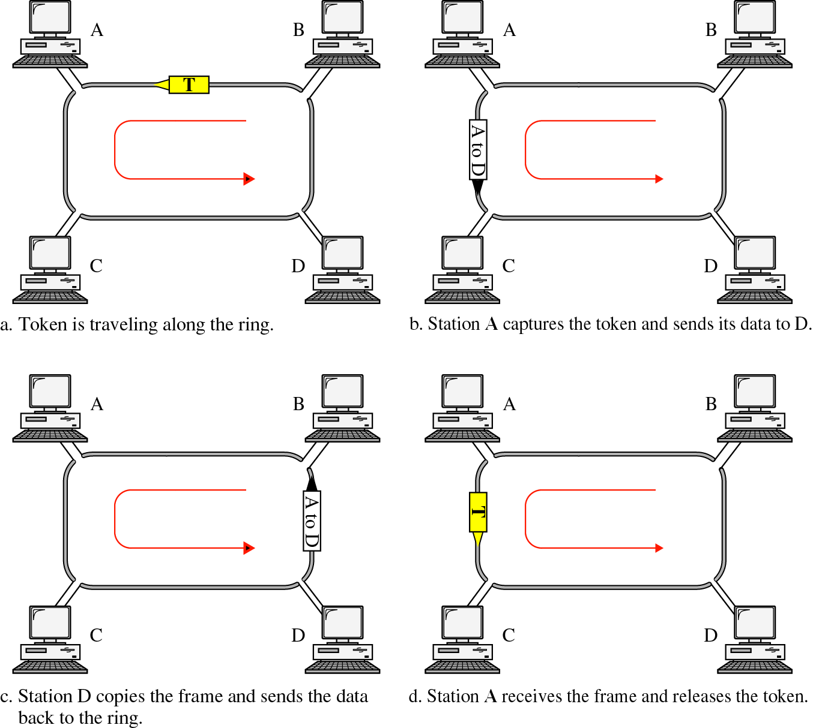

Advantages of Ring Topology
1) This type of network topology is very organized. Each node gets to send the data when it receives an empty token. This helps to reduces chances of collision. Also in ring topology all the traffic flows in only one direction at very high speed.
2) Even when the load on the network increases, its performance is better than that of Bus topology.
3) There is no need for network server to control the connectivity between workstations.
4) Additional components do not affect the performance of network.
5) Each computer has equal access to resources.
Disadvantages of Ring Topology
1) Each packet of data must pass through all the computers between source and destination. This makes it slower than Star topology.
2) If one workstation or port goes down, the entire network gets affected.
3) Network is highly dependent on the wire which connects different components.
4) MAU’s and network cards are expensive as compared to Ethernet cards and hubs.
Token-ring transmission frame Format
Start of Frame  (1 Byte) | Access Control  (1 Byte) | Frame Control  (1 Byte) | Source Address  (6 Bytes) | Destination Address  (6 Bytes) | Data  (Unlimited) | Frame Check sum  (4 Bytes) | Frame Status  (1 Byte) | End of Frame  ( 1 Byte)
Token Ring (IEEE 802.5) Frame Format
Start of frame
The starting delimiter indicates the start of the data frame. It uses a unique signal pattern that does not correspond to either a 0 or 1 bit. These are known as non data values and ensure that no data sequence will ever be mistaken for a delimiter.
Access Control Field
This field identifies whether the frame is a data frame or a token. It contains a bit used to identify a constantly busy token, a priority bit and reservations bits.
Frame Control Field
This field identifies the frame type and for certain types of control frames, the function it is to perform.
Address Fields
Each of the address fields—the destination address and the source address—can be either 2 bytes (16-bit addresses) or 6 bytes (48-bit addresses) in length. If universal addressing is used, the addresses must be 6 bytes each. But if local addressing is used they may be either 2 or 6 bytes long. Both destination and source addresses must be of the same length for all devices on a given network.
The source address must be for an individual device. The destination address can be an individual address, a group address or a broadcast address.
Information Field
The information field contains the actual data packet to be transmitted. This can be either a protocol data unit being passed from the logical link control sub layer or control information supplied by the media access control sub layer. Its length is variable anywhere from 0 to 17800 bytes in length.
Frame Check Sequence
The frame check field is used as an error control mechanism. When the transmitting device assembles a frame, it performs a calculation on the bits in the frame. The algorithm used to perform this calculation always results in a 4 byte value. The sending device stores this value in the frame check sequence field. When the destination device receives the frame, it performs the same calculation and compares the result to that in the frame check sequence field. If the two values are the same, the transmission is assumed to be correct. If the two values are different, the destination station can request a retransmission of the frame.
Frame Status Field
The frame status field contains the address recognized and frame copied control bits.
Ending Delimiter
This identifies the end of the frame by containing non data values. It also contains bits used to identify whether or not it is the last frame in a multi frame transmission and if an error has been detected by any station.
Difference between Token Bus and Token Ring
Token Bus | Token Ring
Design for large factories | Design for offices
Bus topology is used as physical topology | Star topology is used as physical topology
A virtual ring is formed over which the token is passed | A token is passed over the physical ring itself
In Token bus network the maximum time that a token will take to reach the end station cannot be calculated. | In token ring the maximum time that a token will take to reach the end station can be calculated.
Defined by IEEE 802.4 standard | Defined by IEEE 802.5 standard

The table below summarizes the IBM and IEEE 802.5 specifications.

IBM Token Ring v. IEEE 802.5
 | IBM Token Ring | IEEE 802.5
Data rate | 4 or 16 Mbps | 4 or 16 Mbps
Stations per segment | STP - 260  UTP - 72 | 250
Topology | Star | Not specified
Media | Twisted pair | Not specified
Signaling | Baseband | Baseband
Access method | Token passing | Token passing
Encoding | Differential Manchester | Differential Manchester
7. DATA LINK LAYER
The data link layer uses the services of the physical layer to send and receive bits over communication channels. It has a number of functions, including:
1. Providing a well-defined service interface to the network layer.
2. Dealing with transmission errors.
3. Regulating the flow of data so that slow receivers are not swamped by fast senders.
To accomplish these goals, the data link layer takes the packets it gets from the network layer and encapsulates them into frames for transmission. Each frame contains a frame header, a payload field for holding the packet, and a frame trailer, as illustrated in Fig. 3-1
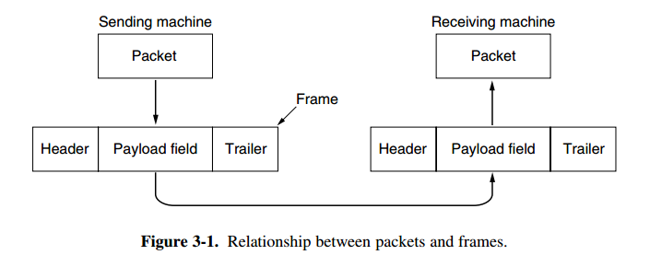
DATA LINK LAYER DESIGN ISSUES
1. Services Provided to the Network Layer
2. Framing
3. Error Control
4. Flow Control
1. Services Provided to the Network Layer
Transfer data from network layer on source machine to network layer on destination machine through “Virtual Communication”. Actual path is through all lower layers.
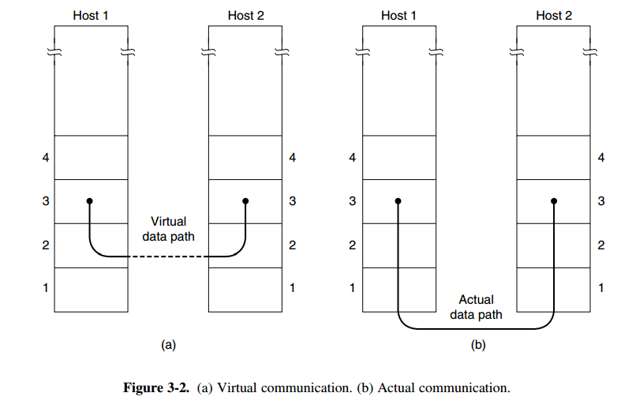
The data link layer can be designed to offer various services. The actual services that are offered vary from protocol to protocol. Three reasonable possibilities that we will consider in turn are:
1. Unacknowledged connectionless service.
2. Acknowledged connectionless service.
3. Acknowledged connection-oriented service
1. Unacknowledged connectionless service.
- Also called as datagram(DG) service or simply connectionless
- Frames can get lost
- No-flow-and error-control mechanisms
- Data delivery not guaranteed
Example: Voice
2. Acknowledged connectionless service.
- Each frame sent is acknowledged but no connections are set up.
- If frame does not arrive, sender can wait and retransmit.
- Can be used over unreliable channels
Example: Wireless systems
3. Acknowledged connection-oriented service
- Also called as Virtual Circuit(VC) service
- Connection established before any data are transferred
- Each frame is sent is numbered and the data link layer guarantees that each frame sent is indeed received.
- Each frame is received only once and that order is maintained.
Example: TCP (Transmission Control Protocol)

2. Framing
- In order to provide service to the network layer, data link layer must use services provided by the physical layer.
- Bit stream delivered by physical layer may not be error free
- Data link layer must correct for errors
- Data link layer breaks bit stream into discrete frames and creates checksum for each frame
Farming methods:
1. Byte count
2. Flag bytes with bytes stuffing
3. Starting & ending flags with bit stuffing
1. Byte count
The first framing method uses a field in the header to specify the number of bytes in the frame. When the data link layer at the destination sees the byte count, it knows how many bytes follow and hence where the end of the frame is. This technique is shown in Fig. 3-3(a) for four small example frames of sizes 5, 5, 8, and 8 bytes, respectively.
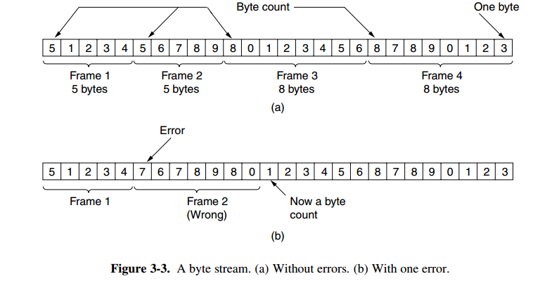
- Even if checksum is incorrect, the destination does not know where the bad frame starts.
2. Flag bytes with bytes stuffing
Each frame start and end with special bytes, called a flag byte, is used as both the starting and ending delimiter. This byte is shown in Fig. 3-4(a) as FLAG. In Fig. 3-4(b). In all cases, the byte sequence delivered after destuffing is exactly the same as the original byte sequence

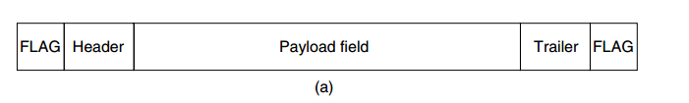
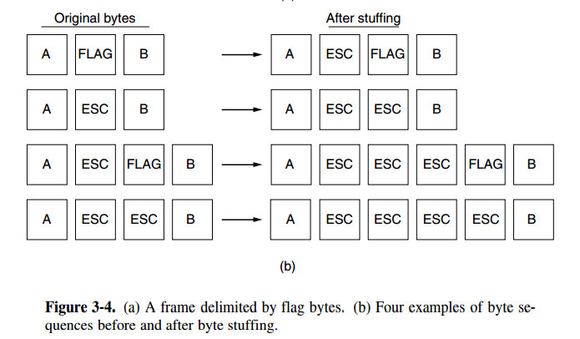
Note: esc means escape Byte
3. Starting & ending flags with bit stuffing
Each frame begins and ends with a special bit pattern, 01111110 or 0x7E in hexadecimal. Whenever the sender’s data link layer encounters five consecutive 1s in the data, it automatically stuffs a 0 bit into the outgoing bit stream
When the receiver sees five consecutive incoming 1 bits, followed by a 0 bit, it automatically destuffs (i.e., deletes) the 0 bit
If the user data contain the flag pattern, 01111110, this flag is transmitted as 011111010 but stored in the receiver’s memory as 01111110. Figure 3-5 gives an example of bit stuffing.
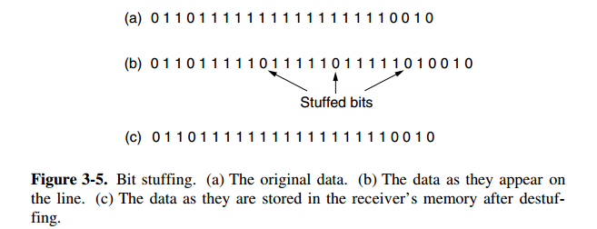

3. Error Control
How to make sure all frames are eventually delivered to the network layer at the destination and in the proper order. Assume for the moment that the receiver can tell whether a frame that it receives contains correct or faulty information. For unacknowledged connectionless service it might be fine if the sender just kept outputting frames without regard to whether they were arriving properly. But for reliable, connection-oriented service it would not be fine at all.

The usual way to ensure reliable delivery is to provide the sender with some feedback about what is happening at the other end of the line. Typically, the protocol calls for the receiver to send back special control frames bearing positive or negative acknowledgements about the incoming frames. If the sender receives a positive acknowledgement about a frame, it knows the frame has arrived safely. On the other hand, a negative acknowledgement means that something has gone wrong and the frame must be transmitted again.
Question: What happen when an error burst destroys a whole frame?
Answer: Receiver knows not that an error has occurred. It wouldn’t send acknowledgement. Sender would hang forever in such case. To solve this problem, data link layer’s have timers. On sending frame a timer is off… if acknowledgement is not received (or loss) before timer goes off, sender is alerted to retransmit frame.
Problem: What to do if frames are submitted multiple times?
Answer: Assign a sequence number to frame. Therefore receiver will be able to distinguish original and retransmitted frame.
The whole issue of managing the timers and sequence numbers so as to ensure that each frame is ultimately passed to the network layer at the destination exactly once, no more and no less, is an important part of the duties of the data link layer.
4. Flow Control
Problem: What to do when sender sends frames faster than receiver can accept them?
Answer: Have rules as to when a sender can send the next frame. The rule could say “send n frames now but do not send any more after that until I ask for them.

8. Error Correction & Error Detection
Data can be corrupted during transmission. For reliable communication, errors must be detected and corrected. Error detection and correction are implemented either at data link layer or the transport layer of the OSI model
TYPES OF ERRORS
Single bit error
Only one bit in the data unit has changed.
Burst error
It means that two or more bits in the data unit have changed.
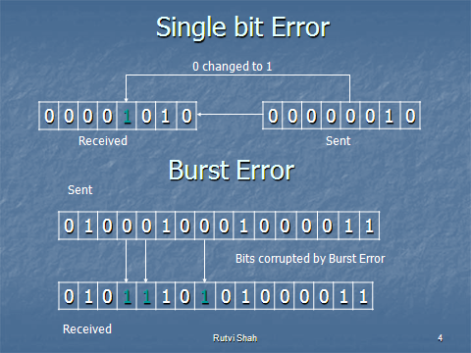
Error Detection
Error detection uses the concept of redundancy, which means adding extra bits for detecting error at the destination
Redundancy
Instead of repeating the entire data stream, a shorter group of bits may be appended to the end of each unit. This technique is called Redundancy because the extra bits are redundant to the information. They are discarded as soon as the accuracy of the transmission has been determined.
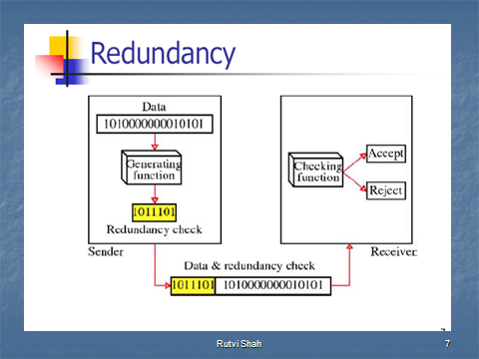
There are basically three types of redundancy checks. They are:
1. VRC (Vertical Redundancy Check).
2. LRC (Longitudinal Redundancy Check).
3. CRC (Cyclical Redundancy Check).
1. Vertical Redundancy Check
- It is also known as parity check
- It is least expensive mechanism for error detection
- In this technique, the redundant bit called parity bit is appended to every data unit so that the total number of 1s in the unit becomes even (including parity bit)
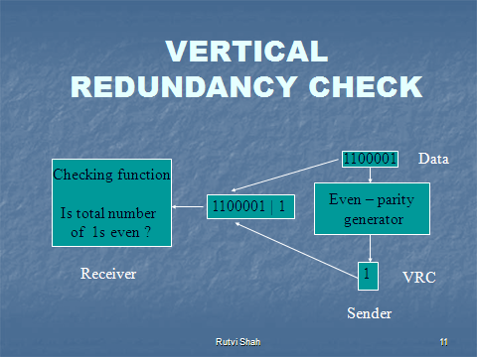

Example :
1110110 1101111 1110010
- After adding the parity bit
11101101 11011110 11100100
- VRC can detect all single – bit errors
- It can detect burst errors if the total number of errors in each data unit is odd.
- VRC cannot detect errors where the total number of bits changed is even.
2. Longitudinal Redundancy Check
In this method , a block of bits is organized in table(rows and columns) calculate the parity bit for each column and the set of this parity bit is also sending with original data. From the block of parity we can check the redundancy.
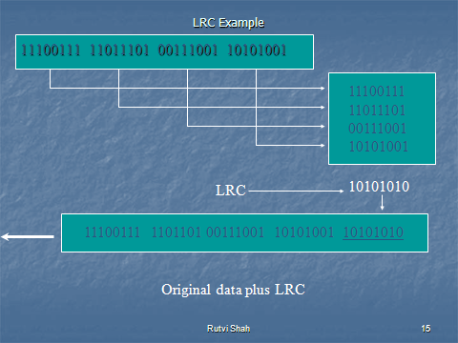
Advantage:
LRC of n bits can easily detect burst error of n bits.
Disadvantage:
If two bits in one data units are damaged and two bits in exactly same position in another data unit are also damaged, the LRC checker will not detect the error.
3. Cyclical Redundancy Check
In this method, a sequence of redundant bits, called the CRC or the CRC remainder, is appended to the end of the unit so that the resulting data unit becomes exactly divisible by a second, predetermined binary number. At its destination, the incoming data unit is divided by the same number. If at this step there is no remainder, the data unit assumes to be correct and is accepted, otherwise it indicates that data unit has been damaged in transmission and therefore must be rejected.
The redundancies bits are used by CRC are derived by dividing the data unit by a predetermined divisor. The remainder is the CRC
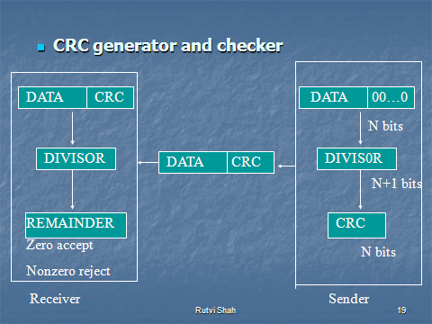
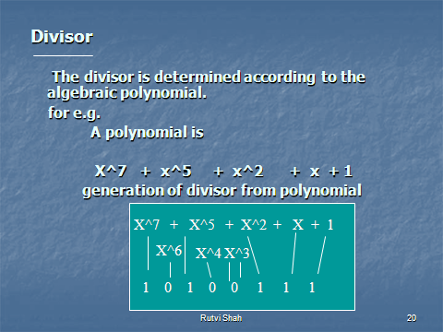
A polynomial should be selected according to the following rule:-
- It should not be divisible by x.
- It should be divisible by x+1.
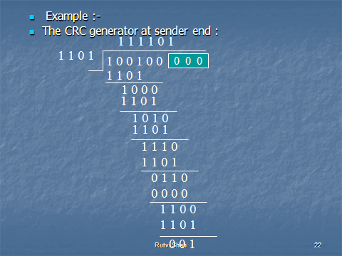
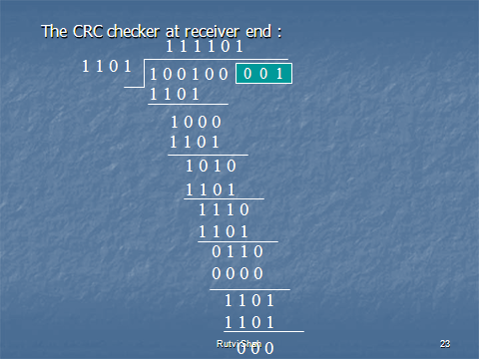
ERROR CORRECTION
Error correcting code is to include enough redundant information along with each block of data sent to enable the receiver to deduce what the transmitted character must have been.
Error Correction must be handled in two ways :
-When an error is discovered, the receiver can have the sender retransmit the entire data unit.
-Receiver can use an error correcting code, which automatically corrects certain errors.

There are two types of Error Correcting techniques:
1. Single bit error correction.
2. Burst error correction.
Error Correction can be done with the help of HAMMING CODE.
HAMMING CODE
- It is a technique developed by R.W.Hamming.
- Hamming code can be applied to data units of any length and uses the relationship between data and redundancy bits. For eg.
- A 7 bit ASCII code requires 4 Redundancy bits that can be added to the end of the data unit or interspersed with the original data bits.
- These bits are placed in positions 1,2,4 and 8. We refer to these bits as r1,r2,r4 and r8.
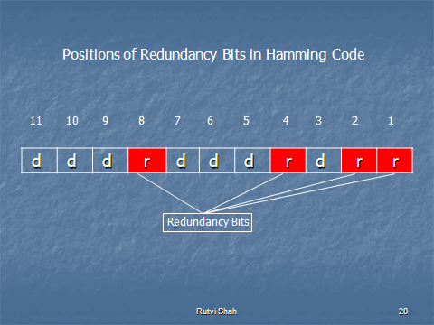
In the Hamming code, each r bit is the VRC bit for one combination of data bits :
-r1 is the one combination of data bits.
-r2 is another combination of data bits. and so on.
The combination used to calculate each of the four values for a 7 bit data sequence are as follows :
-r1 : bits 1,3,5,7,9,11.
-r2 : bits 2,3,6,7,10,11.
-r4 : bits 4,5,6,7.
-r8 : bits 8,9,10,11.
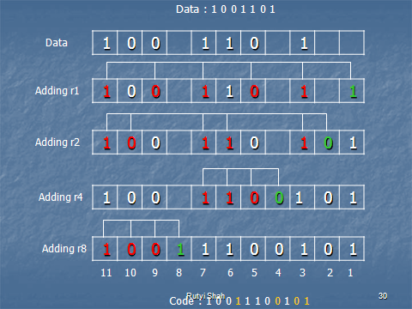
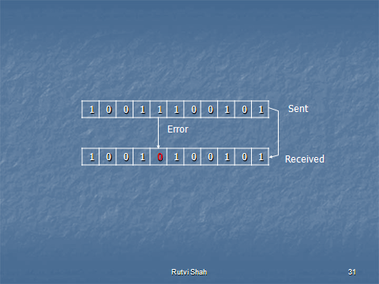
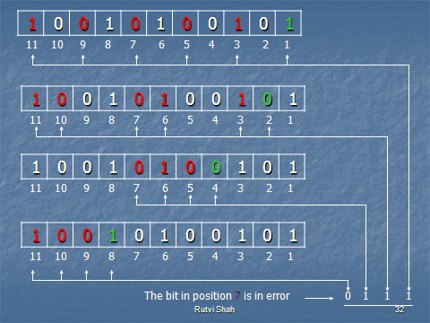
9. Sliding window protocols
In sliding window method, multiple frames are sent by sender at a time before needing an acknowledgment. Multiple frames sent by source are acknowledged by receiver using a single ACK frame.

Sliding Window
- Sliding window refers to an imaginary boxes that hold the frames on both sender and receiver side. It provides the upper limit on the number of frames that can be transmitted before requiring an acknowledgment.
- Frames may be acknowledged by receiver at any point even when window is not full on receiver side. Frames may be transmitted by source even when window is not yet full on sender side.
- The windows have a specific size in which the frames are numbered 0 - n, which means they are numbered from 0 to n-l. For e.g. if n = 8, the frames are numbered 0, 1,2,3,4,5,6, 7, 0, 1,2,3,4,5,6, 7, 0, 1, ....
- The size of window is n-1. For e.g. In this case it is 7. Therefore, a maximum of n-l frames may be sent before an acknowledgment.
- When the receiver sends an ACK, it includes the number of next frame it expects to receive. For example in order to acknowledge the group of frames ending in frame 4, the receiver sends an ACK containing the number 5. When sender sees an ACK with number 5, it comes to know that all the frames up to number 4 have been received.
Sender Sliding Window
eceiver Sliding Window
Sliding Window Example
Stop-And-Wait
One Bit Sliding Window Protocol
One bit sliding window protocol is also called Stop-And-Wait protocol. In this protocol, the sender sends out one frame, waits for acknowledgment before sending next frame, thus the name Stop-And-Wait. Disadvantages:
- At any one moment, only in frame is in transition.
- The sender will have to wait at least one round trip time before sending next.
- The waiting can be long for a slow network such as satellite link.

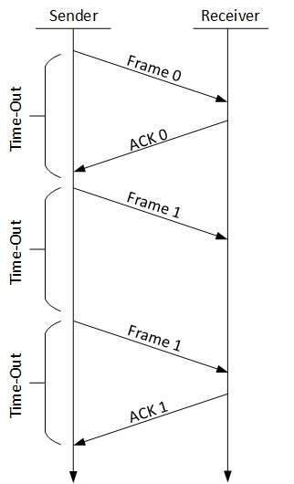
The following transition may occur in Stop-and-Wait ARQ:
- The sender maintains a timeout counter.
- When a frame is sent, the sender starts the timeout counter.
- If acknowledgement of frame comes in time, the sender transmits the next frame in queue.
- If acknowledgement does not come in time, the sender assumes that either the frame or its acknowledgement is lost in transit. Sender retransmits the frame and starts the timeout counter.
- If a negative acknowledgement is received, the sender retransmits the frame.
Go-Back-n
If there is one frame k missing, the receiver simply discard all subsequent frames k+1, k+2... sending no acknowledgments. So the sender will retransmit frames from k onwards. This effectively sets the receiver window size to be 1.This can be a waste of bandwidth.
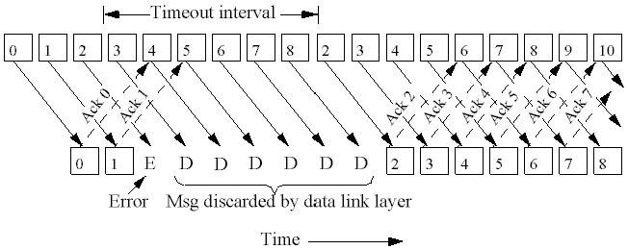
The sending-window size enables the sender to send multiple frames without receiving the acknowledgement of the previous ones. The receiving-window enables the receiver to receive multiple frames and acknowledge them. The receiver keeps track of incoming frame’s sequence number.
When the sender sends all the frames in window, it checks up to what sequence number it has received positive acknowledgement. If all frames are positively acknowledged, the sender sends next set of frames. If sender finds that it has received NACK or has not receive any ACK for a particular frame, it retransmits all the frames after which it does not receive any positive ACK.
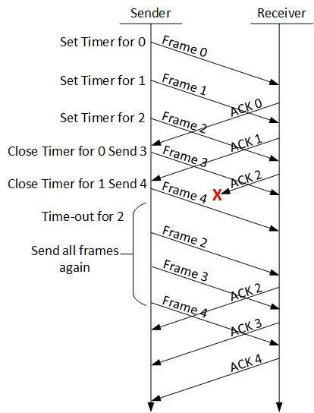
Selective Repeat
Another strategy is to re-send only the ones that are actually lost or damaged. The receiver buffers all the frames after the lost one. When the sender finally noticed the problem (e.g. no ack for the lost frame is received within time-out limit), the sender retransmits the frame in question.
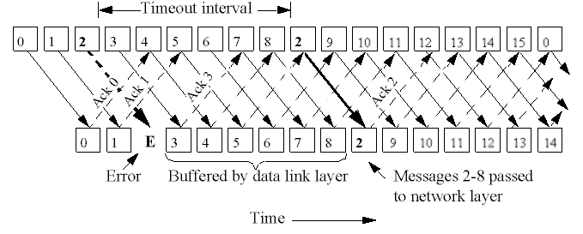
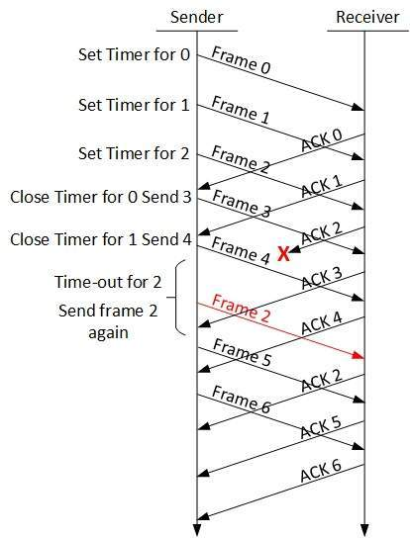

10. Wide area network standards
- WANs are structured with irregular placement of the nodes.
- WANs cover a large geographical area.

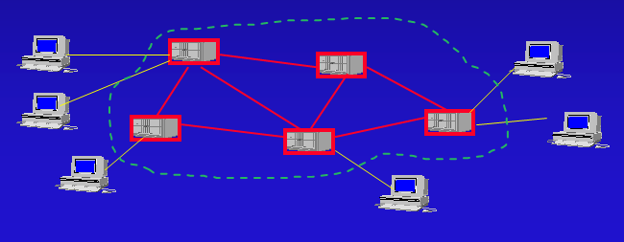
- WAN consists of a number of interconnected switching nodes. Communication is achieved by transmitting data from source to destination through these intermediate switching nodes to the specified destination device.
- Traditionally, WANs have been implemented using one of two technologies: circuit switching and packet switching. Recently, frame relay and ATM networks have assumed major roles.
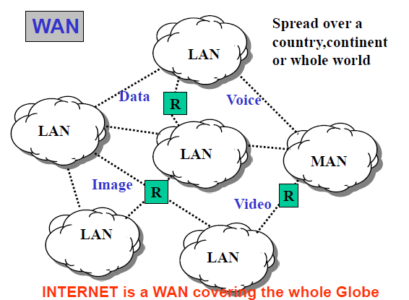
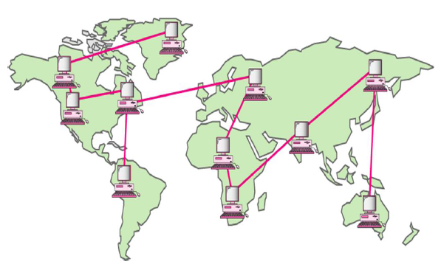
1. Circuit switching
A dedicated communication path is established between two stations through the nodes of the network. Example: the telephone network.
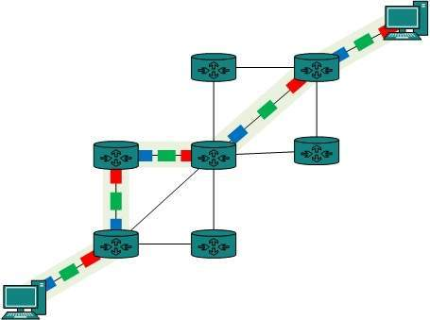
2. Packet Switching
- The entire message is broken down into smaller chunks called packets. The switching information is added in the header of each packet and transmitted independently.
- It is easier for intermediate networking devices to store small size packets
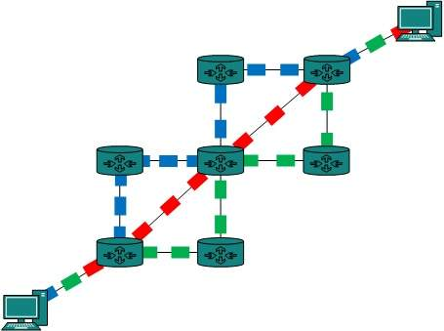
- This allows us to make the switches function for both storing and forwarding.
- Packet-switched network is more efficient than a circuit switched network, but the packets may encounter some delays.
- The internet uses packet switching technique.
- Packets are stored and forwarded according to their priority to provide quality of service.
- To compensate errors, there is a considerable amount of overhead built into the packet-switched schemes.
Example: E-Mail, X.25 network
3. Frame relay
- It was developed to take advantage of high data rates and low error rates that are available in modern high-speed communication systems.
- It operates efficiently at user data rates up to 2 Mbps.
- It uses variable-length packets, called frames.
- Frame relay protocol architecture consists of two separate planes of operation:
  - A control (C) plane, which deals with the establishment and termination of logical connections. C-plane protocols are between a subscriber and the network.
  - A user (U) plane, which is responsible for the transfer of user data between subscribers. U-plane protocols provide end-to-end functionality.
4. ATM (Asynchronous Transfer Mode)
- It can be viewed as an evolution from frame relay.
- ATM uses fixed-length packets, called cells.
- With little overhead for error control.
- Data rates are 10Mbps to Gbps
- Constant data rates using packet switching technique with multiple virtual circuits.

11. HDLC (High-Level Data Link Control)
- HDLC was defined by ISO for use on both point-to-point and multipoint data links.
- It provides both connectionless service and connection oriented services.
- It supports half and full duplex transmission.
- Other similar protocols are
    - Synchronous Data Link Control (SDLC) by IBM
    - Advanced Data Communication Control Procedure (ADCCP) by ANSI
HDLC Features:
1. Reliable protocol
  - selective repeat or go-back-N
2. Full-duplex communication
  - receive and transmit at the same time
3. Bit-oriented protocol
  - use bits to stuff flags occurring in data
4. Flow control
  - adjust window size based on receiver capability
HDLC defines three types of stations

1. Primary station
    - Has the responsibility of controlling the operation of data flow .
    - Handles error recovery
    - Frames issued by the primary station are called commands.
2. Secondary station
    - Operates under the control of the primary station.
    - Frames issued by a secondary station are called responses.
    - The primary station maintains a separate logical link with each secondary station.
3. Combined station
    - Acts as both as primary and secondary station.

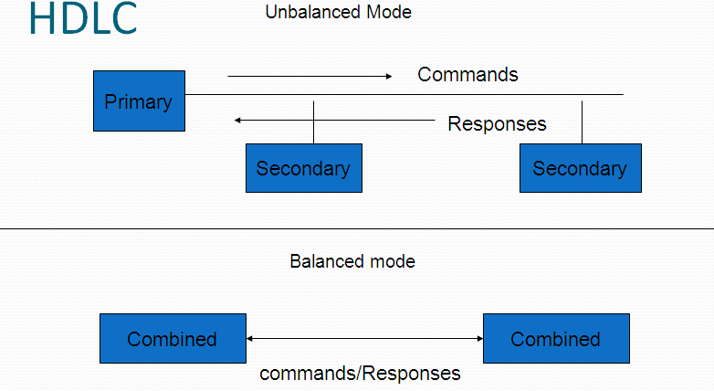

HDLC Defines three types of data transfer mode

1. Normal Response Mode (NRM)
- Secondary station can send ONLY when the primary station instruct it to do so
- Two common configurations
  - Point-to-Point link (one primary station and one secondary station)
  - Multipoint link (the primary station maintain different sessions with different secondary stations)
2. Asynchronous Response Mode (ARM)
- More independent secondary station
- Can send data or control information without explicit permission to do so (note that it is still cannot send commands)
3. Asynchronous Balanced Mode (ABM)
- Mainly used in point-to-point links, for communication between combined stations.
- Either station can send data, control information and commands.
HDLC defines three types of frames

Unnumbered frames: Used in link setup and disconnection, and hence do not contain ACK.
Information frames: Which carry actual information. Such frames can piggyback ACK in case of ABM.
Supervisory frames: Which are used for error and flow control purposes and hence contain send and receive sequence numbers.
- There are four different supervisory frames
  - SS=00, Receiver Ready (RR), and N(R) ACKs all frames received up to and including the one with sequence number N(R) - 1
  - SS=10, Receiver Not Ready (RNR), and N(R) has the same meaning as above
  - SS=01, Reject; all frames with sequence number N(R) or higher are rejected, which in turns ACKs frames with sequence number N(R) -1 or lower.
  - SS=11, Selective Reject; the receive rejects the frame with sequence number N(R)

HDLC Frame Format
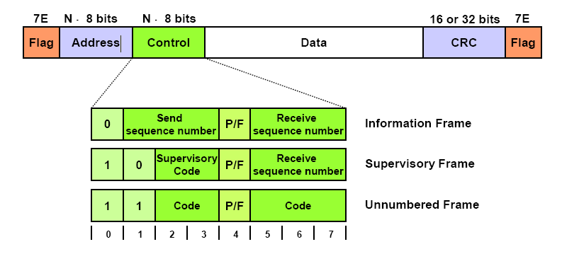
Flag Fields
- Flag fields delimit the frame at both ends with the unique pattern 01111110. A single flag may be used as the closing flag for one frame and the opening flag for the next.
- The pattern 01111110 could be found inside a frame and thus using it as a delimiter will destruct inner structure of the frame thus a method name Bit Stuffing was used in which sender will insert 0 after occurrence of 5 consecutive 1
Bit Stuffing
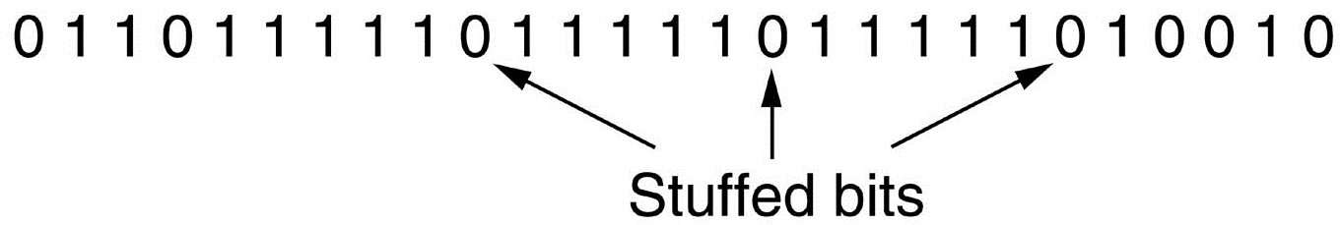
With the use of bit stuffing, arbitrary bit patterns can be inserted into the data field of the frame. This property is known as data transparency.
Address Field :
- The address field identifies the secondary station that transmitted or is to receive the frame. This field is not needed for point-to-point links, but is always included for the sake of uniformity.
- The address field is usually eight bits long but, by prior agreement, an extended format may be used in which the actual address length is a multiple of seven bits. The least significant bit of each octet is 1 or 0, depending on whether it is or is not the last octet of the address field.
- The single-octet address of 11111111 is interpreted as the all-stations address
Control Field:
Three main types of frames:
1) Information frames (I-frames) carry the data to be transmitted for the user. Additionally, flow- and error-control data are piggybacked on an information frame
2) Supervisory frames (S-frames) provide the ARQ mechanism when piggybacking is not used.
3)Unnumbered frames (U-frames) provide supplemental link control functions
Information Field:
- The information field is present only in I-frames and some U-frames.
- The field can contain any sequence of bits but must consist of an integral number of octets. The length of the information field is variable up to some system-defined maximum.
FCS Field
- The frame check sequence (FCS) is an error-detecting code calculated from the remaining bits of the frame, exclusive of flags. The normal code is the 16-bit CRC CCITT . An optional 32-bit FCS, using CRC-32, may be employed if the frame length or the line reliability dictates this choice.

12. SDLC (SDLC Protocol - Synchronous Data Link Control) Protocol
- A synchronous bit-oriented protocol (BOP) developed in the 1970s by IBM for use in System Network Architectures (SNA) environments.
- It can transfer data simplex, half-duplex or full-duplex and it can support a variety of link types and topologies.
- The SDLC protocol supports a vast variety of topologies and types of data links. Like for example point to point links, multi links, switched networks and packet networks and many more.
There are two types of networks identified by the SDLC, the primary node and the secondary node. The primary node is responsible for handling all the secondary nodes and controls all the links. The secondary nodes actually send all the data that is received to the primary node. Data is processed only through the primary node.
SDLC Frame Format
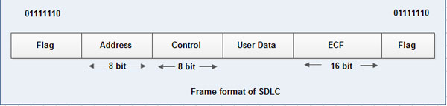
- The flag sequence of 8 bits 01111110 marks the beginning and ending of the frame.
Address Field :
- The address field identifies the secondary station that transmitted or is to receive the frame. This field is not needed for point-to-point links, but is always included for the sake of uniformity.
- The address field is usually eight bits long but, by prior agreement, an extended format may be used in which the actual address length is a multiple of seven bits. The least significant bit of each octet is 1 or 0, depending on whether it is or is not the last octet of the address field.
- The single-octet address of 11111111 is interpreted as the all-stations address
Control Field:
Three main types of frames:
1) Information frames (I-frames) carry the data to be transmitted for the user. Additionally, flow- and error-control data are piggybacked on an information frame
2) Supervisory frames (S-frames) provide the ARQ mechanism when piggybacking is not used.
3)Unnumbered frames (U-frames) provide supplemental link control functions
- The information field or user data field carries the data and is of variable length.
- ECF stands for error checking field and is of 16 bits. It is used for error control.

