SATELLITE COMMUNICATION
Introduction to satellite communication:
Satellites are specifically made for telecommunication purpose. They are used for mobile applications such as communication to ships, vehicles, planes, hand -held terminals and for TV and radio broadcasting.
They are responsible for providing these services to an assigned region (area) on the earth. The power and bandwidth of these satellites depend upon the preferred size of the footprint, complexity of the traffic control protocol schemes and the cost of ground stations.
A satellite works most efficiently when the transmissions are focused with a desired area. When the area is focused, then the emissions don”t go outside that designated area and thus minimizing the interference to the other systems. This leads more efficient spectrum usage.
Satellite ‟ s antenna patterns play an important role and must be designed to best cover the designated geographical area (which is generally irregular in shape). Satellites should be designed by keeping in mind its usability for short and long term effects throughout its life time.
The earth station should be in a position to control the satellite if it drifts from its orbit it is subjected to any kind of drag from the external forces.

THE ORIGIN OF SATELLITES

The Space Age began in 1957 with the U.S.S.R.’s launch of the first artificial satellite, called Sputnik, which transmitted telemetry information for 21 days. This achievement was followed in 1958 by the American artificial satellite Score, which was used to broadcast President Eisenhower’s Christmas message. Two satellites were deployed in 1960: a reflector satellite, called Echo, and Courier. The Courier was particularly significant because it recorded a message that could be played back later. In 1962 active commu-nication satellites (repeaters), called Telstar and Relay, were deployed, and the first geostationary satellite, called Syncom, was launched in 1963. The race for space exploitation for commercial and civil purposes thus truly started.
A satellite is geostationary if it remains relatively fixed (stationary) in an apparent position relative to the earth. This position is typically about 35,784 km away from the earth. Its elevation angle is orthogonal (i.e., 90 ) to the equator, and its period of revolution is synchronized with that of the earth in inertial space. A geostationary satellite has also been called a geosynchronous or synchronous orbit, or simply a geosatellite.
The first series of commercial geostationary satellites (Intelsat and Molnya) was inaugurated in 1965. These satellites provided video (television) and voice (telephone) communications for their audiences. Intelsat was the first commercial global satellite system owned and operated by a consortium of more than 100 nations; hence its name, which stands for International Telecommunications Satellite Organization. The first organization to provide global satellite coverage and connectivity, it continues to be the major communications provider with the broadest reach and the most comprehensive range of services.
Other providers for industrial and domestic markets include Westar in 1974, Satcom in 1975, Comstar in 1976, SBS in 1980, Galaxy and Telstar in 1983, Spacenet and Anik in 1984, Gstar in 1985, Aussat in 1985–86, Optus A2 in 1985, Hughes-Ku in 1987, NASA ACTS in 1993, Optus A3 in 1997, and Iridium and Intelsat VIIIA in 1998. Even more are planned. Some of these satellites host dedicated military communication channels. The need to have market domination and a competitive edge in military surveillance and tactical fields results in more sophisticated developments in the satellite field
APPLICATIONS OF SATELLITES
Weather Forecasting
Certain satellites are specifically designed to monitor the climatic conditions of earth. They continuously monitor the assigned areas of earth and predict the weather conditions of that region. This is done by taking images of earth from the satellite. These images are transferred using assigned radio frequency to the earth station. (Earth Station: it‟s a radio station located on the earth and used for relaying signals from satellites.) These satellites are exceptionally useful in predicting disasters like hurricanes, and monitor the changes in the Earth's vegetation, sea state, ocean color, and ice fields.
Radio and TV Broadcast
These dedicated satellites are responsible for making 100s of channels across the globe available for everyone. They are also responsible for broadcasting live matches, news, world-wide radio services. These satellites require a 30-40 cm sized dish to make these channels available globally.
Military Satellites
These satellites are often used for gathering intelligence, as a communications satellite used for military purposes, or as a military weapon. A satellite by itself is neither military nor civil. It is the kind of payload it carries that enables one to arrive at a decision regarding its military or civilian character.
Navigation Satellites
The system allows for precise localization world-wide, and with some additional techniques, the precision is in the range of some meters. Ships and aircraft rely on GPS as an addition to traditional navigation systems. Many vehicles come with installed GPS receivers. This system is also used, e.g., for fleet management of trucks or for vehicle localization in case of theft.
Global Telephone
One of the first applications of satellites for communication was the establishment of international telephone backbones. Instead of using cables it was sometimes faster to launch a new satellite. But, fiber optic cables are still replacing satellite communication across long distance as in fiber optic cable, light is used instead of radio frequency, hence making the communication much faster (and of course, reducing the delay caused due to the amount of distance a signal needs to travel before reaching the destination.).
Using satellites, to typically reach a distance approximately 10,000 kms away, the signal needs to travel almost 72,000 kms, that is, sending data from ground to satellite and (mostly) from satellite to another location on earth. This cause‟s substantial amount of delay and this delay becomes more prominent for users during voice calls.
Connecting Remote Areas
Due to their geographical location many places all over the world do not have direct wired connection to the telephone network or the internet (e.g., researchers on Antarctica) or because of the current state of the infrastructure of a country. Here the satellite provides a complete coverage and (generally) there is one satellite always present across a horizon.
Global Mobile Communication
The basic purpose of satellites for mobile communication is to extend the area of coverage. Cellular phone systems, such as AMPS and GSM (and their successors) do not cover all parts of a country. Areas that are not covered usually have low population where it is too expensive to install a base station. With the integration of satellite communication, however, the mobile phone can switch to satellites offering world-wide connectivity to a customer. Satellites cover a certain area on the earth. This area is termed as a „footprint‟ of that satellite. Within the footprint, communication with that satellite is possible for mobile users. These users communicate using a Mobile-User-Link (MUL). The base-stations communicate with satellites using a Gateway-Link (GWL). Sometimes it becomes necessary for satellite to create a communication link between users belonging to two different footprints. Here the satellites send signals to each other and this is done using Inter-Satellite-Link (ISL).
FREQUENCY ALLOCATION FOR SATELLITE
Allocation of frequencies to satellite services s a complicated process which requires international coordination and planning. This is done as per the International Telecommunication Union (ITU). To implement this frequency planning, the world is divided into three regions:
Region1: Europe, Africa and Mongolia

Region 2: North and South America and Greenland

Region 3: Asia (excluding region 1 areas), Australia and south-west Pacific.

Within these regions, he frequency bands are allocated to various satellite services. Some of them are listed below.
Fixed satellite service: Provides Links for existing Telephone Networks Used for transmitting television signals to cable companies

Broadcasting satellite service: Provides Direct Broadcast to homes. E.g. Live Cricket matches etc

Mobile satellite services: This includes services for:
Land Mobile,Maritime Mobile,Aeronautical mobile
Navigational satellite services : Include Global Positioning systems

Meteorological satellite services: They are often used to perform Search and Rescue service

Below are the frequencies allocated to these satellites: Frequency Band (GHZ) Designations:
- VHF: 01-0.3

- UHF: 0.3-1.0

- L-band: 1.0-2.0

- S-band: 2.0-4.0

- C-band: 4.0-8.0

- X-band: 8.0-12.0

- Ku-band: 12.0-18.0 (Ku is Under K Band)

- Ka-band: 18.0-27.0 (Ka is Above K Band)

- V-band: 40.0-75.0

- W-band: 75-110

- Mm-band: 110-300

- μm-band: 300-3000

Based on the satellite service, following are the frequencies allocated to the satellites:

Frequency Band (GHZ) Designations:

VHF: 01-0.3 ---Mobile & Navigational Satellite Services

L-band: 1.0-2.0 --- Mobile & Navigational Satellite Services

C-band: 4.0-8.0 --- Fixed Satellite Service

Ku-band: 12.0-18.0 --- Direct Broadcast Satellite Services

TYPES OF SATELLITES (BASED ON ORBITS)
Geostationary or geosynchronous earth orbit (GEO)
GEO satellites are synchronous with respect to earth. Looking from a fixed point from Earth, these satellites appear to be stationary. These satellites are placed in the space in such a way that only three satellites are sufficient to provide connection throughout the surface of the Earth (that is; their footprint is covering almost 1/3rd of the Earth). The orbit of these satellites is circular
There are three conditions which lead to geostationary satellites. Lifetime expectancy of these satellites is 15 years.

- The satellite should be placed 37,786 kms (approximated to 36,000 kms) above the surface of the earth.

- These satellites must travel in the rotational speed of earth, and in the direction of motion of earth, that is eastward.
The inclination of satellite with respect to earth must be 0⁰
Geostationary satellite in practical is termed as geosynchronous as there are multiple factors which make these satellites shift from the ideal geostationary condition.
- Gravitational pull of sun and moon makes these satellites deviate from their orbit. Over the period of time, they go through a drag. (Earth‟s gravitational force has no effect on these satellites due to their distance from the surface of the Earth.)
- These satellites experience the centrifugal force due to the rotation of Earth, making them deviate from their orbit.

- The non-circular shape of the earth leads to continuous adjustment of speed of satellite from the earth station.
These satellites are used for TV and radio broadcast, weather forecast and also, these satellites are operating as backbones for the telephone networks
Disadvantages of GEO: Northern or southern regions of the Earth (poles) have more problems receiving these satellites due to the low elevation above a latitude of 60°, i.e., larger antennas are needed in this case. Shading of the signals is seen in cities due to high buildings and the low elevation further away from the equator limit transmission quality. The transmit power needed is relatively high which causes problems for battery powered devices. These satellites cannot be used for small mobile phones. The biggest problem for voice and also data communication is the high latency as without having any handovers, the signal has to at least travel 72,000 kms. Due to the large footprint, either frequencies cannot be reused or the GEO satellite needs special antennas focusing on a smaller footprint. Transferring a GEO into orbit is very expensive.
Low Earth Orbit (LEO) satellites
These satellites are placed 500-1500 kms above the surface of the earth. As LEOs circulate on a lower orbit, hence they exhibit a much shorter period that is 95 to 120 minutes. LEO systems try to ensure a high elevation for every spot on earth to provide a high quality communication link. Each LEO satellite will only be visible from the earth for around ten minutes
These satellites are mainly used in remote sensing an providing mobile communication services (due to lower latency).
Disadvantages: The biggest problem of the LEO concept is the need for many satellites if global coverage is to be reached. Several concepts involve 50–200 or even more satellites in orbit. The short time of visibility with a high elevation requires additional mechanisms for connection handover between different satellites. The high number of satellites combined with the fast movements resulting in a high complexity of the whole satellite system. One general problem of LEOs is the short lifetime of about five to eight years due to atmospheric drag and radiation from the inner Van Allen belt1. Assuming 48 satellites and a lifetime of eight years, a new satellite would be needed every two months. The low latency via a single LEO is only half of the story. Other factors are the need for routing of data packets from satellite to if a user wants to communicate around the world. Due to the large footprint, a GEO typically does not need this type of routing, as senders and receivers are most likely in the same footprint.

Medium Earth Orbit (MEO) satellites:
MEOs can be positioned somewhere between LEOs and GEOs, both in terms of their orbit and due to their advantages and disadvantages. Using orbits around 10,000 km, the system only requires a dozen satellites which is more than a GEO system, but much less than a LEO system. These satellites move more slowly relative to the earth‟s rotation allowing a simpler system design (satellite periods are about six hours). Depending on the inclination, a MEO can cover larger populations, so requiring fewer handovers.
Disadvantages: Again, due to the larger distance to the earth, delay increases to about 70–80 ms. the satellites need higher transmit power and special antennas for smaller footprints.
The above three are the major three categories of satellites, apart from these, the satellites are also classified based on the following types of orbits
Sun- Synchronous Orbits satellites:
These satellites rise and set with the sun. Their orbit is defined in such a way that they are always facing the sun and hence they never go through an eclipse.
For these satellites, the surface illumination angle will be nearly the same every time.(Surface illumination angle:
The illumination angle is the angle between the inward surface normal and the direction of light. This means that the illumination angle of a certain point of the Earth's surface is zero if the Sun is precisely overhead and that it is 90 degrees at sunset and at sunrise.)Special cases of the sun-synchronous orbit are the noon/midnight orbit, where the local mean solar time of passage for equatorial longitudes is around noon or midnight, and the dawn/dusk orbit, where the local mean solar time of passage for equatorial longitudes is around sunrise or sunset, so that the satellite rides the terminator between day and night.
Hohmann Transfer Orbit:
This is an intermediate orbit having a highly elliptical shape. It is used by GEO satellites to reach their final destination orbits. This orbit is connected to the LEO orbit at the point of perigee forming a tangent and is connected to the GEO orbit at the point of apogee again forming a tangent.
Prograde orbit:
This orbit is with an inclination of less than 90°. Its direction is the same as the direction as the rotation of the primary (planet).
Retrograde orbit:
This orbit is with an inclination of more than 90°. Its direction is counter to the direction of rotation of the planet. Only few satellites are launched into retrograde orbit because the quantity of fuel required to launch them is much greater than for a prograde orbit. This is because when the rocket starts out on the ground, it already has an eastward component of velocity equal to the rotational velocity of the planet at its launch latitude.
Polar Orbits
This orbit passes above or nearly above both poles (north and south pole) of the planet on each of its revolutions. Therefore it has an inclination of (or very close to) 90 degrees. These orbits are highly inclined in shape.

Satellite Advantages and Disadvantages

Advantages:
- High bandwidth
- Coverage over a large geographical area
- Can be cheaper over long distances
Disadvantages:Huge initial cost
- Noise and interference
- Propagation delay

Future trends in communications satellite systems
Satellites very important for modern communications. Radio Frequency communication reaching the end of its usefulness.Laser Communications will eventually be the method of choice for satellites Direct Broadband Satellite Communications for Future U.S. Military and Coast Guard .The current Interim Polar System (IPS) and follow-on Enhanced Polar System ... Mobile and Personal Satellite Communications: Proceedings of the . - Google Books Result A survey of future broadband multimedia satellite systems is provided in this article. Con- sistent with emerging third-generation (3G) communications systems ... Apr 16, 2015 . Special issue: Shining a light on future broadband satellite systems: optical and quantum space communications systems and technologies. Feb 1, 2013 . The companies that supply transmission systems for use on the ground and aboard spacecraft must continuously innovate as satellite ... Future Systems specialises in voice and data communications for the mining, . from mobile satellite communications or HF (Long Distance Radio) for small ... Special issue: Shining a light on future broadband satellite systems .

Kepler’s laws:
Kepler’s law Introduction:
Satellites (spacecraft) orbiting the earth follow the same laws that govern the motion of the planets around the sun.
Kepler’s laws apply quite generally to any two bodies in space which interact through gravitation. The more massive of the two bodies is referred to as the primary, the other, the secondary or satellite.
Kepler’s First Law:
Kepler’s first law states that the path followed by a satellite around the primary will be an ellipse. An ellipse hast Two focal points shown as F1 and F2in

Fig. 2.1. The center of mass of the two-body system, termed the bary center, is always center of the foci.
The semi major axis of the ellipse is denoted by a, and the semi minor axis, by b. The eccentricity e is given by
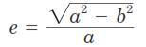
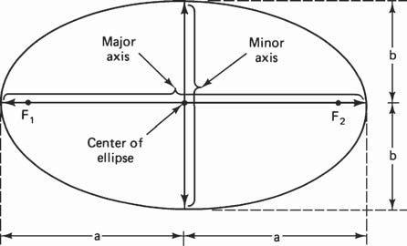

Figure 1.1 The foci F1 and F2, the

semi major axis a, and the semi minor axis b of an ellipse.

Kepler’s Second Law :
Kepler’s second law states that, for equal time intervals, a satellite will sweep out equal areas in its orbital plane, focused at the barycenter. Referring to Fig. 2.2, assuming the satellite travels distances S₁ and S₂ meters in 1 s, then the
areas A₁ and A₂ will be equal. The average velocity in each case is S₁ and S₂ m/s, and because of the equal area law, it follows that the velocity at S₂ is less than that at S₁
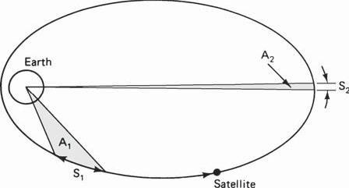

Figure 1.2 Kepler’s second law. The areas A1and

A2swept out in unit time are equal.
Kepler’sThird Law:
Kepler’s third law states that the square of the periodic time of orbit is proportional to the cube of the mean distance between the two bodies. The mean distance is equal to the semi major axis a.

For the artificial satellites orbiting the earth, Kepler’s third law can be written in the form _{= /}

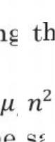
Where n is the mean motion of the satellite in radians per second and is the earth’s geocentric gravitational constant µ=3.986005 X 10¹⁴m³/s²

Newton’s law:
Newton's first law:
An object at rest will remain at rest unless acted on by an unbalanced force. An object in motion continues in motion with the same speed and in the same direction unless acted upon by an unbalanced force. This law is often called "the law of inertia".
Newton's second law:
Acceleration is produced when a force acts on a mass. The greater the mass (of the object being accelerated) the greater the amount of force needed (to accelerate the object).
Newton's first law:
For every action there is an equal and opposite re -action. This means that for every force there is a reaction force that is equal in size, but opposite in direction. That is to say that whenever an object pushes another object it gets pushed back in the opposite direction equally hard.
orbital parameters:
Apogee: A point for a satellite farthest from the Earth. It is denoted as ha.
Perigee: A point for a satellite closest from the Earth. It is denoted as hp.
Line of Apsides: Line joining perigee and apogee through centre of the Earth. It is the major axis of the orbit. One-half of this line‟ s length is the semi-major axis equivalents to satellite‟s mean distance from the Earth.
Ascending Node: The point where the orbit crosses the equatorial plane going from north to south.
Descending Node: The point where the orbit crosses the equatorial plane going from south to north.
Inclination: the angle between the orbital plane and the Earth‟ s equatorial plane. Its measured at the ascending node from the equator to the orbit, going from East to North. Also, this angle is commonly denoted as i.

Line of Nodes: the line joining the ascending and descending nodes through the centre of Earth.
Prograde Orbit: an orbit in which satellite moves in the same direction as the Earth‟s rotation. Its inclination is always between 00 to 900. Many satellites follow this path as Earth‟s velocity makes it easier to lunch these satellites.
Retrograde Orbit: an orbit in which satellite moves in the same direction counter to the Earth‟s rotation.
Argument of Perigee: An angle from the point of perigee measure in the orbital plane at the Earth‟s centre, in the direction of the satellite motion.
Right ascension of ascending node: The definition of an orbit in space, the position of ascending node is specified. But as the Earth spins, the longitude of ascending node changes and cannot be used for reference. Thus for practical determination of an orbit, the longitude and time of crossing the ascending node is used.For absolute measurement, a fixed reference point in space is required.
It could also be defined as “right ascension of the ascendin g node; right ascension is the angular position measured eastward along the celestial equator from the vernal equinox vector to the hour circle of the object”.
Mean anamoly: It giv es the average value to the angular p osition of the satellite with reference to the perigee.
True anamoly: It is the angle from point of perigee to the satellite‟s position, measure at the Earth‟s centre.
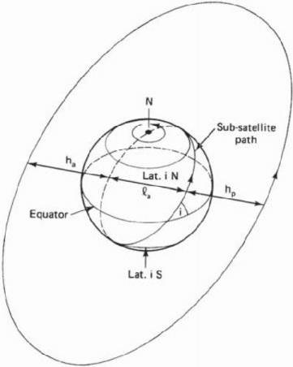

Figure1.2 Apogee height ha, perigee height hp, an d inclination i. Lais the line of apsi des.
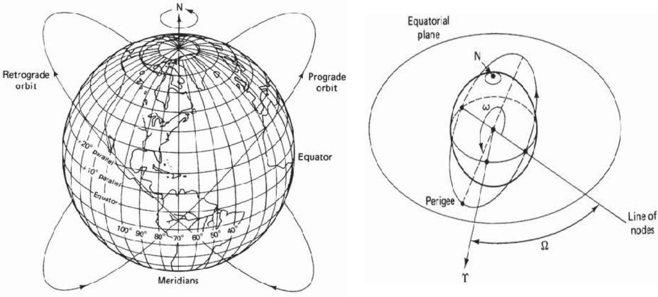

Figure 1.3(a) Progra de and retrograde orbi ts.

Figure.1.4 The argument of perigee w & right ascension of the ascending

node Ω.

Orbital Perturbations: Theoretically, an orbit described by Kepler is ideal as Earth is considered to be a perfect sphere and the force acting around the Earth is the centrifugal force. This force is supposed to balance the gravitational pull of the earth.
In reality, other forces also play an important role and affect the motion of the satellite. These forces are the gravitational forces of Sun and Moon along with the atmospheric drag.
Effect of Sun and Moon is more pronounced on geostationary earth satellites where as the atmospheric drag effect is more pronounced for low earth orbit satellites.
Effects of non-Spherical Earth :
As the shape of Earth is not a perfect sphere, it causes some variations in the path followed by the satellites around the primary. As the Earth is bulging from the equatorial belt, and keeping in mind that an orbit is not a physical entity, and it is the forces resulting from an oblate Earth which act on the satellite produce a change in the orbital parameters.
This causes the satellite to drift as a result of regression of the nodes and the latitude of the point of perigee (point closest to the Earth). This leads to rotation of the line of apsides. As the orbit itself is moving with respect to the Earth, the resultant changes are seen in the values of argument of perigee and right ascension of ascending node.
Due to the non-spherical shape of Earth, one more effect called as the “Satellite Graveyard” is seen. The non -spherical shape leads to the small value of eccentricity (10-5 ) at the equatorial plane. This causes a gravity gradient on GEO satellite and makes them drift to one of the two stable points which coincide with minor axis of the equatorial ellipse.
Atmospheric Drag:
For Low Earth orbiting satellites, the effect of atmospheric drag is more pronounces. The impact of this drag is maximumat the point of perigee. Drag (pull towards the Earth) has an effect on velocity of Satellite (velocity reduces).
This causes the satellite to not reach the apogee height successive revolutions. This leads to a change in value of semi-major axis and eccentricity. Satellites in service are maneuvered by the earth station back to their original orbital position.

Station Keeping:
In addition to having its attitude controlled, it is important that a geo-stationary satellite be kept in its correct orbital slot. The equatorial ellipticity of the earth causes geostationary satel- lites to drift slowly along the orbit, to one of two stable points, at 75°E and 105°W.
To counter this drift, an oppositely directed velocity com-ponent is imparted to the satellite by means of jets, which are pulsed once every 2 or 3 weeks. These maneuvers are termed east-west station-keeping maneuvers. Satellites in the 6/4-GHz band must be kept within 0.1° of the desig- nated longitude, and in the 14/12-GHz band, within 0.05°.
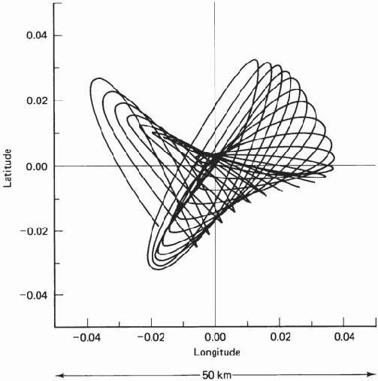

Figure 1.5 Typical satellite motion.(CourtesyofTelesat,Canada,1983.)
Geo stationary and Non Geo-stationary orbits:
Geo stationary:
A geostationary orbit is one in which a satellite orbits the earth at exactly the same speed as the earth turns and at the same latitude, specifically zero, the latitude of the equator. A satellite orbiting in a geostationary orbit appears to be hovering in the same spot in the sky, and is directly over the same patch of ground at all times.

A geosynchronous orbit is one in which the satellite is synchronized with the earth's rotation, but the orbit is tilted with respect to the plane of the equator. A satellite in a geosynchronous orbit will wander up and down in latitude, although it will stay over the same line of longitude. Although the terms 'geostationary' and 'geosynchronous' are sometimes used interchangeably, they are not the same technically; geostationary orbit is a subset of all possible geosynchronous orbits.
The person most widely credited with developing the concept of geostationary orbits is noted science fiction author Arthur C. Clarke (Islands in the Sky, Childhood's End, Rendezvous with Rama, and the movie 2001: a Space Odyssey). Others had earlier pointed out that bodies traveling a certain distance above the earth on the equatorial plane would remain motionless with respect to the earth's surface. But Clarke published an article in 1945's Wireless World that made the leap from the Germans' rocket research to suggest permanent manmade satellites that could serve as communication relays.
Geostationary objects in orbit must be at a certain distance above the earth; any closer and the orbit would decay, and farther out they would escape the earth's gravity altogether. This distance is 35,786 kilometers (22,236 miles) from the surface.
The first geosynchrous satellite was orbited in 1963, and the first geostationary one the following year. Since the only geostationary orbit is in a plane with the equator at 35,786 kilometers, there is only one circle around the world where these conditions obtain.
This means that geostationary 'real estate' is finite. While satellites are in no danger of bumping in to one another yet, they must be spaced around the circle so that their frequencies do not interfere with the functioning of their nearest neighbors.
Geostationary Satellites:
There are 2 kinds of manmade satellites in the heavens above: One kind of satellite ORBITS the earth once or twice a day, and the other kind is called a communications satellite and it is PARKED in a STATIONARY position 22,300 miles (35,900 km) above the equator of the STATIONARY earth.
A type of the orbiting satellite includes the space shuttle and the international space station which keep a low earth orbit (LEO) to avoid the deadly Van Allen radiation belts.

The most prominent satellites in medium earth orbit (MEO) are the satellites which comprise the GLOBAL POSITIONING SYSTEM or GPS as it is called.
The Global Positioning System
The global positioning system was developed by the U.S. military and then opened to civilian use. It is used today to track planes, ships, trains, cars or literally anything that moves. Anyone can buy a receiver and track their exact location by using a GPS receiver.
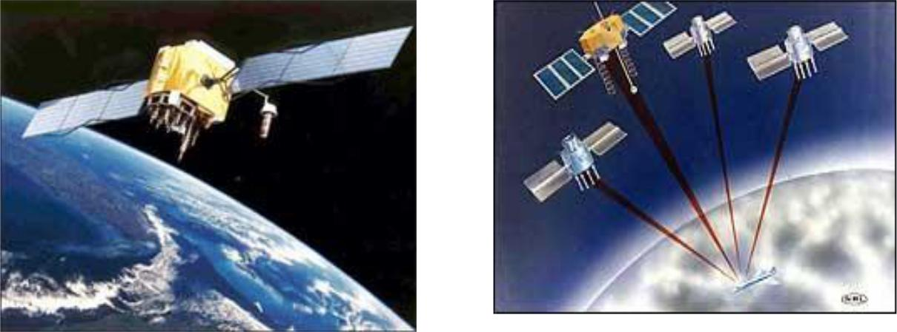

GPS satellites orbit at a height of about 12,000 miles (19,300 km) and orbit the earth once every 12 hours.

About 24 GPS satellites orbit the earth every 12 hour
These satellites are traveling around the earth at speeds of about 7,000 mph (11,200 kph). GPS satellites are powered by solar energy. They have backup batteries onboard to keep them running in the event of a solar eclipse, when there's no solar power.
Small rocket boosters on each satellite keep them flying in the correct path. The satellites have a lifetime of about 10 years until all their fuel runs out.
At exactly 22,300 miles above the equator, the force of gravity is cancelled by the centrifugal force of the rotating universe. This is the ideal spot to park a stationary satellite.
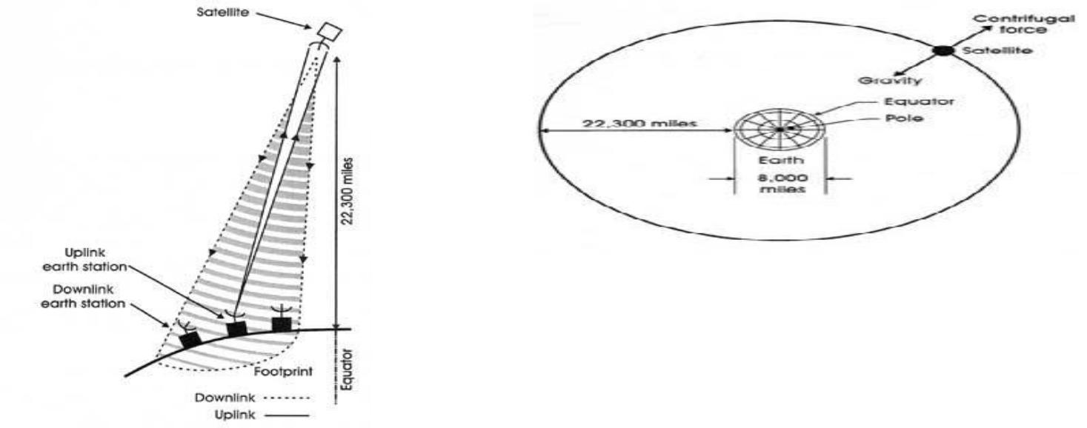

Figure. 1.6 & 1.7 At exactly 22,000 miles (35,900 km) above the equator, the earth's force of gravity is canceled by the centrifugal force of the rotating universe. .
Non Geo-Stationary Orbit:
For the geo- stationary case, the most important of these are the gravitational fields of the moon and the sun, and the nonspherical shape of the earth.
Other significant forces are solar radiation pressure and reaction of the satellite itself to motor movement within the satellite. As a result, station-keeping maneuvers must be carried out to maintain the satel- lite within set limits of its nominal geostationary position.
An exact geostationary orbit therefore is not attainable in practice, and the orbital parameters vary with time. The two-line orbital elements are published at regular intervals.

The period for a geostationary satellite is 23 h, 56 min, 4 s, or 86,164 s. The reciprocal of this is 1.00273896 rev/day, which is about the value tabu-lated for most of the satellites in Fig.
Thus these satellites are geo- synchronous, in that they rotate in synchronism with the rotation of the earth. However, they are not geostationary. The term geosynchronous satellite is used in many cases instead of geostationary to describe these near-geostationary satellites.
It should be noted, however, that in gen- eral a geosynchronous satellite does not have to be near-geostationary, and there are a number of geosynchronous satellites that are in highly elliptical orbits with comparatively large inclinations (e.g., the Tundra satellites).
The small inclination makes it difficult to locate the position of the ascending node, and the small eccentricity makes it difficult to locate the position of the perigee.
However, because of the small inclination, the angles w and Ω can be assumed to be in the same plane.The longitude of the subsatellite point (thesatellitelongitude) is the east early rotation from the Greenwich meridian.
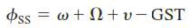

The Greenwich sidereal time (GST) gives the eastward position of the Greenwich meridian relative to the line of Aries, and hence the subsatellite point is at longitudeand the mean longitude of the satellite is given by
Equation(2.31)can be used to calculate the trueanomaly, and because of the small eccentricity, this can be approximated as v = M + 2esinM.

Look Angle Determination:
The look angles for the ground station antenna are Azimuth and Elevation angles. They are required at the antenna so that it points directly at the satellite. Look angles are calculated by considering the elliptical orbit. These angles change in order to track the satellite.

For geostationary orbit, these angels values does not change as the satellites are stationary with respect to earth. Thus large earth stations are used for commercial communications.
For home antennas, antenna beamwidth is quite broad and hence no tracking is essential. This leads to a fixed position for these antennas.
Limits of visibility:
The east and west limits of geostationary are visible from any given Earth station. These limits are set by the geographic coordinates of the Earth station and antenna elevation.
The lowest elevation is zero (in theory) but in practice, to avoid reception of excess noise from Earth. Some finite minimum value of elevation is issued. The earth station can see a satellite over a geostationary arc bounded by +- (81.30) about the earth station‟s longitude.
Eclipse:
It occurs when Earth‟s equatorial plane coincides with the plane f he Earth‟s orbit around the sun.
Near the time of spring and autumnal equinoxes, when the sun is crossing the equator, the satellite passes into sun‟s shadow. This happens for some duration of time every day.
These eclipses begin 23 days before the equinox and end 23 days after the equinox. They last for almost 10 minutes at the beginning and end of equinox and increase for a maximum period of 72 minutes at a full eclipse.
The solar cells of the satellite become non-functional during the eclipse period and the satellite is made to operate with the help of power supplied from the batteries.
A satellite will have the eclipse duration symmetric around the time t=Satellite Longitude/15 + 12 hours. A satellite at Greenwich longitude 0 will have the eclipse duration symmetric around 0/15
UTC +12hours = 00:00 UTC.

The eclipse will happen at night but for satellites in the east it will happen late evening local time.
For satellites in the west eclipse will happen in the early morning hour’s local time.
An earth caused eclipse will normally not happen during peak viewing hours if the satellite is located near the longitude of the coverage area. Modern satellites are well equipped with batteries for operation during eclipse.
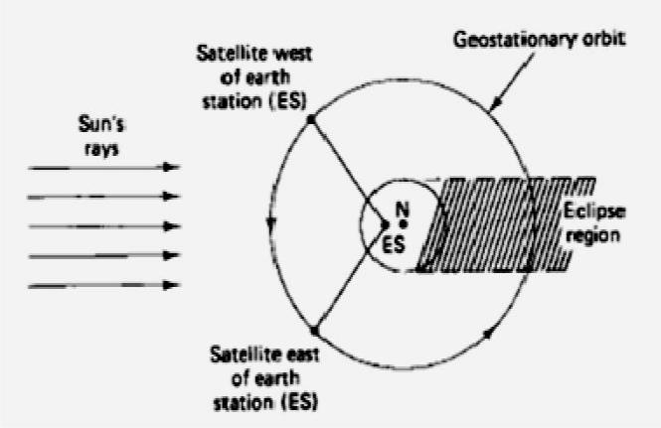

Figure 1.11(i): A satellite east of the earth station enters eclipse during daylight busy) hours at the earth station. A Satellite west of earth station enters eclipse during night and early morning hours (non busy time).
Sub satellite Point:
- Point at which a line between the satellite and the center of the Earth intersects the Earth’s surface

- Location of the point expressed in terms of latitude and longitude

- If one is in the US it is common to use

o Latitude – degrees north from equator

  - Longitude – degrees west of the Greenwich meridian

- Location of the sub satellite point may be calculated from coordinates of the rotating system as:

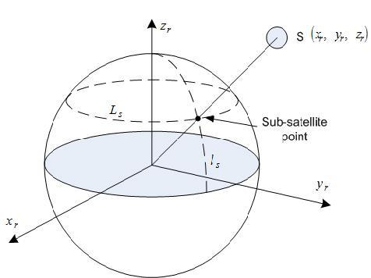

L = ^{π} |  |  | ⎛ |  | z_{r} |  | ⎞
 |  | − cos | −1 ⎜ |  | z_{r} |  | ⎟
 |  | − cos | ⎜ |  | 222 |  | ⎟
s | 2 |  | ⎝ |  | x_{r} + y_{r} + z_{r} |  | ⎠

Figure 1.11(ii) Sub satellite Point
Sun Transit Outage :
Sun transit outage is an interruption in or distortion of geostationary satellite signals caused by interference from solar radiation.
Sun appears to be an extremely noisy source which completely blanks out the signal from satellite. This effect lasts for 6 days around the equinoxes. They occur for a maximum period of 10 minutes.
Generally, sun outages occur in February, March, September and October, that is, around the time of the equinoxes.
At these times, the apparent path of the sun across the sky takes it directly behind the line of sight between an earth station and a satellite.
As the sun radiates strongly at the microwave frequencies used to communicate with satellites (C-band, Ka band and Ku band) the sun swamps the signal from the satellite.
The effects of a sun outage can include partial degradation, that is, an increase in the error rate, or total destruction of the signal.

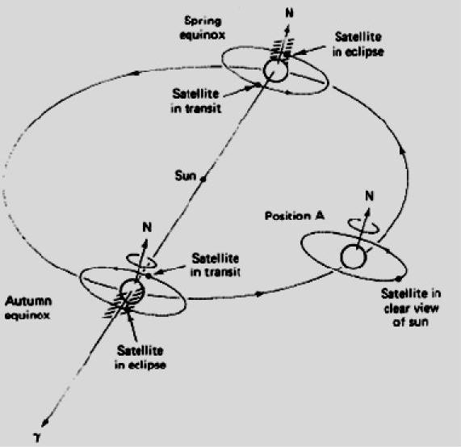

Figure 1.12 : Earth Eclipse of a Satellite and Sun transit Outage

Launching Procedures :
Intoduction:
Low Earth Orbiting satellites are directly injected into their orbits. This cannot be done incase of GEOs as they have to be positioned 36,000kms above the Earth‟s surface.
Launch vehicles are hence used to set these satellites in their orbits. These vehicles are reusable. They are also known as „Space Transportation System‟ (STS).
When the orbital altitude is greater than 1,200 km it becomes expensive to directly inject the satellite in its orbit.
For this purpose, a satellite must be placed in to a transfer orbit between the initial lower orbit and destination orbit. The transfer orbit is commonly known as *Hohmann-Transfer Orbit.

Orbit Transfer:
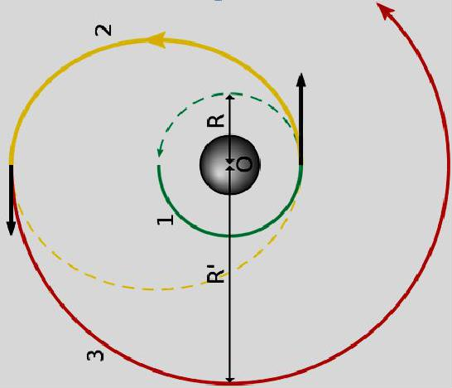

Figure 1.13: Orbit Transfer positions*
About Hohmann Transfer Orbit: This manoeuvre is named for the German civil engineer who first proposed it, Walter Hohmann, who was born in 1880. He didn't work in rocketry professionally (and wasn't associated with military rocketry), but was a key member of Germany's pioneering Society for Space
Travel that included people such as Willy Ley, Hermann, and Werner von Braun. He published his concept of how to transfer between orbits in his 1925 book, The Attainability of Celestial Bodies.)
The transfer orbit is selected to minimize the energy required for the transfer. This orbit forms a tangent to the low attitude orbit at the point of its perigee and tangent to high altitude orbit at the point of its apogee.
Launch vehicles and propulsion:
The rocket injects the satellite with the required thrust** into the transfer orbit. With the STS, the satellite carries a perigee kick motor*** which imparts the required thrust to inject the satellite in its transfer orbit. Similarly, an apogee kick motor (AKM) is used to inject the satellite in its destination orbit.
Generally it takes 1-2 months for the satellite to become fully functional. The Earth Station performs the Telemetry Tracking and Command**** function to control the satellite transits and functionalities.

(**Thrust: It is a reaction force described quantitatively by Newton's second and third laws. When a system expels or accelerates mass in one direction the accelerated mass will cause a force of equal magnitude but opposite direction on that system.)
Kick Motor refers to a rocket motor that is regularly employed on artificial satellites destined for a geostationary orbit. As the vast majority of geostationary satellite launches are carried out from spaceports at a significant distance away from Earth's equator.
The carrier rocket would only be able to launch the satellite into an elliptical orbit of maximum apogee 35,784-kilometres and with a non-zero inclination approximately equal to the latitude of the launch site.
TT&C: it‟s a sub-system where the functions performed by the satellite control network to maintain health and status, measure specific mission parameters and processing over time a sequence of these measurement to refine parameter knowledge, and transmit mission commands to the satellite. Detailed study of TT&C in the upcoming units.
Transfer Orbit :
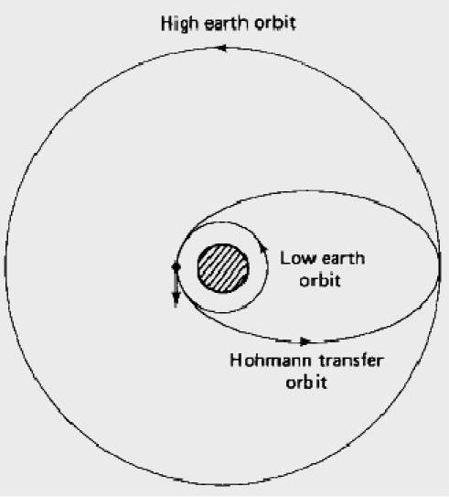
It is better to launch rockets closer to the equator because the Earth rotates at a greater speed here than that at either pole. This extra speed at the equator means a rocket needs less thrust (and therefore less fuel) to launch into orbit.In addition, launching at the equator provides an additional 1,036 mph (1,667 km/h) of speed once the vehicle reaches orbit. This speed bonus means the vehicle needs less fuel, and that freed space can be used to carry more pay load.

Figure 1.14: Hohmann Transfer Orbit

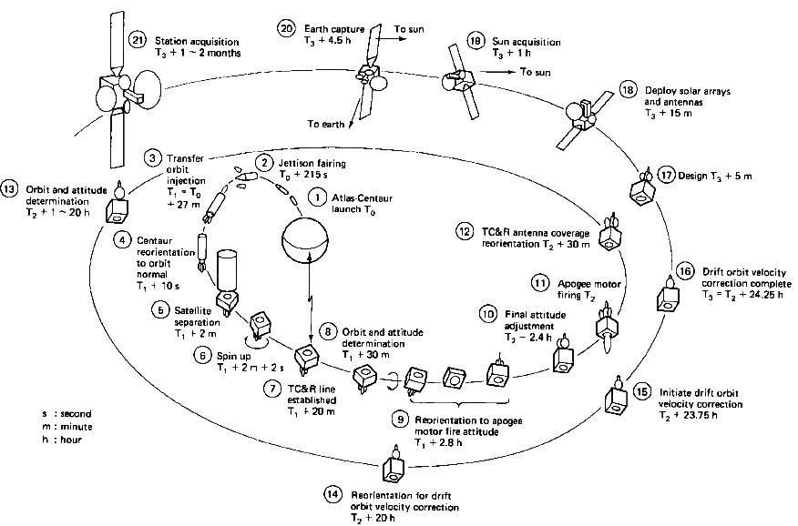

Figure 1.15: Launching stages of a GEO (example INTELSAT)
Rocket launch:
A rocket launch is the takeoff phase of the flight of a rocket. Launches for orbital spaceflights, or launches into interplanetary space, are usually from a fixed location on the ground, but may also be from a floating platform (such as the Sea Launch vessel) or, potentially, from a superheavy An-225-class airplane^{[1]}
Launches of suborbital flights (including missile launches), can also be from:

- a missile silo

- a mobile launcher vehicle

- a submarine

- air launch:

o from a plane (e.g. Scaled Composites Space Ship One, Pegasus Rocket, X-15)

o from a balloon (Rockoon, da Vinci Project (under development))

- a surface ship (Aegis Ballistic Missile Defense System)

- an inclined rail (e.g. rocket sled launch)

"Rocket launch technologies" generally refers to the entire set of systems needed to successfully launch a vehicle, not just the vehicle itself, but also the firing control systems, ground control station, launch pad, and tracking stations needed for a successful launch and/or recovery.
Orbital launch vehicles commonly take off vertically, and then begin to progressively lean over, usually following a gravity turn trajectory.
Once above the majority of the atmosphere, the vehicle then angles the rocket jet, pointing it largely horizontally but somewhat downwards, which permits the vehicle to gain and then maintain altitude while increasing horizontal speed. As the speed grows, the vehicle will become more and more horizontal until at orbital speed, the engine will cut off.
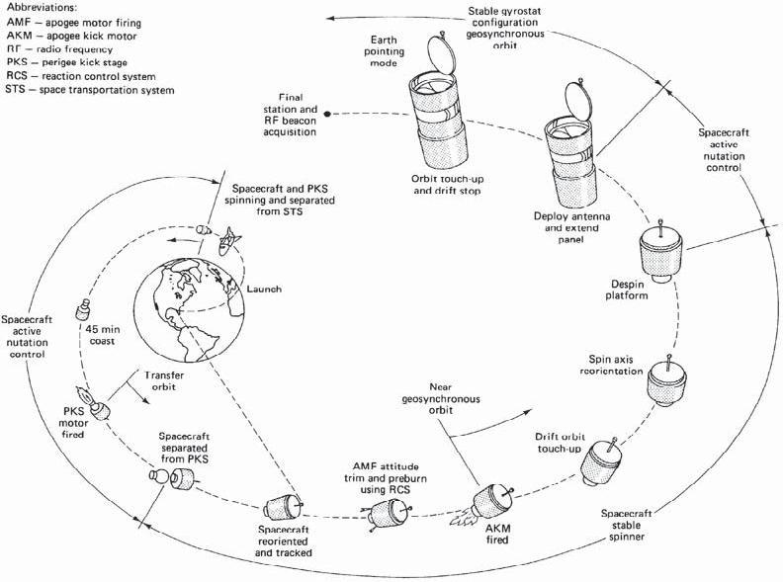

Figure 1.16 STS-7/Anik C2 mission scenario. (From Anik C2 Launch Handbook; courtesy of Telesat, Canada.)

Orbital Perturbations:

Theoretically, an orbit described by Kepler is ideal as Earth is considered to be a perfect sphere and the force acting around the Earth is the centrifugal force. This force is supposed to balance the gravitational pull of the earth.
In reality, other forces also play an important role and affect the motion of the satellite. These forces are the gravitational forces of Sun and Moon along with the atmospheric drag.
Effect of Sun and Moon is more pronounced on geostationary earth satellites where as the atmospheric drag effect is more pronounced for low earth orbit satellites.
Effects of non-Spherical Earth :
As the shape of Earth is not a perfect sphere, it causes some variations in the path followed by the satellites around the primary. As the Earth is bulging from the equatorial belt, and keeping in mind that an orbit is not a physical entity, and it is the forces resulting from an oblate Earth which act on the satellite produce a change in the orbital parameters.
This causes the satellite to drift as a result of regression of the nodes and the latitude of the point of perigee (point closest to the Earth). This leads to rotation of the line of apsides. As the orbit itself is moving with respect to the Earth, the resultant changes are seen in the values of argument of perigee and right ascension of ascending node.
Due to the non-spherical shape of Earth, one more effect called as the “Satellite Graveyard” is seen. The non -spherical shape leads to the small value of eccentricity (10-5 ) at the equatorial plane. This causes a gravity gradient on GEO satellite and makes them drift to one of the two stable points which coincide with minor axis of the equatorial ellipse.
Atmospheric Drag:
For Low Earth orbiting satellites, the effect of atmospheric drag is more pronounces. The impact of this drag is maximumat the point of perigee. Drag (pull towards the Earth) has an effect on velocity of Satellite (velocity reduces).

This causes the satellite to not reach the apogee height successive revolutions. This leads to a change in value of semi-major axis and eccentricity. Satellites in service are maneuvered by the earth station back to their original orbital position.
Station Keeping:
In addition to having its attitude controlled, it is important that a geo-stationary satellite be kept in its correct orbital slot. The equatorial ellipticity of the earth causes geostationary satel- lites to drift slowly along the orbit, to one of two stable points, at 75°E and 105°W.
To counter this drift, an oppositely directed velocity com-ponent is imparted to the satellite by means of jets, which are pulsed once every 2 or 3 weeks. These maneuvers are termed east-west station-keeping maneuvers. Satellites in the 6/4-GHz band must be kept within 0.1° of the desig- nated longitude, and in the 14/12-GHz band, within 0.05°.

Figure 1.5 Typical satellite motion.

