UNIT-II : ELECTROSTATICS

Columb’s law:
The columb’s law states that force between the two point charges Q1 and Q2
- Acts along the line joining the two point charges
- Is directly proportional to the product of two charges.
- Is inversely proportional to the square of the distance between them.

Q1 Q2
R

Q1 exerts force on Q2 and Q2 exerts force on Q1.the force acts along the line joining Q1 and Q2.force exerts them is repulsive if charges are of same polarity ,while attractive if different polarity.
Mathematically the force F between charges can be expressed as

Fα Q₁Q₂
_{R}²
The law states that the force depend on medium in which point charges are located. The effect is introduced in the equation of force as constant of proportionality denoted as “k”.
F = k Q₁Q₂
_{R}²

The constant of proportionality is defined as.
K=$\frac{1}{4πε}$

ε = Permittivity of the medium in which charges are located

Its unit are F/m
ε= ε ₀ε_{r}

ε ₀=permittivity of free space
ε_{r}=relative permittivity/dielectric constant

for ε=ε ₀
columb’s can be expressed as

F = Q₁Q₂
4πε₀R²

Vector form of columb’s law:

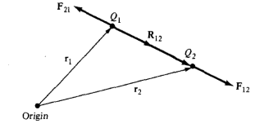
Fig: Coulomb vector force on point changes Q1 and Q2.

If point charges Qy and Q2 are located at points having position vectors I"! and r2, then the force F12 on Q2 due to Qy, shown in Figure above, is given by
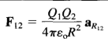
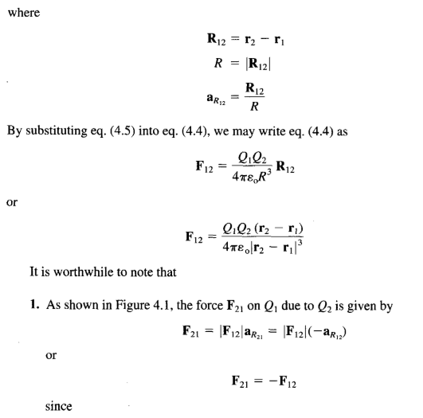

Superposition principle:
If we have more than two point charges, we can use the principle of superposition to determine the force on a particular charge. The principle states that if there are N charges Q₁Q₂. • • •. Q_{n} located, respectively, at points with position vectors r₁; r₂,. . ., r_{n}, the resultant force F on a charge Q located at point r is the vector sum of the forces exerted on Q by each of the charges Q1 Q2,. . ., QN. Hence:

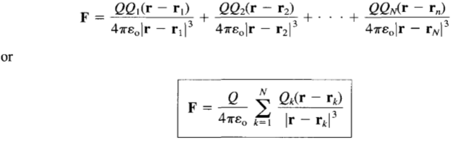
Problem:
Point charges 1 mC and -2 mC are located at (3, 2, -1) and (—1, —1,4), respectively. Calculate the electric force on a 10-nC charge located at (0, 3, 1) and the electric field intensity at that point.
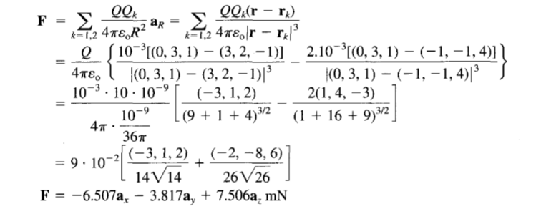

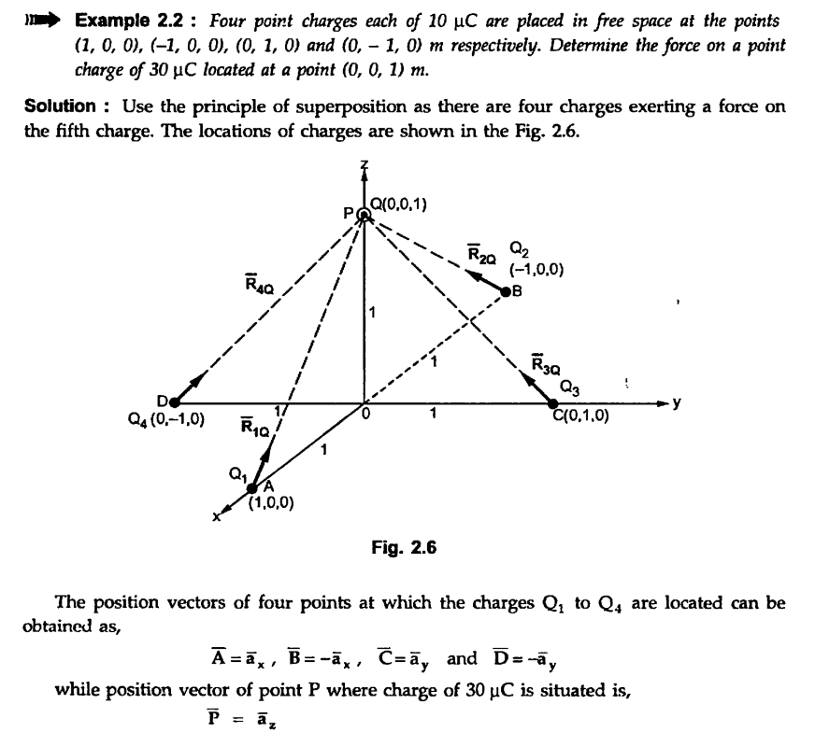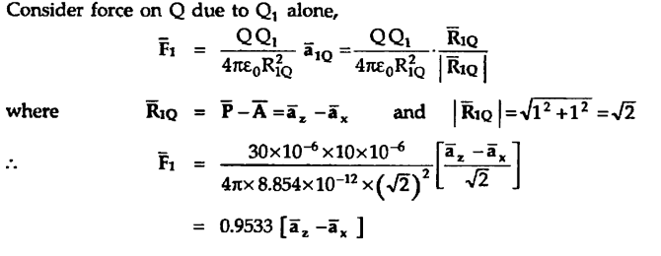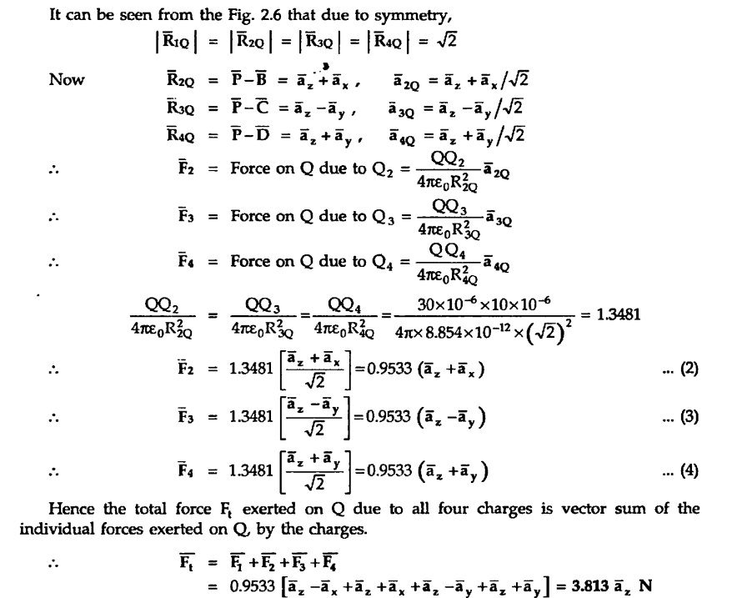

Electric Field Intensity:
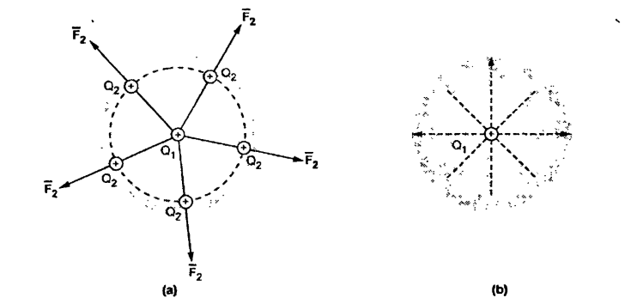
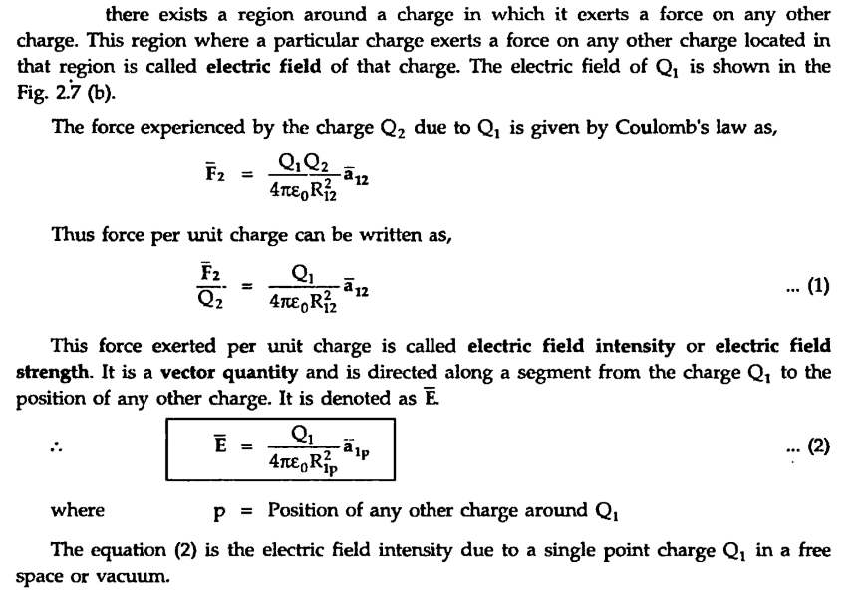
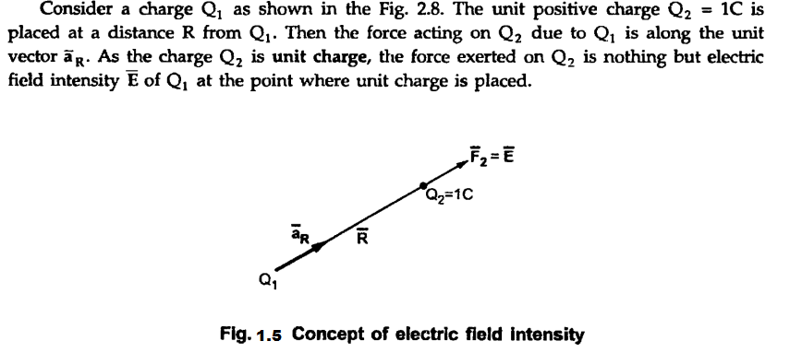
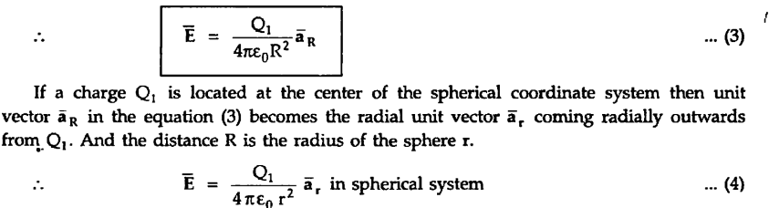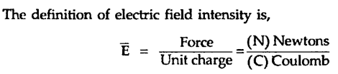

Method of obtaining $\overline{E}$ in Cartesian form:
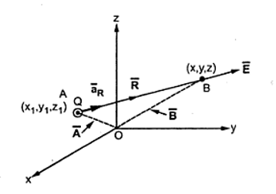
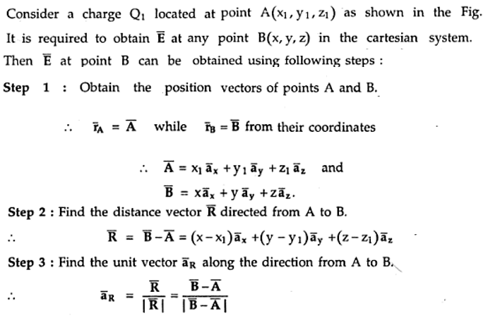
Types of charge distributions:
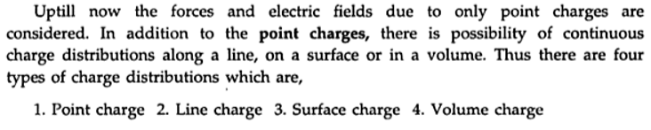
Point charge:
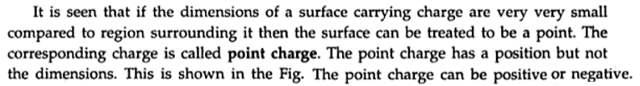
Line charge:
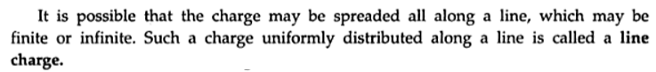
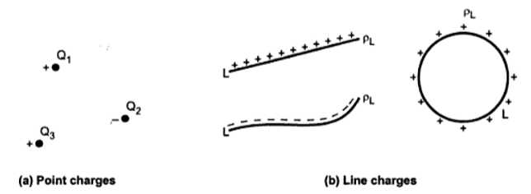

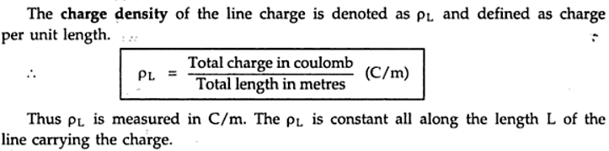
Surface charge:
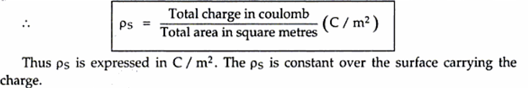

Volume charge:

Electric field intensity due to infinite line charge

Consider an infinitely long straight line carrying uniform line charge having density PL C/m. Let this line lies along z-axis from –infinite to +infinite and hence called infinite line charge. Let point P is on y axis at which electric field intensity is to be determined. The distance of point P from the origin is ‘r as shown in the Fig.

Electrical field intensity due to charged circular ring

Consider a charged circular ring of radius r placed in xy plane with centre at origin, carrying a charge uniformly along its circumference. The charge density is ρL C/rn .
The point P is at a perpendicular distance Z from the ring as shown in the Fig.
Consider a small differential length dl on this ring. The charge on it is dQ.

Electric field intensity due to infinite sheet of charge

Consider an infinite sheet of charge having uniform charge density ρ_{s} C / m², placed in xy plane as show in the Fig. Let us we cylindrical coordinates. The point P at which to be calculated is on z axis. Consider the differential surface area dS carrying a charge dQ.

Electric flux density
Consider the two point charges as shown in the Fig.The flux lines originating from positive charge and terminating at negative charge are shown in the form of tubes.
Consider a unit surface area as shown in the Fig.The number of flux lines are passing through this surface area. The net flux passing normal through the unit surface area is called the electric flux density. It is denoted as . ..It has a specific direction which is normal to the surface area under consideration hence it is a vector field.
Consider a sphere with a charge Q placed at its centre. There are no other charges present around. The total flux distributes radially around the charge is ψ= Q. This flux distributes uniformly over the surface of the sphere.

GAUSS'S LAW
Gauss's law states that the total electric flux ψ through any closed surface is equal tothe total charge enclosed by that surface.

Ψ=Q

APPLICATIONS OF GAUSS'S LAW

Point Charge

Suppose a point charge Q is located at the origin. To determine D at a point P, it is easy to
see that choosing a spherical surface containing P will satisfy symmetry conditions. Thus,
a spherical surface centered at the origin is the Gaussian surface in this case and is shown
in Figure

Since D is everywhere normal to the Gaussian surface,

Infinite Line Charge

Suppose the infinite line of uniform charge pL C/m lies along the z-axis. To determine D at a point P, we choose a cylindrical surface containing P to satisfy symmetry condition as shown in Figure. D is constant on and normal to the cylindrical Gaussian surface;
where § dS = 2Πp€ is the surface area of the Gaussian surface. Note that D • dS evaluated
on the top and bottom surfaces of the cylinder is zero since D has no z-component; that means that D is tangential to those surfaces. Thus

Infinite Sheet of Charge

Consider the infinite sheet of uniform charge ps C/m2 lying on the z = 0 plane. To determine
D at point P, we choose a rectangular box that is cut symmetrically by the sheet of charge and has two of its faces parallel to the sheet as shown in Figure . As D is normal to the sheet,

Note that D • dS evaluated on the sides of the box is zero because D has no components
along ax and ay. If the top and bottom area of the box each has area A

ELECTRIC POTENTIAL

the electric field intensity E due to a charge distribution can be obtained from Coulomb's law in general or from Gauss's law when the charge distribution is symmetric. Another way of obtaining E is from the electric scalar potential V to be defined in this section. In a sense, this way of rinding E is easier because it is easier to handle scalars than vectors.
Suppose we wish to move a point charge Q from point A to point B in an electric field
E as shown in Figure. From Coulomb's law, the force on Q is F = QE so that the work done in displacing the charge by dl is

dW = - F • dl= -QE • dl

The negative sign indicates that the work is being done by an external agent. Thus the total work done, or the potential energy required, in moving Q from A to B is

the potential energy per unit charge. This quantity, denoted by V_{AB}, is known as the potential difference between points A and B. Thus

1. In determining VAB, A is the initial point while B is the final point.
2. If VAB is negative, there is a loss in potential energy in moving Q from A to B; this implies that the work is being done by the field. However, if VAB is positive, there is a gain in potential energy in the movement; an external agent performs the work.
3. VAB is independent of the path taken (to be shown a little later).
4. VAB is measured in joules per coulomb, commonly referred to as volts (V).

where VB and VA are the potentials (or absolute potentials) at B and A, respectively. Thus the potential difference VAB may be regarded as the potential at B with reference to A. In problems involving point charges, it is customary to choose infinity as reference; that is, we assume the potential at infinity is zero. Thus if VA = 0 as rA —»∞ in eq

ENERGY DENSITY IN ELECTROSTATIC FIELDS

To determine the energy present in an assembly of charges, we must first determine the amount of work necessary to assemble them. Suppose we wish to position three point charges Q1, Q2, and Q3 in an initially empty space shown shaded in Figure. No work is required to transfer Q1 from infinity to P1 because the space is initially charge free and there is no electric field. The work done in transferring Q2 from infinity to P2 is equal to the product of Q2 and the potential V2i a t P2 due to Q1. Similarly, the work done in positioning Q3 at P3 is equal to Q3(V32 + V31), where V32 and V31 are the potentials at P3 due to Q2 and Q3 respectively. Hence the total work done in positioning the three charges isW3

