Data Modeling Using the Entity-Relationship (ER) Model

ER Model Concepts

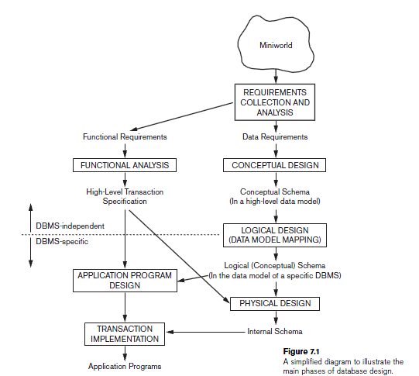

Entities and Attributes

Entities are specific objects or things in the mini-world that are represented in the database. For example the EMPLOYEE John Smith, the Research DEPARTMENT, the ProductX PROJECT

Attributes are properties used to describe an entity. For example an EMPLOYEE entity may have a Name, SSN, Address, Sex, BirthDate

A specific entity will have a value for each of its attributes. For example a specific employee entity may have Name='John Smith', SSN='123456789', Address ='731, Fondren, Houston, TX', Sex='M', BirthDate='09-JAN-55‘

Each attribute has a value set (or data type) associated with it – e.g. integer, string, subrange, enumerated type, …
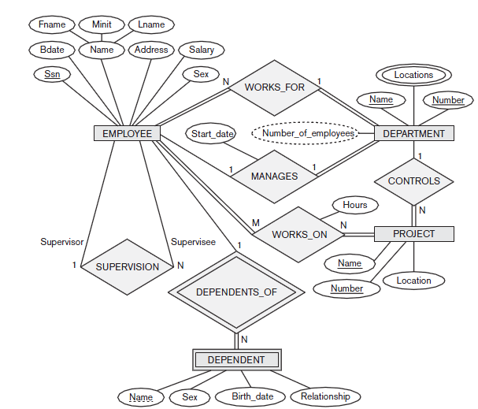

Types of Attributes

Simple

Each entity has a single atomic value for the attribute. For example, SSN or Sex.

Composite

The attribute may be composed of several components. For example, Address (Apt#, House#, Street, City, State, ZipCode, Country) or Name (FirstName, MiddleName, LastName). Composition may form a hierarchy where some components are themselves composite.

Multi-valued

An entity may have multiple values for that attribute. For example, Color of a CAR or PreviousDegrees of a STUDENT. Denoted as {Color} or {PreviousDegrees}.

Types of Attributes

In general, composite and multi-valued attributes may be nested arbitrarily to any number of levels although this is rare. For example, PreviousDegrees of a STUDENT is a composite multi-valued attribute denoted by {PreviousDegrees (College, Year, Degree, Field)}.

Entity Types and Key Attributes

Entities with the same basic attributes are grouped or typed into an entity type. For example, the EMPLOYEE entity type or the PROJECT entity type.

An attribute of an entity type for which each entity must have a unique value is called a key attribute of the entity type. For example, SSN of EMPLOYEE.

A key attribute may be composite. For example, VehicleTagNumber is a key of the CAR entity type with components (Number, State).

An entity type may have more than one key. For example, the CAR entity type may have two keys:

VehicleIdentificationNumber (popularly called VIN) and

VehicleTagNumber (Number, State), also known as license_plate number.

Relationships and Relationship Types

A relationship relates two or more distinct entities with a specific meaning. For example, EMPLOYEE John Smith works on the ProductX PROJECT or EMPLOYEE Franklin Wong manages the Research DEPARTMENT.

Relationships of the same type are grouped or typed into a relationship type. For example, the WORKS_ON relationship type in which EMPLOYEEs and PROJECTs participate, or the MANAGES relationship type in which EMPLOYEEs and DEPARTMENTs participate.

The degree of a relationship type is the number of participating entity types. Both MANAGES and WORKS_ON are binary relationships.

More than one relationship type can exist with the same participating entity types. For example, MANAGES and WORKS_FOR are distinct relationships between EMPLOYEE and DEPARTMENT, but with different meanings and different relationship instances.

Weak Entity Types

An entity that does not have a key attribute

A weak entity must participate in an identifying relationship type with an owner or identifying entity type

Entities are identified by the combination of:

A partial key of the weak entity type

The particular entity they are related to in the identifying entity type

Example:

Suppose that a DEPENDENT entity is identified by the dependent’s first name and birhtdate, and the specific EMPLOYEE that the dependent is related to. DEPENDENT is a weak entity type with EMPLOYEE as its identifying entity type via the identifying relationship type DEPENDENT_OF

Constraints on Relationships

Constraints on Relationship Types

( Also known as ratio constraints )

Maximum Cardinality

One-to-one (1:1)

One-to-many (1:N) or Many-to-one (N:1)

Many-to-many

Minimum Cardinality (also called participation constraint or existence dependency constraints)

zero (optional participation, not existence-dependent)

one or more (mandatory, existence-dependent)

Relationships and Relationship Types

We can also have a recursive relationship type.

Both participations are same entity type in different roles.

For example, SUPERVISION relationships between EMPLOYEE (in role of supervisor or boss) and (another) EMPLOYEE (in role of subordinate or worker).

In following figure, first role participation labeled with 1 and second role participation labeled with 2.

In ER diagram, need to display role names to distinguish participations.

Attributes of Relationship types

A relationship type can have attributes; for example, HoursPerWeek of WORKS_ON; its value for each relationship instance describes the number of hours per week that an EMPLOYEE works on a PROJECT.

Structural constraints on relationships:

Cardinality ratio (of a binary relationship): 1:1, 1:N, N:1, or M:N

SHOWN BY PLACING APPROPRIATE NUMBER ON THE LINK.

Participation constraint (on each participating entity type): total (called existence dependency) or partial.

SHOWN BY DOUBLE LINING THE LINK

NOTE: These are easy to specify for Binary Relationship Types.

Alternative (min, max) notation for relationship structural constraints:

Specified on each participation of an entity type E in a relationship type R

Specifies that each entity e in E participates in at least min and at most max relationship instances in R

Default(no constraint): min=0, max=n

Must have minmax, min0, max 1

Derived from the knowledge of mini-world constraints

Examples:

A department has exactly one manager and an employee can manage at most one department.

Specify (0,1) for participation of EMPLOYEE in MANAGES

Specify (1,1) for participation of DEPARTMENT in MANAGES

An employee can work for exactly one department but a department can have any number of employees.

Specify (1,1) for participation of EMPLOYEE in WORKS_FOR

Specify (0,n) for participation of DEPARTMENT in WORKS_FOR

Relationships of Higher Degree

Relationship types of degree 2 are called binary

Relationship types of degree 3 are called ternary and of degree n are called n-ary
In general, an n-ary relationship is not equivalent to n binary relationships

The Relational Data Model and Relational Database Constraints

Relational Model Concepts

The relational Model of Data is based on the concept of a Relation.

A Relation is a mathematical concept based on the ideas of sets.

The strength of the relational approach to data management comes from the formal foundation provided by the theory of relations.

INFORMAL DEFINITIONS

RELATION: A table of values

A relation may be thought of as a set of rows.

A relation may alternately be though of as a set of columns.

Each row represents a fact that corresponds to a real-world entity or relationship.

Each row has a value of an item or set of items that uniquely identifies that row in the table.

Sometimes row-ids or sequential numbers are assigned to identify the rows in the table.

Each column typically is called by its column name or column header or attribute name.

FORMAL DEFINITIONS

A Relation may be defined in multiple ways.

The Schema of a Relation: R (A1, A2, .....An)

Relation schema R is defined over attributes A1, A2, .....An

For Example -

CUSTOMER (Cust-id, Cust-name, Address, Phone#)

Here, CUSTOMER is a relation defined over the four attributes Cust-id, Cust-name, Address, Phone#, each of which has a domain or a set of valid values. For example, the domain of Cust-id is 6 digit numbers.

A tuple is an ordered set of values

Each value is derived from an appropriate domain.

Each row in the CUSTOMER table may be referred to as a tuple in the table and would consist of four values.

<632895, "John Smith", "101 Main St. Atlanta, GA 30332", "(404) 894-2000">
is a tuple belonging to the CUSTOMER relation.

A relation may be regarded as a set of tuples (rows).

Columns in a table are also called attributes of the relation.

A domain has a logical definition: e.g.,
“USA_phone_numbers” are the set of 10 digit phone numbers valid in the U.S.

A domain may have a data-type or a format defined for it. The USA_phone_numbers may have a format: (ddd)-ddd-dddd where each d is a decimal digit. E.g., Dates have various formats such as monthname, date, year or yyyy-mm-dd, or dd mm,yyyy etc.

An attribute designates the role played by the domain. E.g., the domain Date may be used to define attributes “Invoice-date” and “Payment-date”.

CHARACTERISTICS OF RELATIONS

Ordering of tuples in a relation r(R): The tuples are not considered to be ordered, even though they appear to be in the tabular form.

Ordering of attributes in a relation schema R (and of values within each tuple): We will consider the attributes in R(A₁, A₂, ..., A_{n}) and the values in t=<v₁, v₂, ..., v_{n}> to be ordered .

(However, a more general alternative definition of relation does not require this ordering).

Values in a tuple: All values are considered atomic (indivisible). A special null value is used to represent values that are unknown or inapplicable to certain tuples.

Relational Integrity Constraints

Constraints are conditions that must hold on all valid relation instances. There are three main types of constraints:

Key constraints

Entity integrity constraints

Referential integrity constraints

Key Constraints

Superkey of R: A set of attributes SK of R such that no two tuples in any valid relation instance r(R) will have the same value for SK. That is, for any distinct tuples t1 and t2 in r(R), t1[SK] ≠ t2[SK].

Key of R: A "minimal" superkey; that is, a superkey K such that removal of any attribute from K results in a set of attributes that is not a superkey.

Example: The CAR relation schema:

CAR(State, Reg#, SerialNo, Make, Model, Year)

has two keys Key1 = {State, Reg#}, Key2 = {SerialNo}, which are also superkeys. {SerialNo, Make} is a superkey but not a key.

If a relation has several candidate keys, one is chosen arbitrarily to be the primary key. The primary key attributes are underlined.

Key Constraints

Entity Integrity

Relational Database Schema: A set S of relation schemas that belong to the same database. S is the name of the database.

S = {R₁, R₂, ..., R_{n}}

Entity Integrity: The primary key attributes PK of each relation schema R in S cannot have null values in any tuple of r(R). This is because primary key values are used to identify the individual tuples.

t[PK] ≠ null for any tuple t in r(R)

Note: Other attributes of R may be similarly constrained to disallow null values, even though they are not members of the primary key.

Referential Integrity

A constraint involving two relations (the previous constraints involve a single relation).

Used to specify a relationship among tuples in two relations: the referencing relation and the referenced relation.

Tuples in the referencing relation R₁ have attributes FK (called foreign key attributes) that reference the primary key attributes PK of the referenced relation R₂. A tuple t₁ in R₁ is said to reference a tuple t₂ in R₂ if t₁[FK] = t₂[PK].

A referential integrity constraint can be displayed in a relational database schema as a directed arc from R₁.FK to R₂.

Statement of the constraint

The value in the foreign key column (or columns) FK of the the referencing relation R₁ can be either:

(1) a value of an existing primary key value of the corresponding primary key PK in the referenced relation R_{2,}, or..

(2) a null.

Other Types of Constraints

Semantic Integrity Constraints:

E.g., “the max. no. of hours per employee for all projects he or she works on is 56 hrs per week”

A constraint specification language may have to be used to express these

SQL allows triggers and assertion to allow for some of these

Update Operations on Relations

INSERT a tuple.

DELETE a tuple.

MODIFY a tuple.

Integrity constraints should not be violated by the update operations.

Several update operations may have to be grouped together.

Updates may propagate to cause other updates automatically. This may be necessary to maintain integrity constraints.

Update Operations on Relations

In case of integrity violation, several actions can be taken:

Cancel the operation that causes the violation (REJECT option)

Perform the operation but inform the user of the violation

Trigger additional updates so the violation is corrected (CASCADE option, SET NULL option)

Execute a user-specified error-correction routine

